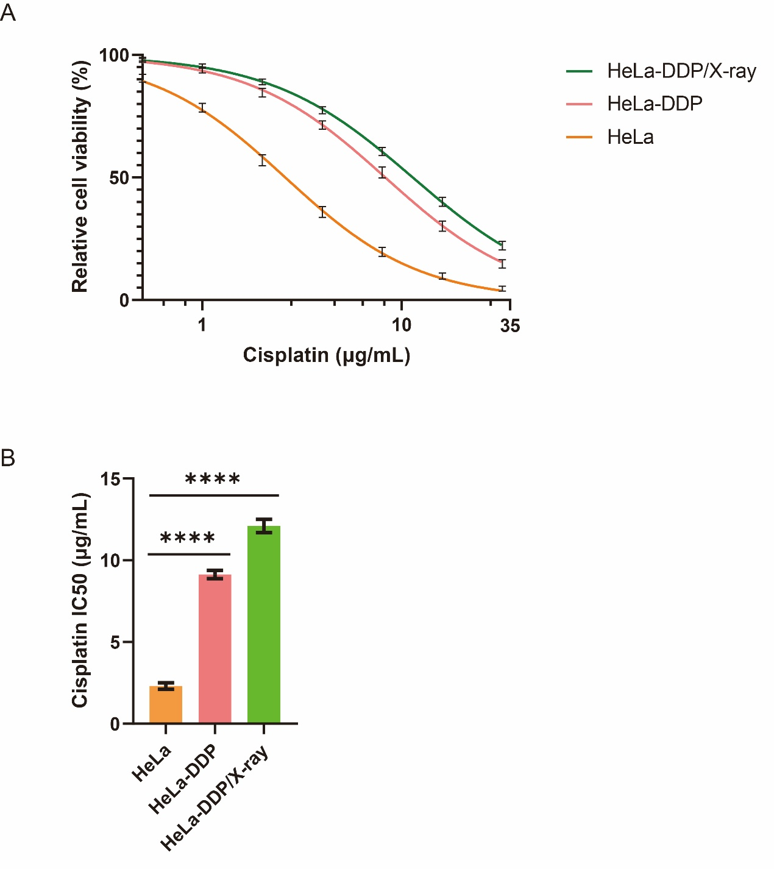
Fig. S1 Characterization of the chemoradiotherapy-resistant HeLa cell model
(A) Cisplatin dose-response curves of parental HeLa cells, cisplatin-resistant HeLa-DDP cells, and irradiation-adapted HeLa-DDP/X-ray cells. Cell viability was assessed by CCK-8 assay after cisplatin treatment at the indicated concentrations. (B) Quantitative analysis of cisplatin IC50 values in the three cell groups, showing progressively increased cisplatin resistance in resistant cells. Data are presented as mean ± SD. Statistical analysis was performed using one-way ANOVA. ****P < 0.0001. DDP, cis-diamminedichloroplatinum (cisplatin); IC50, half maximal inhibitory concentration; CCK-8, Cell Counting Kit-8; SD, standard deviation; ANOVA, analysis of variance.

