Table S1. Statistical results of IDI and NRI
Time | IDI | IDI_Lower | IDI_Upper | IDI_P | NRI | NRI_Lower | NRI_Upper | NRI_P
1-year | -0.015 | -0.057 | 0.012 | P>0.05 | 0.18 | -0.575 | 0.617 | P>0.05
3-year | 0.17 | -0.011 | 0.349 | P>0.05 | 0.457 | 0.067 | 0.692 | P<0.05
5-year | 0.349 | 0.148 | 0.536 | P<0.05 | 0.672 | 0.382 | 0.854 | P<0.05

Supplementary Figure
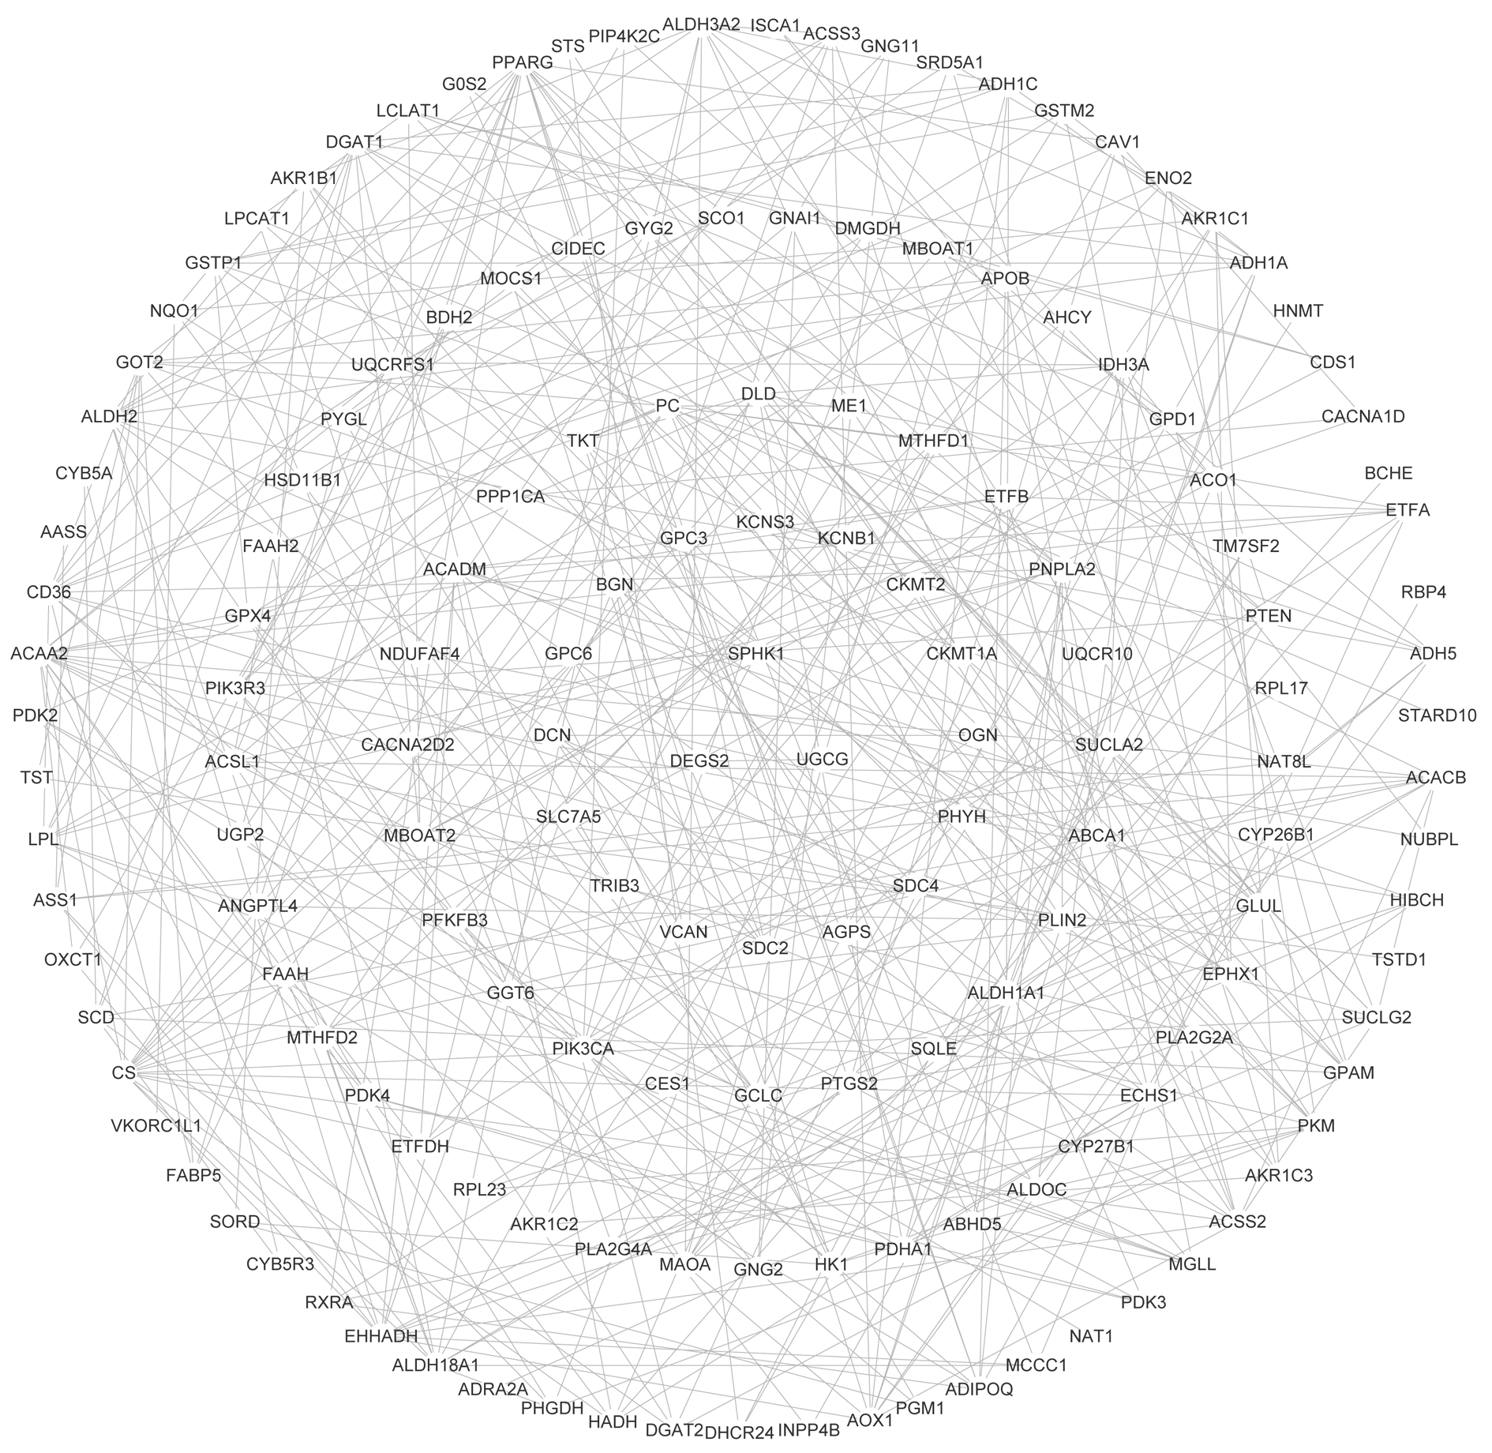
Figure S1: The PPI network of candidate key CSCs and metabolism-associated DEGs.

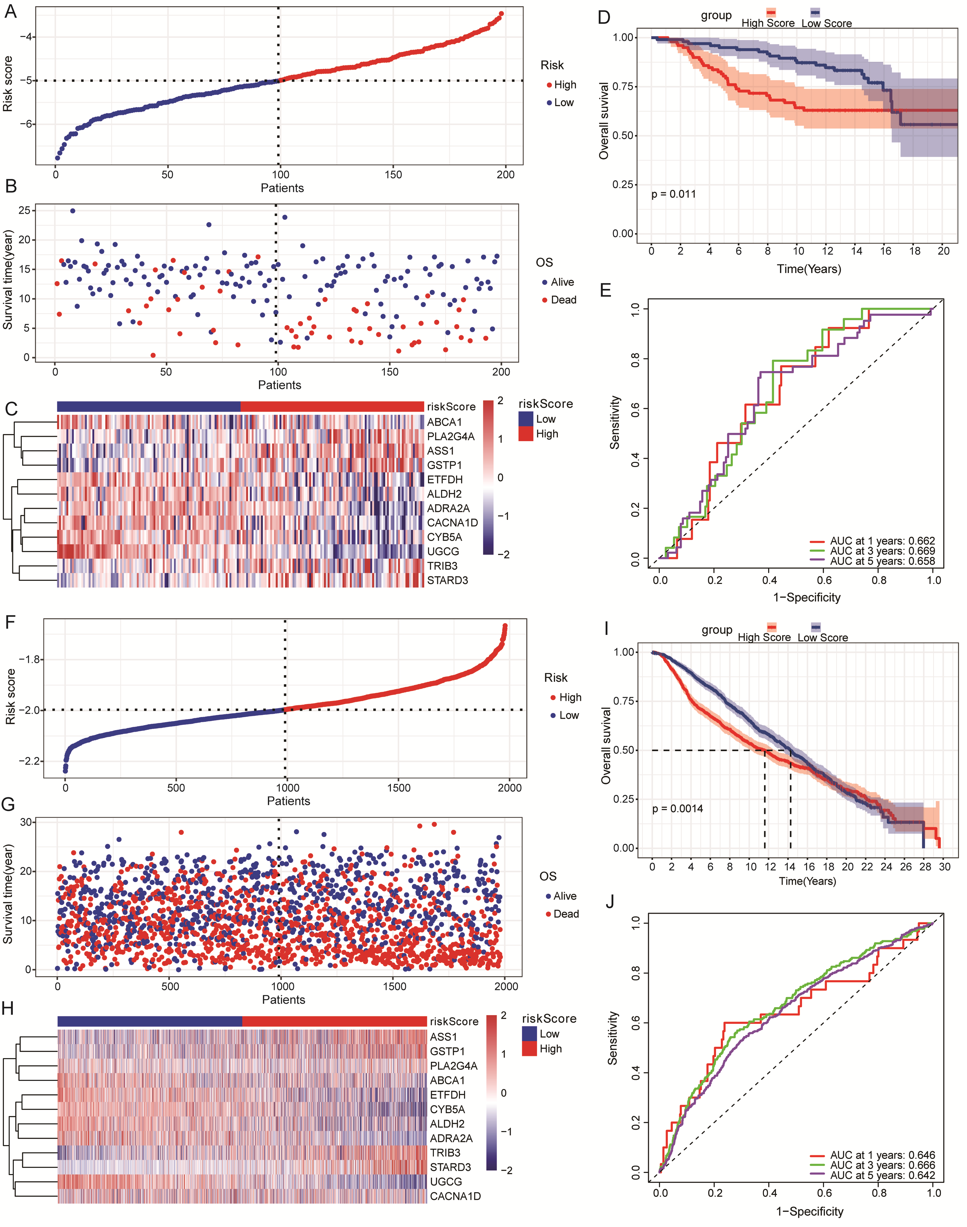
Figure S2: Validation of the risk score model in the GSE7390 and cBioPartal-brca_metabric datasets.
A: Risk score distribution in GSE7390 dataset; B: Survival status in GSE7390 dataset; C: Model genes expression heatmap in GSE7390 dataset; D: Time-dependent ROC curves of the risk score for prediction of 1-, 3-, and 5-year OS in GSE7390 dataset; E: Survival analysis of the high- and low-risk groups in GSE7390 dataset; F: Risk score distribution in cBioPartal-brca_metabric dataset; G: Survival status in cBioPartal-brca_metabric dataset; H: Model genes expression heatmap in cBioPartal-brca_metabric dataset; I: Time-dependent ROC curves of the risk score for prediction of 1-, 3-, and 5-year OS in cBioPartal-brca_metabric dataset; J: Survival analysis of the high- and low-risk groups in cBioPartal-brca_metabric dataset.

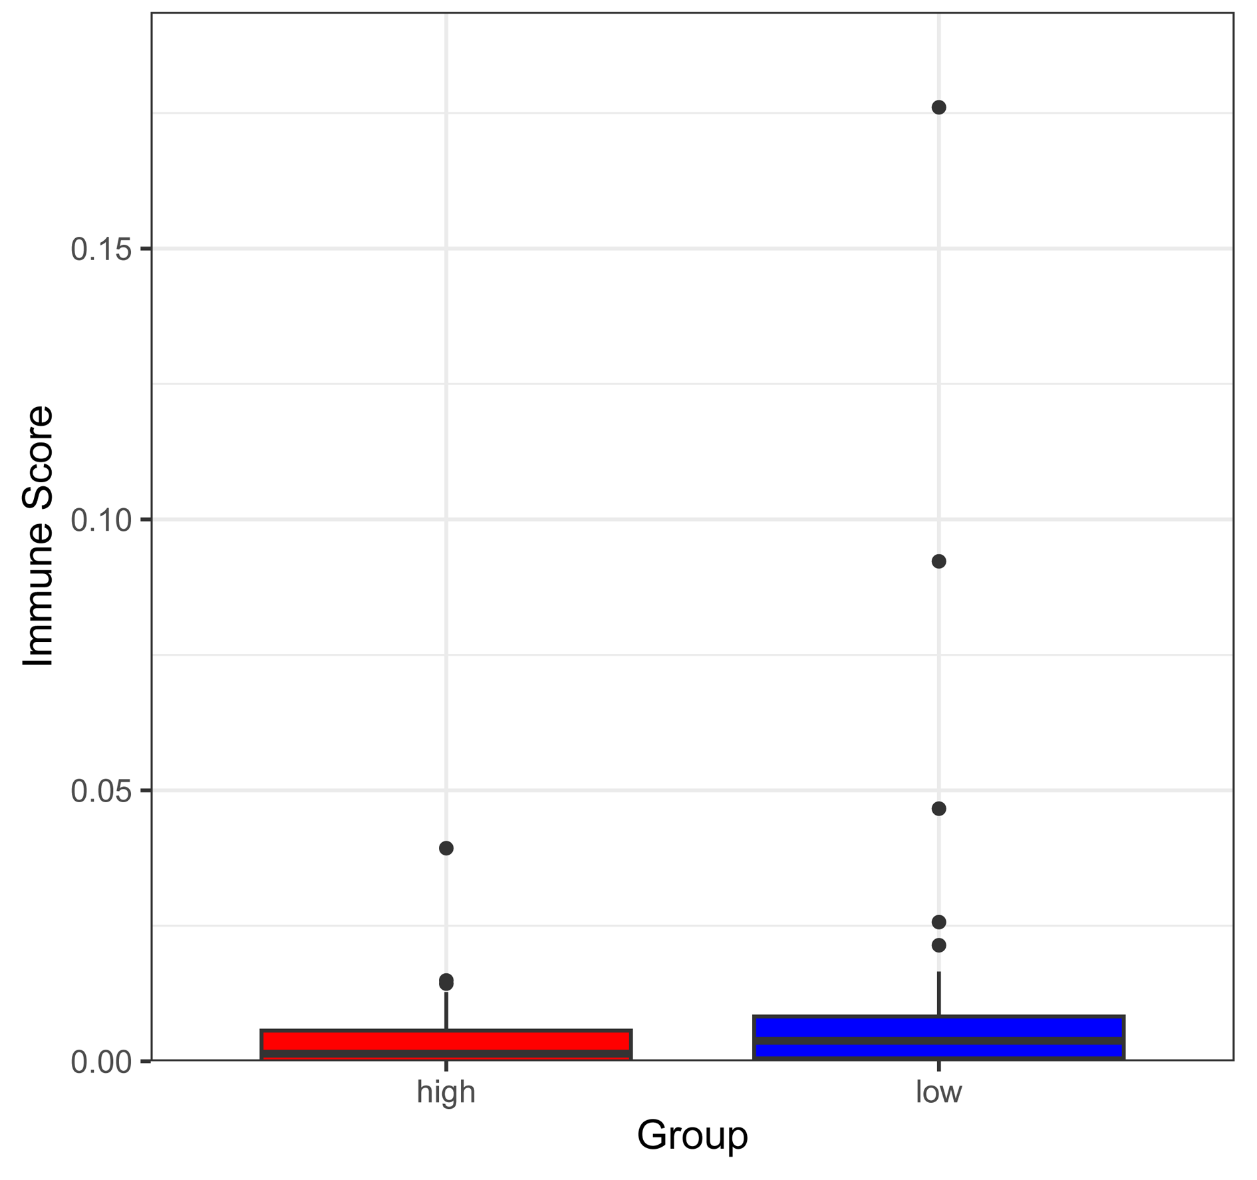
Figure S3: The immune infiltration levels of macrophages M2 in low- and high-risk groups based on xCell analysis.

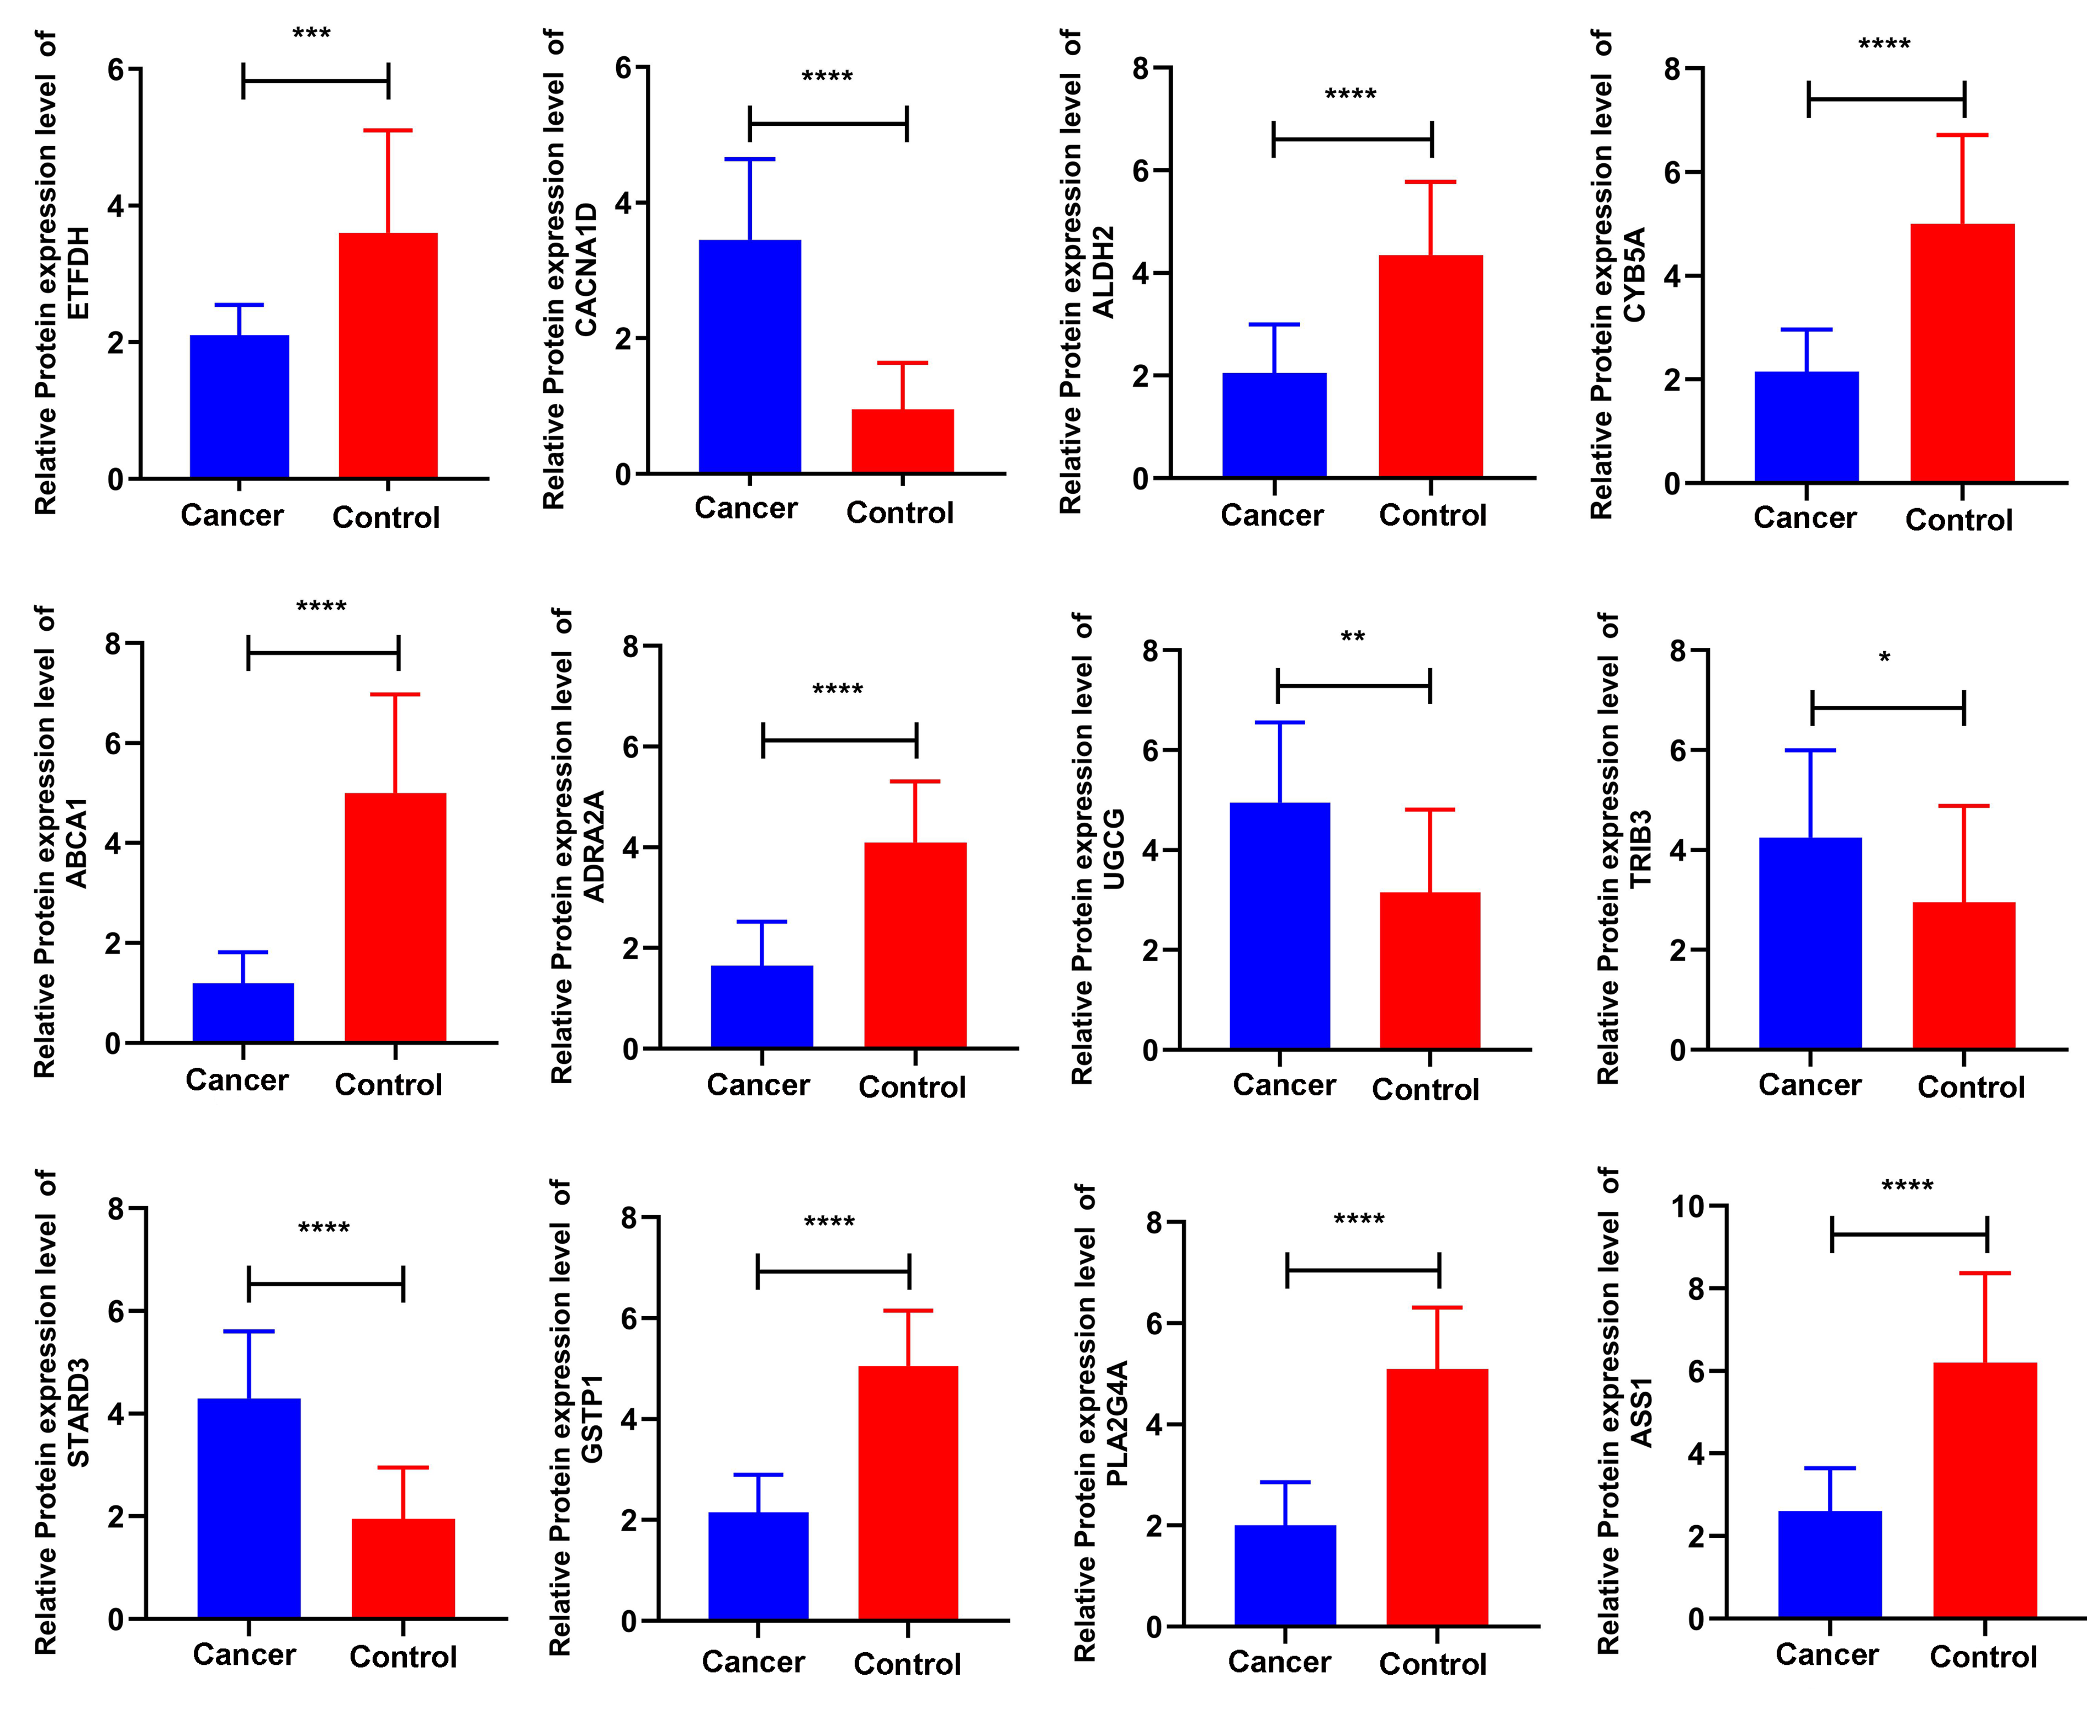
Figure S4: Histogram of statistical analysis (T-test) for protein expression levels of ETFDH, CACNA1D, ALDH2, CYB5A, ABCA1, ADRA2A, UGCG, TRIB3, STARD3, GSTP1, PLA2G4A and ASS1 in breast cancer tissues.
*, P<0.05; **, P<0.01; ***, P<0.001; ****, P<0.0001.

