Supplementary Materials:
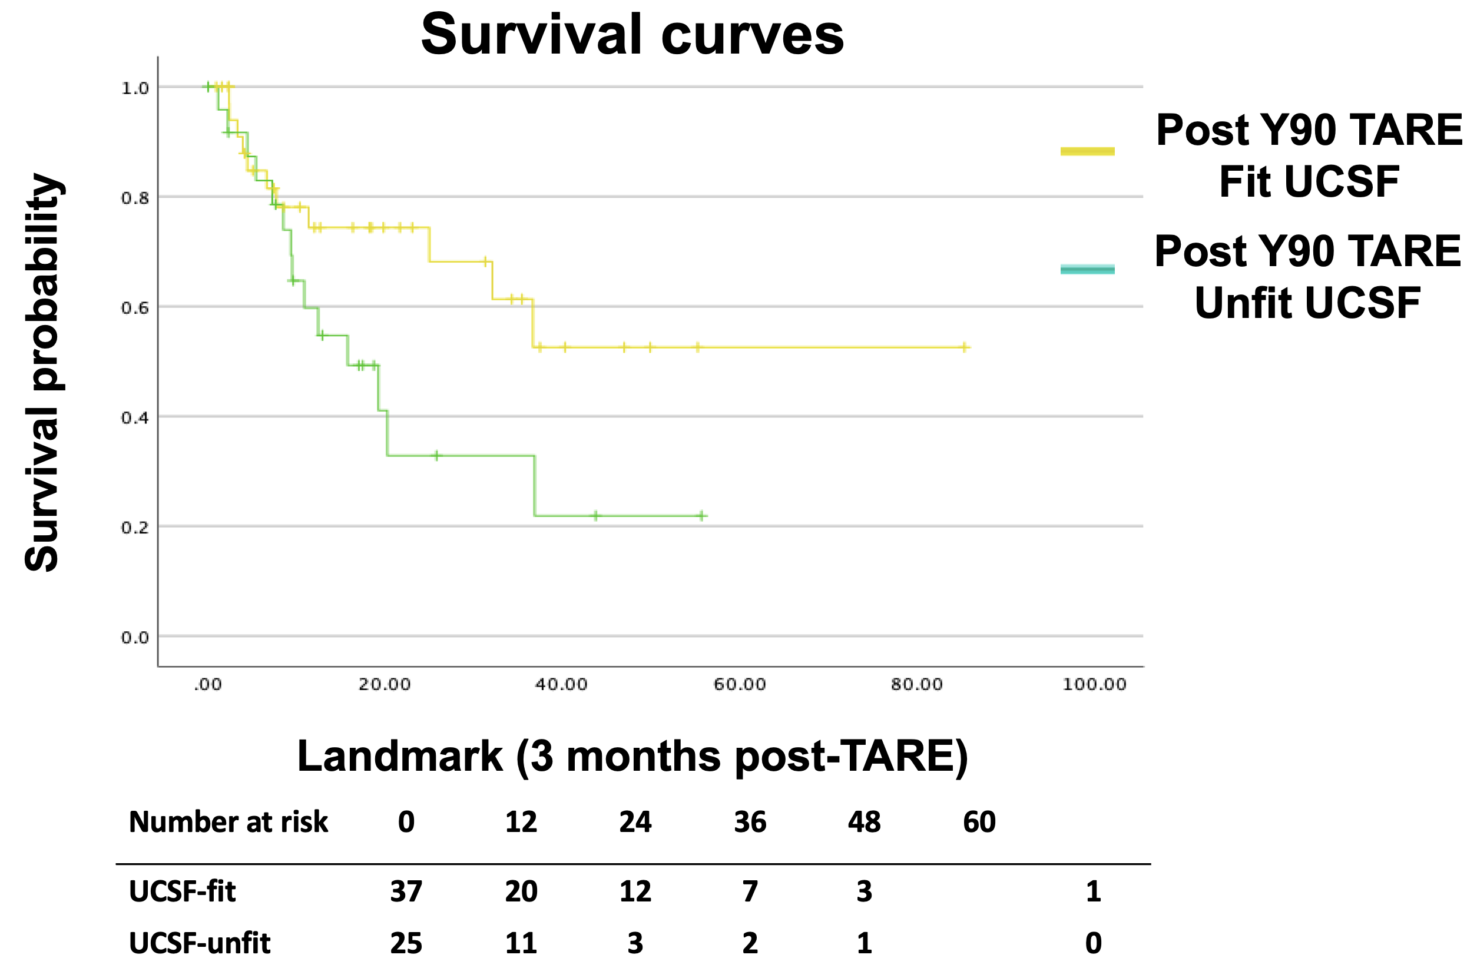
Supplementary Figure 1. Kaplan–Meier overall survival from the 3-month landmark, stratified by post-TARE UCSF status (fit vs unfit). Patients who died within 3 months after TARE were excluded to mitigate time-dependent bias (landmark at 3 months, aligned with response assessment). The landmark population included n=37 in the UCSF-fit group and n=25 in the UCSF-unfit group. Survival separation was attenuated but remained directionally consistent (log-rank p=0.053)

Supplementary Table 1 Sensitivity analysis using ROC-derived tumor size cut-off (≥7.8 cm)
Variable | Odds ratio (OR) | 95% CI | p value
Largest tumor size ≥ 7.8 cm | 4.53 | 1.50–13.66 | 0.007＊
ALBI grade (2 vs 1) | 1.23 | 0.38–4.02 | 0.733
Model statistics: Omnibus χ² = 8.38, p = 0.015; Nagelkerke R² = 0.163
＊Statistically significant difference.

Supplementary Table 2 Interaction analysis between tumor size and tumor number for successful downstaging
Outcome: Successful downstaging to within UCSF criteria (Yes = 1)
Variable | Odds ratio (OR) | 95% CI | p value
Tumor number (per lesion) | 1.03 | 0.94 - 1.13 | 0.49
Largest tumor diameter ≥ 7.8 cm | 0.14 | 0.03 – 0.76 | 0.023
Size × number interaction | 0.95 | 0.78 – 1.15 | 0.612
Model fit: Omnibus χ² = 8.78, p = 0.032; Nagelkerke R² = 0.17

