A Machine Learning Guided System for Therapeutic Decision-Making in Intra-arterial Therapy of Hepatocellular Carcinoma
Running title: An intelligent decision-making method

This supplementary material includes:
- Supplementary Information
E1.1 TACE or HAIC procedures.
E1.2 Criteria for protocol treatment discontinuation.
E1.3 IAIT combination with MAT or ICI.
E1.4 Five representative supervised ML algorithms in detail.

- Supplementary Tables
eTable 1. The abbreviation and details of the 35 clinical variables.
eTable 2. The code parameters of the ML algorithms using preoperative variables.
eTable 3. The code parameters of the ML algorithms using postoperative variables.
eTable 4. Five ML based models for prediction of 1- and 3-years OS based on preoperative variables.
eTable 5. Five ML based models for prediction of 1- and 3-years OS based on postoperative variables.

- Supplementary Figures
eFigure 1. The correlation coefficient matrix heat map of all 35 variables.
eFigure 2. shows the influence of the response to first IAT on 5-years death in the CatBoost model through the SHAP algorithm.
eFigure 3. shows the influence of the ICI on 5-years death in the CatBoost model through the SHAP algorithm.
eFigure 4. shows the influence of the tumor size on 5-years death in the CatBoost model through the SHAP algorithm.
eFigure 5. shows the influence of the BCLC stages on 5-years death in the CatBoost model through the SHAP algorithm.
eFigure 6. shows the influence of the local therapy on 5-years death in the CatBoost model through the SHAP algorithm.
eFigure 7. shows the influence of the PLT on 5-years death in the CatBoost model through the SHAP algorithm.
eFigure 8. shows the influence of the PT on 5-years death in the CatBoost model through the SHAP algorithm.
eFigure 9. shows the influence of the INR on 5-years death in the CatBoost model through the SHAP algorithm.
eFigure 10. shows the influence of the CRP on 5-years death in the CatBoost model through the SHAP algorithm.
eFigure 11. shows the influence of the TKI on 5-years death in the CatBoost model through the SHAP algorithm.
eFigure 12. Decision curve analysis (DCA) and calibration curves comparison between five machine learning models.

- Supplementary Information
Supplementary Information E1.1
TACE or HAIC procedures have been described in our previous report^{[1-3]}. All equipment included i) digital subtraction angiography (Philips, type FD 20 1250 mA, Amsterdam, Netherlands); ii) the artery sheath catheter was inserted into the femoral artery using the modified Seldinger technique; iii) A 5-Fr Yashiro catheter (Terumo, Tokyo, Japan) was advanced into the celiac trunk and superior mesenteric artery to assess the feeding hepatic artery; iv) A 2.7-Fr micro-catheter (Terumo, Tokyo, Japan) was inserted in the feeding artery. The therapeutic principles of these procedures were as follows: 1). TACE: the feeding artery was selected or super-selected whenever possible. Emulsion, which consisted of 10–20 ml lipiodol, 30–50 mg platinum drugs, and 20–40-mg epirubicin was injected slowly until the offending vessel occluded. If necessary, embolization using gel foam mixed with contrast medium was injected to reduce the residual blood flow until there was no longer any tumor staining after repeat angiography. 2). HAIC: all chemo-drugs were given by HAIC through the micro-catheter. A modified FOLFOX6 regimen, including oxaliplatin (130 mg/m² infusion for 3 h on day 1), leucovorin (200 mg/m² for 3–5 hours on day 1), and Fluorouracil (400 mg/m² in bolus, and then 2,400 mg/m² continuous infusion 23-46 h) was applied. Treatment was repeated every 3 weeks and commonly 4–6 cycles unless intrahepatic lesions progress or toxicity became unacceptable.

Supplementary Information E1.2
The criteria for discontinuing the IAT protocol was shown as following:
A)Tumor progression. The progression disease (PD) were assessed by dynamic CT or MRI based on modified Response Evaluation Criteria in Solid Tumor (mRECIST).
B) Intolerable adverse event
i) Patient cannot resume IAIT after 30 days of interruption due to an adverse event;
ii) An adverse event that meets the criteria for IAIT dose reduction occurs after the dose was already reduced to the lowest level;
iii) Life-threatening adverse event;
C)The need for another anticancer treatment due to downstaging at the physician’ s discretion;
D) IAIT becomes technically infeasible;
E) Inadequate blood or bone marrow (leukopenia count < 3.0×10⁹/L, platelet count < 50×10⁹/L, and hemoglobin < 8.0 g/L)
F) Patient requests to discontinue the study；
G) Death.

Supplementary Information E1.3
During HAIC or TACE treatment, molecular-targeted agents (MTAs) and immune checkpoint inhibitors (ICIs) were performed to control the intrahepatic and extrahepatic progression. Oral first-line targeted chemotherapy including sorafenib and lenvatinib was started 1–5 days after the first HAIC or TACE session and continually administered. Once the disease progresses or 3-4 AEs occur, the second-line treatment regimen (regorafenib or apatinib) can be administered. Oral lenvatinib (Lenvimafi; Eisai Co., Ltd.) was administered to the patients with Ad-HCCs. The initial dose was determined based on the patients’ body weight and liver function. Patients weighing > 60 kg with the Child–Pugh A classification started at a dose of 12 mg once daily. Patients weighing < 60 kg with the same liver function started at a dose of 8 mg once daily. A reduction in dosage or interruption of treatment was implemented when AEs were detected. Lenvatinib was administered unless patients were intolerant of radiological tumor progression or AEs. ICI immunotherapy were performed after 1-3 days IAT treat and every 3 weeks intravenously. Fixed-dose administration of PD-1 was used until disease progression or unexpected toxicity. The dose and interval of TKIs allowed changes depending on toxicity and disease conditions.

Supplementary Information E1.4
1.4.1 LGBM
The leaf growth strategy used by LGBM involves finding the leaf with the highest splitting information gain (usually with the largest amount of data) from each leaf for splitting, and so on. XGBoost and other algorithms for layer based growth do not differentiate between leaves on the same layer, and many leaves have low splitting gain, making it unnecessary to search and split. Under the same number of splits, the leaf growth strategy can reduce more errors and achieve better accuracy.
1.4.2. GBDT
GBDT is a Gradient Boosting+Decision Tree. The principle of GBDT is to first train a tree using the training set and the true classification of samples, then use this tree to predict the training set and obtain the predicted values of each sample. Next, use the deviation between the predicted values and the true values, that is, the "residual", as the standard answer to train the next tree. Then continue to use residuals to train the third tree, and so on, to obtain the final prediction result.
Due to the continuous selection and segmentation of features during the growth process of decision trees, GBDT composed of a large number of decision trees vertically has inherent advantages, such as easy ranking of feature importance and strong interpretability. It is commonly used in binary classification problems.
1.4.3. XGboost
XGBoost is a machine learning method that focuses on gradient lifting algorithms and has been improved on the basis of GBDT. Compared with GBDT, XGBoost expands the loss function as a second-order Taylor expansion, optimizes the loss function using its second-order derivative, and selects whether to split nodes based on whether the loss function decreases. Meanwhile, XGBoost incorporates regularization, learning rate, column sampling, and approximate optimal segmentation points to prevent overfitting. Some optimization has also been made in handling missing values.
1.4.4. Catboost
CatBoost is also an improved implementation within the GBDT algorithm framework, which is an algorithm based on symmetric decision trees with fewer parameters, support for categorical variables, and high accuracy. This algorithm can efficiently and reasonably process classified features, and also solve the problems of gradient bias and prediction shift, thereby effectively reducing overfitting and improving the accuracy and generalization ability of the algorithm.
It adopts a special approach to handle categorical features, greatly reducing the workload of processing classified features. Catboost also uses combined category features, which can utilize the connections between features, greatly enriching the feature dimension and providing the possibility of optimizing model performance.
1.4.5. RF
Random forest is a commonly used Bagging class model for binary classification problems. As the name suggests, a random forest is a collection of many decision trees. This algorithm can randomly sample the training dataset into different subsets, and each subset is trained to generate corresponding sub decision trees. Summarize the prediction results of all sub decision trees, and the prediction result with the highest proportion will be used as the final prediction result of the model.
Because the method of random sampling significantly reduces the overall differences in the model, random forests can provide good results from a global perspective and often perform well in binary classification problems.

Reference
1. Ueshima K, Komemushi A, Aramaki T, Iwamoto H, Obi S, Sato Y, Tanaka T, Matsueda K, Moriguchi M, Saito H, Sone M, Yamagami T, Inaba Y, Kudo M, Arai Y. Clinical Practice Guidelines for Hepatic Arterial Infusion Chemotherapy with a Port System Proposed by the Japanese Society of Interventional Radiology and Japanese Society of Implantable Port Assisted Treatment. Liver Cancer. 2022 May 5;11(5):407-425. doi: 10.1159/000524893.
2. Yamasaki T, Saeki I, Yamauchi Y, Matsumoto T, Suehiro Y, Kawaoka T, Uchikawa S, Hiramatsu A, Aikata H, Kobayashi K, Kondo T, Ogasawara S, Chiba T, Takami T, Chayama K, Kato N, Sakaida I. Management of Systemic Therapies and Hepatic Arterial Infusion Chemotherapy in Patients with Advanced Hepatocellular Carcinoma Based on Sarcopenia Assessment. Liver Cancer. 2022 Feb 22;11(4):329-340. doi: 10.1159/000522389.
3. Wang T, Dong J, Zhang Y, Ren Z, Liu Y, Yang X, Sun D, Wang Y. Efficacy and safety of hepatic artery infusion chemotherapy with mFOLFOX in primary liver cancer patients with hyperbilirubinemia and ineffective drainage: a retrospective cohort study. Ann Transl Med. 2022 Apr;10(7):411. doi: 10.21037/atm-22-978.
4.Hiraoka A, Kumada T, Tsuji K, Takaguchi K, Itobayashi E, Kariyama K, et al. Validation of Modified ALBI Grade for More Detailed Assessment of Hepatic Function in Hepatocellular Carcinoma Patients: A Multicenter
Analysis. Liver Cancer. 2019 Mar;8(2):121–129.
- Supplementary Table
eTable 1. The data source of HCC patients form multi-center hospitals.
Hospitals’ name | TACE | HAIC
Total | N=3,226 | N=2,420
Guangdong Provincial Hospital of Chinese Medicine | 84 | 23
The First Affiliated Hospital of Sun Yat-sen University | 115 | 21
The Third Affiliated Hospital of Sun Yat-sen University | 112 | 30
Sun Yat-sen Memorial Hospital of Sun Yat sen University | 58 | 130
Guangdong Provincial People's Hospital | 46 | 12
Jinan University First Affiliated Hospital | 32 | 11
Sun Yat-sen University Cancer Center | 2465 | 1716
Affiliated Hospital of Southern Medical University | 15 | 7
Guangzhou Cancer Hospital | 13 | 150
Chinese Academy of Medical Sciences and Peking Union Medical College | 25 | 200
Chinese PLA General Hospital | 28 | 5
Luhe Hospital, Capital Medical University | 8 | NA
Shandong Shengli Hospital | 233 | NA
Shandong Cancer Hospital and Institute | NA | 115
Shanxi Cancer Hospital and Institute | 8 (0.7) | NA
West China Hospital | 155 (12.7) | NA

eTable 2. The abbreviation of the 35 clinical variables.
Variable | Variable name | Abbreviation
Demographic and history
 | Age
 | Gender
 | Smoking
 | Dringking
 | BMI
 | Pathology differentiation
 | ECOG
 | Etiology
 | Comorbidity score | CS
 | Child-Pugh grade | CTP grade
 | Ascites
Tumor data
 | Number of tumors | No. of tumors
 | Maximum diameter of tumor | MD of tumor
 | Tumor type | TT
 | Vascular invasion
 | Metastasis
Postoperative parameters
 | IAIT modalities | IATM
 | Targeted-immunetherapy | TIT
 | Sequential local therapy | SLT
 | The response of first IAT  Early recurrence  Recurrence type | TRFI  ER  RT
Laboratory findings
 | Alanine aminotransferase | ALT
 | Aspartate aminotransferase | AST
 | α-fetoprotein | AFP
 | des-γ-carboxy prothrombin | DCP
 | Albumin | ALB
 | Total bilirubin | TBIL
 | Creatinine | Cre
 | C reactive protein | CRP
 | Platelet | PLT
 | Lymphocyte | LYM
 | Neutrophils | NEU
 | Prothrombin time | PT
 | Prothrombin activity | PTA
 | International Normalized Ratio | INR
eTable 3. The parameters of the ML models based on preoperative variables
No. | Algorithms | Details
1 | RF | RandomForestClassifier(n_estimators=240, max_depth=4, min_samples_split=20,min_samples_leaf=5, max_features=6, oob_score=True,random_state=2023)
2 | GBDT | GradientBoostingClassifier(n_estimators=500,learning_rate=0.01,max_depth=5,min_samples_split=360,min_samples_leaf=50,max_features=17,subsample=0.9,random_state=0)
3 | LGBM | LGBMClassifier(boosting_type='gbdt',objective='binary',learning_rate=0.005,n_estimators=345,max_depth=5,num_leaves=38,min_child_samples=18,min_child_weight=0.001,bagging_fraction=0.6,feature_fraction=0.5,subsample=1,colsample_bytree=1,reg_alpha=0.1,reg_lambda=0.01,random_state=0)
4 | CatBoost | CatBoostClassifier(loss_function="Logloss",eval_metric="AUC",learning_rate=0.01,iterations=1000,random_seed=42,od_type="Iter",depth=4,early_stopping_rounds=800,colsample_bylevel=0.2,l2_leaf_reg=30,random_strength=800,scale_pos_weight=4,silent=True)
5 | XGBoost | XGBClassifier(objective='binary:logistic',learning_rate=0.05,n_estimators=191,max_depth=4,min_child_weight=15,gamma=0.1,subsample=0.85,colsample_bytree=0.75,scale_pos_weight=1.38,reg_alpha=1,reg_lambda=5,n_jobs=-1,seed=42)

eTable 4. The parameters of the ML models based on postoperative variables
No. | Algorithms | Details
1 | RF | RandomForestClassifier(n_estimators=240, max_depth=4, min_samples_split=20,min_samples_leaf=5, max_features=6, oob_score=True,random_state=2023)
2 | GBDT | GradientBoostingClassifier(n_estimators=500,learning_rate=0.01,max_depth=5,min_samples_split=360,min_samples_leaf=50,max_features=17,subsample=0.9,random_state=0)
3 | LGBM | LGBMClassifier(boosting_type='gbdt',objective='binary',learning_rate=0.005,n_estimators=345,max_depth=5,num_leaves=38,min_child_samples=18,min_child_weight=0.001,bagging_fraction=0.6,feature_fraction=0.5,subsample=1,colsample_bytree=1,reg_alpha=0.1,reg_lambda=0.01,random_state=0)
4 | CatBoost | CatBoostClassifier(loss_function="Logloss",eval_metric="AUC",learning_rate=0.01,iterations=1000,random_seed=42,od_type="Iter",depth=4,early_stopping_rounds=800,colsample_bylevel=0.2,l2_leaf_reg=30,random_strength=800,scale_pos_weight=4,silent=True)
5 | XGBoost | XGBClassifier(objective='binary:logistic',learning_rate=0.05,n_estimators=191,max_depth=3,min_child_weight=1,gamma=0.1,subsample=0.85,colsample_bytree=0.75,scale_pos_weight=1.38,reg_alpha=1,reg_lambda=5,n_jobs=-1,seed=42)

eTable 5. Five ML based models for prediction of 1- and 3-years OS based on preoperative variables
Models | Cohorts | Years | AUC (95% CI) | ACC | SENS | SPEC | PPV | NPV
XGBoost | ITD | 1 year | 0.822 (0.788-0.857) | 0.754 | 0.745 | 0.760 | 0.694 | 0.803
XGBoost | ETD | 3 year | 0.834 (0.800-0.868) | 0.772 | 0.739 | 0.813 | 0.829 | 0.716
CatBoost | ITD | 1 year | 0.852 (0.821-0.883) | 0.785 | 0.831 | 0.750 | 0.709 | 0.859
CatBoost | ETD | 3 year | 0.880 (0.858-0.908) | 0.814 | 0.821 | 0.804 | 0.838 | 0.785
LGBM | ITD | 1 year | 0.809 (0.778-0.855) | 0.750 | 0.831 | 0.690 | 0.663 | 0.848
LGBM | ETD | 3 year | 0.819 (0.794-0.853) | 0.765 | 0.782 | 0.743 | 0.790 | 0.734
RF | ITD | 1 year | 0.835 (0.826-0.884) | 0.772 | 0.806 | 0.747 | 0.700 | 0.840
RF | ETD | 3 year | 0.837 (0.855-0.872) | 0.776 | 0.765 | 0.788 | 0.816 | 0.732
GBDT | ITD | 1 year | 0.846 (0.813-0.879) | 0.785 | 0.780 | 0.788 | 0.729 | 0.830
GBDT | ETD | 3 year | 0.836 (0.802-0.870) | 0.786 | 0.821 | 0.743 | 0.798 | 0.772

eTable 6. Five ML based models for prediction of 1- and 3-years OS based on postoperative variables
Models | Cohorts | Years | AUC (95% CI) | ACC | SENS | SPEC | PPV | NPV
XGBoost | ITD | 1 year | 0.877 (0.845-0.923) | 0.828 | 0.813 | 0.862 | 0.711 | 0.823
XGBoost | ETD | 3 year | 0.880 (0.858-0.908) | 0.832 | 0.798 | 0.842 | 0.820 | 0.724
CatBoost | ITD | 1 year | 0.856 (0.822-0.902) | 0.765 | 0.835 | 0.766 | 0.712 | 0.867
CatBoost | ETD | 3 year | 0.845 (0.811-0.872) | 0.821 | 0.813 | 0.803 | 0.813 | 0.787
LGBM | ITD | 1 year | 0.809 (0.778-0.856) | 0.755 | 0.833 | 0.711 | 0.692 | 0.862
LGBM | ETD | 3 year | 0.845 (0.794-0.887) | 0.779 | 0.782 | 0.763 | 0.79 | 0.737
RF | ITD | 1 year | 0.842 (0.826-0.892) | 0.771 | 0.806 | 0.746 | 0.724 | 0.843
RF | ETD | 3 year | 0.826 (0.823-0.911) | 0.818 | 0.766 | 0.809 | 0.821 | 0.776
GBDT | ITD | 1 year | 0.845 (0.809-0.872) | 0.792 | 0.802 | 0.792 | 0.767 | 0.843
GBDT | ETD | 3 year | 0.852 (0.821-0.902) | 0.802 | 0.824 | 0.778 | 0.802 | 0.773

- Supplementary Figure
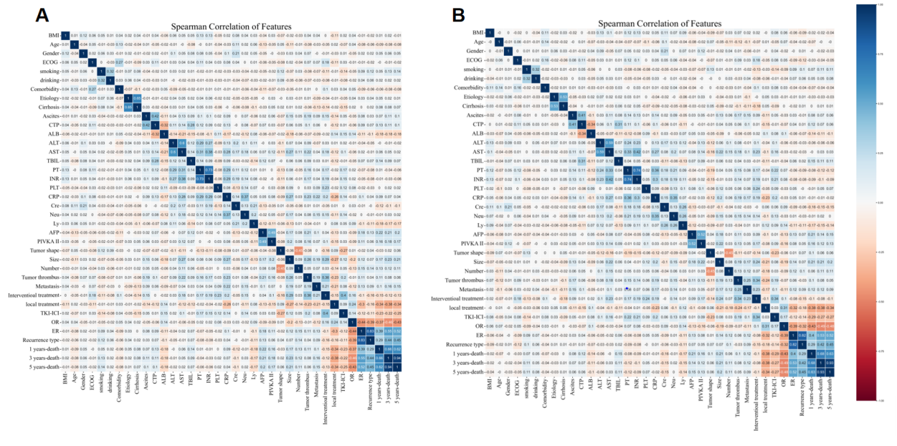
eFigure 1. The correlation coefficient matrix heat map of all 35 variables (A) in the internal testing cohort and (B) in the external testing cohort.

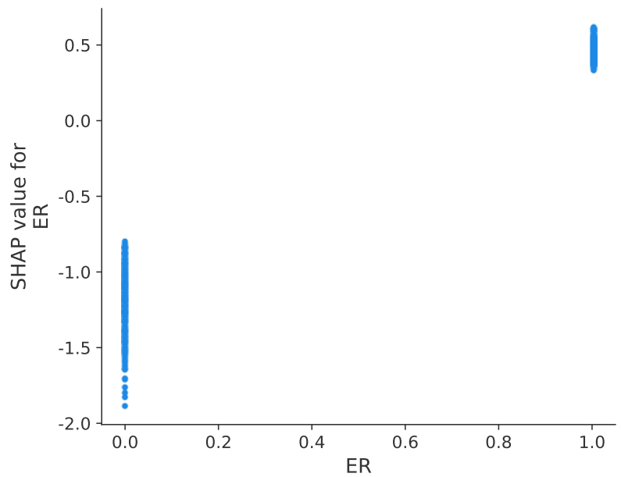
eFigure 2. shows the influence of the ER on 1-years death in the XGBoost model by the SHAP

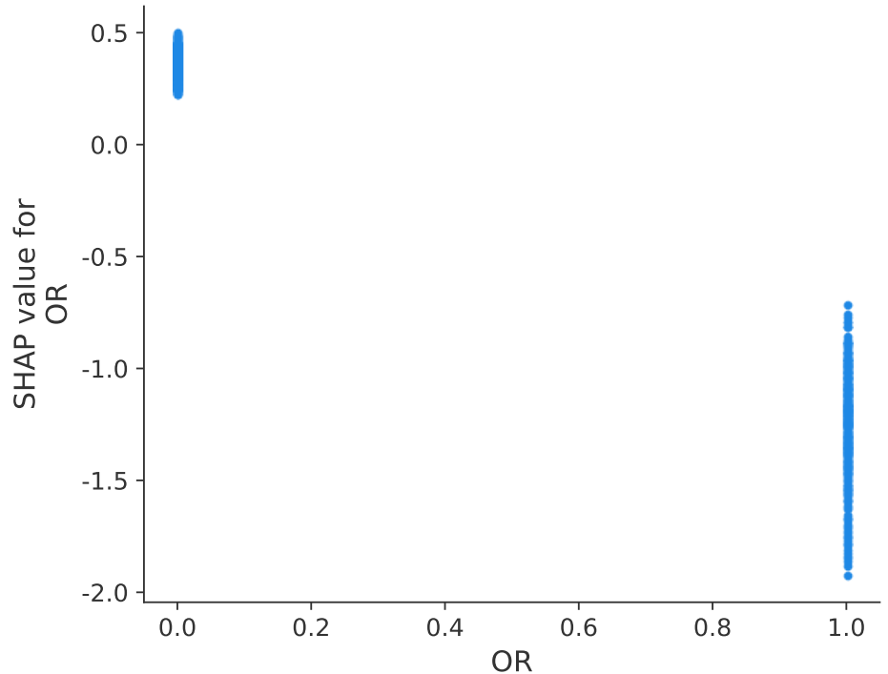
eFigure 3. shows the influence of the ER on 1-years death in the XGBoost model by the SHAP
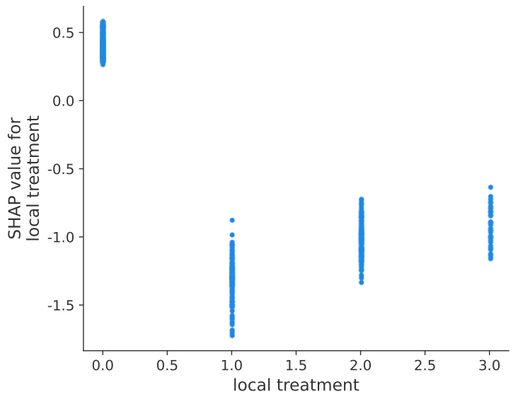
eFigure 4. shows the influence of the local therapy on 1-years death in the XGBoost model by the SHAP

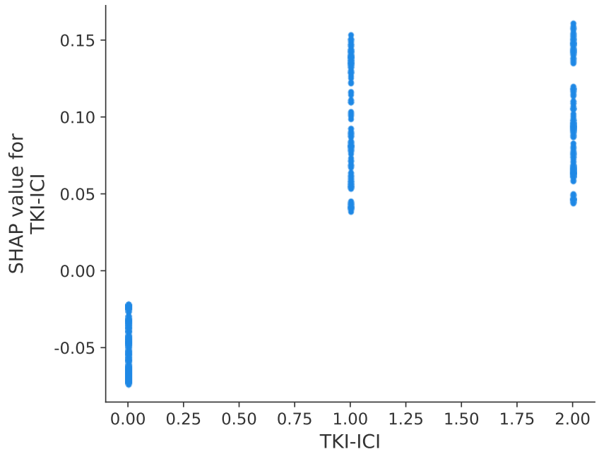
eFigure 5. shows the influence of the targeted-immunetherapy on 1-years death in the XGBoost model by the SHAP

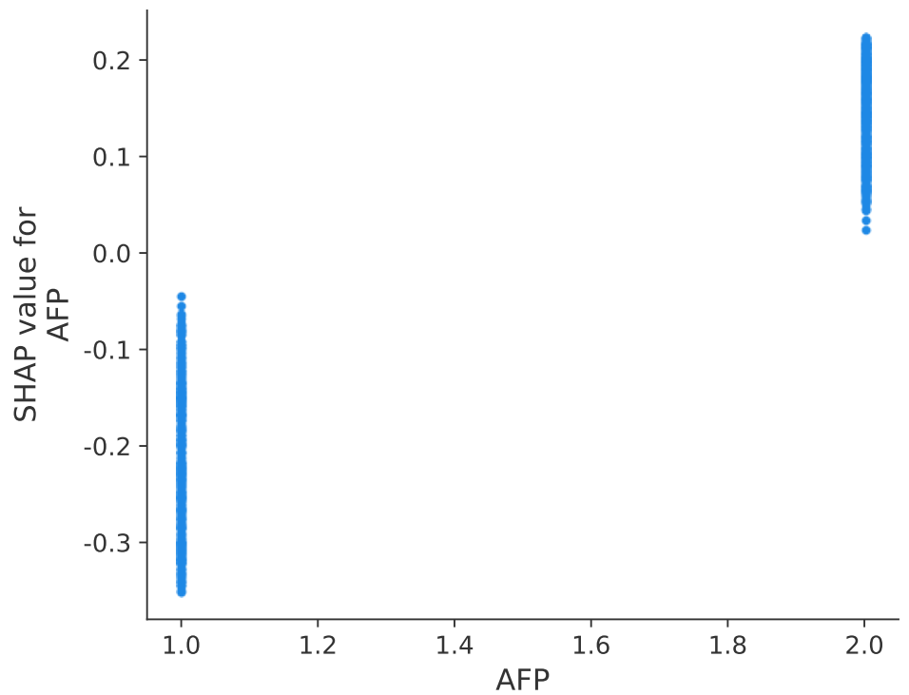
eFigure 6. shows the influence of the AFP on 1-years death in the XGBoost model by the SHAP

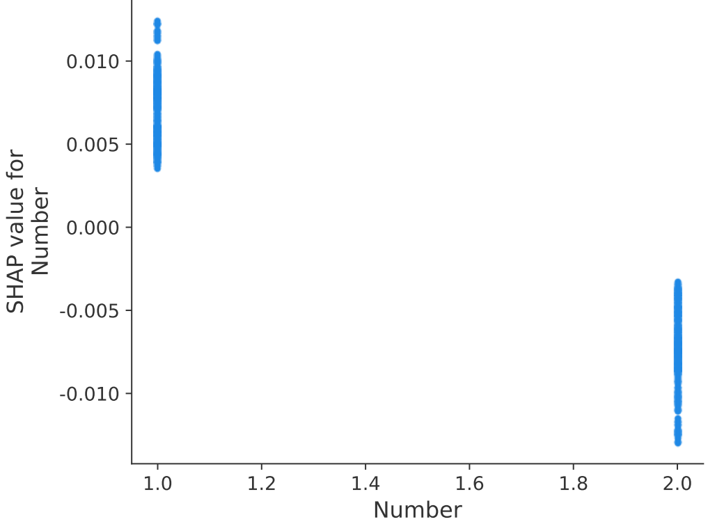
eFigure 7. shows the influence of the No. of tumor on 1-years death in the XGBoost model by the SHAP
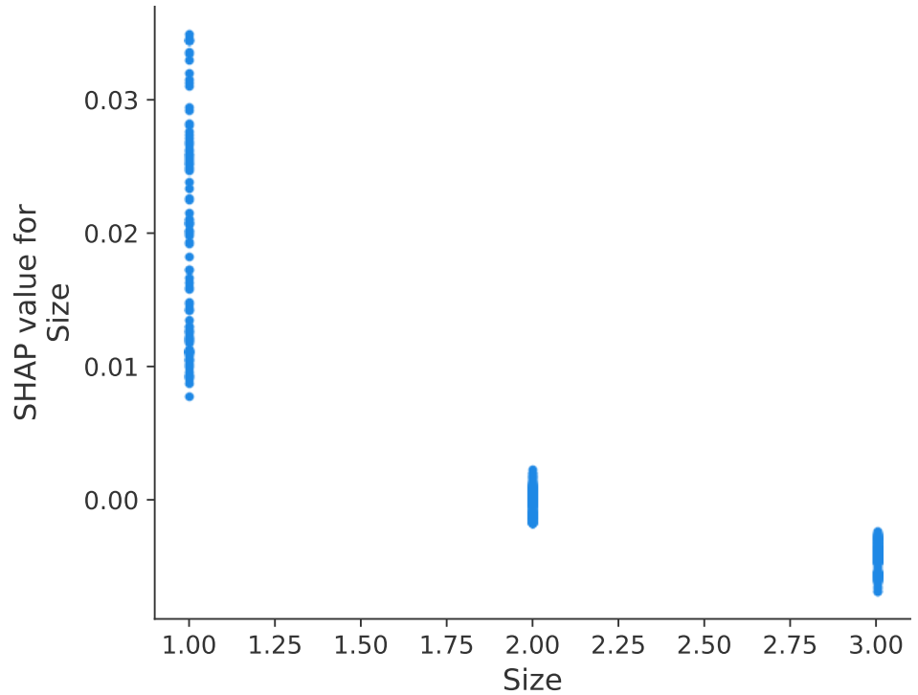
eFigure 8. shows the influence of the diameter of tumor on 1-years death in the XGBoost model by the SHAP

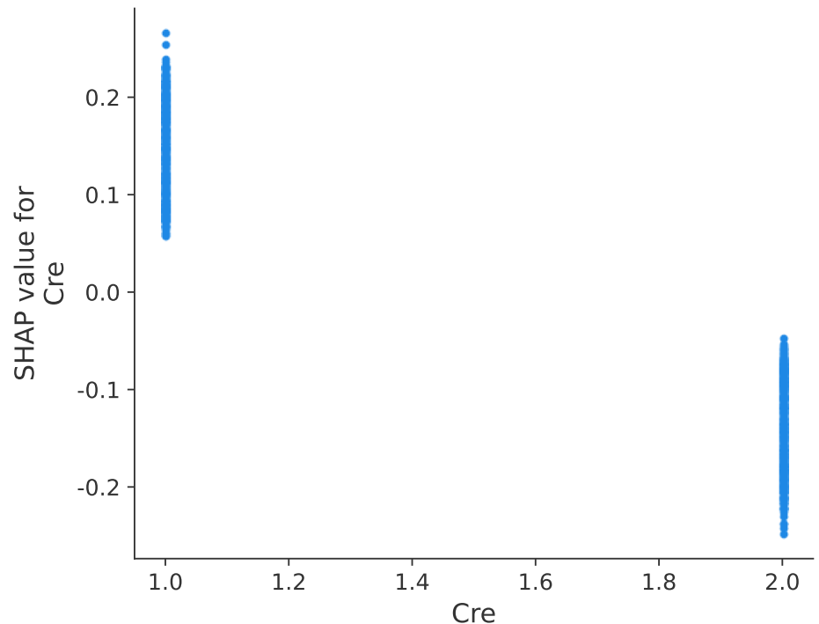
eFigure 9. shows the Cre on 1-years death in the XGBoost model by the SHAP

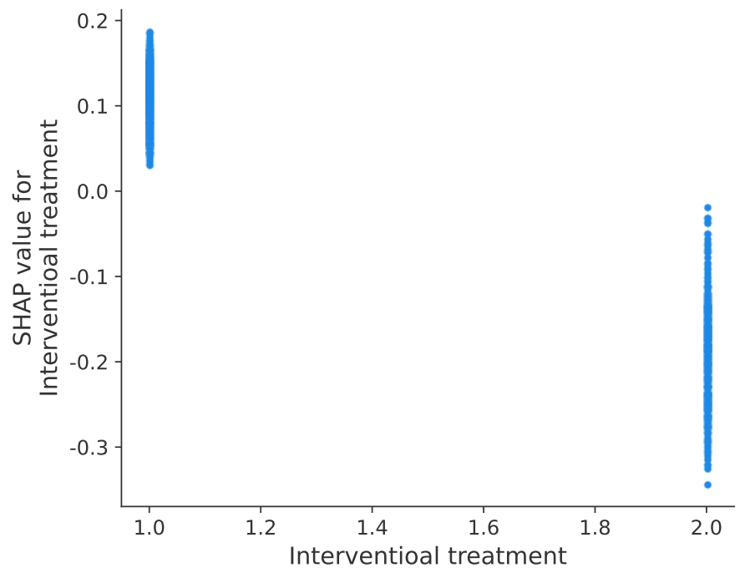
eFigure 10. shows the interventional modality on 1-years death in the XGBoost model by the SHAP

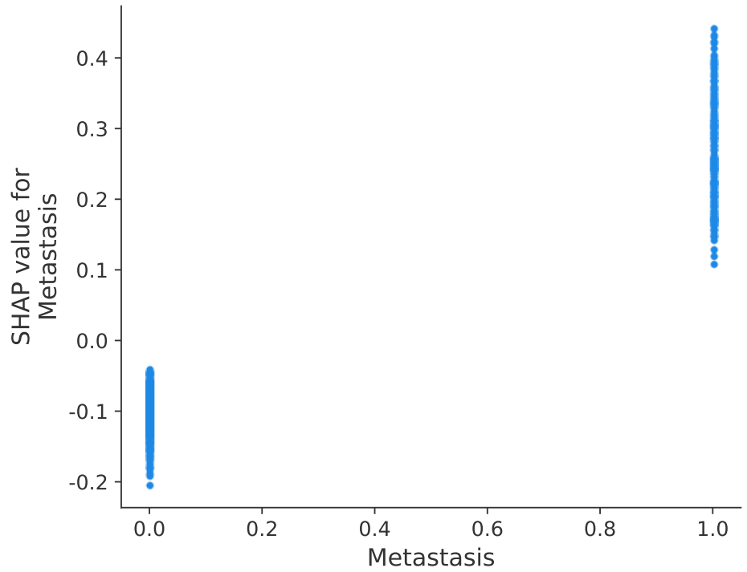
eFigure 11. shows the metastsis on 1-years death in the XGBoost model by the SHAP

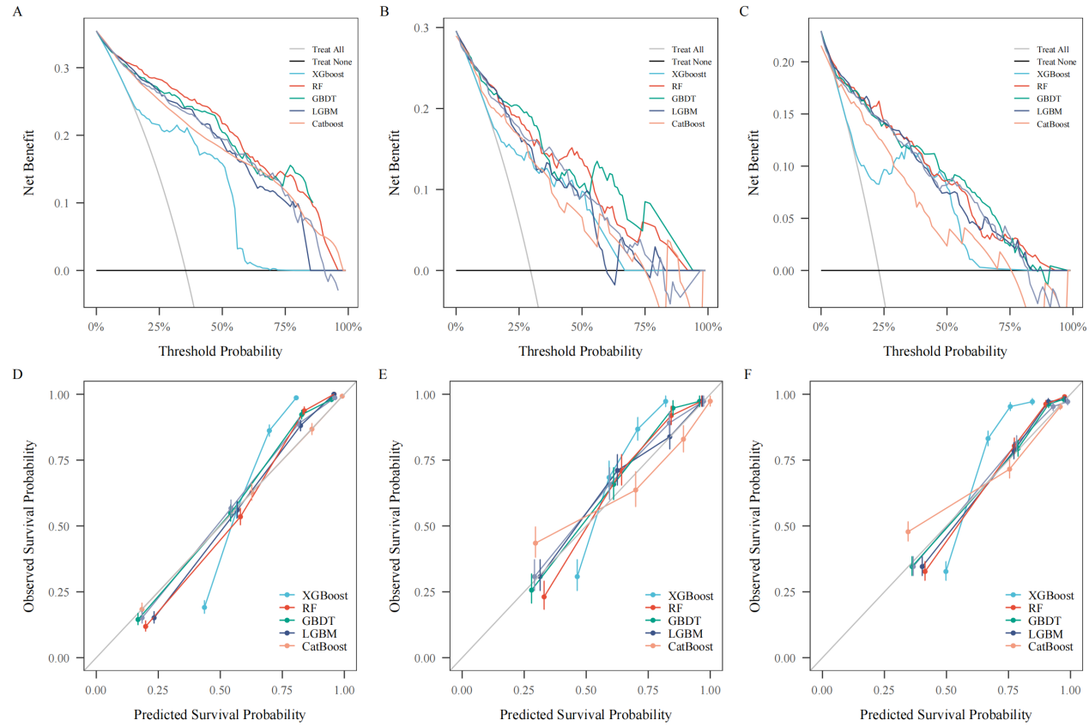

eFigure 12. Decision curve analysis (DCA) comparison between five machine learning models in the training cohort (A), the internal testing cohort (B) and the external testing cohort (C). The bootstrapped calibration curves plotted among five machine learning models in the training cohort (D), the internal testing cohort (E) and the external testing cohort (F).

