Table S1 Sensitivity analysis of associations between PA and anxiety after excluding outliers defined by the IQR method
Variables | Crude |  | Model 1 |  | Model 2
Variables | OR (95% CI) | P | OR (95% CI) | P | OR (95% CI) | P
TPA | 1.34 (1.22, 1.46) | <0.001 | 1.29 (1.17, 1.41) | <0.001 | 1.25 (1.13, 1.38) | <0.001
T1 | 1(Ref) |  | 1(Ref) |  | 1(Ref)
T2 | 0.94 (0.75, 1.18) | 0.618 | 0.89 (0.71, 1.12) | 0.309 | 0.84 (0.66, 1.08) | 0.17
T3 | 1.65 (1.34, 2.03) | <0.001 | 1.46 (1.18, 1.81) | <0.001 | 1.37 (1.08, 1.73) | 0.008
OPA | 1.26 (1.16, 1.38) | <0.001 | 1.29 (1.18, 1.41) | <0.001 | 1.24 (1.12, 1.37) | <0.001
T1 | 1(Ref) |  | 1(Ref) |  | 1(Ref)
T2 | 0.98 (0.75, 1.26) | 0.861 | 0.97 (0.74, 1.26) | 0.82 | 0.94 (0.7, 1.25) | 0.658
T3 | 1.34 (1.1, 1.63) | 0.004 | 1.35 (1.1, 1.66) | 0.004 | 1.24 (0.99, 1.56) | 0.06
HPA | 1.16 (1.07, 1.27) | <0.001 | 1.09 (0.99, 1.19) | 0.074 | 1.11 (1, 1.22) | 0.044
T1 | 1(Ref) |  | 1(Ref) |  | 1(Ref)
T2 | 1.05 (0.84, 1.32) | 0.675 | 0.96 (0.76, 1.21) | 0.711 | 0.97 (0.76, 1.25) | 0.817
T3 | 1.4 (1.14, 1.72) | 0.001 | 1.18 (0.94, 1.46) | 0.148 | 1.24 (0.98, 1.57) | 0.077
LTPA | 0.9 (0.83, 0.97) | 0.008 | 0.89 (0.82, 0.97) | 0.007 | 0.89 (0.81, 0.97) | 0.009
T1 | 1(Ref) |  | 1(Ref) |  | 1(Ref)
T2 | 0.54 (0.23, 1.27) | 0.158 | 0.55 (0.23, 1.32) | 0.182 | 0.61 (0.25, 1.5) | 0.28
T3 | 0.81 (0.65, 1) | 0.047 | 0.8 (0.64, 0.99) | 0.039 | 0.74 (0.59, 0.94) | 0.014
Notes: BMI, body mass index; TPA, total physical activity; OPA, occupational physical activity; HPA, household physical activity; LTPA, leisure-time physical activity. For the continuous variables TPA, OPA, HPA, and LTPA, the odds ratios (ORs) and 95% confidence intervals (CIs) are presented per 1‑SD increment. Crude: no adjusted. Model 1: age, sex. Model 2: age, sex, marital status, education, BMI, length of sleep, pack-years of smoking, alcohol drinking, psychological stress, hypertension, diabetes, heart disease, MLR.
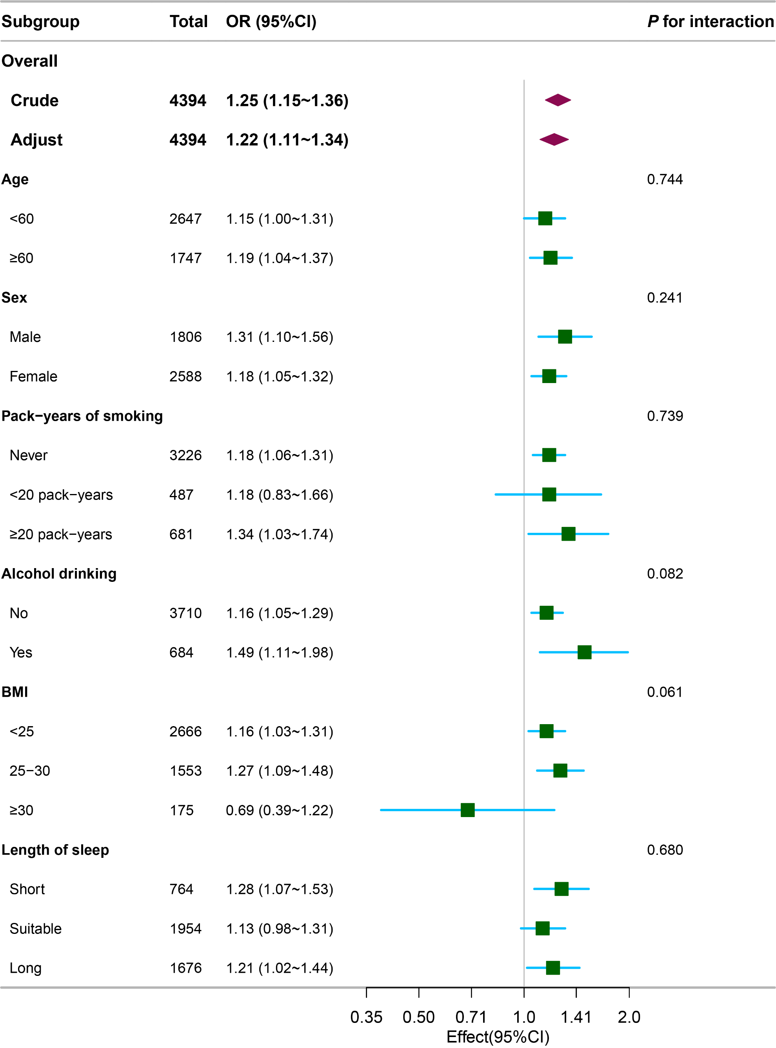
Figure S1 Association between OPA and anxiety.
Each stratification was adjusted for age, sex, marital status, education, BMI, length of sleep, pack-years of smoking, alcohol drinking, psychological stress, hypertension, diabetes, heart disease, MLR except the stratification factor itself. Bold font indicates the overall effect and each subgroup itself.
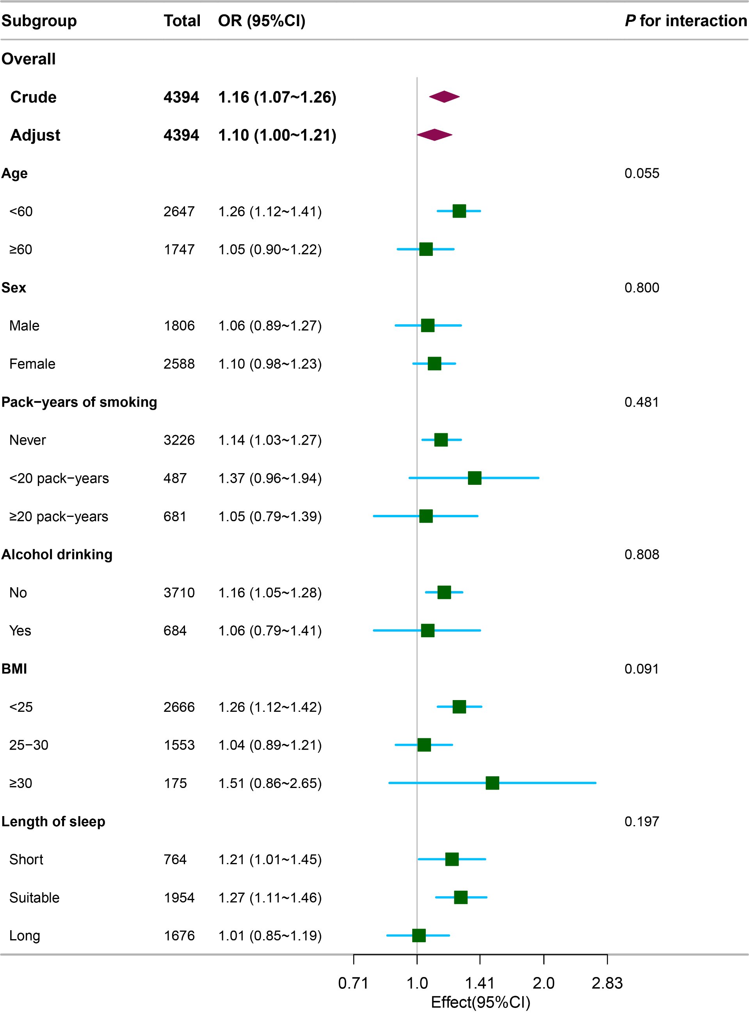

Figure S2 Association between HPA and anxiety.
Each stratification was adjusted for age, sex, marital status, education, BMI, length of sleep, pack-years of smoking, alcohol drinking, psychological stress, hypertension, diabetes, heart disease, MLR except the stratification factor itself. Bold font indicates the overall effect and each subgroup itself.
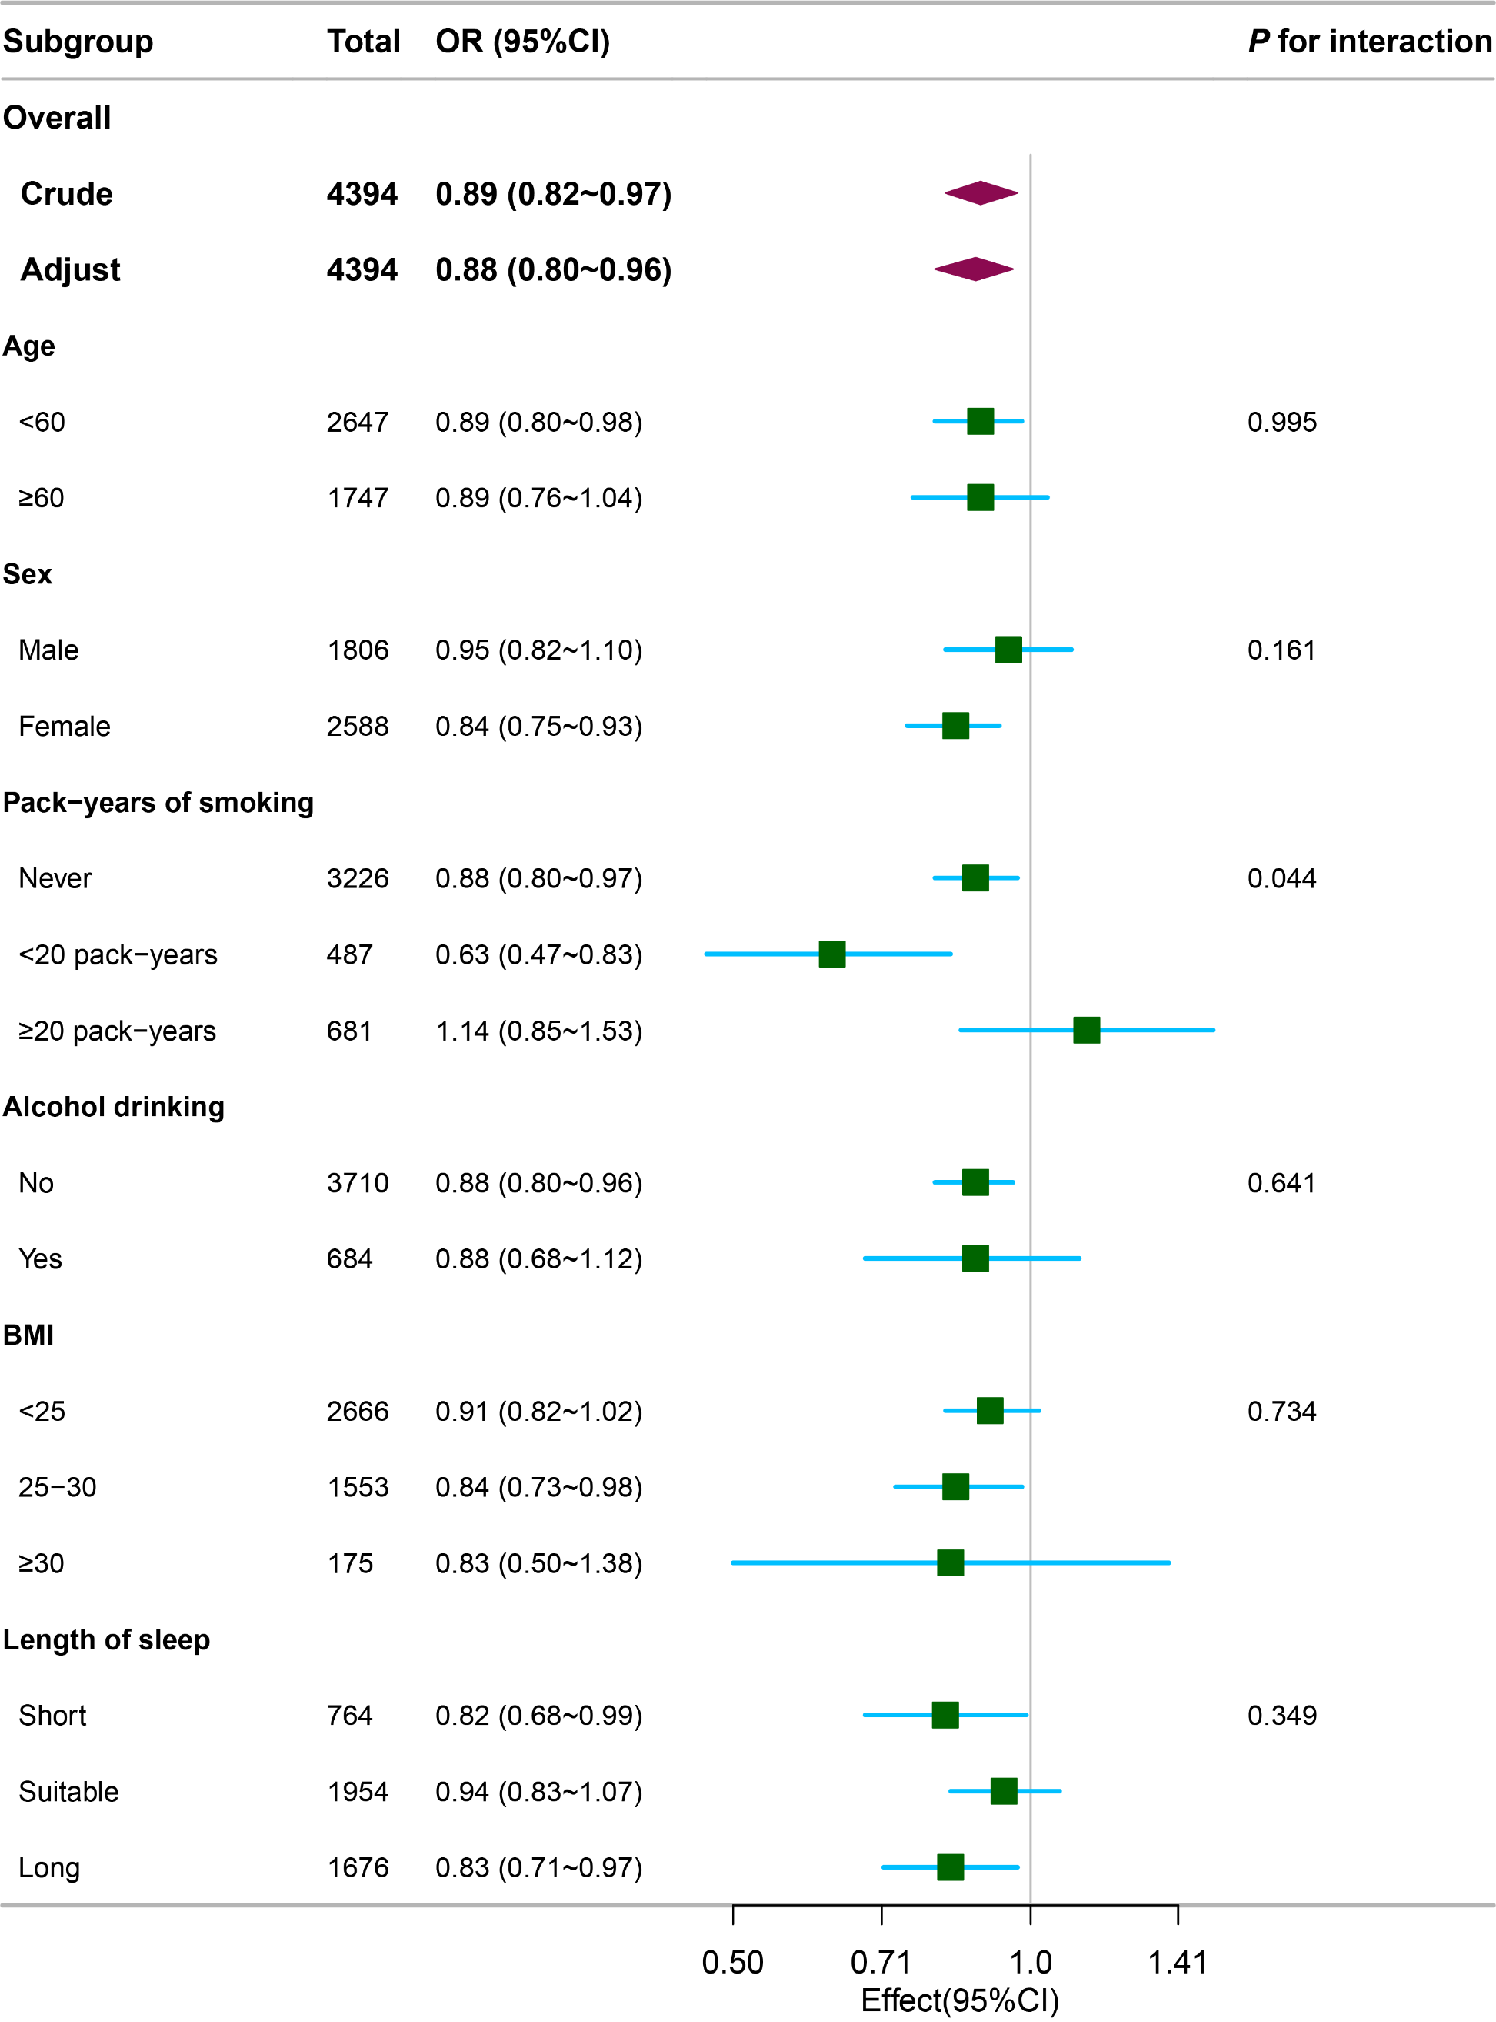
Figure S3 Association between LTPA and anxiety.
Each stratification was adjusted for age, sex, marital status, education, BMI, length of sleep, pack-years of smoking, alcohol drinking, psychological stress, hypertension, diabetes, heart disease, MLR except the stratification factor itself. Bold font indicates the overall effect and each subgroup itself.

