Multimodal Modeling Distinguishes Treatment Response from Overall Survival in Hepatocellular Carcinoma Receiving Combined Interventional and Targeted Immunotherapy
Supplementary Figure 1. Elastic Net Path showing the coefficient trajectories for response prediction.
Supplementary Figure 2. Statistical significance (-log10(p-value)) and effect sizes (d) for selected features in the two filtered modalities for response prediction.
Supplementary Figure 3. Calibration curves for clinical, radiomic, and PRIME-R predicting treatment response in the test cohort.
Supplementary Figure 4. Decision curve analysis of the clinical, imaging, and PRIME-R in the test cohort for response prediction.
Supplementary Figure 5. Correlation matrix of selected clinical and radiomics features for subsequent survival modeling.
Supplementary Figure 6. Stratified survival analysis by age and risk score.
Supplementary Figure 7. Stratified survival analysis by tumor burden and risk score.
Supplementary Figure 8. Stratified survival analysis by disease progression and staging indicators and risk score.
Supplementary Figure 9. Stratified survival analysis by clinical subgroups and risk score.
Supplementary Figure 10. Multivariable Cox regression analysis for overall survival before and after adjustment for subsequent therapy.
Supplementary Figure 11. Boxplots comparing the relative abundance of immune cell types between two risk groups.
Supplementary Method. Treatment regimens, feature processing, model development, and transcriptomic analyses.

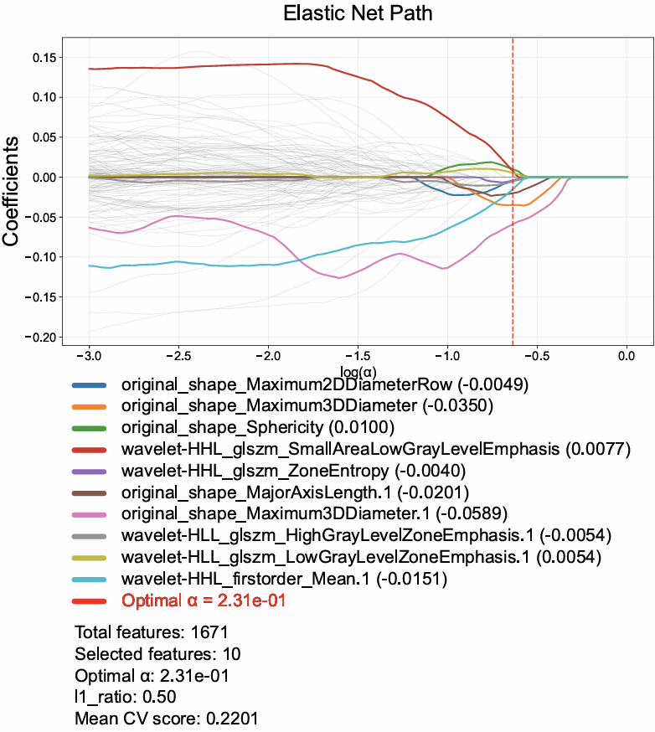
Supplementary Figure 1. Elastic Net Path showing the coefficient trajectories for response prediction. Coefficient trajectories of selected features as a function of log(α). The colored lines represent the 10 features selected by the elastic net model, and the red dashed line indicates the optimal α determined by cross-validation.

Supplementary Figure 2. Statistical significance (-log10(p-value)) and effect sizes (d) for selected features in the two filtered modalities for response prediction. Blue bars represent the t test, and red bars represent the Mann-Whitney U test. Feature abbreviations: PNI: prognostic nutritional index, ALBI: albumin-bilirubin, AFP: alpha-fetoprotein, ECOG: eastern cooperative oncology group performance status, BCLC: barcelona clinic liver cancer, PT: prothrombin time, PNI%: percentage change in prognostic nutritional index one month after treatment relative to one week before treatment.

Supplementary Figure 3. Calibration curves for clinical, radiomic, and PRIME-R predicting treatment response in the test cohort. Calibration curves for the clinical model (blue), radiomic model (orange), and fusion model (green) in the test cohort. The x-axis shows mean predicted probability, and the y-axis shows the observed fraction of positives. The black dotted line represents perfect calibration. Abbreviations: PRIME-R: predictive radiomics-integrated multimodal estimation-response.

Supplementary Figure 4. Decision curve analysis of the clinical, imaging, and PRIME-R in the test cohort for response prediction. Decision curve analysis (DCA) curves for the clinical model (blue dashed line), imaging model (green dashed line), and fusion model (red solid line) in the test cohort. The net benefit is plotted against a range of threshold probabilities. "Treat All" (gray dashed line) and "Treat None" (gray dotted line) strategies are included for reference. Abbreviations: PRIME-R: predictive radiomics-integrated multimodal estimation-response.

Supplementary Figure 5. Correlation matrix of selected clinical and radiomics features for subsequent survival modeling. Pairwise correlation analysis of clinical and radiomics features selected for subsequent modeling. The upper triangle displays the Pearson correlation coefficients between each pair of features, with color coding indicating the strength and direction of correlation (red for positive, blue for negative, as shown by the color bar). The lower triangle shows scatter plots illustrating the linear relationships between feature pairs, accompanied by density plots along the diagonal representing the distribution of each individual feature. Statistical significance is indicated as follows: *P < 0.05, **P < 0.01, and ***P < 0.001. Abbreviations: MON: monocyte count, EHM: extrahepatic metastasis, ECOG: eastern cooperative oncology group performance status, AST: aspartate aminotransferase, HBV: hepatitis B virus, LDH: lactate dehydrogenase, PT: prothrombin time, ALBI: albumin-bilirubin. Note: The "%" symbol (e.g., MON%, PT%, etc.) indicates the percentage change of the marker one month after treatment relative to one week before treatment. RF 1, log-sigma-4-0-mm-3D_glszm_GrayLevelNonUniformityNormalized, RF 2, log-sigma-4-0-mm-3D_glszm_GrayLevelVariance, RF 3, wavelet-LLH_firstorder_Variance.1, RF 4, wavelet-HHL_glszm_SmallAreaEmphasis.1, RF 5, wavelet-HLH_firstorder_Kurtosis, RF 6, log-sigma-4-0-mm-3D_firstorder_Minimum, RF 7, original_shape_MajorAxisLength.1, RF 8, wavelet-LHL_firstorder_Skewness.1, RF 9, wavelet-HHL_glszm_SmallAreaHighGrayLevelEmphasis.1, RF 10, original_shape_Flatness.1.

Supplementary Figure 6. Stratified survival analysis by age and risk score. Kaplan-Meier survival curves for patients stratified by age and further divided into high-risk and low-risk groups based on the median risk score from PRIME-S model. Each row represents one clinical variable, with results shown for the training set, test set, and external validation set (left to right). Panels A–C: age <55 years, D–F: age ≥55 years,. HR, 95% CI, and p-values are shown for each comparison. Abbreviations: HR: hazard ratio, CI: confidence interval. PRIME-S: predictive radiomics-integrated multimodal estimation-survival.

Supplementary Figure 7. Stratified survival analysis by tumor burden and risk score. Kaplan-Meier survival curves for patients stratified by tumor number, diameter and further divided into high-risk and low-risk groups based on the median risk score from PRIME-S model. Each row represents one clinical variable, with results shown for the training set, test set, and external validation set (left to right). Panels A–C: single lesion, D-F: multiple lesions; G–I: tumor diameter ≥10 cm, J–L: tumor diameter <10 cm. Abbreviations: HR: hazard ratio, CI: confidence interval, PRIME-S: predictive radiomics-integrated multimodal estimation-survival.

Supplementary Figure 8. Stratified survival analysis by disease progression and staging indicators and risk score. Kaplan-Meier survival curves for patients stratified by different clinical subgroups and further divided into high-risk and low-risk groups based on the median risk score from PRIME-S model. Each row represents one clinical variable, with results shown for the training set, test set, and external validation set (left to right). Panels A–C: Each row in the figure represents a clinical variable, with the three panels in each row showing Kaplan-Meier survival curves for the training set (left), test set (middle), and external validation set (right): A–C: No EHM, D–F: EHM; G–I: BCLC stage B, J–L: BCLC stage C; M–O: VP <3 (vascular invasion less than segmental branches of portal vein), P–R: VP 3/4 (vascular invasion of segmental branches or main portal vein). Abbreviation: HR: hazard ratio, CI: confidence interval. EHM: extrahepatic metastasis, BCLC: barcelona clinic liver cancer. VP: vascular invasion of portal vein. PRIME-S: predictive radiomics-integrated multimodal estimation-survival.

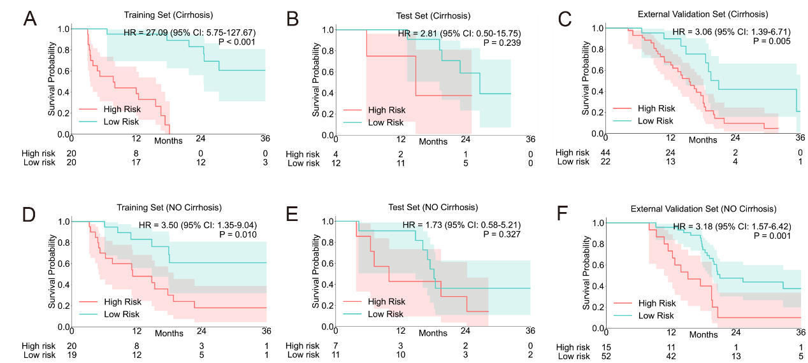
Supplementary Figure 9. Stratified survival analysis by clinical subgroups and risk score. Kaplan-Meier survival curves for patients stratified by different clinical subgroups and further divided into high-risk and low-risk groups based on the median risk score from PRIME-S model. Each row represents one clinical variable, with results shown for the training set, test set, and external validation set (left to right). Panels A–C: Each row in the figure represents a clinical variable, with the three panels in each row showing Kaplan-Meier survival curves for the training set (left), test set (middle), and external validation set (right): A–C: Cirrhosis present, D–F: No cirrhosis. Abbreviation: HR: hazard ratio, CI: confidence interval. PRIME-S: predictive radiomics-integrated multimodal estimation-survival.

Supplementary Figure 10. Multivariable Cox regression analysis for overall survival before and after adjustment for subsequent therapy. Model 1 was not adjusted for subsequent therapy, whereas Model 2 additionally included subsequent therapy as a covariate. PRIME-S remained independently associated with overall survival after adjustment.

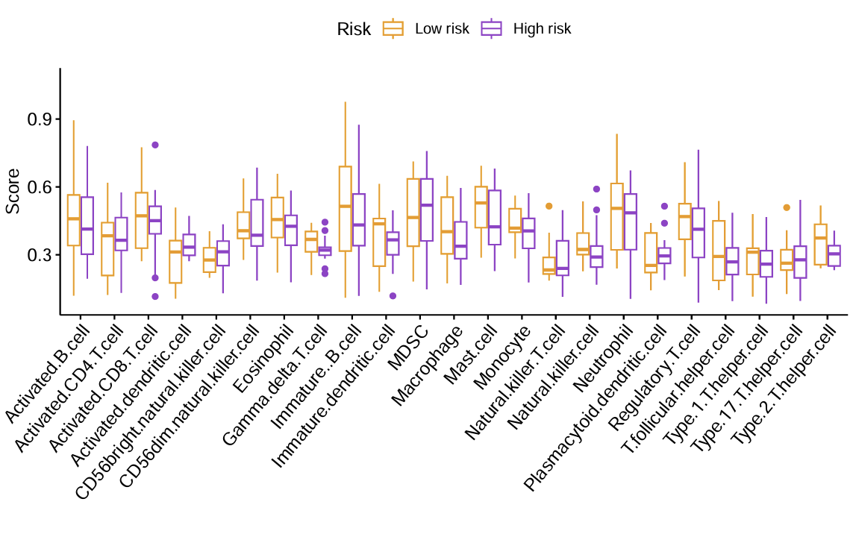
Supplementary Figure 11. Boxplots comparing the relative abundance of immune cell types between two risk groups. Groups were defined by the median survival risk score predicted by the imaging survival model in the TCIA cohort. No immune cell types showed statistically significant differences between the high- and low-risk groups. The boxplots are color-coded according to risk group (high vs. low).

Supplementary Method. Treatment regimens, feature processing, model development, and transcriptomic analyses.

Multimodal Modeling Distinguishes Treatment Response from Overall Survival in Hepatocellular Carcinoma Receiving Combined Interventional and Targeted Immunotherapy
Immune Checkpoint Inhibitors (ICIs)
A variety of ICIs—including Camrelizumab, Pembrolizumab, Sintilimab, Toripalimab, AK104, Penpulimab, Tislelizumab, Atezolizumab, Durvalumab, Nivolumab—were administered according to current guidelines and drug availability in China. All ICIs were given at standard dosages and intervals, temporary discontinuation was allowed in the event of grade 3/4 adverse events (AEs). Treatment with anti-PD-(L)1 agents was continued until either disease progression or the occurrence of unacceptable toxicity.
Anti-VEGF Antibody/Tyrosine Kinase Inhibitors (TKIs)
Patients received various anti-VEGF antibodies or TKIs—including Anlotinib, Lenvatinib, Apatinib, Donafenib, Sorafenib, Bevacizumab—at recommended dosages and schedules. For most agents, dose reductions were allowed in response to grade 3 or 4 AEs. Therapy with anti-VEGF antibodies or TKIs continued until disease progression or the emergence of intolerable toxicities.
Hepatic arterial infusion chemotherapy (HAIC)
HAIC regimen consisted of oxaliplatin 135 mg/m² (administered over hours 0–2 on day 1), leucovorin 400 mg/m² (over hours 2–3 on day 1), a 5-fluorouracil bolus of 400 mg/m² at hour 3, followed by a continuous infusion of 5-fluorouracil 2400 mg/m² over 46 hours across days 1 and 2. After each HAIC cycle, the catheter and sheath were removed, with new catheterization performed as needed for subsequent cycles. HAIC was discontinued after six cycles, after which patients received maintenance therapy with lenvatinib and a PD-1 inhibitor.
Transarterial Chemoembolization (TACE)
A super-selective microcatheter was advanced into the supplying artery of each tumor, through which a mixture of lipiodol (5–15 ml), epirubicin (30–50 mg), and lobaplatin (30–50 mg) was infused. Technical success was defined as complete embolization of the tumor-feeding artery, evidenced by the absence of tumor staining on post-procedure angiography. Repeat TACE procedures were performed as needed, based on consensus after discussion among three experienced clinicians. All therapeutic decisions were made collaboratively through multidisciplinary discussions involving medical oncologists, surgeons, and radiologists.
Clinical features
The demographic features considered in this study included age, sex, height, weight, body mass index (BMI), hepatitis B virus (HBV) status, hepatitis C virus (HCV) status, and Eastern Cooperative Oncology Group performance status (ECOG-PS). Laboratory features encompassed alanine aminotransferase (ALT), aspartate aminotransferase (AST), total bilirubin (TBiL), alpha-fetoprotein (AFP), albumin (ALB), lactate dehydrogenase (LDH), prothrombin time (PT), lymphocyte count (LYM), neutrophil count (NEU), platelet count, and monocyte count (MON). Tumor-related features included maximum tumor diameter, tumor number, hepatic vein tumor thrombus (HVTT), portal vein tumor thrombus (PVTT), cirrhosis, extrahepatic metastasis (EHM), Barcelona Clinic Liver Cancer (BCLC) stage, and presence of ascites. Additionally, the Child-Pugh score was included as a treatment/clinical scoring feature.
Composite Clinical Indices and Their Calculation Formulas
- Platelet-to-lymphocyte ratio (PLR): Platelet count / Lymphocyte count
- Neutrophil-to-lymphocyte ratio (NLR): Neutrophil count / Lymphocyte count
- Lymphocyte-to-monocyte ratio (LMR): Lymphocyte count / Monocyte count
- Systemic immune-inflammation index (SII): (Platelet count × Neutrophil count) / Lymphocyte count
- Prognostic nutritional index (PNI): Albumin (g/L) + 5 × Lymphocyte count (10⁹/L)
- Pan-immune-inflammation value (PIV): (Neutrophil count × Platelet count × Monocyte count) / Lymphocyte count
- Albumin-bilirubin (ALBI) grade: ALBI score = (log₁₀ Total bilirubin [μmol/L] × 0.66) – (Albumin [g/L] × 0.085)
Additionally, these indices (e.g., AFP%, ALB%, LDH%, PT%, LYM%, NEU%, MON%, PLT%, PLR%, NLR%, LMR%, SII%, PNI%, PIV%) represent the percentage change in each parameter, calculated as the value at one month post-treatment minus the value one week before treatment, divided by the value one week before treatment. The resulting value reflects the relative change for each marker following treatment.
Missing Value Handling
The extent of missing data for each variable was evaluated before imputation. To address missing values, the SimpleImputer class from scikit-learn was employed, using the median strategy to replace missing entries in each column with the corresponding median value.
Computed Tomography (CT) scan parameters
- Center A: Contrast-enhanced CT was performed using a 64-slice spiral scanner (Definition AS+, Siemens SOMATOM) with a slice thickness of 5.0 mm, tube voltage of 120 kV, and tube current of 220 mA. An iodinated contrast agent (300 mg/mL) was injected at 1.5 mL/kg body weight via the antecubital vein at a flow rate of 2 mL/s using an automated injector.
- Center B: CECT was performed on a multidetector CT system (Discovery CT750HD, GE Healthcare) with a tube voltage of 120 kVp, tube current of 250–400 mAs, and slice thickness of 0.625 mm. Contrast medium (Ultravist 370) was administered at 1.5 mL/kg through the antecubital vein at 3.0 mL/s with an automatic power injector.
Image Preprocessing Workflow
Raw DICOM images were collected for each patient. All DICOM files were de-identified by replacing patient-specific information (e.g., Patient name and ID) using the Pydicom Python package. The de-identified DICOM series were then converted to NIfTI format using SimpleITK for subsequent radiomic analysis. Image metadata, including voxel size, origin, and orientation, were extracted for quality control.
Image Feature Extraction Workflow
For each patient, radiomics features were extracted from the preprocessed images and segmentation masks using the PyRadiomics Python package. All images were resampled to an isotropic voxel spacing of 1×1×1 mm, and intensity normalization was applied. Features were extracted from the original images as well as from images processed with Laplacian of Gaussian (LoG, σ=4.0) and wavelet transforms. The extracted features included first-order statistics, shape, and texture features.
Three-dimensional (3D) Image Segmentation
3D regions of interest (ROIs) were automatically segmented using the deep learning-based MedSAM model¹. Initial segmentation outputs were manually refined by two experienced hepatobiliary surgeons (PFS and DXW) with 3D Slicer software (version 5.6.2, https://www.slicer.org). For patients presenting with multiple tumor lesions, all detectable tumor areas were included in the ROI segmentation whenever feasible, ensuring a comprehensive assessment of total tumor burden.
Definition of Treatment Response and Overall Survival
Patients with complete response (CR) or partial response (PR) were classified as "responders," while those with stable disease (SD) or progressive disease (PD) were classified as "non-responders." Objective response rate (ORR) was defined as the proportion of patients achieving CR or PR; disease control rate (DCR) as the proportion achieving CR, PR, or SD. Overall survival (OS) was defined as the time from initiation of treatment to death from any cause.
Intraclass correlation coefficient (ICC) Based Feature Selection
For each feature, ICC values were calculated based on repeated measurements from independent segmentations using the Pingouin Python package. Features with ICC > 0.75 were considered highly reproducible and retained for subsequent modeling. Only these stable features were included in the final feature dataset for model development. For both arterial and venous phase contrast-enhanced CT images, a total of 1888 radiomics features were initially extracted from each phase. After filtering for reproducibility using the intraclass correlation coefficient (ICC > 0.75), 851 features were retained from the arterial phase and 824 features from the venous phase, resulting in a combined total of 1,675 radiomics features for subsequent analysis.
Base Models for Classification Tasks
(1) Bagging ensemble using decision trees as base learners (n=50). (2) AdaBoost with random forest estimators as base learners (n=50). (3) Stacking ensemble comprising logistic regression, decision tree, and support vector machine as first-level classifiers, with logistic regression serving as the meta-classifier. (4) Rotation Forest implemented as a random forest with 50 estimators. (5) Gradient Boosting classifier with randomness introduced via subsampling (n=50, subsample=0.8).
Model Hyperparameter Tuning
Optimal hyperparameters were selected by identifying the configuration that achieved the highest mean area under the curve (AUC) for response prediction or concordance index (C-index) for survival prediction across all parameter combinations. The final model, configured with these optimal settings, was retrained and its predictive performance was assessed using five-fold cross-validation on the test set.
Radiomics (Imaging Unimodal) Model Tuning: For the radiomics-only model, the parameter grid included the number of boosting iterations (n_estimators: 30, 50, 70), the maximum depth of the base random forest estimator (max_depth: 3, 5, 7), and the minimum number of samples required to split an internal node (min_samples_split: 2, 5, 10). For each parameter combination, an AdaBoost model was constructed using a random forest base estimator (with 10 trees), and evaluated via five-fold cross-validation on the test set using AUC as the primary metric.
Clinical Unimodal Model Tuning: For the clinical-only model, Rotation Forest was implemented as a random forest classifier. The parameter tuning process involved grid search and five-fold cross-validation, with the clinical dataset split into training and test sets and feature standardization performed prior to modeling. The parameter grid explored the number of trees (n_estimators: 30, 50, 70), maximum tree depth (max_depth: 3, 5, 7), and minimum samples required for node splitting (min_samples_split: 2, 5, 10). Each parameter combination was evaluated using five-fold cross-validation on the test set, with AUC as the primary evaluation metric.
Late Fusion Strategy for Survival Models
Two independently optimized FastSurvivalSVM models—one for each modality—were trained within each fold of cross-validation. The predictive performance of each model on the training set was assessed using the C-index. Model weights were calculated via an exponential transformation of the C-index, giving greater influence to models with higher predictive accuracy. The final risk score for each patient was obtained by computing a weighted average of the risk scores generated by the two unimodal models.
Early Fusion Strategy
In this study, selected features from clinical and radiomics modalities were concatenated to form a unified input for both binary classification and survival prediction tasks. The same model selection process as for unimodal models was applied to this fused feature set, and the best-performing model and its performance metrics were identified. This allowed for direct comparison of the optimal early fusion model against the late fusion model, evaluating the relative effectiveness of both integration strategies.
SHapley Additive exPlanations (SHAP) Analysis Strategy
Specifically, the development cohort was randomly partitioned into five folds. For each iteration, a fusion model was trained on four folds and used to predict the held-out fold, for which SHAP values were computed. This process was repeated until every sample had an out-of-fold SHAP value derived from a model that had not seen it during training. For response prediction，using a custom wrapper for the fusion model that accounts for the dual-modality input. For survival prediction，validation data from both modalities were concatenated, and the risk prediction was defined as the weighted sum of the two unimodal predictions, with weights determined by the relative C-index observed in the training set.
Differential Expression Analysis of Transcriptomic Data
Transcriptomic count data and corresponding imaging data were obtained for the The Cancer Immunome Atlas (TCIA) cohort. Samples were divided into high- and low-risk groups based on the optimal radiomics model of response or survival prediction. Differential gene expression analysis was performed using the R packages edgeR. Genes normalization and dispersion estimation were conducted according to standard pipeline procedures. Differentially expressed genes (DEGs) were identified using a generalized linear model and likelihood ratio test, with significance thresholds set at |log2(Fold Change) | > 1 and FDR < 0.05. Results were visualized using volcano plots and with ggplot2
Gene Set Enrichment Analysis (GSEA)
To explore the biological pathways associated with the transcriptomic differences between radiomics-derived risk groups, Gene Set Enrichment Analysis (GSEA) was performed. All genes were ranked by log2 fold change, and enrichment was assessed using the clusterProfiler R package with Hallmark gene sets (MSigDB v2024.1). Pathways with p-value < 0.05 were considered significant.
Functional Enrichment Analysis
Functional enrichment analysis was performed on significant genes using the R package clusterProfiler. Gene Ontology (GO) and KEGG pathway enrichment analyses were conducted, with gene symbols converted to Entrez IDs via org.Hs.eg.db. Results were filtered with p-value < 0.05, and the top terms were visualized
Single-Sample Gene Set Enrichment Analysis (ssGSEA) of Immune Signatures
To assess the immune landscape associated with radiomics-derived risk groups, single-sample gene set enrichment analysis (ssGSEA) was performed using the GSVA R package. TPM-normalized transcriptomic data were analyzed with curated immune gene sets. ssGSEA scores were normalized, and samples were grouped according to radiomics risk status. Differences in immune cell type scores between groups were visualized with boxplots and violin plots (ggplot2, ggpubr), and statistical significance was assessed with Wilcoxon rank-sum tests.
Comparative GSEA and Pathway Analysis
To compare biological pathway enrichment between survival-based and response-based transcriptomic signatures, we performed parallel Gene Set Enrichment Analysis (GSEA) using the clusterProfiler R package with Hallmark gene sets (MSigDB v2024.1). Genes were ranked by log2 fold change from the respective analyses. Significantly enriched pathways (p < 0.05) were identified for each signature.
Comparative Functional Enrichment Analysis
To compare the biological functions underlying survival and response signatures, Gene Ontology (GO) and KEGG pathway enrichment analyses were performed using the clusterProfiler R package. Gene symbols were converted to Entrez IDs with org.Hs.eg.db. Enrichment results were filtered at p < 0.05. Shared and signature-specific pathways were tabulated for further interpretation.

Reference:
1. Ma J, He Y, Li F, Han L, You C, Wang B. Segment anything in medical images. Nat Commun. 2024;15(1):654. doi:10.1038/s41467-024-44824-z

