Appendix 1. Search strategy

#1 Chronic Prostatitis
("Chronic Prostatitis"[MeSH] OR "Chronic Prostatitis"[Title/Abstract] OR "Chronic Pelvic Pain Syndrome"[Title/Abstract] OR "CPPS"[Title/Abstract] OR "CP/CPPS"[Title/Abstract] OR "Type III Prostatitis"[Title/Abstract] OR "Chronic Bacterial Prostatitis"[Title/Abstract])
#2 Acupuncture-Related Interventions
("Acupuncture Therapy"[MeSH] OR "Acupuncture"[Title/Abstract] OR "Electroacupuncture"[MeSH] OR "Electroacupuncture"[Title/Abstract] OR "Moxibustion"[MeSH] OR "Moxibustion"[Title/Abstract] OR "Warm Needling"[Title/Abstract] OR "Heat-sensitive Moxibustion"[Title/Abstract] OR "Catgut Embedding"[Title/Abstract] OR "Acupoint Catgut Embedding"[Title/Abstract] OR "Acupoint Application Therapy"[Title/Abstract] OR "Press Needle"[Title/Abstract] OR "Manual Acupuncture"[Title/Abstract] OR "Grain-sized Moxibustion"[Title/Abstract] OR "Indirect Moxibustion"[Title/Abstract] OR "Medicine, Chinese Traditional"[MeSH] OR "Chinese Herbal Medicine"[Title/Abstract])
#3 Study Type: Randomized Controlled Trials
("Randomized Controlled Trial" [Publication Type] OR "Randomized Controlled Trials as Topic"[MeSH] OR "randomized"[Title/Abstract] OR "randomly"[Title/Abstract] OR "RCT"[Title/Abstract])
Final Combination:
#1 AND #2 AND #3

Appendix 2. Risk-of-bias assessment

Table S1.Risk of bias of randomized clinical trials.
Study | Randomization process |  | Deviations from intended interventions | Missing outcome data | Measurement of the outcome | Selection of the reported result | Overall Risk of Bias
Sui 2017³⁵ |  | some concerns | some concerns | low | low | low | high
Ou 2020³⁶ |  | low | some concerns | low | low | low | some concerns
Xia 2020³⁷ |  | low | some concerns | low | low | low | some concerns
Xuan 2018³⁸ |  | low | some concerns | low | low | low | some concerns
Zhang 2010³⁹ |  | low | some concerns | low | low | low | some concerns
Cao 2022⁴⁰ |  | low | some concerns | low | low | low | some concerns
Song 2021⁴¹ |  | low | some concerns | low | low | low | some concerns
Liang 2020⁴² |  | low | some concerns | low | low | low | some concerns
Zhou 2025⁴³ |  | low | some concerns | low | low | low | some concerns
Zhou 2016⁴⁴ |  | low | Some concerns | low | low | low | Some concerns
Yong 2021⁴⁵ |  | low | some concerns | low | low | low | high
Yang 2014⁴⁶ |  | low | some concerns | low | low | low | high
Qiao 2016⁴⁷ |  | low | some concerns | low | low | low | some concerns
Chen 2011⁴⁸ |  | some concerns | some concerns | low | low | low | high
Zhu 2011⁴⁹ |  | low | some concerns | low | low | low | some concerns
Zeng 2021⁵⁰ |  | some concerns | some concerns | low | low | low | high
Wang 2007⁵¹ |  | some concerns | some concerns | low | low | low | high
Liu 2009⁵² |  | low | some concerns | low | low | low | some concerns
Liu 2011⁵³ |  | low | Some concerns | low | low | low | Some concerns
Kang 2015⁵⁴ |  | low | some concerns | low | low | low | some concerns
Shang 2008⁵⁵ |  | low | some concerns | low | low | low | some concerns
Chen 2009⁵⁶ |  | low | some concerns | low | low | low | some concerns
Ma 2016⁵⁷ |  | low | some concerns | low | low | low | some concerns
Cai 2020⁵⁸ |  | some concerns | some concerns | low | low | low | high
Gao 2016⁵⁹ |  | some concerns | some concerns | low | low | low | high
Wang 2017⁶⁰ |  | low | some concerns | low | low | low | some concerns
Song 2018⁶¹ |  | low | some concerns | low | low | low | some concerns
Li 2024⁶² |  | some concerns | some concerns | low | low | low | high
Zhou 2016⁶³ |  | low | some concerns | low | low | low | some concerns
Zhang 2017⁶⁴ |  | low | Some concerns | low | low | low | Some concerns
Yin 2019⁶⁵ |  | low | some concerns | low | low | low | some concerns
Zhang 2021⁶⁶ |  | low | low | low | low | low | low
Sun 2006⁶⁷ |  | low | some concerns | low | low | low | some concerns
Jiao 2016⁶⁸ |  | low | some concerns | low | low | low | some concerns
Gu 2024⁶⁹ |  | low | some concerns | low | low | low | some concerns
Pai 2023⁷⁰ |  | low | some concerns | low | low | low | some concerns
Yin 2017⁷¹ |  | low | some concerns | low | low | low | some concerns
Liu 2023⁷² |  | low | some concerns | low | low | low | some concerns
Zhang 2009⁷³ |  | low | some concerns | low | low | low | some concerns
Xu 2013⁷⁴ |  | low | some concerns | low | low | low | some concerns
Li 2015⁷⁵ |  | low | some concerns | low | low | low | some concerns
Gao 2016⁷⁶ |  | low | some concerns | low | low | low | some concerns
Huo 2020⁷⁷ |  | low | some concerns | low | low | low | some concerns
Wang 2021⁷⁸ |  | low | some concerns | low | low | low | some concerns
Hou 2021⁷⁹ |  | low | some concerns | low | low | low | some concerns

Appendix 3.Consistency and Heterogeneity Assessment

Table S2. Consistency and Heterogeneity Assessment.
Outcome | Consistency |  | Heterogeneity  （τ²）
Outcome | Chi² | P | Heterogeneity  （τ²）
NIH-CPSI Total Score | 17.1 | 0.5472 | 0.2994
pain score | 0 | 0.9993 | 0.8622
voiding score | 1.93 | 0.1646 | 0.5879
quality of life score | 0.6072 | 0.26 | 0.7640
Response rate | 8.22 | 0.5119 | 0.0037

Table S3. Node-splitting method for NIH-CPSI Total Score.
Side | Direct |  | Indirect |  | Difference |  | P>|z| | τ²
Side | Coef. | Std.Err. | Coef. | Std.Err. | Coef. | Std.Err. | P>|z| | τ²
AAT vs. Y-CHM | -0.1107687 | 0.0930734 | -0.231059 | 0.1352988 | 0.1202903 | 0.1642285 | 0.464 | 0.003998
AAT vs. Z-WM | -0.2058521 | 0.106684 | -0.0855603 | 0.1248581 | -0.1202918 | 0.1642286 | 0.464 | 0.003998
EA vs. Y-CHM | -0.5744916 | 0.3716735 | -0.1063319 | 0.0854921 | -0.4681597 | 0.3814066 | 0.22 | 0.003659
EA vs. Z-WM | -0.1285817 | 0.0471105 | -0.596724 | 0.3786239 | 0.4681423 | 0.3813989 | 0.22 | 0.003659
EA+CHM vs. Y-CHM | -0.2115846 | 0.0565018 | -0.3323288 | 0.1860293 | 0.1207442 | 0.1944447 | 0.535 | 0.003899
EA+CHM vs. Z-WM | -0.3184536 | 0.1688785 | -0.1977078 | 0.0963792 | -0.1207458 | 0.1944451 | 0.535 | 0.003899
EA+WM vs. Z-WM | -0.0504017 | 0.0684793 | -0.2482714 | 115.272 | 0.1978697 | 115.272 | 0.999 | 0.003793
MA vs. MOX | 0.0536529 | 0.1837025 | -0.084153 | 0.0800245 | 0.1378059 | 0.200947 | 0.493 | 0.004013
MA vs. WMA | 0.21914 | 0.0718838 | 0.0767682 | 0.1162694 | 0.1423717 | 0.1415108 | 0.314 | 0.004445
MA vs. Z-WM | -0.1272196 | 0.0424482 | -0.0708394 | 0.1215476 | -0.0563802 | 0.1290614 | 0.662 | 0.004477
MA+CHM vs. Y-CHM | -0.1825711 | 0.0762487 | -0.1165812 | 99.54156 | -0.06599 | 99.54164 | 0.999 | 0.003793
MOX vs. SMS | 0.1481251 | 0.0742054 | -0.0350842 | 0.1484366 | 0.1832094 | 0.1659841 | 0.27 | 0.004006
MOX vs. WMA | 0.2762372 | 0.1460829 | 0.2240003 | 0.0975811 | 0.0522369 | 0.1741705 | 0.764 | 0.004224
MOX vs. Z-WM | -0.0971149 | 0.0839336 | 0.0039272 | 0.1072701 | -0.101042 | 0.1352751 | 0.455 | 0.004162
SMS vs. Y-CHM | -0.0991272 | 0.098897 | -0.2823367 | 0.1332537 | 0.1832095 | 0.1659846 | 0.27 | 0.004007
WMA vs. Z-WM | -0.2732988 | 0.0887269 | -0.3232975 | 0.085199 | 0.0499987 | 0.1246687 | 0.688 | 0.004519
WMA+CHM vs. Y-CHM | -0.2124047 | 0.0876402 | 0.0636765 | 0.1173791 | -0.2760811 | 0.1464196 | 0.059 | 0.002328
WMA+CHM vs. Z-WM | -0.0246926 | 0.0852858 | -0.3007737 | 0.1190169 | 0.2760811 | 0.1464196 | 0.059 | 0.002328
WMA+WM vs. Z-WM | -0.2657032 | 0.1345531 | -0.0445626 | 200.6799 | -0.2211405 | 200.68 | 0.999 | 0.003793

Table S4.Node-splitting method for Response rate.
Side | Direct |  | Indirect |  | Difference |  | P>|z| | τ²
Side | Coef. | Std.Err. | Coef. | Std.Err. | Coef. | Std.Err. | P>|z| | τ²
AAT vs. Y-CHM | -0.1107687 | 0.0930734 | -0.231059 | 0.1352988 | 0.1202903 | 0.1642285 | 0.464 | 0.003998
AAT vs. Z-WM | -0.2058521 | 0.106684 | -0.0855603 | 0.1248581 | -0.1202918 | 0.1642286 | 0.464 | 0.003998
EA vs. Y-CHM | -0.5744916 | 0.3716735 | -0.1063319 | 0.0854921 | -0.4681597 | 0.3814066 | 0.22 | 0.003659
EA vs. Z-WM | -0.1285817 | 0.0471105 | -0.596724 | 0.3786239 | 0.4681423 | 0.3813989 | 0.22 | 0.003659
EA+CHM vs. Y-CHM | -0.2115846 | 0.0565018 | -0.3323288 | 0.1860293 | 0.1207442 | 0.1944447 | 0.535 | 0.003899
EA+CHM vs. Z-WM | -0.3184536 | 0.1688785 | -0.1977078 | 0.0963792 | -0.1207458 | 0.1944451 | 0.535 | 0.003899
EA+WM vs. Z-WM | -0.0504017 | 0.0684793 | -0.2482714 | 115.272 | 0.1978697 | 115.272 | 0.999 | 0.003793
MA vs. MOX | 0.0536529 | 0.1837025 | -0.084153 | 0.0800245 | 0.1378059 | 0.200947 | 0.493 | 0.004013
MA vs. WMA | 0.21914 | 0.0718838 | 0.0767682 | 0.1162694 | 0.1423717 | 0.1415108 | 0.314 | 0.004445
MA vs. Z-WM | -0.1272196 | 0.0424482 | -0.0708394 | 0.1215476 | -0.0563802 | 0.1290614 | 0.662 | 0.004477
MA+CHM vs. Y-CHM | -0.1825711 | 0.0762487 | -0.1165812 | 99.54156 | -0.06599 | 99.54164 | 0.999 | 0.003793
MOX vs. SMS | 0.1481251 | 0.0742054 | -0.0350842 | 0.1484366 | 0.1832094 | 0.1659841 | 0.27 | 0.004006
MOX vs. WMA | 0.2762372 | 0.1460829 | 0.2240003 | 0.0975811 | 0.0522369 | 0.1741705 | 0.764 | 0.004224
MOX vs. Z-WM | -0.0971149 | 0.0839336 | 0.0039272 | 0.1072701 | -0.101042 | 0.1352751 | 0.455 | 0.004162
SMS vs. Y-CHM | -0.0991272 | 0.098897 | -0.2823367 | 0.1332537 | 0.1832095 | 0.1659846 | 0.27 | 0.004007
WMA vs. Z-WM | -0.2732988 | 0.0887269 | -0.3232975 | 0.085199 | 0.0499987 | 0.1246687 | 0.688 | 0.004519
WMA+CHM vs. Y-CHM | -0.2124047 | 0.0876402 | 0.0636765 | 0.1173791 | -0.2760811 | 0.1464196 | 0.059 | 0.002328
WMA+CHM vs. Z-WM | -0.0246926 | 0.0852858 | -0.3007737 | 0.1190169 | 0.2760811 | 0.1464196 | 0.059 | 0.002328
WMA+WM vs. Z-WM | -0.2657032 | 0.1345531 | -0.0445626 | 200.6799 | -0.2211405 | 200.68 | 0.999 | 0.003793

Appendix 4. Funnel Plots

Figure S1. Funnel plot of NIH-CPSI Total Score.
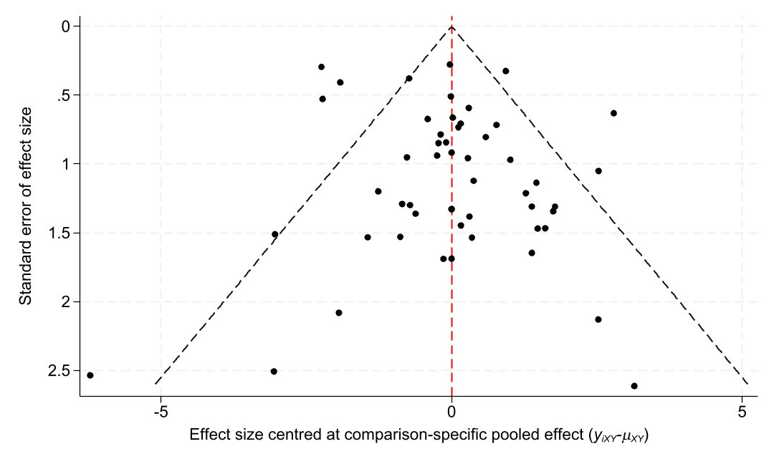

Figure S2. Funnel plot of pain score.
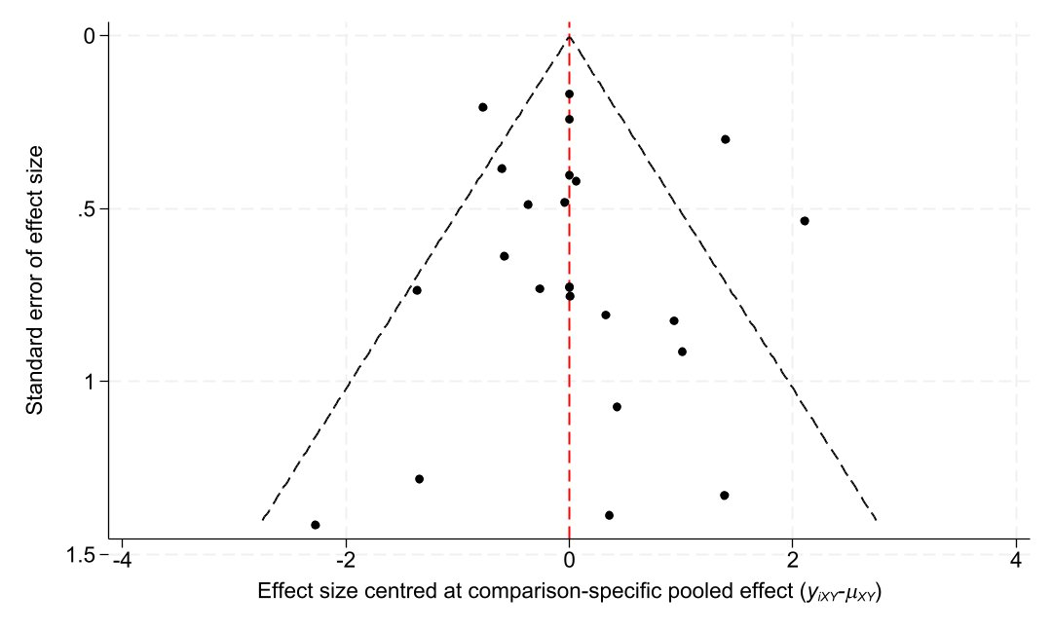

Figure S3. Funnel plot of voiding score.
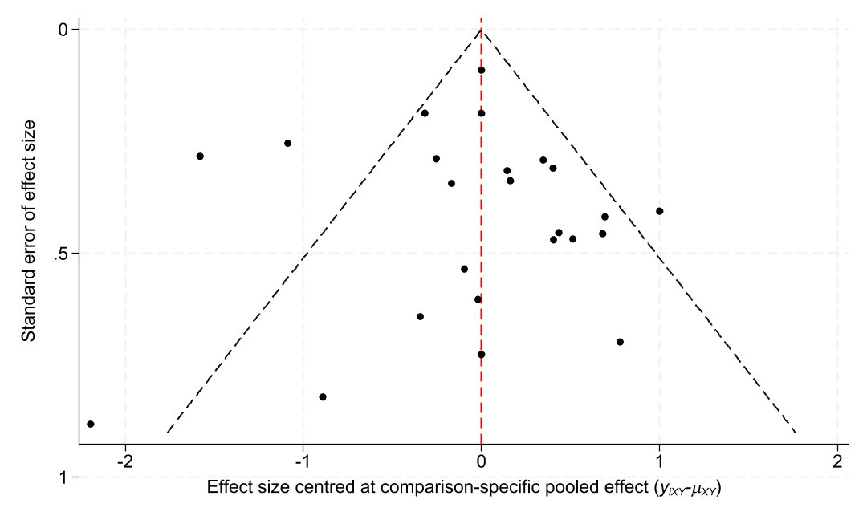

Figure S4. Funnel plot of quality of life score.
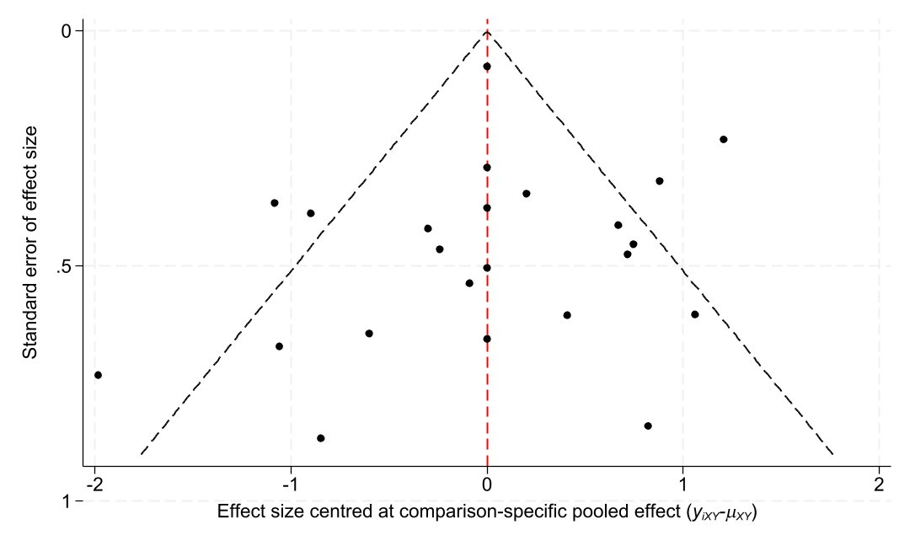

Figure S5. Funnel plot of Response rate.

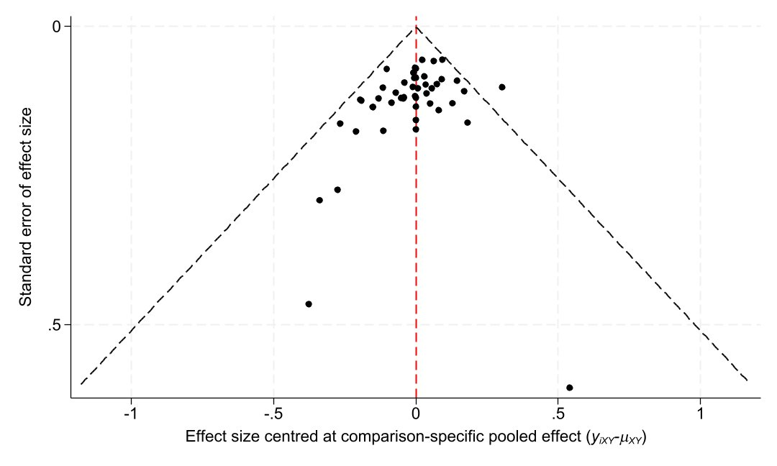

Appendix 5.CINeMA Assessment
We use the CINeMA framework to evidence certainty, assessing it for each network estimate based on the following criteria:
- Within study bias: We classified the overall risk of bias for each study as low risk of bias, the risk of bias as moderate when none of the four assessed risk of bias items were rated as high risk, and the risk of bias as high when one or both items were rated as high risk. See Appendix 2 for the bias assessment. The risk of bias for a pairwise comparison of each drug is shown in figure S5.1-5.12.

Figure S6. Risk of bias contribution by intervention group in median NIH-CPSI total score.
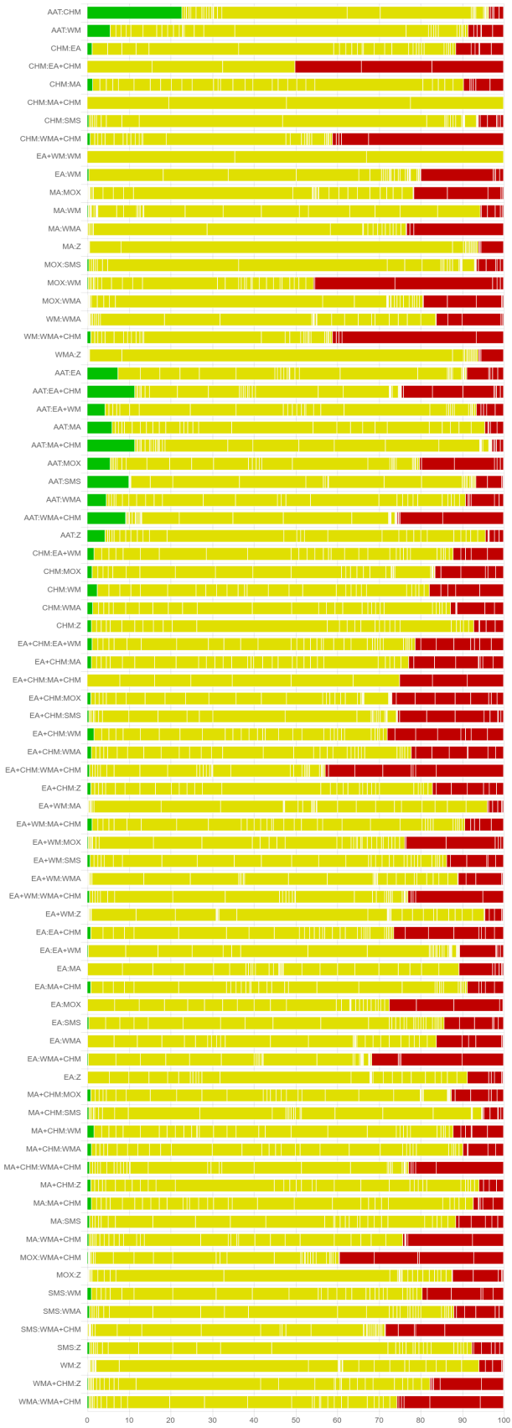
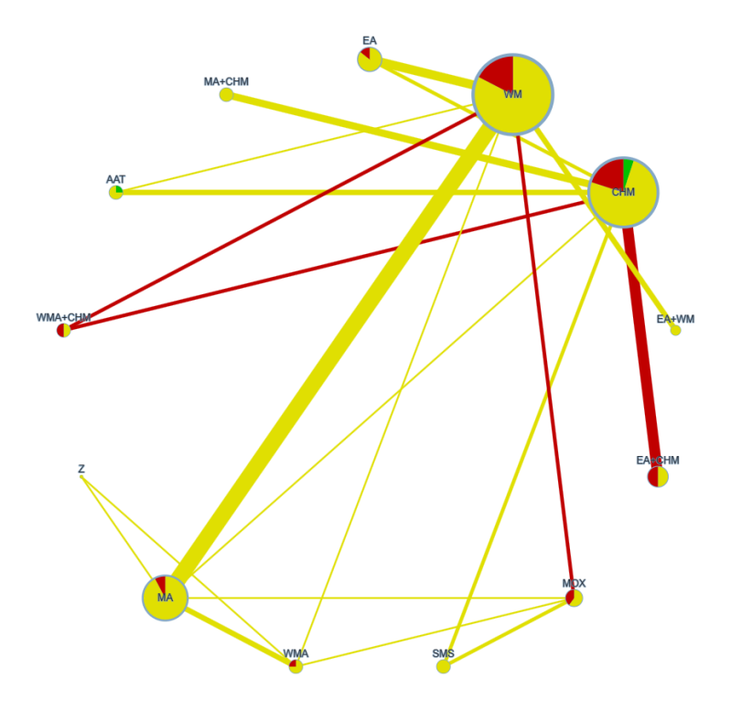

Figure S7. Overall risk of bias by treatment comparison in median NIH-CPSI total score.

Table S5.CINeMA results of NIH-CPSI total score.
Comparison | Within-study bias | Reporting bias | Indirectness | Imprecision | Heterogeneity | Incoherence | Confidence rating
AAT:CHM | Some concerns | Low risk | No concerns | No concerns | No concerns | Major concerns | Low
AAT:WM | Some concerns | Low risk | No concerns | No concerns | No concerns | Major concerns | Low
CHM:EA | Some concerns | Low risk | No concerns | No concerns | Major concerns | Major concerns | Low
CHM:EA+CHM | Major concerns | Low risk | No concerns | No concerns | Major concerns | No concerns | Low
CHM:MA | Some concerns | Low risk | No concerns | No concerns | Major concerns | No concerns | Low
CHM:MA+CHM | Some concerns | Low risk | No concerns | No concerns | No concerns | No concerns | Moderate
CHM:SMS | Some concerns | Low risk | No concerns | No concerns | Major concerns | No concerns | Low
CHM:WMA+CHM | Some concerns | Low risk | No concerns | No concerns | Major concerns | No concerns | Low
EA:WM | Some concerns | Low risk | No concerns | No concerns | Major concerns | Major concerns | Low
EA+WM:WM | Some concerns | Low risk | No concerns | No concerns | Major concerns | No concerns | Low
MA:MOX | Some concerns | Low risk | No concerns | Major concerns | No concerns | No concerns | Low
MA:WM | Some concerns | Low risk | No concerns | No concerns | Major concerns | No concerns | Low
MA:WMA | Some concerns | Low risk | No concerns | No concerns | Major concerns | No concerns | Low
MA:Z | Some concerns | Low risk | No concerns | Major concerns | No concerns | No concerns | Low
MOX:SMS | Some concerns | Low risk | No concerns | Major concerns | No concerns | No concerns | Low
MOX:WM | Some concerns | Low risk | No concerns | Major concerns | No concerns | No concerns | Low
MOX:WMA | Some concerns | Low risk | No concerns | No concerns | Major concerns | No concerns | Low
WM:WMA | Some concerns | Low risk | No concerns | No concerns | No concerns | No concerns | High
WM:WMA+CHM | Some concerns | Low risk | No concerns | No concerns | Major concerns | No concerns | Low
WMA:Z | Some concerns | Low risk | No concerns | Major concerns | No concerns | No concerns | Low
AAT:EA | Some concerns | Low risk | No concerns | Major concerns | No concerns | No concerns | Low
AAT:EA+CHM | Some concerns | Low risk | No concerns | No concerns | Major concerns | No concerns | Low
AAT:EA+WM | Some concerns | Low risk | No concerns | Major concerns | No concerns | No concerns | High
AAT:MA | Some concerns | Low risk | No concerns | No concerns | Major concerns | No concerns | Low
AAT:MA+CHM | Some concerns | Low risk | No concerns | Major concerns | No concerns | No concerns | Low
AAT:MOX | Some concerns | Low risk | No concerns | No concerns | Major concerns | No concerns | Low
AAT:SMS | Some concerns | Low risk | No concerns | No concerns | Major concerns | No concerns | Low
AAT:WMA | Some concerns | Low risk | No concerns | Major concerns | No concerns | No concerns | High
AAT:WMA+CHM | Some concerns | Low risk | No concerns | No concerns | Major concerns | No concerns | Low
AAT:Z | Some concerns | Low risk | No concerns | Major concerns | No concerns | No concerns | High
CHM:EA+WM | Some concerns | Low risk | No concerns | No concerns | Major concerns | No concerns | Low
CHM:MOX | Some concerns | Low risk | No concerns | No concerns | Major concerns | No concerns | Low
CHM:WM | Some concerns | Low risk | No concerns | Major concerns | No concerns | No concerns | Low
CHM:WMA | Some concerns | Low risk | No concerns | No concerns | No concerns | No concerns | High
CHM:Z | Some concerns | Low risk | No concerns | No concerns | Major concerns | No concerns | Low
EA:EA+CHM | Some concerns | Low risk | No concerns | Major concerns | No concerns | No concerns | Low
EA:EA+WM | Some concerns | Low risk | No concerns | Major concerns | No concerns | No concerns | Low
EA:MA | Some concerns | Low risk | No concerns | Major concerns | No concerns | No concerns | Low
EA:MA+CHM | Some concerns | Low risk | No concerns | Major concerns | No concerns | No concerns | Low
EA:MOX | Some concerns | Low risk | No concerns | Major concerns | No concerns | No concerns | Low
EA:SMS | Some concerns | Low risk | No concerns | Major concerns | No concerns | No concerns | Low
EA:WMA | Some concerns | Low risk | No concerns | Major concerns | No concerns | No concerns | Low
EA:WMA+CHM | Some concerns | Low risk | No concerns | Major concerns | No concerns | No concerns | Low
EA:Z | Some concerns | Low risk | No concerns | Major concerns | No concerns | No concerns | Low
EA+CHM:EA+WM | Some concerns | Low risk | No concerns | Major concerns | No concerns | No concerns | Low
EA+CHM:MA | Some concerns | Low risk | No concerns | Major concerns | No concerns | No concerns | Low
EA+CHM:MA+CHM | Some concerns | Low risk | No concerns | Major concerns | No concerns | No concerns | Low
EA+CHM:MOX | Some concerns | Low risk | No concerns | Major concerns | No concerns | No concerns | Low
EA+CHM:SMS | Some concerns | Low risk | No concerns | Major concerns | No concerns | No concerns | Low
EA+CHM:WM | Some concerns | Low risk | No concerns | Major concerns | No concerns | No concerns | Low
EA+CHM:WMA | Some concerns | Low risk | No concerns | No concerns | Major concerns | No concerns | Low
EA+CHM:WMA+CHM | Some concerns | Low risk | No concerns | Major concerns | No concerns | No concerns | Low
EA+CHM:Z | Some concerns | Low risk | No concerns | Major concerns | No concerns | No concerns | Low
EA+WM:MA | Some concerns | Low risk | No concerns | Major concerns | No concerns | No concerns | Low
EA+WM:MA+CHM | Some concerns | Low risk | No concerns | Major concerns | No concerns | No concerns | Low
EA+WM:MOX | Some concerns | Low risk | No concerns | Major concerns | No concerns | No concerns | Low
EA+WM:SMS | Some concerns | Low risk | No concerns | Major concerns | No concerns | No concerns | Low
EA+WM:WMA | Some concerns | Low risk | No concerns | Major concerns | No concerns | No concerns | Low
EA+WM:WMA+CHM | Some concerns | Low risk | No concerns | Major concerns | No concerns | No concerns | Low
EA+WM:Z | Some concerns | Low risk | No concerns | Major concerns | No concerns | No concerns | Low
MA:MA+CHM | Some concerns | Low risk | No concerns | Major concerns | No concerns | No concerns | Low
MA:SMS | Some concerns | Low risk | No concerns | Major concerns | No concerns | No concerns | Low
MA:WMA+CHM | Some concerns | Low risk | No concerns | Major concerns | No concerns | No concerns | High
MA+CHM:MOX | Some concerns | Low risk | No concerns | Major concerns | No concerns | No concerns | Low
MA+CHM:SMS | Some concerns | Low risk | No concerns | Major concerns | No concerns | No concerns | High
MA+CHM:WM | Some concerns | Low risk | No concerns | No concerns | No concerns | No concerns | High
MA+CHM:WMA | Some concerns | Low risk | No concerns | Major concerns | No concerns | No concerns | Low
MA+CHM:WMA+CHM | Some concerns | Low risk | No concerns | Major concerns | No concerns | No concerns | High
MA+CHM:Z | Some concerns | Low risk | No concerns | Major concerns | No concerns | No concerns | Low
MOX:WMA+CHM | Some concerns | Low risk | No concerns | Major concerns | No concerns | No concerns | Low
MOX:Z | Some concerns | Low risk | No concerns | Major concerns | No concerns | No concerns | Low
SMS:WM | Some concerns | Low risk | No concerns | Major concerns | No concerns | No concerns | Low
SMS:WMA | Some concerns | Low risk | No concerns | No concerns | Major concerns | No concerns | Low
SMS:WMA+CHM | Some concerns | Low risk | No concerns | Major concerns | No concerns | No concerns | Low
SMS:Z | Some concerns | Low risk | No concerns | Major concerns | No concerns | No concerns | Low
WM:Z | Some concerns | Low risk | No concerns | Major concerns | No concerns | No concerns | Low
WMA:WMA+CHM | Some concerns | Low risk | No concerns | No concerns | Major concerns | No concerns | Low
WMA+CHM:Z | Some concerns | Low risk | No concerns | Major concerns | No concerns | No concerns | Low

Figure S8. Risk of bias contribution by intervention group in median NIH-CPSI pain score.

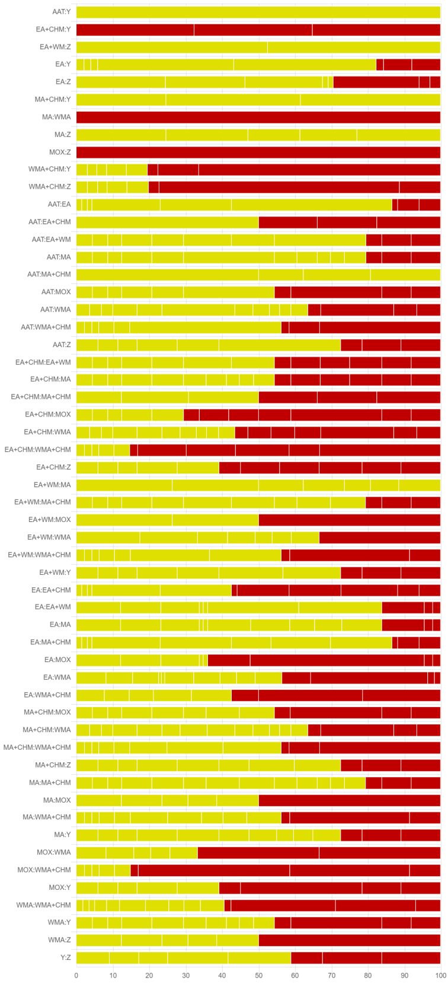
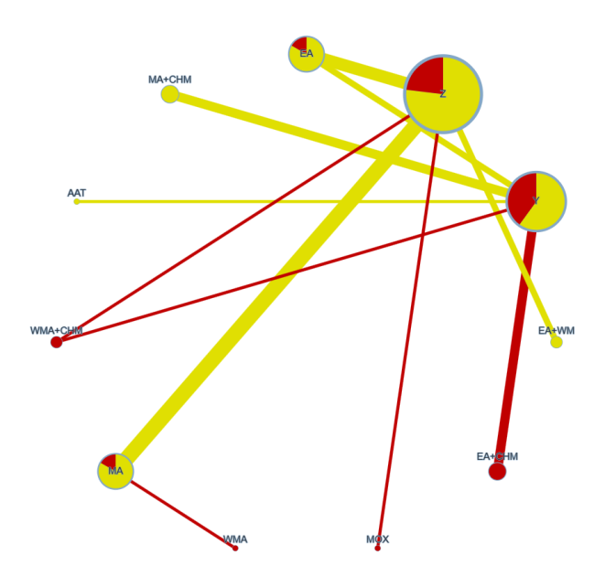

Table S6.CINeMA results of NIH-CPSI pain score.
Comparison | Within-study bias | Reporting bias | Indirectness | Imprecision | Heterogeneity | Incoherence | Confidence rating
AAT:Y | Some concerns | Low risk | No concerns | No concerns | No concerns | No concerns | High
EA:Y | Some concerns | Low risk | No concerns | Major concerns | No concerns | No concerns | Low
EA:Z | Some concerns | Low risk | No concerns | No concerns | Major concerns | No concerns | Low
EA+CHM:Y | Major concerns | Low risk | No concerns | Major concerns | No concerns | No concerns | Low
EA+WM:Z | Some concerns | Low risk | No concerns | No concerns | Major concerns | No concerns | Low
MA:WMA | Major concerns | Low risk | No concerns | Major concerns | No concerns | No concerns | Low
MA:Z | Some concerns | Low risk | No concerns | No concerns | Major concerns | No concerns | Low
MA+CHM:Y | Some concerns | Low risk | No concerns | No concerns | Major concerns | No concerns | Low
MOX:Z | Major concerns | Low risk | No concerns | Major concerns | No concerns | No concerns | Low
WMA+CHM:Y | Major concerns | Low risk | No concerns | Major concerns | No concerns | No concerns | Low
WMA+CHM:Z | Major concerns | Low risk | No concerns | Major concerns | No concerns | No concerns | Low
AAT:EA | Some concerns | Low risk | No concerns | No concerns | No concerns | No concerns | Moderate
AAT:EA+CHM | Some concerns | Low risk | No concerns | No concerns | No concerns | No concerns | Moderate
AAT:EA+WM | Some concerns | Low risk | No concerns | No concerns | No concerns | No concerns | Moderate
AAT:MA | Some concerns | Low risk | No concerns | No concerns | No concerns | No concerns | Moderate
AAT:MA+CHM | Some concerns | Low risk | No concerns | No concerns | No concerns | No concerns | Moderate
AAT:MOX | Some concerns | Low risk | No concerns | No concerns | No concerns | No concerns | Moderate
AAT:WMA | Some concerns | Low risk | No concerns | No concerns | No concerns | No concerns | Moderate
AAT:WMA+CHM | Some concerns | Low risk | No concerns | No concerns | No concerns | No concerns | Moderate
AAT:Z | Some concerns | Low risk | No concerns | No concerns | No concerns | No concerns | Moderate
EA:EA+CHM | Major concerns | Low risk | No concerns | Major concerns | No concerns | No concerns | Very low
EA:EA+WM | Some concerns | Low risk | No concerns | Major concerns | No concerns | No concerns | Low
EA:MA | Some concerns | Low risk | No concerns | Major concerns | No concerns | No concerns | Low
EA:MA+CHM | Some concerns | Low risk | No concerns | Major concerns | No concerns | No concerns | Low
EA:MOX | Major concerns | Low risk | No concerns | Major concerns | No concerns | No concerns | Very low
EA:WMA | Some concerns | Low risk | No concerns | Major concerns | No concerns | No concerns | Low
EA:WMA+CHM | Major concerns | Low risk | No concerns | Major concerns | No concerns | No concerns | Very low
EA+CHM:EA+WM | Some concerns | Low risk | No concerns | Major concerns | No concerns | No concerns | Low
EA+CHM:MA | Some concerns | Low risk | No concerns | Major concerns | No concerns | No concerns | Low
EA+CHM:MA+CHM | Some concerns | Low risk | No concerns | Major concerns | No concerns | No concerns | Low
EA+CHM:MOX | Major concerns | Low risk | No concerns | Major concerns | No concerns | No concerns | Low
EA+CHM:WMA | Major concerns | Low risk | No concerns | Major concerns | No concerns | No concerns | Low
EA+CHM:WMA+CHM | Major concerns | Low risk | No concerns | Major concerns | No concerns | No concerns | Low
EA+CHM:Z | Major concerns | Low risk | No concerns | Major concerns | No concerns | No concerns | Low
EA+WM:MA | Some concerns | Low risk | No concerns | Major concerns | No concerns | No concerns | Low
EA+WM:MA+CHM | Some concerns | Low risk | No concerns | Major concerns | No concerns | No concerns | Low
EA+WM:MOX | Some concerns | Low risk | No concerns | Major concerns | No concerns | No concerns | Low
EA+WM:WMA | Some concerns | Low risk | No concerns | Major concerns | No concerns | No concerns | Low
EA+WM:WMA+CHM | Some concerns | Low risk | No concerns | Major concerns | No concerns | No concerns | Low
EA+WM:Y | Some concerns | Low risk | No concerns | Major concerns | No concerns | No concerns | Low
MA:MA+CHM | Some concerns | Low risk | No concerns | Major concerns | No concerns | No concerns | Low
MA:MOX | Some concerns | Low risk | No concerns | Major concerns | No concerns | No concerns | Low
MA:WMA+CHM | Some concerns | Low risk | No concerns | Major concerns | No concerns | No concerns | Low
MA:Y | Some concerns | Low risk | No concerns | Major concerns | No concerns | No concerns | High
MA+CHM:MOX | Some concerns | Low risk | No concerns | Major concerns | No concerns | No concerns | Low
MA+CHM:WMA | Some concerns | Low risk | No concerns | Major concerns | No concerns | No concerns | Low
MA+CHM:WMA+CHM | Some concerns | Low risk | No concerns | Major concerns | No concerns | No concerns | Low
MA+CHM:Z | Some concerns | Low risk | No concerns | No concerns | Major concerns | No concerns | Low
MOX:WMA | Major concerns | Low risk | No concerns | Major concerns | No concerns | No concerns | Very low
MOX:WMA+CHM | Major concerns | Low risk | No concerns | Major concerns | No concerns | No concerns | Very low
MOX:Y | Major concerns | Low risk | No concerns | Major concerns | No concerns | No concerns | High
WMA:WMA+CHM | Major concerns | Low risk | No concerns | Major concerns | No concerns | No concerns | Very low
WMA:Y | Some concerns | Low risk | No concerns | Major concerns | No concerns | No concerns | Low
WMA:Z | Some concerns | Low risk | No concerns | No concerns | Major concerns | No concerns | Low
Y:Z | Some concerns | Low risk | No concerns | Major concerns | No concerns | No concerns | Low

Figure S10. Risk of bias contribution by intervention group in median NIH-CPSI voiding score.
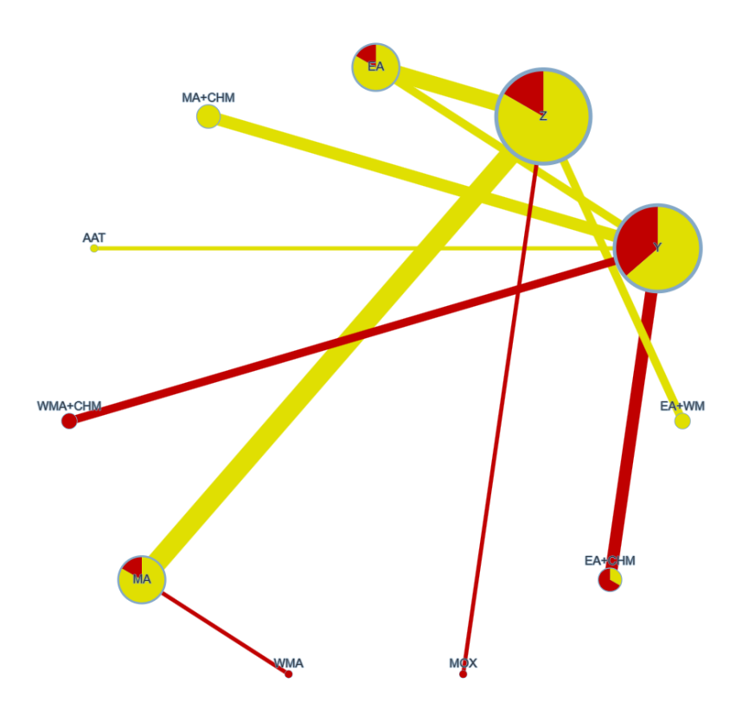

Figure S11. Overall risk of bias by treatment comparison in median NIH-CPSI voiding score.

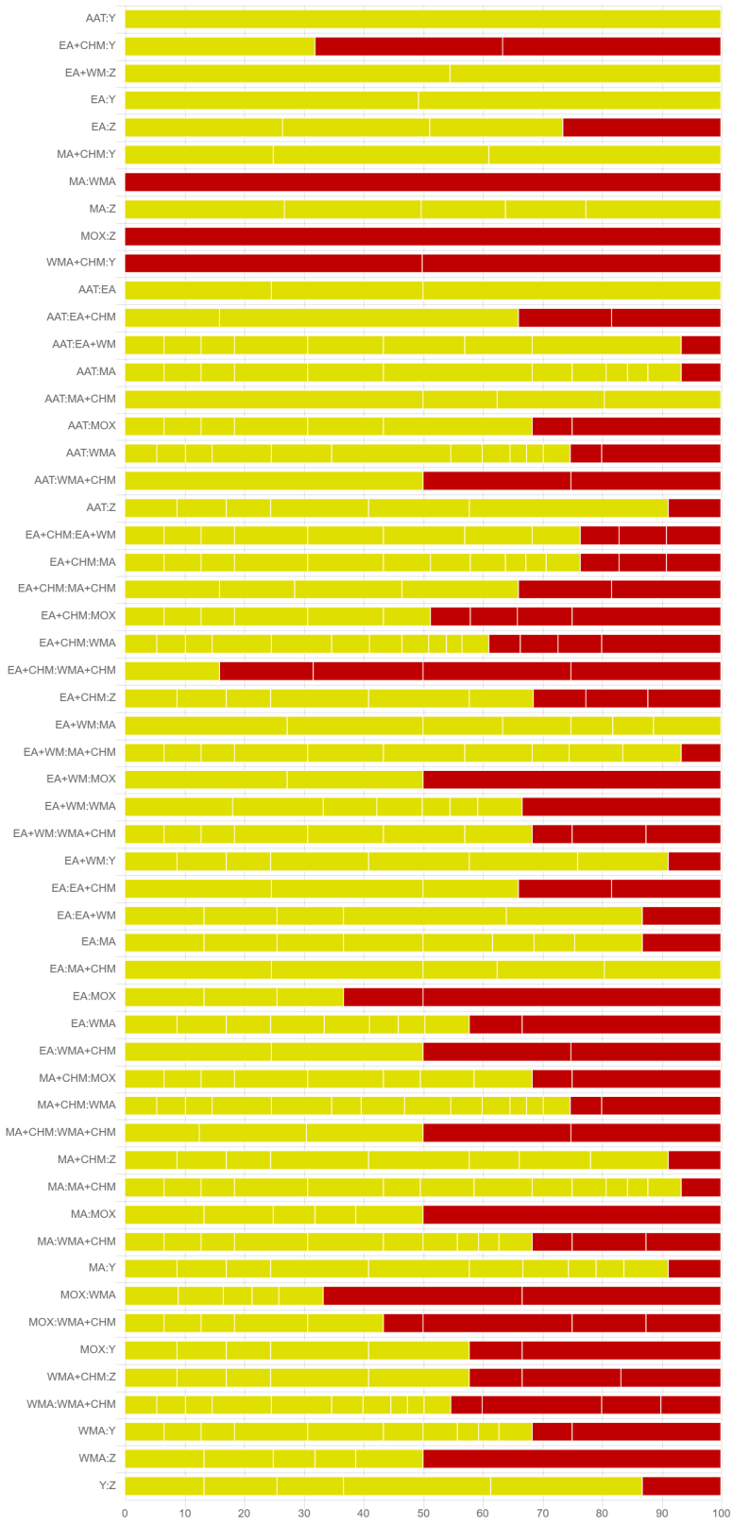

Table S7.CINeMA results of NIH-CPSI voiding score.
Comparison | Within-study bias | Reporting bias | Indirectness | Imprecision | Heterogeneity | Incoherence | Confidence rating
AAT:Y | Some concerns | Low risk | No concerns | No concerns | No concerns | Major concerns | Low
EA:Y | Some concerns | Low risk | No concerns | Major concerns | No concerns | Major concerns | Low
EA:Z | Some concerns | Low risk | No concerns | No concerns | Major concerns | Major concerns | Very low
EA+CHM:Y | Major concerns | Low risk | No concerns | No concerns | Major concerns | Major concerns | Very low
EA+WM:Z | Some concerns | Low risk | No concerns | No concerns | Major concerns | Major concerns | Very low
MA:WMA | Major concerns | Low risk | No concerns | Major concerns | No concerns | Major concerns | Very low
MA:Z | Some concerns | Low risk | No concerns | Major concerns | No concerns | Major concerns | Very low
MA+CHM:Y | Some concerns | Low risk | No concerns | No concerns | Major concerns | Major concerns | Very low
MOX:Z | Major concerns | Low risk | No concerns | Major concerns | No concerns | Major concerns | Very low
WMA+CHM:Y | Major concerns | Low risk | No concerns | No concerns | Major concerns | Major concerns | Very low
AAT:EA | Some concerns | Low risk | No concerns | No concerns | No concerns | Major concerns | Low
AAT:EA+CHM | Some concerns | Low risk | No concerns | No concerns | No concerns | Major concerns | Low
AAT:EA+WM | Some concerns | Low risk | No concerns | No concerns | No concerns | Major concerns | Low
AAT:MA | Some concerns | Low risk | No concerns | No concerns | No concerns | Major concerns | Low
AAT:MA+CHM | Some concerns | Low risk | No concerns | No concerns | No concerns | Major concerns | Low
AAT:MOX | Some concerns | Low risk | No concerns | No concerns | No concerns | Major concerns | Low
AAT:WMA | Some concerns | Low risk | No concerns | No concerns | No concerns | Major concerns | Low
AAT:WMA+CHM | Some concerns | Low risk | No concerns | No concerns | No concerns | Major concerns | Low
AAT:Z | Some concerns | Low risk | No concerns | No concerns | No concerns | Major concerns | High
EA:EA+CHM | Some concerns | Low risk | No concerns | Major concerns | No concerns | Major concerns | Very low
EA:EA+WM | Some concerns | Low risk | No concerns | Major concerns | No concerns | Major concerns | Very low
EA:MA | Some concerns | Low risk | No concerns | Major concerns | No concerns | Major concerns | Very low
EA:MA+CHM | Some concerns | Low risk | No concerns | Major concerns | No concerns | Major concerns | Very low
EA:MOX | Major concerns | Low risk | No concerns | Major concerns | No concerns | Major concerns | Very low
EA:WMA | Some concerns | Low risk | No concerns | Major concerns | No concerns | Major concerns | Very low
EA:WMA+CHM | Some concerns | Low risk | No concerns | Major concerns | No concerns | Major concerns | Very low
EA+CHM:EA+WM | Some concerns | Low risk | No concerns | Major concerns | No concerns | Major concerns | Very low
EA+CHM:MA | Some concerns | Low risk | No concerns | Major concerns | No concerns | Major concerns | Very low
EA+CHM:MA+CHM | Some concerns | Low risk | No concerns | Major concerns | No concerns | Major concerns | Very low
EA+CHM:MOX | Some concerns | Low risk | No concerns | Major concerns | No concerns | Major concerns | Very low
EA+CHM:WMA | Some concerns | Low risk | No concerns | Major concerns | No concerns | Major concerns | Very low
EA+CHM:WMA+CHM | Major concerns | Low risk | No concerns | Major concerns | No concerns | Major concerns | Very low
EA+CHM:Z | Some concerns | Low risk | No concerns | No concerns | Major concerns | Major concerns | Very low
EA+WM:MA | Some concerns | Low risk | No concerns | Major concerns | No concerns | Major concerns | Very low
EA+WM:MA+CHM | Some concerns | Low risk | No concerns | Major concerns | No concerns | Major concerns | Very low
EA+WM:MOX | Some concerns | Low risk | No concerns | Major concerns | No concerns | Major concerns | Very low
EA+WM:WMA | Some concerns | Low risk | No concerns | Major concerns | No concerns | Major concerns | Very low
EA+WM:WMA+CHM | Some concerns | Low risk | No concerns | Major concerns | No concerns | Major concerns | Very low
EA+WM:Y | Some concerns | Low risk | No concerns | Major concerns | No concerns | Major concerns | Very low
MA:MA+CHM | Some concerns | Low risk | No concerns | No concerns | Major concerns | Major concerns | High
MA:MOX | Some concerns | Low risk | No concerns | Major concerns | No concerns | Major concerns | Very low
MA:WMA+CHM | Some concerns | Low risk | No concerns | Major concerns | No concerns | Major concerns | Very low
MA:Y | Some concerns | Low risk | No concerns | Major concerns | No concerns | Major concerns | Very low
MA+CHM:MOX | Some concerns | Low risk | No concerns | Major concerns | No concerns | Major concerns | Very low
MA+CHM:WMA | Some concerns | Low risk | No concerns | Major concerns | No concerns | Major concerns | Very low
MA+CHM:WMA+CHM | Some concerns | Low risk | No concerns | Major concerns | No concerns | Major concerns | Very low
MA+CHM:Z | Some concerns | Low risk | No concerns | No concerns | No concerns | Major concerns | Low
MOX:WMA | Major concerns | Low risk | No concerns | Major concerns | No concerns | Major concerns | Very low
MOX:WMA+CHM | Major concerns | Low risk | No concerns | Major concerns | No concerns | Major concerns | Very low
MOX:Y | Some concerns | Low risk | No concerns | Major concerns | No concerns | Major concerns | Very low
WMA:WMA+CHM | Some concerns | Low risk | No concerns | Major concerns | No concerns | Major concerns | Very low
WMA:Y | Some concerns | Low risk | No concerns | Major concerns | No concerns | Major concerns | Very low
WMA:Z | Some concerns | Low risk | No concerns | Major concerns | No concerns | Major concerns | Very low
WMA+CHM:Z | Some concerns | Low risk | No concerns | No concerns | Major concerns | Major concerns | Very low
Y:Z | Some concerns | Low risk | No concerns | Major concerns | No concerns | Major concerns | Very low

Figure S12. Risk of bias contribution by intervention group in median NIH-CPSI quality of life score.
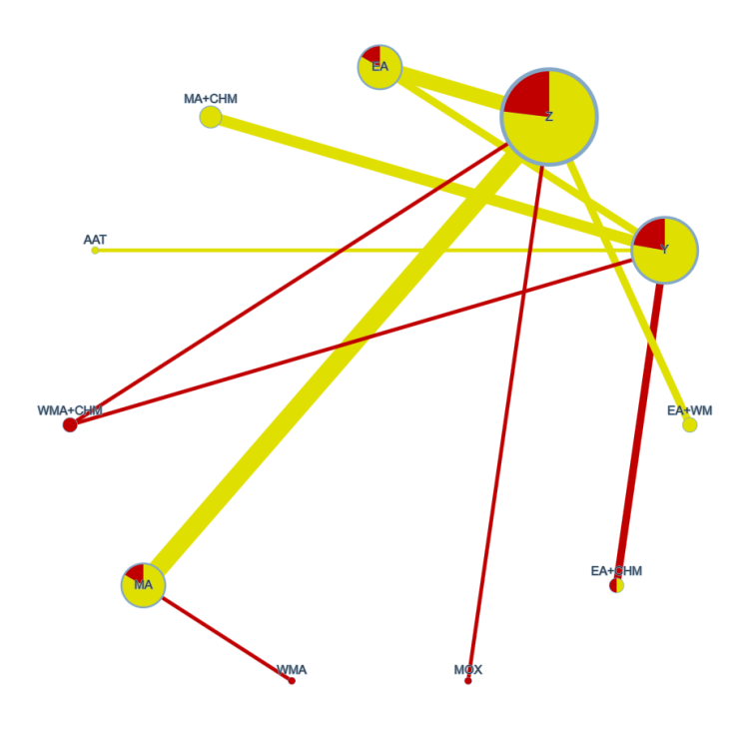

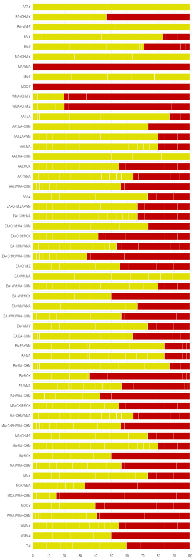
Figure S13. Overall risk of bias by treatment comparison in median NIH-CPSI quality of life score.

Table S8.CINeMA results of NIH-CPSI quality of life score.
Comparison | Within-study bias | Reporting bias | Indirectness | Imprecision | Heterogeneity | Incoherence | Confidence rating
AAT:Y | Some concerns | Low risk | No concerns | No concerns | No concerns | No concerns | High
EA:Y | Some concerns | Low risk | No concerns | Major concerns | No concerns | No concerns | Low
EA:Z | Some concerns | Low risk | No concerns | No concerns | Major concerns | No concerns | Low
EA+CHM:Y | Major concerns | Low risk | No concerns | Major concerns | No concerns | No concerns | Very low
EA+WM:Z | Some concerns | Low risk | No concerns | Major concerns | No concerns | No concerns | Low
MA:WMA | Major concerns | Low risk | No concerns | Major concerns | No concerns | No concerns | Very low
MA:Z | Some concerns | Low risk | No concerns | Major concerns | No concerns | No concerns | Low
MA+CHM:Y | Some concerns | Low risk | No concerns | No concerns | Major concerns | No concerns | Low
MOX:Z | Major concerns | Low risk | No concerns | Major concerns | No concerns | No concerns | Very low
WMA+CHM:Y | Major concerns | Low risk | No concerns | Major concerns | No concerns | No concerns | Very low
WMA+CHM:Z | Major concerns | Low risk | No concerns | Major concerns | No concerns | No concerns | Very low
AAT:EA | Some concerns | Low risk | No concerns | No concerns | No concerns | No concerns | Moderate
AAT:EA+CHM | Some concerns | Low risk | No concerns | No concerns | No concerns | No concerns | Moderate
AAT:EA+WM | Some concerns | Low risk | No concerns | No concerns | No concerns | No concerns | Moderate
AAT:MA | Some concerns | Low risk | No concerns | No concerns | No concerns | No concerns | Moderate
AAT:MA+CHM | Some concerns | Low risk | No concerns | No concerns | No concerns | No concerns | High
AAT:MOX | Some concerns | Low risk | No concerns | No concerns | No concerns | No concerns | Moderate
AAT:WMA | Some concerns | Low risk | No concerns | No concerns | No concerns | No concerns | Moderate
AAT:WMA+CHM | Some concerns | Low risk | No concerns | No concerns | No concerns | No concerns | Moderate
AAT:Z | Some concerns | Low risk | No concerns | No concerns | No concerns | No concerns | Moderate
EA:EA+CHM | Some concerns | Low risk | No concerns | Major concerns | No concerns | No concerns | Low
EA:EA+WM | Some concerns | Low risk | No concerns | Major concerns | No concerns | No concerns | Low
EA:MA | Some concerns | Low risk | No concerns | Major concerns | No concerns | No concerns | Low
EA:MA+CHM | Some concerns | Low risk | No concerns | Major concerns | No concerns | No concerns | Low
EA:MOX | Major concerns | Low risk | No concerns | Major concerns | No concerns | No concerns | Very low
EA:WMA | Some concerns | Low risk | No concerns | Major concerns | No concerns | No concerns | Low
EA:WMA+CHM | Major concerns | Low risk | No concerns | Major concerns | No concerns | No concerns | Low
EA+CHM:EA+WM | Some concerns | Low risk | No concerns | Major concerns | No concerns | No concerns | Low
EA+CHM:MA | Some concerns | Low risk | No concerns | Major concerns | No concerns | No concerns | Low
EA+CHM:MA+CHM | Some concerns | Low risk | No concerns | Major concerns | No concerns | No concerns | Low
EA+CHM:MOX | Major concerns | Low risk | No concerns | Major concerns | No concerns | No concerns | Very low
EA+CHM:WMA | Some concerns | Low risk | No concerns | Major concerns | No concerns | No concerns | Low
EA+CHM:WMA+CHM | Major concerns | Low risk | No concerns | Major concerns | No concerns | No concerns | Very low
EA+CHM:Z | Some concerns | Low risk | No concerns | Major concerns | No concerns | No concerns | Low
EA+WM:MA | Some concerns | Low risk | No concerns | Major concerns | No concerns | No concerns | Low
EA+WM:MA+CHM | Some concerns | Low risk | No concerns | Major concerns | No concerns | No concerns | Low
EA+WM:MOX | Some concerns | Low risk | No concerns | Major concerns | No concerns | No concerns | Low
EA+WM:WMA | Some concerns | Low risk | No concerns | Major concerns | No concerns | No concerns | Low
EA+WM:WMA+CHM | Some concerns | Low risk | No concerns | Major concerns | No concerns | No concerns | Low
EA+WM:Y | Some concerns | Low risk | No concerns | Major concerns | No concerns | No concerns | Low
MA:MA+CHM | Some concerns | Low risk | No concerns | Major concerns | No concerns | No concerns | Low
MA:MOX | Major concerns | Low risk | No concerns | Major concerns | No concerns | No concerns | Very low
MA:WMA+CHM | Some concerns | Low risk | No concerns | Major concerns | No concerns | No concerns | Low
MA:Y | Some concerns | Low risk | No concerns | Major concerns | No concerns | No concerns | Low
MA+CHM:MOX | Some concerns | Low risk | No concerns | Major concerns | No concerns | No concerns | Low
MA+CHM:WMA | Some concerns | Low risk | No concerns | Major concerns | No concerns | No concerns | Low
MA+CHM:WMA+CHM | Some concerns | Low risk | No concerns | Major concerns | No concerns | No concerns | Low
MA+CHM:Z | Some concerns | Low risk | No concerns | No concerns | Major concerns | No concerns | Low
MOX:WMA | Major concerns | Low risk | No concerns | Major concerns | No concerns | No concerns | Very low
MOX:WMA+CHM | Major concerns | Low risk | No concerns | Major concerns | No concerns | No concerns | Very low
MOX:Y | Major concerns | Low risk | No concerns | Major concerns | No concerns | No concerns | Very low
WMA:WMA+CHM | Major concerns | Low risk | No concerns | Major concerns | No concerns | No concerns | Very low
WMA:Y | Some concerns | Low risk | No concerns | Major concerns | No concerns | No concerns | High
WMA:Z | Major concerns | Low risk | No concerns | Major concerns | No concerns | No concerns | Very low
Y:Z | Some concerns | Low risk | No concerns | Major concerns | No concerns | No concerns | Low

- Reporting bias: We judged it visually by a funnel plot (Appendix 4).
- Indirectness: Transferability assumptions were assessed based on the baseline characteristics summarized in the study characteristics table provided in the intervention table.
- Imprecision: We used the CINeMA web application to evaluate the precision of each comparison, following its built-in criteria and grading system.
- Heterogeneity: We assessed concerns about heterogeneity by examining 95% confidence intervals (CIs) within a clinical reasoning framework similar to that used for evaluating imprecision. Specifically, we evaluated whether the CIs and prediction intervals included or excluded clinically important effect sizes, using predefined thresholds for clinical significance. The evaluation was guided by the recommendations automatically generated by CINeMA (https://cinema.ispm.unibe.ch/).
Inconsistency: To assess inconsistency, we reviewed the results of Consistency analyses (Appendix 3). Inconsistency was considered substantial when the p-value was less than 0.10; otherwise, no significant inconsistency was assumed.

Appendix 6. SUCRA Plots

Figure S14. SUCRA plot of NIH-CPSI Total Score.
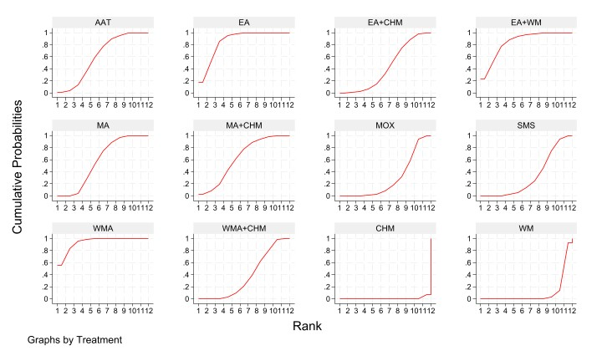

Table S9. SUCRA ranking results for NIH-CPSI total score.
Treatment | SUCRA | PrBest | MeanRank
AAT | 61.1 | 1.1 | 5.3
EA | 86.2 | 17.9 | 2.5
EA+CHM | 43.1 | 0.1 | 7.3
EA+WM | 84.1 | 22.1 | 2.8
MA | 58.6 | 0 | 5.6
MA+CHM | 62.9 | 2.5 | 5.1
MOX | 28 | 0 | 8.9
SMS | 32.6 | 0 | 8.4
WMA | 94.1 | 56.3 | 1.6
WMA+CHM | 38.5 | 0 | 7.8
CHM | 0.7 | 0 | 11.9
WM | 10 | 0 | 10.9

Figure S15. SUCRA plot of pain score.
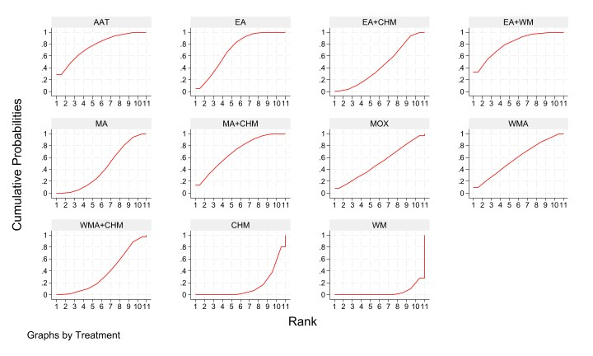

Table S10. SUCRA ranking results for NIH-CPSI pain score.
Treatment | SUCRA | PrBest | MeanRank
AAT | 76.6 | 29.2 | 3.3
EA | 71.5 | 5.8 | 3.8
EA+CHM | 43.4 | 0.9 | 6.7
EA+WM | 80.4 | 32.1 | 3
MA | 42.9 | 0.2 | 6.7
MA+CHM | 69.3 | 12.3 | 4.1
MOX | 52 | 8.6 | 5.8
WMA | 58.2 | 10.4 | 5.2
WMA+CHM | 36.8 | 0.5 | 7.3
CHM | 14.5 | 0 | 9.5
WM | 4.0 | 0 | 10.6

Figure S16. SUCRA plot of voiding score.
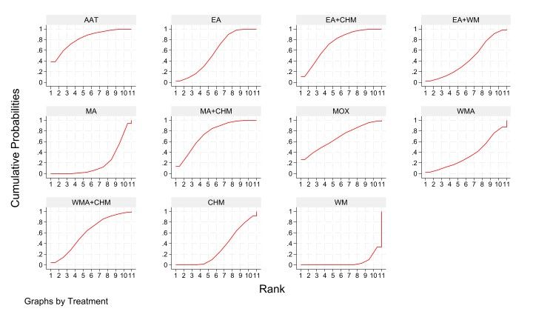

Table S11. SUCRA ranking results for voiding score.
Treatment | SUCRA | PrBest | MeanRank
AAT | 83.4 | 39.4 | 2.7
EA | 56.5 | 1.5 | 5.3
EA+CHM | 72.8 | 11.3 | 3.7
EA+WM | 43.2 | 2.2 | 6.7
MA | 19.5 | 0 | 9.1
MA+CHM | 73.7 | 12.2 | 3.6
MOX | 67.5 | 26 | 4.2
WMA | 36.5 | 2.7 | 7.4
WMA+CHM | 60.6 | 4.8 | 4.9
CHM | 31.4 | 0 | 7.9
WM | 4.7 | 0 | 10.5

Figure S17. SUCRA plot of qualityoflife score.
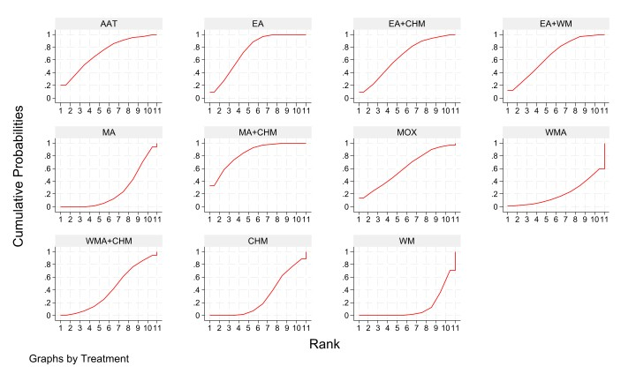

Table S12. SUCRA ranking results for qualityoflife score.
Treatment | SUCRA | PrBest | MeanRank
AAT | 71.8 | 20.6 | 3.8
EA | 74.6 | 9.3 | 3.5
EA+CHM | 65 | 8.7 | 4.5
EA+WM | 66.1 | 12.5 | 4.4
MA | 24.6 | 0 | 8.5
MA+CHM | 83.6 | 33.1 | 2.6
MOX | 60.7 | 14.3 | 4.9
WMA | 20.4 | 0.8 | 9
WMA+CHM | 41.5 | 0.7 | 6.8
CHM | 29.3 | 0 | 8.1
WM | 12.7 | 0 | 9.7

Figure S18. SUCRA plot of Response Rate.
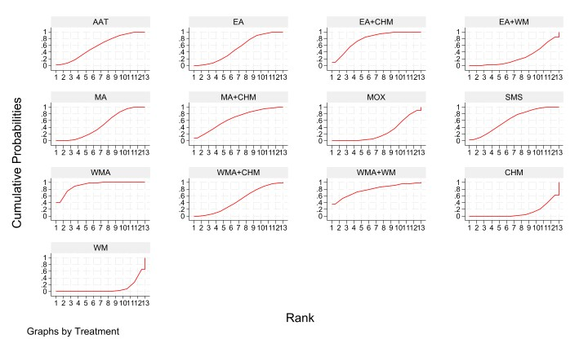

Table S13. SUCRA ranking results for response rate.
Treatment | SUCRA | PrBest | MeanRank
AAT | 57.4 | 1.7 | 6.1
EA | 51.9 | 0.1 | 6.8
EA+CHM | 77.6 | 10.2 | 3.7
EA+WM | 25.4 | 0 | 10
MA | 46.6 | 0 | 7.4
MA+CHM | 65.3 | 7 | 5.2
MOX | 26 | 0 | 9.9
SMS | 61.7 | 2.1 | 5.6
WMA | 91.4 | 42.9 | 2
WMA+CHM | 47.2 | 0.4 | 7.3
WMA+WM | 79 | 35.5 | 3.5
CHM | 11.9 | 0 | 11.6
WM | 8.5 | 0 | 12

Appendix 7. League Tables

Table S14.League table of NIH-CPSI Total Score.
AAT
1.66  (-0.77,4.09) | EA
-0.92  (-3.05,1.21) | -2.58  (-5.09,-0.07) | EA+CHM
1.62  (-1.40,4.63) | -0.04  (-2.72,2.64) | 2.54 (-0.57,5.64) | EA+WM
-0.12  (-2.35,2.11) | -1.78  (-3.61,0.06) | 0.80 (-1.53,3.13) | -1.74 (-4.18,0.71) | MA
0.08  (-2.32,2.49) | -1.57  (-4.32,1.17) | 1.01 (-1.24,3.25) | -1.53 (-4.84,1.78) | 0.20 (-2.39,2.80) | MA+CHM
-1.78  (-4.24,0.68) | -3.43  -5.74,-1.13) | -0.85 (-3.34,1.63) | -3.39 (-6.24,-0.55) | -1.66 (-3.60,0.29) | -1.86 (-4.59,0.87) | MOX
-1.50  (-3.86,0.85) | -3.16  -5.64,-0.69) | -0.58 (-2.86,1.70) | -3.12 (-6.16,-0.08) | -1.38 (-3.61,0.84) | -1.59 (-4.13,0.96) | 0.27 (-1.62,2.16) | SMS
2.42  (-0.19,5.04) | 0.76  (-1.51,3.04) | 3.34 (0.64,6.04) | 0.80 (-1.99,3.60) | 2.54 (0.83,4.25) | 2.34 (-0.59,5.27) | 4.20 (1.93,6.46) | 3.93 (1.36,6.49) | WMA
-1.17  (-3.46,1.12) | -2.83  (-5.11,-0.55) | -0.25 (-2.50,2.01) | -2.79 (-5.65,0.08) | -1.05 (-3.10,1.00) | -1.25 (-3.78,1.27) | 0.61 (-1.77,2.98) | 0.33 (-2.04,2.71) | -3.59 (-6.05,-1.13) | WMA+CHM
-4.39  -6.02,-2.75) | -6.05  (-8.15,-3.95) | -3.47 (-4.84,-2.09) | -6.00 (-8.80,-3.21) | -4.27 (-6.16,-2.37) | -4.47 (-6.24,-2.70) | -2.61 (-4.70,-0.53) | -2.88 (-4.72,-1.05) | -6.81 (-9.14,-4.48) | -3.22 (-5.01,-1.42) | CHM
-3.13  -5.18,-1.07) | -4.78  (-6.30,-3.27) | -2.20 (-4.39,-0.02) | -4.74 (-6.94,-2.54) | -3.01 (-4.07,-1.95) | -3.21 (-5.68,-0.74) | -1.35 (-3.16,0.46) | -1.62 (-3.71,0.47) | -5.55 (-7.27,-3.83) | -1.96 (-3.78,-0.13) | 1.26 (-0.46,2.98) | WM
Footnote: The columns represent the comparison of the row intervention to the column intervention. The rows represent the comparison of the row intervention to other interventions. The effect estimates are expressed as mean difference and 95% confidence interval. Mean difference <0 favors the intervention in the row. Values highlighted in red indicate statistically significant comparisons, defined as 95% confidence intervals that did not include 0.

Table S15.League table ofpain score.
AAT
-0.35 (-2.94,2.24) | EA
-1.32 (-3.55,0.91) | -0.97 (-3.19,1.24) | EA+CHM
0.15 (-3.02,3.32) | 0.50 (-1.53,2.52) | 1.47 (-1.40,4.34) | EA+WM
-1.29 (-4.13,1.55) | -0.94 (-2.40,0.52) | 0.03 (-2.48,2.54) | -1.44 (-3.46,0.58) | MA
-0.35 (-2.63,1.92) | -0.01 (-2.27,2.26) | 0.97 (-0.87,2.80) | -0.50 (-3.42,2.41) | 0.94 (-1.61,3.49) | MA+CHM
-0.98 (-4.50,2.53) | -0.63 (-3.17,1.90) | 0.34 (-2.91,3.59) | -1.13 (-4.02,1.76) | 0.31 (-2.22,2.84) | -0.63 (-3.91,2.66) | MOX
-0.76 (-4.17,2.64) | -0.41 (-2.79,1.97) | 0.56 (-2.57,3.69) | -0.91 (-3.67,1.85) | 0.53 (-1.35,2.41) | -0.41 (-3.57,2.76) | 0.22 (-2.93,3.37) | WMA
-1.57 (-4.08,0.95) | -1.22 (-3.15,0.72) | -0.25 (-2.36,1.87) | -1.72 (-4.27,0.83) | -0.28 (-2.40,1.85) | -1.21 (-3.38,0.96) | -0.58 (-3.55,2.38) | -0.81 (-3.64,2.03) | WMA+CHM
-2.42 (-4.26,-0.58) | -2.07 (-3.90,-0.25) | -1.10 (-2.35,0.15) | -2.57 (-5.15,0.02) | -1.13 (-3.30,1.04) | -2.06 (-3.41,-0.72) | -1.44 (-4.44,1.56) | -1.66 (-4.53,1.21) | -0.85 (-2.56,0.86) | CHM
-3.13 (-5.78,-0.48) | -2.78 (-3.82,-1.75) | -1.81 (-4.10,0.47) | -3.28 (-5.02,-1.55) | -1.84 (-2.87,-0.81) | -2.78 (-5.11,-0.44) | -2.15 (-4.46,0.16) | -2.37 (-4.51,-0.23) | -1.57 (-3.43,0.30) | -0.71 (-2.63,1.20) | WM
Footnote: The columns represent the comparison of the row intervention to the column intervention. The rows represent the comparison of the row intervention to other interventions. The effect estimates are expressed as mean difference and 95% confidence interval. Mean difference <0 favors the intervention in the row. Values highlighted in red indicate statistically significant comparisons, defined as 95% confidence intervals that did not include 0.

Table S16.League table of voiding score.
AAT
-1.03 (-3.15,1.08) | EA
-0.44 (-2.23,1.35) | 0.59  (-1.19,2.37) | EA+CHM
-1.44 (-4.01,1.12) | -0.41 (-1.86,1.04) | -1.00 (-3.30,1.29) | EA+WM
-2.19 (-4.62,0.24) | -1.16 (-2.35,0.03) | -1.75 (-3.90,0.40) | -0.75 (-2.17,0.67) | MA
-0.40 (-2.20,1.40) | 0.63  (-1.15,2.42) | 0.04  (-1.34,1.43) | 1.05  (-1.25,3.34) | 1.79 (-0.35,3.94) | MA+CHM
-0.56 (-3.64,2.52) | 0.47  (-1.77,2.71) | -0.12 (-2.98,2.75) | 0.88  (-1.49,3.26) | 1.63 (-0.59,3.86) | -0.16 (-3.03,2.70) | MOX
-1.74 (-4.62,1.14) | -0.71 (-2.66,1.24) | -1.30 (-3.94,1.35) | -0.30 (-2.40,1.80) | 0.45 (-1.09,2.00) | -1.34 (-3.99,1.30) | -1.18 (-3.89,1.53) | WMA
-0.81 (-2.68,1.07) | 0.22  (-1.64,2.09) | -0.36 (-1.84,1.12) | 0.64  (-1.72,3.00) | 1.39 (-0.83,3.60) | -0.41 (-1.90,1.08) | -0.25 (-3.16,2.67) | 0.93 (-1.76,3.63) | WMA+CHM
-1.60 (-3.11,-0.09) | -0.57 (-2.06,0.92) | -1.16 (-2.13,-0.19) | -0.16 (-2.23,1.92) | 0.59 (-1.32,2.50) | -1.20 (-2.18,-0.22) | -1.04 (-3.73,1.65) | 0.14 (-2.31,2.60) | -0.79 (-1.91,0.32) | CHM
-2.71 (-4.99,-0.42) | -1.68 (-2.54,-0.81) | -2.27 (-4.25,-0.29) | -1.27 (-2.43,-0.10) | -0.52 (-1.33,0.30) | -2.31 (-4.29,-0.33) | -2.15 (-4.22,-0.08) | -0.97 (-2.72,0.78) | -1.90 (-3.96,0.15) | -1.11 (-2.83,0.61) | WM
Footnote: The columns represent the comparison of the row intervention to the column intervention. The rows represent the comparison of the row intervention to other interventions. The effect estimates are expressed as mean difference and 95% confidence interval. Mean difference <0 favors the intervention in the row. Values highlighted in red indicate statistically significant comparisons, defined as 95% confidence intervals that did not include 0.

Table S17.League table of quality of life score.
AAT
-0.08 (-2.33,2.18) | EA
-0.28 (-2.49,1.93) | -0.20 (-2.23,1.82) | EA+CHM
-0.30 (-3.04,2.44) | -0.23 (-1.92,1.47) | -0.02 (-2.58,2.53) | EA+WM
-1.69 (-4.19,0.81) | -1.62 (-2.89,-0.34) | -1.41 (-3.71,0.88) | -1.39 (-3.06,0.27) | MA
0.38 (-1.67,2.44) | 0.46  (-1.40,2.32) | 0.66 (-1.14,2.46) | 0.68 (-1.74,3.11) | 2.08 (-0.07,4.22) | MA+CHM
-0.43 (-3.50,2.63) | -0.36 (-2.54,1.83) | -0.16 (-3.06,2.75) | -0.13 (-2.56,2.30) | 1.26 (-0.90,3.42) | -0.82 (-3.60,1.97) | MOX
-2.00 (-5.09,1.08) | -1.93 (-4.14,0.28) | -1.72 (-4.64,1.19) | -1.70 (-4.16,0.75) | -0.31 (-2.11,1.49) | -2.38 (-5.19,0.42) | -1.57 (-4.38,1.24) | WMA
-1.10 (-3.42,1.22) | -1.02 (-2.74,0.69) | -0.82 (-2.92,1.28) | -0.80 (-2.99,1.40) | 0.59 (-1.29,2.48) | -1.48 (-3.42,0.45) | -0.67 (-3.26,1.93) | 0.90 (-1.71,3.51) | WMA+CHM
-1.41 (-3.12,0.30) | -1.34 (-2.81,0.14) | -1.13 (-2.53,0.27) | -1.11 (-3.25,1.03) | 0.28 (-1.54,2.11) | -1.79 (-2.93,-0.66) | -0.98 (-3.52,1.57) | 0.59 (-1.98,3.16) | -0.31 (-1.88,1.26) | CHM
-2.02 (-4.37,0.32) | -1.95 (-2.88,-1.02) | -1.75 (-3.87,0.38) | -1.72 (-3.14,-0.30) | -0.33 (-1.20,0.54) | -2.41 (-4.37,-0.44) | -1.59 (-3.57,0.39) | -0.02 (-2.02,1.98) | -0.92 (-2.60,0.75) | -0.61 (-2.22,0.99) | WM
Footnote: The columns represent the comparison of the row intervention to the column intervention. The rows represent the comparison of the row intervention to other interventions. The effect estimates are expressed as mean difference and 95% confidence interval. Mean difference <0 favors the intervention in the row. Values highlighted in red indicate statistically significant comparisons, defined as 95% confidence intervals that did not include 0.

Table S18.League table of Response rate.
AAT
1.02 (0.85,1.22) | EA
0.93 (0.78,1.11) | 0.91 (0.76,1.10) | EA+CHM
1.11 (0.90,1.37) | 1.09 (0.92,1.28) | 1.19 (0.96,1.48) | EA+WM
1.03 (0.87,1.23) | 1.01 (0.90,1.14) | 1.11 (0.93,1.33) | 0.93 (0.80,1.09) | MA
0.97 (0.78,1.20) | 0.95 (0.76,1.18) | 1.04 (0.87,1.25) | 0.87 (0.68,1.11) | 0.93 (0.75,1.16) | MA+CHM
1.10 (0.91,1.33) | 1.08 (0.93,1.26) | 1.18 (0.98,1.42) | 0.99 (0.82,1.19) | 1.06 (0.92,1.23) | 1.14 (0.91,1.42) | MOX
0.98 (0.81,1.20) | 0.97 (0.81,1.16) | 1.06 (0.88,1.27) | 0.89 (0.72,1.09) | 0.95 (0.80,1.13) | 1.02 (0.82,1.26) | 0.89 (0.79,1.02) | SMS
0.87 (0.71,1.05) | 0.85 (0.73,0.98) | 0.93 (0.76,1.13) | 0.78 (0.65,0.93) | 0.84 (0.75,0.94) | 0.90 (0.71,1.13) | 0.79 (0.67,0.92) | 0.88 (0.73,1.06) | WMA
1.03 (0.85,1.25) | 1.01 (0.85,1.20) | 1.11 (0.93,1.32) | 0.93 (0.76,1.14) | 1.00 (0.84,1.18) | 1.07 (0.87,1.31) | 0.94 (0.78,1.12) | 1.05 (0.87,1.27) | 1.19 (0.99,1.43) | WMA+CHM
0.90 (0.66,1.22) | 0.88 (0.66,1.16) | 0.96 (0.71,1.31) | 0.81 (0.60,1.08) | 0.87 (0.66,1.14) | 0.93 (0.66,1.29) | 0.81 (0.61,1.09) | 0.91 (0.67,1.24) | 1.03 (0.77,1.38) | 0.87 (0.64,1.17) | WMA+WM
1.16 (1.00,1.35) | 1.14 (0.97,1.34) | 1.25 (1.12,1.39) | 1.05 (0.86,1.27) | 1.12 (0.96,1.31) | 1.20 (1.03,1.39) | 1.05 (0.90,1.24) | 1.18 (1.01,1.38) | 1.34 (1.12,1.60) | 1.13 (0.97,1.30) | 1.30 (0.96,1.75) | CHM
1.17 (1.00,1.37) | 1.15 (1.04,1.26) | 1.25 (1.06,1.48) | 1.05 (0.92,1.20) | 1.13 (1.05,1.22) | 1.21 (0.98,1.48) | 1.06 (0.93,1.20) | 1.19 (1.01,1.39) | 1.35 (1.20,1.51) | 1.13 (0.98,1.31) | 1.30 (1.00,1.70) | 1.01 (0.87,1.16) | WM
Footnote: The columns represent the comparison of the row intervention to the column intervention. The rows represent the comparison of the row intervention to other interventions. The effect estimates are expressed as risk ratio and 95% confidence interval. Risk ratio <1 favors the intervention in the row. Values highlighted in red indicate statistically significant comparisons, defined as 95% confidence intervals that did not include 1.

