Supplementary material S1: Standards for Reporting Qualitative Research (SRQR)
No. | Topic |  | Item | page number
Title and abstract
S1 | Title |  | Concise description of the nature and topic of the study Identifying the study as qualitative or indicating the approach (e.g., ethnography,grounded theory) or data collection methods (e.g., interview, focus group) is recommended | 1
S2 | Abstract |  | Summary of key elements of the study using the abstract format of the intended publication; typically includes background, purpose, methods, results, and conclusions | 2
Introduction
S3 | Problem formulation |  | Description and significance of the problem/phenomenon studied; review of relevant theory and empirical work; problem statement | 4
S4 | Purpose or research question |  | Purpose of the study and specific objectives or questions | 6
Methods
S5 | Qualitative approach and research paradigm |  | Qualitative approach (e.g., ethnography, grounded theory, case study, phenomenology, narrative research) and guiding theory if appropriate; identifying the research paradigm (e.g., post positivist, constructivist/interpretivist) is also recommended; rationale^{b} | 7
S6 | Researcher characteristics and reflexivity |  | Researchers’ characteristics that may influence the research, including personal attributes, qualifications/experience, relationship with participants, assumptions, and/or presuppositions; potential or actual interaction between researchers’ characteristics and the research questions, approach, methods, results, and/or transferability | 7
S7 | Context |  | Setting/site and salient contextual factors; rationale^{b} | 7
S8 | Sampling strategy |  | How and why research participants, documents, or events were selected; criteria for deciding when no further sampling was necessary (e.g., sampling saturation); rationale^{b} | 7
S9 | Ethical issues pertaining to human subjects |  | Documentation of approval by an appropriate ethics review board and participant consent, or explanation for lack thereof; other confidentiality and data security issues | 10
S10 | Data collection methods |  | Types of data collected; details of data collection procedures including (as appropriate) start and stop dates of data collection and analysis, iterative process, triangulation of sources/methods, and modification of procedures in response to evolving study findings; rationale^{b} | 8
S11 | Data collection instruments and technologies |  | Description of instruments (e.g., interview guides, questionnaires) and devices (e.g., audio recorders) used for data collection; if/how the instrument(s) changed over the course of the study | 8
S12 | Units of study |  | Number and relevant characteristics of participants, documents, or  events included in the study; level of participation (could be reported  in results) | 8
S13 | Data processing |  | Methods for processing data prior to and during analysis, including transcription, data entry, data management and security, verification of data integrity, data coding, and anonymization/deidentification of excerpts | 9
S14 | Data analysis |  | Process by which inferences, themes, etc., were identified and developed, including the researchers involved in data analysis; usually references a specific paradigm or approach; rationale^{b} | 9
S15 | Techniques to enhance trustworthiness |  | Techniques to enhance trustworthiness and credibility of data analysis (e.g., member checking, audit trail, triangulation); rationale^{b} | 9
Results/findings
S16 | Synthesis and interpretation |  | Main findings (e.g., interpretations, inferences, and themes); might include development of a theory or model, or integration with prior research or theory | 10
S17 | Links to empirical data |  | Evidence (e.g., quotes, field notes, text excerpts, photographs) to substantiate analytic findings | 11
Discussion
S18 | Integration with prior work, implications, transferability, and contribution(s) to the field |  | Short summary of main findings; explanation of how findings and conclusions connect to, support, elaborate on, or challenge conclusions of earlier scholarship; discussion of scope of application/generalizability; identification of unique contribution(s) to scholarship in a discipline or field | 16
S19 | Limitation |  | Trustworthiness and limitations of findings | 19
S20 | Conflicts of interest |  | Potential sources of influence or perceived influence on study conduct and conclusions; how these were managed | 21
S21 | Funding |  | Sources of funding and other support role of funders in data collection, interpretation, and reporting | 21
^{b}The rationale should briefly discuss the justification for choosing that theory, approach, method, or technique rather than other options available, the assumptions and limitations implicit in those choices, and how those choices influence study conclusions and transferability. As appropriate, the rationale for several items might be discussed together.

Supplementary material S2: Recruitment and analysis Flowchart
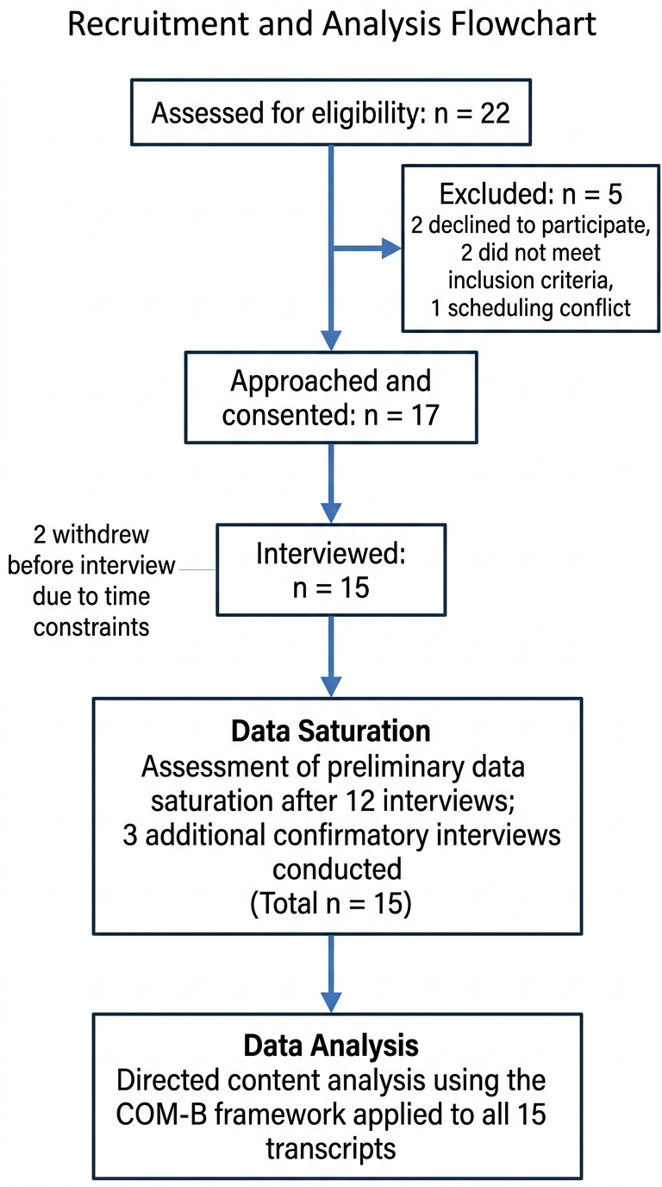

Supplementary material S3: Interview Outline

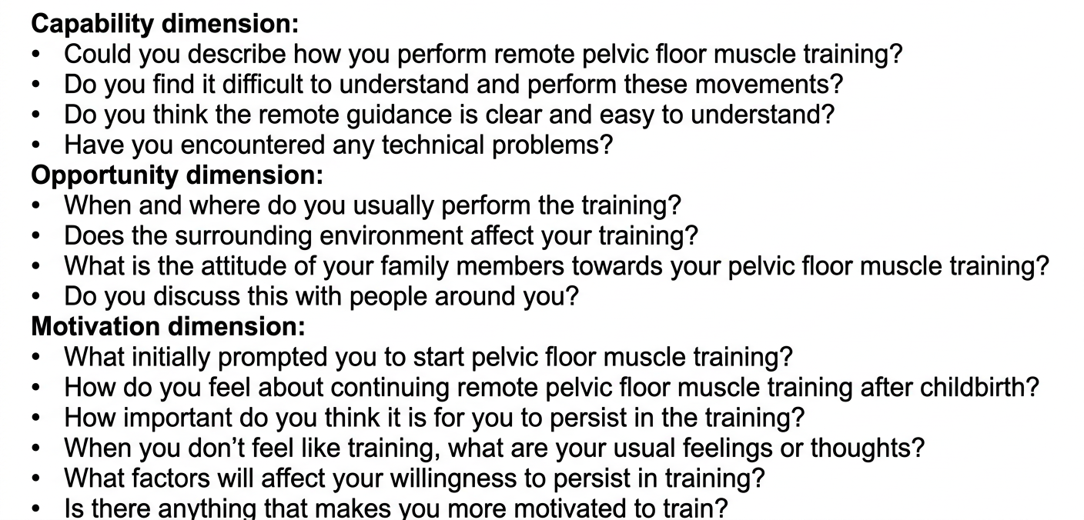

Supplementary material S4
Measures taken to increase data trustworthiness
Criterion | Measures
Credibility | Purposive sampling with maximum variation was used to recruit postpartum women with diverse characteristics. The interviewer was involved throughout the research process, including participant recruitment, interviews, transcription checking, and preliminary analysis, which promoted immersion in the data. Peer debriefing was conducted within the research team, and member checking was performed with selected participants to confirm whether the preliminary findings accurately reflected their experiences.
Dependability | All interviews were audio-recorded with participants’ permission. Verbatim transcription was completed within 24 hours after each interview. Field notes were taken during and immediately after the interviews. A detailed audit trail was maintained to document participant recruitment, interview procedures, coding decisions, and theme development.
Confirmability | Reflexive memo writing was used throughout the study to document assumptions, analytic decisions, and emerging interpretations. Two researchers independently coded part of the transcripts and discussed discrepancies until consensus was reached; a third researcher was consulted when necessary. Preliminary findings were also verified with selected participants to support authenticity.
Transferability | Maximum variation purposive sampling was adopted to ensure the inclusion of participants with diverse backgrounds and experiences. Detailed descriptions of the study setting, participant characteristics, sampling strategy, data collection process, and analytical procedures were provided. The study was reported in accordance with the SRQR checklist.
Research team and reflexivity | Interviews were conducted by DZ, a nurse researcher trained in qualitative research methods. Before data collection, DZ had no prior clinical relationship with the participants. During the interviews, efforts were made to build a respectful and trusting relationship with participants. Reflexive notes were maintained throughout the study to document personal assumptions, methodological decisions, and emerging analytical insights, thereby reducing the influence of researcher preconceptions on data interpretation.

