Supplementary information

Table S1. The volume of different solutions used for synthesis of HfO2 NPs
Sample No. | HfCl₄ solution  （mL） | KOH solution  (mL） | DI water (mL) | pH -- 1* | pH -- 2**
1 | 6 | 0 | 9 | -- | 0.85
2 | 6 | 1 | 8 | 0.94 | 1.28
3 | 6 | 4 | 5 | 1.59 | 1.80
4 | 6 | 6 | 3 | 3.12 | 3.45
5 | 6 | 6.1 | 2.9 | 5.03 | 5.88
6 | 6 | 6.4 | 2.6 | 8.60 | 8.82
7 | 6 | 7.5 | 1.5 | 11.6 | 10.8
8 | 6 | 8 | 1 | -- | 11.6
*pH--1: the pH value before adding DI water
**pH--2: the pH value after adding DI water

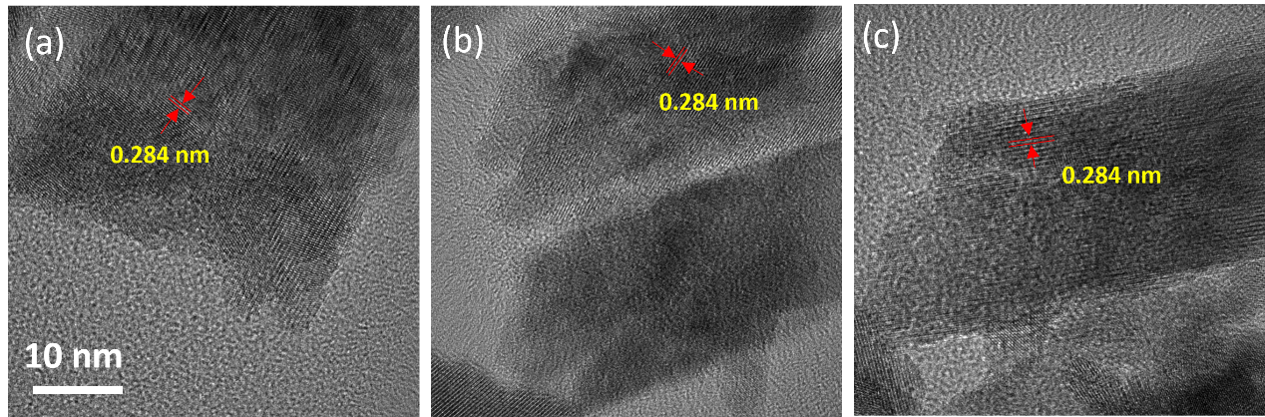
Figure S1. High-resolution TEM of HfO₂ samples produced under (a) pH=0.85, 180ºC, 8h, (b) pH=3.45, 180ºC, 8h and (c) pH=5.88, 180ºC, 8h The red arrows indicate the lattice spacing of the obtained samples.

Figure S2. XPS spectra of Hf4f of HfO₂ samples prepared under (a) 180ºC, 8h, (b) 180ºC, 4h, (c) 180ºC, 12h, (d) 140ºC, 8h, (e) 160ºC, 8h; XPS spectra of O1s of HfO₂ samples prepared under (f) 180ºC, 8h, (g) 180ºC, 4h, (h) 180ºC, 12h, (i) 140ºC, 8h, (j) 160ºC, 8h.

Table S2. Quantify analysis of XPS spectra of different HfO₂ samples
Sample | Synthesis Parameter |  |  | Hf 4f/eV |  | O1s/eV
 | Duration/h | Temperature/ºC | Hf 4f _{7/2} |  | Hf 4f _{5/2} |  | O-Hf | O-H | O _{def}
HfO₂ | 8 | 180 | 16.76 |  | 18.45 |  | 529.88 (60.7) | 531.46 (39.3) | /
HfO₂-4h | 4 | 180 | 16.67 |  | 18.32 |  | 529.93 (69.6) | 531.56 (19.2) | 532.67 (11.1)
HfO₂-12h | 12 | 180 | 16.68 |  | 18.36 |  | 529.89 (64.4) | 531.49 (35.6) | /
HfO₂-140C | 8 | 140 | 17.18 |  | 18.88 |  | 530.49 (30.4) | 531.76 (27.9) | 533.02 (41.7)
HfO₂-160C | 8 | 160 | 16.82 |  | 18.48 |  | 530.15 (61.8) | 531.60 (20.5) | 532.49 (17.6)
The bold numbers represent the proportions of oxygen covalent bond types within O1s.

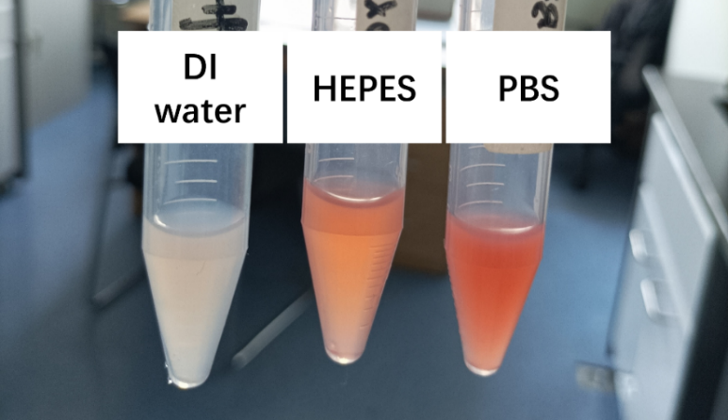
Figure S3. The image of Dox loaded HfO₂ NPs synthesized in DI water, HEPES buffer and PBS buffer
Figure S4. Zeta potential of BSA@Hf suspended in different solvent
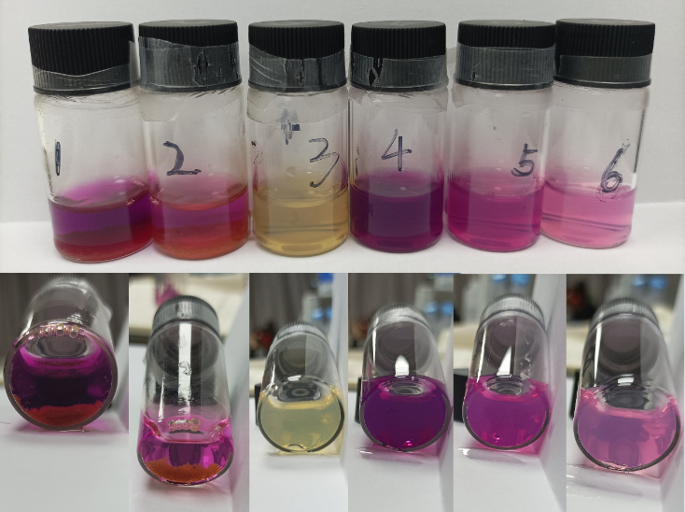
Figure S5. Images of the reaction system of KMnO₄ and BSA@Hf NPs as a function of KMnO₄ concentrations Sample 1: Cons(KMnO₄)=5 mM, Sample 1: Cons(KMnO₄)=1.67 mM, Sample 3: Cons(KMnO₄)=0. 5 mM; Images of the reaction system of KMnO₄ and HfO₂ NPs as a function of KMnO₄ concentrations Sample 4: Cons(KMnO₄)=5 mM, Sample 5: Cons(KMnO₄)=1.67 mM, Sample 6: Cons(KMnO₄)=0. 5 mM
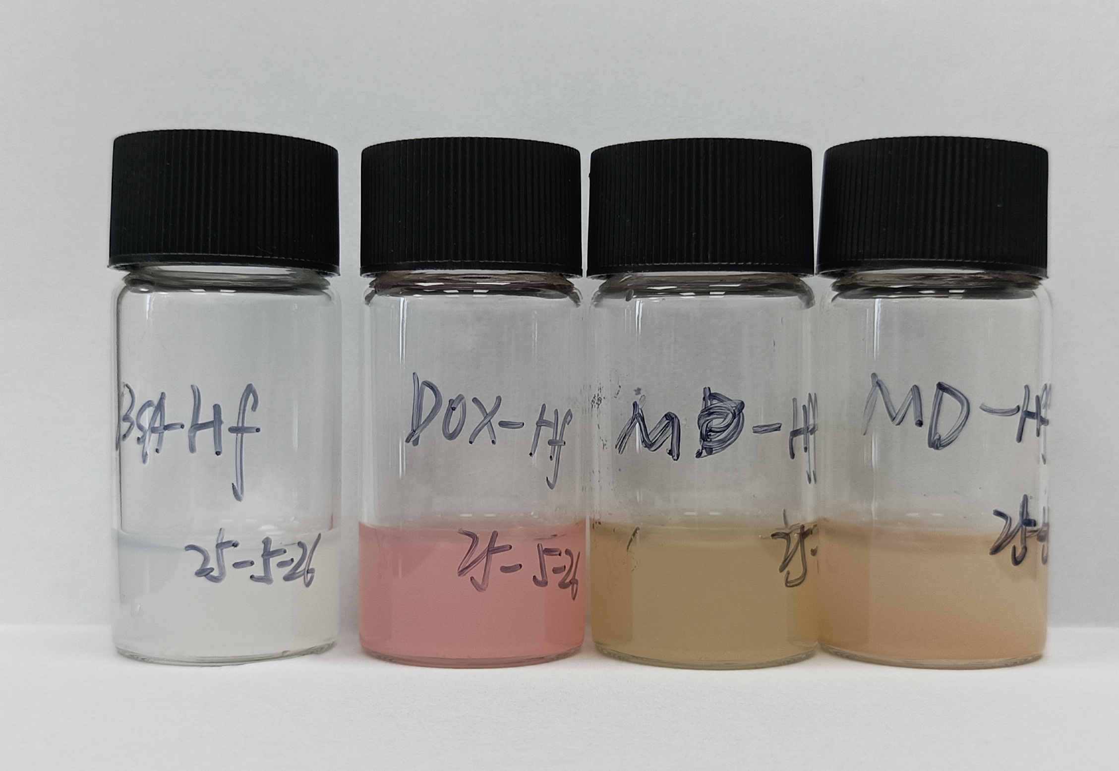
Figure S6. Images of the samples: BSA@Hf, D-Hf, M-Hf, MD-Hf (left to right)
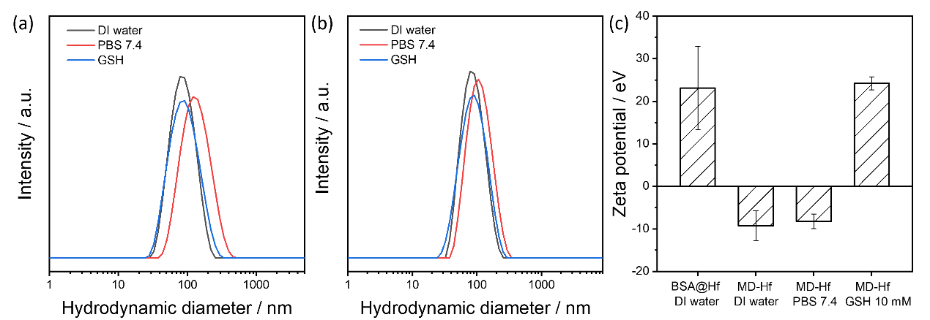
Figure S7. Size distribution of MD-Hf in different solvent at (a) 0 hour and (b) 5 hour; (c) Zeta potential of different Hf based NPs in different solvents at 5 hour. (The MD-Hf solvent is mixed with different solvent by the volume ratio of 1:1)
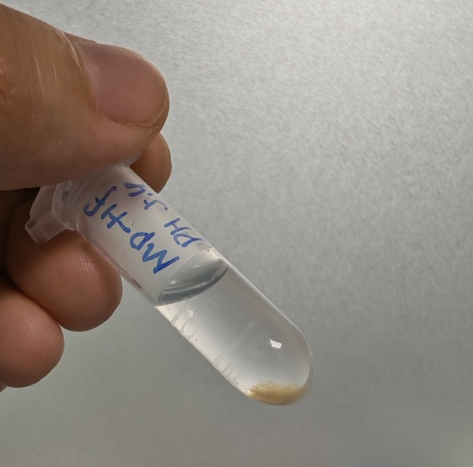
Figure S8 Image of MD-Hf mixed with PBS (pH=5.4)
Figure S9. TEM-EDS mapping of DM-Hf sample: (a) HADDF, (b) Hf distribution, (c) Mn distribution and (d) C distribution.
Figure S10 GSH concentration in cells with different treatments.

Figure S11. TEM image of DM-Hf sample (a)before and (b) after incubation with 10 mM GSH; TEM-EDS mapping of MD-Hf sample interact with GSH for 30 min: (c) HADDF, (d) Hf distribution, (e) Mn distribution and (f) C distribution.
Table S3. Element composition of samples according to the qualitative analysis of TEM-EDS
Sample | Hf  Mass ratio / % | C  Mass ratio / % | Mn  Mass ratio / %
DM-Hf (-GSH) | 92.01 | 7.44 | 0.55
DM-Hf (+GSH) | 92.77 | 6.8 | 0.43

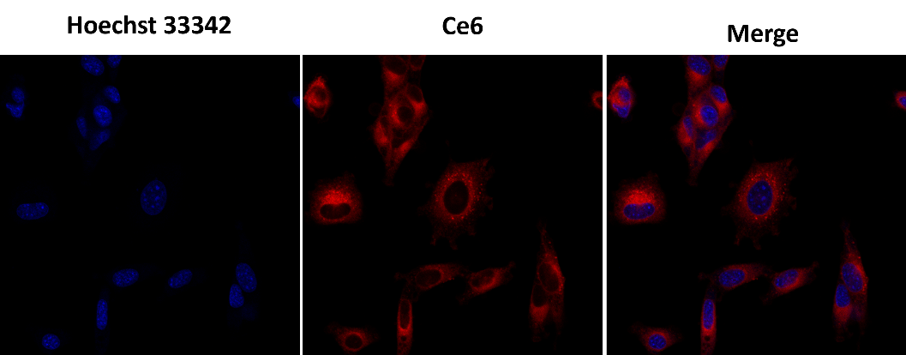
Figure S12. CLSM images of the Hep 1-6 cells after administrated Ce6 labled BSA@Hf for 24 hours.
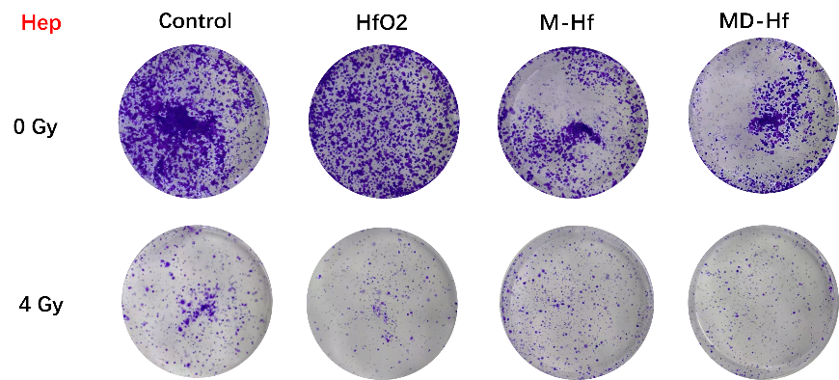
Figure S13. the colony formation of Hep 1-6 cell line after different treatment.

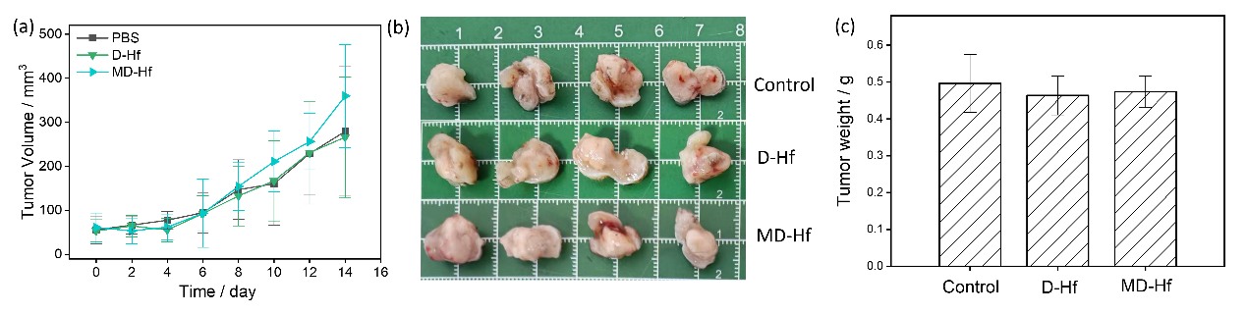
Figure S14. The time-dependent curves of the (a)tumor volume, (b) pictures of tumor excised from each group and (c) the histogram of tumor weight（n=4）of different treatment groups.
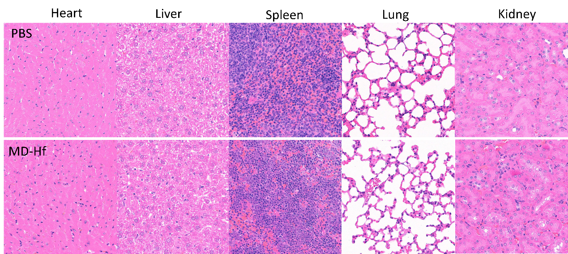
Figure S15. Representative H&E-stained sections of major organs from mice after different treatments (Up: organs from PBS treated group; down: organs from MD-Hf treated group).
Figure S16. Volcano plots of differentially expressed genes (DEGs) under different treatment (a) HfO₂ vs RT(only X-ray), (b) D-Hf vs HfO₂, (c) M-Hf vs HfO₂ and (d) MD-Hf vs HfO₂.(n=3)

