In our analysis, stepwise regression identified EMT as an independent risk factor for PAS, which appeared inconsistent with the initial PSM analysis using a 7 mm cutoff. We hypothesized that this discrepancy arose from the loss of numerical granularity when EMT was dichotomized.To test this, we reanalyzed the data using alternative cutoffs (6, 6.5, 7.5, and 8 mm; Supplementary Tables 1–7;Table 6). A significant difference in PAS incidence emerged only when 8 mm was used, both before and after PSM. (The 6 mm cutoff yielded a very small subgroup after matching, limiting interpretability.)

1.Baseline data of all patients after IVF/ICSI transfer before and after stratification matching based on an EMT of 6 mm
Before PSM，the distribution of baseline characteristics and transplantation variables between the two groups was slightly imbalanced. Compared with the patients in the EMT ≥ 6 mm group, those in the EMT < 6 mm group had a higher number of previous TCRA (2.27±1.22 vs. 1.68±1.01, P=0.03). After PSM, the baseline characteristics and transplantation variables of the two groups achieved balance, with no statistically significant differences observed in indicators such as the number of previous TCRA procedures (P > 0.05)(Supplementary Table 1)
Supplementary Table 1. Baseline data of all patients after IVF/ICSI transfer before and after stratification matching based on an EMT of 6 mm
Baseline data | Before PSM |  |  | After PSM
Baseline data | EMT≥6mm  （447 cases） | EMT＜6mm  （15 cases） | P | EMT≥6mm  （30 cases） | EMT＜6mm  （15 cases） | P
Age（$years,\overline{x}$±s） | 32.57±4.06 | 33.60±3.33 | 0.330 | 32.77±3.76 | 33.60±3.33 | 0.471
AMH（ng/ml,$\overline{x}$±s） | 4.09±3.03 | 4.41±2.87 | 0.687 | 5.74±4.88 | 4.41±2.87 | 0.336
BMI（kg/m²,$\overline{x}$±s） | 21.85±2.74 | 22.10±4.44 | 0.734 | 21.95±2.67 | 22.10±4.44 | 0.885
Duration of infertility（years,$\overline{x}$±s） | 2.39±1.97 | 2.79±2.22 | 0.445 | 2.55±1.73 | 2.79±2.22 | 0.696
Types of infertility |  |  | 0.583 |  |  | 0.721
Primary | 53（11.9%） | 3（20.0%） |  | 9（30.0%） | 3（20.0%）
Secondary | 394（88.1%） | 12（80.0%） |  | 21（70.0%） | 12（80.0%）
Number of previous cesarean sections（No.,$\overline{x}$±s） | 0.08±0.28 | 0.00±0.00 | 0.275 | 0.00±0.00 | 0.00±0.00 | NaN
Number of previous vaginal deliveries（No.,$\overline{x}$±s） | 0.06±0.26 | 0.00±0.00 | 0.363 | 0.00±0.00 | 0.00±0.00 | NaN
Number of previous abortions（No.,$\overline{x}$±s） | 1.47±1.14 | 1.27±1.16 | 0.492 | 1.40±1.16 | 1.27±1.16 | 0.719
History of previous uterine curettage |  |  | 0.650 |  |  | 1.000
No | 83（18.6%） | 4（26.7%） |  | 8（26.7%） | 4（26.7%）
Yes | 364（81.4%） | 11（73.3%） |  | 22（73.3%） | 11（73.3%）
Number of previous uterine curettage（No.,$\overline{x}$±s） | 1.40±1.13 | 1.27±1.16 | 0.641 | 1.40±1.16 | 1.27±1.16 | 0.719
Preoperative menstrual flow |  |  | 0.644 |  |  | 1.000
Normal | 286（64.0%） | 8（53.3%） |  | 16（53.3%） | 8（53.3%）
Hypomenorrhea | 158（35.3%） | 7（46.7%） |  | 14（46.7%） | 7（46.7%）
Amenorrhea | 3（0.7%） | 0（0.0%） |  | 0（0.0%） | 0（0.0%）
Degree of IUA |  |  | 0.219 |  |  | 0.887
Mild | 188（42.1%） | 3（20.0%） |  | 7（23.3%） | 3（20.0%）
Moderate | 230（51.5%） | 11（73.3%） |  | 20（66.7%） | 11（73.3%）
Severe | 29（6.4%） | 1（6.7%） |  | 3（10.0%） | 1（6.7%）
Number of previous TCRA（No.,$\overline{x}$±s） | 1.68±1.01 | 2.27±1.22 | 0.030 | 2.47±1.59 | 2.27±1.22 | 0.672
Method of insemination |  |  | 1.000 |  |  | 0.721
IVF | 300（67.1%） | 10（66.7%） |  | 23（76.7%） | 10（66.7%）
ICSI | 147（32.9%） | 5（33.3%） |  | 7（23.3%） | 5（33.3%）
ET/FET |  |  | 0.627 |  |  | 1.000
FET | 338（75.6%） | 10（66.7%） |  | 20（66.7%） | 10（66.7%）
ET | 109（24.4%） | 5（33.3%） |  | 10（33.3%） | 5（33.3%）
Number of previous embryo transfers（No.,$\overline{x}$±s） | 1.93±1.58 | 1.67±0.82 | 0.525 | 1.73±1.08 | 1.67±0.82 | 0.834
Number of high-quality embryo transferred（No.,$\overline{x}$±s） | 1.07±0.76 | 0.93±0.88 | 0.496 | 0.90±0.71 | 0.93±0.88 | 0.892
Number of embryo transferred（No.,$\overline{x}$±s） | 1.79±0.50 | 1.87±0.35 | 0.567 | 1.87±0.51 | 1.87±0.35 | 1.000
PSM: Propensity Score Matching, EMT: Endometrial Thickness, AMH: Anti-Müllerian Hormone, BMI: Body Mass Index, TCRA: Transcervical Resection of Adhesions.
2.The outcomes of PAS in patients with EMT ≥ 6 mm and EMT < 6 mm before and after PSM
We separately compared the outcomes of PAS in patients with EMT ≥ 6 mm and those with EMT < 6 mm before and after PSM. The results showed that both before and after PSM, the incidence of PAS in the EMT < 6 mm group was higher than that in the EMT ≥ 6 mm group (26.7% vs. 18.3%, P = 0.633; 26.7% vs. 20.0%, P = 0.899), but the differences were not statistically significant (Supplementary Table 2).
Supplementary Table 2.PAS Outcomes After Embryo Transfer in IVF/ICSI Patients Stratified by an EMT Cut-off of 6 mm

Pregnancy outcomes | Before PSM |  | P | After PSM |  | P
Pregnancy outcomes | EMT≥6mm  （447 cases） | EMT＜6mm  （15 cases） | P | EMT≥6mm  （30 cases） | EMT＜6mm  （15 cases） | P
PAS |  |  | 0.633 |  |  | 0.899
No | 365（81.7%） | 11（73.3%） |  | 24（80.0%） | 11（73.3%）
Yes | 82（18.3%） | 4（26.7%） |  | 6（20.0%） | 4（26.7%）
PSM: Propensity Score Matching; EMT: Endometrial Thickness
3.Baseline Data of Pregnant Patients After IVF/ICSI Embryo Transfer Stratified by an EMT Cut-off of 6.5 mm Before and After Matching
Before PSM, the distribution of baseline characteristics and transplantation variables was imbalanced between the two groups. Compared with patients in EMT ≥ 6.5 mm group, those in the EMT < 6.5 mm group had a higher proportion of hypomenorrhea and amenorrhea before surgery (48.1% vs. 34.9%, 3.7% vs. 0.5%, P = 0.040), a higher proportion of moderate and severe intrauterine adhesions (74.1% vs. 50.8%, 11.1% vs. 6.2%, P = 0.015), and a greater number of previous TCRA procedures (2.41 ± 1.08 vs. 1.66 ± 1.01, P < 0.001). After PSM, the baseline characteristics and transplantation variables of the two groups achieved balance. No statistically significant differences were observed in preoperative menstrual volume, the degree of intrauterine adhesions, the number of previous TCRA procedures, and other aspects (P > 0.05) (Supplementary Table 3).
Supplementary Table 3.Baseline Data of Pregnant Patients After IVF/ICSI Embryo Transfer Stratified by an EMT Cut-off of 6.5 mm Before and After Matching

Baseline | Before PSM |  |  | After PSM
Baseline | EMT≥6.5mm  （435 cases） | EMT＜6.5mm  （27 cases） | P | EMT≥6.5mm  （50 cases） | EMT＜6.5mm  （27 cases） | P
Age（$years,\overline{x}$±s） | 32.51±4.07 | 34.04±3.13 | 0.057 | 34.68±3.91 | 34.04±3.13 | 0.465
AMH（ng/ml,$\overline{x}$±s） | 4.09±3.05 | 4.30±2.75 | 0.721 | 4.01±2.75 | 4.30±2.75 | 0.661
BMI（kg/m²,$\overline{x}$±s） | 21.86±2.75 | 21.82±3.63 | 0.944 | 22.22±2.73 | 21.82±3.63 | 0.590
Duration of infertility（years,$\overline{x}$±s） | 2.38±1.92 | 2.79±2.73 | 0.291 | 2.38±1.96 | 2.79±2.73 | 0.449
Types of infertility |  |  | 0.890 |  |  | 1.000
Primary | 52（12.0%） | 4（14.8%） |  | 8（16.0%） | 4（14.8%）
Secondary | 383（88.0%） | 23（85.2%） |  | 42（84.0%） | 23（85.2%）
Number of previous cesarean sections（No.,$\overline{x}$±s） | 0.08±0.27 | 0.07±0.27 | 0.974 | 0.12±0.33 | 0.07±0.27 | 0.535
Number of previous vaginal deliveries（No.,$\overline{x}$±s） | 0.06±0.25 | 0.11±0.32 | 0.265 | 0.12±0.39 | 0.11±0.32 | 0.919
Number of previous abortions（No.,$\overline{x}$±s） | 1.45±1.10 | 1.70±1.59 | 0.262 | 1.82±1.21 | 1.70±1.59 | 0.720
History of previous uterine curettage |  |  | 0.833 |  |  | 0.714
No | 81（18.6%） | 6（22.2%） |  | 8（16.0%） | 6（22.2%）
Yes | 354（81.4%） | 21（77.8%） |  | 42（84.0%） | 21（77.8%）
Number of previous uterine curettage（No.,$\overline{x}$±s） | 1.38±1.10 | 1.67±1.49 | 0.207 | 1.82±1.26 | 1.67±1.49 | 0.634
Preoperative menstrual flow |  |  | 0.040 |  |  | 0.941
Normal | 281（64.6%） | 13（48.1%） |  | 22（44.0%） | 13（48.1%）
Hypomenorrhea | 152（34.9%） | 13（48.1%） |  | 26（52.0%） | 13（48.1%）
Amenorrhea | 2（0.5%） | 1（3.7%） |  | 2（4.0%） | 1（3.8%）
Degree of IUA |  |  | 0.015 |  |  | 0.493
Mild | 187（43.0%） | 4（14.8%） |  | 7（14.0%） | 4（14.8%）
Moderate | 221（50.8%） | 20（74.1%） |  | 32（64.0%） | 20（74.1%）
Severe | 27（6.2%） | 3（11.1%） |  | 11（22.0%） | 3（11.1%）
Number of previous TCRA（No.,$\overline{x}$±s） | 1.66±1.01 | 2.41±1.08 | ＜0.001 | 2.22±1.04 | 2.41±1.08 | 0.458
Method of insemination |  |  | 0.872 |  |  | 1.000
IVF | 291（66.9%） | 19（70.4%） |  | 36（72.0%） | 19（70.4%）
ICSI | 144（33.1%） | 8（29.7%） |  | 14（28.0%） | 8（29.6%）
ET/FET |  |  | 0.593 |  |  | 0.791
FET | 326（74.9%） | 22（81.5%） |  | 38（76.0%） | 22（81.5%）
ET | 109（25.1%） | 5（18.5%） |  | 12（24.0%） | 5（18.5%）
Number of previous embryo transfers（No.,$\overline{x}$±s） | 1.93±1.60 | 1.81±0.92 | 0.720 | 1.64±0.92 | 1.81±0.92 | 0.429
Number of high-quality embryo transferred（No.,$\overline{x}$±s） | 1.07±0.76 | 0.96±0.81 | 0.473 | 0.96±0.75 | 0.96±0.81 | 0.987
Number of embryo transferred（No.,$\overline{x}$±s） | 1.79±0.50 | 1.85±0.36 | 0.536 | 1.84±0.58 | 1.85±0.36 | 0.924
PSM: Propensity Score Matching; EMT: Endometrial Thickness; AMH: Anti-Müllerian Hormone; BMI: Body Mass Index; TCRA: Transcervical Resection of Adhesions
4.PAS Outcomes in Patients with EMT ≥ 6.5 mm and EMT < 6.5 mm Before and After PSM
We separately compared the PAS outcomes between the EMT ≥ 6.5 mm group and EMT < 6.5 mm group before and after PSM. The results showed that before PSM, the incidence of PAS in the EMT < 6.5 mm group was higher than that in the EMT ≥ 6.5 mm group (29.6% vs. 17.9%, P = 0.207), but the difference was not statistically significant. After PSM, the incidence of PAS in the EMT < 6.5 mm group was almost identical to that in the EMT ≥ 6.5 mm group (29.6% vs. 30%, P = 1.000). (Supplementary Table 4 )
Supplementary Table 4.PAS Outcomes after Embryo Transfer in IVF/ICSI Patients Stratified by an EMT of 6.5 mm
Pregnancy outcomes | Before PSM |  | P | After PSM |  | P
Pregnancy outcomes | EMT≥6.5mm  （435 cases） | EMT＜6.5mm  （27 cases） | P | EMT≥6.5mm  （50 cases） | EMT＜6.5mm  （27 cases） | P
PAS |  |  | 0.207 |  |  | 1.000
No | 357（82.1%） | 19（70.4%） |  | 35（70.0%） | 19（70.4%）
Yes | 78（17.9%） | 8（29.6%） |  | 15（30.0%） | 8（29.6%）
PSM :Propensity Score Matching; EMT:Endometrial Thickness
5.Baseline Data of Pregnant IVF/ICSI Patients After Embryo Transfer Before and After Matching, Stratified by an EMT cut-off of 7.5 mm
Before PSM, the distribution of baseline characteristics and transplantation variables was imbalanced between the two groups. Compared with the patients in the EMT ≥ 7.5 mm group, those in the EMT < 7.5 mm group had a higher mean age (33.28 ± 3.89 vs. 32.39 ± 4.07, P = 0.046), a greater number of previous miscarriages (1.78 ± 1.28 vs. 1.37 ± 1.07, P = 0.001), more previous uterine curettages (1.75 ± 1.27 vs. 1.29 ± 1.06, P < 0.001), a higher proportion of hypomenorrhea and amenorrhea before surgery (48.1% vs. 31.9%, 1.0% vs. 0.6%, P = 0.007), a higher prevalence of moderate and severe intrauterine adhesions (68.5% vs. 47.2%, 11.1% vs. 5.1%, P < 0.001), a greater number of previous TCRAs (2.30 ± 1.21 vs. 1.52 ± 0.89, P < 0.001), and a higher rate of frozen embryo transfer (85.4% vs. 72.3%, P = 0.010).
After PSM, the baseline characteristics and transplantation variables achieved balance between the two groups. No statistically significant differences were observed in age, number of previous miscarriages, number of previous uterine curettages, preoperative menstrual flow, severity of intrauterine adhesions, rate of frozen embryo transfer, and other indicators (P > 0.05) (Supplementary Table 5).

Supplementary Table 5.Baseline Data of Pregnant IVF/ICSI Patients After Embryo Transfer Before and After Matching, Stratified by an EMT cut-off of 7.5 mm
Baseline | Before PSM |  |  | After PSM
Baseline | EMT≥7.5mm  （354 cases） | EMT＜7.5mm  （108 cases） | P | EMT≥7.5mm  （168 cases） | EMT＜7.5mm  （108 cases） | P
Age（$years,\overline{x}$±s） | 32.39±4.07 | 33.28±3.89 | 0.046 | 33.11±4.04 | 33.28±3.89 | 0.738
AMH（ng/ml,$\overline{x}$±s） | 4.02±3.00 | 4.38±3.12 | 0.275 | 4.36±3.33 | 4.38±3.12 | 0.954
BMI（kg/m²,$\overline{x}$±s） | 21.86±2.79 | 21.85±2.88 | 0.978 | 21.59±2.43 | 21.85±2.88 | 0.410
Duration（years,$\overline{x}$±s） | 2.47±2.01 | 2.19±1.87 | 0.195 | 2.28±1.79 | 2.19±1.87 | 0.690
Type of infertility |  |  | 0.060 |  |  | 1.000
Primary | 49（13.8%） | 7（6.5%） |  | 11（6.5%） | 7（6.5%）
Secondary | 305（86.2%） | 101（93.5%） |  | 157（93.5%） | 101（93.5%）
Number of previous cesarean sections（No.,$\overline{x}$±s） | 0.07±0.27 | 0.08±0.28 | 0.742 | 0.08±0.28 | 0.08±0.28 | 1.000
Number of previous vaginal deliveries（No.,$\overline{x}$±s） | 0.06±0.26 | 0.05±0.21 | 0.569 | 0.06±0.26 | 0.05±0.21 | 0.659
Number of previous abortions（No.,$\overline{x}$±s） | 1.37±1.07 | 1.78±1.28 | 0.001 | 1.62±1.07 | 1.78±1.28 | 0.268
History of previous uterine curettage |  |  | 0.101 |  |  | 1.000
No | 73（20.6%） | 14（13.0%） |  | 22（13.1%） | 14（13.0%）
Yes | 281（79.4%） | 94（87.0%） |  | 146（86.9%） | 94（87.0%）
Number of previous uterine curettage（No,$\overline{x}$±s） | 1.29±1.06 | 1.75±1.27 | ＜0.001 | 1.57±1.10 | 1.75±1.27 | 0.217
Preoperative menstrual flow |  |  | 0.007 |  |  | 0.255
Normal | 239（67.5%） | 55（50.9%） |  | 102（60.7%） | 55（50.9%）
Hypomenorrhea | 113（31.9%） | 52（48.1%） |  | 64（38.1%） | 52（48.1%）
Amenorrhea | 2（0.6%） | 1（1.0%） |  | 2（1.2%） | 1（0.9%）
Degree of IUA |  |  | ＜0.001 |  |  | 0.064
Mild | 169（47.7%） | 22（20.4%） |  | 56（33.3%） | 22（20.4%）
Moderate | 167（47.2%） | 74（68.5%） |  | 95（56.5%） | 74（68.5%）
Severe | 18（5.1%） | 12（11.1%） |  | 17（10.1%） | 12（11.1%）
Number of previous TCRA（No.,$\overline{x}$±s） | 1.52±0.89 | 2.30±1.21 | ＜0.001 | 1.83±1.07 | 2.30±1.21 | 0.001
Method of insemination |  |  | 0.035 |  |  | 0.494
IVF | 228（64.4%） | 82（75.9%） |  | 120（71.4%） | 82（75.9%）
ICSI | 126（35.6%） | 26（24.1%） |  | 48（28.6%） | 26（24.1%）
ET/FET |  |  | 0.010 |  |  | 0.388
FET | 256（72.3%） | 92（85.4%） |  | 135（80.4%） | 92（85.2%）
ET | 98（27.7%） | 16（14.8%） |  | 33（19.6%） | 16（14.8%）
Number of previous embryo transfer（No.,$\overline{x}$±s） | 1.92±1.67 | 1.93±1.19 | 0.964 | 1.99±2.07 | 1.93±1.19 | 0.777
Number of high-quality embryo transferred（No.,$\overline{x}$±s） | 1.09±0.76 | 0.97±0.75 | 0.148 | 1.05±0.77 | 0.97±0.75 | 0.425
Number of embryo transferred（No.,$\overline{x}$±s） | 1.81±0.49 | 1.76±0.53 | 0.401 | 1.79±0.50 | 1.76±0.53 | 0.607
PSM Propensity Score Matching; EMT Endometrial Thickness; AMH Anti-Müllerian Hormone; BMI Body Mass Index; TCRA Transcervical Resection of Adhesions
6.PAS Outcomes in Patients with EMT ≥ 7.5 mm and EMT < 7.5 mm Before and After PSM
We separately compared the PAS outcomes between the EMT ≥ 7.5 mm group and the EMT < 7.5 mm group before and after PSM. The results showed that both before and after PSM, the incidence of PAS in the EMT < 7.5 mm group was higher than that in the EMT ≥ 7.5 mm group (28.7% vs. 15.5%, P = 0.003; 28.7% vs. 18.5%, P = 0.065), with no statistically significant difference observed after matching (Supplementary Table 6 ).
Supplementary Table 6.PAS Outcomes after Embryo Transfer in IVF/ICSI Patients Stratified by an EMT cut-off of 7.5 mm
Pregnancy outcome | Before PSM |  | P | After PSM |  | P
Pregnancy outcome | EMT≥7.5mm  （354 cases） | EMT＜7.5mm  （108 cases） | P | EMT≥7.5mm  （168 cases） | EMT＜7.5mm  （108 cases） | P
PAS |  |  | 0.003 |  |  | 0.065
No | 299（84.5%） | 77（71.3%） |  | 137（81.5%） | 77（71.3%）
Yes | 55（15.5%） | 31（28.7%） |  | 31（18.5%） | 31（28.7%）
PSM Propensity Score Matching; EMT Endometrial Thickness
7.Baseline Data of Pregnant IVF/ICSI Patients After Embryo Transfer Before and After Matching, Stratified by an EMT cut-off of 8 mm
Before PSM, the distributions of baseline characteristics and transplantation variables were imbalanced between the two groups. Compared with patients in the EMT ≥ 8 mm group, those in the EMT < 8 mm group had a significantly older age (33.10 ± 3.99 vs. 32.30 ± 4.05, P = 0.039), a higher number of previous miscarriages (1.68 ± 1.23 vs. 1.33 ± 1.06, P = 0.001), a higher proportion of patients with a history of previous uterine curettage (87.4% vs. 77.4%, P = 0.012), a higher number of previous uterine curettages (1.66 ± 1.22 vs. 1.25 ± 1.04, P < 0.001), a higher proportion of patients with hypomenorrhea before surgery (46% vs. 29.5%, P = 0.002), a higher proportion of moderate and severe intrauterine adhesions (64.4% vs. 44.8% and 8.6% vs. 5.2%, respectively, P = 0.001), a higher number of previous TCRA procedures (2.12 ± 1.20 vs. 1.45 ± 0.81, P < 0.001), and a higher proportion of frozen embryo transfer (86.8% vs. 68.4%, P < 0.001).
After PSM, the baseline characteristics and transplantation variables were well-balanced between the two groups, with no statistically significant differences in age, number of previous miscarriages, history of previous uterine curettage, number of previous uterine curettages, preoperative menstrual volume, and severity of intrauterine adhesions (P > 0.05) ( Supplementary Table 7 )
Supplementary Table 7.Baseline Data of Pregnant Patients After IVF/ICSI Embryo Transfer Stratified by an EMT cut-off of 8 mm Before and After Matching
Baseline | Before PSM |  |  | After PSM
Baseline | EMT≥8mm  （288 cases） | EMT＜8mm  （174 cases） | P | EMT≥8mm  （136 cases） | EMT＜8mm  （174 cases） | P
Age（$years,\overline{x}$±s） | 32.30±4.05 | 33.10±3.99 | 0.039 | 32.68±4.10 | 33.10±3.99 | 0.351
AMH（ng/ml,$\overline{x}$±s） | 4.07±3.13 | 4.15±2.85 | 0.794 | 4.17±3.49 | 4.15±2.85 | 0.944
BMI（kg/m²,$\overline{x}$±s） | 21.85±2.78 | 21.88±2.86 | 0.918 | 21.65±2.75 | 21.88±2.86 | 0.466
Duration（years,$\overline{x}$±s） | 2.41±1.86 | 2.39±2.17 | 0.884 | 2.36±1.95 | 2.39±2.17 | 0.926
Types of infertility |  |  | 0.291 |  |  | 1.000
Primary | 39（13.5%） | 17（9.8%） |  | 15（10.1%） | 17（9.8%）
Secondary | 249（86.5%） | 157（90.2%） |  | 133（89.9%） | 157（90.2%）
Number of previous cesarean sections（No.,$\overline{x}$±s） | 0.08±0.28 | 0.07±0.25 | 0.678 | 0.07±0.26 | 0.07±0.25 | 0.853
Number of previous abortions（No.,$\overline{x}$±s） | 0.06±0.26 | 0.05±0.25 | 0.657 | 0.05±0.23 | 0.05±0.25 | 0.930
Number of previous abortions（No.,$\overline{x}$±s） | 1.33±1.06 | 1.68±1.23 | 0.001 | 1.56±1.10 | 1.68±1.23 | 0.349
History of previous uterine curettage |  |  | 0.012 |  |  | 0.558
No | 65（22.6%） | 22（12.6%） |  | 23（15.5%） | 22（12.6%）
Yes | 223（77.4%） | 152（87.4%） |  | 125（84.5%） | 152（87.4%）
Number of previous uterine curettage（No.,$\overline{x}$±s） | 1.25±1.04 | 1.66±1.22 | ＜0.001 | 1.51±1.08 | 1.66±1.22 | 0.252
Preoperative menstrual flow |  |  | 0.002 |  |  | 0.074
Normal | 201（69.8%） | 93（53.4%） |  | 96（64.9%） | 93（53.4%）
Hypomenorrhea | 85（29.5%） | 80（46.0%） |  | 50（33.8%） | 80（46.0%）
Amenorrhea | 2（0.7%） | 1（0.6%） |  | 2（1.4%） | 1（0.6%）
Degree of IUA |  |  | ＜0.001 |  |  | 0.102
Mild | 144（50.0%） | 47（27.0%） |  | 56（37.8%） | 47（27.0%）
Moderate | 129（44.8%） | 112（64.4%） |  | 79（53.4%） | 112（64.4%）
Severe | 15（5.2%） | 15（8.6%） |  | 13（8.8%） | 15（8.6%）
Number of previous TCRA（No.,$\overline{x}$±s） | 1.45±0.81 | 2.12±1.20 | ＜0.001 | 1.65±0.94 | 2.12±1.20 | ＜0.001
Method of insemination |  |  | 0.168 |  |  | 0.393
IVF | 186（64.6%） | 124（71.3%） |  | 98（66.2%） | 124（71.3%）
ICSI | 102（35.4%） | 50（28.7%） |  | 50（33.8%） | 50（28.7%）
ET/FET |  |  | ＜0.001 |  |  | 0.046
FET | 197（68.4%） | 151（86.8%） |  | 115（77.7%） | 151（86.8%）
ET | 91（31.6%） | 23（13.2%） |  | 33（22.3%） | 23（13.2%）
Number of previous embryo transfer（No.,$\overline{x}$±s） | 1.91±1.76 | 1.94±1.18 | 0.857 | 1.74±1.14 | 1.94±1.18 | 0.138
Number of high-quality embryo（No.,$\overline{x}$±s） | 1.12±0.76 | 0.98±0.76 | 0.053 | 1.02±0.77 | 0.98±0.76 | 0.613
Number of embryo transferred（No.,$\overline{x}$±s） | 1.80±0.47 | 1.79±0.54 | 0.966 | 1.80±0.46 | 1.79±0.54 | 0.847
PSM Propensity Score Matching; EMT Endometrial Thickness; AMH Anti-Müllerian Hormone; BMI Body Mass Index; TCRA Transcervical Resection of Adhesions.

Supplementary figure 1 Nomogram
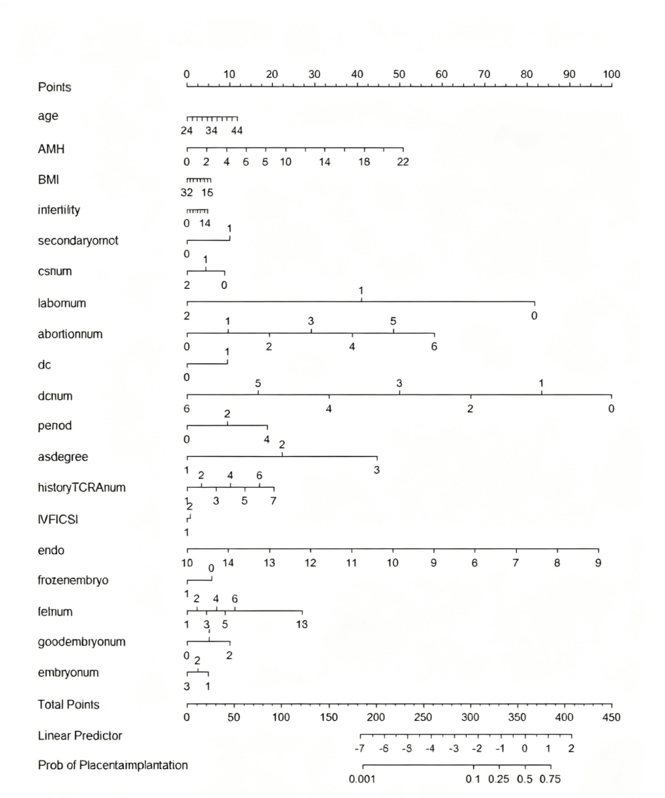
Supplementary figure 1 is a nomogram for evaluating various risk factors for the occurrence of PAS. Locate the position of each variable on its corresponding axis, draw a line to the points axis, sum up the points for all variables, and then draw a line from the total points axis to determine the probability of PAS occurrence at the bottom of the nomogram.
Abbreviations:Age: age, AMH: anti-Müllerian hormone, BMI: body mass index, infertility: duration of infertility, secondary or not: type of infertility (primary or secondary), cs num: number of previous cesarean sections, labor num: number of previous vaginal deliveries, abortion num: number of previous abortions, dc: history of previous uterine curettage (yes or no), dc num: number of previous uterine curettages, period: preoperative menstrual flow, as degree: severity of intrauterine adhesion, history TCRA num: number of previous TCRA procedures, IVF/ICSI: insemination method (IVF/ICSI), endo: endometrial thickness on the day of embryo transfer, frozen embryo: type of transferred embryo (fresh or frozen), fet num: number of previous embryo transfers, good embryo num: number of high-quality embryos transferred, embryo num: number of embryos transferred.
Supplementary figure 2 Matching - process Diagram
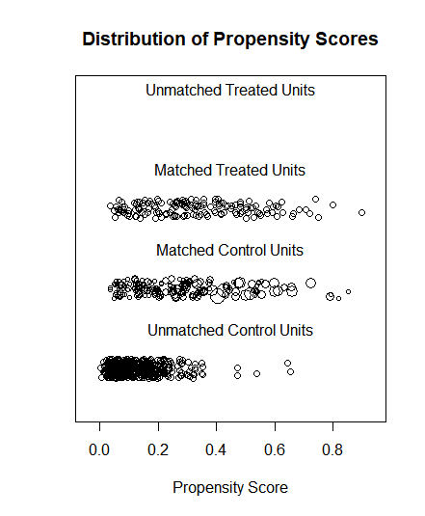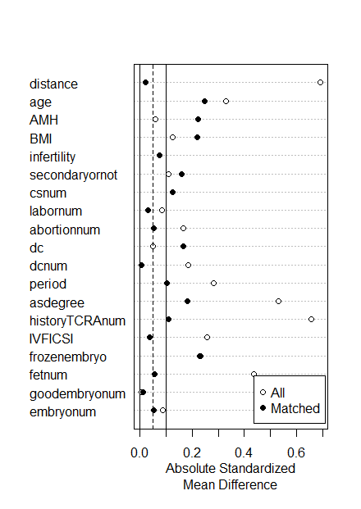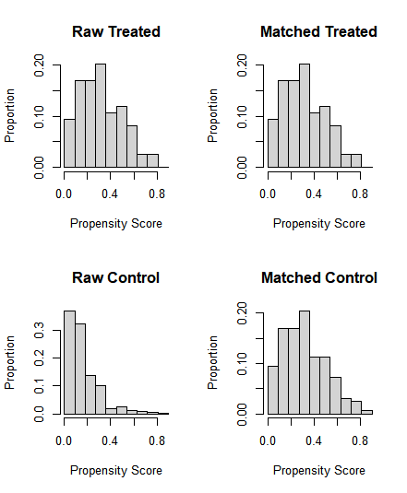
Supplementary figure 2 is a propensity score matching process diagram of baseline data for all patients after IVF/ICSI transfer, stratified by an endometrial thickness of 7 mm
Supplementary figure 3 Statistical results of multicollinearity assessed by VIF
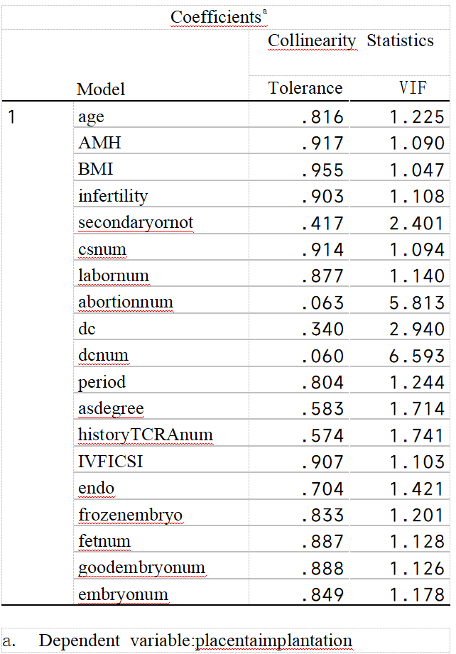
Abbreviations:age: age, AMH: anti-Müllerian hormone, BMI: body mass index, infertility: duration of infertility, secondary or not: type of infertility (primary or secondary), cs num: number of previous cesarean sections, labor num: number of previous vaginal deliveries, abortion num: number of previous abortions, dc: history of previous uterine curettage (yes or no), dc num: number of previous uterine curettages, period: preoperative menstrual flow, as degree: severity of intrauterine adhesion, history TCRA num: number of previous TCRA procedures, IVF/ICSI: insemination method (IVF/ICSI), endo: endometrial thickness on the day of embryo transfer, frozen embryo: type of transferred embryo (fresh or frozen), fet num: number of previous embryo transfers, good embryo num: number of high-quality embryos transferred, embryo num: number of embryos transferred.

