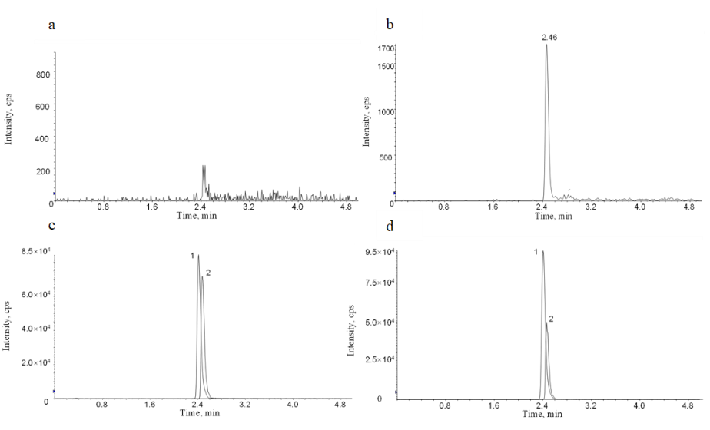
Figure S1. Extracted ion chromatograms.
1: Ertapenem (ERT) chromatographic peak; 2: Internal standard (IS) chromatographic peak.a. Blank plasma; b. Plasma at the lower limit of quantification (LLOQ); c. Spiked plasma sample with ERT concentration of 5 μg/L; d. Patient plasma sample spiked with ERT.

Table S1 Precision and accuracy of ERT in human plasma（n=6）
Section | Spiked conc.  /(mg/L) | Intra-day (n=6) |  |  | Inter-day (n=3)
Section | Spiked conc.  /(mg/L) | Mean±SD/(mg/L) | RSD/% | RE/% | Mean±SD/(mg/L) | RSD/% | RE/%
Total blood drug conc. | 0.10 | 0.0970±0.002 | 2.08 | -2.57 | 0.097.58±0.007 | 7.45 | -2.42
Total blood drug conc. | 0.30 | 0.299±0.011 | 3.69 | -2.78 | 0.299.33±0.025 | 8.65 | -0.22
Total blood drug conc. | 25.00 | 25.600±0.644 | 2.52 | 2.40 | 25.477±1.493 | 5.86 | 1.91
Total blood drug conc. | 37.50 | 37.100±0.935 | 2.52 | -0.01 | 38.889±1.612 | 4.15 | 0.04
Free blood drug conc. | 0.025 | 0.0240±0.001 | 8.12 | -2.40 | 0.024.75±0.002 | 8.79 | -1.00
Free blood drug conc. | 0.075 | 0.0760±0.001 | 2.58 | 0.37 | 0.076.62±0.004 | 5.85 | 0.47
Free blood drug conc. | 12.50 | 12.583±0.278 | 2.21 | 0.67 | 12.916±0.526 | 4.07 | 3.33
Free blood drug conc. | 18.75 | 18.300±0.316 | 1.73 | -2.40 | 19.094±0.765 | 4.01 | 1.84
Notes: conc.: concentration; SD: standard deviation; RSD: relative standard deviation; RE: relative error.

Table s2 Dilution reliability
Spiked conc.(mg/L) | Mean±SD/(mg/L) | RSD/% | RE/%
40 | 38.483±1.699 | 4.42 | -3.79
20 | 20.316±0.790 | 3.89 | 1.58

Table S3 Extraction and matrix effect
Section | Spiked conc.(mg/L) | Extraction(ERT) |  | Extraction(IS) |  | Matrix
Section | Spiked conc.(mg/L) | Mean±SD/% | RSD/% | Mean±SD/% | RSD/% | Mean±SD/% | RSD/%
Total blood drug conc. | 0.30 | 103.75±7.20 | 6.94 | 87.95±9.38 | 10.67 | 91.06±3.73 | 4.09
Total blood drug conc. | 25.00 | 99.8±7.07 | 7.08 | 90.67±6.76 | 7.46 | 93.91±7.83 | 8.33
Total blood drug conc. | 37.50 | 99.9±3.87 | 3.87 | 93.92±4.09 | 4.36 | 97.56±3.37 | 3.45
Free blood drug conc. | 0.075 | 99.22±9.40 | 9.47 | 95.65±7.21 | 7.53 | 97.74±7.80 | 7.98
Free blood drug conc. | 12.50 | 94,48±10.11 | 10.7 | 93.98±9.87 | 10.50 | 100.27±4.26 | 4.25
Free blood drug conc. | 18.75 | 102.52±1.81 | 1.77 | 108.89±4.16 | 3.82 | 101.50±3.75 | 3.69

Table S4 Stability of ERT in the reserve solution under different storage conditions
Solvent | Time | LQC（0.3mg/L） |  |  | HQC（37.5mg/L）
Solvent | Time | Mean+SD/% | RSD/% | RE/% | Mean+SD/% | RSD/% | RE/%
MeOH | 1W | 76.07+6.86 | 9.02 | -23 .93 | 72.11+2.15 | 2.98 | -27.89
MeOH | 2W | 71.47+3.84 | 5.37 | -28.53 | 61.17+2.42 | 3.95 | -38.83
Water(5% MeOH) | 1W | 96.07+1.91 | 1.98 | -3.93 | 100.27+3.48 | 3.47 | 0.27
Water(5% MeOH) | 2W | 84.87+3.65 | 4.30 | -15.13 | 94.13+3 .71 | 3.95 | -5.87

Table S5 Stability of ERT in human plasma samples under different storage conditions
Storage condition | Time | LQC（0.3mg/L） |  |  | HQC（37.5mg/L）
Storage condition | Time | Mean+SD/% | RSD/% | RE/% | Mean+SD/% | RSD/% | RE/%
Stability of untreated samples(Room temperayure) | 4H | 94.53+3.63 | 3.84 | -5.47 | 107.09+1.37 | 1.28 | 7.09
Stability of untreated samples(Room temperayure) | 8H | 97.53 +5.58 | 5.72 | -2.47 | 91.25+2.27 | 2.48 | -8.75
Stability of untreated samples(Room temperayure) | 12H | 103.40+1.36 | 1.32 | 3.40 | 97.60+4.27 | 4.37 | -2.40
Stability of untreated samples (4℃) | 4H | 99.87+1.30 | 1.31 | -0.13 | 105.76+3.40 | 3 .21 | 5.76
Stability of untreated samples (4℃) | 8H | 97.13+5.41 | 5.57 | -2.87 | 100.91+3.99 | 3.95 | 0.91
Stability of untreated samples (4℃) | 12H | 102.00+1.76 | 1.73 | 2.00 | 101.12+6.46 | 6.39 | 1.12
Stability of untreated samples (4℃) | 24H | 95.33+5.04 | 5.29 | -4.67 | 96.27+5.44 | 5.65 | -3.73
Stability of untreated samples (4℃) | 72H | 91.47+2.63 | 2.88 | -8.53 | 99.31+4.01 | 4.04 | -0.69
Stability of untreated samples (4℃) | 168H | 84.73+1.66 | 1.96 | -15.27 | 92.53 +4.66 | 5.03 | -7.47
Stability of frozen storage(-20°C) | 1Mo. | 96.13+5.70 | 5.93 | -3.87 | 91.89+1.68 | 1.83 | -8.11
Stability of frozen storage(-20°C) | 3Mo. | 82.40+3.38 | 4.10 | -17.60 | 88.11+3.09 | 3.51 | -11.89
Stability of frozen storage(-20°C) | 3 Times | 90.27+4.65 | 5.15 | -9.73 | 88.37+1.86 | 2.11 | -11.63
Stability in the autosampler(15°C) | 12H | 97.07+1.91 | 1.96 | -2.93 | 98.83+3.13 | 3.17 | -1.17
Stability in the autosampler(15°C) | 24H | 89.93+4.23 | 4.71 | -10.07 | 91.52+4.91 | 5.37 | -8.48

Table S6 Intracavitary and extracavitary ERT recovery rates of PS hollow fibers in blank plasma ultrafiltration matrix (%, n=6)
Spiked conc.(mg/L) | Inside | Outside
0.075 | 100.56±2.37 | 99.45±2.03
12.50 | 104.06±1.90 | 102.99±1.35
18.75 | 104.83±2.37 | 107.34±0.31

