SUPPORTING INFORMATION
Figure S1. The relative fluorescence intensity of RUNX2 expression in Figure 5E. **p < 0.01.
Figure S2. The relative fluorescence intensity of BMP2 expression in Figure 5E. **p < 0.01.
Figure S3. The relative ALP activity in Figure 5F. **p < 0.01.
Figure S4. Quantitative analysis of mineralized nodules in Figure 5G. **p < 0.01.
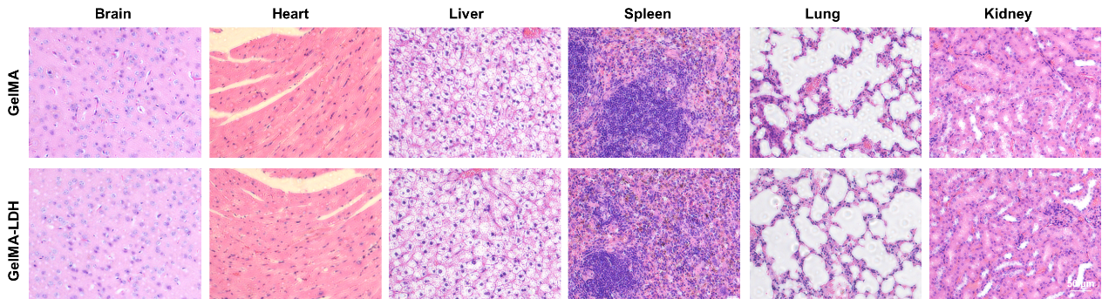
Figure S5. H&E staining of the tissue in all groups.
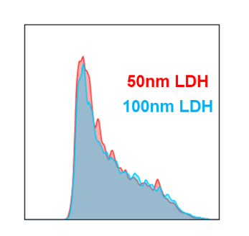
Figure S6. Flow cytometric quantification of FITC-labeled LDH nanoparticle uptake in BMSCs.
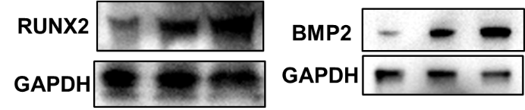
Figure S7. Western blot analysis of RUNX2 and BMP2 protein expression in BMSCs treated with 50 nm or 100 nm LDH nanoparticles.
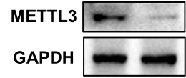
Figure S8. Western blot validation of METTL3 knockdown efficiency in BMSCs.
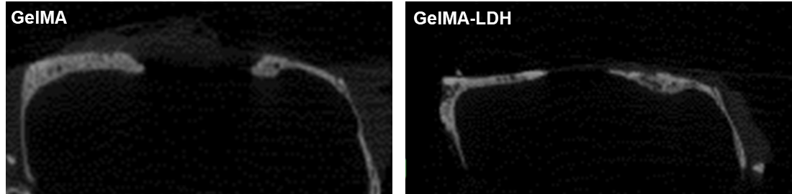
Figure S9. Representative cross-sectional images of calvarial defects at 12 weeks after implantation.
Figure S10. Quantitative analysis of trabecular number (Tb.N), trabecular thickness (Tb.Th), and trabecular separation (Tb.Sp). Data are presented as mean ± SD (n=3). **p < 0.01.
Table S1. The qPCR primer used in this work.
Gene name | Forward primer (5’-3’) | Reverse primer (5’-3’)
Gapdh | AGTGCCAGCCTCGTCTCATA | TGAACTTGCCGTGGGTAGAG
Opn | GCTTGGCTTATGGACTGAGGTC | CCTTAGACTCACCGCTCTTCATG
Runx2 | CCTGAACTCTGCACCAAGTCCT | TCATCTGGCTCAGATAGGAGGG
Alp | CCAGAAAGACACCTTGACTGTGG | TCTTGTCCGTGTCGCTCACCAT
Bmp2 | AACACCGTGCGCAGCTTCCATC | CGGAAGATCTGGAGTTCTGCAG
Mettl3 | CAGTGCTACAGGATGACGGCTT | CCGTCCTAATGATGCGCTGCAG
Mettl14 | GCAGAAACCTACGCGTCCTA | CACCACGGTCAGACTTGGA
Wtap | AGTGCCTGGAAGTTTACGCCTG | GCTTCAAGCTGTGCAATACGGC
Alkbh5 | TCGGAACCTGTGCTTTCTCTGC | CTTCCTGAGAATGATGACCGCC
Fto | GCCTCGGTTTAGTTCCACTCAC | GTCGCCATCGTCTGAGTCATTG

Table S2. Sequences of possible sites of Runx2 mRNA with m⁶A modification
Position | Sequence context | Score (combined) | Decision
54 | CAGAA CCACA AGUGC  GGUGC AAACU UUCUC  CAGGA GGACA GCAAG | 0.626 | m⁶A site (High confidence)
70 | GGUGC AAACU UUCUC  CAGGA GGACA GCAAG  GAGGC CCUGG UGUUU | 0.625 | m⁶A site (High confidence)
205 | CUAUC UGGAA AAAAA  AGGAG GGACU AUGGC  GUCAA ACAGC CUCUU | 0.723 | m⁶A site (Very high confidence)
238 | AAACA GCCUC UUCAG  UGCAG UGACA CCGUG  UCAGC AAAAC UUCUU | 0.557 | m⁶A site (Low confidence)
255 | GCAGU GACAC CGUGU  CAGCA AAACU UCUUU  UGGGA UCCGA GCACC | 0.550 | m⁶A site (Low confidence)
555 | ACCAU GGUGG AGAUC  AUCGC GGACC ACCCG  GCCGA ACUGG UCCGC | 0.581 | m⁶A site (Moderate confidence)
568 | UCAUC GCGGA CCACC  CGGCC GAACU GGUCC  GCACC GACAG CCCCA | 0.649 | m⁶A site (High confidence)
605 | CCUCG GAGAG GUACC  CGAUG GGACC GUGGU  UACCG UCAUG GCCGG | 0.610 | m⁶A site (High confidence)
720 | GUCAU GGCCG GGAAU  GAUGA GAACU ACUCU  GCCGA GCUAC GAAAU | 0.582 | m⁶A site (Moderate confidence)
830 | ACGAG GCAAG AGUUU  CACUU UGACC AUAAC  GGUCU UCACA AAUCC | 0.534 | m⁶A site (Low confidence)
893 | UUACC ACAGA GCUAU  UAAAG UGACA GUGGA  CGGUC CCCGG GAACC | 0.575 | m⁶A site (Moderate confidence)
925 | CCCGG GAACC AAGAA  GGCAC AGACA GAAGC  UUGAU GACUC UAAAC | 0.589 | m⁶A site (Moderate confidence)
939 | AGGCA CAGAC AGAAG  CUUGA UGACU CUAAA  CCUAG UUUGU UCUCU | 0.566 | m⁶A site (Moderate confidence)
1045 | CAGAA CCCAC GGCCC  UCCCU GAACU CAGCA  CCAAG UCCUU UUAAU | 0.589 | m⁶A site (Moderate confidence)
1075 | CAAGU CCUUU UAAUC  CACAA GGACA GAGUC  AGAUU ACAGA UCCCA | 0.597 | m⁶A site (Moderate confidence)
1330 | AGAGC CAGGC AGGUG  CUUCA GAACU GGGCC  CUUUU UCAGA CCCCA | 0.633 | m⁶A site (High confidence)
1537 | GCUCU UCCCA AAGCC  AGAGC GGACC CUUCC  AGACC AGCAG CACUC | 0.560 | m⁶A site (Moderate confidence)
2091 | CCACA ACAAU UCAGA  GAGGU GGACU CUGGG  UCCGG GAGGA AGAAC | 0.641 | m⁶A site (High confidence)
4073 | AAACU UCCCU GGGCU  UAGAU GGACA UGGUU  CUCGA AGGAG CACAA | 0.583 | m⁶A site (Moderate confidence)
4851 | GCACC CAGCC CAUAA  UAGAA AGACU UACCA  GAUUU AACUA GUUGG | 0.596 | m⁶A site (Moderate confidence)
4909 | CUCCG AGACC CUAAG  AAAAC GAACA GAGCA  ACAUC UCCAC AUCAU | 0.557 | m⁶A site (Low confidence)
4917 | CAACA UCUCC ACAUC  AUUAG AGACU GUCCA  CAGUA GGUUC AGAAG | 0.721 | m⁶A site (Very high confidence)
5006 | CUUGC UCCAA GGAAA  GGCAC UGACU GACCU  AGUUU UAGAG AACAG | 0.606 | m⁶A site (High confidence)
5519 | GUUUA CUCUG AACUU  CAAAG GGACU AUUUG  UAUUG UAUGU UGCAA | 0.555 | m⁶A site (Low confidence)

