Supplementary Table S1. Full search strategies and database-specific filters used in this review.
Database | Full search strategy | Filters / limits
PubMed/MEDLINE | ("Nanoparticles" OR "Nano-based") AND ("Root canal irrigant" OR "Antibiofilm") AND ("Dentin surface" OR "Biocompatibility") | English language; publication dates from 1 January 2015 to 31 December 2025
ScienceDirect | ("Nanoparticles" OR "Nano-based") AND ("Root canal irrigant" OR "Antibiofilm") AND ("Dentin surface" OR "Biocompatibility") | English language; publication years 2015–2025; subject area: Medicine and Dentistry

Supplementary Table S2. Primary reasons for exclusion of full-text studies after eligibility assessment.
Study | Primary reason for exclusion
- Shrestha et al. (2016) ¹⁹ | Nanoparticle application not evaluated as a root canal irrigant or final rinse (dentin-conditioning/regenerative NP system)
- Akbari et al. (2017) ²⁰ | Nanoparticle application not evaluated as a root canal irrigant or final rinse (PDT photosensitizer-carrier system)
- Rosa et al. (2017) ²¹ | Did not evaluate a NP-based irrigation/disinfection strategy (PDT-centered protocol without a NP irrigant)
- Souza et al. (2017) ²² | Did not evaluate a NP-based irrigation/disinfection strategy (PDT protocol without a NP irrigant)
- Batinić et al. (2018) ²³ | Did not evaluate a NP-based irrigation/disinfection strategy (PDT-based disinfection comparison, not an NP irrigant study)
- Bukhari et al. (2018) ²⁴ | Did not use extracted human teeth with natural root canal anatomy (prepared dentin-block model)
- Chávez-Andrade et al. (2019) ¹⁶ | Did not use extracted human teeth with natural root canal anatomy (bovine dentin/root dentine model)
- Daood et al. (2019) ²⁵ | Did not evaluate a NP-based irrigation/disinfection strategy (quaternary ammonium silane formulation)
- Ioannidis et al. (2019) ²⁶ | Did not use extracted human teeth with natural root canal anatomy (hemi-sectioned teeth with artificially created lateral canals)
- Li et al. (2019) ²⁷ | Nanoparticle application not evaluated as a root canal irrigant or final rinse (NP coating/microbubble delivery study)
- Naseri et al. (2019) ²⁸ | Nanoparticle application not evaluated as a root canal irrigant or final rinse (nano-calcium hydroxide intracanal medicament/microhardness study)
- Savitha et al. (2019) ²⁹ | Nanoparticle application not evaluated as a root canal irrigant or final rinse (intracanal medicament gel)
- Daood et al. (2020) ³⁰ | Did not evaluate a NP-based irrigation/disinfection strategy (quaternary ammonium silane formulation)
- Marinković et al. (2020) ³¹ | Did not evaluate a NP-based irrigation/disinfection strategy (essential-oil irrigants)
- Daood et al. (2021) ³² | Did not evaluate a NP-based irrigation/disinfection strategy (K21-E formulation; not a NP irrigant)
- Hussein and Kishen (2021) ³³ | Nanoparticle application not evaluated as a root canal irrigant or final rinse (immunomodulatory macrophage–fibroblast model)
- Singh et al. (2022) ³⁴ | Nanoparticle application not evaluated as a root canal irrigant or final rinse (wound-repair/macrophage-polarization model)
- Minhaco et al. (2023) ³⁵ | Did not use extracted human teeth with natural root canal anatomy (bovine-tooth model)
- Teimoory et al. (2023) ³⁶ | Did not evaluate a NP-based irrigation/disinfection strategy (silver diamine fluoride/NaOCl/ozone protocol)
- Zhang et al. (2023) ³⁷ | Not an endodontic root canal irrigation study (general antibacterial nanoconjugate study)
- Jafari Semnani et al. (2024) ³⁸ | Did not evaluate a NP-based irrigation/disinfection strategy (photosensitizer penetration/activation study)
- Selvaraj et al. (2024) ³⁹ | Not an endodontic root canal irrigation study (S. mutans/caries-biofilm focus)
- Ci et al. (2025) ⁴⁰ | Did not evaluate a NP-based irrigation/disinfection strategy (laser + nanobubble protocol; no NPs)
- Hu et al. (2025) ⁴¹ | Not an endodontic root canal irrigation study (non-tooth model; non-endodontic pathogen focus)
- Hwang et al. (2025) ⁴² | Did not evaluate a NP-based irrigation/disinfection strategy (Triton chemical irrigant; no NPs)
- Ismael et al. (2025) ⁴³ | Not an endodontic root canal irrigation study (general silver NP synthesis/antimicrobial study)
- Jouhar et al. (2025) ⁴⁴ | Retracted article
- Nekkanti and Kaukab (2025) ⁴⁵ | Nanoparticle application not evaluated as a root canal irrigant or final rinse (intracanal medicament in primary teeth)
- Pradeep et al. (2025) ⁴⁶ | Not an endodontic root canal irrigation study (carbon dots/bio-imaging study)
- Rajan et al. (2025) ⁴⁷ | Not an endodontic root canal irrigation study (periodontal/anti-biofilm chitosan–nisin spheres)
- Rao et al. (2025) ⁴⁸ | Nanoparticle application not evaluated as a root canal irrigant or final rinse (Ca(OH)₂-based intracanal medicament; dentin-block model)
- Silva et al. (2025) ⁴⁹ | Did not evaluate a NP-based irrigation/disinfection strategy (extended NaOCl protocol; no NPs)
- Xu et al. (2025) ⁵⁰ | Did not use extracted human teeth with natural root canal anatomy (hydroxyapatite-disk and dentin-disk model)
NP: Nanoparticle, PDT: photodynamic therapy, K21-E: quaternary ammonium silane formulation, S. mutans: Streptococcus mutans, MB/rGO: methylene blue-functionalized reduced graphene oxide, Ca(OH)₂: calcium hydroxide, NaOCl: sodium hypochlorite

Supplementary Table S3. Study-level assessment of methodological quality domains in the included studies.
Study | Sample/model adequately described | Comparator/control groups adequate | Randomization/  allocation reported | Blinding reported | Nanoparticle characterization adequate | Outcome reporting complete | Statistical analysis appropriate
- Monzavi et al. (2015) ⁵¹ | Yes | Yes | Unclear | Unclear | Unclear | Yes | Yes
- Afkhami et al. (2017) ⁵² | Yes | Yes | Yes | Unclear | Unclear | Yes | Yes
- Chávez-Andrade et al. (2017) ⁵³ | Yes | Yes | Unclear | Unclear | Yes | Yes | Yes
- Shrestha et al. (2018) ⁵⁴ | Yes | Yes | Unclear | Unclear | Unclear | Yes | Yes
- Guo et al. (2021) ⁵⁵ | Yes | Yes | Unclear | Unclear | Yes | Yes | Yes
- Zhao et al. (2022) ⁵⁶ | Yes | Yes | Unclear | Unclear | Yes | Yes | Yes
- Yu et al. (2024) ⁵⁷ | Yes | Yes | Unclear | Unclear | Yes | Yes | Yes
- Alkhudhairy & AlRefeai (2024) ⁵⁸ | Yes | Yes | Unclear | Unclear | Unclear | Yes | Yes
- Ebrahim et al. (2024) ⁵⁹ | Yes | Yes | Unclear | Unclear | Unclear | Yes | Yes
- Khangwal et al. (2024) ⁶⁰ | Yes | Yes | Yes | Unclear | Unclear | Yes | Yes
- Alhamdan (2025) ⁶¹ | Yes | Yes | Unclear | Unclear | Unclear | Yes | Yes
- Usta et al. (2025) ⁶² | Yes | Yes | Unclear | Unclear | Unclear | Yes | Yes

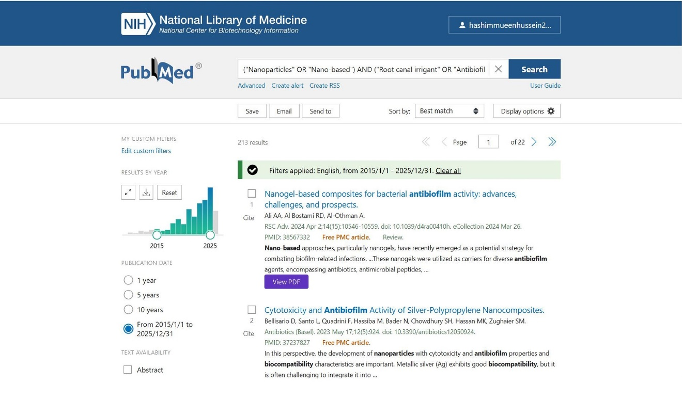
Supplementary Fig S1. PubMed/MEDLINE search results screenshot.
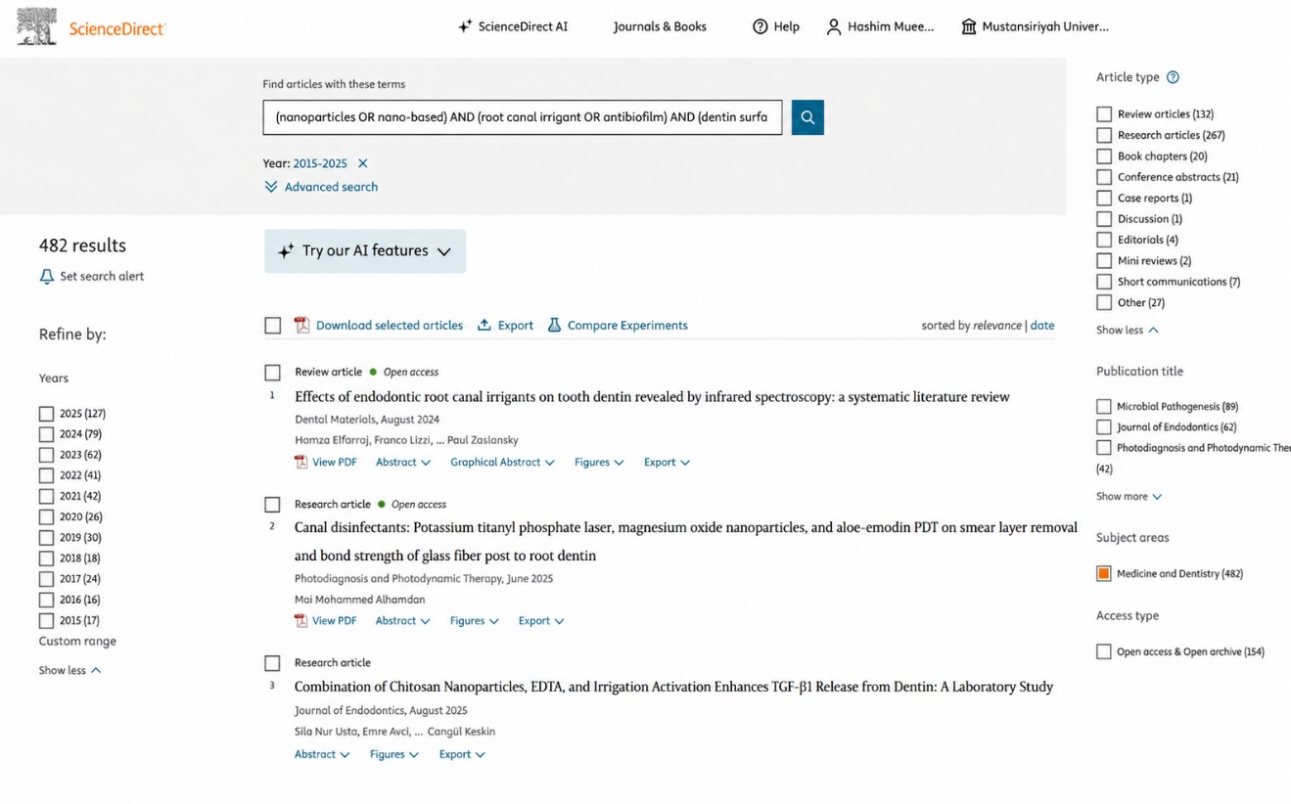
Supplementary Fig S2. ScienceDirect search results screenshot.

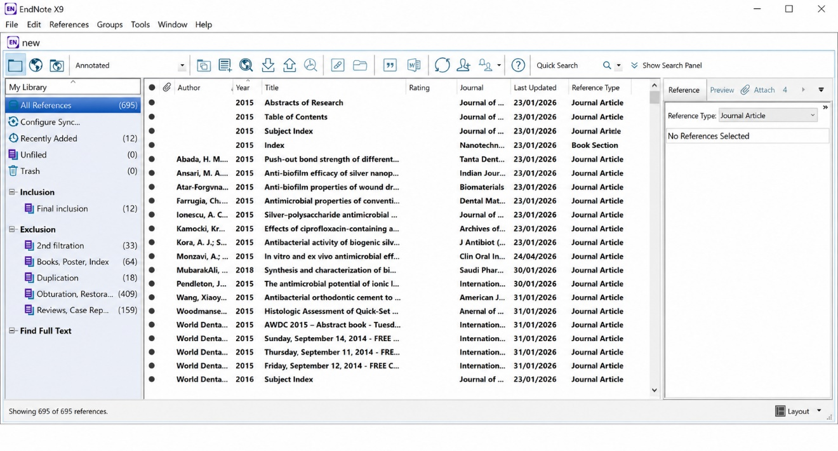
Supplementary Fig S3. EndNote duplicate-removal screenshot.

Figure legends:
Supplementary Table S1. Full search strategies and database-specific filters used in this review.
Supplementary Table S2. Primary reasons for exclusion of full-text studies after eligibility assessment.
Supplementary Table S3. Study-level assessment of methodological quality domains in the included studies.ity assessment.
Supplementary Fig S1. PubMed/MEDLINE search results screenshot.
Supplementary Fig S2. ScienceDirect search results screenshot.
Supplementary Fig S3. EndNote duplicate-removal screenshot.

