Supplementary material

Supplementary Figures S1. The TIC diagram obtained by the chromatographic analysis of Xiaoer Fengreqing by UHPLC-QTOF-MS. (A) Negative ion mode. (B) Positive ion mode.
Supplementary Figures S2. The second TIC diagram obtained by the chromatographic analysis of Xiaoer Fengreqing by UHPLC-QTOF-MS. (A) Negative ion mode. (B) Positive ion mode;

Supplementary Figures S3. The TIC diagram of serum sample1 (blank control). (A) Negative ion mode. (B) Positive ion mode.
Supplementary Figures S4. The second TIC diagram of serum sample1 (blank control). (A) Negative ion mode. (B) Positive ion mode.
Supplementary Figures S5. The TIC diagram of serum sample1 (normal dose drug treatment). (A) Negative ion mode. (B) Positive ion mode.
Supplementary Figures S6. The TIC diagram of serum sample1 (high dose drug treatment). (A) Negative ion mode. (B) Positive ion mode

Supplementary Figures S7: RT-qPCR analysis of (A)IL-6, (B)TNF-α, (C)IP-10, (D)MCP-1, and (E)IFN-γ in SARS-CoV-2-infected HMC3 cells treated with XF. The values are presented as the means ± S.D. of six individual experiments. ***p < 0.001, when compared to the viral control.

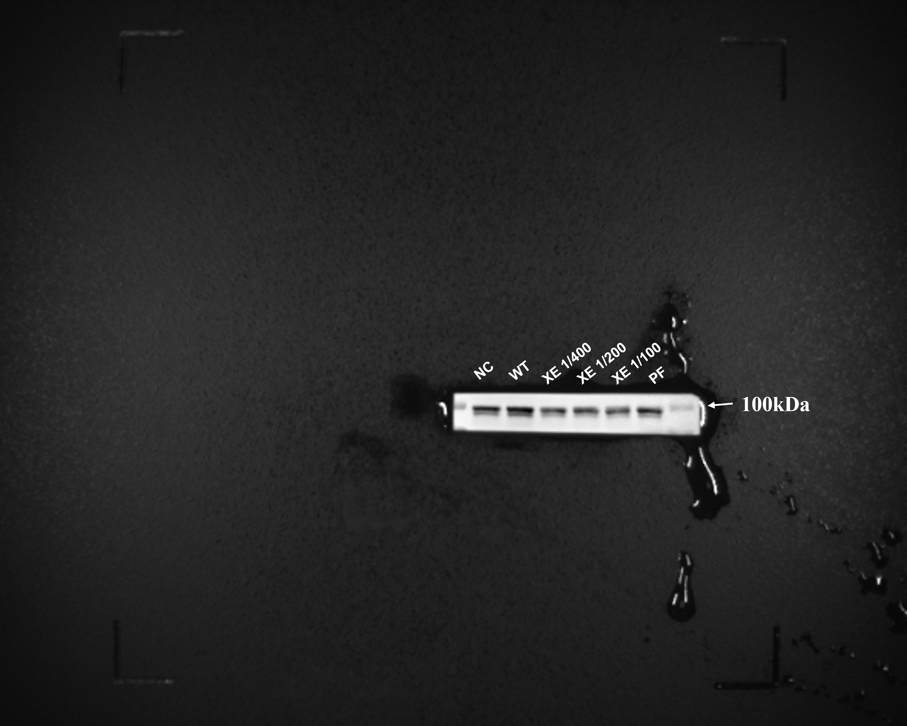
Supplementary Figures S8: The band of STAT1 protein (not cropped)

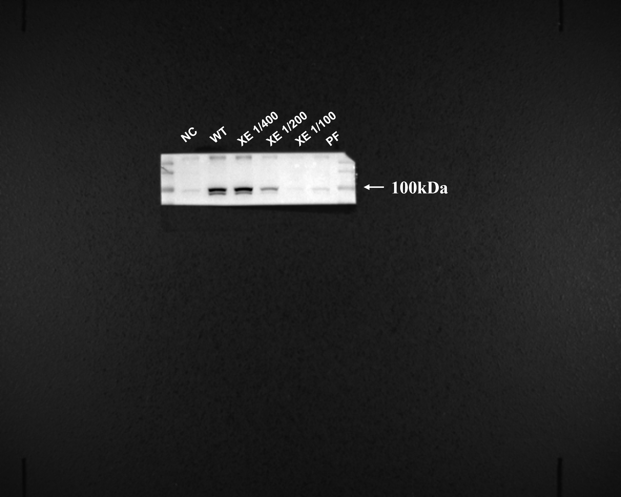
Supplementary Figures S9: The band of P-STAT1 protein (not cropped)

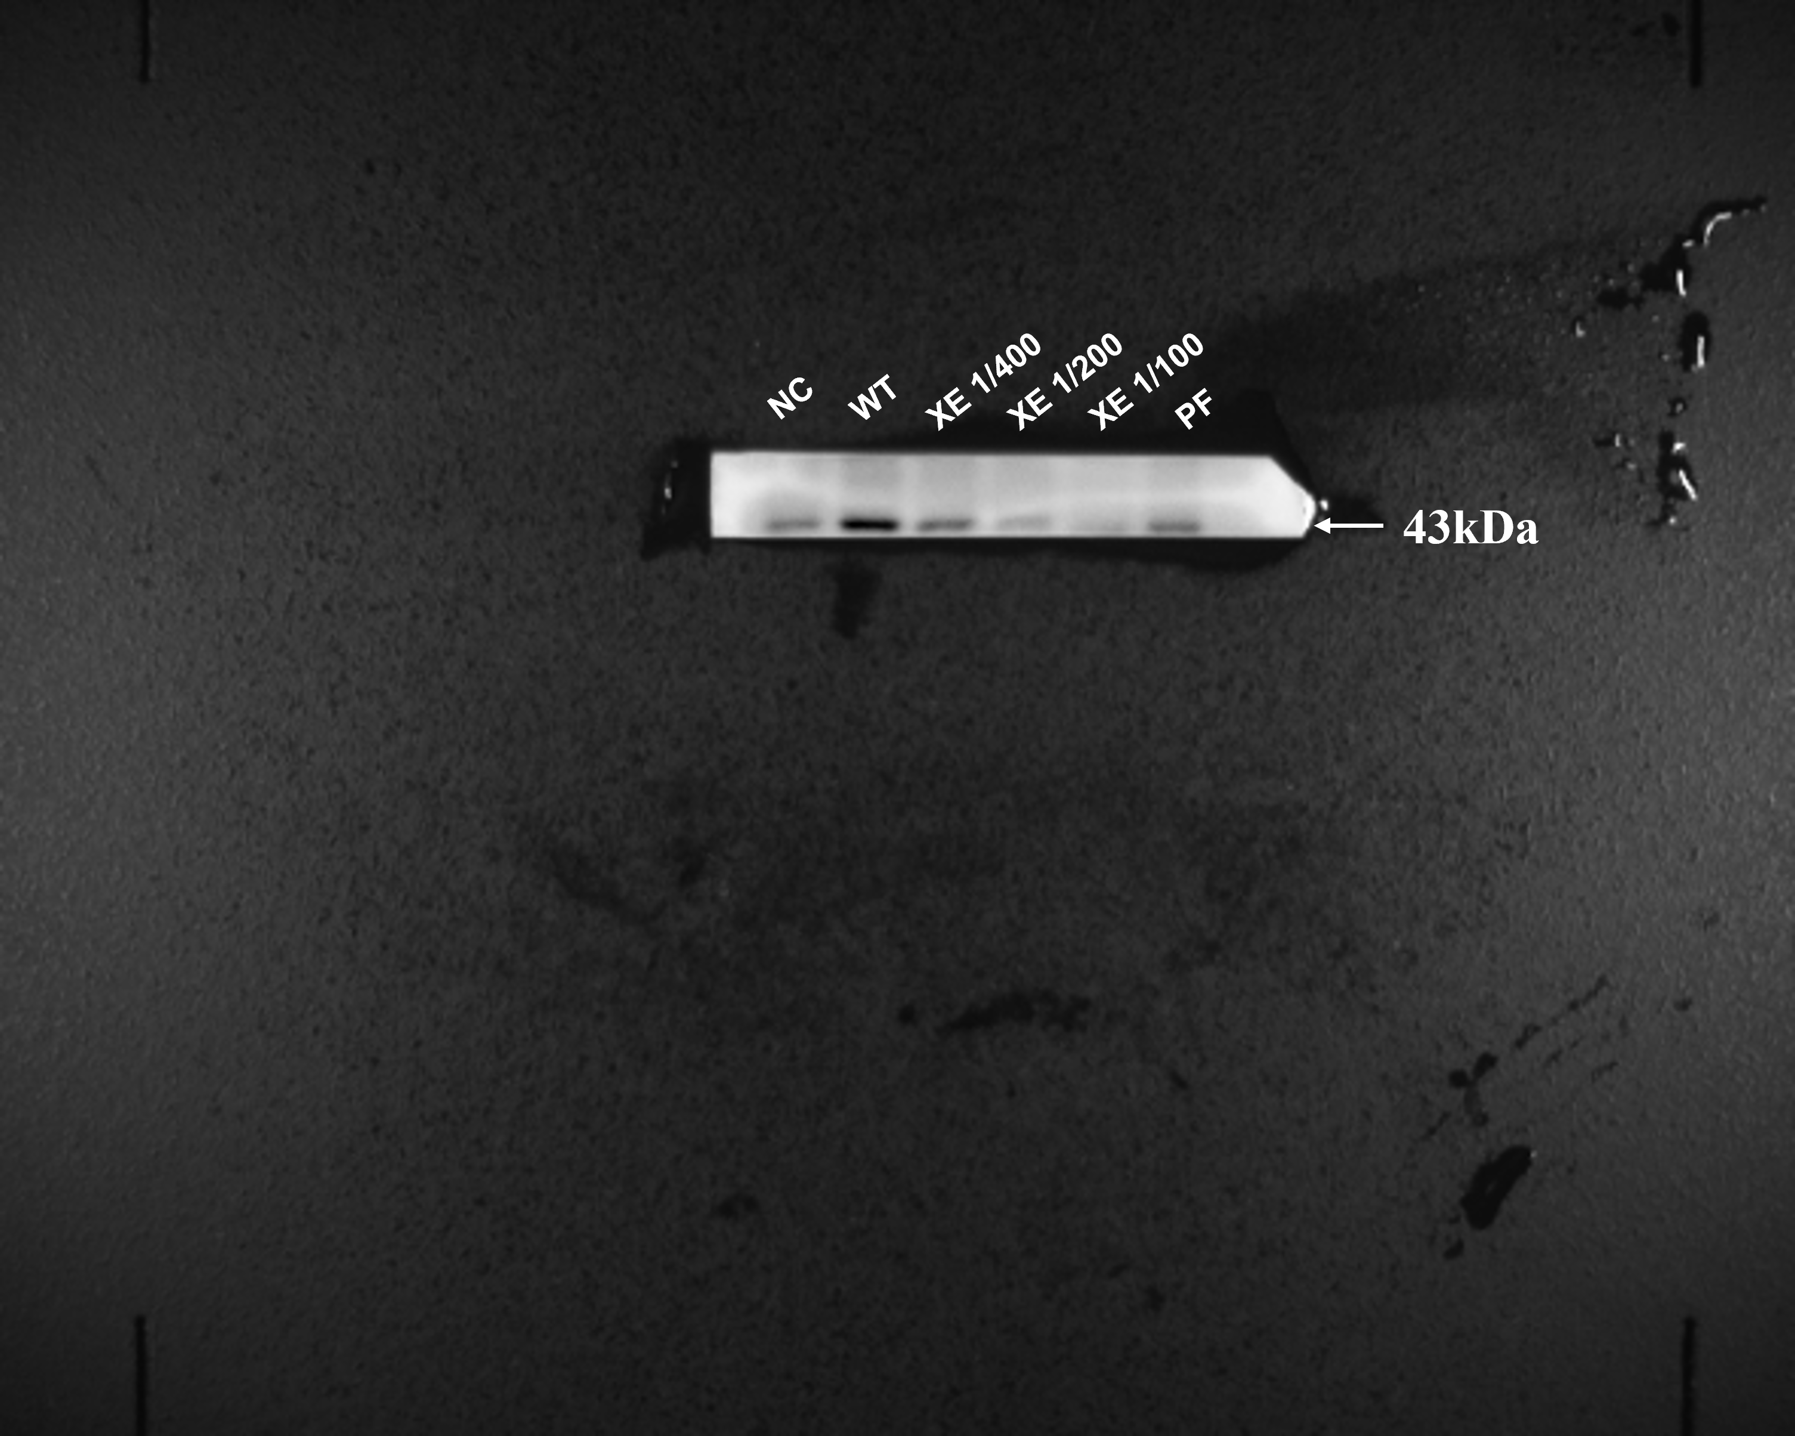
Supplementary Figures S10: The band of P-p38 MAPK protein (not cropped)

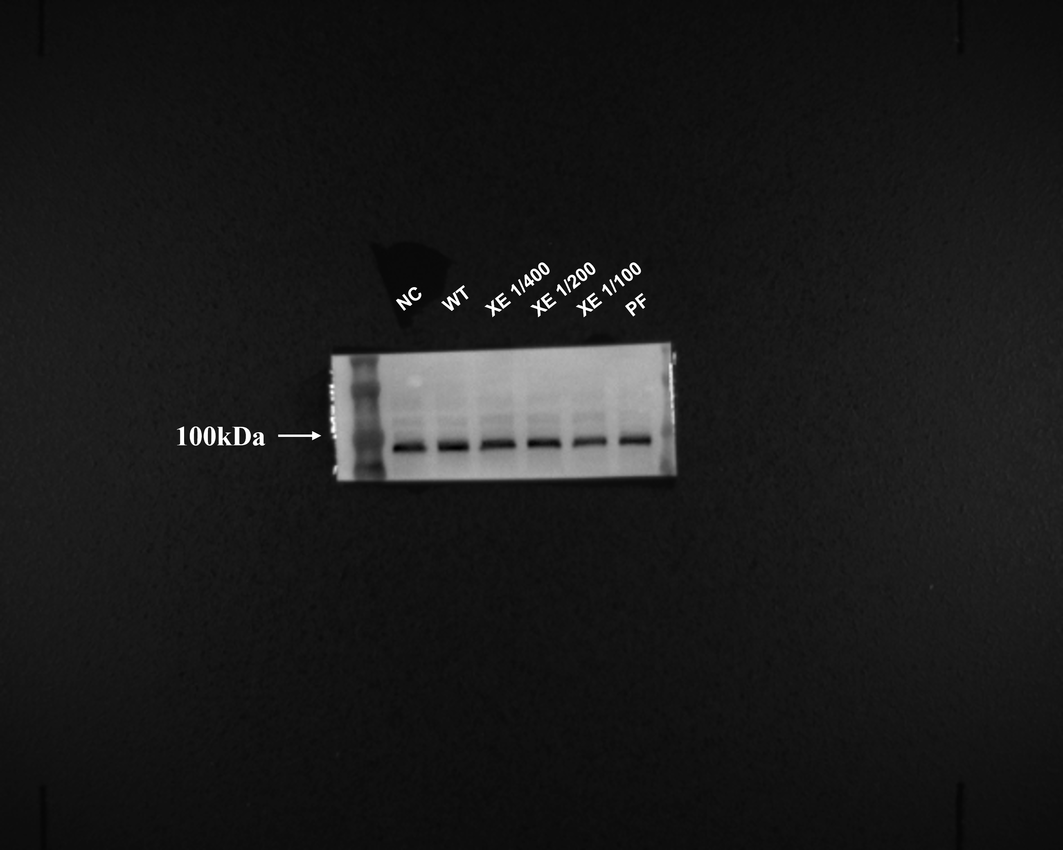
Supplementary Figures S11: The band of PI3K P85α protein (not cropped)

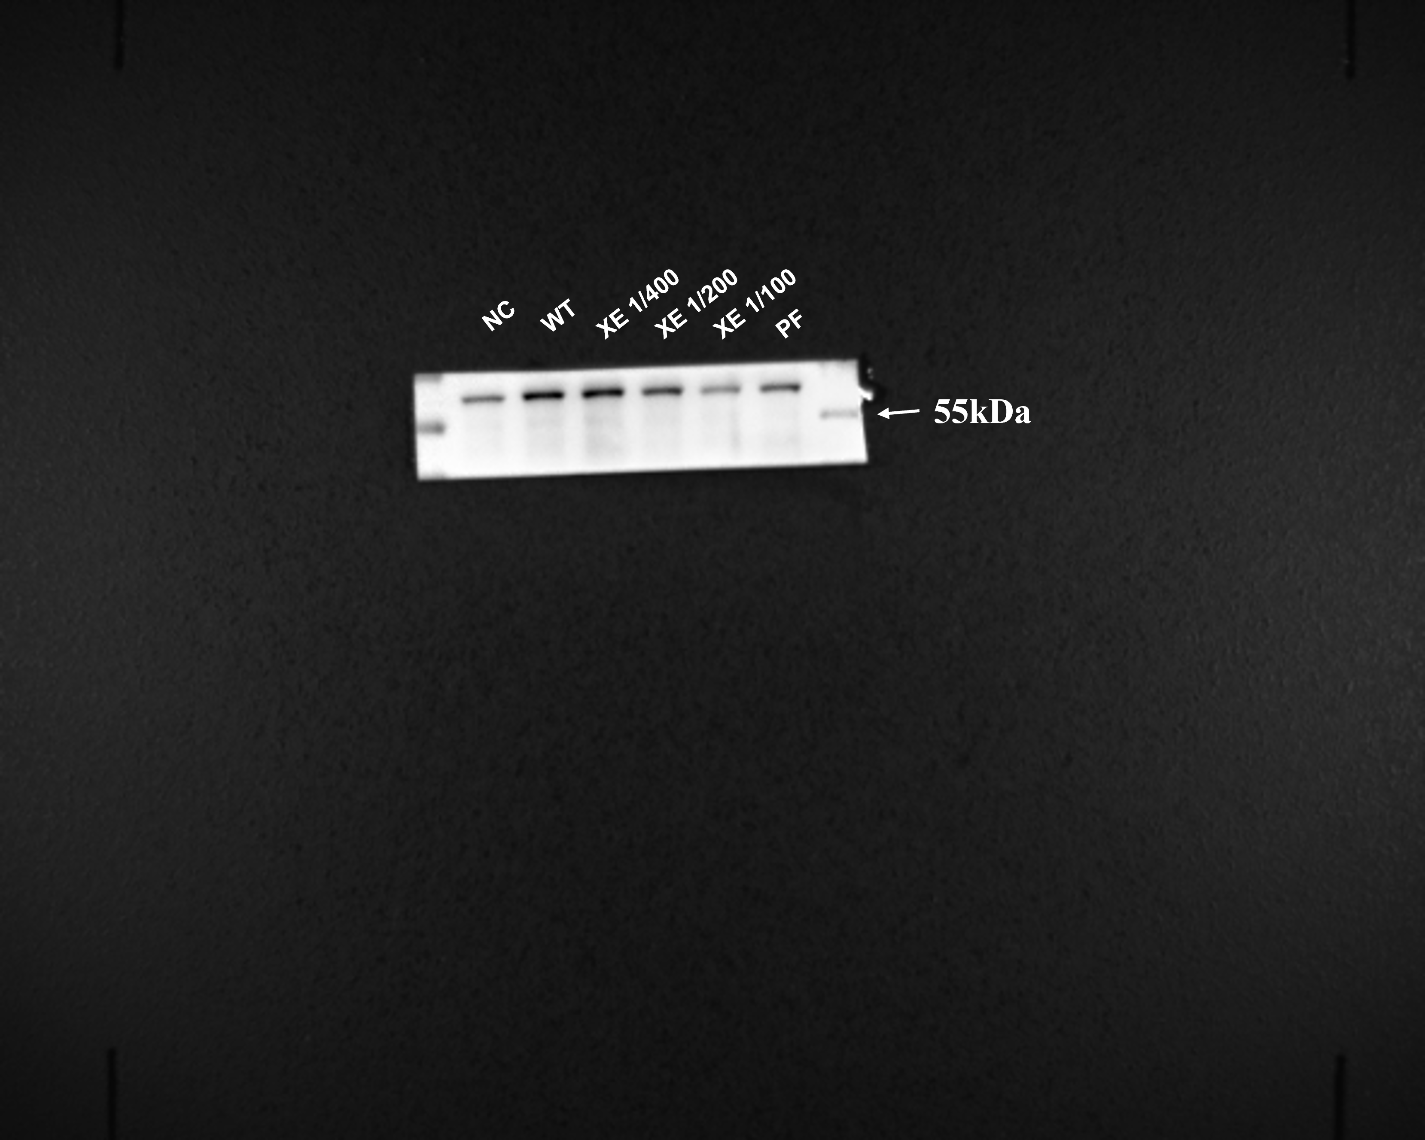
Supplementary Figures S12: The band of P-AKT protein (not cropped)

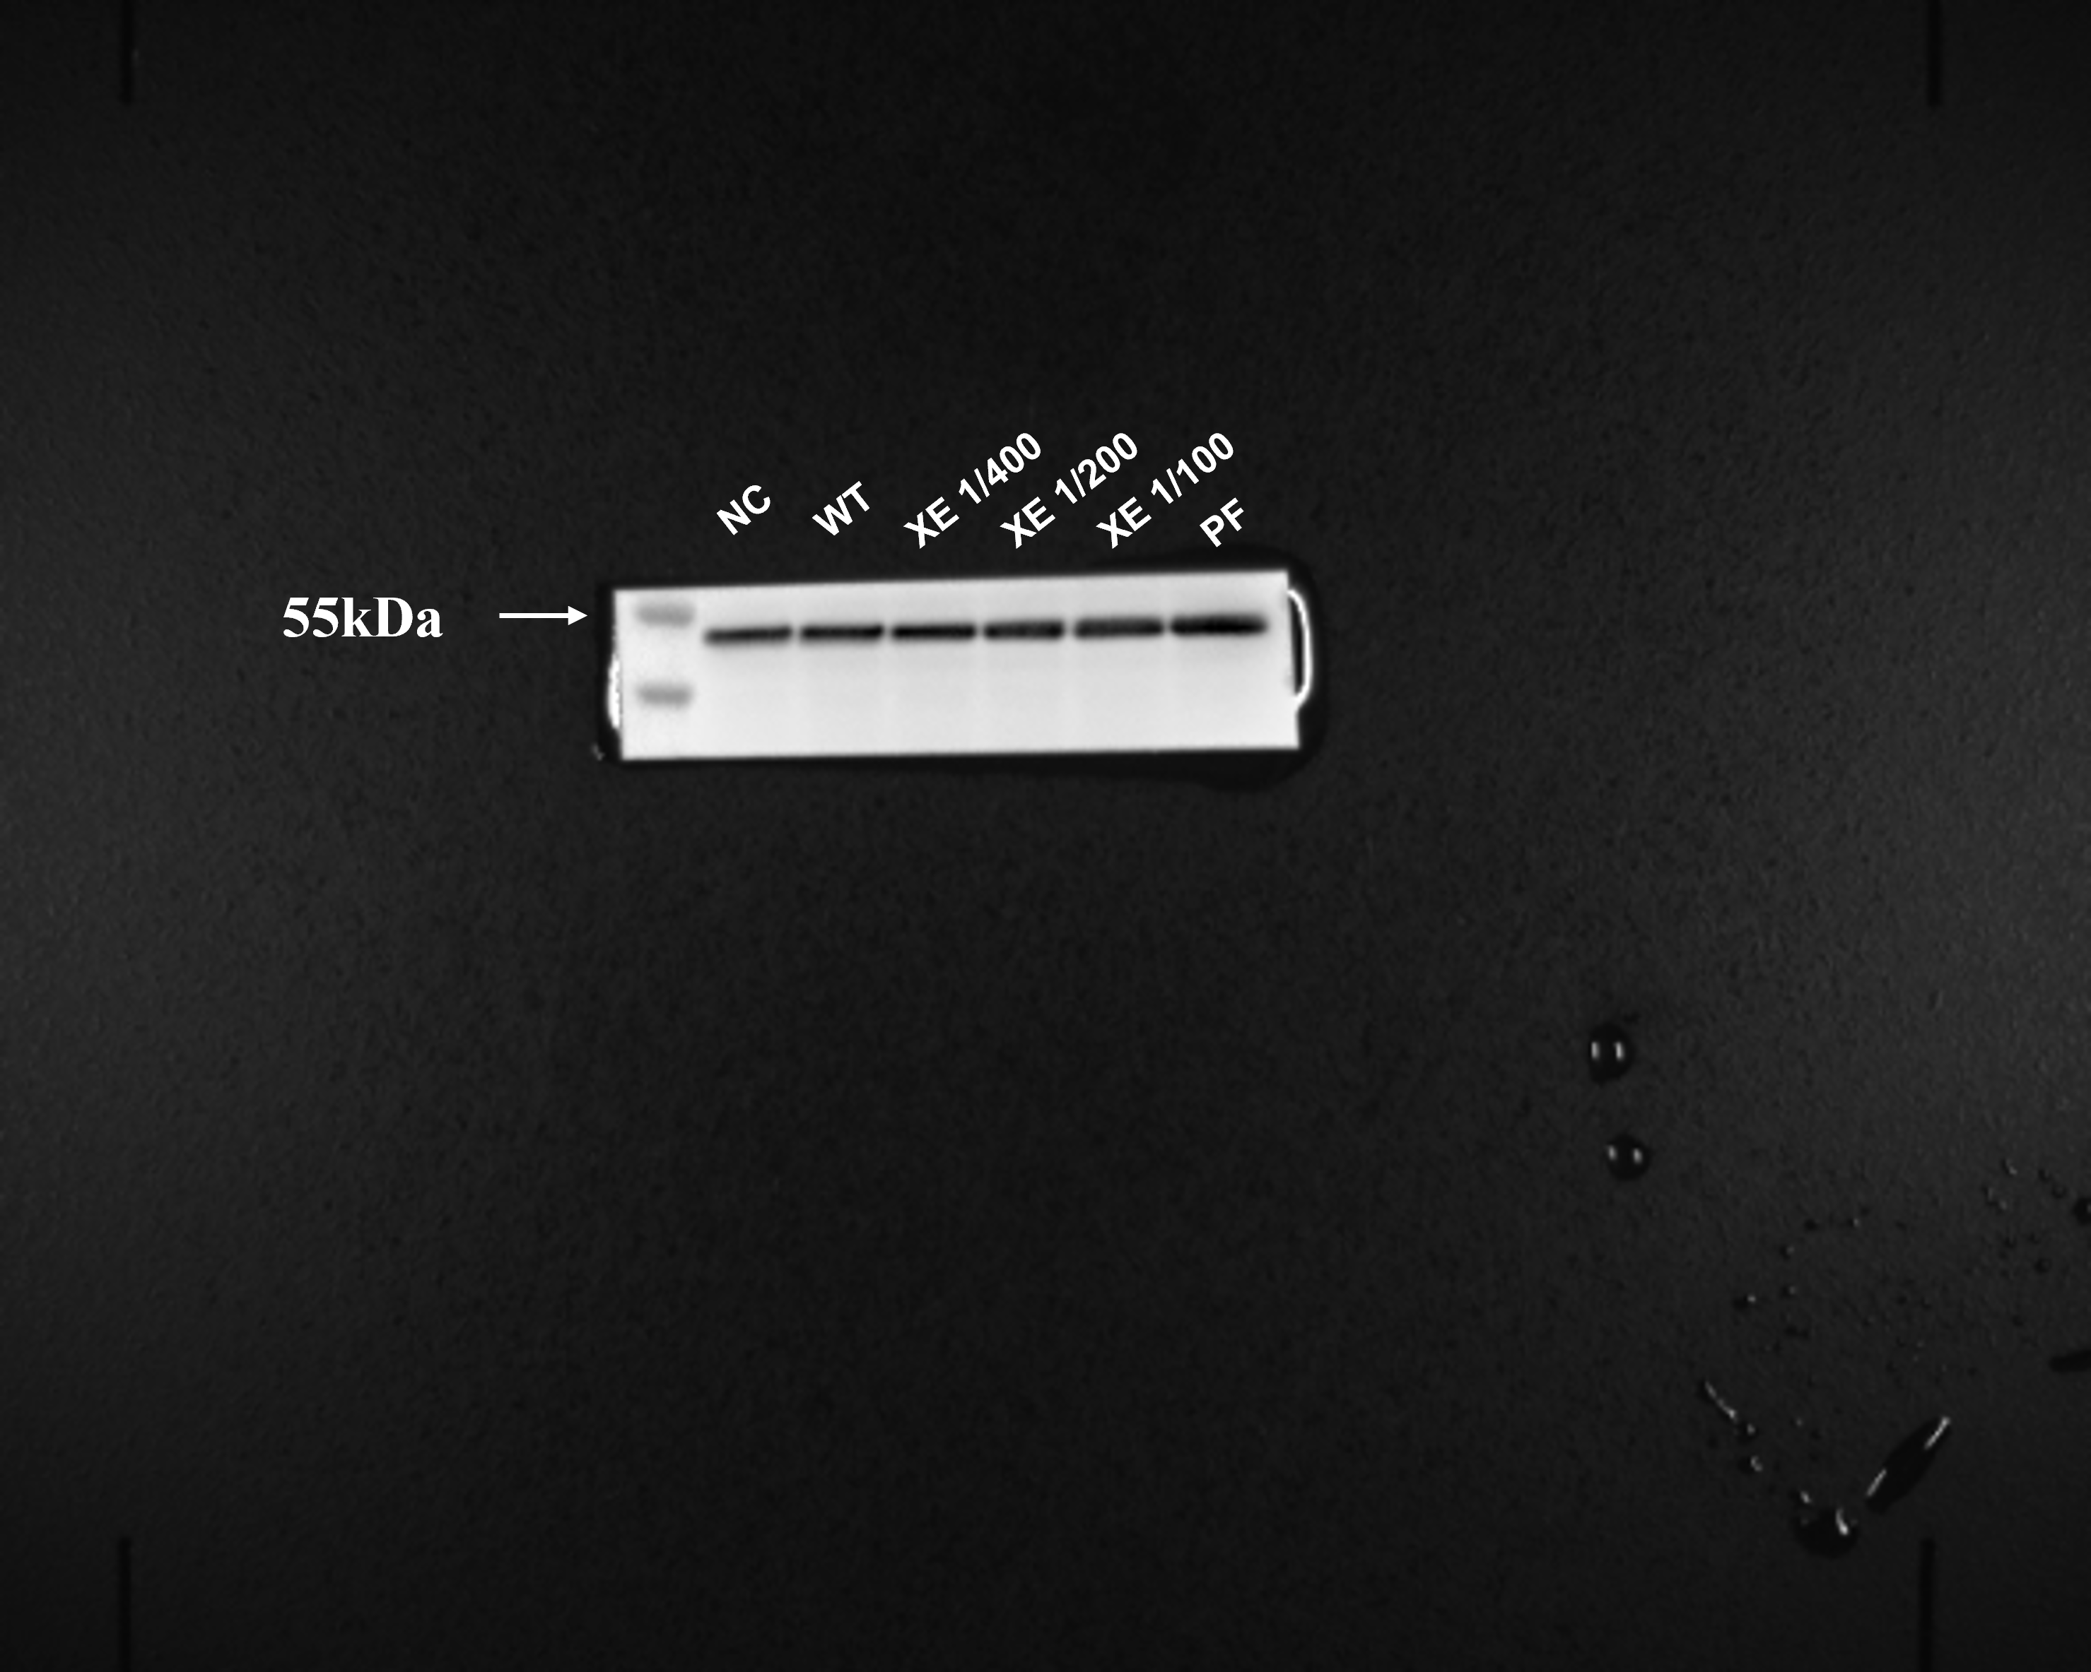
Supplementary Figures S13: The band of p38 MAPK protein (not cropped)

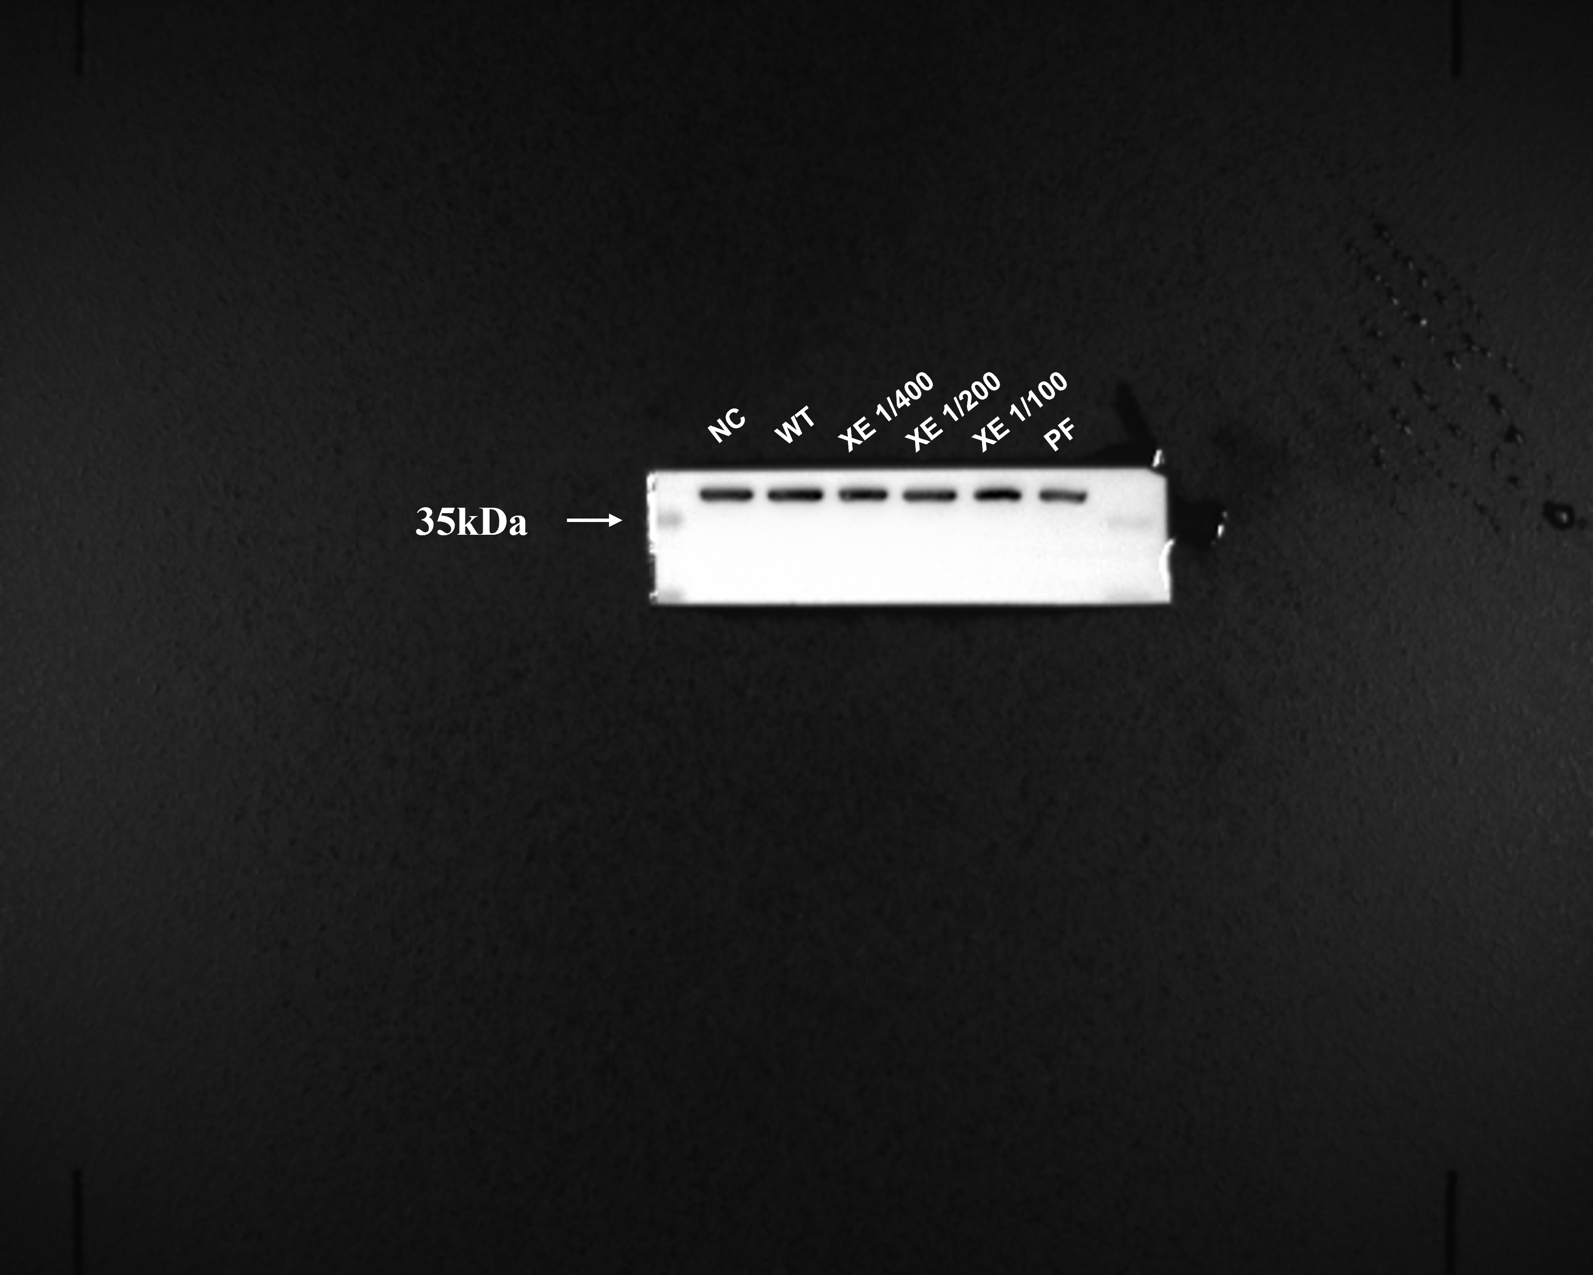
Supplementary Figures S14: The band of GAPDH protein (not cropped)

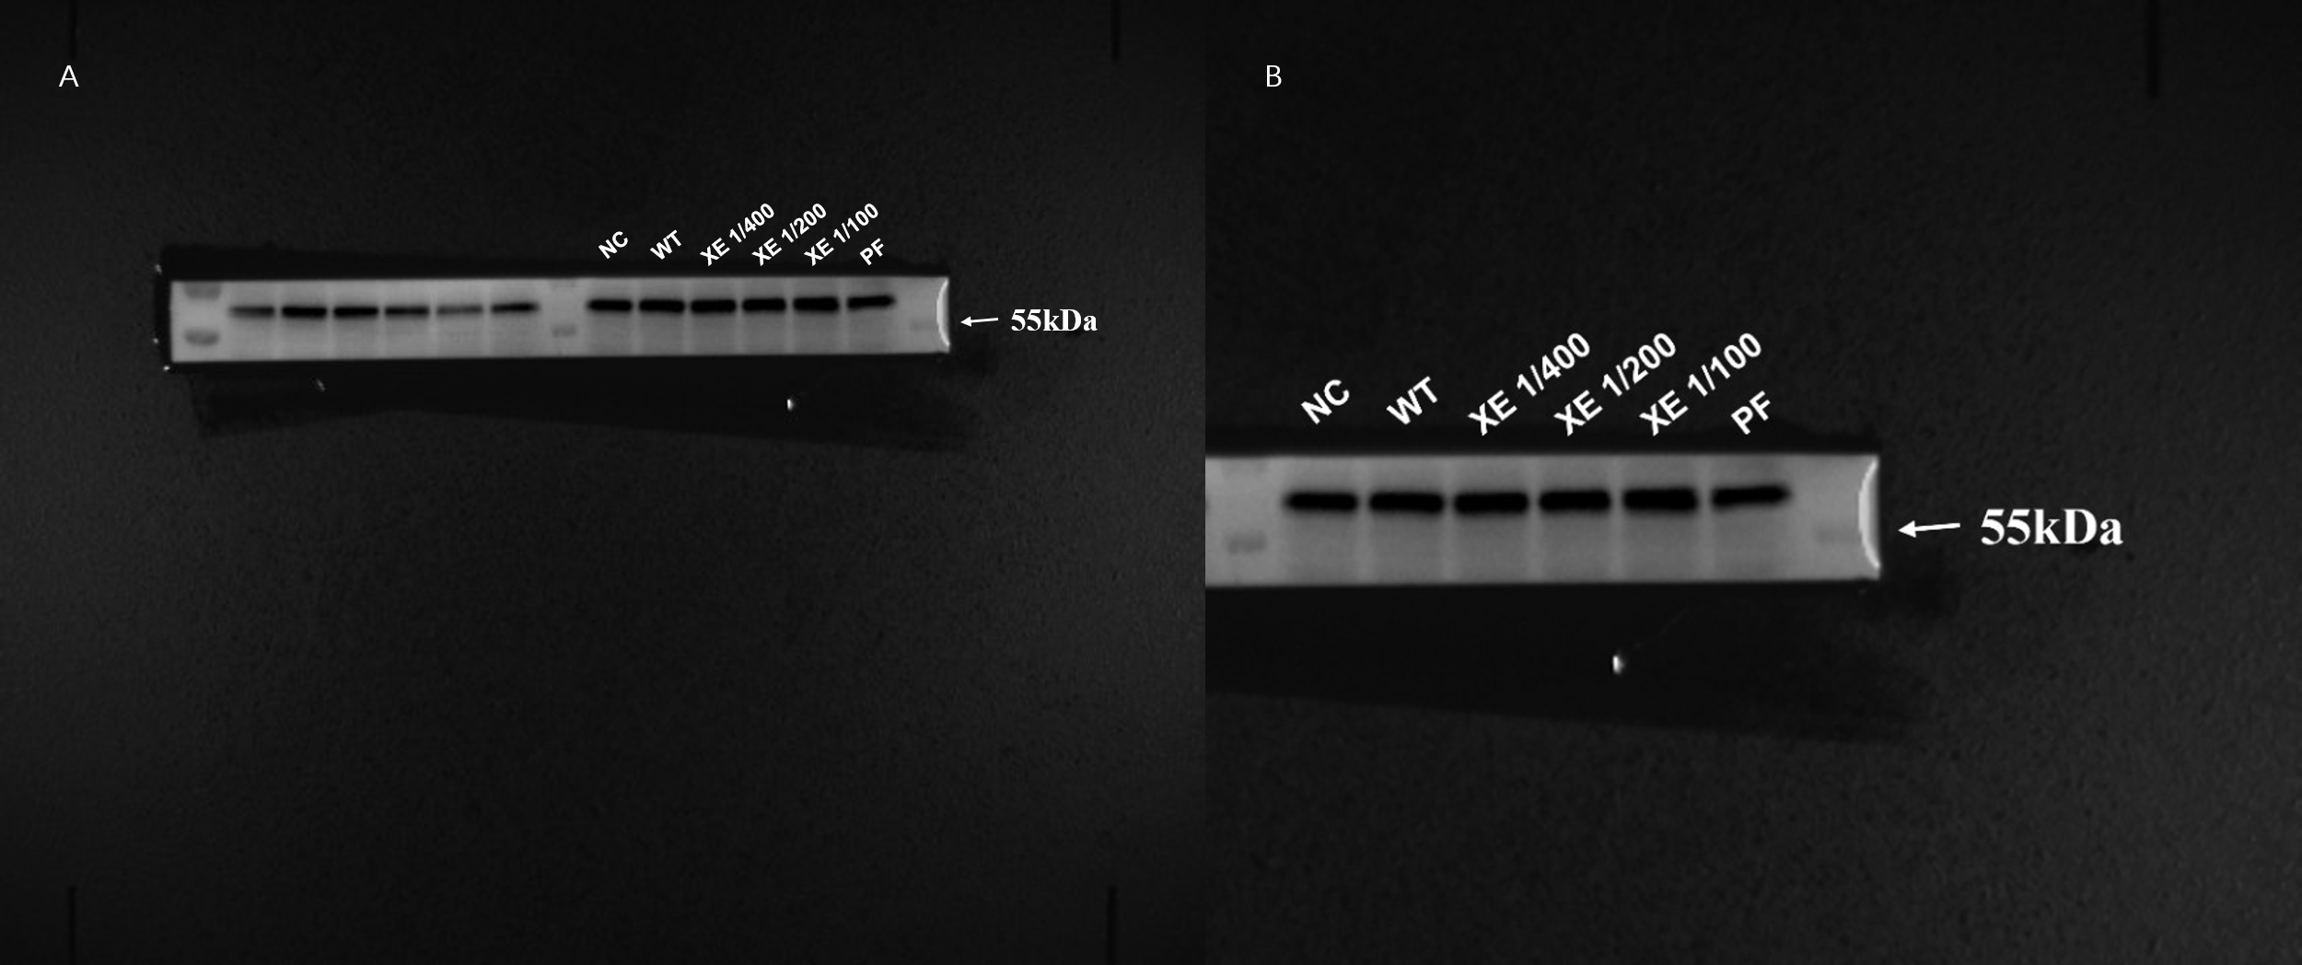
Supplementary Figures S15: The band of AKT protein (not cropped). A. The left part of the membrane contains data from another unrelated experimental group, which is not part of this study. B. This figure displays only the experimental bands relevant to the current study, corresponding to the right portion of Supplementary Figures S15A.

Supplementary Table S1

Compounds of Xiaoer Fengreqing obtained by integrating the results of UHPLC-QTOF-MS
Num | Compound | Category | Ionic mode | Chemical formula | Molecular weight | Retention time
1 | 18.beta.-Glycyrrhetinic acid | Oleanolic acid type pentacyclic triterpenoids | Negative | C30H46O4 | 453.3352003 | 9.357383333
2 | 3,3',4'-Trimethoxyflavone | Flavonoids | Negative | C18H16O5 | 313.1068372 | 9.334883333
3 | 3,4-Dihydroxybenzaldehyde | Benzaldehyde | Negative | C7H6O3 | 139.0385657 | 2.611066667
4 | 3,4-Dimethoxybenzoic acid | Benzoic acids | Negative | C9H10O4 | 165.0540541 | 4.5323
5 | 3,7-Dihydroxy-3',4'-dimethoxyflavone | Flavonoids | Negative | C17H14O6 | 315.0860071 | 9.8762
6 | 4'-O-.beta.-D-Glucosyl-5-O-methylvisamminol | Glycosides | Negative | C22H28O10 | 453.174244 | 6.0649
7 | 5,7-Dihydroxy-8,2'-dimethoxyflavone 7-glucuronide | Flavonoid glycosides | Negative | C23H22O12 | 491.1173405 | 7.915133333
8 | Acteoside | Phenylpropanoid Glycosides | Negative | C29H36O15 | 647.193449 | 5.457583333
9 | Albiflorin | Glycosides | Negative | C23H28O11 | 481.1696821 | 4.079166667
10 | Arctigenin | Lignin | Negative | C21H24O6 | 355.1535261 | 7.126
11 | Baicalein 6-methyl ether 7-glucuronide | Flavonoid glycosides | Negative | C22H20O11 | 461.1069458 | 7.41865
12 | Baicalin | Flavonoid glycosides | Negative | C21H18O11 | 447.0923791 | 7.1485
13 | Baicalin methyl ester | Flavonoid glycosides | Negative | C22H20O11 | 461.1068834 | 7.126
14 | Caffeic acid | Phenylpropionic acids | Negative | C9H8O4 | 163.0386261 | 3.06205
15 | Chrysin 6-C-glucoside-8-C-alpha-L-arabinopyranoside | Flavonoid glycosides | Negative | C26H28O13 | 549.1594771 | 5.3676
16 | Cimifugin | Chromogenic ketones | Negative | C16H18O6 | 307.1173439 | 5.66025
17 | Cynarin | Caffeioyl Quinic Acids | Negative | C25H24O12 | 499.1226769 | 5.817066667
18 | Dihydronorwogonin | Flavonoids | Negative | C15H12O5 | 273.0754294 | 7.035683333
19 | Diosmetin | Flavonoids | Negative | C16H12O6 | 301.0704622 | 8.005116667
20 | Genipin | Iridoids | Negative | C11H14O5 | 209.0806809 | 3.78585
21 | Geniposide | Iridoid glycosides | Negative | C17H24O10 | 411.1260419 | 3.78585
22 | Glycyrrhizic acid | Triterpene saponin | Negative | C42H62O16 | 823.4094348 | 9.357383333
23 | Hesperidin | Flavonoid glycosides | Negative | C28H34O15 | 611.1960132 | 6.380883333
24 | Hispidulin 7-O-beta-glucuronide | Flavonoid glycosides | Negative | C22H20O12 | 477.1018432 | 7.59965
25 | Hyperoside | Flavonol glycosides | Negative | C21H20O12 | 465.1016442 | 3.265366667
26 | Isoorientin | Flavonoids | Negative | C21H20O11 | 449.1071152 | 4.352483333
27 | Isosakuranetin | Flavonoids | Negative | C16H14O5 | 287.0907085 | 7.554483333
28 | Linarin | Flavonoid glycosides | Negative | C28H32O14 | 593.1853002 | 7.193333333
29 | Naringenin-4'-O-.beta.-D-glucuronide | Flavonoid glycosides | Negative | C21H20O11 | 449.1065333 | 7.035683333
30 | Nobiletin | Flavonoids | Negative | C21H22O8 | 403.1378717 | 9.853866667
31 | Oleoside 11-methyl ester | Phenylpropanoids | Negative | C17H24O11 | 427.1204447 | 4.5323
32 | Oroxylin A | Flavonoids | Negative | C16H12O5 | 285.0755268 | 10.01085
33 | p-Coumaric acid | coumarin | Negative | C9H8O3 | 147.0435355 | 4.26115
34 | Pectolinarigenin | Flavonoids | Negative | C17H14O6 | 315.086028 | 9.492383333
35 | Poncirin | Flavonoid glycosides | Negative | C28H34O14 | 595.2004608 | 7.350666667
36 | prim-O-Glucosylcimifugin | Flavonoid glycosides | Negative | C22H28O11 | 469.1699234 | 4.7818
37 | Rutin | Flavonoids | Negative | C27H30O16 | 611.1597733 | 5.119766667
38 | Saikosaponin D | Triterpene saponin | Negative | C42H68O13 | 803.453259 | 9.943516667
39 | Scutellarein tetramethyl ether | Flavonoids | Negative | C19H18O6 | 343.1171959 | 9.920866667
40 | Scutellarin | Flavonoid glycosides | Negative | C21H18O12 | 463.0864293 | 5.322766667
41 | sec-O-Glucosylhamaudol | Flavonoid glycosides | Negative | C21H26O10 | 439.159272 | 7.41865
42 | Stachydrine | Pyrrolidine alkaloids | Negative | C7H13NO2 | 144.101556 | 0.655833333
43 | Suspensaside | Caffeic acyl phenylethanol glycoside | Negative | C29H36O16 | 663.1887847 | 4.283983333
44 | Sweroside | Iridoid glycosides | Negative | C16H22O9 | 359.1335781 | 3.9435
45 | Tachiogroside B |  | Negative | C18H24O12 | 433.1334213 | 3.4892
46 | Tectorigenin | Flavonoids | Negative | C16H12O6 | 301.0704275 | 8.568766667
47 | Trigonelline | Pinidine alkaloids | Negative | C7H7NO2 | 138.0545597 | 0.655833333
48 | DL-Arginine | Amino acid | Negative | C6H14N4O2 | 175.1187053 | 0.56685
49 | Stachyose | Sugar | Negative | C24H42O21 | 689.2102969 | 0.589183333
50 | Glycerophosphocholine | Alkaloids | Negative | C8H20NO6P | 280.0925894 | 0.633516667
51 | Sucrose | Sugar | Negative | C12H22O11 | 365.1051896 | 0.633516667
52 | 3-Aminopentanoic acid | Amino acid | Negative | C5H11NO2 | 118.0859198 | 0.678516667
53 | Adenine | Amino acid | Negative | C5H5N5 | 136.0616234 | 0.701333333
54 | Synephrine | Alkaloids | Negative | C9H13NO2 | 150.0909641 | 0.768333333
55 | Nicotinic acid | Vitamins | Negative | C6H5NO2 | 124.03909 | 0.835166667
56 | Adenosine | Azosides | Negative | C10H13N5O4 | 268.1042109 | 0.857833333
57 | Phenylacetaldehyde | Aromatic aldehydes | Negative | C8H8O | 121.0643385 | 0.9255
58 | L-Isoleucine | Amino acid | Negative | C6H13NO2 | 132.101479 | 1.015983333
59 | L-Tyrosine | Amino acid | Negative | C9H11NO3 | 182.080433 | 1.357466667
60 | L-Phenylalanine | Amino acid | Negative | C9H11NO2 | 166.085857 | 1.471966667
61 | 2-Amino-1-phenylethanol | Alkaloids | Negative | C8H11NO | 120.0802723 | 1.4948
62 | trans-Cinnamic acid | Phenylpropionic acids | Negative | C9H8O2 | 149.0592263 | 1.4948
63 | (3,4-Dihydroxyphenyl)ethanol | Phenylpropionic acids | Negative | C8H10O3 | 137.0593186 | 1.5638
64 | 5-Hydroxymethyl-2-furaldehyde | Furan cyclic aldehyde | Negative | C6H6O3 | 109.0280384 | 1.635883333
65 | Rotundioside N | Triterpene saponin | Negative | C48H78O18 | 965.5067377 | 10.12401667
66 | 9-Hydroperoxy-10E,12Z,15Z-octadecatrienoic acid | Fatty Acids | Negative | C18H30O4 | 311.2211134 | 10.39433333
67 | Tangeritin | Flavonoids | Negative | C20H20O7 | 373.1276109 | 10.461
68 | Stearidonic acid | Fatty Acids | Negative | C18H28O2 | 277.2157333 | 10.551
69 | Artemisetin | Flavonoids | Negative | C20H20O8 | 389.1223044 | 10.82198333
70 | 3-Hydroxy-3',4'-dimethoxyflavone | Flavonoids | Negative | C17H14O5 | 299.0908399 | 11.13846667
71 | 9,10-Dihydroxy-12Z-octadecenoic acid | Fatty Acids | Negative | C18H34O4 | 337.2344599 | 11.25145
72 | Monolinolenin (9c,12c,15c) | Fatty Acids | Negative | C21H36O4 | 353.267978 | 11.61426667
73 | Isoalantolactone | Phenylpropanoids | Negative | C15H20O2 | 233.1533054 | 11.65993333
74 | Chlorogenic acid | Phenylpropionate glycosides | Negative | C16H18O9 | 377.0841541 | 2.089266667
75 | 7,8-Dihydroxy-4-methylcoumarin | coumarin | Negative | C10H8O4 | 175.03822 | 2.24825
76 | 3-Indoleacrylic acid | Alkaloid | Negative | C11H9NO2 | 188.0705306 | 2.29375
77 | 8-Epiloganic acid | Iridoid glycosides | Negative | C16H24O10 | 359.1335024 | 2.429416667
78 | Kynurenic acid | Alkaloid | Negative | C10H7NO3 | 190.0499329 | 2.611066667
79 | 1-Naphthalenamine | Alkaloids | Negative | C10H9N | 144.0804438 | 3.287866667
80 | 2'-Hydroxy-6'-methoxyacetophenone | Phenylpropanoids | Negative | C9H10O3 | 167.0699394 | 3.354866667
81 | Ethyl 2,4-dihydroxy-6-methylbenzoate | Phenylpropanoids | Negative | C10H12O4 | 197.0807607 | 3.377033333
82 | Syringic acid | Phenylpropanoids | Negative | C9H10O5 | 199.0596151 | 3.512183333
83 | Isopropyl 4-hydroxybenzoate | Phenylpropanoids | Negative | C10H12O3 | 163.0747706 | 3.649183333
84 | (-)-Riboflavin | Vitamins | Negative | C17H20N4O6 | 377.1454914 | 3.83085
85 | Vicenin 2 | Protein | Negative | C27H30O15 | 617.146222 | 3.87585
86 | Norharmane | Alkaloid | Negative | C11H8N2 | 169.0758764 | 3.898333333
87 | Luteolin 7-glucoside | Flavonoid glycosides | Negative | C21H20O11 | 449.1068895 | 4.0565
88 | Loganin | Iridoid glycosides | Negative | C17H26O10 | 413.1414202 | 4.124
89 | 2-(1',2',3',4'-Tetrahydroxybutyl)quinoxaline | Alkaloid | Negative | C12H14N2O4 | 251.1032418 | 4.283983333
90 | Syringaldehyde | Phenylpropanoids | Negative | C9H10O4 | 183.0653081 | 4.6453
91 | Isoscoparin | Flavonoid glycosides | Negative | C22H22O11 | 463.1231927 | 4.668133333
92 | 2-Pentylfuran | Furan | Negative | C9H14O | 121.1006853 | 4.7138
93 | cis-Pinonic acid |  | Negative | C10H16O3 | 207.0993482 | 4.7138
94 | Carthamidin | Flavonoids | Negative | C15H12O6 | 289.0704676 | 5.209766667
95 | 3,5,7,2',6'-Pentahydroxyflavone 2'-glucoside | Flavonoid glycosides | Negative | C21H20O12 | 465.1016231 | 5.300266667
96 | Skimmin | coumarin | Negative | C15H16O8 | 325.0916977 | 5.435083333
97 | Luteolin-4'-O-glucoside | Flavonoid glycosides | Negative | C21H20O11 | 431.09543 | 5.457583333
98 | Syringetin 3-glucoside | Flavonoid glycosides | Negative | C23H24O13 | 509.1281567 | 5.502583333
99 | Lonicerin | Flavonoid glycosides | Negative | C27H30O15 | 595.1648031 | 5.524916667
100 | Aurantio-obtusin beta-D-glucoside | Anthraquinone glycosides | Negative | C23H24O12 | 493.1331039 | 5.884733333
101 | Isorhamnetin 3-O-glucoside | Flavonoid glycosides | Negative | C22H22O12 | 479.1171069 | 5.974733333
102 | Naringenin-7-O-glucoside | Flavonoid glycosides | Negative | C21H22O10 | 435.1274082 | 6.020066667
103 | Genistin | Flavonoid glycosides | Negative | C21H20O10 | 433.112054 | 6.042566667
104 | Diosmin | Flavonoid glycosides | Negative | C28H32O15 | 609.1801895 | 6.1324
105 | Isochlorogenic acid b | Coffee tannin | Negative | C25H24O12 | 517.1330057 | 6.154716667
106 | Azelaic acid | Fatty Acids | Negative | C9H16O4 | 171.1010663 | 6.22255
107 | Iridin | Flavonoid glycosides | Negative | C24H26O13 | 523.1438851 | 6.22255
108 | (E)-Aldosecologanin | Iridoid derivative glycosides | Negative | C34H46O19 | 781.2517804 | 6.22255
109 | Kaempferol 7-O-glucoside | Flavonoid glycosides | Negative | C21H20O11 | 449.1074358 | 6.267716667
110 | Hispidulin 7-O-beta-glucoside | Flavonoid glycosides | Negative | C22H22O11 | 463.1225819 | 6.358383333
111 | Matairesinoside | Lignan Glycosides | Negative | C26H32O11 | 543.182887 | 6.4937
112 | Scutellarein | Flavonoids | Negative | C15H10O6 | 287.0546325 | 6.5162
113 | Isoliquiritin | Lignan Glycosides | Negative | C21H22O9 | 419.1337867 | 6.607533333
114 | 3',4',5,7-Tetrahydroxy-3,6,8-trimethoxyflavone | Flavonoids | Negative | C18H16O9 | 377.085744 | 6.697866667
115 | 5,2',6'-Trihydroxy-7,8-dimethoxyflavone 2'-glucuronide | Flavonoid glycosides | Negative | C23H22O13 | 507.1121003 | 6.697866667
116 | Ononin | Flavonoid glycosides | Negative | C22H22O9 | 453.1144884 | 6.787016667
117 | Chrysin 8-C-glucopyranoside | Flavonoid glycosides | Negative | C21H20O9 | 417.1173441 | 6.854683333
118 | Norcimifugin | Volatile oils | Negative | C15H16O6 | 293.1015958 | 6.94535
119 | (+)-Abscisic acid | Terpenoids | Negative | C15H20O4 | 287.1253433 | 7.035683333
120 | Arctiin | Phenylpropanoid Glycosides | Negative | C27H34O11 | 535.2131872 | 7.035683333
121 | Luteolin | Flavonoids | Negative | C15H10O6 | 287.0550059 | 7.081333333
122 | 5-O-Methylvisamminol | Flavonoids | Negative | C16H18O5 | 291.1226258 | 7.126
123 | Wogonin 5-glucoside | Flavonoid glycosides | Negative | C22H22O10 | 447.1273723 | 7.373316667
124 | Gabapentin related compound D | Alkaloids | Negative | C18H29NO3 | 308.221853 | 7.689966667
125 | Tricin | Flavonoids | Negative | C17H14O7 | 331.0806892 | 7.7353
126 | Aloenin | Anthraquinone glycosides | Negative | C19H22O10 | 433.1118262 | 7.779966667
127 | Wogonoside | Flavonoid glycosides | Negative | C22H20O11 | 461.1067901 | 7.779966667
128 | Psoralen | Coumarin | Negative | C11H6O3 | 187.0390096 | 7.8023
129 | Matairesinol | Lignan | Negative | C20H22O6 | 341.1381196 | 8.18545
130 | 3-Hydroxy-3',4',5'-trimethoxyflavone | Flavonoids | Negative | C18H16O6 | 329.1016176 | 8.25295
131 | 5,2'-Dihydroxy-7,8,6'-trimethoxyflavone 2'-glucuronide | Flavonoid glycosides | Negative | C24H24O13 | 521.127314 | 8.3886
132 | Baicalein | Flavonoids | Negative | C15H10O5 | 271.0597489 | 8.681433333
133 | Liquiritigenin | Flavonoids | Negative | C15H12O4 | 257.0803398 | 8.726916667
134 | Demethylnobiletin | Flavonoids | Negative | C20H20O8 | 389.1217696 | 8.726916667
135 | Gardenin B | Flavonoids | Negative | C19H18O7 | 359.1125297 | 8.79475
136 | 5-Methoxypsoralen | coumarin类 | Negative | C12H8O4 | 217.0493677 | 8.817416667
137 | Isosinensetin | Flavonoids | Negative | C20H20O7 | 373.1275362 | 8.817416667
138 | Corchorifatty acid B | Fatty Acids | Negative | C18H28O4 | 309.2054696 | 8.88475
139 | Formononetin | Flavonoids | Negative | C16H12O4 | 269.0803429 | 8.99725
140 | 6''-O-Acetylglycitin | Flavonoid glycosides | Negative | C24H24O11 | 489.1376043 | 9.1549
141 | 4',5,7-Trihydroxy 3,3',6,8-tetramethoxyflavone | Flavonoids | Negative | C19H18O9 | 391.1014937 | 9.2449
142 | 5,6,7,3',4'-Pentamethoxyflavone | Flavonoids | Negative | C20H20O7 | 373.1273654 | 9.312383333
143 | 5,3'-Dihydroxy-6,7,4'-trimethoxyflavone | Flavonoids | Negative | C18H16O7 | 345.0969414 | 9.379883333
144 | 4',5,7,8-Tetramethoxyflavone | Flavonoids | Negative | C19H18O6 | 343.1172346 | 9.402216667
145 | Tricin methyl ether | Flavonoids | Negative | C18H16O7 | 345.0963407 | 9.650866667
146 | 3',4',5',5,6,7-Hexamethoxyflavone | Flavonoids | Negative | C21H22O8 | 403.1378577 | 9.673366667
147 | Wogonin | Flavonoids | Negative | C16H12O5 | 307.05731 | 9.740866667
148 | Chrysin | Flavonoids | Negative | C15H10O4 | 255.0650007 | 9.8087
149 | Casticin | Flavonoids | Negative | C19H18O8 | 375.1065902 | 9.943516667
150 | (+)-Pinoresinol | Lignan | Positive | C20H22O6 | 357.1336144 | 8.164183333
151 | 20-Carboxyarachidonic acid | Fatty Acids | Positive | C20H30O4 | 333.2064372 | 10.14858333
152 | 3-(4-Hydroxyphenyl)propionic acid | Phenylpropionic acids | Positive | C9H10O3 | 165.0558375 | 2.51715
153 | 3,5-Dicaffeoylquinic acid | Coffee tannin | Positive | C25H24O12 | 515.1199423 | 5.71215
154 | Apigenin 7-glucoside | Flavonoid glycosides | Positive | C21H20O10 | 477.1034624 | 6.071633333
155 | Datiscetin | Flavonoids | Positive | C15H10O6 | 285.0403907 | 7.57755
156 | Didymin | Flavonoid glycosides | Positive | C28H34O14 | 639.1929117 | 7.329733333
157 | DL-Malic acid | Organic acid | Positive | C4H6O5 | 133.0140693 | 0.682566667
158 | Forsythiaside | Caffeic acyl phenylethanol glycoside | Positive | C29H36O15 | 623.1975815 | 5.128516667
159 | Forsythoside E | Caffeic acyl phenylethanol glycoside | Positive | C20H30O12 | 461.1654464 | 2.539483333
160 | Icariside F2 | Glycosides | Positive | C18H26O10 | 447.150016 | 3.664416667
161 | Icaritin | Flavonoids | Positive | C21H20O6 | 367.1180527 | 10.26191667
162 | Liquiritin | Flavonoid glycosides | Positive | C21H22O9 | 417.1183564 | 5.217833333
163 | Loganic acid | Monoterpene | Positive | C16H24O10 | 357.1185094 | 2.629466667
164 | Methylmalonic acid | Fatty Acids | Positive | C4H6O4 | 117.0190649 | 0.9289
165 | Morroniside | Iridoid glycosides | Positive | C17H26O11 | 451.1447465 | 2.899466667
166 | Phillyrin | Dicycloxylignan Glycosides | Positive | C27H34O11 | 579.2080049 | 7.150566667
167 | Pinoresinol O-beta-D-glucopyranoside | Phenylpropanoid oxyglycoside | Positive | C26H32O11 | 519.1863209 | 5.913466667
168 | Plantamajoside | Lignin Glycosides | Positive | C29H36O16 | 639.193031 | 4.29555
169 | Pratensein | Flavonoids | Positive | C16H12O6 | 299.0556858 | 8.570833333
170 | Rengyolone | Flavonoids | Positive | C8H10O3 | 135.0449522 | 3.19095
171 | Salidroside | Phenylpropanoid Glycosides | Positive | C14H20O7 | 345.1187519 | 2.403483333
172 | Schaftoside | Flavonoid glycosides | Positive | C26H28O14 | 563.1402501 | 4.43055
173 | Scutellarin methyl ester | Flavonoid glycosides | Positive | NA | 475.0872661 | 7.57755
174 | trans-2-Hydroxycinnamic acid | Fatty Acids | Positive | C9H8O3 | 163.0401057 | 4.250716667
175 | D-(+)-Raffinose | Sugar | Positive | C18H32O16 | 549.1666712 | 0.59275
176 | D-Arabinonic acid | Sugar | Positive | C5H10O6 | 165.0403971 | 0.615083333
177 | Citric acid | Organic acid | Positive | C6H8O7 | 191.0199357 | 0.682566667
178 | D-Gluconic acid | Monosaccharide | Positive | C6H12O7 | 177.0402035 | 0.861233333
179 | (-)-Quinic acid | Fatty Acids | Positive | C7H12O6 | 237.0618725 | 0.883566667
180 | Cornoside | Benzoquinone Glycosides | Positive | C14H20O8 | 315.106959 | 1.451366667
181 | 10-Hydroxydecanoic acid | Fatty Acids | Positive | C10H20O3 | 187.1340078 | 10.10341667
182 | Eupatilin | Flavonoids | Positive | C18H16O7 | 343.0817096 | 10.26191667
183 | Semilicoisoflavone B | Flavonoids | Positive | C20H16O6 | 351.0869416 | 10.2844
184 | 12,13-Dihydroxy-9Z-octadecenoic acid | Fatty Acids | Positive | C18H34O4 | 313.2374607 | 11.0722
185 | Rotundifolioside G | Triterpene saponin | Positive | C47H76O18 | 909.4859724 | 11.18536667
186 | Methyl hexadecanoate | Saturated fatty acids | Positive | C17H34O2 | 315.2537579 | 11.658
187 | Secoxyloganin | Monoterpene Glycosides | Positive | C17H24O11 | 385.1134349 | 1.996833333
188 | Esculin | coumarin | Positive | C15H16O9 | 339.0714485 | 2.357483333
189 | 2-Isopropylmalic acid | Organic acid | Positive | C7H12O5 | 175.0610798 | 2.855466667
190 | Forsythide | Iridoid glycosides | Positive | C16H22O11 | 389.1082928 | 3.101116667
191 | Esculetin | coumarin | Positive | C9H6O4 | 223.0255732 | 3.168283333
192 | 4-Hydroxybenzaldehyde | Benzaldehyde | Positive | C7H6O2 | 121.0294161 | 3.482933333
193 | Corilagin | Tannin | Positive | C27H22O18 | 633.0735458 | 3.482933333
194 | (.+/-.)-2-Hydroxyisocaproic acid | Organic acid | Positive | C6H12O3 | 113.0605335 | 3.957066667
195 | Indican | Alkaloid | Positive | C14H17NO6 | 340.1031509 | 4.024566667
196 | Nepetin 7-glucoside | Flavonoid glycosides | Positive | C22H22O12 | 477.1036076 | 4.38555
197 | Pinoresinol diglucoside | Lignan glycoside | Positive | C32H42O16 | 727.2457716 | 4.38555
198 | N-Acetyl-L-phenylalanine | Amino acid | Positive | C11H13NO3 | 206.0821464 | 4.609866667
199 | Suberic acid | Fatty Acids | Positive | C8H14O4 | 173.0818274 | 4.858516667
200 | Ellagic acid | Phenols | Positive | C14H6O8 | 301.0011763 | 4.858516667
201 | 2-Hydroxyoctanoic acid | Fatty Acids | Positive | C8H16O3 | 159.1017076 | 5.084016667
202 | Isovitexin | Flavonoids | Positive | C21H20O10 | 431.0975456 | 5.172666667
203 | Violanthin | Flavonoid glycosides | Positive | C27H30O14 | 577.1554563 | 5.172666667
204 | Isoverbascoside | Phenylpropanoid Glycosides | Positive | C29H36O15 | 623.1975966 | 5.868466667
205 | 4-Hydroxybenzoic acid | Benzoic acids | Positive | C7H6O3 | 137.0242249 | 6.0263
206 | Neoisoliquiritin | Lignan glycoside | Positive | C21H22O9 | 463.1231717 | 6.453266667
207 | Tamarixetin | Flavonoids | Positive | C16H12O7 | 315.0505214 | 6.92525
208 | 2-cis-4-trans-Abscisic acid | Sesquiterpenoids | Positive | C15H20O4 | 263.1283879 | 7.060916667
209 | Quercetin | Flavonols | Positive | C15H10O7 | 301.034905 | 7.0834
210 | 6-Methoxyluteolin | Flavonoids | Positive | C16H12O7 | 315.0504681 | 7.329733333
211 | Dihydronorwogonin 7-O-glucuronide | Flavonoid glycosides | Positive | C21H20O11 | 429.0816221 | 7.4419
212 | Coumestrol | coumarin | Positive | C15H8O5 | 267.0295446 | 7.532216667
213 | trans-Traumatic acid | Fatty Acids | Positive | C12H20O4 | 227.1288151 | 8.005533333
214 | Undecanedioic acid | Fatty Acids | Positive | C11H20O4 | 215.1288351 | 8.277683333
215 | Hesperetin | Flavonoids | Positive | C16H14O6 | 301.0714869 | 8.300183333
216 | 3,6,3'-Trihydroxyflavone | Flavonoids | Positive | C15H10O5 | 269.0453081 | 8.345016667
217 | 4',5,7-Trihydroxy 3,6,8-trimethoxyflavone | Flavonoids | Positive | C18H16O8 | 359.0765721 | 8.97565
218 | Saikosaponin C | Triterpene saponin | Positive | C48H78O17 | 971.5233768 | 9.1793
219 | Topazolin | Flavonoids | Positive | C21H20O6 | 367.1178763 | 9.562116667
220 | Chrysosplenetin | Flavonoids | Positive | C19H18O8 | 373.0921297 | 9.945933333

Supplementary Table S2

Compounds of Xiaoer Fengreqing ingested into the blood obtained by integrating the results of UHPLC-QTOF-MS
Num | Name | Category | Ionic mode | Molecular formula | Molecular weight
1 | 18.beta.-Glycyrrhetinic acid | Terpenoids | Negative | C30H46O4 | 453.3352003
2 | 3,3',4'-Trimethoxyflavone | Flavonoids | Negative | C18H16O5 | 313.1068372
3 | 3,4-Dihydroxybenzaldehyde | Benzaldehyde | Negative | C7H6O3 | 139.0385657
4 | 3,4-Dimethoxybenzoic acid | Benzoic acids | Negative | C9H10O4 | 165.0540541
5 | 3,7-Dihydroxy-3',4'-dimethoxyflavone | Flavonoids | Negative | C17H14O6 | 315.0860071
6 | 4'-O-.beta.-D-Glucosyl-5-O-methylvisamminol | Glycosides | Negative | C22H28O10 | 453.174244
7 | 5,7-Dihydroxy-8,2'-dimethoxyflavone 7-glucuronide | Flavonoid glycosides | Negative | C23H22O12 | 491.1173405
8 | Acteoside | Phenylpropanoid Glycosides | Negative | C29H36O15 | 647.193449
9 | Albiflorin | Glycosides | Negative | C23H28O11 | 481.1696821
10 | Arctigenin | Lignin | Negative | C21H24O6 | 355.1535261
11 | Baicalein 6-methyl ether 7-glucuronide | Flavonoid glycosides | Negative | C22H20O11 | 461.1069458
12 | Baicalin | Flavonoid glycosides | Negative | C21H18O11 | 447.0923791
13 | Baicalin methyl ester | Flavonoid glycosides | Negative | C22H20O11 | 461.1068834
14 | Caffeic acid | Phenylpropionic acids | Negative | C9H8O4 | 163.0386261
15 | Chrysin 6-C-glucoside-8-C-alpha-L-arabinopyranoside | Flavonoid glycosides | Negative | C26H28O13 | 549.1594771
16 | Cimifugin | Chromogenic ketones | Negative | C16H18O6 | 307.1173439
17 | Cynarin | Caffeioyl Quinic Acids | Negative | C25H24O12 | 499.1226769
18 | Dihydronorwogonin | Flavonoids | Negative | C15H12O5 | 273.0754294
19 | Diosmetin | Flavonoids | Negative | C16H12O6 | 301.0704622
20 | Genipin | Terpenoids | Negative | C11H14O5 | 209.0806809
21 | Geniposide | Iridoid glycosides | Negative | C17H24O10 | 411.1260419
22 | Glycyrrhizic acid | Triterpene saponin | Negative | C42H62O16 | 823.4094348
23 | Hesperidin | Flavonoid glycosides | Negative | C28H34O15 | 611.1960132
24 | Hispidulin 7-O-beta-glucuronide | Flavonoid glycosides | Negative | C22H20O12 | 477.1018432
25 | Hyperoside | Flavonol glycosides | Negative | C21H20O12 | 465.1016442
26 | Isoorientin | Flavonoids | Negative | C21H20O11 | 449.1071152
27 | Isosakuranetin | Flavonoids | Negative | C16H14O5 | 287.0907085
28 | Linarin | Flavonoid glycosides | Negative | C28H32O14 | 593.1853002
29 | Naringenin-4'-O-.beta.-D-glucuronide | Flavonoid glycosides | Negative | C21H20O11 | 449.1065333
30 | Nobiletin | Flavonoids | Negative | C21H22O8 | 403.1378717
31 | Oleoside 11-methyl ester | Phenylpropanoids | Negative | C17H24O11 | 427.1204447
32 | Oroxylin A | Flavonoids | Negative | C16H12O5 | 285.0755268
33 | p-Coumaric acid | coumarin | Negative | C9H8O3 | 147.0435355
34 | Pectolinarigenin | Flavonoids | Negative | C17H14O6 | 315.086028
35 | Poncirin | Flavonoid glycosides | Negative | C28H34O14 | 595.2004608
36 | prim-O-Glucosylcimifugin | Flavonoid glycosides | Negative | C22H28O11 | 469.1699234
37 | Rutin | Flavonoids | Negative | C27H30O16 | 611.1597733
38 | Saikosaponin D | Triterpene saponin | Negative | C42H68O13 | 803.453259
39 | Scutellarein tetramethyl ether | Flavonoids | Negative | C19H18O6 | 343.1171959
40 | Scutellarin | Flavonoid glycosides | Negative | C21H18O12 | 463.0864293
41 | sec-O-Glucosylhamaudol | Flavonoid glycosides | Negative | C21H26O10 | 439.159272
42 | Stachydrine | Alkaloid | Negative | C7H13NO2 | 144.101556
43 | Suspensaside | Caffeic acyl phenylethanol glycoside | Negative | C29H36O16 | 663.1887847
44 | Sweroside | Iridoid glycosides | Negative | C16H22O9 | 359.1335781
45 | Tachiogroside B |  | Negative | C18H24O12 | 433.1334213
46 | Tectorigenin | Flavonoids | Negative | C16H12O6 | 301.0704275
47 | Trigonelline | Alkaloid | Negative | C7H7NO2 | 138.0545597
48 | DL-Arginine | Amino acid | Negative | C6H14N4O2 | 175.1187053
49 | Sucrose | Sugar | Negative | C12H22O11 | 365.1051896
50 | Adenine | Amino acid | Negative | C5H5N5 | 136.0616234
51 | Synephrine | Alkaloid | Negative | C9H13NO2 | 150.0909641
52 | Adenosine | Azosides | Negative | C10H13N5O4 | 268.1042109
53 | Phenylacetaldehyde | Aldehyde | Negative | C8H8O | 121.0643385
54 | L-Phenylalanine | Amino acid | Negative | C9H11NO2 | 166.085857
55 | Tangeritin | Flavonoids | Negative | C20H20O7 | 373.1276109
56 | Stearidonic acid | Fatty Acids | Negative | C18H28O2 | 277.2157333
57 | 3-Hydroxy-3',4'-dimethoxyflavone | Flavonoids | Negative | C17H14O5 | 299.0908399
58 | Isoalantolactone | Phenylpropanoids | Negative | C15H20O2 | 233.1533054
59 | Chlorogenic acid | Phenylpropionate glycosides | Negative | C16H18O9 | 377.0841541
60 | 3-Indoleacrylic acid | Alkaloid | Negative | C11H9NO2 | 188.0705306
61 | 1-Naphthalenamine | Alkaloid | Negative | C10H9N | 144.0804438
62 | Ethyl 2,4-dihydroxy-6-methylbenzoate | Phenylpropanoids | Negative | C10H12O4 | 197.0807607
63 | Syringic acid | Phenylpropanoids | Negative | C9H10O5 | 199.0596151
64 | (-)-Riboflavin | Vitamins | Negative | C17H20N4O6 | 377.1454914
65 | Norharmane | Alkaloid | Negative | C11H8N2 | 169.0758764
66 | Luteolin 7-glucoside | Flavonoid glycosides | Negative | C21H20O11 | 449.1068895
67 | Loganin | Iridoid glycosides | Negative | C17H26O10 | 413.1414202
68 | Isoscoparin | Flavonoid glycosides | Negative | C22H22O11 | 463.1231927
69 | cis-Pinonic acid |  | Negative | C10H16O3 | 207.0993482
70 | 3,5,7,2',6'-Pentahydroxyflavone 2'-glucoside | Flavonoid glycosides | Negative | C21H20O12 | 465.1016231
71 | Syringetin 3-glucoside | Flavonoid glycosides | Negative | C23H24O13 | 509.1281567
72 | Lonicerin | Flavonoid glycosides | Negative | C27H30O15 | 595.1648031
73 | Isorhamnetin 3-O-glucoside | Flavonoid glycosides | Negative | C22H22O12 | 479.1171069
74 | Diosmin | Flavonoid glycosides | Negative | C28H32O15 | 609.1801895
75 | Isochlorogenic acid b | Coffee tannin | Negative | C25H24O12 | 517.1330057
76 | (E)-Aldosecologanin | Iridoid derivative glycosides | Negative | C34H46O19 | 781.2517804
77 | 5,2',6'-Trihydroxy-7,8-dimethoxyflavone 2'-glucuronide | Flavonoid glycosides | Negative | C23H22O13 | 507.1121003
78 | Chrysin 8-C-glucopyranoside | Flavonoid glycosides | Negative | C21H20O9 | 417.1173441
79 | Norcimifugin | Volatile oils | Negative | C15H16O6 | 293.1015958
80 | Arctiin | Phenylpropanoid Glycosides | Negative | C27H34O11 | 535.2131872
81 | Luteolin | Flavonoids | Negative | C15H10O6 | 287.0550059
82 | 5-O-Methylvisamminol | Flavonoids | Negative | C16H18O5 | 291.1226258
83 | Wogonin 5-glucoside | Flavonoid glycosides | Negative | C22H22O10 | 447.1273723
84 | Matairesinol | Lignan | Negative | C20H22O6 | 341.1381196
85 | Baicalein | Flavonoids | Negative | C15H10O5 | 271.0597489
86 | Corchorifatty acid B | Fatty Acids | Negative | C18H28O4 | 309.2054696
87 | Formononetin | Flavonoids | Negative | C16H12O4 | 269.0803429
88 | 6''-O-Acetylglycitin | Flavonoid glycosides | Negative | C24H24O11 | 489.1376043
89 | Tricin methyl ether | Flavonoids | Negative | C18H16O7 | 345.0963407
90 | Chrysin | Flavonoids | Negative | C15H10O4 | 255.0650007
91 | (+)-Pinoresinol | Lignan | Positive | C20H22O6 | 357.1336144
92 | 20-Carboxyarachidonic acid | Fatty Acids | Positive | C20H30O4 | 333.2064372
93 | 3-(4-Hydroxyphenyl)propionic acid | Phenylpropionic acids | Positive | C9H10O3 | 165.0558375
94 | 3,5-Dicaffeoylquinic acid | Coffee tannin | Positive | C25H24O12 | 515.1199423
95 | Apigenin 7-glucoside | Flavonoid glycosides | Positive | C21H20O10 | 477.1034624
96 | Datiscetin | Flavonoids | Positive | C15H10O6 | 285.0403907
97 | Didymin | Flavonoid glycosides | Positive | C28H34O14 | 639.1929117
98 | DL-Malic acid | Organic acid | Positive | C4H6O5 | 133.0140693
99 | Forsythiaside | Caffeic acyl phenylethanol glycoside | Positive | C29H36O15 | 623.1975815
100 | Forsythoside E | Caffeic acyl phenylethanol glycoside | Positive | C20H30O12 | 461.1654464
101 | Icariside F2 | Glycosides | Positive | C18H26O10 | 447.150016
102 | Icaritin | Flavonoids | Positive | C21H20O6 | 367.1180527
103 | Liquiritin | Flavonoid glycosides | Positive | C21H22O9 | 417.1183564
104 | Loganic acid | Monoterpene | Positive | C16H24O10 | 357.1185094
105 | Methylmalonic acid | Fatty Acids | Positive | C4H6O4 | 117.0190649
106 | Morroniside | Iridoid glycoside | Positive | C17H26O11 | 451.1447465
107 | Phillyrin | Phenylpropanoid oxyglycoside | Positive | C27H34O11 | 579.2080049
108 | Pinoresinol O-beta-D-glucopyranoside | Phenylpropanoid oxyglycoside | Positive | C26H32O11 | 519.1863209
109 | Plantamajoside | Glycosides | Positive | C29H36O16 | 639.193031
110 | Pratensein | Flavonoids | Positive | C16H12O6 | 299.0556858
111 | Halleridone | Flavonoids | Positive | C8H10O3 | 135.0449522
112 | Salidroside | Phenylpropanoid Glycosides | Positive | C14H20O7 | 345.1187519
113 | Schaftoside | Flavonoid glycosides | Positive | C26H28O14 | 563.1402501
114 | Scutellarin methyl ester | Flavonoid glycosides | Positive | NA | 475.0872661
115 | trans-2-Hydroxycinnamic acid | Fatty Acids | Positive | C9H8O3 | 163.0401057
116 | D-(+)-Raffinose | Sugar | Positive | C18H32O16 | 549.1666712
117 | D-Arabinonic acid | Sugar | Positive | C5H10O6 | 165.0403971
118 | Citric acid | Organic acid | Positive | C6H8O7 | 191.0199357
119 | Cornoside | Glycosides | Positive | C14H20O8 | 315.106959
120 | 12,13-Dihydroxy-9Z-octadecenoic acid | Fatty Acids | Positive | C18H34O4 | 313.2374607
121 | Esculin | coumarin | Positive | C15H16O9 | 339.0714485
122 | Forsythide | Caffeic acyl phenylethanol glycoside | Positive | C16H22O11 | 389.1082928
123 | (.+/-.)-2-Hydroxyisocaproic acid | Organic acid | Positive | C6H12O3 | 113.0605335
124 | Indican | Alkaloid | Positive | C14H17NO6 | 340.1031509
125 | Nepetin 7-glucoside | Flavonoid glycosides | Positive | C22H22O12 | 477.1036076
126 | Pinoresinol diglucoside | Lignan | Positive | C32H42O16 | 727.2457716
127 | 2-Hydroxyoctanoic acid | Fatty Acids | Positive | C8H16O3 | 159.1017076
128 | Isovitexin | Flavonoids | Positive | C21H20O10 | 431.0975456
129 | Violanthin | Flavonoid glycosides | Positive | C27H30O14 | 577.1554563
130 | Isoverbascoside | Phenylpropanoid Glycosides | Positive | C29H36O15 | 623.1975966
131 | 4-Hydroxybenzoic acid | Benzoic acids | Positive | C7H6O3 | 137.0242249
132 | 2-cis-4-trans-Abscisic acid | Terpenoids | Positive | C15H20O4 | 263.1283879
133 | Quercetin | Flavonols | Positive | C15H10O7 | 301.034905
134 | 6-[(5,8-Dihydroxy-4-oxo-2-phenyl-3,4-dihydro-2H-1-benzopyran-7-yl)oxy]-3,4,5-trihydroxyoxane-2-carboxylic acid | Flavonoid glycosides | Positive | C21H20O11 | 429.0816221
135 | Hesperetin | Flavonoids | Positive | C16H14O6 | 301.0714869
136 | 4H-1-BENZOPYRAN-4-ONE, 3,6-DIHYDROXY-2-(3-HYDROXYPHENYL)- | Flavonols | Positive | C15H10O5 | 269.0453081
137 | 4',5,7-Trihydroxy 3,6,8-trimethoxyflavone | Flavonoids | Positive | C18H16O8 | 359.0765721

Supplementary Table S3

The binding energy between ACE2 with compounds of XF ingested into the blood
Num | Name | Molecular formula | BindingEnergy(ACE2)/(kJ/mol < -5)
1 | 3,4-Dihydroxybenzaldehyde | C7H6O3 | -3.88
2 | Acteoside | C29H36O15 | -2.48
3 | Albiflorin | C23H28O11 | -2.7
4 | Caffeic acid | C9H8O4 | -1.89
5 | Cynarin | C25H24O12 | -0.96
6 | Diosmetin | C16H12O6 | -5.8
7 | Geniposide | C17H24O10 | -2.41
8 | Hyperoside | C21H20O12 | -3.05
9 | Isosakuranetin | C16H14O5 | -6.05
10 | p-Coumaric acid | C9H8O3 | -3.95
11 | Poncirin | C28H34O14 | -3.08
12 | Saikosaponin D | C42H68O13 | -1.08
13 | sec-O-Glucosylhamaudol | C21H26O10 | -4.02
14 | Adenine | C5H5N5 | -3.83
15 | Chlorogenic acid | C16H18O9 | -4.01
16 | Syringic acid | C9H10O5 | -3.32
17 | Luteolin 7-glucoside | C21H20O11 | -3.55
18 | Loganin | C17H26O10 | -2.78
19 | 3,5,7,2',6'-Pentahydroxyflavone 2'-glucoside | C21H20O12 | -2.44
20 | Syringetin 3-glucoside | C23H24O13 | -3.22
21 | Isorhamnetin 3-O-glucoside | C22H22O12 | -3.9
22 | Isochlorogenic acid b | C25H24O12 | -2.87
23 | Chrysin 8-C-glucopyranoside | C21H20O9 | -3.27
24 | Luteolin | C15H10O6 | -5.97
25 | Wogonin 5-glucoside | C22H22O10 | -2.91
26 | 3-(4-Hydroxyphenyl)propionic acid | C9H10O3 | -4.02
27 | 3,5-Dicaffeoylquinic acid | C25H24O12 | -2.41
28 | Apigenin 7-glucoside | C21H20O10 | -3.44
29 | Datiscetin | C15H10O6 | -5.53
30 | Didymin | C28H34O14 | -2.2
31 | DL-Malic acid | C4H6O5 | -0.98
32 | Forsythiaside | C29H36O15 | -2.81
33 | Liquiritin | C21H22O9 | -5.52
34 | Loganic acid | C16H24O10 | -1.97
35 | Methylmalonic acid | C4H6O4 | -1.81
36 | Halleridone | C8H10O3 | -4.74
37 | trans-2-Hydroxycinnamic acid | C9H8O3 | -3.9
38 | Esculin | C15H16O9 | -3.98
39 | (.+/-.)-2-Hydroxyisocaproic acid | C6H12O3 | -2.95
40 | Indican | C14H17NO6 | -4.09
41 | Nepetin 7-glucoside | C22H22O12 | -3.5
42 | Isovitexin | C21H20O10 | -3.9
43 | Isoverbascoside | C29H36O15 | -1.49
44 | Quercetin | C15H10O7 | -4.39
45 | Dihydronorwogonin 7-O-glucuronide | C21H20O11 | -2.3
46 | 3,4-Dimethoxybenzoic acid | C9H10O4 | -3.37
47 | 4'-O-.beta.-D-Glucosyl-5-O-methylvisamminol | C22H28O10 | -4.32
48 | 5,7-Dihydroxy-8,2'-dimethoxyflavone 7-glucuronide | C23H22O12 | -3.47
49 | Arctigenin | C21H24O6 | -4.41
50 | Baicalein 6-methyl ether 7-glucuronide | C22H20O11 | -3.09
51 | Baicalin | C21H18O11 | -2.93
52 | Baicalin methyl ester | C22H20O11 | -5.05
53 | Chrysin 6-C-glucoside-8-C-alpha-L-arabinopyranoside | C26H28O13 | -2.84
54 | Cimifugin | C16H18O6 | -5.09
55 | Dihydronorwogonin | C15H12O5 | -5.99
56 | Hesperidin | C28H34O15 | -2.4
57 | Hispidulin 7-O-beta-glucuronide | C22H20O12 | -2.09
58 | Isoorientin | C21H20O11 | -3.13
59 | Linarin | C28H32O14 | -2.06
60 | Oleoside 11-methyl ester | C17H24O11 | -1.59
61 | Rutin | C27H30O16 | -0.31
62 | Suspensaside | C29H36O16 | -1.36
63 | Sweroside | C16H22O9 | -3.68
64 | Adenosine | C10H13N5O4 | -2.81
65 | Phenylacetaldehyde | C8H8O | -3.84
66 | 3-Hydroxy-3',4'-dimethoxyflavone | C17H14O5 | -4.74
67 | Isoalantolactone | C15H20O2 | -4.8
68 | Norharmane | C11H8N2 | -4.93
69 | Isoscoparin | C22H22O11 | -3.77
70 | Diosmin | C28H32O15 | -2.8
71 | 5,2',6'-Trihydroxy-7,8-dimethoxyflavone 2'-glucuronide | C23H22O13 | -3.81
72 | Arctiin | C21H24O6 | -3.27
73 | Baicalein | C15H10O5 | -5.81
74 | 6''-O-Acetylglycitin | C24H24O11 | -3.25
75 | Icaritin | C21H20O6 | -4.84
76 | Morroniside | C17H26O11 | -3.14
77 | Phillyrin | C27H34O11 | -3.56
78 | Pinoresinol O-beta-D-glucopyranoside | C26H32O11 | -3.45
79 | Plantamajoside | C29H36O16 | -2.14
80 | Salidroside | C14H20O7 | -3.43
81 | D-Arabinonic acid | C5H10O6 | -1.42
82 | 4-Hydroxybenzoic acid | C7H6O3 | -4.12
83 | 3,6,3'-Trihydroxyflavone | C15H10O5 | -6.04
84 | Genipin | C11H14O5 | -4.1
85 | Naringenin-4'-O-.beta.-D-glucuronide | C21H20O11 | -4.23
86 | Tachiogroside B | C18H24O12 | -0.38
87 | Trigonelline | C7H7NO2 | -3.88
88 | Synephrine | C9H13NO2 | -5.23
89 | 18.beta.-Glycyrrhetinic acid | C30H46O4 | -5.08
90 | Glycyrrhizic acid | C42H62O16 | 2.32
91 | prim-O-Glucosylcimifugin | C22H28O11 | -3.1
92 | 1-Naphthalenamine | C10H9N | -4.23
93 | Lonicerin | C27H30O15 | -3.11
94 | (E)-Aldosecologanin | C34H46O19 | 1.2
95 | Forsythoside E | C20H30O12 | -1.72
96 | Icariside F2 | C18H26O10 | -3
97 | Schaftoside | C26H28O14 | -2.27
98 | Scutellarin methyl ester | NA | -2.92
99 | Cornoside | C14H20O8 | -3.85
100 | Forsythide | C16H22O11 | -0.65
101 | Violanthin | C27H30O14 | -1.86
102 | Scutellarin | C21H18O12 | -2.18
103 | Stachydrine | C7H13NO2 | -3.66
104 | DL-Arginine | C6H14N4O2 | -5.25
105 | Sucrose | C12H22O11 | -0.47
106 | L-Phenylalanine | C9H11NO2 | -4.33
107 | 3-Indoleacrylic acid | C11H9NO2 | -4.36
108 | (-)-Riboflavin | C17H20N4O6 | -3.17
109 | Pinoresinol diglucoside | C32H42O16 | -3.4
110 | D-(+)-Raffinose | C18H32O16 | 1.2
111 | Citric acid | C6H8O7 | 0

