Supplementary data
Supplementary Table S1.
Pubmed | (((("Immunotherapy"[Mesh]) OR ("sublingual immunotherapy"[Title/Abstract])) OR ("subcutaneous immunotherapy"[Title/Abstract]) OR (SCIT[Title/Abstract]) OR (SLIT[Title/Abstract])) OR (Immunotherapies [Title/Abstract])) AND (((multiallergen [Title/Abstract]) OR ("multiple allergens"[Title/Abstract])) OR (polysensitiz*[Title/Abstract]))
Cochrane Library | #1 MeSH descriptor: [Immunotherapy] explode all trees  #2 ("polysensitized"):ti,ab,kw OR ("multiallergen"):ti,ab,kw OR ("multiple allergens"):ti,ab,kw (Word variations have been searched)  #3 #1 AND #2
Web of Science | TS=("Immunotherapy" OR "sublingual immunotherapy" OR "subcutaneous immunotherapy" OR SCIT OR SLIT OR "Immunotherapies") AND TS=(multiallergen OR "multiple allergens" OR polysensitiz*)
Embase | #1 'immunotherapy'/exp OR 'sublingual immunotherapy'/exp OR 'subcutaneous immunotherapy'/exp OR 'immunotherapies'  #2 'polysensitization'/exp OR multiallergen OR 'multiple allergens'  #3 #1 AND #2

Supplementary Table S2. Inclusion criteria of the systematic review.
Population | We included studies focusing on allergic rhinitis with or without allergic conjunctivitis and bronchial hypersensitivity.
Intervention | Patients should be treated with multiallergen immunotherapy either subcutaneously or sublingually.
Comparison | A control group treated with single allergen immunotherapy or placebo/drug only was required.
Outcomes | Studies must report at least one of the following outcomes:  - combined or separated symptom score and medication score. The scoring system of symptom score should include nasal itching, sneezing, rhinorrhea, nasal obstruction, and eye itching, redness, teary eye if with allergic conjunctivitis, and cough or wheezing if with asthma or respiratory hypersensitivity. Scores of each symptom should be on a scale of 0-3. Medication score was defined as: each dose of oral anti-histamine agent and spray of nasal glucocorticoid was scored as 1;  - Detailed number of adverse events should be recorded as well as discontinuation due to adverse events;

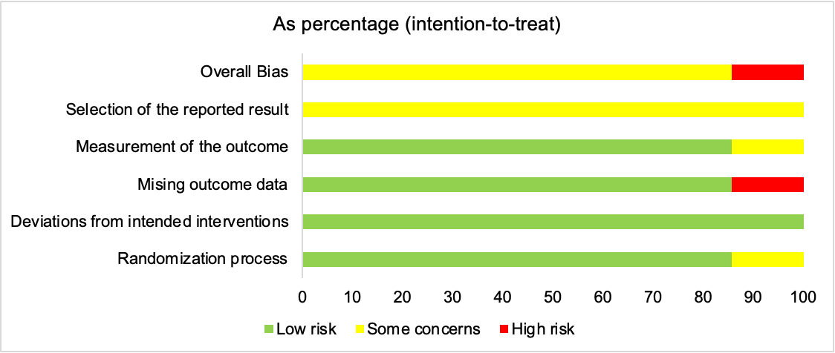
Supplementary Figure S1. Bar graphs of risk-of-bias assessment of included randomized controlled trials

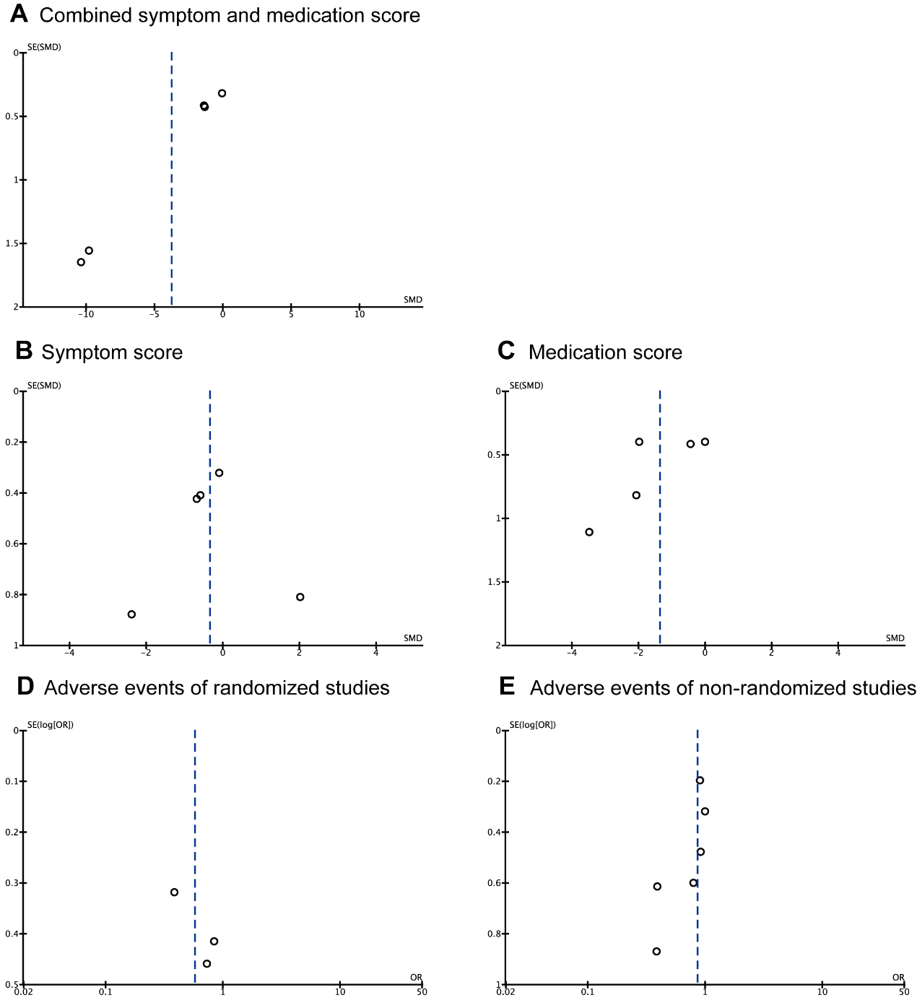
Supplementary Figure S2. Funnel plots of the efficacy and safety of multiallergen AIT in polysensitized AR patients. (A) Combined symptom score and medication score. (B) Symptom score. (C) Medication score. (D) Adverse events of randomized studies. (E) Adverse events of non-randomized studies.

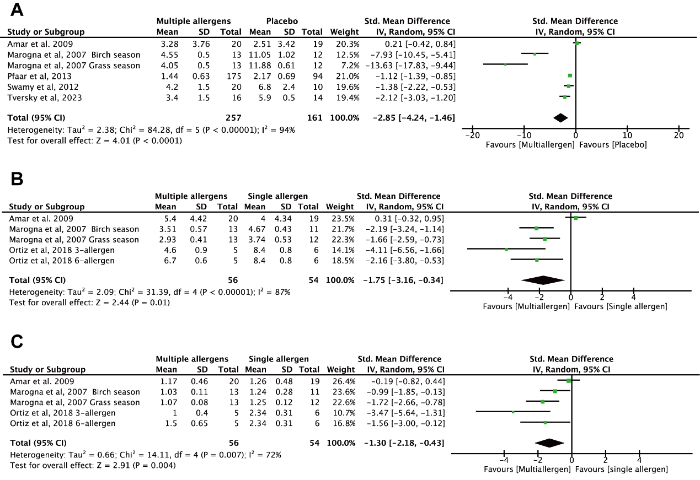
Supplementary Figure S3. Meta-analysis of (A) combined symptom and medication score; (B) symptom score; (C) medication score, at the last follow-up.

