Supplementary Material
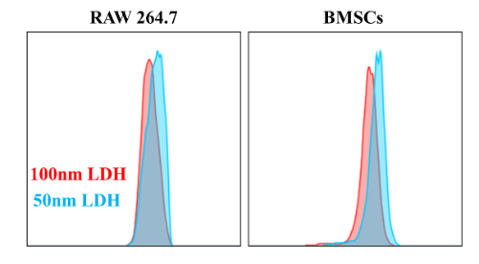
Figure S1. Flow-cytometric analysis of LDH uptake by macrophages and BMSCs.
Figure S2. Quantitative analyses of new bone area percentage and collagen deposition area.

Table S1. The qPCR primer used in this work.
Gene name | Forward primer (5’-3’) | Reverse primer (5’-3’)
Gapdh | AGTGCCAGCCTCGTCTCATA | TGAACTTGCCGTGGGTAGAG
Opn | TTGGCTTTGCAGTCTCCTGCGG | AGGCAAGGCCGAACAGGCAAA
Runx2 | CCATAACGGTCTTCACAAATCCT | TCTGTCTGTGCCTTCTTGGTTC
Ocn | GCTGCTACTGTGGAAGAGAAGG | CCACAGATGACTGAGAACGCCT
Bmp2 | CACGAAGAAGCCATCGAGGA | GCTTCCTGCATTTGTTCCCG
Il-4 | ATCATCGGCATTTTGAACGAGGTC | ACCTTGGAAGCCCTACAGACGA
Il-10 | GCTGGACAACATACTGCTAACC | ATTTCCGATAAGGCTTGGCAA
iNOS | GAGACAGGGAAGTCTGAAGCAC | CCAGCAGTAGTTGCTCCTCTTC
Il-1β | TGGACCTTCCAGGATGAGGACA | GTTCATCTCGGAGCCTGTAGTG
Dvl | ATCACACGCACCAGCTCTTCCT | AGTCCTGAGTCTGGCAACTGCA
β-catenin | GTTCGCCTTCATTATGGACTGCC | ATAGCACCCTGTTCCCGCAAAG
Rela | TCCTGTTCGAGTCTCCATGCAG | GGTCTCATAGGTCCTTTTGCGC
Fzd2 | CGCTTCCACTTTCTTCACGGTC | GGAGAACGAAGCCCGCAATGTA

Table S2. Descriptive statistics of M1 and M2 markers in macrophages.
Group | n | iNOS | Il-1β | Il-4 | Il-10
M0 | 3 | mean ± SD | mean ± SD | mean ± SD | mean ± SD
M1 | 3 | mean ± SD | mean ± SD | mean ± SD | mean ± SD
100 nm LDH | 3 | mean ± SD | mean ± SD | mean ± SD | mean ± SD
50 nm LDH | 3 | mean ± SD | mean ± SD | mean ± SD | mean ± SD
Table S3. Descriptive statistics of osteogenic markers in BMSCs.
Group | n | Ocn | Opn | Runx2 | Bmp2
Ctrl | 3 | mean ± SD | mean ± SD | mean ± SD | mean ± SD
100 nm LDH | 3 | mean ± SD | mean ± SD | mean ± SD | mean ± SD
50 nm LDH | 3 | mean ± SD | mean ± SD | mean ± SD | mean ± SD
Table S4. Descriptive statistics of micro-CT outcomes at 12 weeks.
Group | n | BV/TV | BMD
GelMA | 3 | mean ± SD | mean ± SD
GelMA-100 nm LDH | 3 | mean ± SD | mean ± SD
GelMA-50 nm LDH | 3 | mean ± SD | mean ± SD

