Supplementary material
Supplementary Table 1. Physiotherapeutic goals interventions and MobMS
Physiotherapeutic goals
Passive mobility
Cardiorespiratory endurance
Turning in bed
Changing position
Standing up and/or sitting down
Sitting
Standing
Transferring
Wheelchair mobility
Walking
Climbing stairs
Physiotherapeutic interventions
Respiratory therapy
Contracture prophylaxis
Pain management
Joint mobilization
Positioning
Wheelchair mobilization
Mobility training in bed
Transfer training
Standing training
Strength training
Balance training in sitting (e.g., edge-of-bed exercises)
Balance training in standing / gait balance training
Gait training
Stair training
Verticalization training
Group therapy
Endurance training
Wheelchair training
Adaptive physical activity / medical exercise therapy
Functional electrical stimulation
Relaxation therapy
Self-directed exercise practice
Physiotherapeutic MobMS
1 | Sitting in a wheelchair for one hour
2 | Turning to both sides in bed
3 | Sitting up at the edge of the bed (bilaterally)
4 | Dynamic unsupported sitting
5 | Independent transfer
6 | Independent wheelchair mobility
7 | Independent sit-to-stand
8 | Dynamic unsupported standing
9 | Walking with therapist assistance (with or without aid)
10 | Walking with assistive device
11 | Independent walking
12 | Walking distances on the ward level
13 | Walking distance ≥ 270 m
14 | Independent stair climbing
15 | Walking distance > 1 km

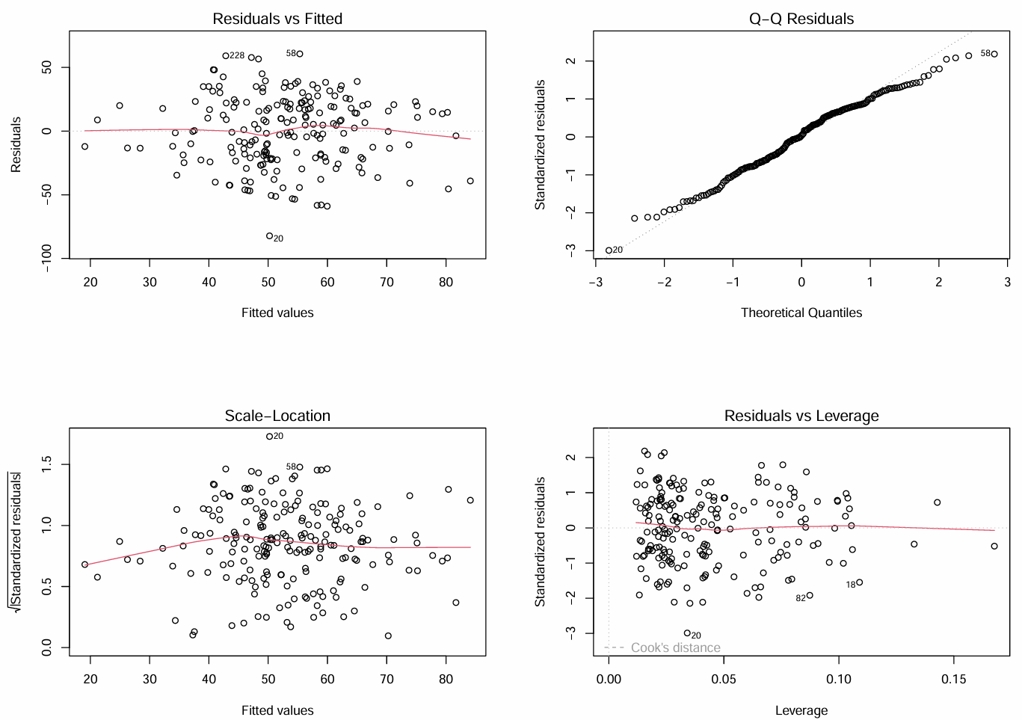
Supplementary Figure 1. Diagnostic plots for model assumptions. Note: Cook’s distance indicates influential observations in the regression model.

Supplementary Table 2. Bootstrap model frequencies
Model | Included predictors |  | Absolute frequency | Relative  frequency (%) | Cumulative frequency (%)
1 | Cerebral lesion; CIP/CIM; Sepsis; IPAQ; Duration mech. ventilation; ECS; Sex |  | 20 | 2.0 | 2.0
2 | Cerebral lesion; CIP/CIM; Sepsis; IPAQ; Frailty; Sex |  | 12 | 1.2 | 3.2
3 | Cerebral lesion; CIP/CIM; Sepsis; IPAQ; Duration mech. ventilation; Frailty |  | 11 | 1.1 | 4.3
4 | Cerebral lesion; CIP/CIM; Sepsis; IPAQ; Duration mech. ventilation; ECS; Sex; Diabetes |  | 11 | 1.1 | 5.4
5 | Cerebral lesion; CIP/CIM; Sepsis; Duration mech. ventilation; ECS; Sex |  | 9 | 0.9 | 6.3
6 | Cerebral lesion; CIP/CIM; Sepsis; IPAQ; Duration mech. ventilation; ECS; Sex; Age |  | 9 | 0.9 | 7.2
7 | Cerebral lesion; CIP/CIM; Sepsis; Duration mech. ventilation; Frailty |  | 8 | 0.8 | 8
8 | Cerebral lesion; CIP/CIM; Sepsis; IPAQ; Frailty; Frequency of physiotherapy interventions |  | 8 | 0.8 | 8.8
9 | Cerebral lesion; CIP/CIM; Sepsis; IPAQ; Duration mech. ventilation; ECS; Frailty |  | 7 | 0.7 | 9.5
10 | Cerebral lesion; CIP/CIM; Sepsis; Duration mech. ventilation; ECS; Frailty; Sex |  | 7 | 0.7 | 10.2
11 | Cerebral lesion; CIP/CIM; Sepsis; Duration mech. ventilation; ECS; Sex; Diabetes |  | 7 | 0.7 | 10.9
12 | Cerebral lesion; CIP/CIM; Sepsis; IPAQ; Frailty; Diabetes |  | 6 | 0.6 | 11.5
13 | Cerebral lesion; CIP/CIM; Duration mech. ventilation; ECS; Sex; Diabetes |  | 6 | 0.6 | 12.1
14 | Cerebral lesion; Sepsis; IPAQ; Duration mech. ventilation; ECS; Sex; Diabetes |  | 6 | 0.6 | 12.7
15 | Cerebral lesion; Sepsis; Duration mech. ventilation; ECS; Sex; Diabetes;  Frequency of physiotherapy interventions |  | 6 | 0.6 | 13.3
16 | Cerebral lesion; CIP/CIM; Sepsis; IPAQ; Duration mech. ventilation; ECS |  | 5 | 0.5 | 13.8
17 | Cerebral lesion; CIP/CIM; Sepsis; IPAQ; Frailty |  | 5 | 0.5 | 14.3
18 | Cerebral lesion; CIP/CIM; Duration mech. ventilation; Frailty |  | 5 | 0.5 | 14.8
19 | Cerebral lesion; CIP/CIM; Sepsis; IPAQ; Duration mech. ventilation; ECS; Frailty; Sex |  | 5 | 0.5 | 15.3
20 | Cerebral lesion; Sepsis; IPAQ; Duration mech. ventilation; ECS; Diabetes |  | 5 | 0.5 | 15.8

Supplementary Table 3. Parameterwise shrinkage factors and shrunken regression coefficients
Predictor | Parameterwise shrinkage factor | β-coefficient of selected model | Shrunken β-coefficient
CIP/CIM | 0.85 | -12.02 | -10.22
Frailty | 0.83 | -11.24 | -9.33
IPAQ | 0.80 | 0.001 | 0.0008
Duration mech. ventilation | 0.73 | -0.11 | -0.08
Cerebral lesion | 0.70 | -17.19 | -12.03
Sepsis | 0.68 | -8.48 | -5.77
ECS | 0.56 | -0.52 | -0.29
Sex | 0.35 | 6.03 | 2.11

