Supplementary Figures
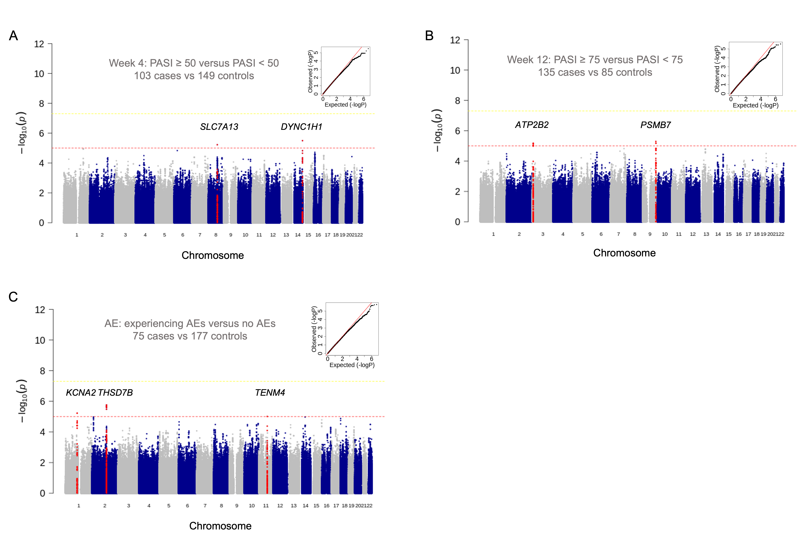
Figure S1. Manhattan plots of NB-UVB treatment response and adverse events in the management of psoriasis
(A) Manhattan plot shows a significant correlation between SNP loci in chromosome 8q21 and 14q32 regions and whether PASI 50 is reached at week 4; (B) Manhattan plot shows a significant correlation between SNP loci in chromosome 3p25 and 9q33 regions and whether PASI 75 is reached at week 12; (C) Manhattan plot shows a significant correlation between SNP loci in chromosome 1p13, 2q22 and 11q14 regions and whether AEs occur. (yellow threshold, 5×10⁻⁸; red threshold, 1×10⁻⁵). SNP, single-nucleotide polymorphism; PASI, psoriasis area and severity index; AE, adverse event; NB-UVB, narrow-band ultraviolet B.
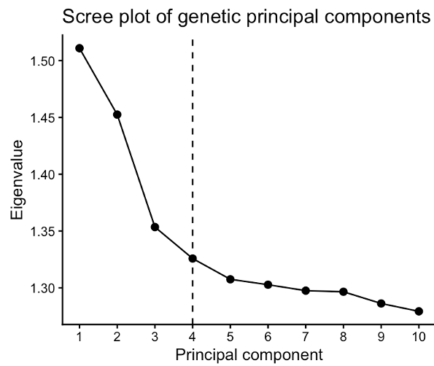
Figure S2. Scree plot of top 10 genetic PCs
PC, principal component.

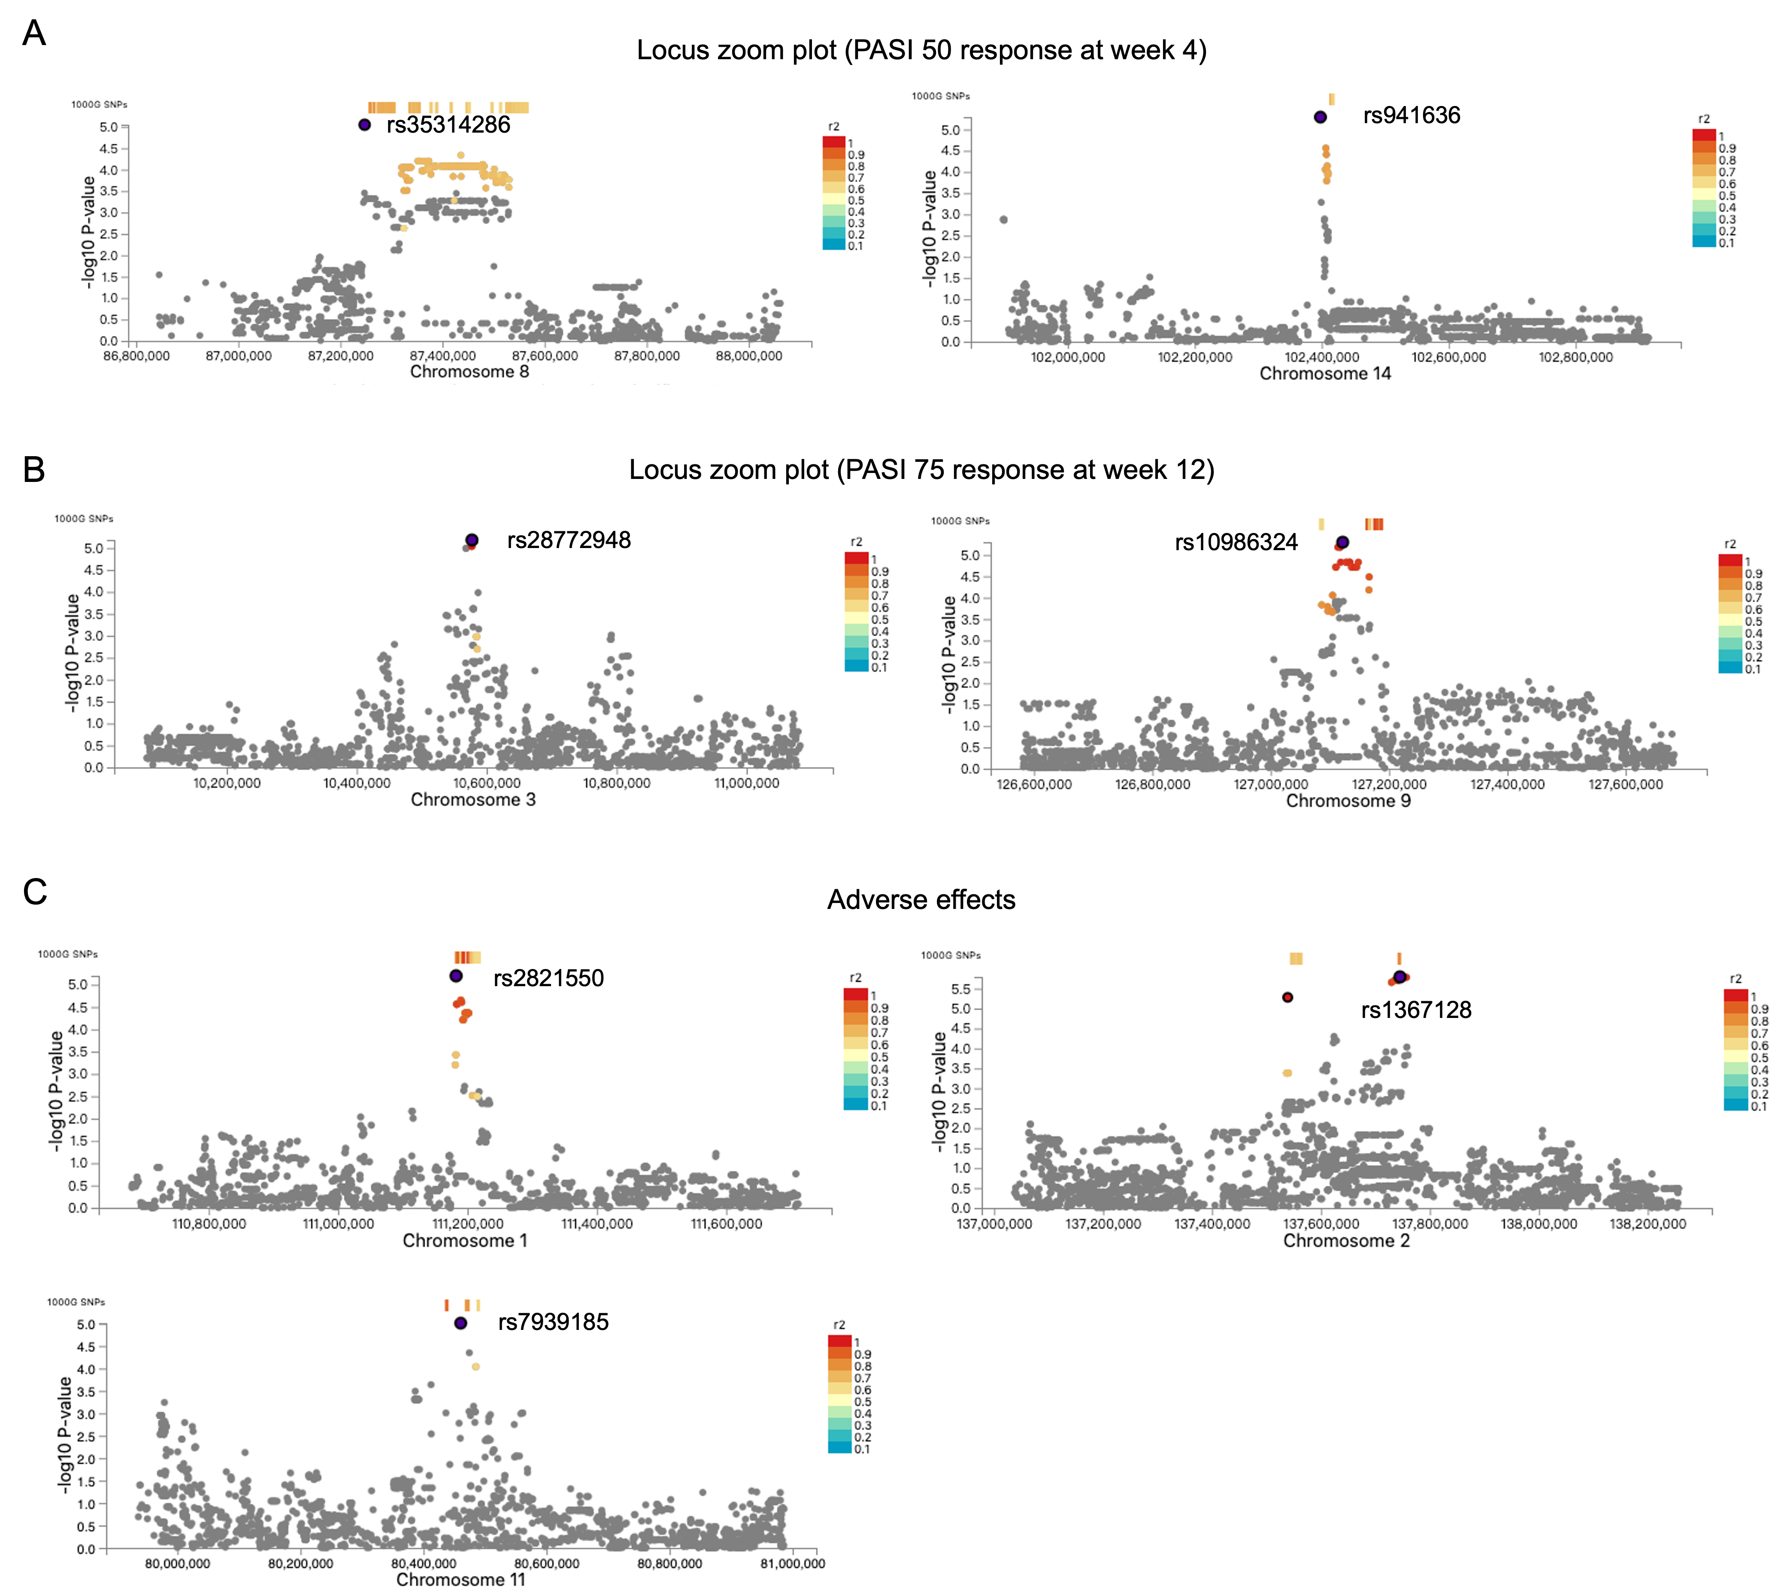
Figure S3. Regional association plot for the locus suggestively associated with NB-UVB treatment response and adverse events.
(A) Locus for PASI 50 response at week 4: SNPs rs35314286 (SLC7A13) on chromosome 8q21.13 and rs941636 (DYNC1H1) on chromosome 14q32.31; (B) Locus for PASI 75 response at week 12: SNPs rs28772948 (ATP2B2) on chromosome 3p25.3 and rs10986324 (PSMB7) on chromosome 9q33.3; (C) Locus for adverse events: SNPs rs2821550 (KCNA2) on chromosome 1p13.3, rs1367128 (THSD7B) on chromosome 2q22.1, and rs7939185 (TENM4) on chromosome 11q14.1. PASI, psoriasis area and severity index; AE, adverse event; SNP, single-nucleotide polymorphism; NB-UVB, narrow-band ultraviolet B.

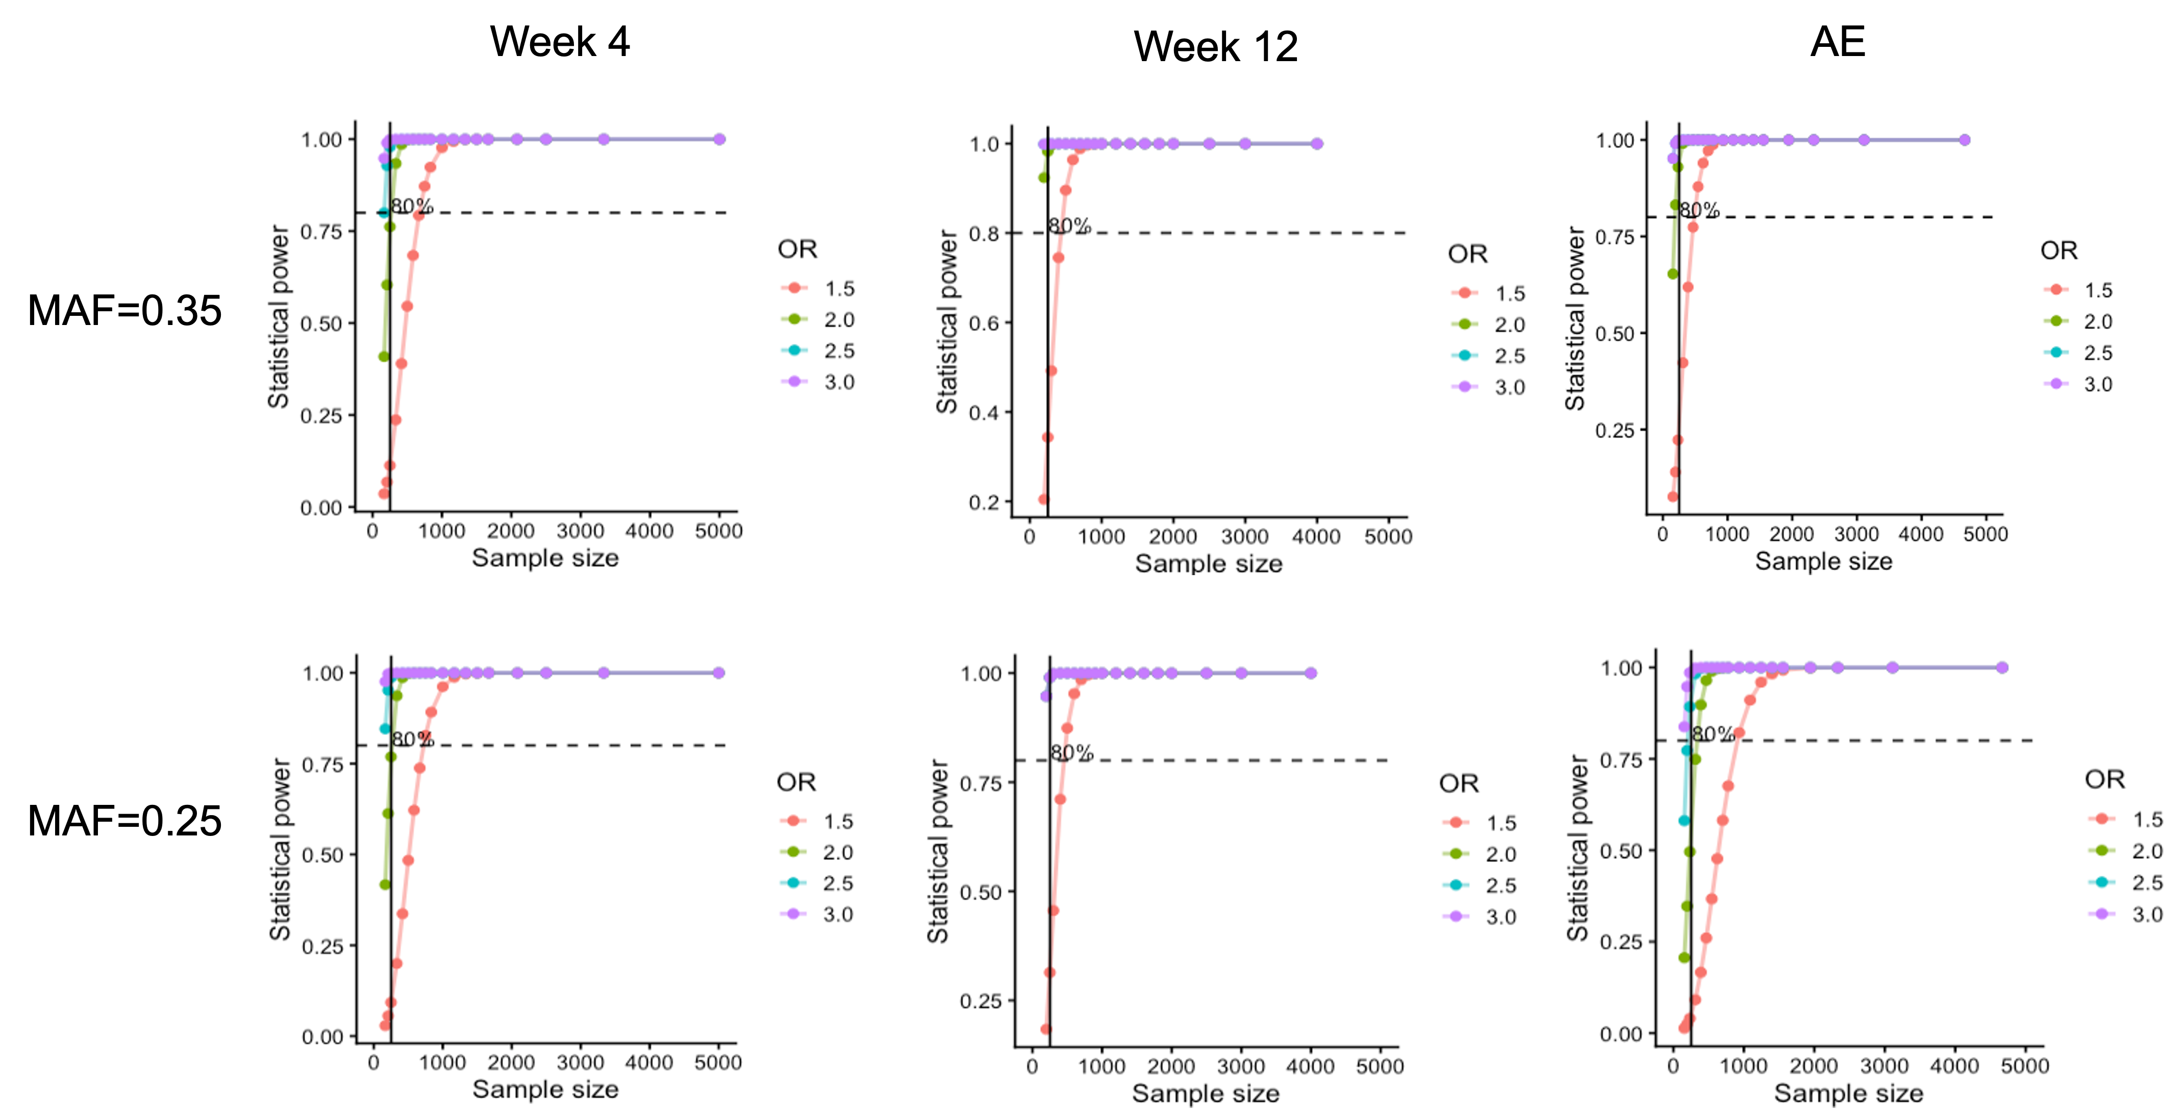
Figure S4. Post hoc power calculation for GWAS under different MAF and OR settings.
GWAS, genome-wide association study; MAF, minor allele frequency; OR, odds ratio; AE, adverse event.

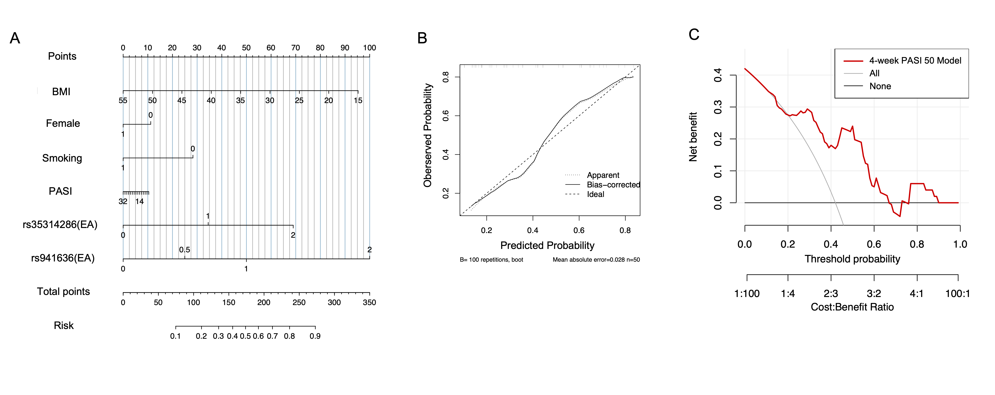
Figure S5. Predictive models of 4-week PASI 50 response for NB-UVB treatment in psoriasis
(A) 4-week PASI 50 response prediction nomogram; (B) Calibration curve evaluation of the difference between predicted and actual values of 4-week PASI 50 response prediction nomogram; (C) Decision curve analysis for the 4-week PASI 50 prediction model. pASI, Psoriasis area and severity index; NB-UVB, narrow-band ultraviolet B; EA, effect allele.
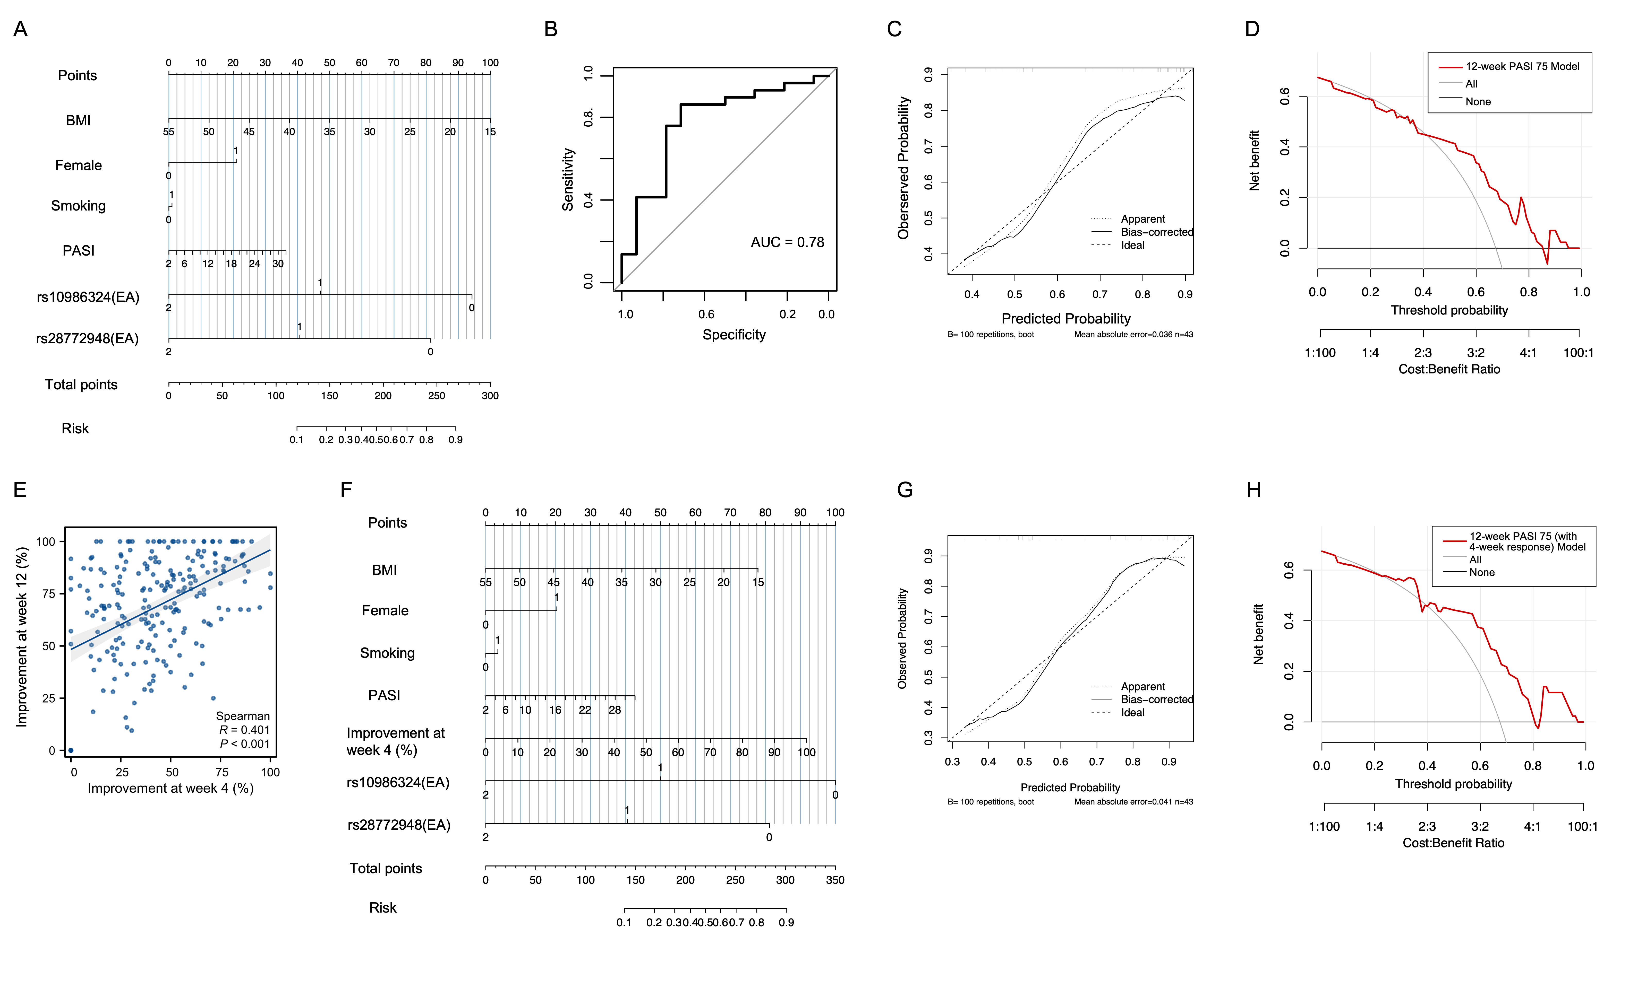
Figure S6. Predictive models of 12-week PASI 75 response to NB-UVB treatment in psoriasis
(A) Nomogram for predicting 12‑week PASI 75 response; (B) ROC curve of the 12-week PASI 75 response prediction model; (C) Calibration curve assessing the agreement between predicted and observed probabilities of the 12‑week PASI 75 response nomogram; (D) Decision-curve analysis of the 12-week PASI 75 prediction model; (E) Scatter plot showing the correlation between PASI score improvement at week 4 and week 12; (F) Nomogram for predicting 12‑week PASI 75 response incorporating 4‑week PASI response as a predictor; (G) Calibration curve for the 12-week PASI 75 prediction model with 4-week response added; (H) Decision-curve analysis for the 12-week PASI 75 prediction model with 4-week response added. PASI, psoriasis area and severity index; NB-UVB, narrow-band ultraviolet B; EA, effect allele; ROC, receiver operating characteristic; AUC, area under the curve.

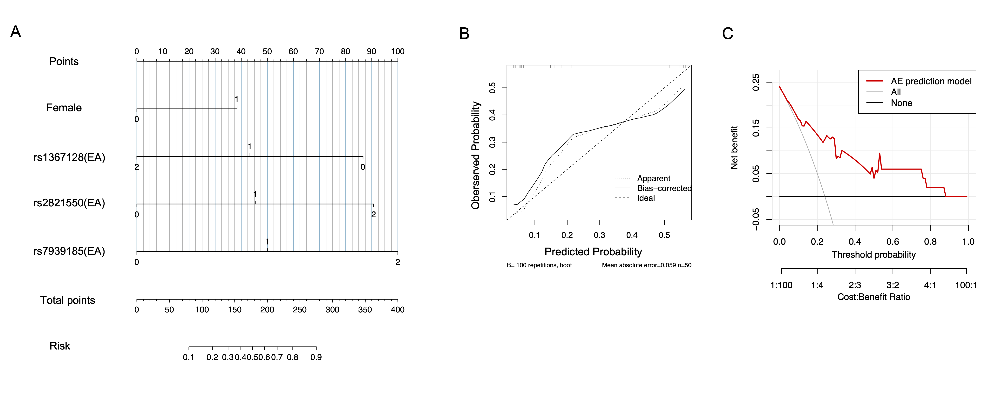Figure S7. Predictive models for adverse-event development during NB-UVB treatment in psoriasis
(A) Nomogram for predicting adverse‑event (AE) development; (B) Calibration curve assessing the agreement between predicted and observed probabilities of the AE‑development nomogram; (C) Decision-curve analysis of the AE prediction model. AE, adverse event; NB-UVB, narrow-band ultraviolet B; EA, effect allele.

Supplementary Tables
Table S1. Inclusion and exclusion criteria
Inclusion criteria | Exclusion criteria
Adults (age ≥ 18 years) | Other types of psoriasis or skin diseases that may affect disease assessment
Stable moderate-to-severe psoriasis for ≥ 6 months (PASI ≥ 5 and BSA ≥ 5%) | History of skin cancer or solar keratosis
No systemic treatment (acitretin, cyclosporine, methotrexate, ultraviolet phototherapy, biologics) within the last one month | History of photosensitive skin diseases or treatment with photosensitizing drugs
No topical treatment (topical corticosteroids, calcipotriol, or other anti-psoriatic agents) except emollients | Pregnant or breastfeeding women
Reduced sun exposure | Severe comorbidities
 | History of severe allergic reactions, especially allergy to ultraviolet light
 | Previous phototherapy with unsatisfactory response
 | Other conditions deemed unsuitable for the study

Table S2. Single-nucleotide polymorphisms correlated with PASI 50 response at week 4
SNP | Gene | VEP | CHR | MAF | EA | OA | OR | 95% CI | SE | P-value
rs35314286 | SLC7A13 | / | 8 | 0.346 | TA | T | 2.631 | 1.731-3.999 | 0.2136 | 5.96E-06
rs941636 | DYNC1H1 | downstream gene variant | 14 | 0.278 | A | G | 3.066 | 1.914-4.911 | 0.2404 | 3.15E-06
PASI, psoriasis area and severity index; SNP, single-nucleotide polymorphism; VEP, variant effect prediction; CHR, chromosome; MAF, minor allele frequency; EA, effect allele; OA, other allele; OR, odds ratio; CI, confidence interval; SE, standard error.

Table S3. Single-nucleotide polymorphisms correlated with PASI 75 response at week 12
SNP | Gene | VEP | CHR | MAF | EA | OA | OR | 95% CI | SE | P-value
rs9841486 | ATP2B2 | intron variant | 3 | 0.4646 | T | C | 2.817 | 1.783-4.451 | 0.2333 | 9.00E-06
rs9310365 | ATP2B2 | intron variant | 3 | 0.4646 | T | G | 2.817 | 1.783-4.451 | 0.2333 | 9.00E-06
rs12714854 | ATP2B2 | intron variant | 3 | 0.3657 | T | G | 0.3348 | 0.2073-0.5407 | 0.2446 | 7.66E-06
rs12714855 | ATP2B2 | intron variant | 3 | 0.3657 | C | A | 0.3348 | 0.2073-0.5407 | 0.2446 | 7.66E-06
rs28772948 | ATP2B2 | intron variant | 3 | 0.3638 | C | A | 0.3300 | 0.2044-0.5329 | 0.2444 | 5.76E-06
rs7642750 | ATP2B2 | intron variant | 3 | 0.3633 | A | C | 0.3319 | 0.2056-0.5359 | 0.2444 | 6.39E-06
rs6783783 | ATP2B2 | intron variant | 3 | 0.3633 | A | C | 0.3319 | 0.2056-0.5359 | 0.2444 | 6.39E-06
rs1323761 | PSMB7 | intron variant | 9 | 0.3037 | T | C | 0.3039 | 0.1836-0.503 | 0.2571 | 3.62E-06
rs1330811 | PSMB7 | intron variant | 9 | 0.3037 | A | G | 0.3039 | 0.1836-0.503 | 0.2571 | 3.62E-06
rs7857897 | PSMB7 | intron variant | 9 | 0.2981 | A | G | 0.3245 | 0.1978-0.5324 | 0.2526 | 8.36E-06
rs10986324 | PSMB7 | intron variant | 9 | 0.3019 | C | T | 0.2996 | 0.181-0.4961 | 0.2573 | 2.81E-06
rs6478658 | PSMB7 | intron variant | 9 | 0.2981 | A | G | 0.3245 | 0.1978-0.532 | 0.2526 | 8.36E-06
rs6478659 | PSMB7 | intron variant | 9 | 0.2981 | A | G | 0.3245 | 0.1978-0.532 | 0.2526 | 8.36E-06
rs3758207 | PSMB7 | intron variant | 9 | 0.2981 | G | A | 0.3245 | 0.1978-0.532 | 0.2526 | 8.36E-06
rs7854989 | PSMB7 | intron variant | 9 | 0.2981 | C | T | 0.3245 | 0.1978-0.532 | 0.2526 | 8.36E-06
rs6478660 | PSMB7 | intron variant | 9 | 0.2981 | T | A | 0.3245 | 0.1978-0.532 | 0.2526 | 8.36E-06
rs17315546 | PSMB7 | intron variant | 9 | 0.2981 | T | C | 0.3245 | 0.1978-0.532 | 0.2526 | 8.36E-06
PASI, psoriasis area and severity index; SNP, single-nucleotide polymorphism; VEP, variant effect prediction; CHR, chromosome; MAF, minor allele frequency; EA, effect allele; OA, other allele; OR, odds ratio; CI, confidence interval; SE, standard error.

Table S4. Single-nucleotide polymorphisms correlated with adverse effects
SNP | Gene | VEP | CHR | MAF | EA | OA | OR | 95% CI | SE | P-value
rs2821550 | KCNA2 | regulatory region variant | 1 | 0.4296 | G | T | 2.908 | 1.832-4.617 | 0.2358 | 5.97E-06
rs2640498 | KCNA2 | regulatory region variant | 1 | 0.4296 | A | G | 2.908 | 1.832-4.617 | 0.2358 | 5.97E-06
rs2251313 | THSD7B | intron variant | 2 | 0.3177 | A | G | 0.2752 | 0.1598-0.4741 | 0.2775 | 3.32E-06
rs1346736 | THSD7B | intron variant | 2 | 0.4272 | G | C | 0.3249 | 0.2033-0.5192 | 0.2392 | 2.60E-06
2:137734995 | THSD7B | / | 2 | 0.4235 | A | ATTT | 0.3231 | 0.2024-0.5159 | 0.2387 | 2.21E-06
rs7567733 | THSD7B | intron variant | 2 | 0.4235 | A | G | 0.3231 | 0.2024-0.5159 | 0.2387 | 2.21E-06
rs7573891 | THSD7B | intron variant | 2 | 0.4235 | T | G | 0.3231 | 0.2024-0.5159 | 0.2387 | 2.21E-06
rs1367128 | THSD7B | intron variant | 2 | 0.4179 | A | G | 0.3148 | 0.1961-0.5055 | 0.2416 | 1.72E-06
rs1897419 | THSD7B | intron variant | 2 | 0.4204 | G | A | 0.3148 | 0.1958-0.5062 | 0.2423 | 1.85E-06
rs7939185 | TENM4 | downstream gene variant | 11 | 0.2929 | T | C | 3.069 | 1.867-5.043 | 0.2535 | 9.73E-06
SNP, single-nucleotide polymorphism; VEP, variant effect prediction; CHR, chromosome; MAF, minor allele frequency; EA, effect allele; OA, other allele; OR, odds ratio; CI, confidence interval; SE, standard error.

Table S5. Associated phenotypes of single-nucleotide polymorphisms correlated with PASI 50 response at week 4
Phenotypes | SNP | EA | OA | Beta | P-value | Study ID | Author (Year)
Vitamin D deficiency | rs941636 | G | A | -0.461 | 0.0037 | FINNGEN_R6_E4_VIT_D_DEF | FINNGEN_R6 (2022)
Interleukin 15 receptor subunit alpha levels | rs941636 | G | A | -0.282 | 3×10⁻⁵ | PMID:32641083  GCST90000474 | Hillary RF (2020)
PASI, psoriasis area and severity index; SNP, single-nucleotide polymorphism; EA, effect allele; OA, other allele; Beta, regression coefficient.

Table S6. Associated phenotypes of single-nucleotide polymorphisms correlated with PASI 75 response at week 12
Phenotypes | SNP | EA | OA | Beta | P-value | Study ID | PMID | Author (Year)
CXCL9 levels | rs12714854 | G | T | 0.187 | 0.0045 | GCST90000463 | PMID:32641083 | Hillary RF (2020)
CXCL9 levels | rs12714855 | A | C | 0.221 | 0.0010 | GCST90000463 | PMID:32641083 | Hillary RF (2020)
CXCL9 levels | rs28772948 | A | C | 0.188 | 0.0044 | GCST90000463 | PMID:32641083 | Hillary RF (2020)
CXCL9 levels | rs7642750 | C | A | 0.221 | 0.0012 | GCST90000463 | PMID:32641083 | Hillary RF (2020)
CXCL9 levels | rs6783783 | C | A | 0.215 | 0.0014 | GCST90000463 | PMID:32641083 | Hillary RF (2020)
CXCL10 levels | rs1330811 | A | G | -0.129 | 0.0034 | GCST90000463 | PMID:32641083 | Hillary RF (2020)
CXCL10 levels | rs10986324 | C | T | -0.126 | 0.0043 | GCST90000463 | PMID:32641083 | Hillary RF (2020)
CXCL10 levels | rs6478658 | G | A | 0.126 | 0.0044 | GCST90000463 | PMID:32641083 | Hillary RF (2020)
CXCL10 levels | rs6478659 | G | A | 0.126 | 0.0044 | GCST90000463 | PMID:32641083 | Hillary RF (2020)
CXCL10 levels | rs3758207 | G | A | -0.125 | 0.0049 | GCST90000463 | PMID:32641083 | Hillary RF (2020)
Interleukin 15 receptor subunit alpha levels | rs1330811 | A | G | -0.145 | 0.00099 | GCST90000474 | PMID:32641083 | Hillary RF (2020)
Interleukin 15 receptor subunit alpha levels | rs10986324 | C | T | -0.146 | 0.00098 | GCST90000474 | PMID:32641083 | Hillary RF (2020)
Interleukin 15 receptor subunit alpha levels | rs6478658 | G | A | 0.144 | 0.0011 | GCST90000474 | PMID:32641083 | Hillary RF (2020)
Interleukin 15 receptor subunit alpha levels | rs6478659 | G | A | 0.144 | 0.0011 | GCST90000474 | PMID:32641083 | Hillary RF (2020)
Interleukin 15 receptor subunit alpha levels | rs3758207 | G | A | -0.144 | 0.0011 | GCST90000474 | PMID:32641083 | Hillary RF (2020)
Interleukin 15 receptor subunit alpha levels | rs7854989 | C | T | -0.146 | 0.00099 | GCST90000474 | PMID:32641083 | Hillary RF (2020)
Interleukin 15 receptor subunit alpha levels | rs6478660 | T | A | -0.144 | 0.0012 | GCST90000474 | PMID:32641083 | Hillary RF (2020)
Interleukin 15 receptor subunit alpha levels | rs17315546 | T | C | -0.137 | 0.0021 | GCST90000474 | PMID:32641083 | Hillary RF (2020)
PASI, psoriasis area and severity index; SNP, single-nucleotide polymorphism; EA, effect allele; OA, other allele; Beta, regression coefficient.

Table S7. Associated phenotypes of single-nucleotide polymorphisms correlated with NB-UVB adverse events
Phenotypes | SNP | EA | OA | Beta | P-value | Study ID | PMID | Author (Year)
Tumor necrosis factor receptor 2 levels | rs2821550 | T | G | 0.130 | 0.0022 | GCST90010267 | PMID:33303764 | Gilly A (2020)
Tumor necrosis factor receptor 2 levels | rs2640498 | G | A | 0.134 | 0.0016 | GCST90010267 | PMID:33303764 | Gilly A (2020)
Interleukin-18 levels | rs2640498 | G | A | 0.122 | 0.0039 | GCST90010141 | PMID:33303764 | Gilly A (2020)
Melanoma in situ of trunk | rs1346736 | C | G | 0.513 | 0.0022 | FINNGEN_R6_CD2_INSITU_MELANOMA_TRUNK | / | FINNGEN_R6 (2022)
Melanoma in situ of trunk | rs7567733 | G | A | 0.518 | 0.0020 | FINNGEN_R6_CD2_INSITU_MELANOMA_TRUNK | / | FINNGEN_R6 (2022)
Melanoma in situ of trunk | rs7573891 | G | T | 0.518 | 0.0020 | FINNGEN_R6_CD2_INSITU_MELANOMA_TRUNK | / | FINNGEN_R6 (2022)
Melanoma in situ of trunk | rs1367128 | G | A | 0.518 | 0.0021 | FINNGEN_R6_CD2_INSITU_MELANOMA_TRUNK | / | FINNGEN_R6 (2022)
Melanoma in situ of trunk | rs1897419 | A | G | 0.519 | 0.0020 | FINNGEN_R6_CD2_INSITU_MELANOMA_TRUNK | / | FINNGEN_R6 (2022)
SNP, single-nucleotide polymorphism; EA, effect allele; OA, other allele; Beta, regression coefficient.
Table S8. Sensitivity analysis of SNPs associated with PASI 50 response at week 4 after adjustment for PC1-10.
SNP | OR | SE | L95 | U95 | STAT | P-value
rs35314286 | 2.846 | 0.2223 | 1.841 | 4.399 | 4.705 | 2.54E-06
rs941636 | 3.109 | 0.2457 | 1.921 | 5.032 | 4.617 | 3.90E-06
PASI, psoriasis area and severity index; SNP, single-nucleotide polymorphism; PC, principal component; OR, odds ratio; SE, standard error; L95, lower bound of 95% confidence interval; U95, upper bound of 95% confidence interval; STAT, Z-statistic (β/SE).

Table S9. Sensitivity analysis of SNPs associated with PASI 75 response at week 12 after adjustment for PC1-10.
SNP | OR | SE | L95 | U95 | STAT | P-value
rs9841486 | 2.841 | 0.2419 | 1.768 | 4.565 | 4.317 | 1.58E-05
rs9310365 | 2.841 | 0.2419 | 1.768 | 4.565 | 4.317 | 1.58E-05
rs12714854 | 0.3134 | 0.2563 | 0.1897 | 0.5179 | -4.528 | 5.97E-06
rs12714855 | 0.3134 | 0.2563 | 0.1897 | 0.5179 | -4.528 | 5.97E-06
rs28772948 | 0.3084 | 0.2562 | 0.1867 | 0.5096 | -4.591 | 4.41E-06
rs7642750 | 0.3108 | 0.256 | 0.1882 | 0.5134 | -4.564 | 5.01E-06
rs6783783 | 0.3108 | 0.256 | 0.1882 | 0.5134 | -4.564 | 5.01E-06
rs1323761 | 0.3177 | 0.2598 | 0.1909 | 0.5286 | -4.414 | 1.01E-05
rs1330811 | 0.3177 | 0.2598 | 0.1909 | 0.5286 | -4.414 | 1.01E-05
rs7857897 | 0.3399 | 0.255 | 0.2062 | 0.5603 | -4.232 | 2.32E-05
rs10986324 | 0.3125 | 0.26 | 0.1878 | 0.5202 | -4.474 | 7.69E-06
rs6478658 | 0.3399 | 0.255 | 0.2062 | 0.5603 | -4.232 | 2.32E-05
rs6478659 | 0.3399 | 0.255 | 0.2062 | 0.5603 | -4.232 | 2.32E-05
rs3758207 | 0.3399 | 0.255 | 0.2062 | 0.5603 | -4.232 | 2.32E-05
rs7854989 | 0.3399 | 0.255 | 0.2062 | 0.5603 | -4.232 | 2.32E-05
rs6478660 | 0.3399 | 0.255 | 0.2062 | 0.5603 | -4.232 | 2.32E-05
rs17315546 | 0.3399 | 0.255 | 0.2062 | 0.5603 | -4.232 | 2.32E-05
PASI, psoriasis area and severity index; SNP, single-nucleotide polymorphism; PC, principal component; OR, odds ratio; SE, standard error; L95, lower bound of 95% confidence interval; U95, upper bound of 95% confidence interval; STAT, Z-statistic (β/SE).

Table S10. Sensitivity analysis of SNPs associated with adverse effects after adjustment for PC1-10.
SNP | OR | SE | L95 | U95 | STAT | P-value
rs2821550 | 2.929 | 0.2436 | 1.817 | 4.722 | 4.412 | 1.02E-05
rs2640498 | 2.929 | 0.2436 | 1.817 | 4.722 | 4.412 | 1.02E-05
rs2251313 | 0.2739 | 0.2863 | 0.1563 | 0.4801 | -4.523 | 6.10E-06
rs1346736 | 0.3191 | 0.2476 | 0.1964 | 0.5184 | -4.613 | 3.97E-06
2:137734995 | 0.3184 | 0.2469 | 0.1963 | 0.5166 | -4.635 | 3.58E-06
rs7567733 | 0.3184 | 0.2469 | 0.1963 | 0.5166 | -4.635 | 3.58E-06
rs7573891 | 0.3184 | 0.2469 | 0.1963 | 0.5166 | -4.635 | 3.58E-06
rs1367128 | 0.3102 | 0.25 | 0.19 | 0.5062 | -4.683 | 2.82E-06
rs1897419 | 0.309 | 0.251 | 0.189 | 0.5054 | -4.679 | 2.89E-06
rs7939185 | 3.027 | 0.2633 | 1.807 | 5.07 | 4.207 | 2.59E-05
SNP, single-nucleotide polymorphism; PC, principal component; OR, odds ratio; SE, standard error; L95, lower bound of 95% confidence interval; U95, upper bound of 95% confidence interval; STAT, Z-statistic (β/SE).

Table S11. Optimal cut-off values, sensitivity, and specificity of ROC models for NB-UVB treatment response in psoriasis
Model | Optimal cut-off | Sensitivity (%) | Specificity (%) | AUC
4-week PASI 50 | 0.496 | 71.4 | 89.7 | 0.81
12-week PASI 75 | 0.360 | 86.2 | 71.4 | 0.78
12-week PASI 75 (with 4-week response) | 0.541 | 72.4 | 85.7 | 0.80
AE prediction | 0.264 | 91.7 | 68.4 | 0.85
PASI, psoriasis area and severity index; NB-UVB, Narrow-band Ultraviolet B; ROC, receiver operating characteristic; AUC, area under the curve; AE, adverse event.

Table S12. Calibration metrics of predictive models for NB-UVB treatment response in psoriasis
Model | Hosmer-Lemeshow χ² | df | P-value | Brier score
4-week PASI 50 | 4.115 | 3 | 0.249 | 0.181
12-week PASI 75 | 4.882 | 3 | 0.181 | 0.192
12-week PASI 75 (with 4-week response) | 7.171 | 3 | 0.067 | 0.176
AE prediction | 2.942 | 3 | 0.401 | 0.125
NB-UVB, narrow-band ultraviolet B; PASI, psoriasis area and severity index; AE, adverse event; df, degrees of freedom; χ², chi-squared.

Table S13. Repeated 5-fold cross-validation performance (100 repeats) of predictive models for NB-UVB treatment response in psoriasis
Model | AUC | AUC 95% CI lower | AUC 95% CI upper
4-week PASI 50 | 0.709 | 0.702 | 0.715
12-week PASI 75 | 0.749 | 0.742 | 0.755
12-week PASI 75 (with 4-week response) | 0.775 | 0.769 | 0.782
AE prediction | 0.775 | 0.768 | 0.781
NB-UVB, narrow-band ultraviolet B; PASI, psoriasis area and severity index; AE, adverse event; AUC, area under the curve; CI, confidence interval.

Table S14. Interaction effects between candidate SNPs and clinical variables
Endpoint | SNP | Clinical variable | OR (95% CI) | P-value
4-week PASI 50 | rs35314286 | PASI | 0.96 (0.87 - 1.07) | 0.481
4-week PASI 50 | rs35314286 | Female | 1.87 (0.63 - 6.10) | 0.275
4-week PASI 50 | rs35314286 | BMI | 1.00 (0.90 - 1.13) | 0.95
4-week PASI 50 | rs35314286 | Smoking | 1.30 (0.53 - 3.17) | 0.567
4-week PASI 50 | rs941636 | PASI | 1.00 (0.90 - 1.10) | 0.956
4-week PASI 50 | rs941636 | Female | 1.13 (0.38 - 3.60) | 0.829
4-week PASI 50 | rs941636 | BMI | 0.94 (0.82 - 1.07) | 0.311
4-week PASI 50 | rs941636 | Smoking | 1.26 (0.47 - 3.43) | 0.643
12-week PASI 75 | rs10986324 | BMI | 0.89 (0.77 - 1.01) | 0.085
12-week PASI 75 | rs10986324 | Female | 0.61 (0.18 - 1.87) | 0.405
12-week PASI 75 | rs10986324 | Smoking | 1.26 (0.45 - 3.58) | 0.658
12-week PASI 75 | rs10986324 | PASI | 0.91 (0.79 - 1.03) | 0.195
12-week PASI 75 | rs28772948 | BMI | 0.99 (0.86 - 1.13) | 0.828
12-week PASI 75 | rs28772948 | Female | 1.81 (0.61 - 5.34) | 0.281
12-week PASI 75 | rs28772948 | Smoking | 1.36 (0.49 - 3.88) | 0.563
12-week PASI 75 | rs28772948 | PASI | 1.08 (0.97 - 1.19) | 0.135
AE | rs1367128 | Female | 0.92 (0.35 - 2.29) | 0.861
AE | rs2821550 | Female | 1.05 (0.42 - 2.73) | 0.917
AE | rs7939185 | Female | 0.96 (0.35 - 2.74) | 0.938
PASI, psoriasis area and severity index; AE, adverse event; OR, odds ratio; CI, confidence interval.

