Physicochemical Stability and Cross-Context Validation of PEGylated Human Serum Albumin Nanoparticles for Dual Neurotrophin Delivery in the Rabbit Eye and Oxidative Stress Models
Iga Stukan^{1,*,}, Maria Dąbkowska^{2,*}, Anna Machalińska³ , Karolina Łuczkowska¹, Kamila Pukacka², Monika Wasilewska⁴, Patrycja Stodolak¹, Mateusz Winiarczyk⁵, Dagmara Winiarczyk⁶, Jowita Zwolska⁷, Barbara Kuduk⁷, Mateusz Szadkowski⁷, Ireneusz Balicki⁷, Miłosz Kawa¹, Bogusław Machaliński¹

Supplementary Information

6-OHDA | NaIO₃
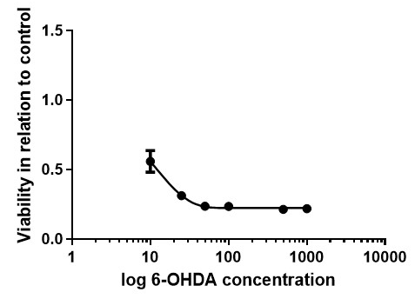 | 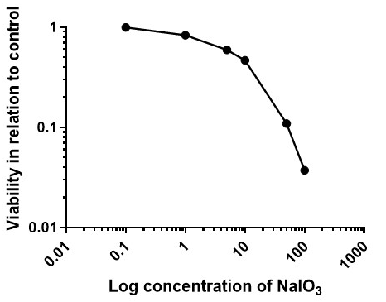
  6-OHDA [µM] | Mean viability (in relation to control) [%] | SD  [%]
  0 | 100 | 0
  10 | 56 | 1
  25 | 31 | 1
  50 | 24 | 3
  100 | 22 | 2
  NaIO₃ [mM] | Mean viability (in relation to control) [%] | SD  [%]
  0 | 100 | 7
  1 | 83 | 13
  5 | 59 | 7
  10 | 47 | 11
  50 | 11 | 1
  100 | 4 | 0

Supplementary Figure 1. Dose–response optimization of oxidative stress induction in ARPE-19 and RA-differentiated SH-SY5Y cells. ARPE-19 cells were exposed to increasing concentrations of NaIO₃, whereas RA-differentiated SH-SY5Y cells were exposed to increasing concentrations of 6-OHDA. The selected concentrations, 10 mM NaIO₃ and 25 µM 6-OHDA, induced robust but incomplete cellular injury and preserved a measurable dynamic range for subsequent nanoparticle treatment experiments. Data are presented as mean ± SD.

Supplementary table 1. The sequences of RT-qPCR primers for the target genes in rabbits.
Gene target | Primer sequence 5’ -> 3’
Oc-AKT1 | rabAktR ACTCCATGCTGTCATCTGCG  rabAktF CAGGACCACGAGAAGCTGTT
Oc-Mknk1 | rabMAPK1R TAAATGAGGGCCACATCTCGG  rabMAPK1F ATGGACCTGACGCTCTTCGC
Oc-Mapkapk2 | rabMAPK2R TCATAGACGTCCACGATGCG  rabMAPK2F AAGATGCTTCAGGACTGCCC
Oc-Mapkapk3 | rabMAPK3R TTGTTGAGGAGCCGGTTGTT  rabMAPK3F CGGTGACGGATGACTACCAG
Oc-Tp53 | rabP53R CACAGGGCAGGTCTTTGCTA  rabP53F GACACGCTCTCCTGAGGACT
Oc- Nkap | rabNFkBR TGACTGAGGCCATTCCGTTC  rabNFkBF AACGATTCCCAAGGTTCCCC
Oc-Cnksr2 | rabRASR TTGTGCTGCAGAGAGGACTG  rabRASF AGAGGACCCGAGTGGTGTTA
Oc-crebbp | rabCREBR CAGGAGCTCCGACAGTTGTT  rabCREBF CCAAACGAGCCAAACTCAGC
Oc-MTOR | rabmTORF CTGCCTGCCGATTGGTCTTC  rabmTORR AGCATCTTGCCCTGAGGTTC
Oc-PCNA | rabPCNAF GCACGTATATGCCGAGACCT  rabPCNAR CACTGGCGGAAAACTTCACC
Oc-BCL2 | rabBcl2F TTTTTCAACAGAGCGGTGCG  rabBcl2R GGCCAAGTCCCACTATTGCT
Oc-CASP3 | RabCasp3FGCAAATCAATGGACTCTGGGAA  rabCasp3R CCCCACTGTCTGTCTCGATG
Oc-Gapdh | rabGapdhF AGGTCGGTGTGAACGGATTTG  rabGapdhR TGTAGACCATGTAGTTGAGGTCA

Supplementary table 2. The sequences of RT-qPCR primers for the target genes in humans.
Gene | Primer sequence 5’ -> 3’
FCGRT | AAACCTGGAGTGGAAGGAGC  GGTAGAAGGAGAAGGCGCTG
SPARC | AAGAAGGGCCACAAGCTCCA  TTCTTGAGCCAGTCCCGCAT
CREB | TGGGAGAAGCGGAGTGTTGG  CCCGGATCTCGCTGGAGTTT
TRKB | CTGGTGCATTCCATTCACTG  CGTGGTACTCCGTGTGATTG
TRKC | TGGCTGGACTATGTGGGCT  CCCATTGCTGTTCCCTGAATC
P75^{NTR} | CCTACGGCTACTACCAGGATG  CACACGGTGTTCTGCTTGTC
GAPDH | GGTTCACACCCATGACGAAC  GAGTCCACTGGCGTCTTCAC

Supplementary Figure 2. Representative HPLC chromatograms of MDA standards and biological samples used for lipid peroxidation analysis.
(A) Representative chromatograms of MDA calibration standards prepared from tetraethoxypropane (TEP) and derivatized with thiobarbituric acid (TBA) prior to reverse-phase HPLC analysis. The chromatograms demonstrate concentration-dependent fluorescence signals of the MDA-(TBA)₂ adduct with highly reproducible retention times ranging from approximately 5.09 to 5.14 min. (B) Representative chromatograms obtained from ARPE-19 cell culture supernatants following oxidative stress induction and nanoparticle treatment. The MDA-(TBA)₂ adduct peak was detected at approximately 5.07–5.10 min, confirming consistent chromatographic separation and reliable identification of lipid peroxidation products in biological samples. (C) Calibration curve for MDA quantification using TEP standards. Linear regression analysis of tetraethoxypropane (TEP)-derived MDA standards used for HPLC-based quantification of lipid peroxidation products. The calibration curve demonstrates a linear relationship between fluorescence signal intensity (LU) and MDA concentration (µmol/L) within the tested concentration range, MDA concentrations were quantified using an Agilent 1260 Infinity II HPLC system equipped with a BDS Hypersil C18 column and fluorescence detection (Ex 528 nm, Em 553 nm). Separation was performed using a KH₂PO₄/methanol (70:30, v/v) mobile phase at a flow rate of 0.5 mL/min with a total run time of 6.5 min. Quantification was based on integration of retention times and peak areas relative to the TEP calibration curve. The chromatograms demonstrated reproducible retention times for the MDA-(TBA)₂ adduct, ranging from approximately 5.07 to 5.14 min, confirming reliable chromatographic separation and peak identification across both calibration standards and biological samples.
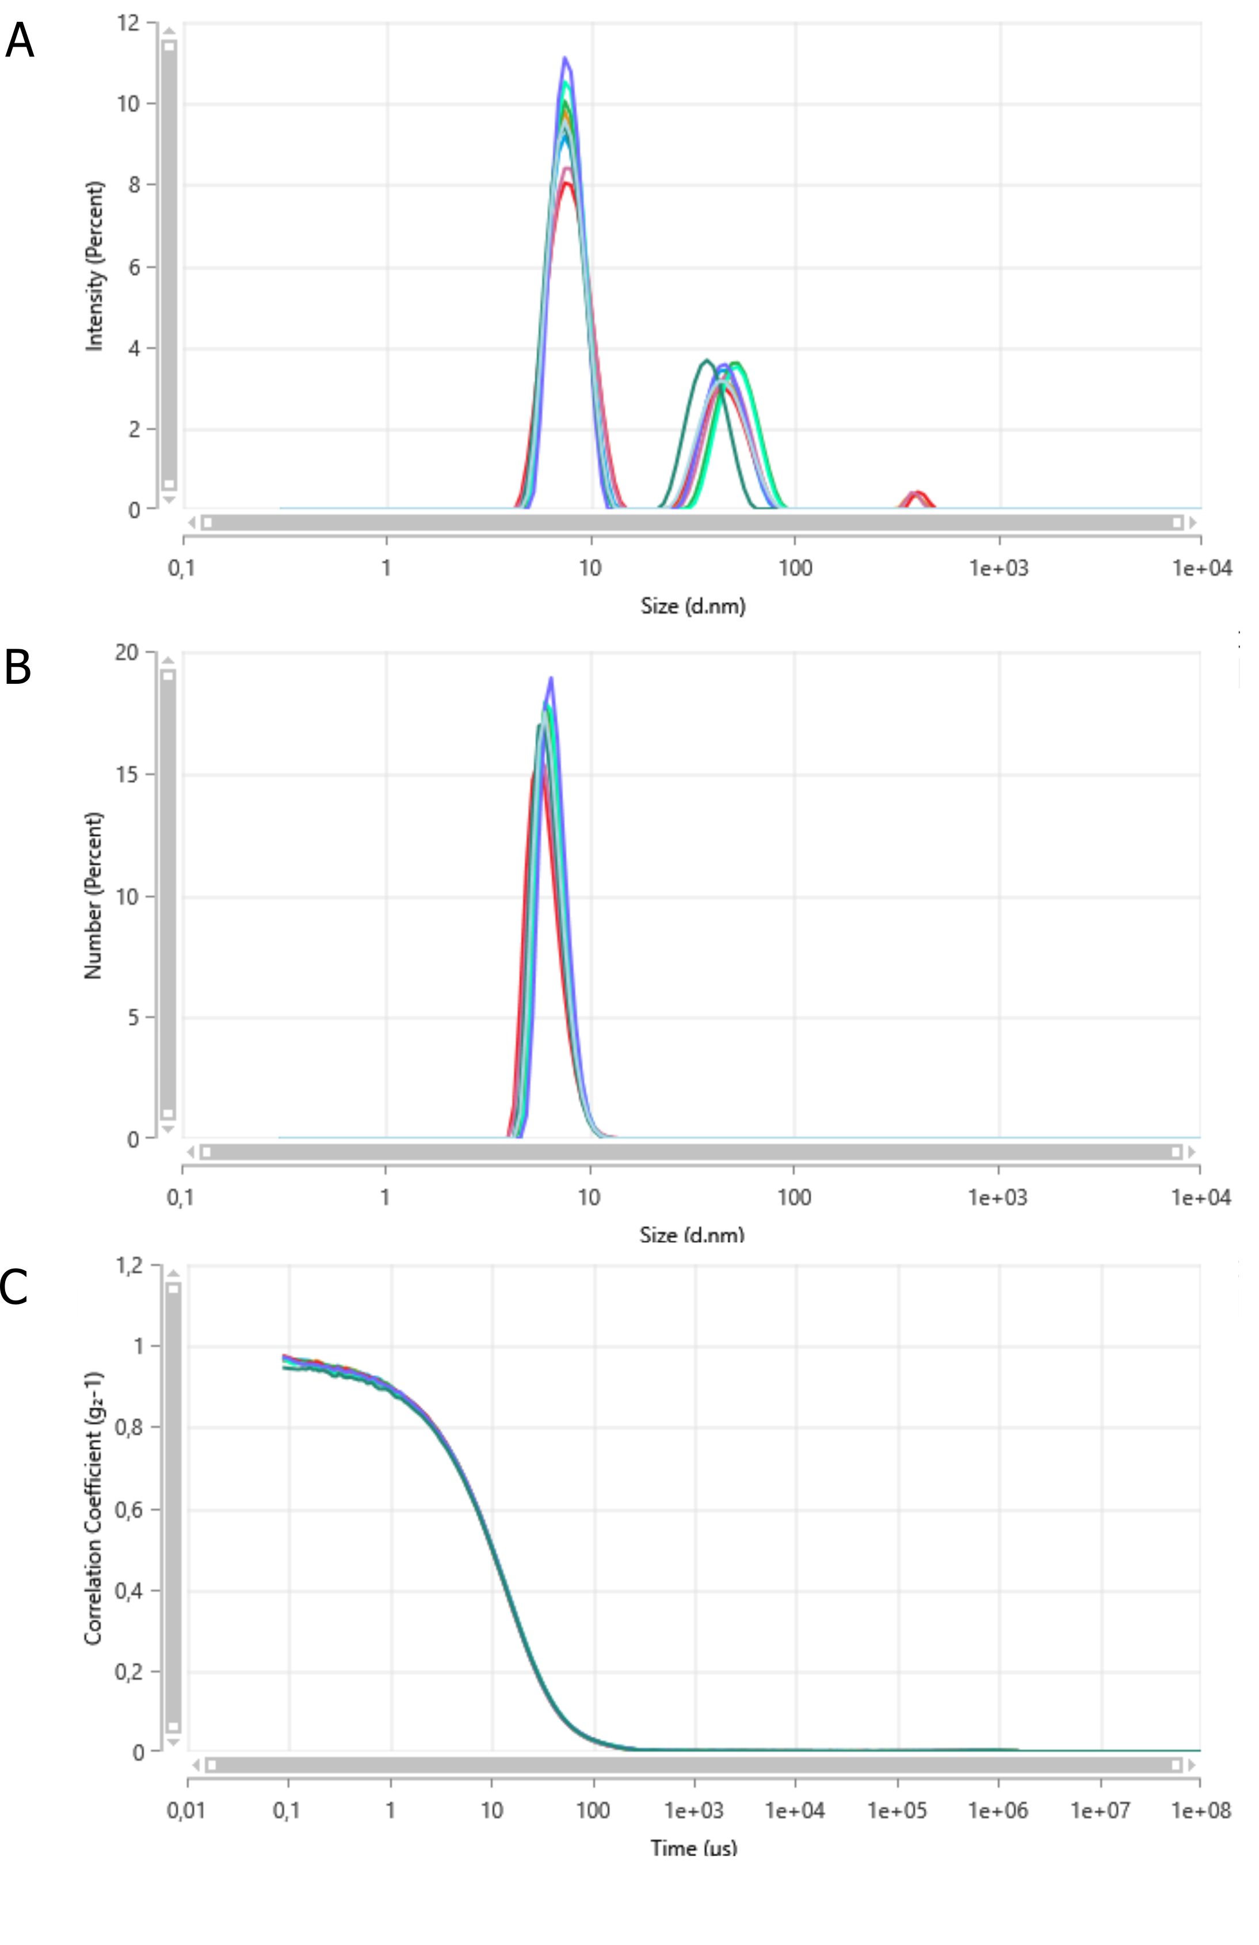

Supplementary Figure 3. Physicochemical characterization of PEGylated HSA/NT3/BDNF nanoparticles (NeO5 formulation) over 28 days after formulation. Representative MADLS intensity-weighted particle size distributions (A), number-weighted particle size distributions (B), and autocorrelation functions (C) measured in Ringer’s solution (pH 4.9, ionic strength 0.15 M). Intensity-weighted analysis revealed two reproducible nanoparticle populations centered approximately at 5.9 nm and 42.4 nm, which remained stable throughout the 28-day observation period with minimal variation in peak position and intensity. In contrast, number-weighted distributions demonstrated that the overwhelming majority of nanoparticles belonged to the smaller nanoscale population (~5.9–10 nm), whereas the larger population represented only a minor numerical fraction. The nearly overlapping autocorrelation functions further confirmed highly reproducible diffusion behavior and absence of progressive aggregation or colloidal destabilization during storage. All measurements were performed in independent replicates, and individual curves represent nanoparticle distributions obtained at different time points over the 28-day storage period.

Supplementary Figure 4. Scatter plots of individual biological replicates from Figure 4. Scatter plots showing individual biological replicates (black point) for each analyzed gene following nanoparticle exposure at 72 h and 28 days. Expression levels were quantified by RT-qPCR and calculated using the 2^{-ΔΔCt} method, normalized to intact control samples. Horizontal lines indicate group means. Data are presented for descriptive purposes to illustrate inter-sample variability. No inferential statistical testing was performed due to limited sample size.
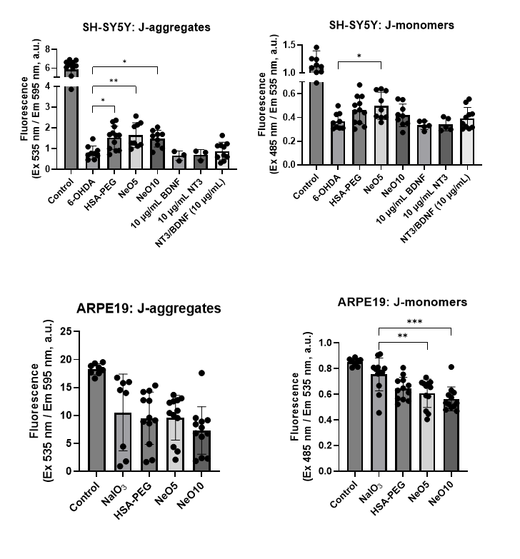
Supplementary figure 5. Raw JC-1 fluorescence signals. Raw JC-1 fluorescence signals corresponding to J-aggregates and J-monomers were measured using a fluorescence plate reader at Ex/Em 535/595 nm and Ex/Em 485/535 nm, respectively. Data are shown as mean ± SD. Statistical analysis was performed using one-way ANOVA followed by Dunnett’s multiple comparisons test (GraphPad Prism) *p < 0.05, **p < 0.01, ***p < 0.001

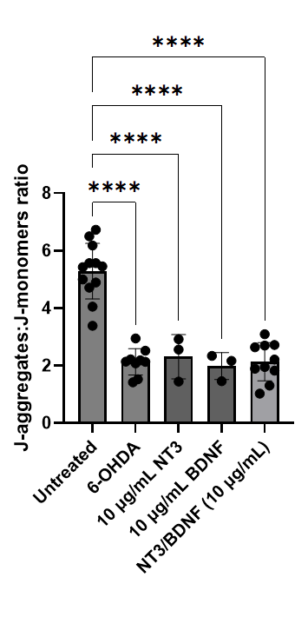
Supplementary Figure 6. Effect of free NT3 and/or BDNF on viability and mitochondrial membrane potential in 6-OHDA-stressed RA-differentiated SH-SY5Y cells.
RA-differentiated SH-SY5Y cells were exposed to 6-OHDA-induced oxidative stress and subsequently treated with free NT3, free BDNF, or combined NT3/BDNF at 10 µg/mL each. Mitochondrial membrane potential was assessed using the JC-1 assay and expressed as the J-aggregates:J-monomers fluorescence ratio. Data are presented as mean ± SD, with individual points representing biological replicates. Statistical significance was determined using one-way ANOVA with Tukey’s multiple comparisons test; ****p < 0.0001.

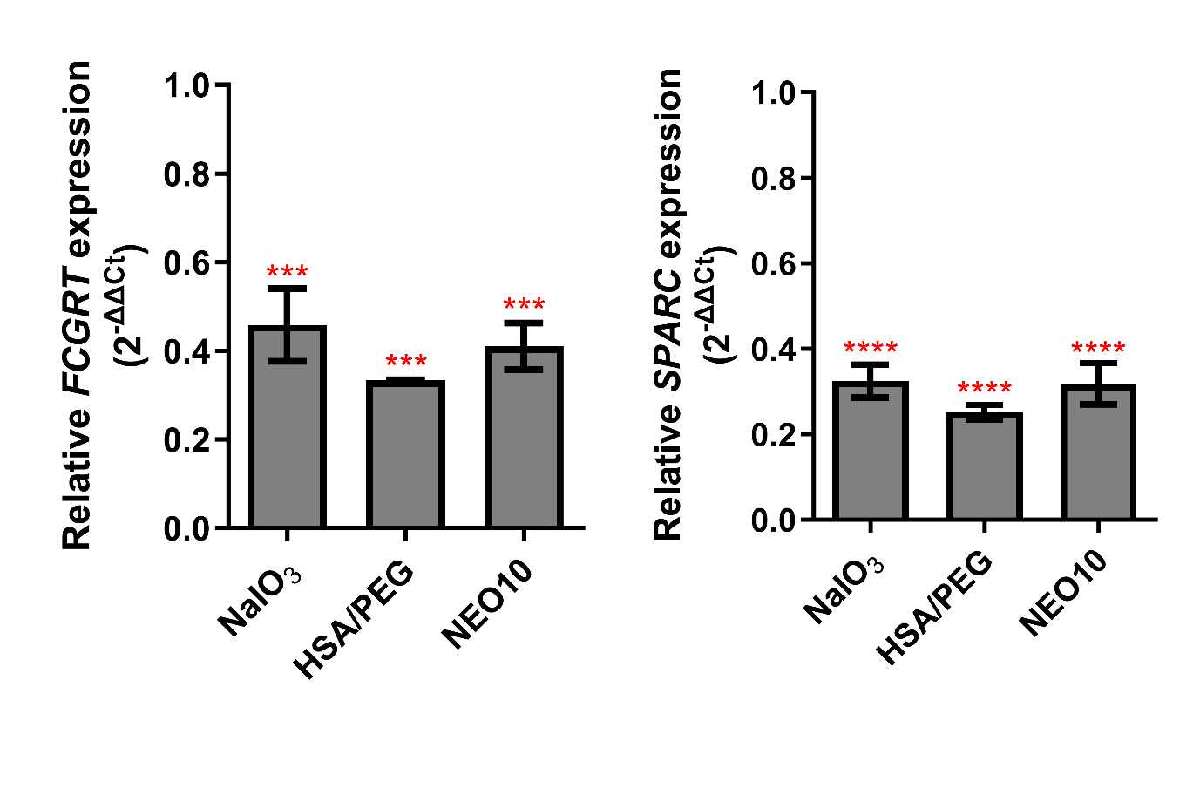
Supplementary Figure 7. The expression of FCGRT and SPARC in ARPE19 cells. Statistical analysis was done in GraphPad Prism using one-way ANOVA with Tukey's multiple comparisons test *** p< 0.001, **** p< 0.0001

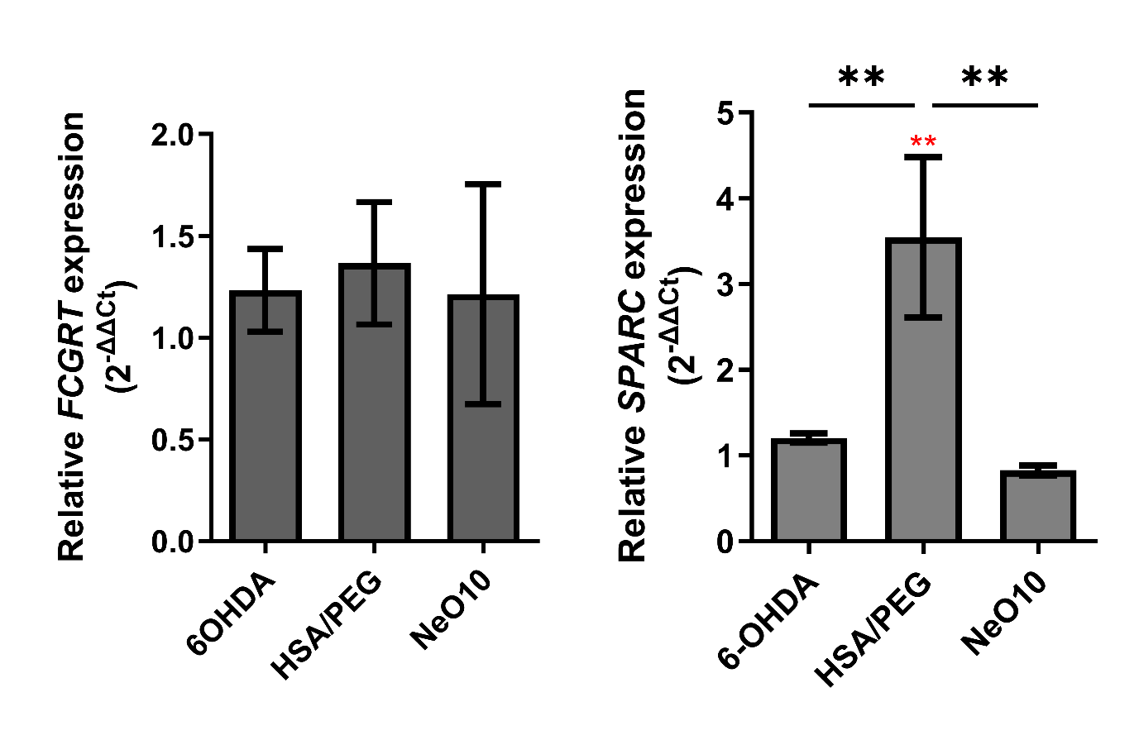
Supplementary Figure 8. The expression of FCGRT and SPARC in SH-SY5Y cells. Statistical analysis was done in GraphPad Prism using one-way ANOVA with Tukey's multiple comparisons test ** p<0.01

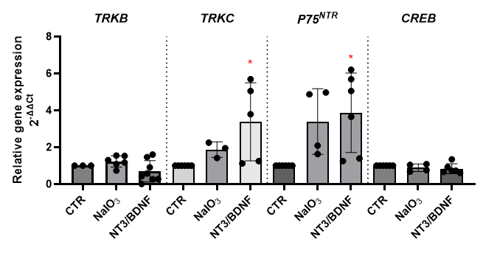
Supplementary Figure 9. Effect of free NT3/BDNF treatment on neurotrophin-related transcript expression in ARPE-19 cells.
Relative mRNA expression of TRKB, TRKC, p75NTR, and CREB in ARPE-19 cells treated with 10 µg/mL NT3 and 10 µg/mL BDNF. Untreated cells served as control (CTR), and NaIO₃-treated cells were included as an oxidative stress control. Gene expression was calculated using the 2^{(-ΔΔCt )}method and normalized to the control group. Data are presented as mean ± SD, with individual points representing biological replicates. Statistical significance was determined using one-way ANOVA with Tukey’s multiple comparisons test and marked with red stars *; *p < 0.05.

