Supplementary Material
Supplementary Methods 1:

Social determinants of health

The area-level SDOH measures were derived from the US Centers for Disease Control (CDC) and Prevention PLACES data (complete descriptions can be found on the CDC website).¹ The PLACES SDOH data capture estimated prevalence of nine key measures that influence health and well-being using 5-year estimates from the American Community Survey, a recurring survey of the US population conducted by the Census Bureau. The SDOH measures quantify the percentages of the population within 3-digit ZIP code level regions for the following groups: aged ≥65 years; no broadband internet subscription among households; experiencing crowding among housing units (1.01–1.50 and ≥1.51 occupants per room); experiencing housing cost burden (annual income <$75,000 with ≥30% household income spent on housing); no high school diploma (among adults aged ≥25 years); living below 150% of the poverty level; of racial or ethnic or minority status; living in single-parent households (female or male, with children aged <18 years and no spouse/partner); or unemployed (among people aged ≥16 years; civilian labor force).¹
References
1. U.S. Centers for Disease Control and Prevention. Social determinants of health. https://www.cdc.gov/places/measure-definitions/social-determinants-of-health.html. Accessed June 22, 2025.

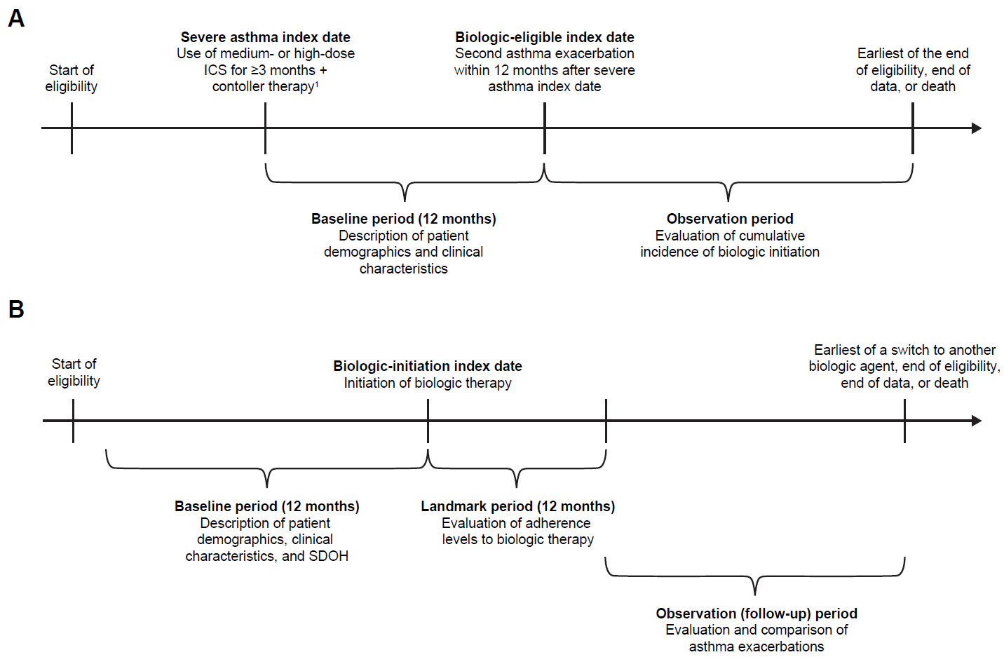
Supplemental Figure 1. Study design scheme for A) biologic-eligible and
B) biologic-user cohorts.

Data Source: Komodo Research Database with data ranging from January 1, 2016, to June 30, 2024.
Patients with severe asthma were defined as those with ≥1 dispensing of medium- or high-dose ICS for ≥3 months with ≥1 overlapping day of supply of controller therapy. Patients' severe asthma index dates were defined as the first overlapping day of supply with ICS and controller therapy. For patients with separate periods of medium-dose ICS and high-dose ICS that both overlapped with controller therapy, the first day of overlapping supply of the high-dose ICS period and controller therapy was used to define the severe asthma index date. Patient’s first claim of biologic therapy from benralizumab, dupilumab, mepolizumab, omalizumab, reslizumab, or tezepelumab during their continuous health insurance eligibility period defined their biologic-user index date.
ICS, inhaled corticosteroid; SDOH, social determinants of health.

Supplemental Table 1. Demographics and clinical characteristics of biologic users, stratified by adherence to biologic therapy, in the weighted population
Characteristics* (N=16,336) | Adherent  N=10,226 (62.6%) | Partially adherent  N=1972 (12.1%) | Minimally adherent  N=499 (3.1%) | Discontinuation  N=3639 (22.3%)
Age, years, mean (SD) | 49.2 ± 16.2 | 49.1 ± 16.1 | 48.6 ± 15.9 | 49.1 ± 16.2
Female, n (%) | 6846 (66.9) | 1322 (67.0) | 351 (70.3) | 2439 (67.0)
Region, n (%)
South | 3601 (35.2) | 704 (35.7) | 188 (37.7) | 1274 (35.0)
Northeast | 2838 (27.8) | 543 (27.5) | 140 (28.0) | 1012 (27.8)
Midwest | 2450 (24.0) | 464 (23.6) | 104 (20.8) | 879 (24.2)
West | 1337 (13.1) | 261 (13.2) | 67 (13.5) | 473 (13.0)
Unknown | 1 (0.0) | 0 (0.0) | 0 (0.0) | 0 (0.0)
Insurance plan type, n (%)
Commercial | 6959 (68.1) | 1343 (68.1) | 333 (66.7) | 2456 (67.5)
Medicaid | 1643 (16.1) | 321 (16.3) | 86 (17.3) | 594 (16.3)
Medicare | 1623 (15.9) | 308 (15.6) | 80 (16.1) | 589 (16.2)
Unknown | 1 (0.0) | 0 (0.0) | 0 (0.0) | 0 (0.0)
Race/ethnicity, n (%)
White | 5167 (50.5) | 992 (50.3) | 245 (49.1) | 1839 (50.5)
Black/African American | 1337 (13.1) | 258 (13.1) | 72 (14.3) | 472 (13.0)
Hispanic/Latino | 926 (9.1) | 177 (9.0) | 47 (9.4) | 337 (9.3)
Asian or Pacific Islander | 245 (2.4) | 46 (2.3) | 15 (3.0) | 86 (2.4)
Other | 231 (2.3) | 48 (2.4) | 11 (2.2) | 81 (2.2)
Unknown | 2321 (22.7) | 449 (22.8) | 110 (22.0) | 824 (22.6)
Provider/prescriber speciality†, n (%)
Respiratory specialist | 5909 (57.8) | 1082 (54.9) | 279 (55.9) | 2007 (55.1)
Primary care | 1552 (15.2) | 317 (16.1) | 68 (13.6) | 558 (15.3)
Other | 2765 (27.0) | 573 (29.1) | 153 (30.6) | 1074 (29.5)
Biological administration location, n (%)
Office | 5560 (54.4) | 1073 (54.4) | 272 (54.4) | 1969 (54.1)
At home | 4666 (45.6) | 899 (45.6) | 227 (45.6) | 1670 (45.9)
Severe asthma diagnosis‡, n (%) | 7243 (70.8) | 1376 (69.8) | 356 (71.4) | 2521 (69.3)
Asthma exacerbations, mean (SD)
Overall | 3.2 ± 1.6 | 3.2 ± 1.6 | 3.2 ± 1.6 | 3.2 ± 1.6
IP-/ER-defined | 0.9 ± 1.4 | 0.9 ± 1.3 | 0.9 ± 1.4 | 0.9 ± 1.4

*Baseline characteristics presented using weighted results and evaluated on the biologic-user index date; †Evaluated using medical or pharmacy claims on the biologic-user index date. In the case of multiple claims on the same day, the following hierarchy was assigned: respiratory specialist>primary care>other. Other provider specialties included, but were not limited to, unspecified specialist, diagnostic radiology, emergency medicine, otolaryngology, and physical therapist; ‡Severe asthma diagnosis comprises primary or secondary diagnoses.
ER, emergency room; IP, inpatient; SD, standard deviation.

