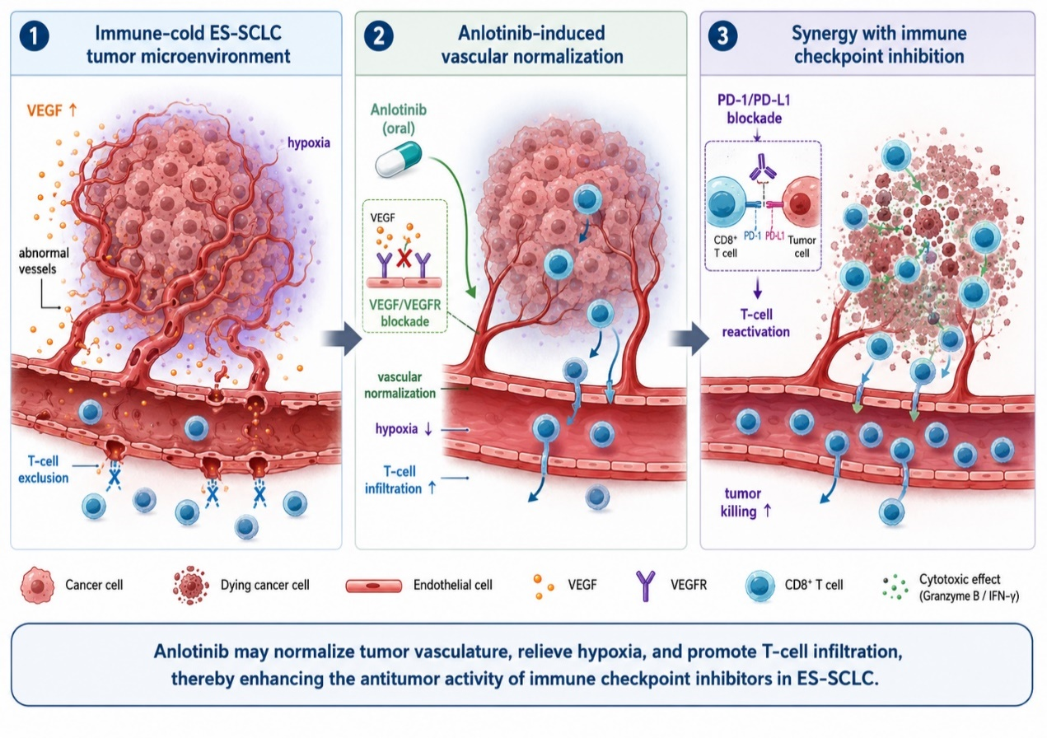
Supplementary Figure S1. Synergistic mechanism of anlotinib plus immune checkpoint inhibitors in ES-SCLC
Schematic illustration of the potential synergistic mechanism of anlotinib combined with immune checkpoint inhibitors in extensive-stage small-cell lung cancer (ES-SCLC). In an immune-cold tumor microenvironment, aberrant tumor vasculature, increased VEGF signaling, and hypoxia may limit CD8⁺ T-cell infiltration. Anlotinib may inhibit VEGF/VEGFR signaling and promote tumor vascular normalization, thereby reducing hypoxia and facilitating CD8⁺ T-cell entry into the tumor microenvironment. Subsequent PD-1/PD-L1 blockade may reactivate antitumor T-cell responses, enhance cytotoxic activity, and shift the tumor microenvironment from an immune-cold state toward a more immune-active state.

