Supplemental Table 1. Time from referral to surgery by surgery type
Surgery Type | N | Median (IQR) (days) | Min (days) | Max (days)
Cataract | 39 | 41 (23, 84) | 1 | 406
Cornea | 2 | 108 (54, 161) | 1 | 214
Glaucoma | 6 | 30 (14, 58) | 3 | 224
Oculoplastics | 3 | 49 (25, 63) | 1 | 76
Retina | 13 | 27 (2, 39) | 1 | 130
Overall | 63 | 39 (12, 78) | 1 | 406

IQR: interquartile range (25th to 75th percentile).

Time calculated in days from date of program referral to date of surgery.
Analysis restricted to patients who successfully received surgery.
One eye had a missing referral or surgery date and was excluded from this analysis.

Supplemental Figure 1. Kaplan-Meier curves for time from referral to surgery by surgery type

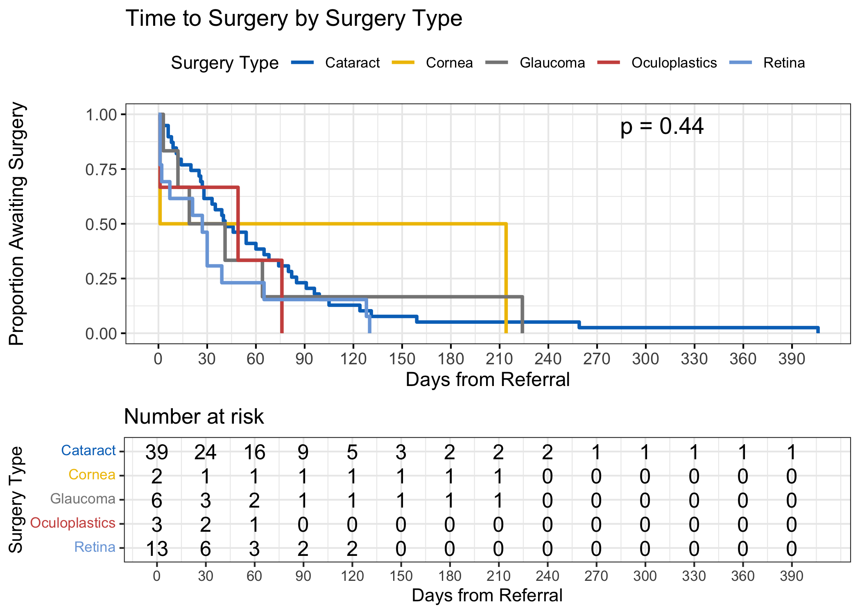
Eyes were treated as the unit of analysis. As some patients contributed both eyes, observations were not fully independent; this limitation should be considered when interpreting these results. p-value from log-rank test

