Supplementary Material
Search Strategy
((("Ischemic Stroke"[Mesh]) OR ((((((((((((((((Ischemic Stroke[Title/Abstract]) OR (Ischemic Strokes[Title/Abstract])) OR (Stroke, Ischemic[Title/Abstract])) OR (Ischaemic Stroke[Title/Abstract])) OR (Ischaemic Strokes[Title/Abstract])) OR (Stroke, Ischaemic[Title/Abstract])) OR (Acute Ischemic Stroke[Title/Abstract])) OR (Acute Ischemic Strokes[Title/Abstract])) OR (Ischemic Stroke, Acute[Title/Abstract])) OR (Stroke, Acute Ischemic[Title/Abstract])) OR (Cryptogenic Ischemic Stroke[Title/Abstract])) OR (Cryptogenic Ischemic Strokes[Title/Abstract])) OR (Ischemic Stroke, Cryptogenic[Title/Abstract])) OR (Stroke, Cryptogenic Ischemic[Title/Abstract])) OR (Cryptogenic Embolism Stroke[Title/Abstract])) OR (Cryptogenic Embolism Strokes[Title/Abstract]))) AND (("Cognitive Dysfunction"[Mesh]) OR ((((((((((((((((((((((((((Cognitive Dysfunction[Title/Abstract]) OR (Cognitive Dysfunctions[Title/Abstract])) OR (Dysfunction, Cognitive[Title/Abstract])) OR (Dysfunctions, Cognitive[Title/Abstract])) OR (Cognitive Disorder[Title/Abstract])) OR (Cognitive Disorders[Title/Abstract])) OR (Disorder, Cognitive[Title/Abstract])) OR (Disorders, Cognitive[Title/Abstract])) OR (Cognitive Impairments[Title/Abstract])) OR (Cognitive Impairment[Title/Abstract])) OR (Impairment, Cognitive[Title/Abstract])) OR (Impairments, Cognitive[Title/Abstract])) OR (Mild Cognitive Impairment[Title/Abstract])) OR (Cognitive Impairment, Mild[Title/Abstract])) OR (Cognitive Impairments, Mild[Title/Abstract])) OR (Impairment, Mild Cognitive[Title/Abstract])) OR (Impairments, Mild Cognitive[Title/Abstract])) OR (Mild Cognitive Impairments[Title/Abstract])) OR (Cognitive Decline[Title/Abstract])) OR (Cognitive Declines[Title/Abstract])) OR (Decline, Cognitive[Title/Abstract])) OR (Declines, Cognitive[Title/Abstract])) OR (Mental Deterioration[Title/Abstract])) OR (Deterioration, Mental[Title/Abstract])) OR (Deteriorations, Mental[Title/Abstract])) OR (Mental Deteriorations[Title/Abstract])))) AND (("Risk Factors"[Mesh]) OR (((((((((((((((((((Risk Factors[Title/Abstract]) OR (Factor, Risk[Title/Abstract])) OR (Risk Factor[Title/Abstract])) OR (Population at Risk[Title/Abstract])) OR (Populations at Risk[Title/Abstract])) OR (Risk Scores[Title/Abstract])) OR (Risk Score[Title/Abstract])) OR (Score, Risk[Title/Abstract])) OR (Risk Factor Scores[Title/Abstract])) OR (Risk Factor Score[Title/Abstract])) OR (Score, Risk Factor[Title/Abstract])) OR (Health Correlates[Title/Abstract])) OR (Correlates, Health[Title/Abstract])) OR (Social Risk Factors[Title/Abstract])) OR (Factor, Social Risk[Title/Abstract])) OR (Factors, Social Risk[Title/Abstract])) OR (Risk Factor, Social[Title/Abstract])) OR (Risk Factors, Social[Title/Abstract])) OR (Social Risk Factor[Title/Abstract])))

Table S1 Meta regression
Age>75
Variable | Coefficient | Standard Error | P | [95% Confidence Interval]
Year | -0.005 | 0.003 | 0.122 | [-0.121, 0.002]
Country | 0.034 | 0.047 | 0.481 | [-0.068, 0.136]
Study design | 0.062 | 0.072 | 0.406 | [-0.095, 0.219]
Diagnosis of Cognitive impairment | 0.181 | 0.369 | 0.001 | [0.101, 0.261]
Regression model | 0.052 | 0.075 | 0.497 | [-0.111, 0.216]
low educational level
Year | 0.004 | 0.029 | 0.885 | [-0.066, 0.752]
Country | 0.131 | 0.201 | 0.538 | [-0.361, 0.624]
Diagnosis of Cognitive impairment | -0.226 | 0.244 | 0.391 | [-0.824, 0.372]
Regression model | 0.230 | 0.244 | 0.382 | [-0.366, 0.826]

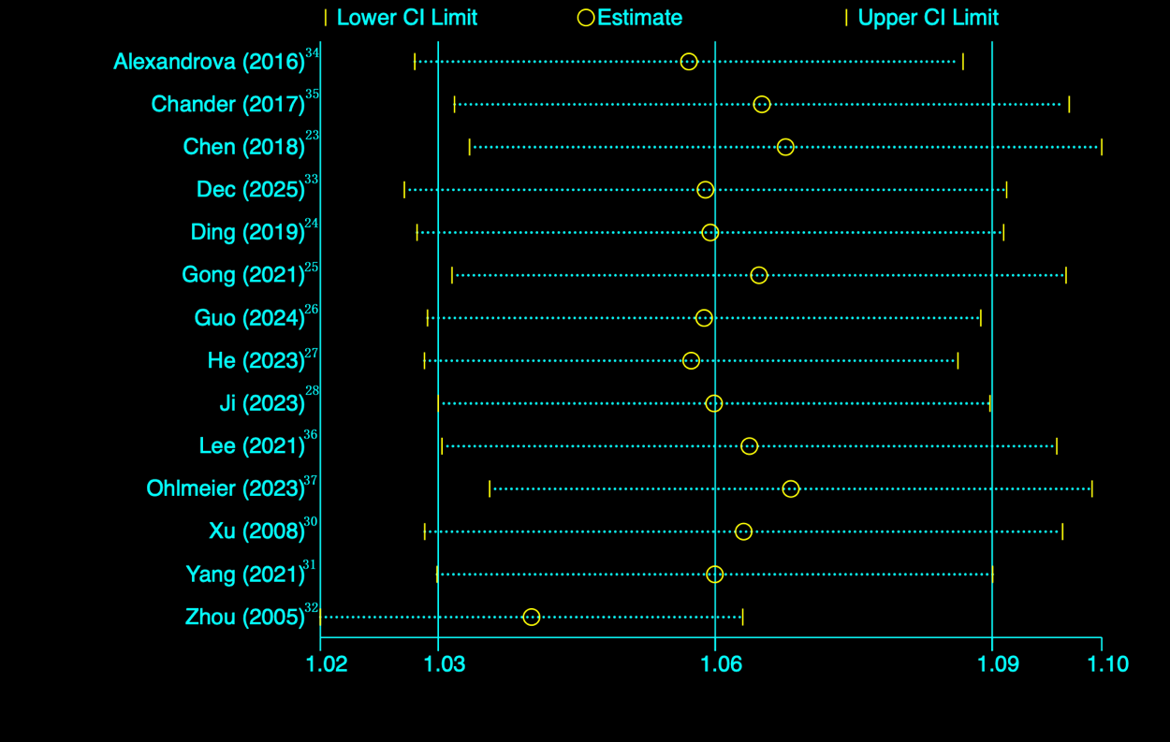

Figure S1 Age>75 sensitivity analysis
Abbreviations: CI, confidence interval.

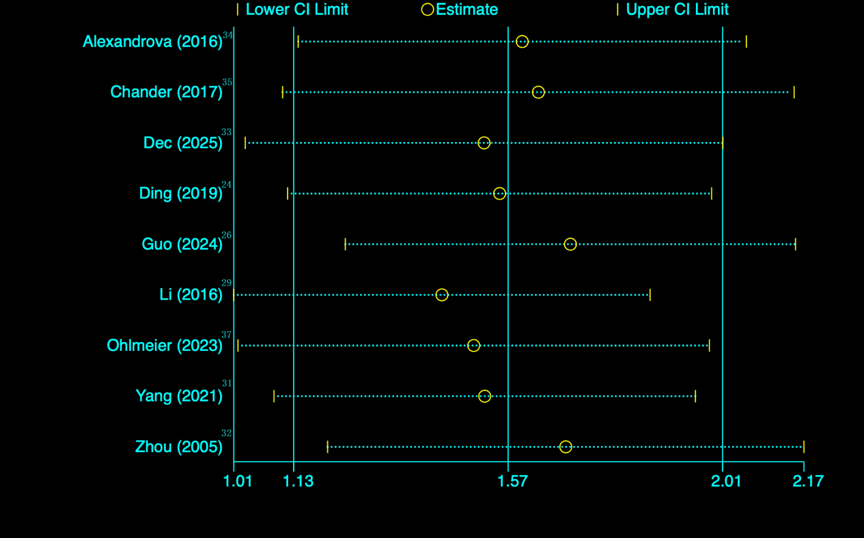
Figure S2 history of diabetes sensitivity analysis
Abbreviations: CI, confidence interval.

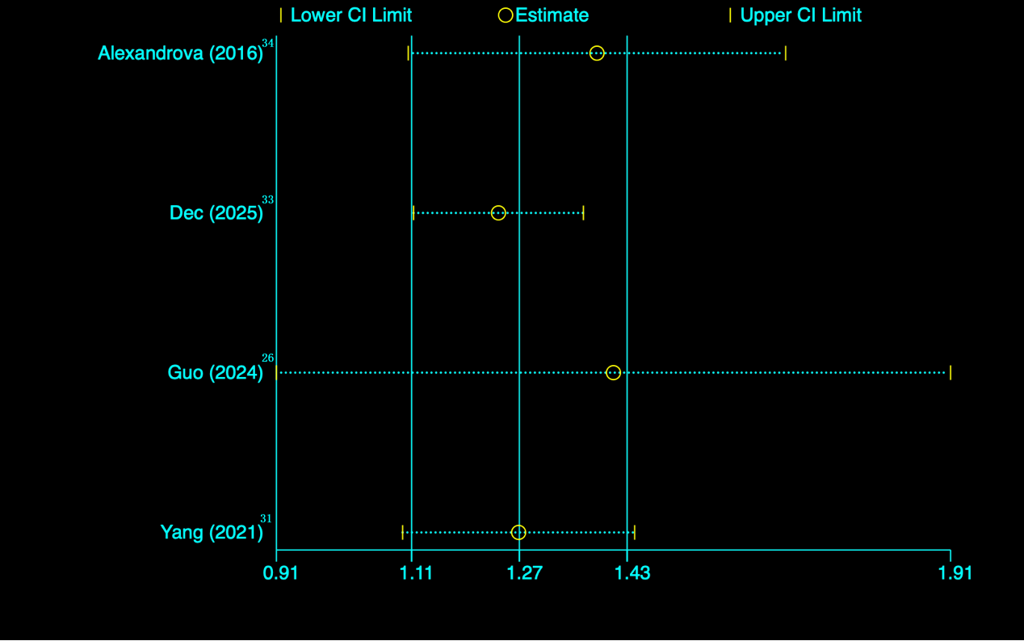
Figure S3 C-reactive protein sensitivity analysis
Abbreviations: CI, confidence interval.

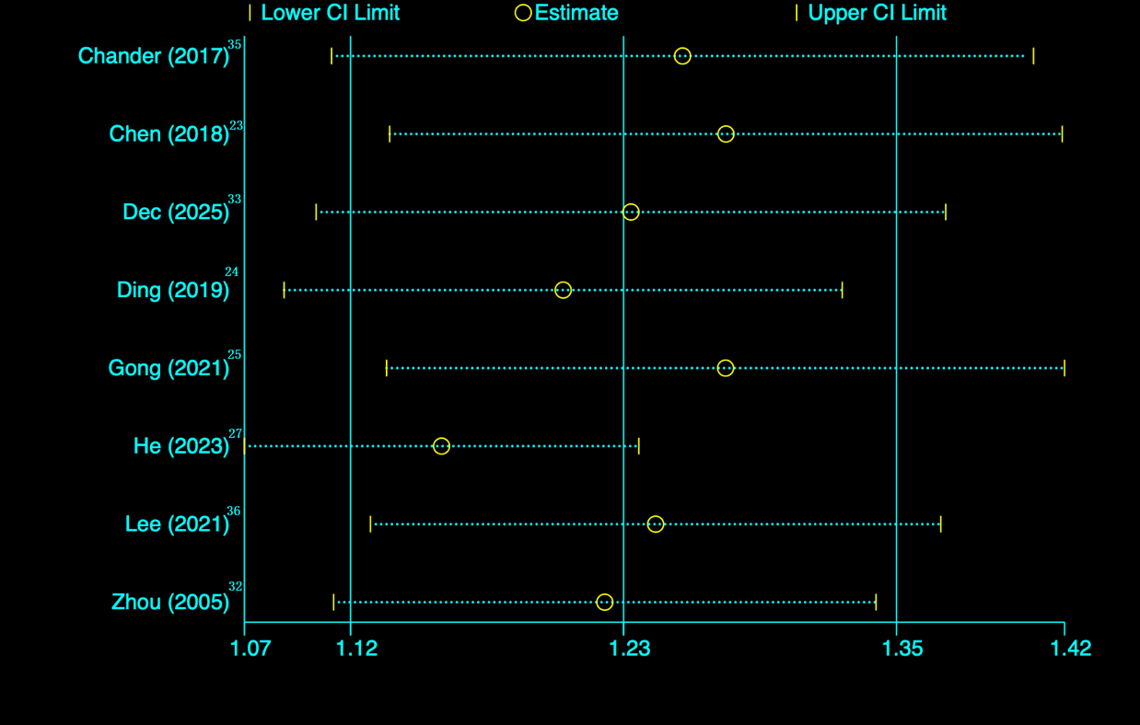
Figure S4 low educational level sensitivity analysis
Abbreviations: CI, confidence interval.

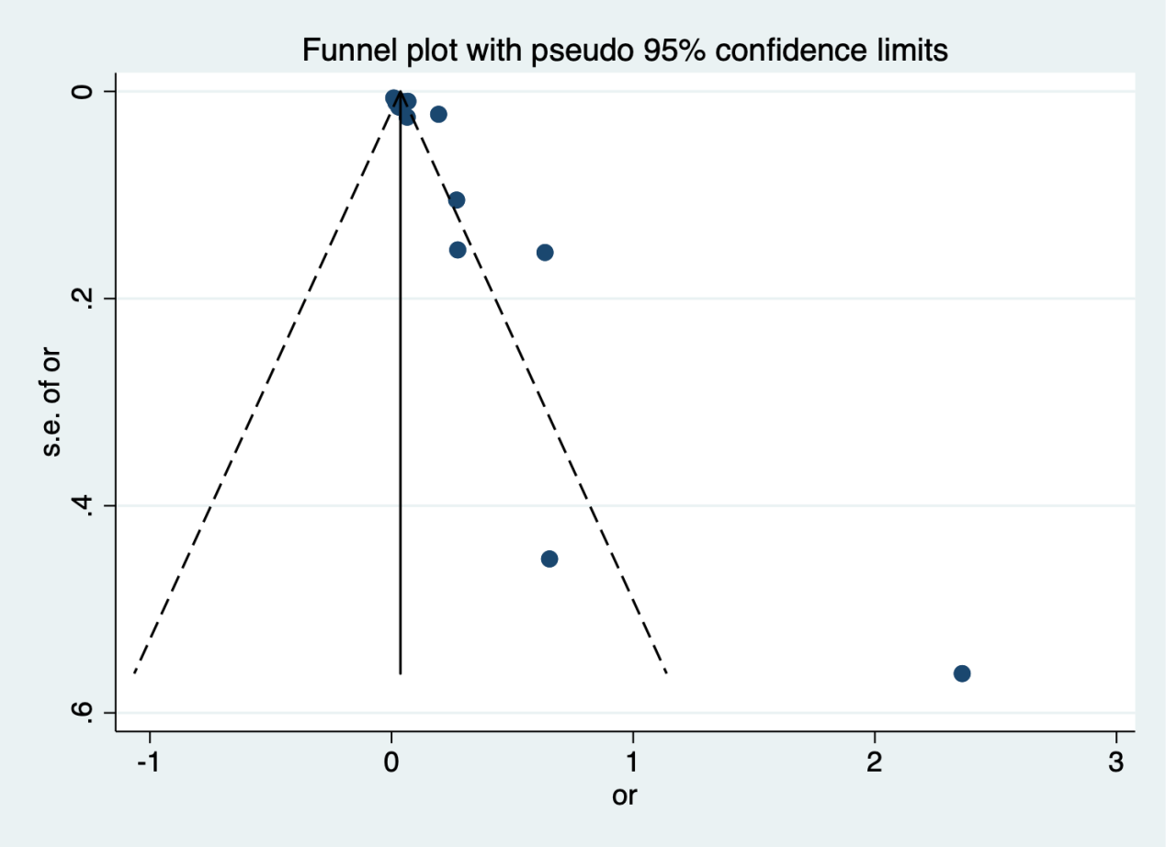
Figure S5 Meta-analysis funnel plot of age>75
Abbreviations: s.e., standard error; or, odds ratio.

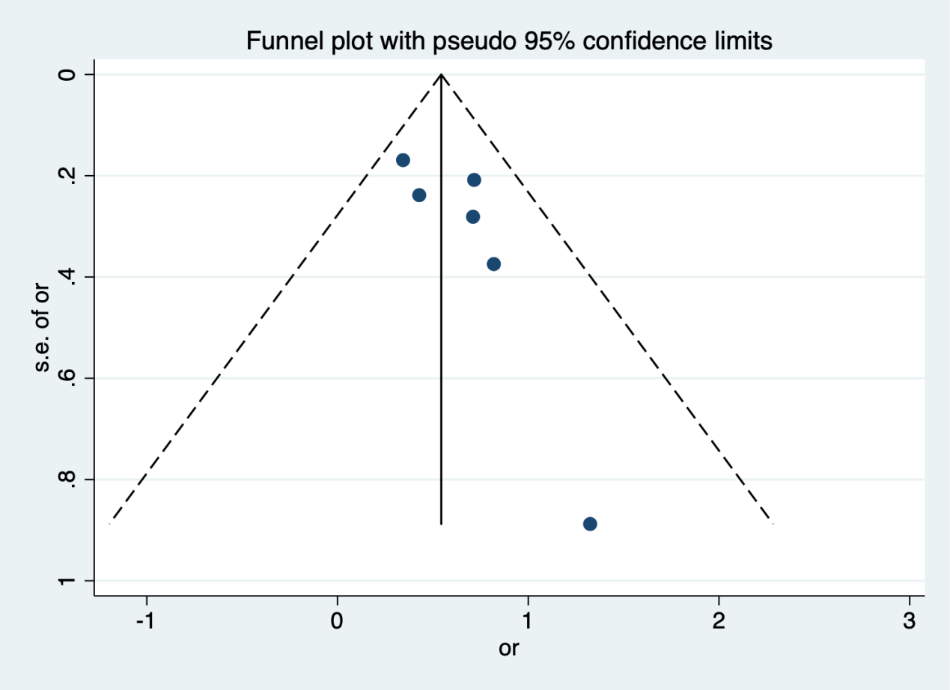
Figure S6 Meta-analysis funnel plot of female
Abbreviations: s.e., standard error; or, odds ratio.

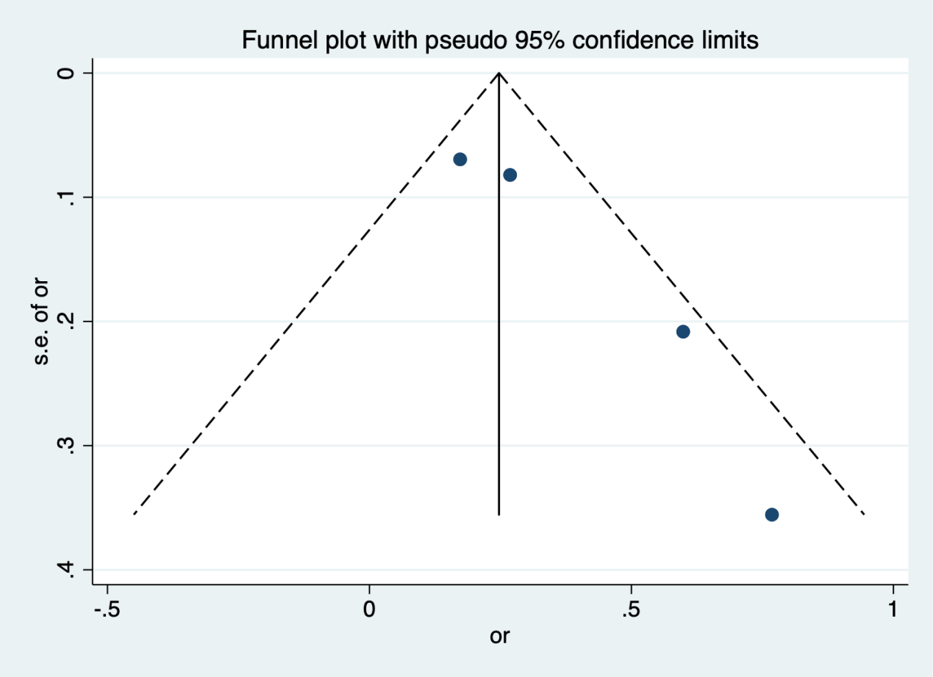
Figure S7 Meta-analysis funnel plot of high C-reactive protein
Abbreviations: s.e., standard error; or, odds ratio.

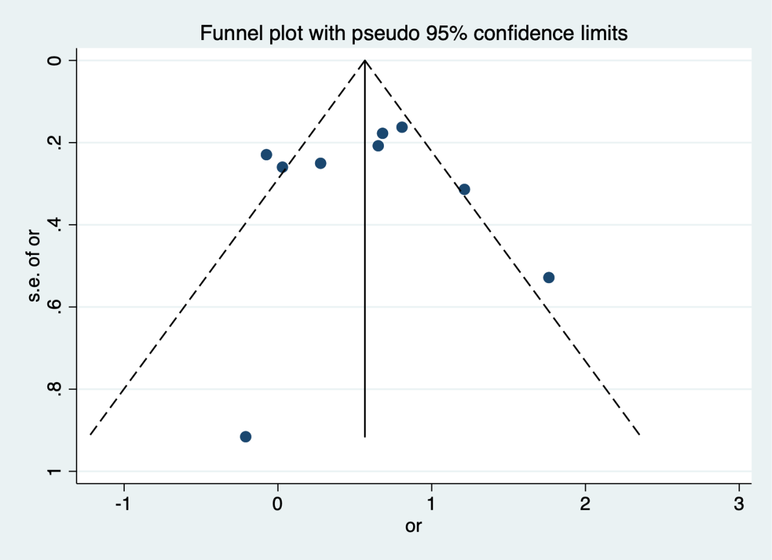
Figure S8 Meta-analysis funnel plot of history of diabetes
Abbreviations: s.e., standard error; or, odds ratio.

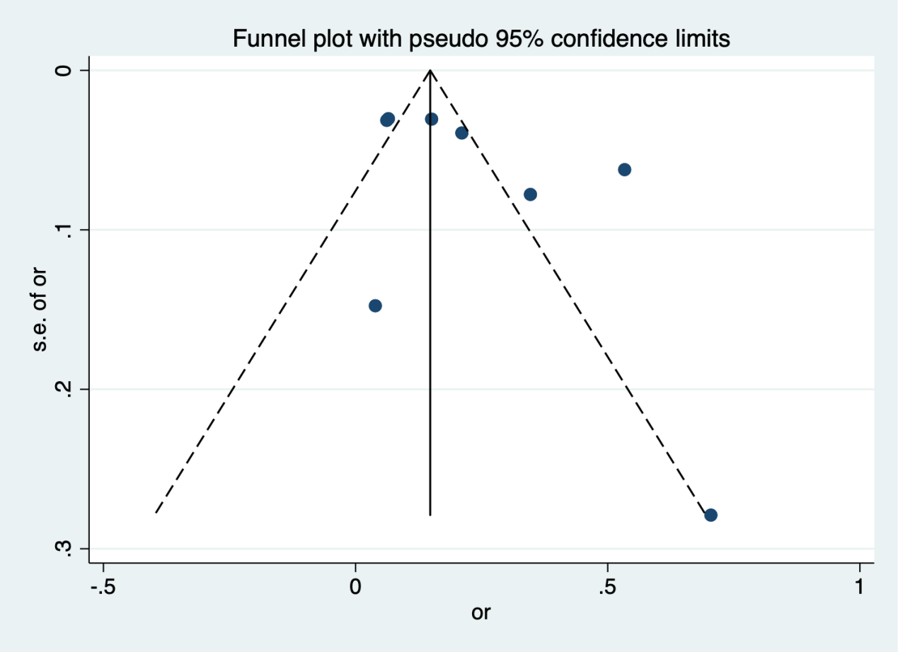
Figure S9 Meta-analysis funnel plot of low educational level
Abbreviations: s.e., standard error; or, odds ratio.

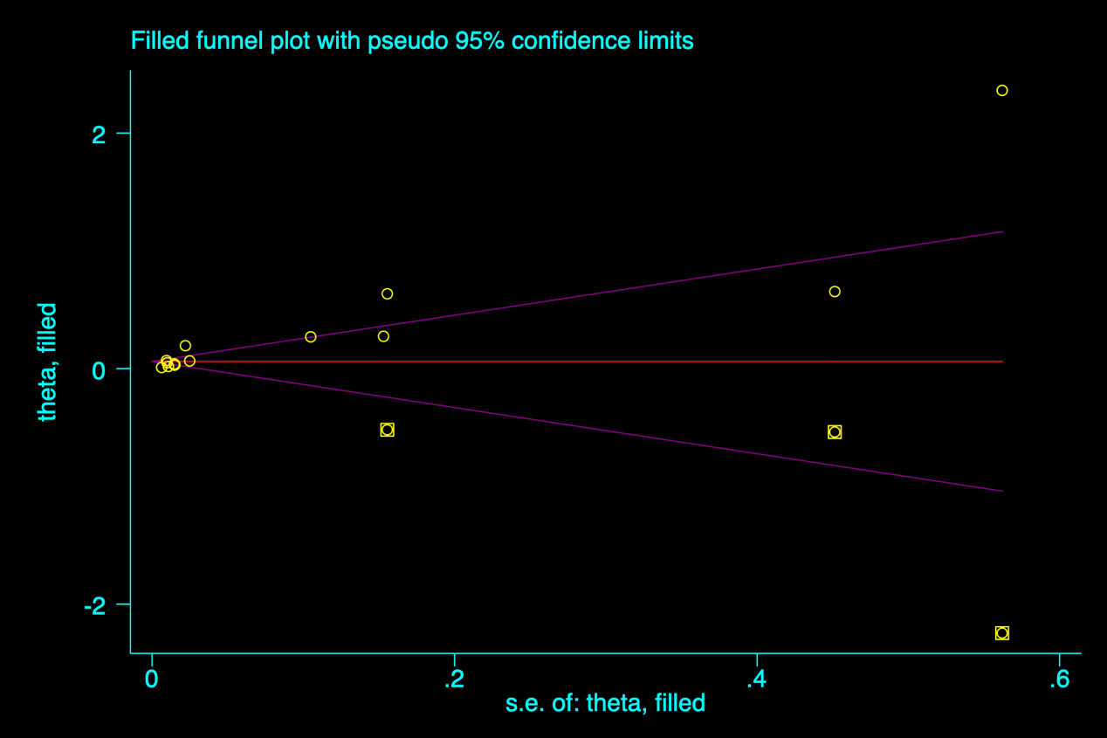
Figure S10 The trim and fill funnel plot of age>75
Abbreviations: s.e., standard error.

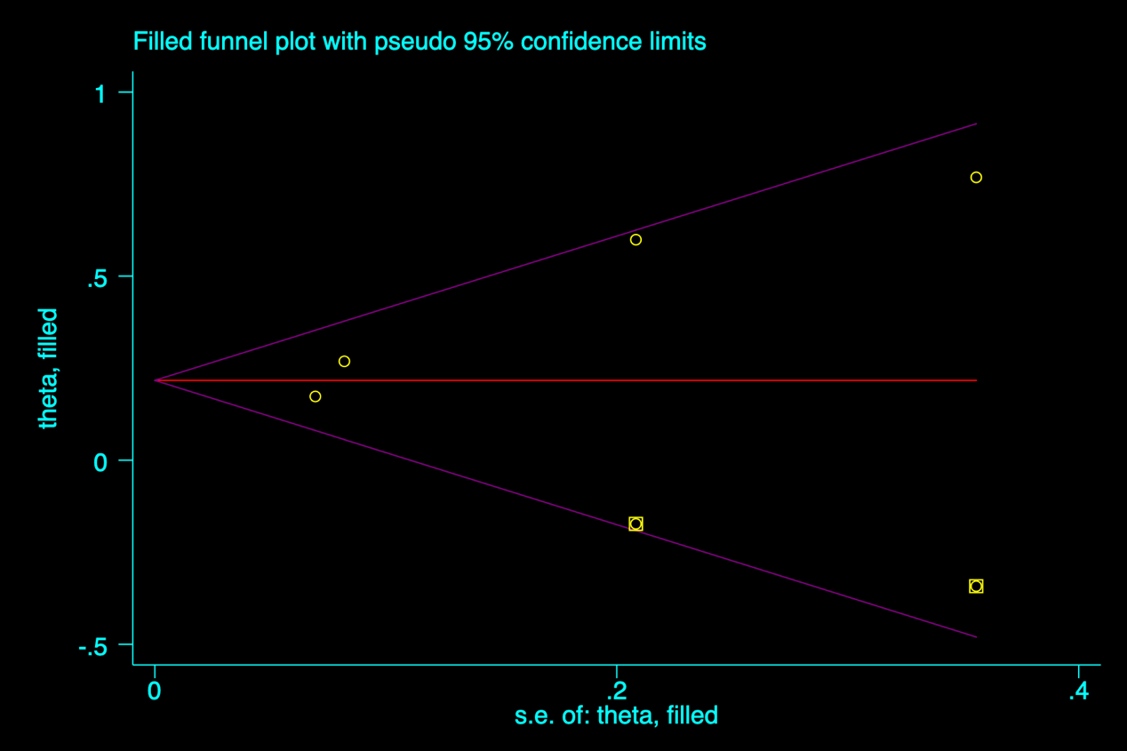
Figure S11 The trim and fill funnel plot of high C-reactive protein
Abbreviations: s.e., standard error.

