Supplementary Material
Supplemental Figures
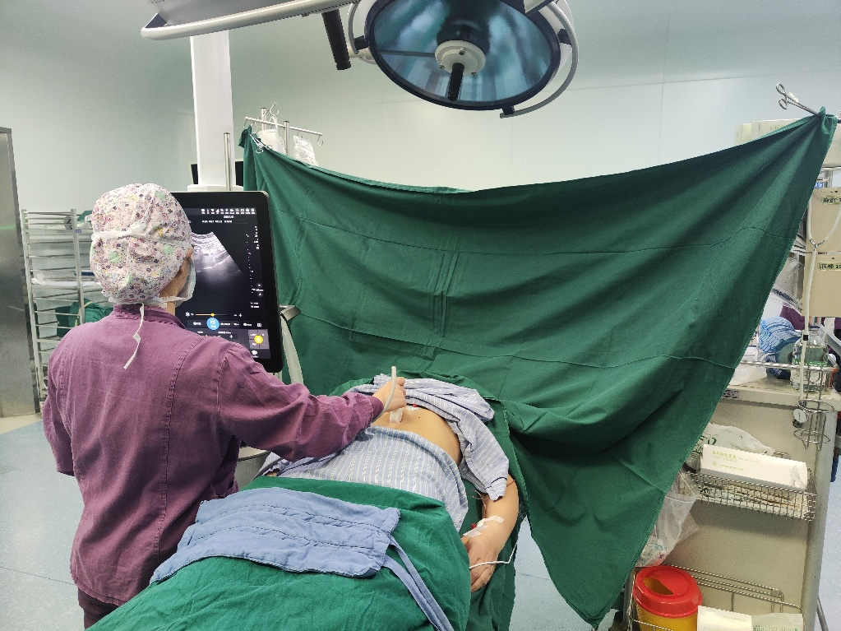
Supplemental Figure S1 Gastric antrum ultrasound examination

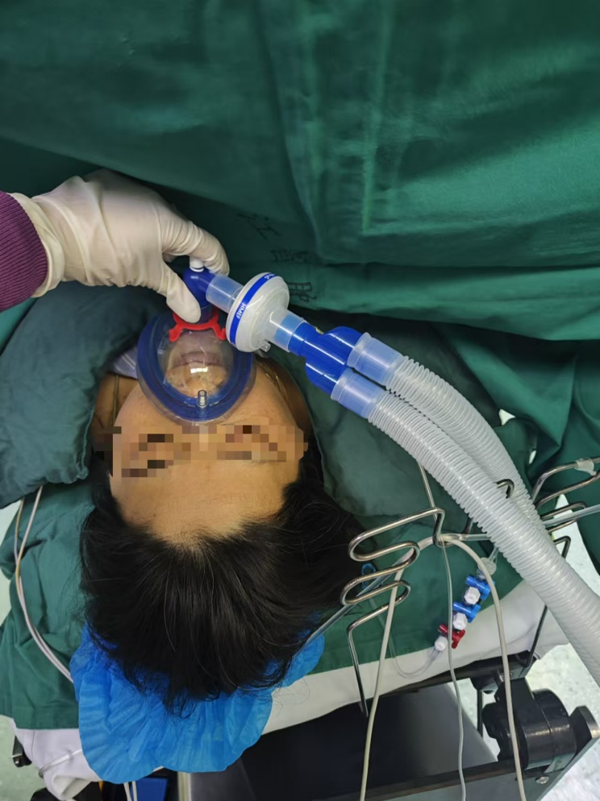
Supplemental Figure S2 Group M performed pre-oxygenation
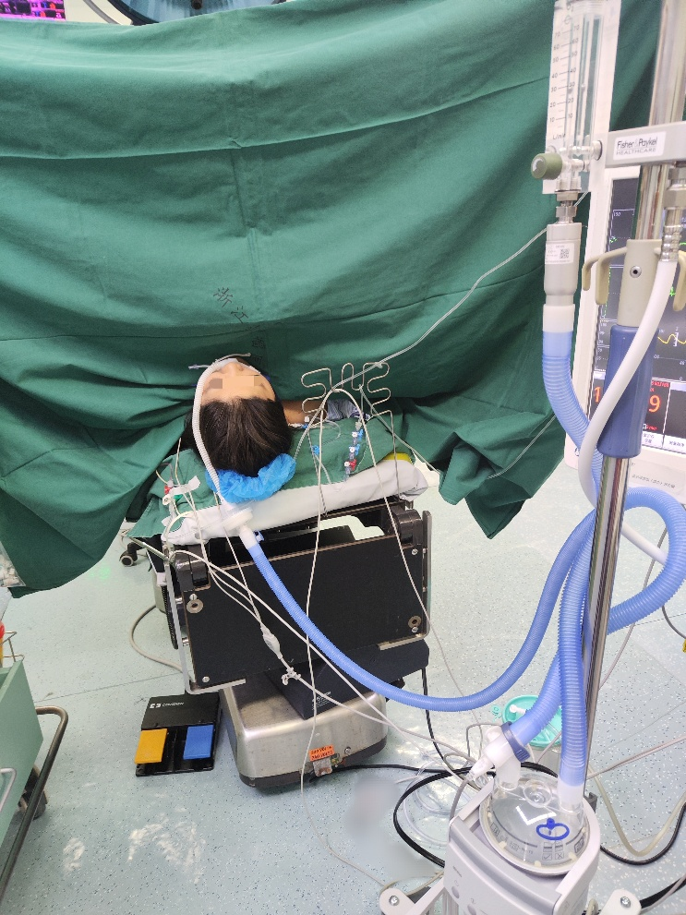
Supplemental Figure S3 Group T performed pre-oxygenation

Supplemental Figure S4 A six-point smiley face scale

Supplemental Tables
Supplemental Table 1 Comparison of CSAa (cm²) in supine position
 | Group M (n=47) | Group T (n=47) | t/U | P
T₁ | 3.87 (1.21) | 4.02 (1.10) | -0.623 | 0.535
T₂ | 4.12 (1.17) | 4.18 (1.08) | -0.272 | 0.786
T₄ | 4.59 (1.42) | 4.49 (1.18) | 0.360 | 0.720
Percentage increase at T₄（%） | 13.24 [3.64–33.48] | 7.62 [2.55–18.55] | 865.000 | 0.070
F | F=15.676 | F=11.899
P | P<0.001 | P<0.001
Between-group effect | F=0.027，P=0.871
Within-group effect | F=41.446，P<0.001
interaction effect | F=1.744，P=0.190
Notes: Data presented as mean (SD), median [IQR]. T₁, before pre-oxygenation; T₂, after 3 min of pre-oxygenation; T₄, immediately after intubation.
Abbreviations: CSAa: Cross-sectional area of gastric antrum.

Supplemental Table 2 Changes in SpO₂ and blood gas analysis at different time points
 | Group M (n=47) | Group T (n=47) | t/z | P
T₁SpO₂ (%) | 96 [95–97] | 96 [95–97] | -0.073 | 0.942
T₂SpO₂ (%) | 100 [100–100] | 100 [100–100] | -0.584 | 0.559
T₃SpO₂ (%) | 100 [100–100] | 100 [100–100] | -3.321 | 0.001
T₄SpO₂ (%) | 100 [100–100] | 100 [98–100] | -4.815 | <0.001
T₁pH | 7.41 (0.02) | 7.41 (0.02) | -0.302 | 0.763
T₂pH | 7.39 (0.03) | 7.41 (0.03) | -2.239 | 0.028
T₃pH | 7.37 (0.04) | 7.32 (0.02) | 8.193 | <0.001
T₄pH | 7.33 (0.03) | 7.30 (0.03) | 5.024 | <0.001
T₁PaO₂ (mmHg) | 78.26 (10.13) | 75.64 (8.87) | 1.332 | 0.186
T₂PaO₂ (mmHg) | 288.83 (63.89) | 354.47 (79.90) | -4.399 | <0.001
T₃PaO₂ (mmHg) | 376.87 (62.65) | 217.74 (99.23) | 9.296 | <0.001
T₄PaO₂ (mmHg) | 309.64 (76.31) | 172.06 (91.33) | 7.925 | <0.001
T₁PaCO₂ (mmHg) | 39.45 (3.97) | 39.51 (3.37) | -0.084 | 0.933
T₂PaCO₂ (mmHg) | 41.28 (3.92) | 38.85 (3.56) | 3.143 | 0.002
T₃PaCO₂ (mmHg) | 45.38 (6.61) | 54.67 (3.68) | -8.418 | <0.001
T₄PaCO₂ (mmHg) | 51.83 (6.09) | 57.64 (3.83) | -5.535 | <0.001
Notes: Data presented as mean (SD), median [IQR]. T₁, before pre-oxygenation; T₂, after 3 min of pre-oxygenation; T₃, after 3 min of ventilation following induction of unconsciousness by anesthesia; T₄, immediately after intubation.

Supplemental Table 3 The occurrence of adverse reactions
Adverse reactions | Group M (n=47) | Group T (n=47) | P
Epistaxis | 0 (0.0%) | 0 (0.0%) | 1.000
Nasopharyngeal discomfort | 2 (4.3%) | 1 (2.1%) | 1.000
Barometric injuries | 0 (0.0%) | 0 (0.0%) | 1.000
Reflux aspiration | 0 (0.0%) | 0 (0.0%) | 1.000
Nausea and vomiting 24h postoperatively | 5 (10.6%) | 5 (10.6%) | 1.000
Notes: Data presented as n (%).

Supplemental Table 4 Comfort scores
Comfort scores | Group M（n=47） | Group T（n=47） | U | P
0/1/2/3/4/5 (scores) | 3/29/15/0/0/0 | 31/10/6/0/0/0 | 458.500 | <0.001
Notes: Data presented as numbers.

