Supplementary Information
Table S1 Baseline Characteristics
 | Single agent (n=45) | Platinum combination (n=26)
Median age, years (SD) | 62.6 (10.5) | 59.6 (10.6)
Age ≥ 65 years, n (%) | 19 (42.2) | 10 (38.5)
Sex, n (%)  Male  Female | 26 (57.8)  19 (42.2) | 11 (42.3)  15 (57.7)
ECOG PS, n (%)  0-1  ≥ 2 | 37 (82.2)  8 (17.8) | 24 (92.3)  2 (7.7)
BMI, n (%)  < 18.5 kg/m²  18.5–22.9 kg/m²  ≥ 23 kg/m² | 10 (22.2)  21 (46.7)  14 (31.1) | 6 (23.0)  10 (38.5)  10 (38.5)
Comorbidity, n (%)  Diabetes mellitus  Hypertension  Chronic kidney disease  Cerebrovascular disease  Coronary artery disease | 18 (40.0)  12 (26.7)  6 (13.3)  3 (6.7)  2 (4.4)  1 (2.2) | 10 (38.5)  3 (11.5)  13 (18.3)  5 (7.0)  3 (4.2)  5 (7.0)
Laboratory at cancer diagnosis  Hemoglobin, g/dL (SD)  Albumin, g/dL (SD)  CEA, ng/mL (IQR)  CA 19-9, U/mL (IQR) | 11.8 (2)  4.1 (3.6, 4.3)  7.2 (2.5, 18.1)  116.5 (26.2, 952.2) | 11.1 (2.5)  4.0 (3.6, 4.3)  3.3 (2.1, 4.4)  29.8 (6.3, 150.4)
Tumor differentiation, n (%)  Well differentiated  Moderately differentiated  Poorly differentiated | 28 (62.2)  15 (33.3)  2 (4.4) | 13 (50.0)  9 (34.6)  4 (15.4)
T stage, n (%)  T1  T2  T3  T4 | 1 (2.2)  5 (11.1)  37 (82.2)  2 (4.4) | 0 (0)  2 (7.7)  21 (80.8)  3 (11.5)
N stage, n (%)  N0  N1  N2  N3 | 21 (46.7)  15 (33.3)  8 (17.8)  1 (2.2) | 10 (38.5)  8 (30.8)  7 (26.9)  1 (3.8)
Metastasis  Recurrent  De novo | 33 (73.3)  12 (26.7) | 17 (65.4)  9 (34.6)
Number of organ metastasis  1  ≥ 2 | 26 (57.8)  19 (42.2) | 16 (61.5)  10 (38.5)
Organ metastasis  Liver  Lung  Distant lymph node  Pancreas  Peritoneal  Pleura  Bone  Brain  Adrenal  Ovary | 26 (57.8)  11 (24.4)  22 (48.9)  4 (8.9)  2 (4.4)  1 (2.2)  4 (8.9)  1 (2.2)  2 (4.4)  1 (2.2) | 14 (53.8)  7 (26.9)  12 (46.2)  1 (3.8)  2 (7.7)  0 (0)  0 (0)  0 (0)  0 (0)  1 (3.8)

ECOG, Eastern Cooperative Oncology Group; PS, performance status; BMI, body mass index; SD, standard deviation; IQR, interquartile range; COPD, chronic obstructive pulmonary disease; CEA, carcinoembryonic antigen; CA19-9, cancer antigen 19-9.

Table S2 Treatment information
 | Chemotherapy
 | Fluoropyrimidine-based (n=28) | Gemcitabine-based (n=43)
Second line chemotherapy, n (%)  5-FU  Capecitabine  TS-one  Carboplatin plus 5-FU  CAPOX  FOLFOX  FOLFIRI  Gemcitabine  Carboplatin plus gemcitabine  Cisplatin plus gemcitabine  Carboplatin plus etoposide  Cisplatin plus etoposide | 9 (32.1)  -  -  -  -  -  -  1 (3.6)  4 (14.3)  2 (7.1)  1 (3.6)  -  1 (3.6) | 23 (53.5)  6 (14.0)  2 (4.7)  1 (1.4)  3 (7.0)  1 (2.3)  8 (18.6)  -  1 (2.3)  -  -  1 (2.3)  -
Third line chemotherapy, n (%)  5-FU  TS-1  FOLFOX  FOLFIRI | 2 (7.1)  -  1 (3.6)  1 (3.6)  - | 5 (11.6)  1 (2.3)  -  1 (2.3)  3 (7.0)
Fourth line chemotherapy, n (%)  FOLFIRI | 1 (3.6)  1 (3.6) | 1 (2.3)  1 (2.3)

5-FU: 5-fluorouracil; FOLFOX: 5-fluorouracil plus folinic acid and oxaliplatin; FOLFIRI: 5-fluorouracil plus folinic acid and irinotecan.

Figure S1 Median OS between patients who underwent metastasectomy and those without metastasectomy.
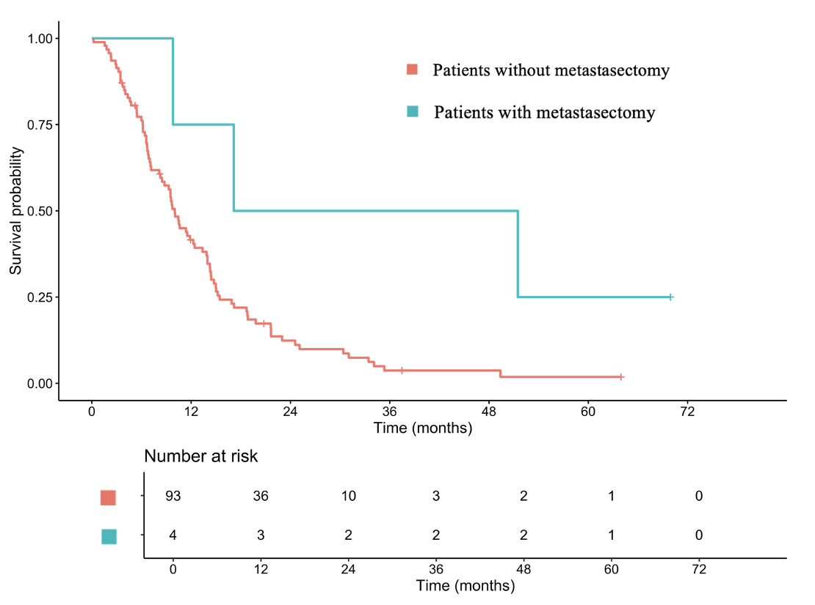

Figure S2. Median PFS between patients with patients who received fluoropyrimidine-based chemotherapy and gemcitabine-based chemotherapy

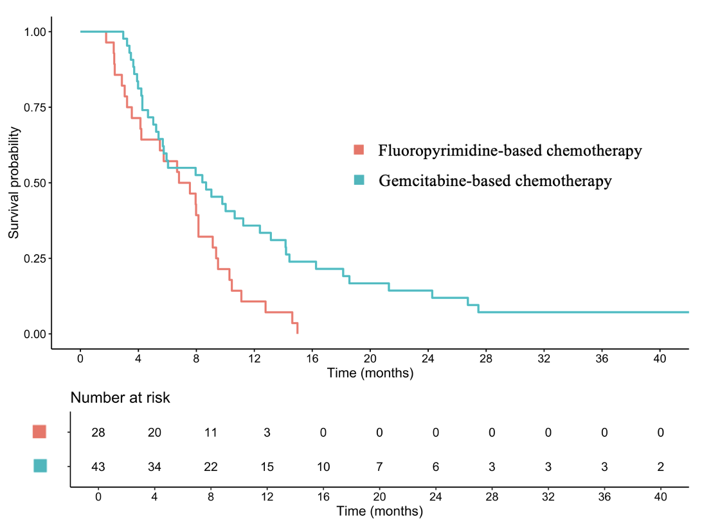

Figure S3. Median PFS between patients who received monotherapy chemotherapy and platinum combined chemotherapy
