Supplementary Note 1. Details of Deep Learning Training Process
Data Augmentation: In this study, we applied Z-score normalization to standardize the intensity distribution across RGB channels in images, which were then used as input for our model. During the training phase, we employed real-time data augmentation techniques, such as random cropping and horizontal and vertical flipping. For the test images, we restricted the preprocessing to normalization only, without applying any augmentation.
Data Normalization: We normalized the grayscale values of the image slices using a min-max transformation to adjust the range to [-1, 1]. Each cropped subregion image was resized to 224 × 224（299*299 for inception_v3） pixels using nearest neighbor interpolation, ensuring compatibility with the input requirements of our deep learning models.
Training Parameters: To optimize the learning process for our specific image dataset, we adjusted the learning rate using a cosine decay strategy, detailed in the following equation:
$$η_{t}=η_{min}^{i}+\frac{1}{2}\left(η_{max}^{i}-η_{min}^{i}\right)\left(1+cos\left(\frac{T_{cur}}{T_{i}}π\right)\right) \text{(1)}$$
where $η_{min}^{i}$ is set to 0, and $η_{max}^{i}$ to 0.01, with $T_{i}$ representing the number of iteration epochs. We utilized SGD (Stochastic Gradient Descent) as the optimizer, and softmax cross entropy as the loss function.
Supplementary Note 2. Details Multi-Instance Learning-Based Feature Fusion
In our study, we implemented two multi-instance learning fusion techniques. Using 2.5D deep learning models, we created Predict Likelihood Histograms (PLH) that map out the predictive probabilities and labels for each slice, offering a probabilistic summary of the prediction landscape. We also applied a Bag of Words (BoW) approach, segmenting each image into slices and extracting data to compile seven predictive results per sample, using the Term Frequency-Inverse Document Frequency (TF-IDF) method for analysis. Additionally, we enhanced our model by integrating PLH and BoW features with radiomic data, leveraging diverse data sources to improve the representational power and accuracy of our classification tasks.
Our multi-instance learning approach aimed to enhance predictive accuracy by integrating various data points from a single sample into a comprehensive feature set, involving:
- Slice Prediction: Each slice was analyzed using the deep learning model to derive probabilities and labels, denoted as $Slice_{prob}$ and $Slice_{pred}$, retained to two decimal places.
- Multi Instance Learning Feature Aggregation:
  - Histogram Feature Aggregation:
    - Distinct numbers were treated as "bins" to count occurrences across types.
    - Frequencies of $Slice_{prob}$ and $Slice_{pred}$ in each bin were tallied and normalized using min-max normalization, resulting in $Histo_{prob}$ and $Histo_{pred}$.
  - Bag of Words (BoW) Feature Aggregation:
    - A dictionary was constructed from unique elements in $Slice_{prob}$ and $Slice_{pred}$.
    - Each slice was represented as a vector noting the frequency of each dictionary element, with a TF-IDF transformation applied to emphasize informative features.
    - This resulted in a BoW feature representation for each slice, encapsulating both the presence and significance of features.
- Feature Early Fusion: We integrated $Histo_{prob}$, $Histo_{pred}$, $Bow_{prob}$, and $Bow_{pred}$ using a feature concatenation method ($⊕$), combining these into a single comprehensive feature vector:
$$feature_{fusion}=Histo_{prob}⊕Histo_{pred}⊕Bow_{prob}⊕Bow_{pred} \text{(2)}$$

Supplementary Table S1. Baseline clinical characteristics across all cohorts
Feature_name | train | val | test | P value
age | 58.60±10.50 | 58.45±10.98 | 54.39±11.71 | 0.834
maximum_diameter | 87.95±39.66 | 95.86±54.81 | 104.23±47.19 | 0.602
CA125 | 770.47±1183.79 | 918.14±1656.15 | 408.93±602.28 | 0.706
CA199 | 58.83±183.02 | 122.22±286.35 | 188.64±352.61 | 0.134
HE4 | 328.83±427.39 | 389.13±382.56 | 820.05±2818.91 | 0.144
AFP | 9.76±56.07 | 65.18±383.50 | 45.88±229.32 | 0.204
CEA | 3.40±6.24 | 12.91±52.80 | 1.28±0.62 | 0.09
menopausal_status |  |  |  | 0.345
0 | 23(25.27) | 6(15.79) | 8(28.57)
1 | 68(74.73) | 32(84.21) | 20(71.43)
pelvic_fluid |  |  |  | 0.906
0 | 29(31.87) | 11(28.95) | 5(17.86)
1 | 62(68.13) | 27(71.05) | 23(82.14)
lateral |  |  |  | 0.059
0 | 47(51.65) | 12(31.58) | 17(60.71)
1 | 44(48.35) | 26(68.42) | 11(39.29)
peritoneal_thickening |  |  |  | 0.749
0 | 50(54.95) | 19(50.00) | 17(60.71)
1 | 41(45.05) | 19(50.00) | 11(39.29)
pelvic_wall_nodules |  |  |  | 0.435
0 | 54(59.34) | 19(50.00) | 13(46.43)
1 | 37(40.66) | 19(50.00) | 15(53.57)

Supplementary Table S2. Performance of different clinical machine learning models
Model_name | Accuracy | AUC | 95% CI | Sensitivity | Specificity | PPV | NPV | Cohort
LR_clin | 0.791 | 0.852 | 0.773 - 0.931 | 0.784 | 0.796 | 0.725 | 0.843 | train
LR_clin | 0.763 | 0.807 | 0.653 - 0.960 | 0.750 | 0.773 | 0.706 | 0.810 | val
LR_clin | 0.679 | 0.787 | 0.619 - 0.956 | 0.625 | 0.700 | 0.455 | 0.824 | test
SVM_clin | 0.780 | 0.853 | 0.775 - 0.931 | 0.784 | 0.778 | 0.707 | 0.840 | train
SVM_clin | 0.763 | 0.838 | 0.695 - 0.981 | 0.875 | 0.682 | 0.667 | 0.882 | val
SVM_clin | 0.714 | 0.794 | 0.627 - 0.960 | 0.750 | 0.700 | 0.500 | 0.875 | test
XGBoost_clin | 0.769 | 0.842 | 0.761 - 0.922 | 0.838 | 0.722 | 0.674 | 0.867 | train
XGBoost_clin | 0.605 | 0.750 | 0.585 - 0.915 | 0.687 | 0.545 | 0.524 | 0.706 | val
XGBoost_clin | 0.786 | 0.856 | 0.733 - 0.980 | 0.750 | 0.800 | 0.600 | 0.889 | test

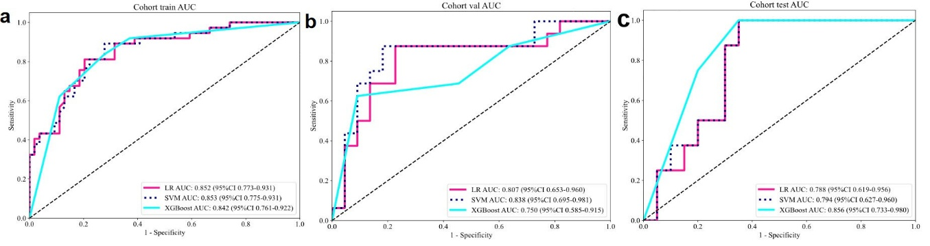
Supplementary Figure S1. ROC of different clinical models in training (a), validation (b),
and test cohorts (c).

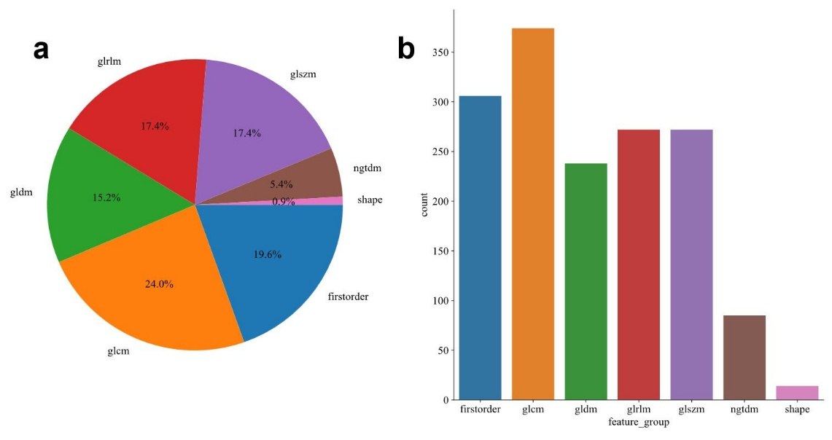
Supplementary Figure S2. Feature extraction and selection for radiomics model.
Pie chart (a) and histogram chart (b) of extracted features.

