Supporting Information

A Porphyrinic Covalent Organic Polymer Nanoplatform for Carborane Delivery and Multifunctional Imaging-guided Boron Neutron Capture Therapy of Breast Cancer
Jing Ren¹*, Tingran Wang²*, Changmin Zuo³*, Ruiping Zhang⁴, Liping Li^{2,3}
¹Shanxi Bethune Hospital, Shanxi Academy of Medical Sciences Tongji Shanxi Hospital, Third Hospital of Shanxi Medical University Taiyuan 030032, China; ²Department of Chemistry, Basic Medical College, Shanxi Medical University, Taiyuan 030001, China; ³Institute of Medical Technology, Shanxi Medical University, Taiyuan 030001, China; ⁴The Radiology Department of Shanxi Provincial People’s Hospital Affiliated to Shanxi Medical University, Taiyuan 030001, China
Jing Ren¹*
Tingran Wang²*
Changmin Zuo³*
*These authors contributed equally to this work
Correspondence: Ruiping Zhang, The Radiology Department of Shanxi Provincial People’s Hospital Affiliated to Shanxi Medical University, Taiyuan 030001, China, Email zrp_7142@sxmu.edu.cn; Liping Li, Department of Chemistry, Basic Medical College, Shanxi Medical University, Taiyuan 030001, China, Email liliping@sxmu.edu.cn

Details of the thermal neutron source
BNCT experiments in cells and mice were carried out using a miniature neutron source reactor at the In-Hospital Neutron Irradiator (IHNI), a low power research reactor designed and manufactured by the China Institute of Atomic Energy (CIAE). The experimental condition at IHNI is rated power 30 kW, the thermal neutron beam energy field of IHNI is <0.4 eV and the neutron flux is 1.9 × 10⁹ cm⁻² ·s⁻¹.

Parameters of BNCT treatment
In the BNCT experiment, the parameters of thermal neutrons, including thermal neutron dose rate, epithermal neutron dose rate, fast neutron dose rate, total neutron dose rate, γ-dose rate as well as 1 ppm B generated dose, are represented by the terms D_{th}, D_{epi}, D_{f}, D_{n}, D_{γ}, and D_{B-10}, respectively. Substitute the above parameters into the following equation to calculate the total irradiation dose (D_{total}) delivered to blood, tumor, and normal tissues.
D_{total} = D_{n} + D_{γ} + D_{B}
D_{n} = 6.26314E-02 × 60 × 30/100=1.13 Gy
D_{γ} = 1.50833E-02 × 60 × 30/100=0.27 Gy
D_{B-1ppm} = 1.23542E-02 × 60 × 30/100=0.22 Gy

Operation details of BNCT treatment
Briefly, the neutron was irradiated to the mice placed on an acrylic holder, with a circular hole in the center. The nontumor section was protected by the radiation shield that made up of 25 mm Bi plate and 35 mm ⁶Li-containing polyethylene plate.

Statistical analysis
All quantitative results were expressed as the mean ± standard deviation (SD) from at least three independent experiments. Statistical analysis was performed using Student’s t-test (two group comparison) and one-way ANOVA with Tukey’s honest significant difference post hoc test (multiple groups comparison). Differences were considered statistically significant at p < 0.01 (**), p < 0.001 (***), p < 0.0001 (****) and p > 0.05 (No significant, NS).

Figure.S1 The synthetic routes of TAPP and ATPP.
Preparation of 5,10,15,20-tetrakis[4-(1,3,2-dioxaborinan-2-yl)phenyl]-21H,23H-porphine (TAPP). A chloroform solution (250 mL) containing pyrrole (0.14 mL, 2 mmol) and 4-(1,3,2- dioxaborinan-2-yl)-benzaldehyde (0.38 g, 2 mmol) was degassed with a stream of Ar for 30 min. To a solution was added with boron trifluoride ethyl ether complex (BF₃·Et₂O, 30 µL). After the reaction mixture was stirred at r. t. for 1 h under Ar, p-chloranil (0.74 g, 3 mmol) was added to the mixture, and the mixture was further stirred for 12 h. The solvent was evaporated and then the residue was purified by column chromatography (silica gel, CHCl₃/CH₃OH = 9.5/0.5 in vol.), yield 13.68%. ¹ H NMR (400 MHz, CDCl₃): δ = 8.81 (s, 8H, CH of pyrrole), 8.13-8.20 (dd, J = 12.0 Hz, 16H, ArH), 4.30-4.33 (t, J = 6.0 Hz, 16H, CH2), 2.17-2.21 (m, 8H, CH2), -2.80 (s, 2H, NH of Pyrrole) ppm; ¹³C NMR (400 MHz, CDCl₃): δ = 144.6, 134.2, 132.1, 120.4, 62.36, 27.75 ppm; MALDI-TOF MS: m/z calcd 950.40 for C₅₆H₅₀B₄N₄O₈, found 950.07.
Preparation of 5, 10, 15, 20-tetrakis[4-(dihydroxyboryl)phenyl]-21H,23H-porphine (ATPP). 5,10,15,20-Tetrakis[4-(1,3,2-dioxaborinan-2-yl)phenyl]-21H,23H-porphine (95 mg, 0.1 mmol) was dissolved in THF (100 mL), an aqueous solution of HCl (pH = 1.0, 100 mL) was added to the mixture slowly. The mixture was stirred at room temperature for 24 h. CH₂Cl₂ (100 mL) was added to the mixture, and the organic layer was washed with aqueous solution of NaHCO₃ (100 Ml x 3; 5% in wt) and water (100 mL x 3), and dried over anhydrous Na₂SO₄. The solution was concentrated under vacuum and poured into hexane (100 mL). The purple precipitate was collected by centrifugation, yield 80%. ¹H NMR (400 MHz, d₈-THF): δ ＝ 8.83 (s, 8H, CH of pyrrole), 8.18-8.23 (dd, J = 4.0 Hz ,16H, ArH), 7.47 (s, 8H, OH), -2.78 (m, 2H, NH of Pyrrole) ppm; ¹³C NMR (400 MHz, CDCl₃): δ ＝ 145.0, 134.7, 133.5, 121.4 ppm; MALDITOF MS: m/z calcd 790.27 for C₄₄H₃₄B₄N₄O₈, found 790.01.
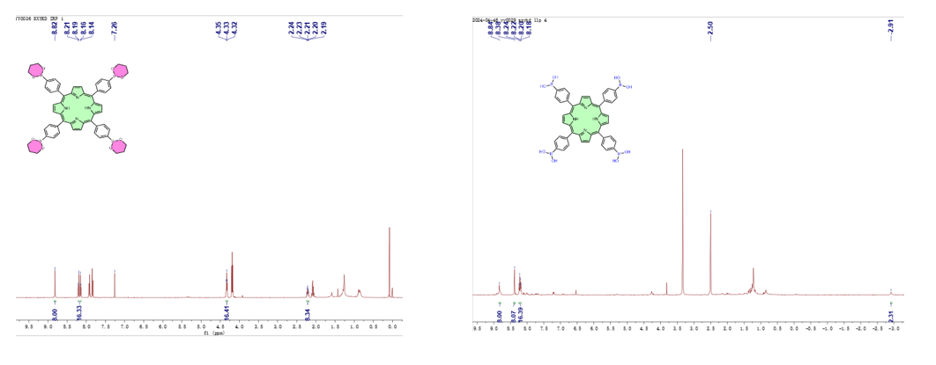
Figure.S2 ¹H NMR characteristic spectra of TAPP and ATPP.
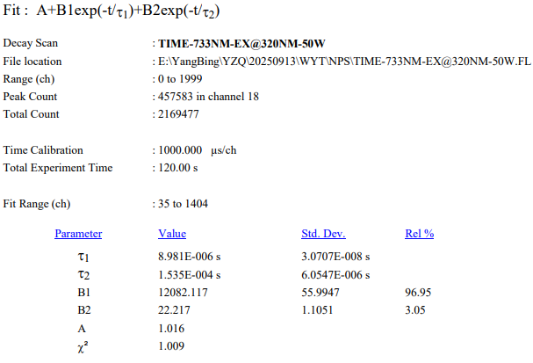
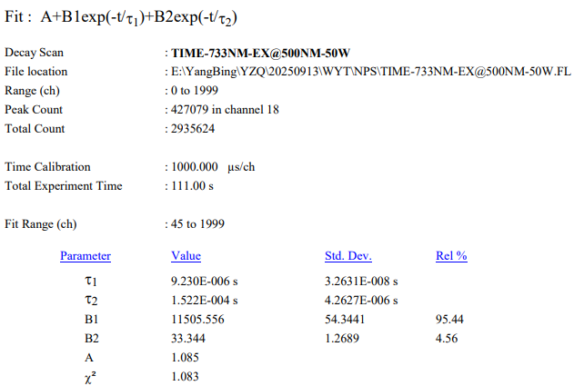 Figure.S3 Theoretical calculation of fluorescence lifetime.
Figure.S4 Blood routine indexes of mice after tretament with T-COP@o-CB NPs at different point time (n=3). Blood routine indicators inciude lympnocyte rauo (LYM%), intermediate cell ratio (MON%), neutrophil ratio (GRA%), total red blood cell count (RBC), hemoglobin (HGB), hematocrit (HCT), mean corpuscular volume (MCV), mean hemoglobin content (MCH), mean hemoglobin concentration (MCHC), erythrocyte distribution width CV(RDW), platelet mean volume (MPV), platelet distribution width CV(PDW).
Table. S1 Blood routine indexes of mice after tretament with T-COP@o-CB NPs at different point time (n=3). Blood routine indicators inciude lympnocyte rauo (LYM%), intermediate cell ratio (MON%), neutrophil ratio (GRA%), total red blood cell count (RBC), hemoglobin (HGB), hematocrit (HCT), mean corpuscular volume (MCV), mean hemoglobin content (MCH), mean hemoglobin concentration (MCHC), erythrocyte distribution width CV(RDW), platelet mean volume (MPV), platelet distribution width CV(PDW).

