Supplemental Figure 1. Stacked bar charts for categorical variables (gender and ASA classification) and kernel density plots for continuous variables (age, BMI, baseline eGFR, operative time, R.E.N.A.L. score, and clamp time) after IPTW matching
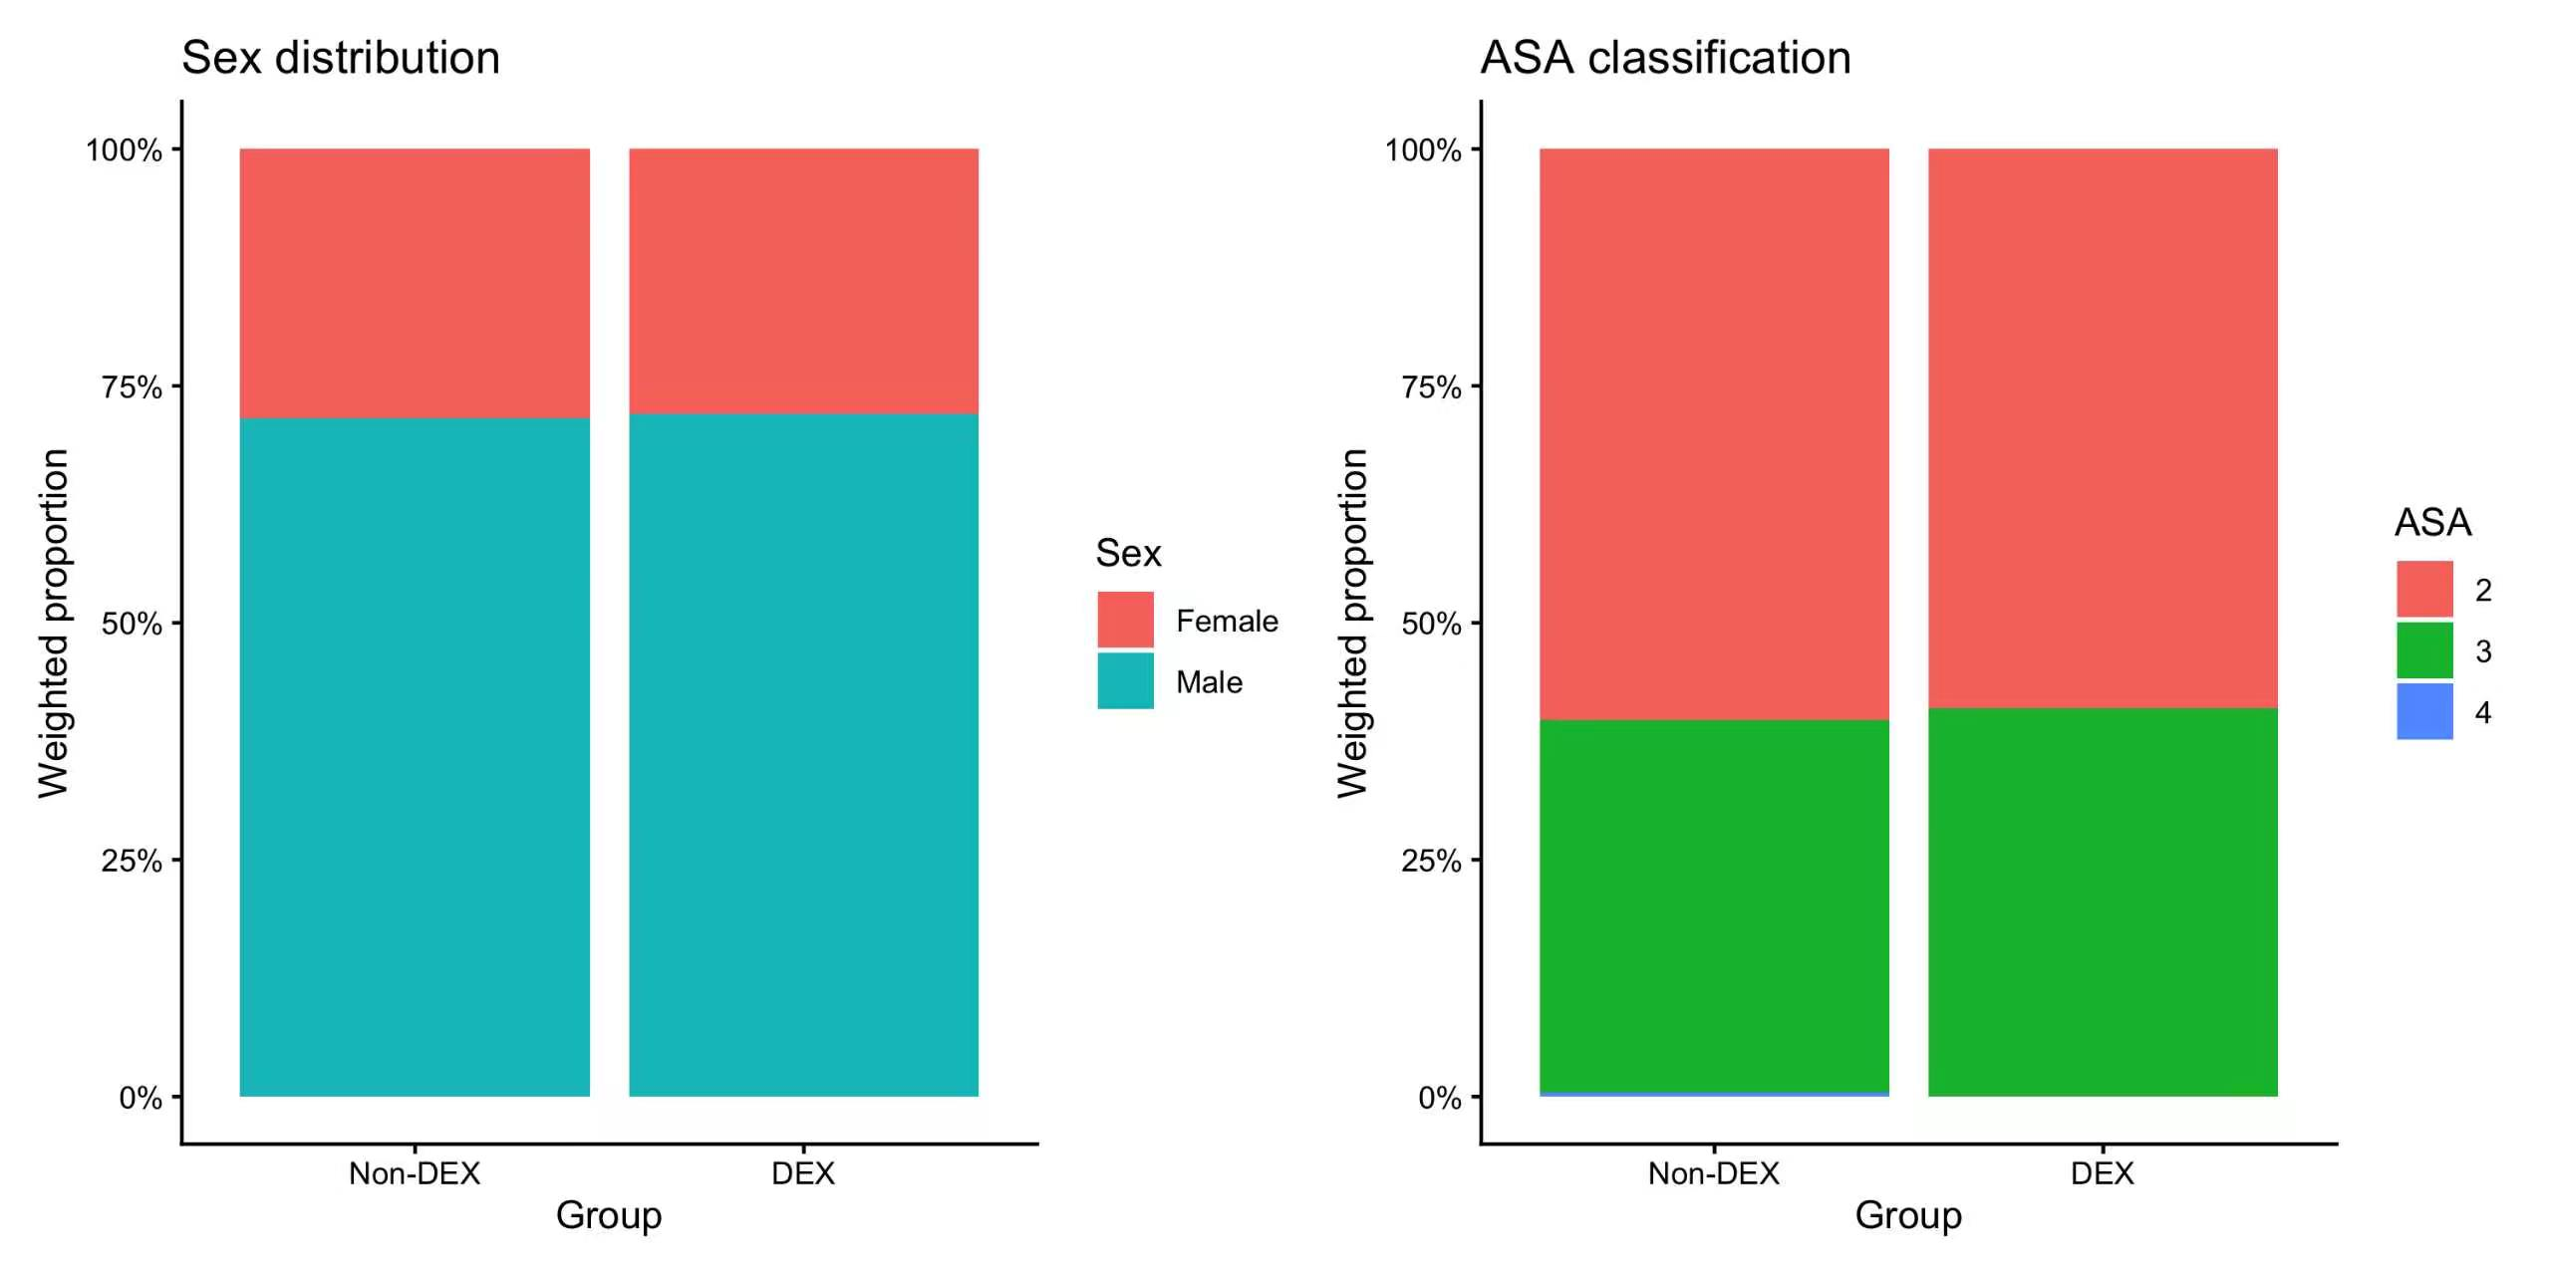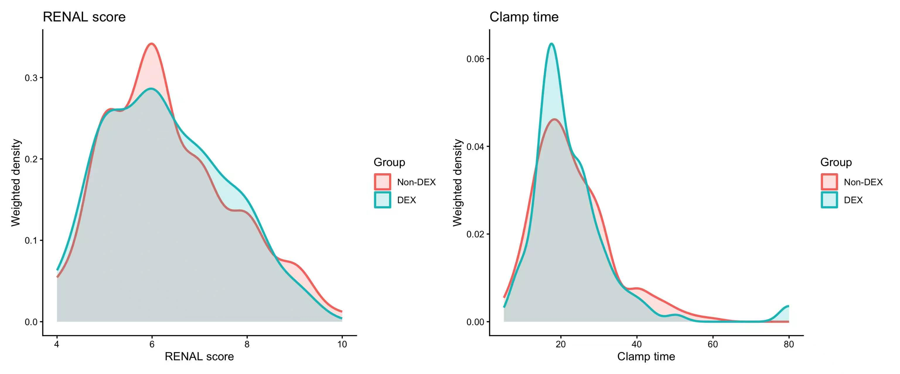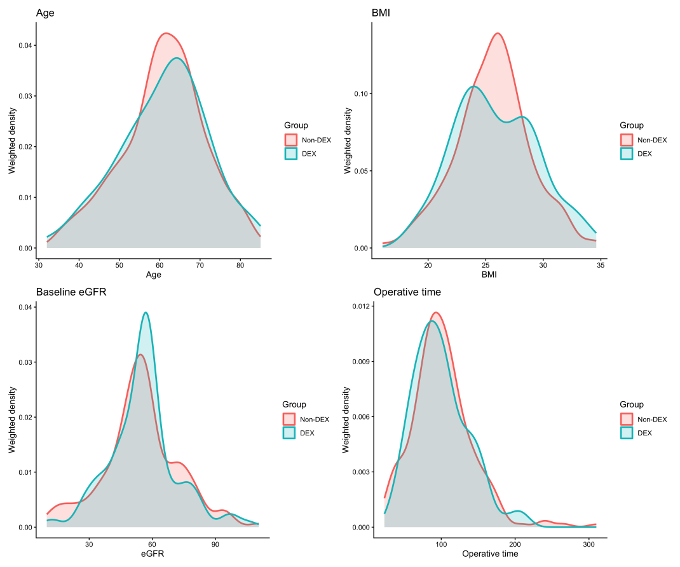
ASA, American Society of Anesthesiologists; BMI, body mass index; DEX, dexmedetomidine; eGFR, estimated glomerular ﬁltration rate; IPTW, Inverse Probability of Treatment Weighting.

Supplemental Table 1. IPTW-Weighted Logistic Regression of Factors Associated With Postoperative AKI.
 | Univariate |  |  | Multivariate
 | OR | 95%CI | P value | OR | 95%CI | P value
ASA classification | 1.314 | 0.780 to 2.216 | 0.304 | 1.326 | 0.784 to 2.243 | 0.292
Dexmedetomidine use | 0.499 | 0.271 to 0.921 | 0.026 | 0.497 | 0.269 to 0.918 | 0.026
ASA, American Society of Anesthesiologists; CI, confidence interval; IPTW, Inverse Probability of Treatment Weighting; OR, odds ratio.

