5. Supplementary Materials

5.1 Imputation Quality Assessment
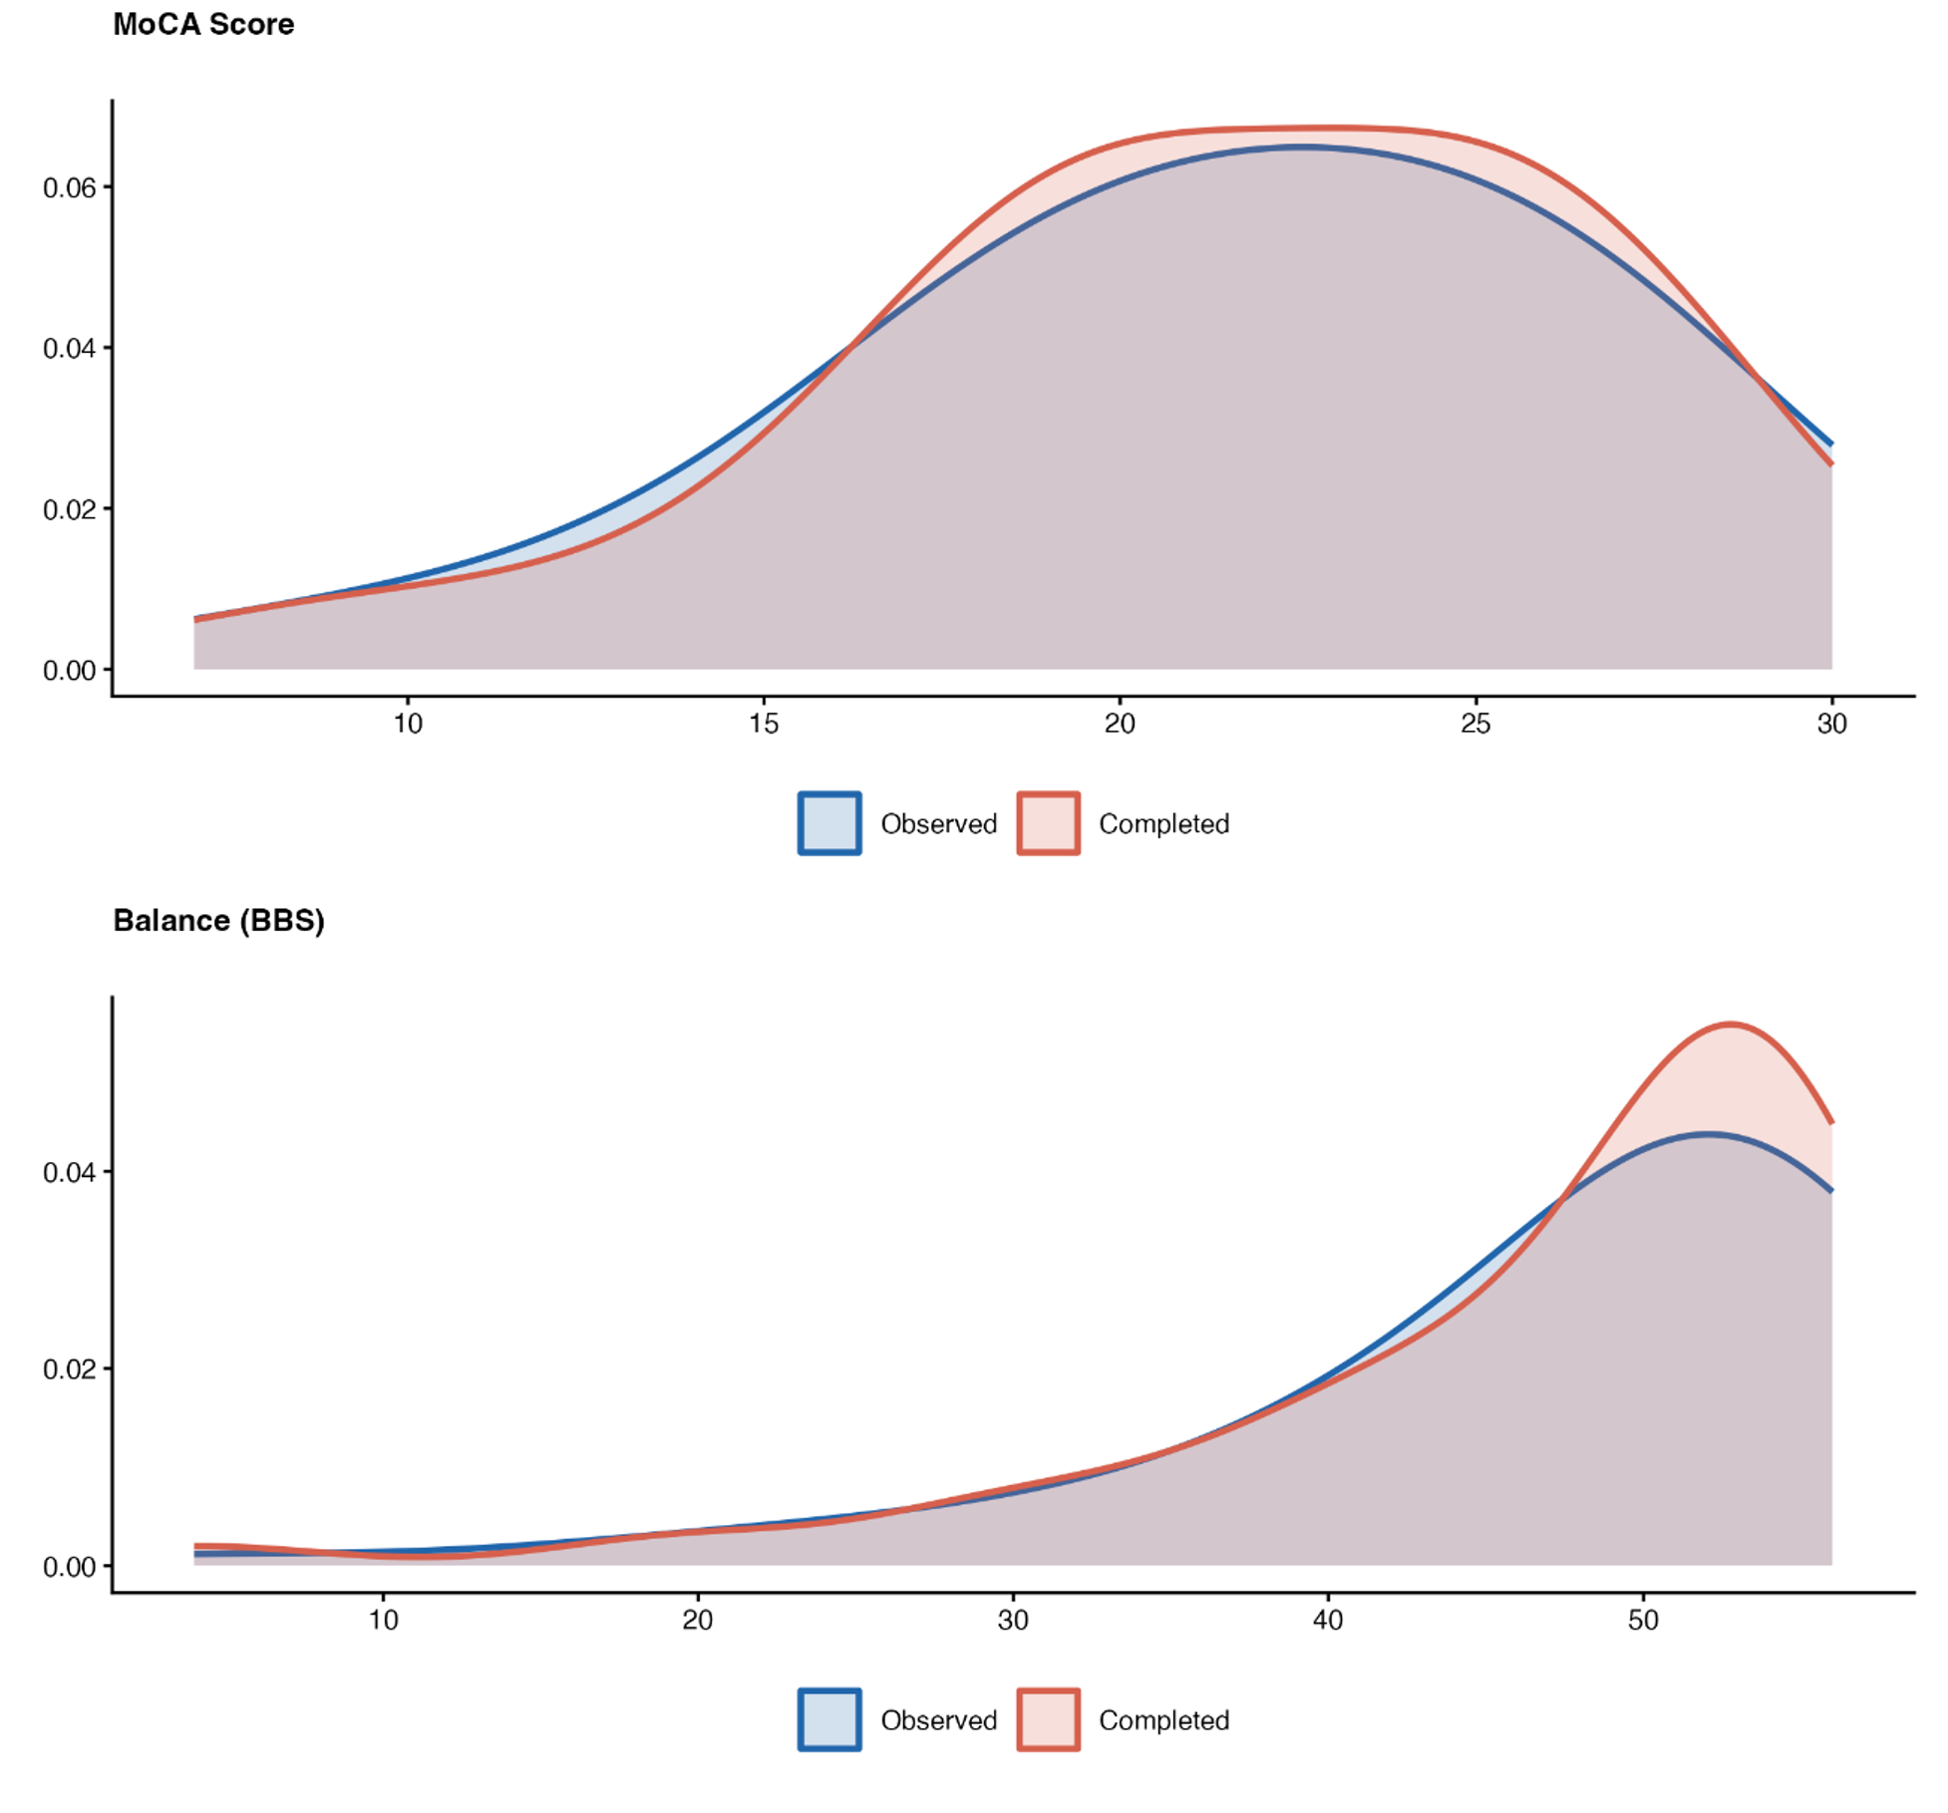
Supplementary Figure 1. Imputation Quality. Kernel density estimates of variables with missing data before and after multiple imputation in the MS cohort (n = 104). Blue curves represent observed values; red curves represent the completed dataset (observed + imputed values), pooled across m = 5 imputations. Close agreement between the two curves indicates that imputation preserved the original marginal distribution. Missingness: MoCA = 1.0 %, BBS = 43.3 %.

5.2 Bootstrap Stability Analysis
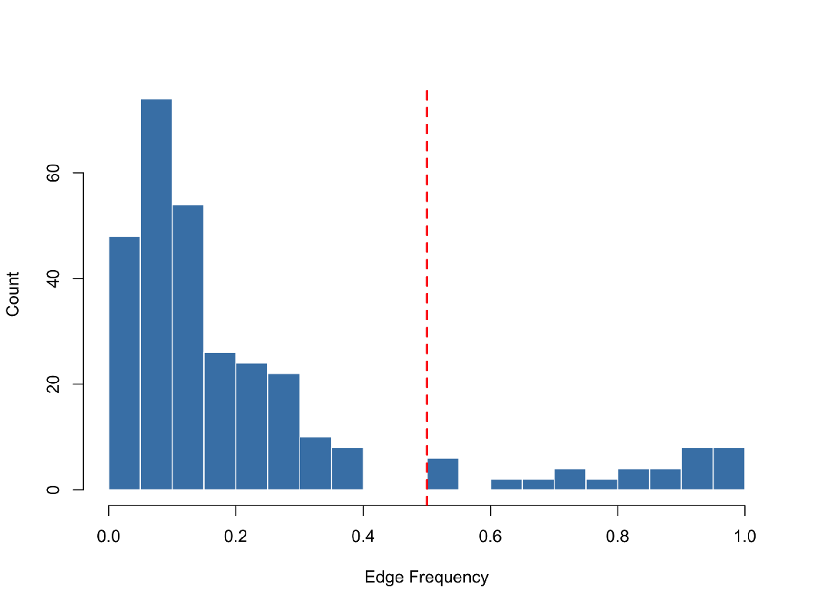
Supplementary Figure 2. Bootstrap edge frequencies for the Multiple Sclerosis Bayesian Network (500 resamples). The histogram shows the distribution of edge inclusion probabilities across bootstrap samples. The dashed red line indicates the 50 % stability threshold used to define stable edges. 21 of 27 edges (77.8 %) appeared in at least 50 % of bootstrap resamples.
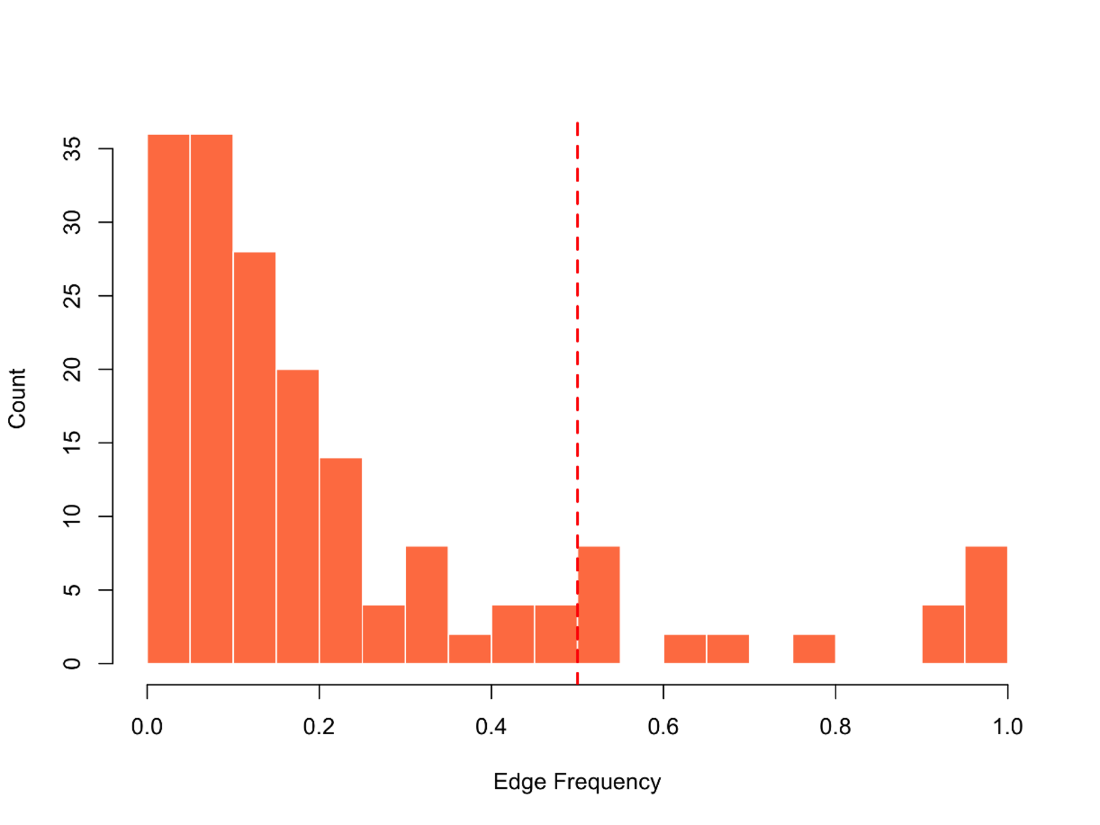
Supplementary Figure 3. Bootstrap edge frequencies for the Parkinson’s Disease Bayesian Network (500 resamples). The histogram shows the distribution of edge inclusion probabilities across bootstrap samples. The dashed red line indicates the 50 % stability threshold. 14 of 15 edges (93.3 %) exceeded the threshold; results should nevertheless be interpreted as hypothesis-generating given the smaller sample (n = 54).

5.3 Pairwise Correlation Matrices
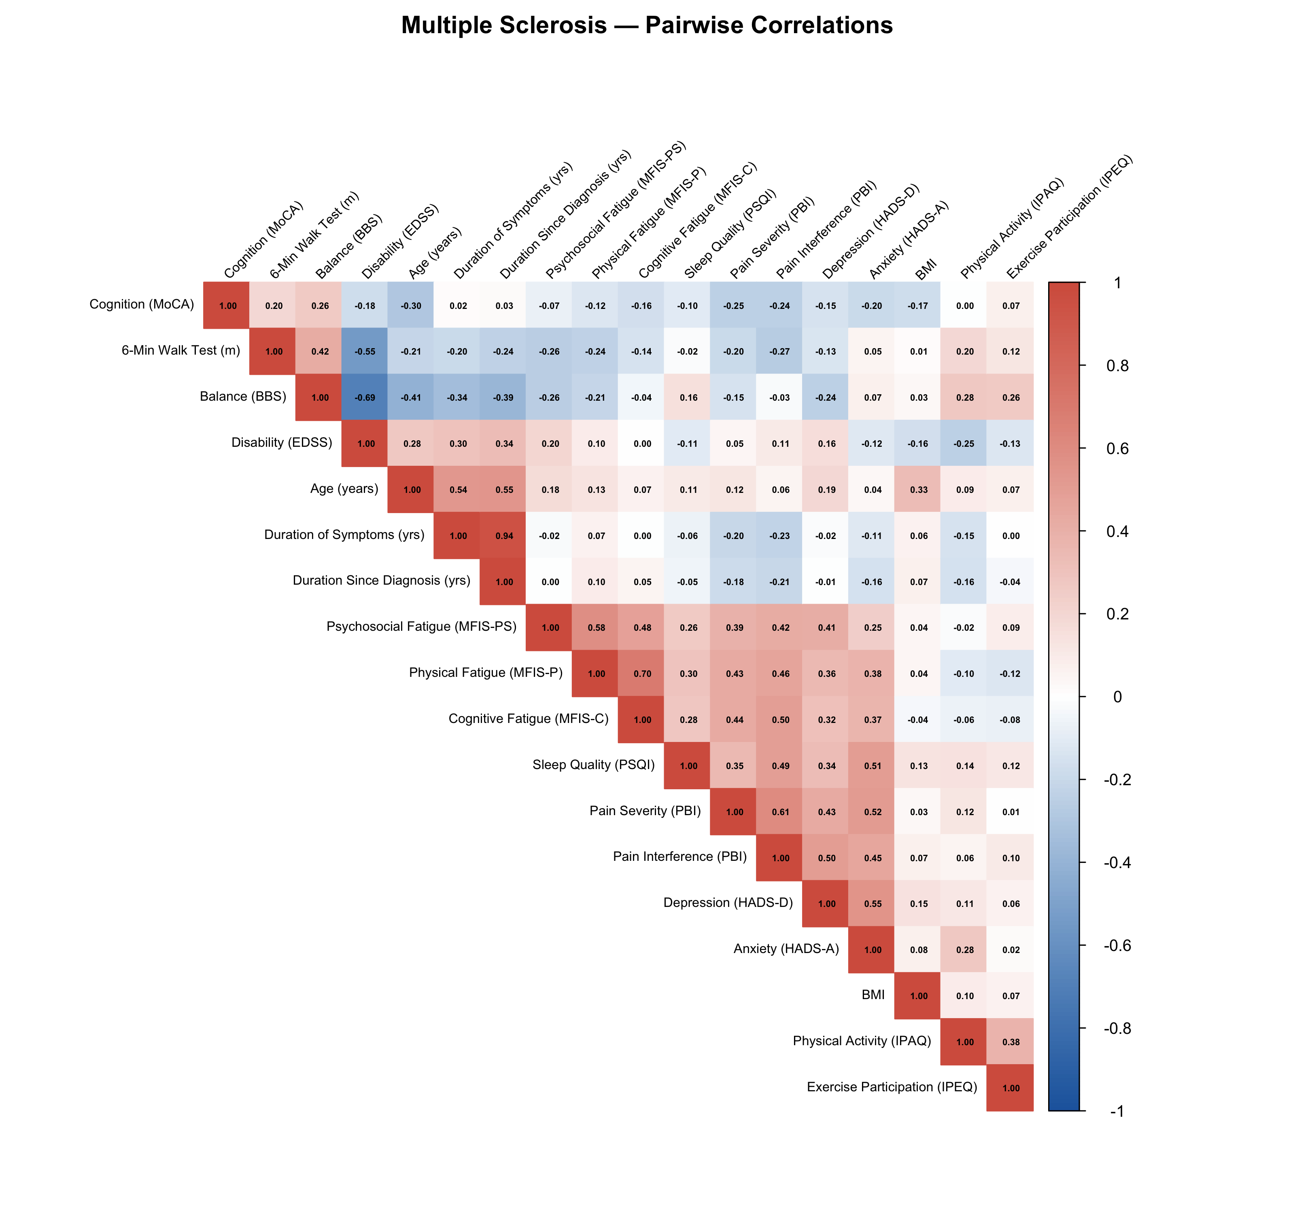
Supplementary Figure 4. Pairwise Pearson correlation matrix for the 18 variables included in the MS Bayesian Network (n = 104). Cell colours encode the sign and magnitude of each pairwise correlation; red indicates positive and blue negative association, with intensity proportional to |r|. Variable pairs with |r| > 0.70 should be interpreted as conditionally associated rather than directionally distinct in the network.
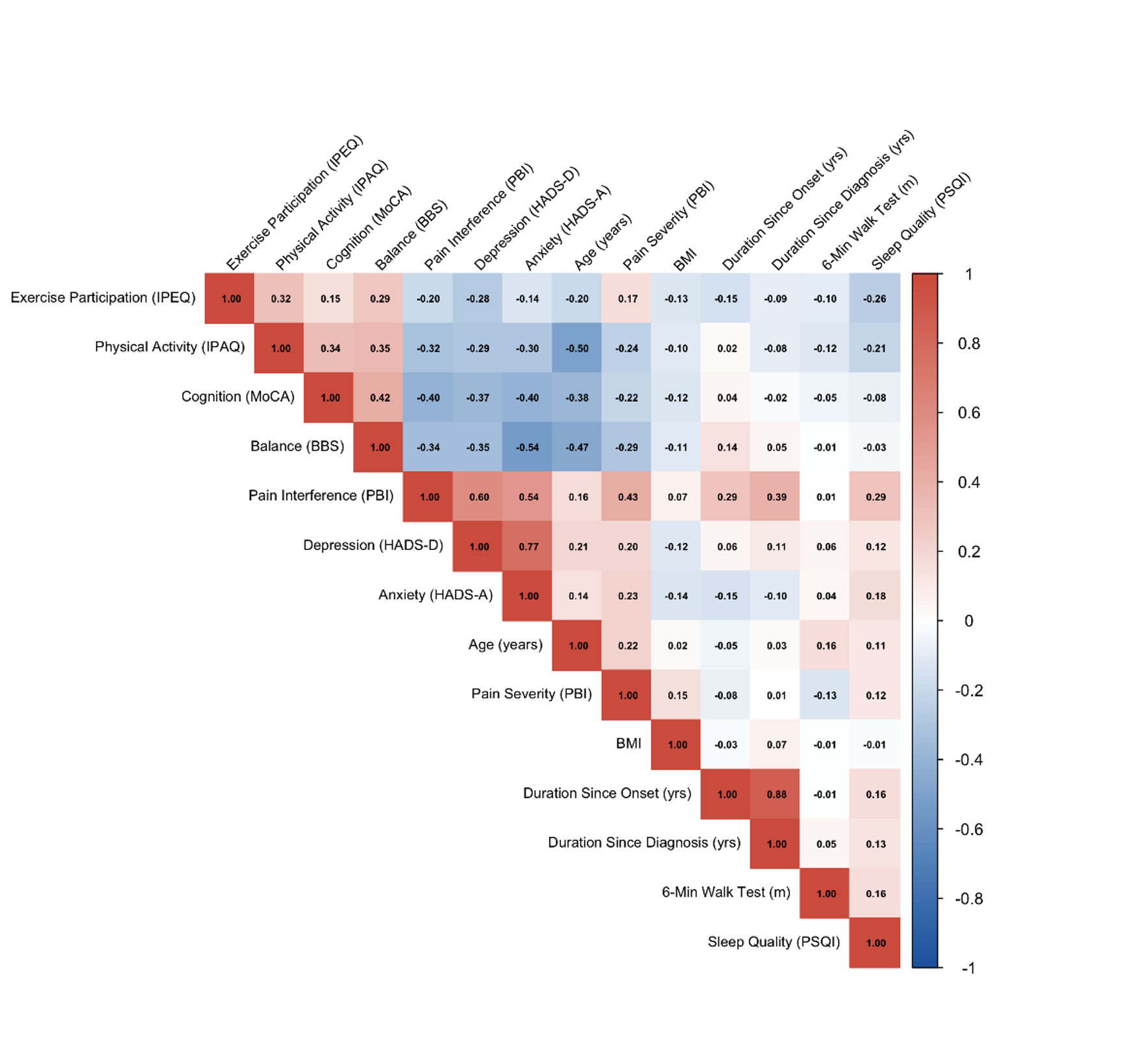
Supplementary Figure 5. Pairwise Pearson correlation matrix for the 14 variables included in the PD Bayesian Network (n = 54). Same colour conventions as Supplementary Figure 4. The high correlation between Duration since Onset and Duration since Diagnosis (r ≈ 0.94) was handled in the Bayesian Network by the temporal blacklist constraint described in Methods §2.5.

5.4 Sensitivity Analyses for the MS Bayesian Network
To assess the robustness of the MS Bayesian Network reported in Figure 1 to the choice of blacklist, three sensitivity analyses were performed by re-learning the network with the Hill-Climbing algorithm under modified constraints. All three analyses use the same first imputed dataset, the same z-standardised variables, and the same random seed (set.seed(42)) as the main analysis.
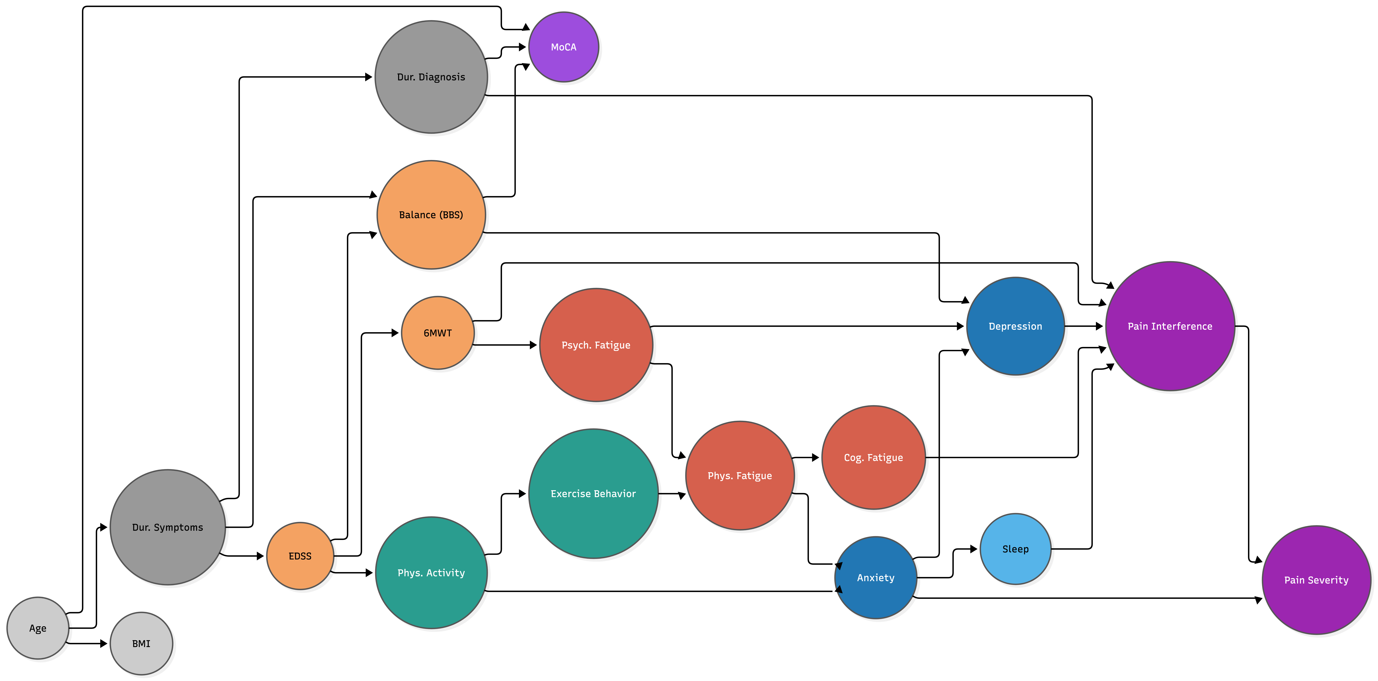
Supplementary Figure 6. Sensitivity analysis of the MS Bayesian Network with the BBS → EDSS edge added to the blacklist, in addition to the constraints used in the main analysis. Under this constraint the Hill-Climbing algorithm reverses the disability edge (EDSS → Balance) and recruits Duration since first symptoms as a direct parent of EDSS, while the depression–anxiety–pain triangle, the fatigue cluster and the IPAQ–IPEQ coupling remain unchanged. The resulting network has 18 nodes and 29 edges (vs. 26 in the main analysis). Node colours denote clinical domains as in Figure 1.
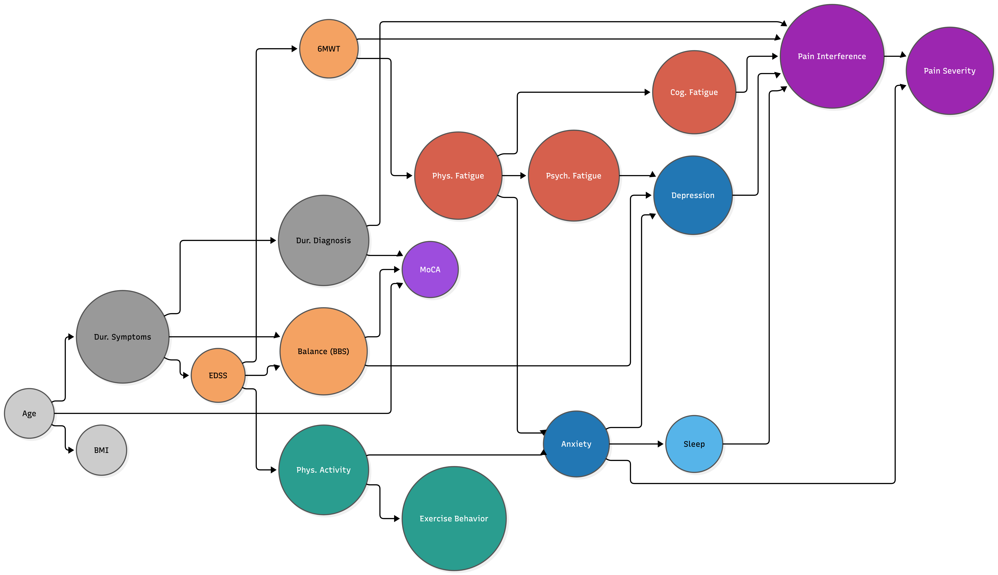
Supplementary Figure 7. Maximally restrictive sensitivity analysis with both BBS → EDSS and 6MWT → EDSS forbidden, in addition to the main-analysis blacklist. The resulting MS network differs from Supplementary Figure 6 by only two edges, indicating that the disability sub-network is robust to whether one or both motor → EDSS edges are permitted a priori. The network has 18 nodes and 28 edges. Node colours and conventions match Figure 1.
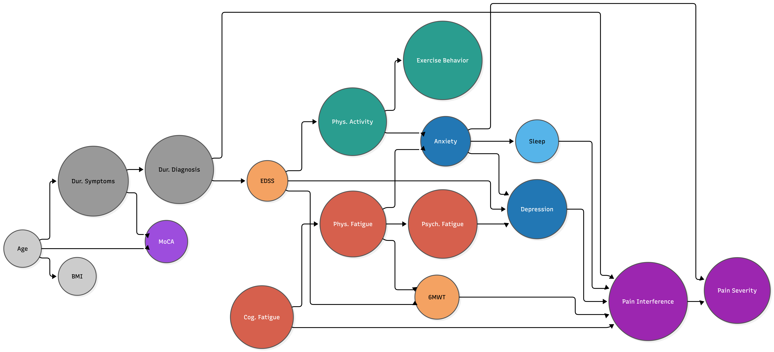
Supplementary Figure 8. Sensitivity analysis with Balance (BBS) excluded from the variable set and the MS network re-learned on 17 nodes. All four BBS-related edges naturally drop out and are replaced by a direct Duration since diagnosis → EDSS edge and a Duration since first symptoms → MoCA edge — both biologically plausible associations. The resulting network has 17 nodes and 25 edges, slightly more parsimonious than the main analysis. Node colours and conventions match Figure 1.

