Development and Validation of a Nomogram Incorporating Platelet Distribution Width and the Triglyceride-Glucose Index for Predicting Obstructive Sleep Apnea

Table of Content
Supporting figures 2
Figure S1. Variable selection using LASSO logistic regression. (A) LASSO coefficient profiles of the candidate predictors. (B) Ten-fold cross-validation curve for selecting the optimal penalty parameter λ. The two vertical dashed lines indicate lambda.min and lambda.1se. 2
Supporting tables 3
Table S1. Variables selected by LASSO logistic regression 3
Table S2. Additional laboratory and inflammation-related indicators by OSA status in the training and validation cohorts 4

Supporting figures
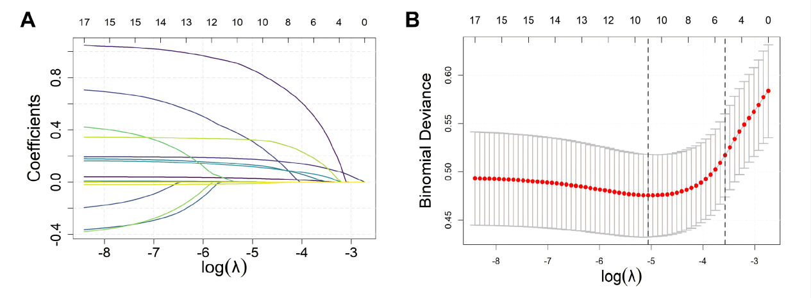

Figure S1. Variable selection using LASSO logistic regression. (A) LASSO coefficient profiles of the candidate predictors. (B) Ten-fold cross-validation curve for selecting the optimal penalty parameter λ. The two vertical dashed lines indicate lambda.min and lambda.1se.

Supporting tables

Table S1. Variables selected by LASSO logistic regression
Criterion | Variable | Coefficient
lambda.min | Age | 0.030723
lambda.min | Sex | 0.868940
lambda.min | BMI | 0.176349
lambda.min | Hypertension | 0.323596
lambda.min | WBC | 0.132818
lambda.min | Platelet count | 0.000785
lambda.min | PDW | 0.119794
lambda.min | ALT | 0.001794
lambda.min | TyG index | 0.324465
lambda.min | NLR | -0.011145
lambda.1se | Age | 0.006383
lambda.1se | Sex | 0.405742
lambda.1se | BMI | 0.111405
lambda.1se | WBC | 0.007851
lambda.1se | PDW | 0.046584
lambda.1se | TyG index | 0.134353
Variables with non-zero coefficients were considered selected predictors. The intercept was not listed. LASSO, least absolute shrinkage and selection operator; WBC, white blood cell count; PDW, platelet distribution width; ALT, alanine aminotransferase; TyG index, triglyceride-glucose index; NLR, neutrophil-to-lymphocyte ratio.

Table S2. Additional laboratory and inflammation-related indicators by OSA status in the training and validation cohorts
Variables | Total Levels | Training cohort |  | P-value | Validation cohort |  | P-value
Variables | Total Levels | Without OSA | OSA | P-value | Without OSA | OSA | P-value
LYM (×10⁹/L) | 10.2 ± 13.8 | 9.84 ± 15.3 | 10.5 ± 13.7 | 0.700 | 16.8 ± 19.1 | 9.10 ± 12.9 | 0.019
NEU (×10⁹/L) | 11.2 ± 18.5 | 13.6 ± 21.7 | 11.5 ± 18.9 | 0.405 | 8.80 ± 16.9 | 10.4 ± 16.9 | 0.570
ALT (U/L) | 33.6 ± 25.5 | 25.5 ± 17.2 | 35.2 ± 26.7 | 0.000 | 24.3 ± 14.2 | 32.8 ± 24.4 | 0.034
Albumin (g/L) | 45.0 ± 4.08 | 45.4 ± 3.97 | 45.0 ± 3.97 | 0.457 | 45.8 ± 4.74 | 44.6 ± 4.29 | 0.102
PNI | 96.2 ± 69.4 | 94.6 ± 76.8 | 97.3 ± 68.7 | 0.734 | 129.6 ± 96.6 | 90.1 ± 64.9 | 0.017
SII | 863.2 ± 1995.2 | 1101.7 ± 2655.6 | 837.3 ± 1995.1 | 0.346 | 385.0 ± 477.3 | 838.6 ± 1925.3 | 0.144
NLR | 3.56 ± 8.90 | 4.95 ± 12.9 | 3.49 ± 8.09 | 0.326 | 1.63 ±1.80 | 3.61 ± 10.0 | 0.220
LYM, lymphocyte count; NEU, neutrophil count; ALT, alanine aminotransferase; PNI, prognostic nutritional index; SII, systemic immune-inflammation index; NLR, neutrophil-to-lymphocyte ratio.

