Supplementary Material
Technical specifications of HRV measurement
Participants wore the device at the midpoint between the throat and the left nipple. This device can accurately measure heart rates in the range of 30-240 beats per minute (bpm) with R-R intervals of 250-2000 milliseconds. It operates using a 2.4GHz wireless transmission and can continuously monitor for up to 40 hours.³⁴ It is anti-allergenic since the sensor, strap, and wearable patch are biocompatible (ISO10993 certification). Moreover, the device can be connected to the BEATINFO mobile application for data collection and further HRV data analysis.
To minimize potential inaccuracies due to improper installation, researchers initially set up portable ECG devices and connected them to a mobile phone at the start of the study. Participants and their partners were taught how to reinstall the device after showering, with a return demonstration and a pamphlet providing detailed step-by-step instructions and illustrations. Additionally, the research team will monitor the device’s connection status online to reduce the likelihood of measurement errors further.
Mathematical Formula: The frequency domain transformation was conducted utilizing the Fast Fourier Transform (FFT).
$$X\left(t\right)=\int_{-∞}^{∞}{S\left(f\right)e^{i2πft}}df$$
Figure S1: Fast Fourier transform formula.
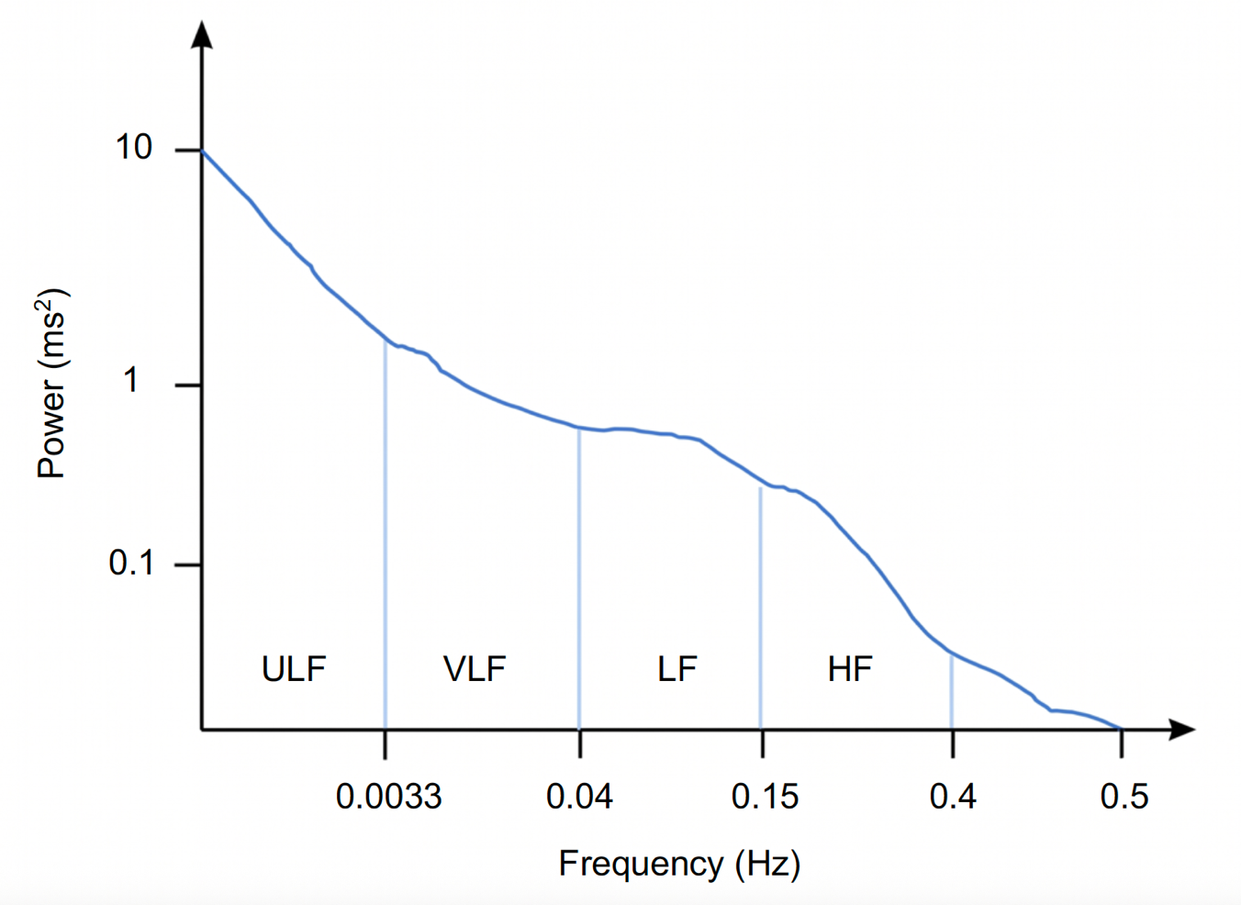
Figure S2: Definitions of different frequency domains and power standards.
Note. HF, high frequency; LF, low frequency; ULF, ultra low frequency; VLF, very low frequency. The image is the property of the author.

Table S1. Comparison of Demographic and Clinical Characteristics Between Included and Excluded Participants (N = 43)
Basic Information | Excluded  (n = 13) | Included  (n = 30) | t / χ² | p
Age | 33.6 (4.59) | 33.2 (2.36) | 0.42 | 0.675
Education
High school/ Vocational school | 0 (0) | 1 (3) | 0.73 ª | 0.806
Bachelor’s degree | 10 (77) | 20 (67)
Master’s degree | 3 (23) | 9 (30)
Marital status
Married | 13 (100) | 27 (90) | 1.40 ª | 0.542
Unmarried | 0 (0) | 3 (10)
Intended pregnancy
Yes | 11 (85) | 24 (83) | 0.02 ª | 1.00
No | 2 (15) | 5 (17)
Employment status
Yes | 9 (69) | 27 (90) | 2.87 ª | 0.172
No | 4 (31) | 3 (10)
Family income (USD/ month)
≤ $3,000 | 6 (50) | 11 (38) | 1.88 | 0.670
> $3,000 | 6 (50) | 18 (62)
Rooming-in level
< 8 h | 0 (0) | 0 (0) | 6.60 | 0.025*
≥ 8 & <16 h | 8 (62) | 6 (20)
≥16 & < 24 h | 5 (38) | 22 (73)
24 h | 0 (0) | 2 (7)
Fatigue on Day1 (possible range: 30-120) | 54.8 (13.15) | 53.6 (13.37) | 0.28 | 0.779
Nipple pain (e.g., cracked or blistered)
None | 7 (54) | 6 (20) | 5.63 | 0.113
Mild | 2 (15) | 12 (40)
Moderate | 4 (31) | 9 (30)
Severe | 0 (0) | 3 (10)
Perceived insufficiency of human milk for newborns
No problem | 4 (31) | 6 (20) | 0.84 ª | 0.887
Mild | 4 (31) | 9 (30)
Moderate | 3 (23) | 9 (30)
Severe | 2 (15) | 6 (20)
Breast engorgement
None | 3 (23) | 15 (50) | 3.64 ª | 0.280
Mild | 8 (62) | 11 (37)
Moderate | 2 (15) | 3 (10)
Severe | 0 (0) | 1 (3)
Flat or inverted nipples
None | 9 (69) | 19 (63) | 5.84 ª | 0.084
Mild | 1 (8) | 9 (30)
Moderate | 1 (8) | 2 (7)
Severe | 2 (15) | 0 (0)
Newborn latching difficulties
None | 4 (31) | 9 (30) | 3.49 ª | 0.319
Mild | 2 (15) | 12 (40)
Moderate | 4 (31) | 4 (13)
Severe | 3 (23) | 5 (17)
Mastitis (including breast abscess)
None | 12 (92) | 27 (90) | 0.71 ª | 1.00
Mild | 1 (7) | 2 (7)
Moderate | 0 (0) | 1 (3)
Severe | 0 (0) | 0 (0)
Assisted birth
Vacuum | 5 (38) | 16 (53) | 0.80 | 0.370
None | 8 (62) | 14 (47)
Feeding method
Exclusive breastfeeding | 3 (23) | 17 (57) | 4.46 ª | 0.099
Mixed feeding (as advised by a physician) | 1 (7) | 1 (3)
Mixed feeding (as requested by family) | 9 (69) | 12 (40)
Note. Abbreviations: USD, United States dollars; ª calculated using Fisher-Freeman-Halton Exact Test due to expected cell counts < five; *p < 0.05.

Table S2. Sensitivity analysis after multiple imputation (N=43)
 |  | nLF among Four Newborn States (N=43)
Newborn States |  | Lowest |  | Highest
 |  | n (%) |  | n (%)
Crying |  | 10.5 (24) |  | 6.4 (15)
Breastfeeding |  | 14.1 (33) |  | 3.3 (8)
Being held |  | 10.4 (24) |  | 3.2 (7)
Sleeping |  | 2.1 (5) |  | 24.2 (56)
Systematic missing |  | 6 (14) |  | 6 (14)
Note. n is the average of 20 iterations of multiple imputation

