Supplementary Materials
Supplementary Figure 1. Least Absolute Shrinkance and Selection Operator - Cox regression analysis plot. (A) LASSO-Cox regression coefficients for clinical and pathological features. (B) Selection of tuning parameter (lambda) in the LASSO regression using 10-fold cross-validation. The black dotted line represents lambda. min, while the red dotted line represents lambda.1-se. When λ = lambda.1-se, four variables were selected: PNI-dNLR, ASA, Surgical approach, AJCC pTNM.
Abbreviations: ASA, American Society of Anesthesiologists; AJCC, American Joint Committee on Cancer.
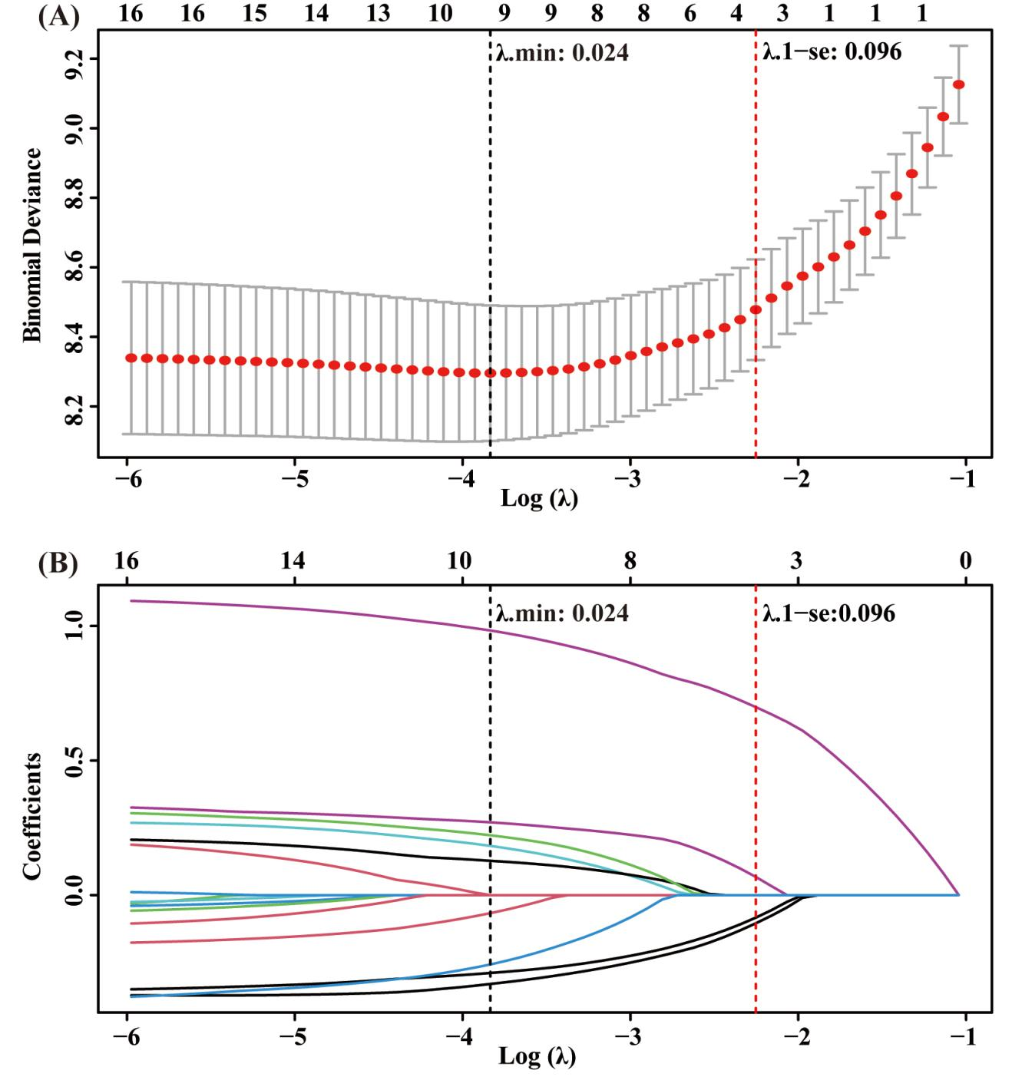
Supplementary Figure 2. Random Survival Forest analysis plot. (A) Variable importance for clinical and pathological features. (B) Out-of-Bag (OOB) Error versus the number of variables. When the optimal number of variables is 8 as indicated by the lowest OOB error. eight variables were selected: PNI-dNLR, ASA, Surgical approach, Histological type, AJCC pTNM, Vascular invasion, CD, ACT.
Abbreviations: BMI, Body Mass Index; ASA, American Society of Anesthesiologists; AJCC, American Joint Committee on Cancer; CD, Clavien-Dino grade system; ACT, adjuvant chemotherapy.
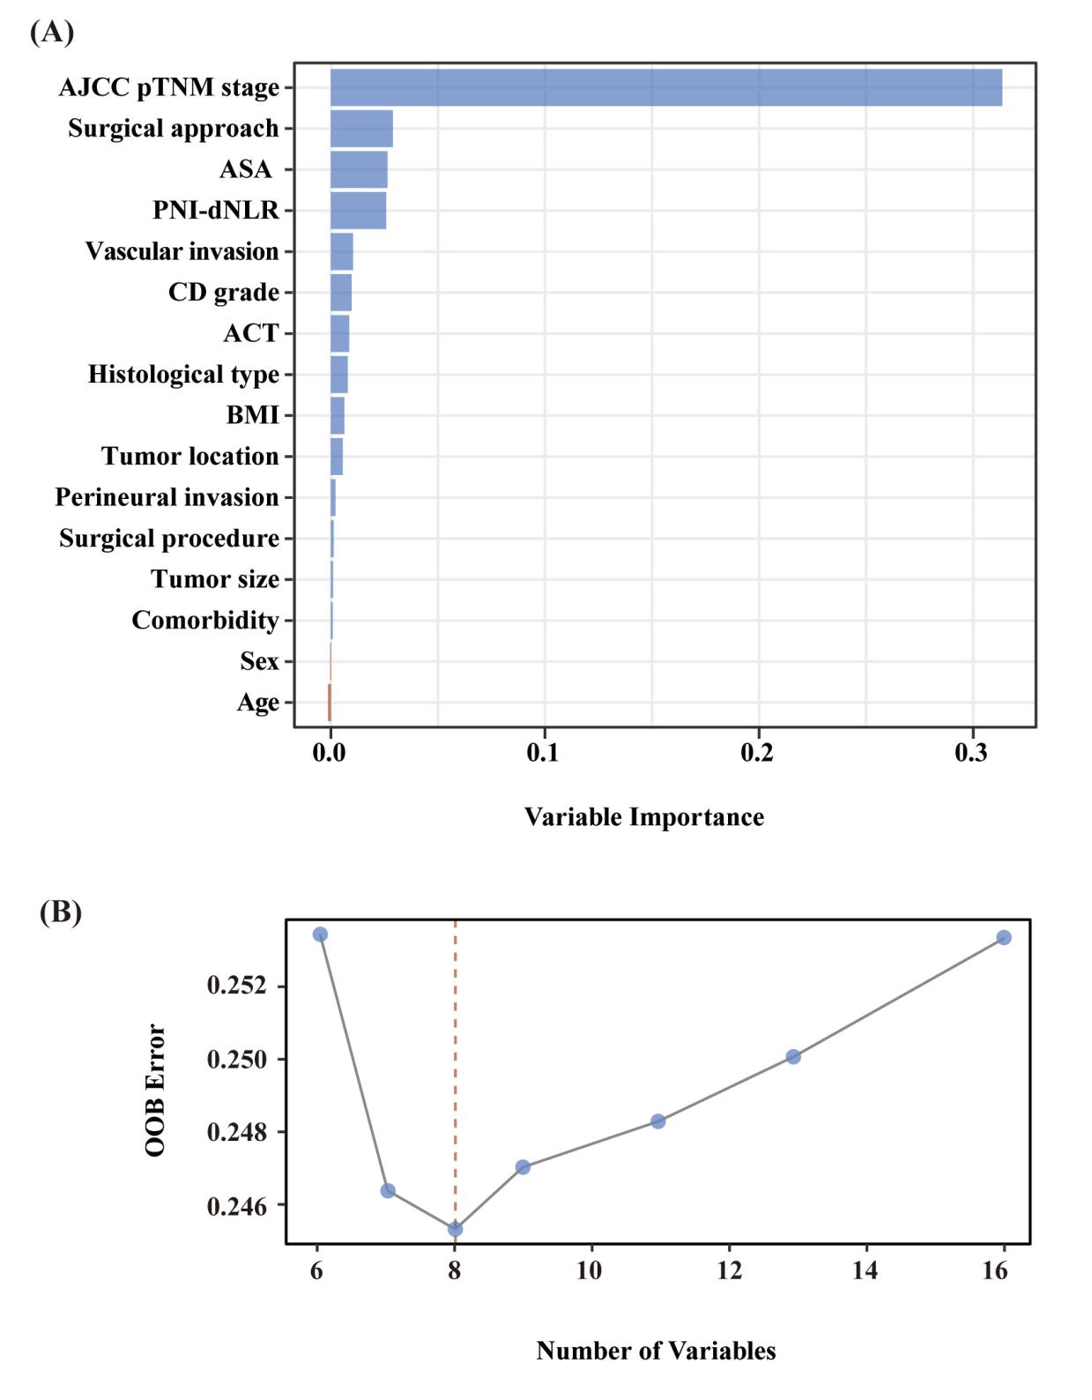

Supplementary Figure 3. Survival tree visualization and variable importance plot. (A) Survival tree visualization. (B) Variable importance plot.
Abbreviations: BMI, Body Mass Index; ASA, American Society of Anesthesiologists; AJCC, American Joint Committee on Cancer; CD, Clavien-Dino grade system; ACT, adjuvant chemotherapy.
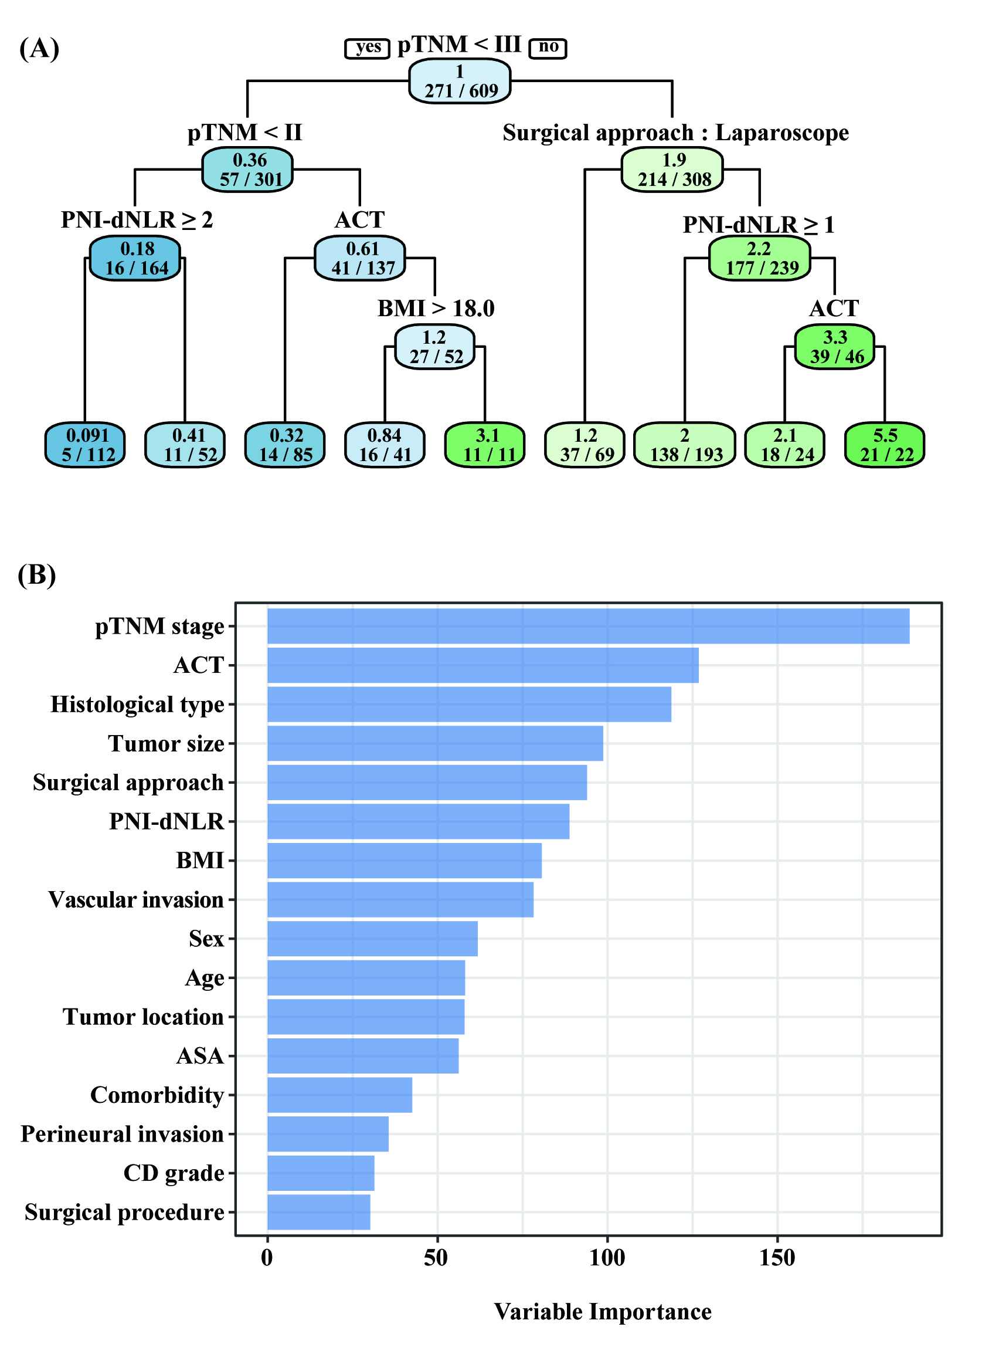

Supplementary Table 1. Calculation methods of combination in each nutrition/inflammation-based indicator
Indicators | Calculation formula
NLR | neutrophil count (×10⁹) / lymphocyte count (×10⁹)
LMR | lymphocyte count (×10⁹) / monocyte count(×10⁹)
PLR | platelet count (×10⁹) / lymphocyte count (×10⁹)
dNLR | neutrophil count (×10⁹) / (white cell count (×10⁹) -neutrophil count (×10⁹))
SII | platelet count (×10⁹) × neutrophil count (×10⁹) / lymphocyte count (×10⁹)
SIRI | neutrophil count (×10⁹) × monocyte count(×10⁹) / lymphocyte count (×10⁹)
AISI | neutrophil count (×10⁹) × monocyte count(×10⁹) × platelet count (×10⁹) /lymphocyte count (×10⁹)
GNRI | 1.489×albumin (g/L) + 41.7× current weight/ IBW (ideal body weight)
If current weight is greater than IBW, current weight/IBW is regarded as 1. The IBW of men and women were calculated by the formula, height(cm)-100-[height (cm)-150/4] and height(cm)-100-[height (cm)-150/2.5], respectively.

Abbreviations: AISI: Aggregate Index of Systemic Inflammation; dNLR: derived neutrophil-to-lymphocyte ratio; GNRI: Geriatric Nutritional Risk Index; LMR: lymphocyte-to-monocyte ratio; NLR: neutrophil-to-lymphocyte ratio; PLR: platelet-to-lymphocyte ratio; SII: systemic immune-inflammation index; SIRI: systemic inflammation response index.

Supplementary Table 2. Baseline characteristics stratified by PNI and dNLR
 | High PNI  (n=362) | Low PNI  (n=247) | P-value | High dNLR  (n=133) | Low dNLR  (n=476) | P-value
Sex, n (%) |  |  | 0.060 |  |  | 0.689
Female | 99 (27.3%) | 51 (20.6%) |  | 31 (23.3%) | 119 (25.0%)
Male | 263 (72.7%) | 196 (79.4%) |  | 102 (76.7%) | 357 (75.0%)
Age(years), n (%) |  |  | <0.001 |  |  | 0.181
<70 | 191 (52.8%) | 92 (37.2%) |  | 55 (41.4%) | 228 (47.9%)
≥70 | 171 (47.2%) | 155 (62.8%) |  | 78 (58.6%) | 248 (52.1%)
Comorbidity, n (%) |  |  | 0.192 |  |  | 0.346
No | 230 (63.5%) | 144 (58.3%) |  | 77 (57.9%) | 297 (62.4%)
Yes | 132 (36.5%) | 103 (41.7%) |  | 56 (42.1%) | 179 (37.6%)
BMI(kg/m²), n (%) |  |  | 0.002 |  |  | 0.188
<18.5 | 34 (9.4%) | 47 (19.0%) |  | 24 (18.1%) | 57 (12.0%)
18.5-24.9 | 278 (76.8%) | 175 (70.9%) |  | 93 (69.9%) | 360 (75.6%)
>24.9 | 50 (13.8%) | 25 (10.1%) |  | 16 (12.0%) | 59 (12.4%)
ASA, n (%) |  |  | 0.002 |  |  | 0.517
Ⅰ | 137 (37.8%) | 72 (29.2%) |  | 42 (31.6%) | 167 (35.1%)
Ⅱ | 211 (58.3%) | 150 (60.7%) |  | 80 (60.2%) | 281 (59.0%)
Ⅲ | 14 (3.9%) | 25 (10.1%) |  | 11 (8.2%) | 28 (5.9%)
Surgical approach, n (%) |  |  | <0.001 |  |  | 0.020
Laparoscope | 180 (49.7%) | 75 (30.4%) |  | 44 (33.1%) | 211 (44.3%)
Open | 182 (50.3%) | 172 (69.6%) |  | 89 (66.9%) | 265 (55.7%)
Surgical procedure, n (%) |  |  | 0.095 |  |  | 0.400
Subtotal | 80 (22.1%) | 41 (16.6%) |  | 23 (17.3%) | 98 (20.6%)
Total | 282 (77.9%) | 206 (83.4%) |  | 110 (82.7%) | 378 (79.4%)
Tumor location, n (%) |  |  | 0.016 |  |  | 0.117
Upper | 175 (48.3%) | 108 (43.7%) |  | 54 (40.6%) | 229 (48.1%)
Middle | 89 (24.6%) | 64 (25.9%) |  | 35 (26.3%) | 118 (24.8%)
Lower | 84 (23.2%) | 50 (20.2%) |  | 30 (22.6%) | 104 (21.8%)
Overlapping | 14 (3.9%) | 25 (10.2%) |  | 14 (10.5%) | 25 (5.3%)
Tumor size(cm), n (%) |  |  | <0.001 |  |  | 0.002
<5 | 228 (63.0%) | 110 (44.5%) |  | 58 (43.6%) | 280 (58.8%)
≥5 | 134 (37.0%) | 137 (55.5%) |  | 75 (56.4%) | 196 (41.2%)
Histological type, n (%) |  |  | 0.379 |  |  | 0.001
Differentiated | 189 (52.2%) | 120 (48.6%) |  | 51 (38.3%) | 258 (54.2%)
Undifferentiated | 173 (47.8%) | 127 (51.4%) |  | 82 (61.7%) | 218 (45.8%)
AJCC pT stage, n (%) |  |  | <0.001 |  |  | 0.002
T1 | 90 (24.9%) | 34 (13.8%) |  | 14 (10.5%) | 110 (23.1%)
T2 | 40 (11.0%) | 20 (8.0%) |  | 8 (6.0%) | 52 (10.9%)
T3 | 72 (19.9%) | 74 (30.0%) |  | 40 (30.1%) | 106 (22.3%)
T4a | 160 (44.2%) | 119 (48.2%) |  | 71 (53.4%) | 208 (43.7%)
AJCC pN stage, n (%) |  |  | 0.057 |  |  | 0.046
N0 | 160 (44.2%) | 85 (34.4%) |  | 40 (30.1%) | 205 (43.1%)
N1 | 54 (14.9%) | 37 (15.0%) |  | 26 (19.5%) | 65 (13.7%)
N2 | 50 (13.8%) | 44 (17.8%) |  | 21 (15.8%) | 73 (15.3%)
N3a | 69 (19.1%) | 48 (19.4%) |  | 27 (20.3%) | 90 (18.9%)
N3b | 29 (8.0%) | 33 (13.4%) |  | 19 (14.3%) | 43 (9.0%)
AJCC pTNM stage, n (%) |  |  | <0.001 |  |  | <0.001
Ⅰ | 119 (32.9%) | 45 (18.2%) |  | 19 (14.3%) | 145 (30.5%)
Ⅱ | 74 (20.4%) | 63 (25.5%) |  | 37 (27.8%) | 100 (21.0%)
Ⅲ | 169 (46.7%) | 139 (56.3%) |  | 77 (57.9%) | 231 (48.5%)
Vascular invasion, n (%) |  |  | 0.078 |  |  | 0.013
No | 274 (75.7%) | 171 (69.2%) |  | 86 (64.7%) | 359 (75.4%)
Yes | 88 (24.3%) | 76 (30.8%) |  | 47 (35.3%) | 117 (24.6%)
Perineural invasion, n (%) |  |  | 0.211 |  |  | 0.005
No | 284 (78.5%) | 183 (74.1%) |  | 90 (67.7%) | 377 (79.2%)
Yes | 78 (21.5%) | 64 (25.9%) |  | 43 (32.3%) | 99 (20.8%)
CD, n (%) |  |  | <0.001 |  |  | 0.257
<Ⅱ | 315 (87.0%) | 186 (75.3%) |  | 105 (78.9%) | 396 (83.2%)
≥Ⅱ | 47 (13.0%) | 61 (24.7%) |  | 28 (21.1%) | 80 (16.8%)
ACT, n (%) |  |  | 0.242 |  |  | 0.219
No | 176 (48.6%) | 132 (53.4%) |  | 61 (45.9%) | 247 (51.9%)
Yes | 186 (51.4%) | 115 (46.6%) |  | 72 (54.1%) | 229 (48.1%)
AFP(ng/ml), median (IQR) | 2.6 (1.9,3.7) | 2.5 (1.6,3.6) | 0.092 | 2.4 (1.6,3.5) | 2.6 (1.9,3.7) | 0.112
CEA(ng/ml), median (IQR) | 2.8 (1.7,5.4) | 3.1 (1.8,6.1) | 0.255 | 3.1 (1.9,6.0) | 2.9 (1.7,5.5) | 0.193
CA199(ng/ml), median (IQR) | 12.2(6.9,32.9) | 13.7 (6.8,42.2) | 0.316 | 13.0 (5.9,41.8) | 12.7 (7.2,32.5) | 0.998
Abbreviations: ACT: adjuvant chemotherapy; AFP: Alpha Fetal Protein; AJCC: American Joint Committee on Cancer; ASA: American Society of Anesthesiologists; BMI: Body Mass Index; CA199: Carbohydrate Antigen199; CD: Clavien-Dindo grade system; CEA: Carcinoembryonic Antigen; IQR: interquartile range; PNI: Prognostic Nutritional Index.

Supplementary Table 3. The relationship between the PNI-dNLR and clinicopathological characteristics in elder patients undergoing curative resection for gastric cancer
 | PNI-dNLR =0  (n=94) | PNI-dNLR =1  (n=192) | PNI-dNLR =3  (n=323) | P-value
Sex, n (%) |  |  |  | 0.330
Female | 19 (20.2%) | 44 (22.9%) | 87 (26.9%)
Male | 75 (79.8%) | 148 (77.1%) | 236 (73.1%)
Age(years), n (%) |  |  |  | 0.003
<70 | 35 (37.2%) | 77 (40.1%) | 171 (52.9%)
≥70 | 59 (62.8%) | 115 (59.9%) | 152 (47.1%)
Comorbidity, n (%) |  |  |  | 0.345
No | 54 (57.4%) | 113 (58.9%) | 207 (64.1%)
Yes | 40 (42.6%) | 79 (41.1%) | 116 (35.9%)
BMI(kg/m²), n (%) |  |  |  | 0.023
<18.5 | 21 (22.3%) | 29 (15.1%) | 31 (9.6%)
18.5-24.9 | 64 (68.1%) | 140 (72.9%) | 249 (77.1%)
≥25.0 | 9 (9.6%) | 23 (12.0%) | 43 (13.3%)
ASA, n (%) |  |  |  | 0.009
Ⅰ | 29 (30.9%) | 56 (29.2%) | 124 (38.4%)
Ⅱ | 57 (60.6%) | 116 (60.4%) | 188 (58.2%)
Ⅲ | 8 (8.5%) | 20 (10.4%) | 11 (3.4%)
Surgical approach, n (%) |  |  |  | <0.001
Laparoscope | 25 (26.6%) | 69 (35.9%) | 161 (49.8%)
Open | 69 (73.4%) | 123 (64.1%) | 162 (50.2%)
Surgical procedure, n (%) |  |  |  | 0.284
Subtotal | 14 (14.9%) | 36 (18.8%) | 71 (22.0%)
Total | 80 (85.1%) | 156 (81.2%) | 252 (78.0%)
Tumor location, n (%) |  |  |  | 0.020
Upper | 35 (37.2%) | 92 (47.9%) | 156 (48.3%)
Middle | 29 (30.9%) | 41 (21.4%) | 83 (25.7%)
Lower | 18 (19.1%) | 44 (22.9%) | 72 (22.3%)
Overlapping | 12 (12.8%) | 15 (7.8%) | 12 (3.7%)
Tumor size(cm), n (%) |  |  |  | <0.001
<5 | 40 (42.6%) | 88 (45.8%) | 210 (65.0%)
≥5 | 54 (57.4%) | 104 (54.2%) | 113 (35.0%)
Histological type, n (%) |  |  |  | 0.051
Differentiated | 38 (40.4%) | 95 (49.5%) | 176 (54.5%)
Undifferentiated | 56 (59.6%) | 97 (50.5%) | 147 (45.5%)
AJCC pT stage, n (%) |  |  |  | <0.001
T1 | 9 (9.6%) | 30 (15.6%) | 85 (26.3%)
T2 | 6 (6.4%) | 16 (8.3%) | 38 (11.8%)
T3 | 32 (34.0%) | 50 (26.1%) | 64 (19.8%)
T4a | 47 (50.0%) | 96 (50.0%) | 136 (42.1%)
AJCC pN stage, n (%) |  |  |  | 0.056
N0 | 29 (30.9%) | 67 (34.9%) | 149 (46.1%)
N1 | 14 (14.9%) | 35 (18.2%) | 42 (13.0%)
N2 | 17 (18.1%) | 31 (16.1%) | 46 (14.2%)
N3a | 18 (19.1%) | 39 (20.3%) | 60 (18.6%)
N3b | 16 (17.0%) | 20 (10.5%) | 26 (8.1%)
AJCC pTNM stage, n (%) |  |  |  | <0.001
Ⅰ | 12 (12.7%) | 40 (20.8%) | 112 (34.7%)
Ⅱ | 26 (27.7%) | 48 (25.0%) | 63 (19.5%)
Ⅲ | 56 (59.6%) | 104 (54.2%) | 148 (45.8%)
Vascular invasion, n (%) |  |  |  | 0.032
No | 62 (66.0%) | 133 (69.3%) | 250 (77.4%)
Yes | 32 (34.0%) | 59 (30.7%) | 73 (22.6%)
Perineural invasion, n (%) |  |  |  | 0.051
No | 66 (70.2%) | 141 (73.4%) | 260 (80.5%)
Yes | 28 (29.8%) | 51 (26.6%) | 63 (19.5%)
CD, n (%) |  |  |  | 0.007
<Ⅱ | 70 (74.5%) | 151 (78.6%) | 280 (86.7%)
≥Ⅱ | 24 (25.5%) | 41 (21.4%) | 43 (13.3%)
ACT, n (%) |  |  |  | 0.910
No | 49 (52.1%) | 95 (49.5%) | 164 (50.8%)
Yes | 45 (47.9%) | 97 (50.5%) | 159 (49.2%)
AFP(ng/ml), median (IQR) | 2.4 (1.5,3.4) | 2.5 (1.7,3.8) | 2.6 (1.9,3.7) | 0.132
CEA(ng/ml), median (IQR) | 3.2 (2.2,7.6) | 2.9 (1.6,5.5) | 2.8 (1.7,5.5) | 0.045
CA199(ng/ml), median (IQR) | 12.4(5.6,39.0) | 14.6 (7.5,41.9) | 12.1 (7.1,31.4) | 0.417
Abbreviations: ACT: adjuvant chemotherapy; AFP: Alpha Fetal Protein; AJCC: American Joint Committee on Cancer; ASA: American Society of Anesthesiologists; BMI: Body Mass Index; CA199: Carbohydrate Antigen199; CD: Clavien-Dindo grade system; CEA: Carcinoembryonic Antigen; dNLR: derived neutrophil-to-lymphocyte ratio; IQR: interquartile range; PNI-dNLR: prognostic nutritional index-derived neutrophil-to-lymphocyte ratio.

Supplementary Table 4. Univariate and Multivariate analysis of clinicopathologic variables in relation to disease-free Survival in elder patients undergoing curative resection for gastric cancer
 | Model 0 |  | Model 1 |  | Model 2
 | HR (95% CI) | P-value | HR (95% CI) | P-value | HR (95% CI) | P-value
PNI-dNLR
0 | Reference |  | Reference |  | Reference
1 | 0.68 (0.49-0.93) | 0.017 | 0.63 (0.45-0.88) | 0.006 | 0.63 (0.45-0.87) | 0.006
2 | 0.40 (0.29-0.54) | <0.001 | 0.40 (0.29-0.56) | <0.001 | 0.47 (0.33-0.66) | <0.001
Model 0: no cofounder.
Model 1: adjusted for sex, age, comorbidity, BMI, ASA.
Model 2: adjusted for sex, age, comorbidity, BMI, ASA, surgical approach, surgical procedure, tumor location, tumor size, histological type, AJCC pTNM stage, vascular invasion, perineural invasion, CD, ACT.

Abbreviations: ACT: adjuvant chemotherapy; AJCC: American Joint Committee on Cancer; ASA: American Society of Anesthesiologists; BMI: Body Mass Index; CD: Clavien-Dindo grade system; CI: confidence interval; HR: hazard ratio; PNI-dNLR: prognostic nutritional index-derived neutrophil-to-lymphocyte ratio.

Supplementary Table 5. The Akaike information criterion and Bayesian information criterion of indicators for overall survival in elder patients with gastric cancer
 | AIC | BIC
PNI | 858.85 | 872.04
dNLR | 868.69 | 881.88
PNI-dNLR | 853.89 | 867.09
Abbreviations: AIC: Akaike information criterion; BIC: Bayesian information criterion; dNLR: derived neutrophil-to-lymphocyte ratio; PNI: Prognostic Nutritional Index; PNI-dNLR: prognostic nutritional index-derived neutrophil-to-lymphocyte ratio.

Supplementary Table 6. Predictor variables of overall survival in elder patients using different selection methods
Methods | Predictor variables
LASSO-COX | PNI-dNLR, ASA, Surgical approach, AJCC pTNM.
COX | PNI-dNLR, ASA, Surgical approach, Histological type, AJCC pTNM, CD, ACT.
RSF | PNI-dNLR, ASA, Surgical approach, Histological type, AJCC pTNM, Vascular invasion, CD, ACT.
ST | PNI-dNLR, Surgical approach, AJCC pTNM, BMI, ACT.
Abbreviations: ACT: adjuvant chemotherapy; AJCC: American Joint Committee on Cancer; ASA: American Society of Anesthesiologists; BMI: Body Mass Index; CD: Clavien-Dindo grade system; COX: Cox Proportional Hazards Model; LASSO-COX: Least Absolute Shrinkage and Selection Operator - Cox Regression; PNI-dNLR: prognostic nutritional index-derived neutrophil-to-lymphocyte ratio; RSF: Random Survival Forests; ST: Survival Tree.

