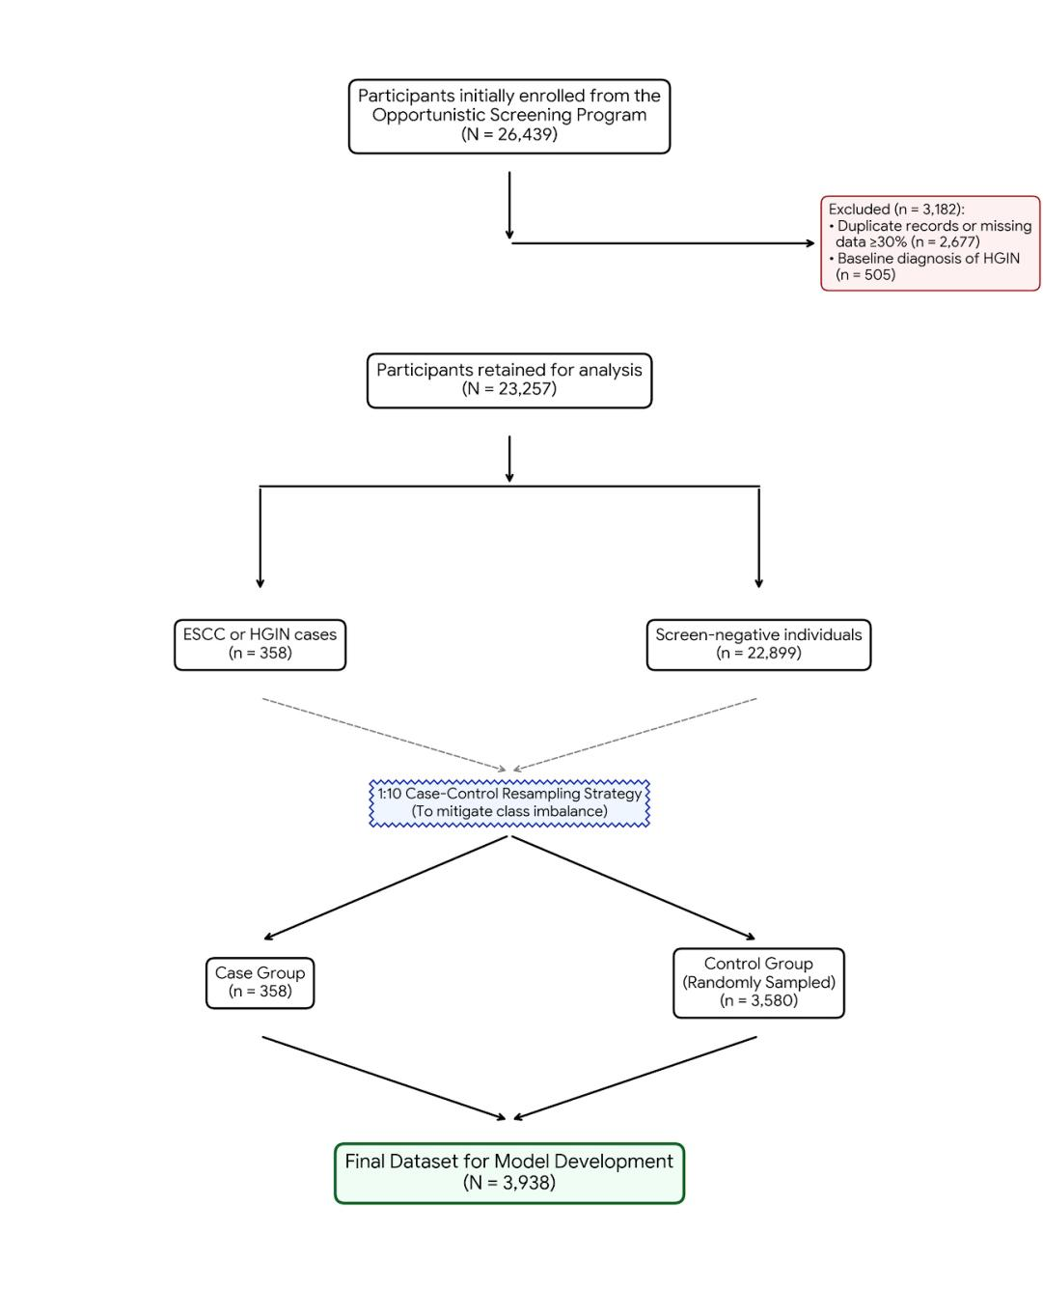
Supplementary Figure 1. Flowchart of participant selection and study design. The diagram illustrates the stepwise process of initial enrollment from the Opportunistic Screening Program, the application of specific exclusion criteria, and the implementation of the 1:10 case-control resampling strategy to mitigate class imbalance. Ultimately, a final dataset of 3,938 participants (comprising 358 ESCC/HGIN cases and 3,580 randomly sampled controls) was generated for subsequent model development and internal validation.

