Supplementary Methods

Materials and Methods
Materials
All chemical reagents are of the highest purity and require no further purification prior to use. Tetrachlorocupric chloride (HAuCl₄), silver nitrate (AgNO₃), hexamethylimidazolium chloride (HMT), polyvinylpyrrolidone (PVP), ascorbic acid (AA), and anhydrous ethanol were procured from Yangzhou Qianchen Chemical Co., Ltd. (China). 4-Mercaptobenzoic acid (4-MBA), PBS (pH=7.4), and sodium chloride (NaCl) were purchased from Yangzhou Youno Chemical Co., Ltd. (China). Triethanolamine phosphate (TCEP) was purchased from Aladdin (Shanghai) Biochemical Technology Co., Ltd. Polydimethylsiloxane (PDMS) was purchased from Thermo Fisher Scientific. TE buffer, miRNA-103a, miRNA-221, Capture DNA-103a-Cy3, Capture DNA-221-Cy5, Mutant RNA-U/C-miRNA-103a, Mutant RNA-U/C-miRNA-221, and miRNA-196a were all purchased from Shanghai Sangon Biotech Co., Ltd. Additionally, qRT-PCR kits were procured from Takara Bio Inc. Double-stranded nucleases (DSN) were purchased from Thermo Fisher Scientific. Nucleotide sequences employed in this study are detailed in Table S1. All experiments utilised ultrapure water (18.2 MΩ·cm). Reusable containers were immersed in aqua regia followed by thorough rinsing with ultrapure water.

Preparation of Au-AgNBs
To prepare Au-AgNBs, slowly add HAuCl₄ solution (3 mL, 0.75 M) dropwise to HMT solution (3 mL, 0.03 M) whilst maintaining stirring until the solution becomes transparent. Add polyvinylpyrrolidone solution (PVP, 3 mL, 0.30 M) dropwise, continuing stirring for a period until the mixture is homogeneous. Then add silver nitrate solution (AgNO₃, 10 mL, 0.01 M) dropwise until the mixture becomes colourless and transparent. After stirring for 30 seconds, slowly add ascorbic acid solution (AA, 10 mL, 0.08 M) while stirring for 20 minutes. The solution gradually changes from colourless to blue-black. Allow the resulting mixture to stand at room temperature for approximately 12 hours. All of the above synthesis procedures were carried out at room temperature using ultrapure water with a pH of 7.0; the pH was not adjusted during the synthesis. Finally, after three washes with ethanol and ultrapure water, disperse the Au-AgNBs particles in ultrapure water and store at 4°C for subsequent use.
Experimental Instrumentation
Au-AgNBs were characterised by a field emission scanning electron microscope (SEM, Hitachi S-4800) at 1 kV for 5 μA. Similarly, high-resolution transmission electron microscopy (HRTEM) images were acquired at 200 kV acceleration voltage via a Tecnai G2 F30 S-TWIN microscope. Transmission electron microscopy images were likewise acquired using the Tecnai G2 F30 S-TWIN microscope. SERS measurements were performed using a Renishaw in Via Raman microscope equipped with a 785 nm (100mW) excitation laser and a 50× objective lens. Ultraviolet-visible absorption spectra were recorded at 365 nm using a Cary 5000 spectrophotometer (Varian). The Renishaw Raman spectrometer used in this study has a laser power of 100 mW, a 50× objective lens and a numerical aperture of 0.75. The spectral resolution is approximately 0.65 cm⁻¹. The spectral range is 100-2000 cm-1. Particle size and zeta potential of Au-AgNBs were characterised by a Malvern particle analyser (ES90 Nano). Imaging characterisation of the Au-AgNBs array was performed using a DXRxi micro-Raman imaging spectrometer.

Fig. S1 physical image of the microarray chips, Figure S1A showed the microarray chip and the PDMS cover. Figure S1B showed the microarray chip with the cover in place, along with a side view.
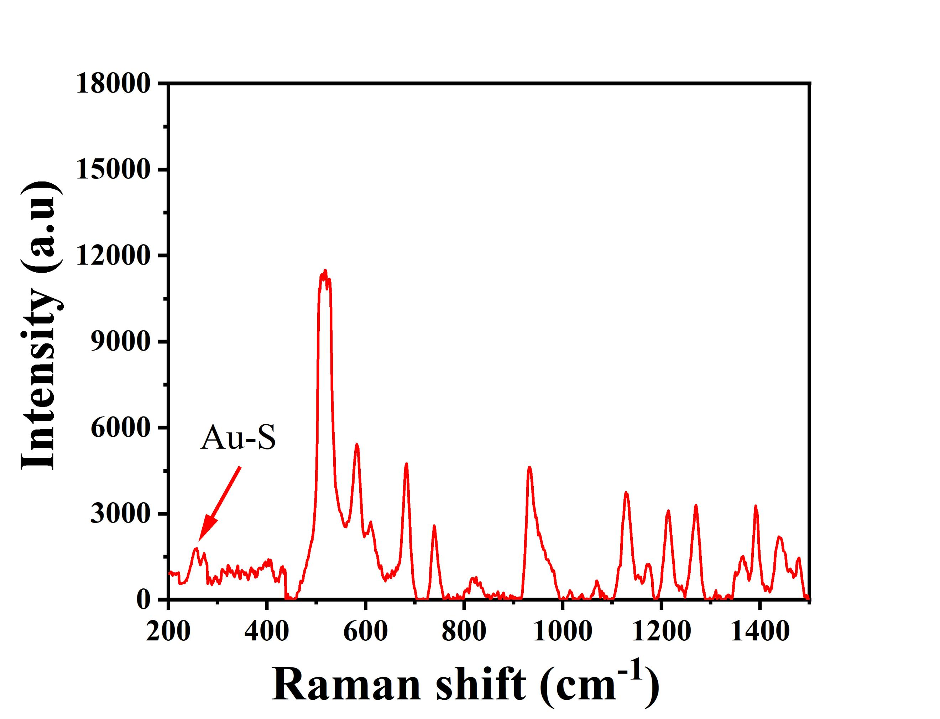
Fig. S2 The Raman spectrum of DNA-103a labeled Au-AgNBs at the range of 200-1500 cm⁻¹.

