Supplementary Information

Supplementary Table S1. Demographic and clinicopathological characteristics of 54 treatment-naïve CM patients.
Variables | Stage III CM patients (n = 35) | Stage IV CM patients (n = 18) | Total (n = 54)
Sex, n (%)
Male | 18 (51.4) | 14 (77.8) | 33 (61.1)
Female | 17 (48.6) | 4 (22.2) | 21 (38.9)
Median age, years (range) | 60 (39−84) | 71 (47−91) | 66 (39–91)
Stage†, n (%)
IIC |  |  | 1 (1.9)
III |  |  | 35 (64.8)
IIIA | 2 (5.7)
IIIB | 11 (31.4)
IIIC | 18 (51.4)
IIID | 4 (11.4)
IV |  |  | 18 (33.3)
BRAF status, n (%)
Wildtype | 19 (54.3) | 17 (94.4) | 36 (66.7)
Mutated | 15 (42.8) | 1 (5.6) | 16 (29.6)
Missing‡ | 1 (2.9) | --- | 2 (3.7)
Histology subtype, n (%)
Superficial spreading | 16 (45.7) | 9 (50.0) | 26 (48.1)
Nodular | 12 (34.3) | 3 (16.67) | 15 (27.8)
Acral lentiginous | 1 (2.85) | 3 (16.67) | 4 (7.4)
Nevoid | 1 (2.85) | --- | 1 (1.9)
Missing‡ | 5 (14.3) | 3 (16.67) | 8 (14.8)
Median Breslow thickness, mm (range) | 2.8 (0.9−13) | 4.4 (0.9−26) | 3.5 (0.9–26)
Missing‡ (n, %) | 6 (17.1) | 1 (5.6) | 7 (13.0)
Ulceration, n (%)
Absent | 15 (42.85) | 9 (50.0) | 25 (46.3)
Present | 15 (42.85) | 7 (38.9) | 22 (40.7)
Missing‡ | 5 (14.3) | 2 (11.1) | 7 (13.0)
Median follow-up, months (95% CI) | 35.8 (30.5−41.1) | 44.3 (28.0−60.6) | 36.0 (24.9–47.1)
Median OS, months (95% CI) | 48.5 (37.7−59.3) | 15.3 (0.0−39.0) | 39.3 (23.6–55.0)
OS status, n (%)
Alive | 21 (60.0) | 6 (33.3) | 28 (51.9)
Deceased | 14 (40.0) | 12 (66.7) | 26 (48.1)
Median EFS, months (95% CI) | 29.4 (8.2−50.6) | 9.6 (1.3−17.9) | 21.3 (11.6–31.0)
EFS status, n (%)
Progression/disease-free | 17 (48.6) | 7 (38.9) | 25 (46.3)
Progression/recurrence | 18 (51.4) | 11 (61.1) | 29 (53.7)

(continued)
Variables | Stage III CM patients (n = 35) | Stage IV CM patients (n = 18) | Total (n = 54)
Subsequent therapy, n (%)
Targeted therapy | 2 (5.7) | --- | 2 (3.7)
Immune-checkpoint inhibitors | 30 (85.7) | 12 (66.7) | 43 (87.0)
None | 3 (8.6) | 6 (33.3) | 9 (16.7)
† Staging was performed according to American Joint Committee on Cancer (AJCC) staging version 8 [49].
‡ Data not available in the clinical records or not assessed.
Abbreviations: CM, cutaneous melanoma; EFS, event-free survival; OS, overall survival.

Supplementary Table S2. ICI regimens and clinical outcomes in 43 CM patients enrolled while treatment-naïve (baseline).
Variables | ICI baseline
Variables | Adjuvant (n = 31) | Palliative (n = 12) | Total (n = 43)
Type of ICI, n (%)
Pembrolizumab | 28 (90.3) | 6 (50.0) | 34 (79.1)
Nivolumab | 3 (9.7) | 5 (41.7) | 8 (18.6)
Nivolumab+ipilimumab | 0 (0) | 1 (8.3) | 1 (2.3)
Therapeutic Benefit, n (%)
Yes |  |  | 24 (55.8)
DFS ≥ 24 months | 17 (54.8)
Good responders |  | 7 (58.3)
CR |  | 4 (57.1)
PR |  | 1 (14.3)
SD > 6 months |  | 2 (28.6)
No |  |  | 19 (44.2)
Recurrence < 24 months | 14 (45.2)
Poor responders |  | 5 (41.7)
SD < 6 months |  | 0 (0)
PD |  | 5 (100)
Abbreviations: CM, cutaneous melanoma; CR, complete response; DFS, disease-free survival; ICI, immune-checkpoint inhibitor; PD, progressive disease; PR, partial response; SD, stable disease.

Supplementary Table S3. Fluorochrome-conjugated anti-human monoclonal antibodies used for flow cytometry-based immunophenotyping of PBMCs and tumor-derived single-cell suspensions. All antibodies were obtained from BioLegend.
Target antigen | Clone | Fluorochrome | Catalog no. | Staining Panel(s)
CD3 | HIT3a | PerCP | 300326 | 1, 2
CD4 | OKT4 | FITC | 317408 | 1, 2
CD25 | BC96 | PE | 302606 | 1
CD127 (IL-7Rα) | A019D5 | PE/Cyanine7 | 351320 | 1
HLA-DR | L243 | APC | 307610 | 1, 2
CD194 (CCR4) | L291H4 | BV421 | 359414 | 1
CD45RA | HI100 | APC/Cyanine7 | 304128 | 1
CD8a | HIT8a | PE | 300908 | 2
CD69 | FN50 | PE/Cyanine7 | 310912 | 2
CD25 | BC96 | APC/Cyanine7 | 302614 | 2
CD279 (PD-1) | EH12.2H7 | BV421 | 329920 | 2
CD45 | HI30 | PerCP | 304026 | 3
CD14 | 63D3 | FITC | 367116 | 3 (PBMCs only)
CD16 | 3G8 | BV421 | 302038 | 3 (PBMCs only)
CD68† | Y1/82A | APC | 333810 | 3
CD80 | 2D10 | FITC | 305206 | 3 (Tumors only)
CD80 | 2D10 | PE/Cyanine7 | 305218 | 3 (PBMCs only)
CD163 | GHI/61 | PE | 333606 | 3
CD206 (MMR) | 15-2 | APC/Cyanine7 | 321120 | 3
†Intracellular marker; PBMCS, peripheral blood mononuclear cells.

Supplementary Table S4. Primer sequences used in RT-qPCR.
Gene | Forward primer (5’→3’) | Reverse primer (5’→3’)
MMP3 | AGT CTT CCA ATC CTA CTG TTG CT | TCC CCG TCA CCT CCA ATC C
IL1A | TGG TAG TAG CAA CCA ACG GGA | ACT TTG ATT GAG GGC GTC ATT C
IL1B | CCT GTC CTG CGT GTT GAA AGA | GGG AAC TGG GCA GAC TCA AA
CCL2 | CAG CCA GAT GCA ATC AAT GCC | TGG AAT CCT GAA CCC ACT TCT
CXCL8 | ACT GAG AGT GAT TGA GAG TGG AC | AAC CCT CTG CAC CCA GTT TTC
VEGFA | AGG GCA GAA TCA TCA CGA AGT | AGG GTC TCG ATT GGA TGG CA
STAT1 | CGG CTG AAT TTC GGC ACC T | CAG TAA CGA TGA GAG GAC CCT
CXCL9 | CAG CAC CAA CCA AGG GAC TAT C | CAC ATC TGC TGA ATC TGG GTT TAG
CXCL10 | ACC TCC AGT CTC AGC ACC ATG A | TGC AGG TAC AGC GTA CAG TTC T
MMP2 | CTT CAA GGA CCG GTT CAT TTG G | GCC TCG TAT ACC GCA TCA ATC
MMP7 | GGT CAC CTA CAG GAT CGT ATC | CAA CTT TCC TGA AAT GCA GGG G
CCL22 | CCT ACA GAC TGC ACT CCT GGT T | CCT TAT CCC TGA AGG TTA GCA AC
IDO1 | GCT GTT CCT TAC TGC CAA CT | AGC AAA GTG TCC CGT TCT
IFNG | GTT TTG GGT TCT CTT GGC TGT TA | AAA AGA GTT CCA TTA TCC GCT ACA TC
GZMB | GGG GGA CCC AGA GAT TAA AA | CCA TTG TTT GGT CCA TAG GAG
PRF1 | GCA ATG TGC ATG TGT CTG TG | GGG AGT GTG TAC CAC ATG GA
IL12A | CCT TGC ACT TCT GAA GAG ATT GA | ACA GGG CCA TCA TAA AAG AGG T
CSF1 | AGA CCT CGT GCC AAA TTA CAT T | AGG TGT CTC ATA GAA AGT TCG GA
FOXP3 | CAC AAC ATG CGA CCC CCT TTC ACC | AGG TTG TGG CGG ATG GCG TTC TTC
IL10 | GCT GGA GGA CTT TAA GGG TTA CCT | CTT GAT GTC TGG GTC TTG GTT CT
MMP9 | CTG GCA GAG GAA TAC CTG TAC | GAC AGT TGC TTC TGG AGA AGC
(continued)
Gene | Forward primer (5’→3’) | Reverse primer (5’→3’)
CCR2 | TAC GGT GCT CCC TGT CAT AAA | TAA GAT GAG GAC GAC CAG CAT
CCR4 | AGA AGG CAT CAA GGC ATT TGG | ACA CAT CAG TCA TGG ACC TGA G
TGFB | CAA GGG CTA CCA TGC CAA CT | AGG GCC AGG ACC TTG CTG
HLA-DRA | AGT CCC TGT GCT AGG ATT TTT CA | ACA TAA ACT CGC CTG ATT GGT C
TNFA | CCC CAG GGA CCT CTC TCT AAT C | GGT TTG CTA CAA CAT GGG CTA CA
TBP | GAG CTG TGA TGT GAA GTT TCC | TCT GGG TTT GAT CAT TCT GTA G

Supplementary Table S5. Spearman’s rank correlation of CM patient age with circulating immune cell subsets and their functional marker expression (exp.). N = 54 (monocyte subset analysis was limited to 41 patients due to low monocyte frequencies).
Age vs. | Spearman’s r | p-value
CD3⁺ T cells (%) | 0.186 | 0.178
CD4⁺ T cells (%) | 0.106 | 0.446
HLA-DR exp. (CD4⁺ T cells) | −0.280 | 0.040
CD69 exp. (CD4⁺ T cells) | −0.012 | 0.933
PD-1 exp. (CD4⁺ T cells) | −0.316 | 0.020
Regulatory T cells (%) | 0.008 | 0.955
HLA-DR exp. (Tregs) | −0.088 | 0.527
CCR4 exp. (Tregs) | −0.176 | 0.203
CD45RA exp. (Tregs) | −0.259 | 0.059
CD8⁺ T cells (%) | 0.156 | 0.261
Ratio CD4⁺ T:CD8⁺ T | −0.056 | 0.687
Ratio CD8⁺ T:Tregs | 0.007 | 0.961
HLA-DR exp. (CD8⁺ T cells) | −0.261 | 0.057
CD69 exp. (CD8⁺ T cells) | 0.203 | 0.141
PD-1 exp. (CD8⁺ T cells) | −0.079 | 0.572
CD25 exp. (CD8⁺ T cells) | −0.070 | 0.617
Total monocytes (%) | −0.354 | 0.007
Classical monocytes (%) | −0.222 | 0.164
Intermediate monocytes (%) | 0.021 | 0.895
Non-classical monocytes (%) | 0.175 | 0.274
CD80 exp. (monocytes) | 0.190 | 0.233
CD163 exp. (monocytes) | −0.047 | 0.768
CD206 exp. (monocytes) | 0.200 | 0.211

Supplementary Table S6. Univariable Cox regression analysis for overall and event-free survival in 54 treatment-naïve CM patients (monocyte subsets, n = 41).
 | Overall survival |  |  |  | Event-free survival¶
Variables | p-value | HR | 95% CI |  | p-value | HR | 95% CI
Variables | p-value | HR | Lower | Upper | p-value | HR | Lower | Upper
Sex | 0.123 | 0.515 | 0.222 | 1.197 | 0.891 | 0.949 | 0.451 | 1.997
Age | 0.025 | 1.037 | 1.004 | 1.070 | 0.206 | 1.018 | 0.990 | 1.047
Stage† | 0.016 | 2.595 | 1.193 | 5.644 | 0.079 | 1.969 | 0.925 | 4.190
BRAF mutational status‡ | 0.957 | 0.978 | 0.431 | 2.217 | 0.702 | 0.856 | 0.387 | 1.894
Breslow thickness§ | 0.338 | 0.957 | 0.876 | 1.046 | 0.143 | 0.934 | 0.852 | 1.023
Ulceration§ | 0.579 | 0.782 | 0.329 | 1.860 | 0.456 | 0.743 | 0.341 | 1.621
CD3⁺ T cells (%) | 0.101 | 1.022 | 0.996 | 1.050 | 0.359 | 1.011 | 0.987 | 1.036
CD4⁺ T cells (%) | 0.934 | 0.998 | 0.962 | 1.036 | 0.107 | 1.029 | 0.994 | 1.065
HLA-DR exp. (CD4⁺ T cells) | 0.071 | 0.942 | 0.883 | 1.005 | 0.015 | 0.913 | 0.849 | 0.982
CD69 exp. (CD4⁺ T cells) | 0.090 | 0.899 | 0.795 | 1.017 | 0.228 | 0.945 | 0.862 | 1.036
PD-1 exp. (CD4⁺ T cells) | 0.402 | 0.844 | 0.567 | 1.255 | 0.354 | 1.174 | 0.836 | 1.649
Regulatory T cells (%) | 0.340 | 0.898 | 0.720 | 1.120 | 0.270 | 0.884 | 0.710 | 1.100
HLA-DR exp. (Tregs) | 0.650 | 0.988 | 0.940 | 1.040 | 0.884 | 0.997 | 0.953 | 1.043
CCR4 exp. (Tregs) | 0.595 | 0.986 | 0.935 | 1.039 | 0.498 | 1.014 | 0.974 | 1.056
CD45RA exp. (Tregs) | 0.122 | 0.973 | 0.940 | 1.007 | 0.813 | 1.001 | 0.994 | 1.008
CD8⁺ T cells (%) | 0.010 | 1.049 | 1.011 | 1.087 | 0.815 | 1.004 | 0.969 | 1.041
CD4⁺ T:CD8⁺ T (ratio) | 0.053 | 0.597 | 0.354 | 1.007 | 0.346 | 1.182 | 0.835 | 1.672
CD8⁺ T:Tregs (ratio) | 0.005 | 1.079 | 1.024 | 1.137 | 0.643 | 1.012 | 0.961 | 1.067
HLA-DR exp. (CD8⁺ T cells) | 0.164 | 0.912 | 0.801 | 1.038 | 0.371 | 0.960 | 0.878 | 1.050
CD69 exp. (CD8⁺ T cells) | 0.853 | 0.974 | 0.740 | 1.283 | 0.351 | 1.120 | 0.883 | 1.420
PD-1 exp. (CD8⁺ T cells) | 0.519 | 0.914 | 0.695 | 1.201 | 0.736 | 1.042 | 0.822 | 1.319
CD25 exp. (CD8⁺ T cells) | 0.960 | 1.004 | 0.874 | 1.152 | 0.145 | 0.881 | 0.744 | 1.045
Classical monocytes (%) | 0.968 | 0.999 | 0.932 | 1.070 | 0.905 | 0.997 | 0.941 | 1.055
Intermediate monocytes (%) | 0.703 | 0.967 | 0.814 | 1.149 | 0.580 | 0.963 | 0.843 | 1.101
Non-classical monocytes (%) | 0.787 | 1.013 | 0.923 | 1.112 | 0.604 | 1.022 | 0.941 | 1.109
CD80 exp. (monocytes) | 0.497 | 0.979 | 0.920 | 1.041 | 0.376 | 0.976 | 0.925 | 1.030
CD163 exp. (monocytes) | 0.734 | 0.918 | 0.561 | 1.502 | 0.549 | 1.139 | 0.744 | 1.744
CD206 exp. (monocytes) | 0.784 | 0.985 | 0.884 | 1.098 | 0.984 | 0.999 | 0.919 | 1.086
†One patient with CM stage IIC excluded; ‡Two patients with missing BRAF status excluded; §Seven patients with missing Breslow thickness and ulceration excluded. Significant and nearly significant p-values are shown in bold (p < 0.1); ¶Events include recurrence (stage IIC/III) and progression (stage IV).
Categorical variables: sex (reference: male); stage (reference: stage III); BRAF status (reference: wildtype); ulceration (reference: absent).
Abbreviations: CI, confidence interval; CM, cutaneous melanoma; exp., expression; HR, hazard ratio.

Supplementary Table S7. Coefficients from multivariable Cox regressions used to derive the clinical risk scores and final prognostic models for overall survival (OS) and event-free survival (EFS). Data from 52 treatment-naïve cutaneous melanoma patients was used (2 excluded patients of the total 54 due to missing clinical data). Clinical risk scores correspond to the linear predictor ($Xβ$), calculated as the weighted sum of mean-centred covariates†.
 | Covariates | Value | β, OS | Mean, OS | β, EFS | Mean, EFS
Clinical risk score regression | Sex | Male = 0 | −0.477 | 0.385 | 0.050 | 0.392
Clinical risk score regression | Sex | Female = 1
Clinical risk score regression | Age | Age (in years) | 0.029 | 64.885 | 0.009 | 65.235
Clinical risk score regression | Stage | Stage III = 0 | 0.847 | 0.346 | 0.694 | 0.333
Clinical risk score regression | Stage | Stage IV = 1
Clinical risk score regression | BRAF mutational status | Wildtype = 0 | 0.533 | 0.308 | 0.116 | 0.314
Clinical risk score regression | BRAF mutational status | Mutated = 1
Final prognostic models | Clinical risk score | $Xβ$ from previous Cox regression | 1.104 | 0.000 | 0.437 | 0.000
Final prognostic models | HLA-DR exp. (CD4⁺ T cells) | MFI ratio | −0.050 | 17.988 | −0.084 | 18.125
Final prognostic models | CD69 exp. (CD4⁺ T cells) | MFI ratio | −0.199 | 10.290 | --- | ---
Final prognostic models | CD8⁺ T cells (%) | % of live PBMCs | 0.043 | 22.812 | --- | ---
†$Xβ=\sum{β(value-mean)}$

Supplementary Table S8. Univariable logistic regression analysis for therapeutic benefit in 43 CM patients who underwent treatment with immune-checkpoint inhibitor (monocyte subsets, n = 34).
Variables at baseline | p-value | OR | 95% CI
Variables at baseline | p-value | OR | Lower | Upper
Sex | 0.759 | 0.825 | 0.241 | 2.822
Age | 0.458 | 0.983 | 0.941 | 1.028
Stage† | 0.331 | 2.000 | 0.494 | 8.089
BRAF mutational status‡ | 0.236 | 0.437 | 0.111 | 1.720
Breslow thickness§ | 0.139 | 1.120 | 0.964 | 1.302
Ulceration§ | 0.634 | 1.358 | 0.385 | 4.787
CD3⁺ T cells (%) | 0.980 | 0.999 | 0.956 | 1.044
CD4⁺ T cells (%) | 0.669 | 0.986 | 0.924 | 1.052
HLA-DR exp. (CD4⁺ T cells) | 0.076 | 1.155 | 0.985 | 1.355
CD69 exp. (CD4⁺ T cells) | 0.080 | 1.189 | 0.979 | 1.444
PD-1 exp. (CD4⁺ T cells) | 0.119 | 0.611 | 0.328 | 1.136
Regulatory T cells (%) | 0.479 | 1.131 | 0.804 | 1.592
HLA-DR exp. (Tregs) | 0.393 | .965 | 0.888 | 1.048
CCR4 exp. (Tregs) | 0.870 | 0.995 | 0.932 | 1.062
CD45RA exp. (Tregs) | 0.536 | 1.006 | 0.987 | 1.024
CD8⁺ T cells (%) | 0.895 | 1.004 | 0.945 | 1.066
Ratio CD4⁺ T:CD8⁺ T | 0.979 | 1.009 | 0.541 | 1.880
(continued)
Variables at baseline | p-value | OR | 95% CI
Variables at baseline | p-value | OR | Lower | Upper
Ratio CD8⁺ T:Tregs | 0.660 | 0.981 | 0.900 | 1.069
HLA-DR exp. (CD8⁺ T cells) | 0.404 | 1.075 | 0.908 | 1.272
CD69 exp. (CD8⁺ T cells) | 0.312 | 1.299 | 0.782 | 2.159
PD-1 exp. (CD8⁺ T cells) | 0.805 | 0.952 | 0.642 | 1.411
CD25 exp. (CD8⁺ T cells) | 0.422 | 1.103 | 0.869 | 1.400
Total monocytes (%) | 0.631 | 1.021 | 0.938 | 1.111
Classical monocytes (%) | 0.455 | 1.036 | 0.943 | 1.139
Intermediate monocytes (%) | 0.707 | 1.045 | 0.832 | 1.311
Non-classical monocytes (%) | 0.273 | 0.929 | 0.814 | 1.060
CD80 exp. (monocytes) | 0.327 | 1.045 | 0.957 | 1.141
CD163 exp. (monocytes) | 0.548 | 0.820 | 0.428 | 1.569
CD206 exp. (monocytes) | 0.363 | 1.091 | 0.905 | 1.314
†One patient with CM stage IIC excluded; ‡Two patients with missing BRAF status excluded; §Four patients with missing Breslow thickness and ulceration excluded. Significant and nearly significant p-values (p < 0.1) are shown in bold.
Categorical variables: sex (reference: male); stage (reference: stage III); BRAF status (reference: wildtype); ulceration (reference: absent).
Abbreviations: CI, confidence interval; CM, cutaneous melanoma; exp., expression; OR, odds ratio.

Supplementary Table S9. Coefficients from multivariable logistic regressions used to derive the clinical risk scores and the final model predicting therapeutic benefit. Data from 41 cutaneous melanoma patients prior to receiving immune-checkpoint inhibitors was used (2 excluded patients of the total 43 due to missing clinical data). Risk scores correspond to the linear predictor ($Xβ$), calculated as the weighted sum of covariates from the logistic model†. The predicted probabilities (P) of therapeutic benefit were calculated using the logistic regression equation‡, using the corresponding $Xβ$.
 | Covariates | Value | β | Intercept (β₀)
Clinical risk score regression | Sex | Male = 0 | 0.194 | 1.862
Clinical risk score regression | Sex | Female = 1 | 0.194 | 1.862
Clinical risk score regression | Age | Age (in years) | −0.026 | 1.862
Clinical risk score regression | Stage | Stage III = 0 | 0.781 | 1.862
Clinical risk score regression | Stage | Stage IV = 1 | 0.781 | 1.862
Clinical risk score regression | BRAF mutational status | Wildtype = 0 | −0.719 | 1.862
Clinical risk score regression | BRAF mutational status | Mutated = 1 | −0.719 | 1.862
Final predictve model | Clinical risk score | $Xβ$ from previous logistic regression | 1.267 | −4.644
Final predictve model | HLA-DR exp. (CD4⁺ T cells) | MFI ratio | 0.170 | −4.644
Final predictve model | CD69 exp. (CD4⁺ T cells) | MFI ratio | 0.169 | −4.644
†$Xβ=(\sum{(β×value))}+β_{0}$; ‡$P= \frac{1}{1+e^{-Χβ}}$
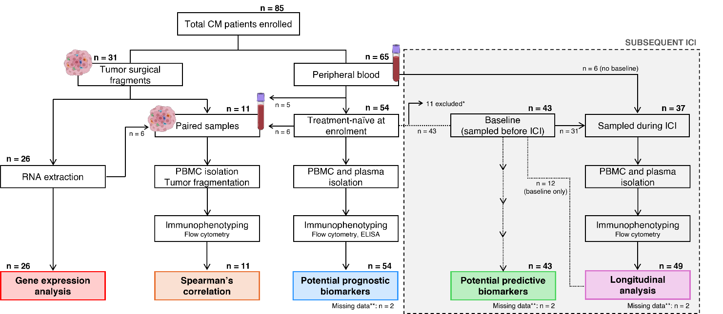

Supplementary Figure S1. Overview of study design and patient distribution. A total of 85 cutaneous melanoma (CM) patients were prospectively enrolled. Tumor surgical fragments from 31 patients enabled gene expression analysis (n = 26) and immune profiling of paired tumor-blood samples (n = 11). Peripheral blood was collected from 65 patients, including 54 treatment-naïve. Samples were immunophenotyped to identify potential prognostic biomarkers. Of these, 43 patients subsequently initiated immune-checkpoint inhibitors (ICIs), and their baseline samples were used to identify potential predictive biomarkers. Longitudinal blood samples during ICI treatment were available from 37 patients, including 6 without baseline samples; inclusion of 12 baseline-only cases yielded 49 patients for longitudinal immunophenotyping.
Sample sets overlap across analyses, so patient numbers are not mutually exclusive.
*11 patients were excluded due to initiation of targeted therapy or absence of systemic therapy.
**2 patients were excluded from multivariable analyses due to missing BRAF status.

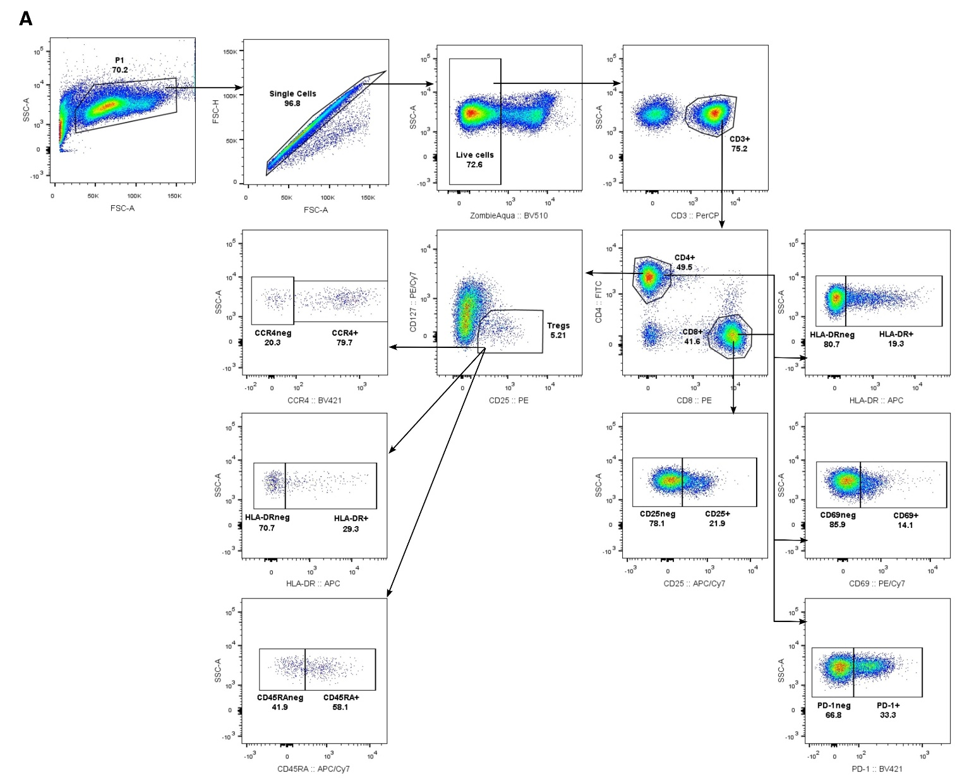

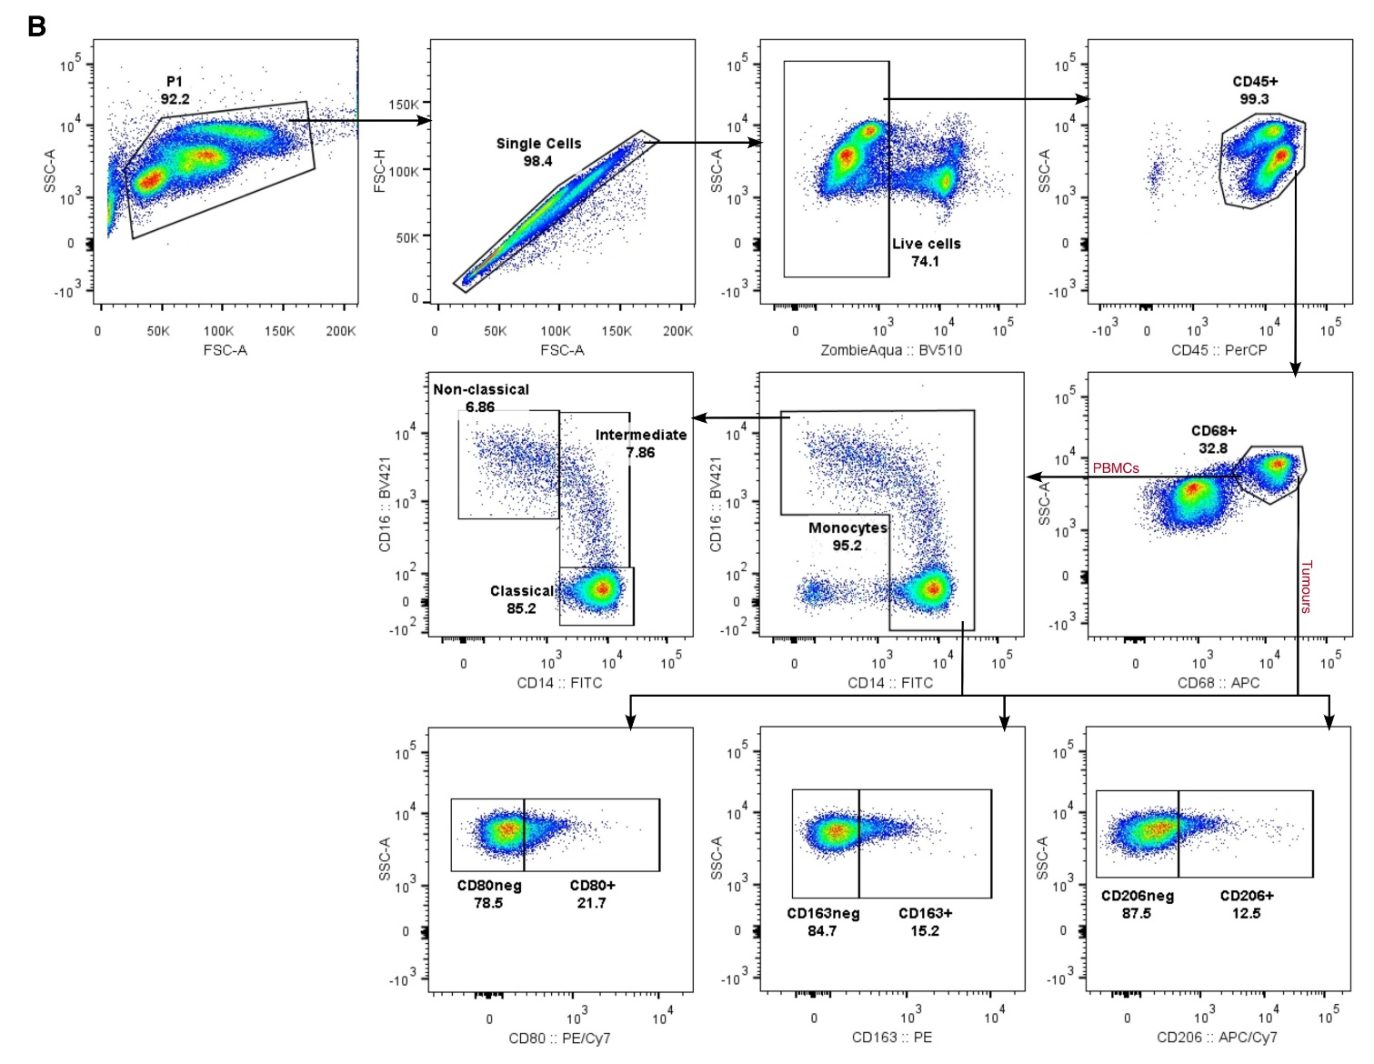
Supplementary Figure S2. Gating strategy for identification of immune cell subsets. (A) Lymphocyte subsets, including CD4⁺ and CD8⁺ T cell activation markers and markers of Treg immunosuppression. (B) Monocyte/macrophage subsets, including M1- and M2-like markers.

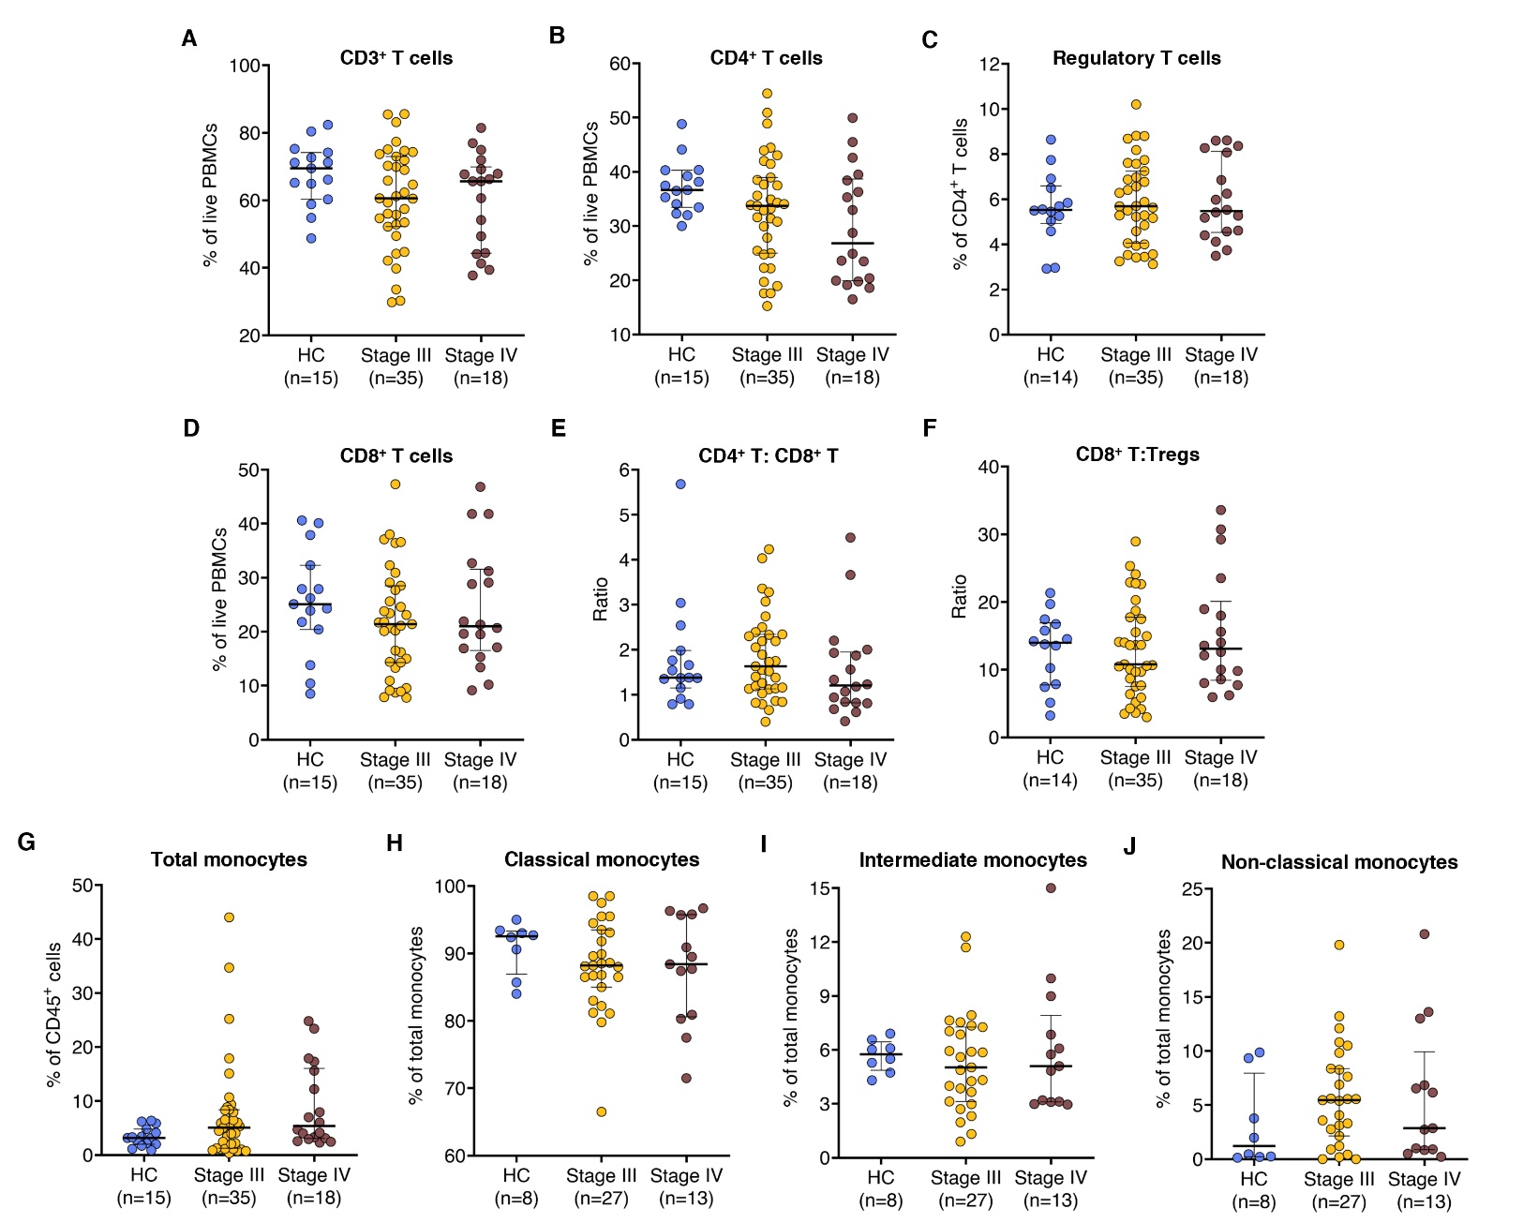
Supplementary Figure S3. Frequencies of circulating immune cell subsets are comparable between healthy donors and cutaneous melanoma patients, and across disease stages. Percentages of immune cell subsets were quantified by flow cytometry in peripheral blood mononuclear cells (PBMCs) from 15 healthy controls (HC) and 53 cutaneous melanoma (CM) patients (divided into stage III and stage IV). Analyzed subsets include (A) CD3⁺ T cells and (B) CD4⁺ T cells (gated on live PBMCs); (C) Regulatory T cells (Tregs, gated on CD4⁺ T cells); (D) CD8⁺ T cells (gated on live PBMCs); (E) CD4⁺:CD8⁺ T cell ratio and (F) CD8⁺ T cell:Treg ratio (gated on CD3⁺ T cells); (G) total monocytes (gated on CD45⁺ cells); and (H) classical, (I) intermediate, and (J) non-classical monocyte subsets (gated on total monocytes). Monocyte subset analysis was limited to 41 patients and 8 healthy controls due to low monocyte frequencies. Each dot represents an individual. Data are shown as median with interquartile range. Statistical comparisons were performed using the Kruskal-Wallis test followed by Dunn’s multiple comparisons test.

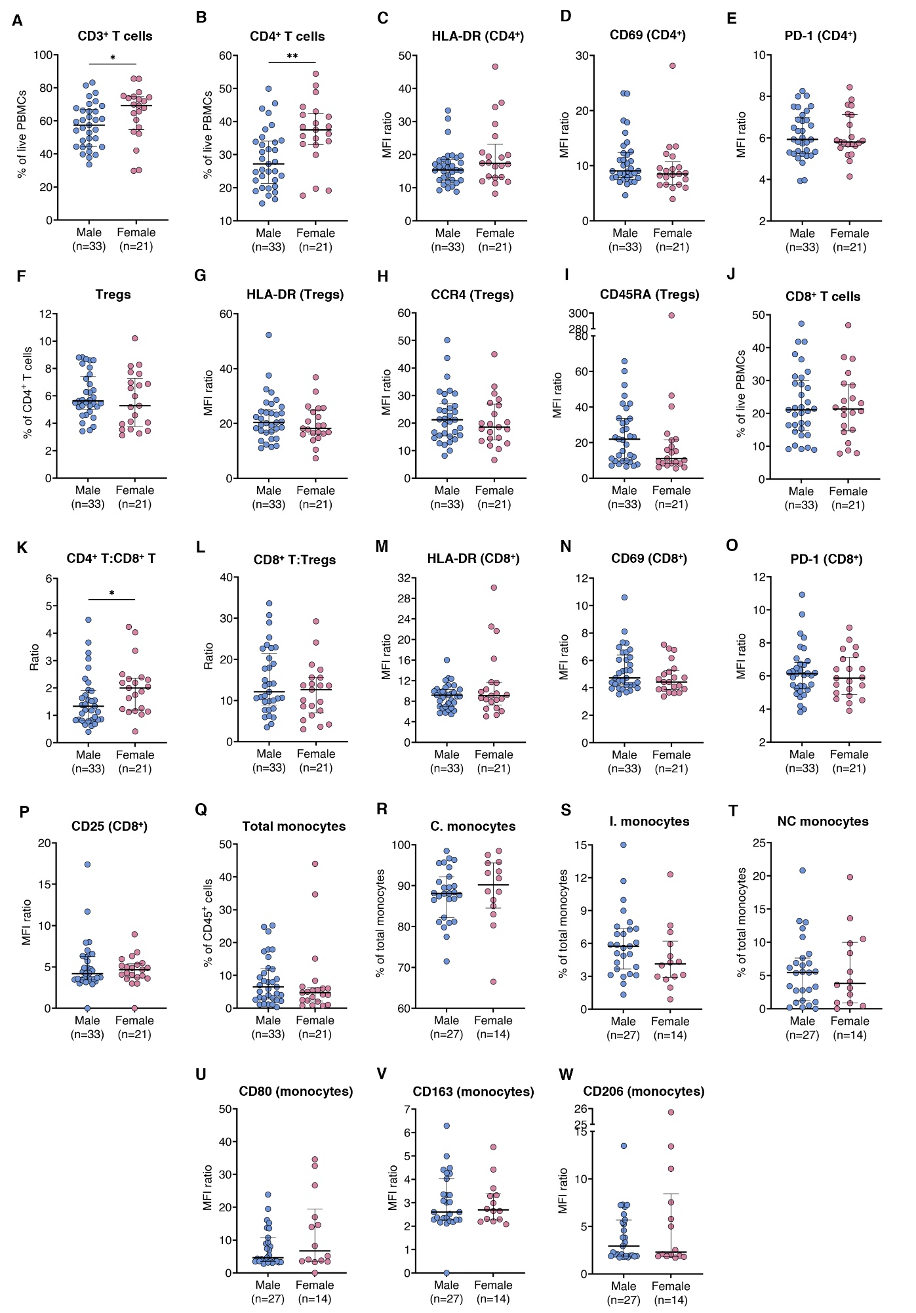
Supplementary Figure S4. Sex-based comparison of circulating immune cell subsets and functional marker expression in cutaneous melanoma patients. Flow cytometry was used to quantify immune cell subsets and functional marker expression in peripheral blood mononuclear cells (PBMCs) from 54 cutaneous melanoma (CM) patients, stratified by sex. Marker expression levels are defined as the ratio of median fluorescence intensity (MFI) between marker-positive and -negative populations. Analyzed subsets and markers include (A) CD3⁺ T cells and (B) CD4⁺ T cells (gated on live PBMCs); (C) HLA-DR (D) CD69, and (E) PD1 expression on CD4⁺ T cells; (F) Regulatory T cells (Tregs, gated on CD4⁺ T cells); (G) HLA-DR, (H) CCR4, and (I) CD45RA expression on Tregs; (J) CD8⁺ T cells (gated on live PBMCs); (K) CD4⁺:CD8⁺ T cell ratio and (L) CD8⁺ T cell:Treg ratio (gated on CD3⁺ T cells); (M) HLA-DR, (N) CD69, (O) PD-1, and (P) CD25 expression on CD8⁺ T cells; (Q) total monocytes (gated on CD45⁺ cells); (R) classical, (S) intermediate, and (T) non-classical monocytes (gated on total monocytes); (U) CD80, (V) CD163, and (W) CD206 expression on monocytes. Monocyte subset analysis was limited to 41 patients due to low monocyte frequencies. Each dot represents one patient. Data are shown as median with interquartile range. Statistical comparisons were performed using the Mann-Whitney U test. *, p < 0.05; **, p < 0.01.

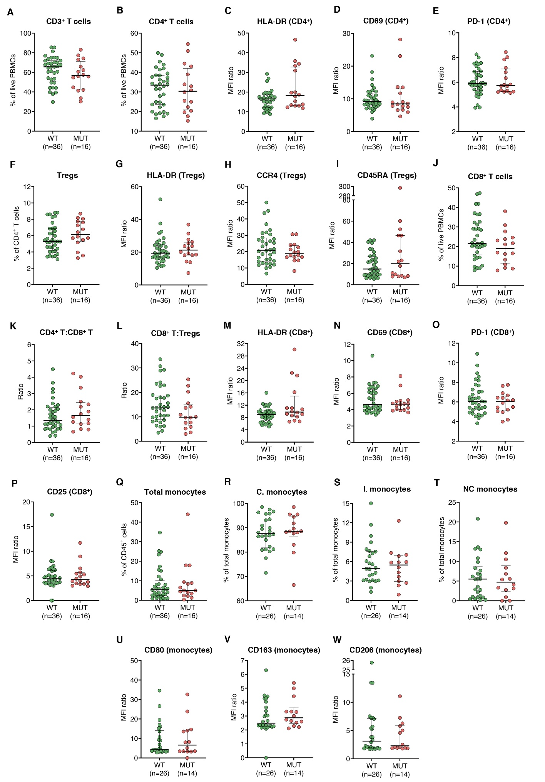
Supplementary Figure S5. Impact of BRAF mutational status on circulating immune cell subsets and functional marker expression in CM patients. Flow cytometry was used to quantify immune cell subsets and functional marker expression in PBMCs from 54 CM patients, stratified by BRAF mutational status. Marker expression levels (exp.) are defined as the ratio of MFI between marker-positive and -negative populations. Analyzed subsets and markers include (A) CD3⁺ T cells and (B) CD4⁺ T cells (gated on live PBMCs); (C) HLA-DR (D) CD69, and (E) PD1 expression on CD4⁺ T cells; (F) Tregs (gated on CD4⁺ T cells); (G) HLA-DR, (H) CCR4, and (I) CD45RA expression on Tregs; (J) CD8⁺ T cells (gated on live PBMCs); (K) CD4⁺:CD8⁺ T cell ratio and (L) CD8⁺ T cell:Treg ratio (gated on CD3⁺ T cells); (M) HLA-DR, (N) CD69, (O) PD-1, and (P) CD25 expression on CD8⁺ T cells; (Q) total monocytes (gated on CD45⁺ cells); (R) classical, (S) intermediate, and (T) non-classical monocytes (gated on total monocytes); (U) CD80, (V) CD163, and (W) CD206 expression on monocytes. Monocyte subset analysis was limited to 41 patients due to low monocyte frequencies. Each dot represents one patient. Data are shown as median with interquartile range. Statistical comparisons were performed using the Mann-Whitney U test.
Abbreviations: CM, cutaneous melanoma; MFI, median fluorescence intensity; MUT, mutated; PBMCs, peripheral blood mononuclear cells; Tregs, regulatory T cells; WT, wildtype.

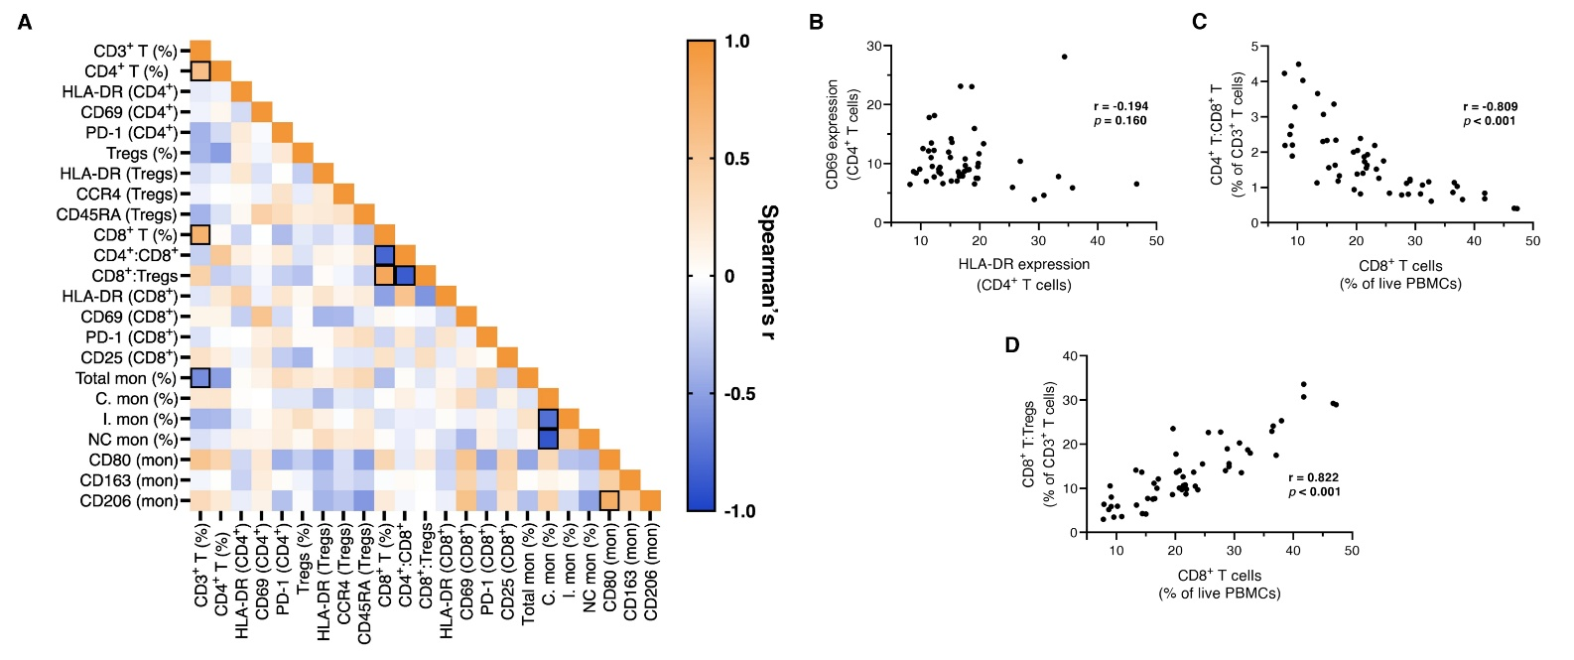
Supplementary Figure S6. Correlation analysis identifies strongly associated circulating immune variables. Spearman’s rank correlations were calculated across 54 treatment-naïve cutaneous melanoma patients, based on the frequency of major immune subsets and expression levels of functional markers, calculated by flow cytometry in PBMCs. Due to low monocyte frequencies in some individuals, monocyte subset analysis was limited to 41 CM patients. Expression levels are defined as the MFI ratio between marker-positive and -negative populations. (A) Correlation matrix depicting Spearman’s rank correlation coefficients (r) for each pairwise comparison; significant correlations (p < 0.05 and |r| > 0.6) are outlined. (B) HLA-DR vs. CD69 expression on circulating CD4⁺ T cells. (C) Frequency of circulating CD8⁺ T cells (gated on live PBMCs) vs CD4⁺:CD8⁺ T cell ratio (gated on CD3⁺ T cells). (D) Frequency of circulating CD8⁺ T cells (gated on live PBMCs) vs. CD8⁺ T:Treg ratio (gated on CD3⁺ T cells).
Abbreviations: C., classical; I., intermediate; MFI, median fluorescence intensity; mon, monocytes; NC, non-classical; PBMCs, peripheral blood mononuclear cells; Tregs, regulatory T cells.

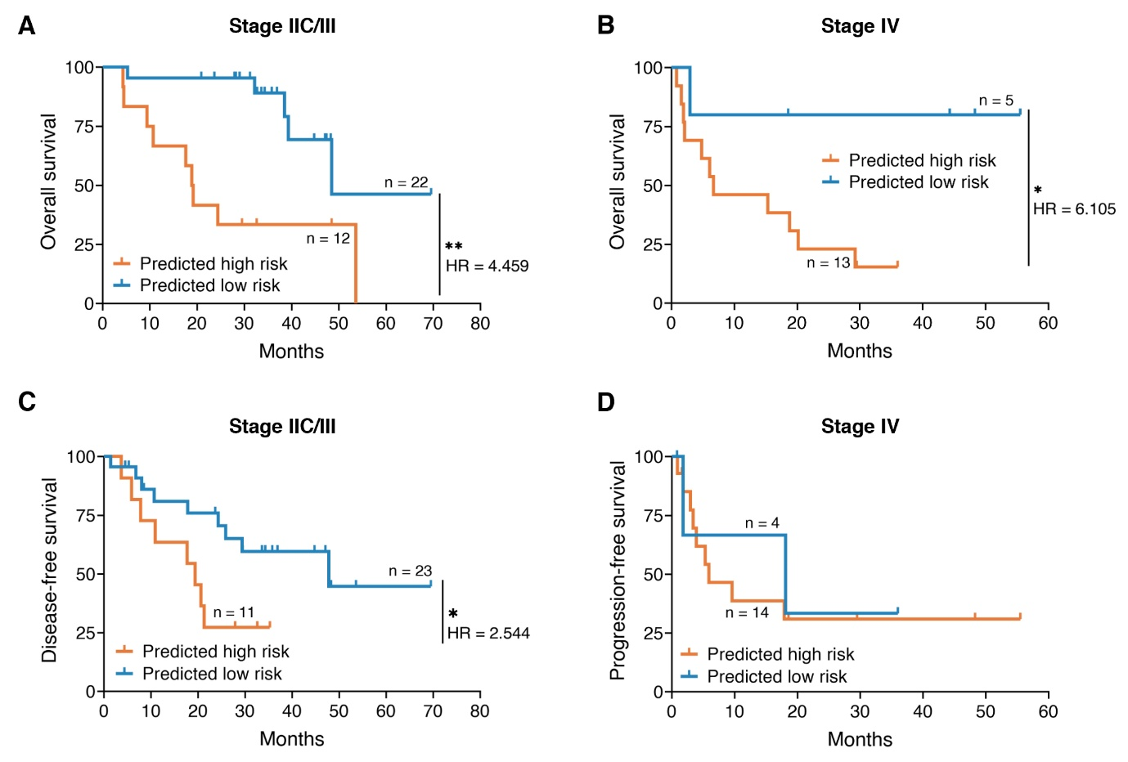Supplementary Figure S7. Stage-specific risk stratification of cutaneous melanoma patients using final prognostic models. 52 treatment-naïve cutaneous melanoma patients were stratified by stage: 34 stage IIC/III patients (top panels) and 18 stage IV patients (bottom panels). Patients were divided into high- and low-risk groups using optimal cut-off values (maximized Youden’s index) derived from the final prognostic OS and EFS models. Kaplan-Meier survival curves with log-rank testing are shown for (A,B) OS, (C) DFS, and (D) PFS.
Abbreviations: DFS, disease-free survival; EFS, event-free survival; HR, hazard ratio; OS, overall survival; PFS, progression-free survival. *, p < 0.05; **, p < 0.01.
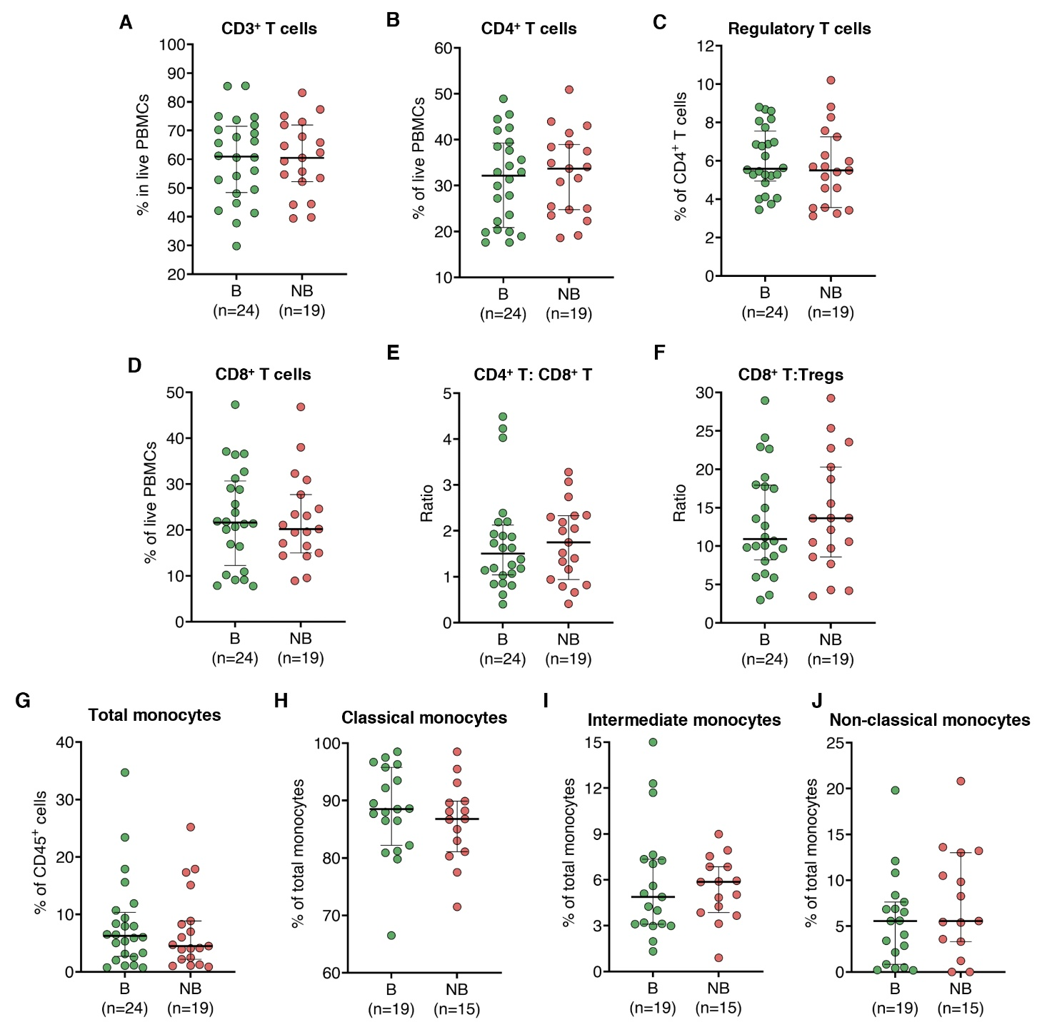
Supplementary Figure S8. Frequencies of circulating immune cell subsets at baseline do not differ between cutaneous melanoma patients with or without therapeutic benefit from ICIs. Percentages of immune cell subsets were quantified by flow cytometry in PBMCs from 43 CM patients prior to receiving ICI treatment, stratified by therapeutic benefit (yes vs. no). Analyzed subsets include (A) CD3⁺ T cells and (B) CD4⁺ T cells (gated on live PBMCs); (C) Tregs, gated on CD4⁺ T cells; (D) CD8⁺ T cells (gated on live PBMCs); (E) CD4⁺:CD8⁺ T cell ratio and (F) CD8⁺ T cell:Treg ratio (gated on CD3⁺ T cells); (G) total monocytes (gated on CD45⁺ cells); and (H) classical, (I) intermediate, and (J) non-classical monocyte subsets (gated on total monocytes). Each dot represents a patient. Data are shown as median with interquartile range. Statistical comparisons were performed using the Mann-Whitney U test.
Abbreviations: B, therapeutic benefit; CM, cutaneous melanoma; ICIs, immune-checkpoint inhibitors; NB, no therapeutic benefit; PBMCs, peripheral blood mononuclear cells; Tregs, regulatory T cells.

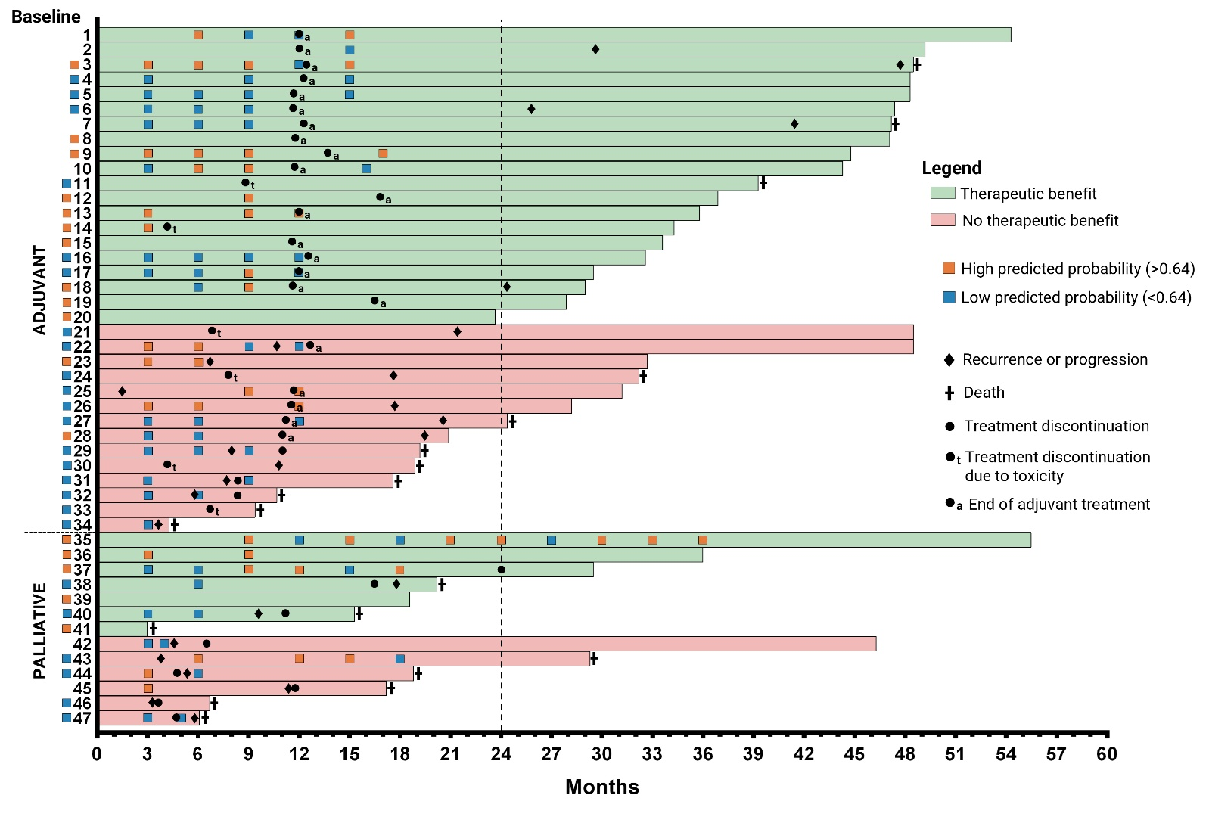
Supplementary Figure S9. Predictive model based on HLA-DR and CD69 expression on circulating CD4+ T cells lacks reliability for longitudinal monitoring during immune-checkpoint blockade. Swimmer plot depicting the evolution of predictive probabilities of therapeutic benefit during treatment in 47 cutaneous melanoma patients, as calculated by the previously established multivariable logistic regression model (two patients excluded due to missing clinical data). Probabilities were derived from HLA-DR and CD69 expression on CD4⁺ T cells (MFI ratio, flow cytometry) and the clinical risk score, and divided into high (orange squares) or low (blue squares) based on the optimal baseline cut-off (P = 0.64). Each horizontal bar represents one patient’s follow-up duration (in months) from the start of treatment, with the squares to the left of each bar indicating values at baseline. Key clinical events, such as progression, death, treatment discontinuation or termination, are annotated along the timeline.

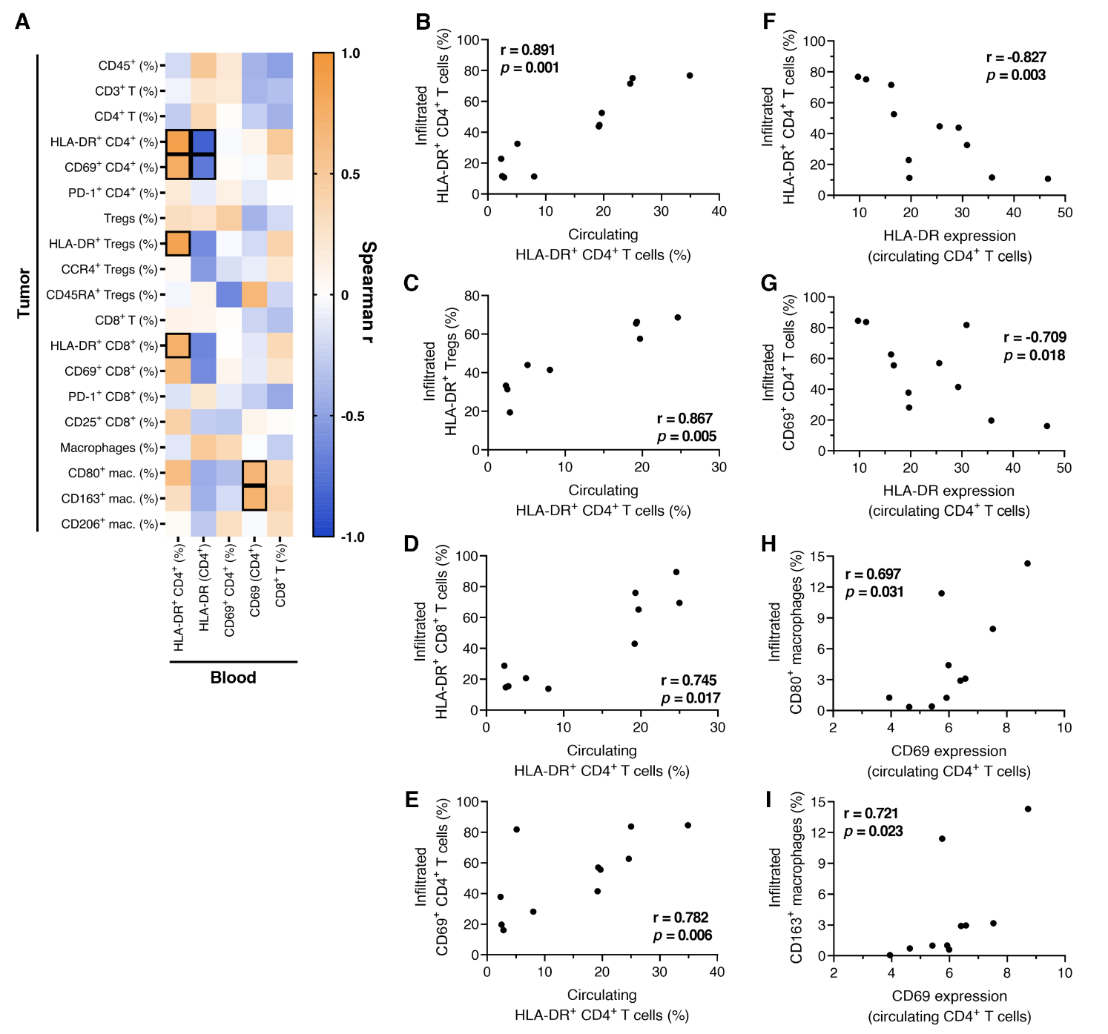

Supplementary Figure S10. The circulating immune profile partially reflects the tumor immune microenvironment. Spearman’s rank correlations were performed between circulating immune biomarkers of interest and the frequency of tumor-infiltrating immune subsets, assessed by flow cytometry in paired blood and tumor samples from 11 cutaneous melanoma patients. Expression levels are defined as the median fluorescence intensity (MFI) ratio between marker-positive and -negative populations. (A) Heatmap showing Spearman’s rank correlation coefficients (r) for each pairwise comparison; significant correlations (p < 0.05 and |r| > 0.6) are outlined. Correlations between the frequency of circulating HLA-DR⁺ CD4⁺ T cells (gated on CD4⁺ T cells) and the frequency of infiltrating (B) HLA-DR⁺ CD4⁺ T cells, (C) HLA-DR⁺ Tregs, (D) HLA-DR⁺ CD8⁺ T cells, and (E) CD69⁺ CD4⁺ T cells (all gated on respective parent populations). Correlations between HLA-DR expression on circulating CD4⁺ T cells and (F) HLA-DR⁺ and (G) CD69⁺ tumor-infiltrating CD4⁺ T cells (gated on CD4⁺ T cells). Correlations between CD69 expression on circulating CD4⁺ T cells and (H) CD80⁺ and (I) CD163⁺ macrophages in the tumor (gated on CD68⁺ cells).

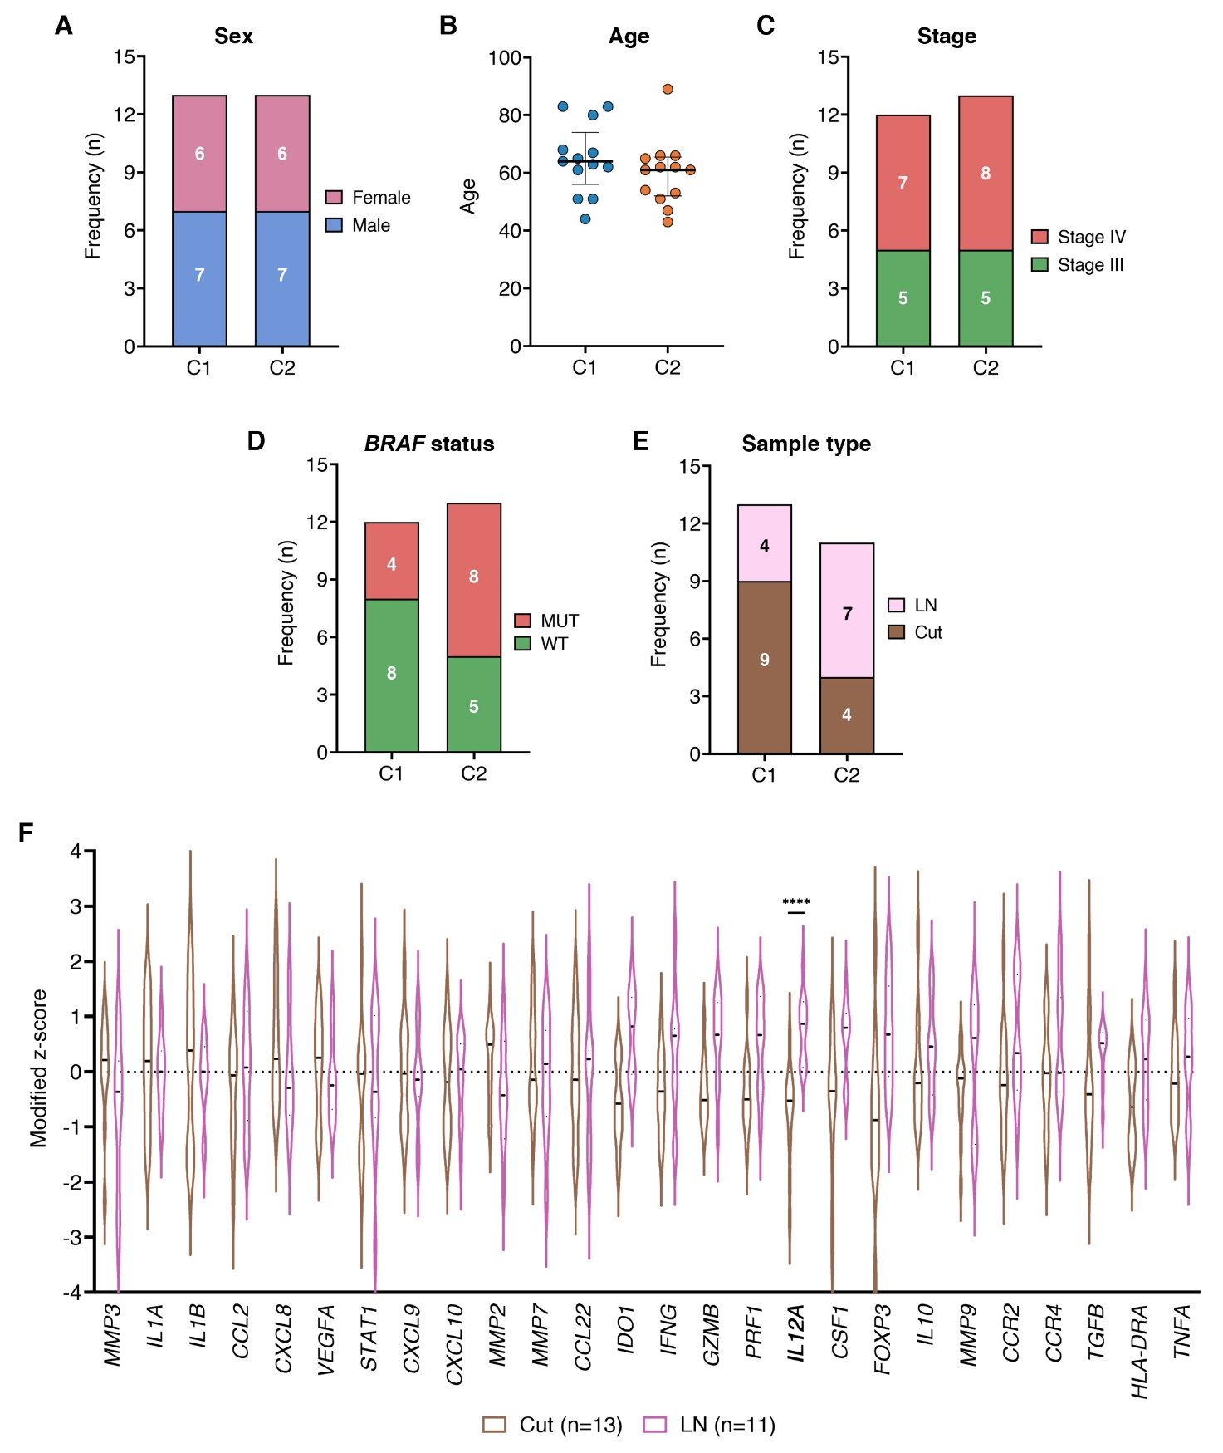Supplementary Figure S11. Demographic and clinical characteristics of cutaneous melanoma patients according to tumor gene expression clusters. Clinical features of 26 cutaneous melanoma patients included in the tumor gene expression analysis, stratified by unsupervised clustering based on a 26-gene immune-related panel. (A) Distribution of sex between cluster 1 (C1) and 2 (C2). (B) Age distribution of patients in each cluster, presented as median with interquartile range. (C) Distribution of disease stages in each cluster; 1 patient with stage IIC excluded. (D) Frequency of BRAF mutational status (WT, wildtype; MUT, mutant) in each cluster; 1 patient excluded due to missing data. (E) Distributions of lymph node (LN) and cutaneous (Cut) samples in each cluster; 2 patients with soft tissue metastases excluded. (F) Violin plots showing the distribution of modified z-scores for individual immune-related genes in cutaneous versus lymph node samples. Associations between cluster assignment and binary clinical variables were assessed using Fisher’s exact test; age comparisons between clusters were performed using the Mann-Whitney U test; differences in gene expression between sample types were assessed by multiple Mann-Whitney U tests, followed by false discovery rate correction using the Benjamini-Kieger-Yekutieli two-stage step-up method. ****, p < 0.0001.

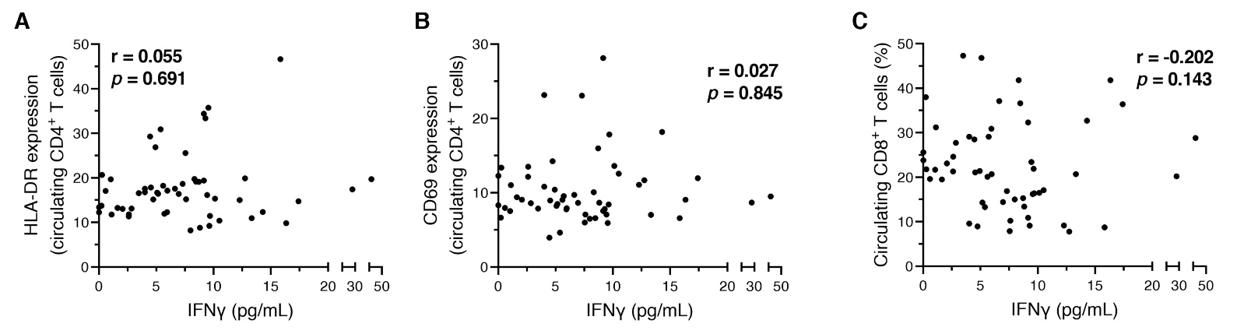
Supplementary Figure S12. Correlation between identified circulating prognostic biomarkers and plasma IFN-γ levels. Spearman’s rank correlations were performed using samples from 54 treatment-naïve cutaneous melanoma patients. Circulating immune biomarkers of interest were measured in peripheral blood mononuclear cells (PBMCs) by flow cytometry, while plasma IFN-γ concentrations were quantified by ELISA. Biomarker expression levels are defined as the median fluorescence intensity (MFI) ratio between marker-positive and -negative populations. Correlations were assessed between plasma IFN-γ concentrations and (A) HLA-DR expression on circulating CD4⁺ T cells, (B) CD69 expression on circulating CD4⁺ T cells, and (C) frequency of circulating CD8⁺ T cells (gated on live PBMCs). Each dot represents a patient.

