Melittin-Loaded Fe₃O₄-Au_{shell} Nanocomposite Hydrogel for Multifunctional Treatment of Atopic Dermatitis
Wen Chao Xu^{2,3*}, Xiao Qu Duan^{2*}, Li Zhong^{4*}, Yuan Chao Li ², Lei Ran², Hai Huan Xu³, Qian Wu², Ke Huang², Na Nan Miao², Tao Jiang², Qiu Han Chen², Yang Zhang², Hong Zhuang Zhang⁵, Ru Peng Wang ², Mingfu Gong¹
Author affiliations:
- Department of Radiology, Xinqiao Hospital, Army Medical University, Chongqing 400037, China.
- Department of Rheumatology and Dermatology, Xinqiao Hospital, Army Medical University, Chongqing 400037, China.
- Department of Dermatology, Characteristic Medical center of Chinese People's Armed Police Force, Tianjin 300162, China.
- National & Local Joint Engineering Research Center of Harbour Oil & Gas Storage and Transportation Technology/Zhejiang Key Laboratory of Pollution Control for Port-Petrochemical Industry, Zhejiang Ocean University, 316022 Zhoushan, China
- Department of Burns, Characteristic Medical center of Chinese People's Armed Police Force, Tianjin 300162, China.
*These authors contributed equally to this work.
Correspondence to:
Mingfu Gong
Department of Radiology, Xinqiao Hospital, Army Medical University
183 Xinqiao Main Street, Shapingba District, Chongqing 400037, China.
E-mail: hummer198625@tmmu.cdu.cn
Ru Peng Wang
Department of Rheumatology and Dermatology, Xinqiao Hospital, Army Medical University
183 Xinqiao Main Street, Shapingba District, Chongqing 400037, China.
E-mail: Wrp71@tmmu.edu.cn

Supplementary methods
1. Total RNA extraction and qRT-PCR for TSLP mRNA expression detection
1.1 Total RNA Extraction
Total RNA was extracted from HaCaT cells using a magnetic bead-based rapid total RNA extraction and purification kit (Cat. No.: ZH0050-S, Zeheng Biotech, China) following the manufacturer’s instructions. The concentration and purity of the extracted RNA were determined using a NanoDrop 2000 spectrophotometer (Thermo Fisher Scientific, USA). Samples with an A260/A280 ratio between 1.8 and 2.0 were selected for subsequent experiments.
1.2 Reverse transcription and qRT-PCR
First-strand cDNA was synthesized using a reverse transcription kit (Cat. No.: HY-K0511, MedChemExpress, USA). qRT-PCR was performed on a real-time PCR system (CFX, Bio-Rad, USA) with a 2× SP qPCR Mix kit (Cat. No.: ZH0014, Zeheng Biotech, China). The amplification program was as follows: initial denaturation at 94°C for 20 s; followed by 40 cycles of denaturation at 94°C for 10 s and combined annealing/extension at 60°C for 30 s. Melting curve analysis was performed after each amplification run to confirm the specificity of the amplified products.
1.3 Primer design and data analysis
The primer sequences used were as follows:
TSLP:
Forward: 5′-ATGTTCGCCATGAAACTAAGGC-3′
Reverse: 5′-GCGACGCCACAATCCTTGTA-3′
β-actin (housekeeping gene):
Forward: 5′-CATGTACGTTGCTATCCAGGC-3′
Reverse: 5′-CTCCTTAATGTCACGCACGAT-3′
The housekeeping gene β-actin was used as an internal reference to normalize the expression level of the target gene (TSLP). The relative mRNA expression level of TSLP was calculated using the 2^−ΔΔCt method.
1.4 Enzyme-linked immunosorbent assay (ELISA) for protein expression detection
TSLP protein detection in HaCaT cell supernatant
For sample preparation, the cell culture supernatant was collected and centrifuged at low temperature to remove impurities and cell debris. Then, the treated cell supernatant was diluted at a ratio of 1:2 with the diluent provided with the ELISA kit to ensure that the detection concentration was within the linear range of the standard curve. The ELISA was performed strictly in accordance with the instructions of the TSLP ELISA kit. A microplate reader was used to measure the absorbance at 450 nm for each well, a standard curve was plotted based on the OD values of the standards, and the secretion level of TSLP protein in the cell culture supernatant was calculated in combination with the sample dilution factor.
2 Detection of IL-4 and IL-13 protein levels in AD mouse skin tissues
2.1 Preparation of skin tissue samples
Skin tissue samples were harvested from AD mice in each group. Connective tissue and impurities were removed, and the samples were rinsed with normal saline and blotted dry. Subsequently, 100 mg of tissue was weighed and placed into a sterile centrifuge tube. Pre-cooled PBS was added at a mass-to-volume ratio of 1:9, followed by homogenization at a low temperature. The homogenate was then centrifuged at 3000 rpm for 10 min at 4°C. The resulting supernatant was collected as the test sample.
2.2 Determination of total protein concentration in skin tissue supernatant
The tissue supernatant was diluted 20 times, added to a 96-well plate together with BCA standards (three replicate wells per sample), and the total protein concentration was detected according to the procedures of the BCA protein kit (G2026, Servicebio, China). Finally, a microplate reader was used to measure the absorbance at 562 nm, and the total protein concentration was calculated based on the standard curve for subsequent result normalization.
2.3 ELISA detection of IL-4 and IL-13 protein levels
The samples, along with standards and blank controls, were added to a 96-well plate (in triplicate). The ELISA procedure was performed strictly according to the kit instructions. Absorbance at 450 nm was measured using a microplate reader. The concentrations of IL-4 and IL-13 were calculated based on the standard curve. The actual expression levels in skin tissues were then determined by normalizing these concentrations to the total protein content, taking into account all dilution factors.
Supplementary Figures
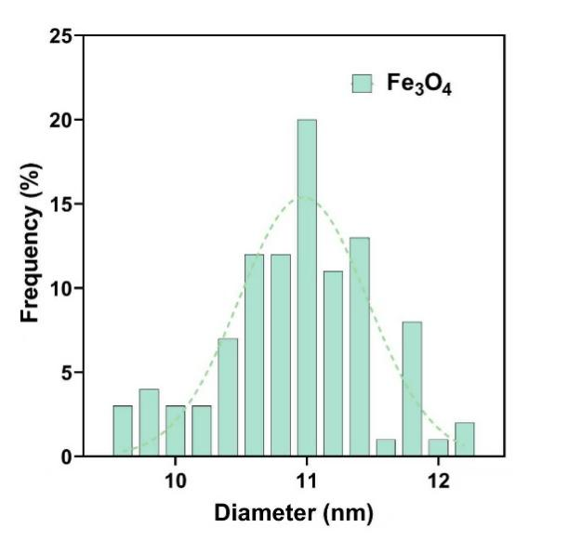
Figure S1. Size distribution of Fe₃O₄ NPs based on the TEM.

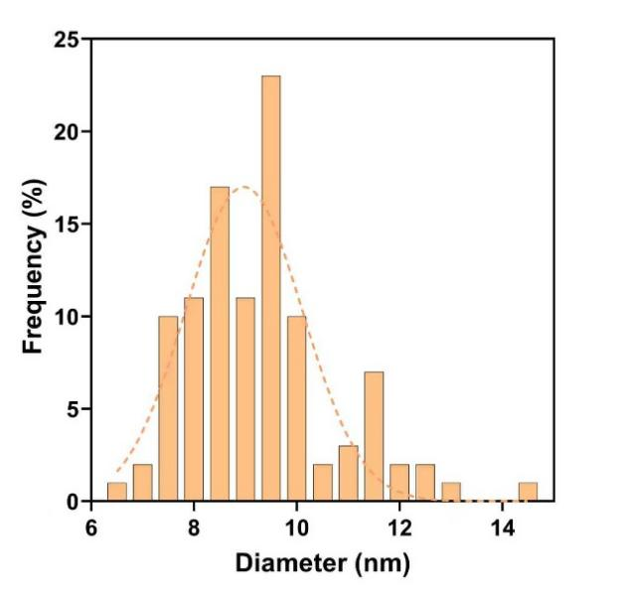
Figure S2. Size distribution of Au_{shell} inner diameter NPs based on the TEM.
Figure S3. Cumulative release of MFA from the MFA@PF127.

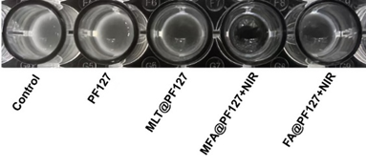
Figure S4. Representative photographs of S. aureus suspension.

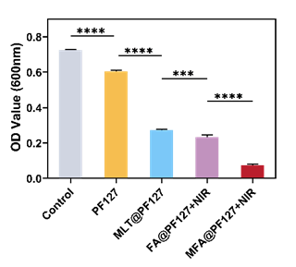
Figure S5. Absorbance at 600 nm of S. aureus suspensions. Data are presented as the mean ± SD (n = 3). ***p < 0.001, ****p < 0.0001, ns indicates no significant difference.
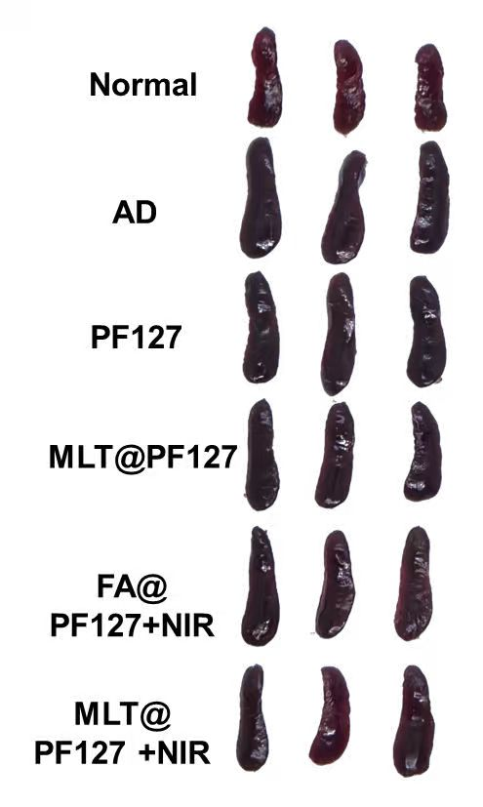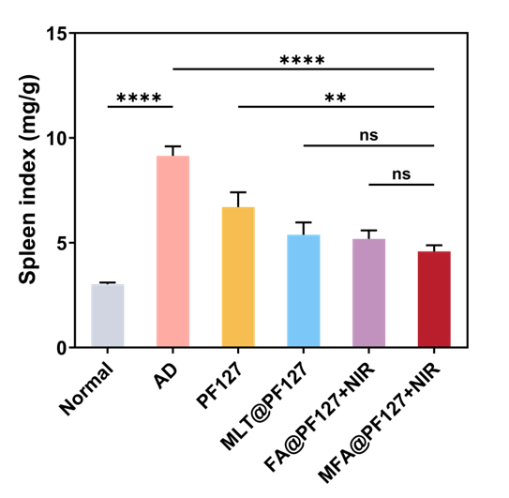

Figure S6. Representative photographs of spleen and the spleen index (n = 3). Data are presented as mean ± SD. ∗∗p < 0.01, ∗∗∗∗p < 0.0001; ns indicates no significant difference.

