Supplemental eAppendix
Search Strategy for Meta-analysis

Electronic searches were performed in the following databases to identify eligible studies. There were no publication period limitations. Searches were restricted to English-language publications.

Embase (n = 1,457)
('liver cell carcinoma'/exp OR 'liver tumor'/exp OR 'hepatocellular carcinoma':ti,ab OR 'liver cancer':ti,ab OR 'hcc':ti,ab)
AND
('regorafenib'/exp OR 'regorafenib':ti,ab OR 'stivarga':ti,ab)
AND
('immune checkpoint inhibitor'/exp OR 'immunotherapy'/exp OR 'programmed cell death 1 receptor'/exp OR 'immune checkpoint inhibitor':ti,ab OR 'ici':ti,ab OR 'pd-1':ti,ab OR 'pd-l1':ti,ab OR 'nivolumab':ti,ab OR 'pembrolizumab':ti,ab OR 'camrelizumab':ti,ab OR 'sintilimab':ti,ab OR 'tislelizumab':ti,ab OR 'toripalimab':ti,ab OR 'atezolizumab':ti,ab)
AND [english]/lim

PubMed (n = 257)
(("Carcinoma, Hepatocellular"[Mesh] OR "Liver Neoplasms"[Mesh] OR "Hepatocellular carcinoma"[tiab] OR "Liver cancer"[tiab] OR "HCC"[tiab] OR "Liver tumor"[tiab])
AND
("Regorafenib"[Supplementary Concept] OR "Regorafenib"[tiab] OR "Stivarga"[tiab])
AND
("Immune Checkpoint Inhibitors"[Mesh] OR "Immunotherapy"[Mesh] OR "Programmed Cell Death 1 Receptor"[Mesh] OR "Immune checkpoint inhibitor"[tiab] OR "ICI"[tiab] OR "PD-1"[tiab] OR "PD-L1"[tiab] OR "Nivolumab"[tiab] OR "Pembrolizumab"[tiab] OR "Camrelizumab"[tiab] OR "Sintilimab"[tiab] OR "Tislelizumab"[tiab] OR "Toripalimab"[tiab] OR "Atezolizumab"[tiab]))
AND English[LA]

Cochrane Library (n = 40)
(("Hepatocellular carcinoma" OR "Liver cancer" OR "HCC" OR "Liver Neoplasms")
AND
("Regorafenib" OR "Stivarga")
AND
("Immune checkpoint inhibitors" OR "Immunotherapy" OR "PD-1" OR "PD-L1" OR "Nivolumab" OR "Pembrolizumab" OR "Camrelizumab" OR "Sintilimab" OR "Tislelizumab" OR "Toripalimab"))
AND "English"[Language]

Web of Science (n = 372)
TS=("Hepatocellular carcinoma" OR "Liver Neoplasms" OR "Liver cancer" OR "HCC")
AND
TS=("Regorafenib" OR "Stivarga")
AND
TS=("Immune Checkpoint Inhibitors" OR "Immunotherapy" OR "PD-1" OR "PD-L1" OR "Nivolumab" OR "Pembrolizumab" OR "Camrelizumab" OR "Sintilimab" OR "Tislelizumab" OR "Toripalimab")

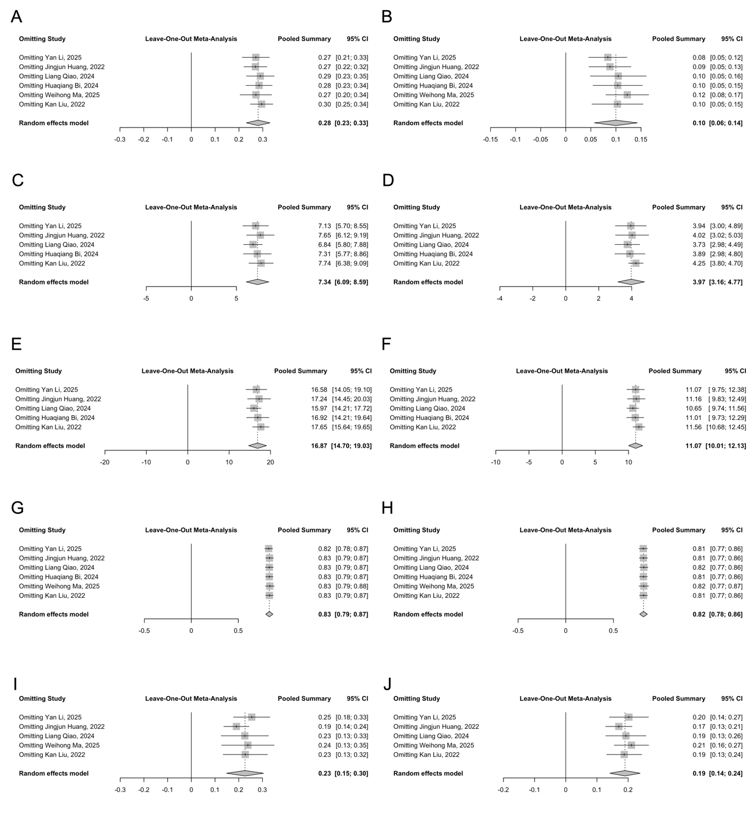
Supplemental Figure 1. Leave-one-out sensitivity analysis verifying the robustness of pooled estimates for efficacy and safety outcomes. The influence of individual studies was assessed by sequentially omitting one study at a time for objective response rate (A, B), median progression-free survival (C, D), median overall survival (E, F), all-grade adverse events (G, H), and grade ≥3 adverse events (I, J). Left panels (A, C, E, G, I) correspond to the regorafenib plus ICIs group, while right panels (B, D, F, H, J) correspond to the regorafenib monotherapy group. Each row shows the random-effects pooled estimate and 95% CI after omitting the corresponding study.

