Supplementary Table Legends:
Table S1. Descriptive criteria for the 5-point dermoscopic image quality scale (DIQS-5) across three domains: Focus & depth of field, sharpness & clarity, and colour.
Score | Focus & Depth of Field | Sharpness & Clarity | Colour Fidelity
1  (Very Poor) | The image is severely out of focus; all areas are blurry. | The image is severely soft; no details are distinguishable. | The image has severely distorted colours or minimal contrast.
2  (Poor) | The image has noticeable focus issues; only a few areas are focused. | The image has noticeable softness; only a few details are clear. | The image has noticeable colour imbalances or low contrast.
3  (Acceptable) | The image has adequate focus; some areas are blurry. | The image has adequate detail; some details lack clarity. | The image has adequate colour accuracy and contrast.
4  (Good) | The image is well-focused; most areas are in focus. | The image is well-defined;  most details are clear. | The image has well-balanced colours or good contrast.
5  (Excellent) | The entire image is perfectly focused; no areas are blurry. | The entire image is perfectly sharp; all details are clearly distinguishable. | The image has perfectly balanced colours with excellent contrast.

Supplementary Figure Legend:
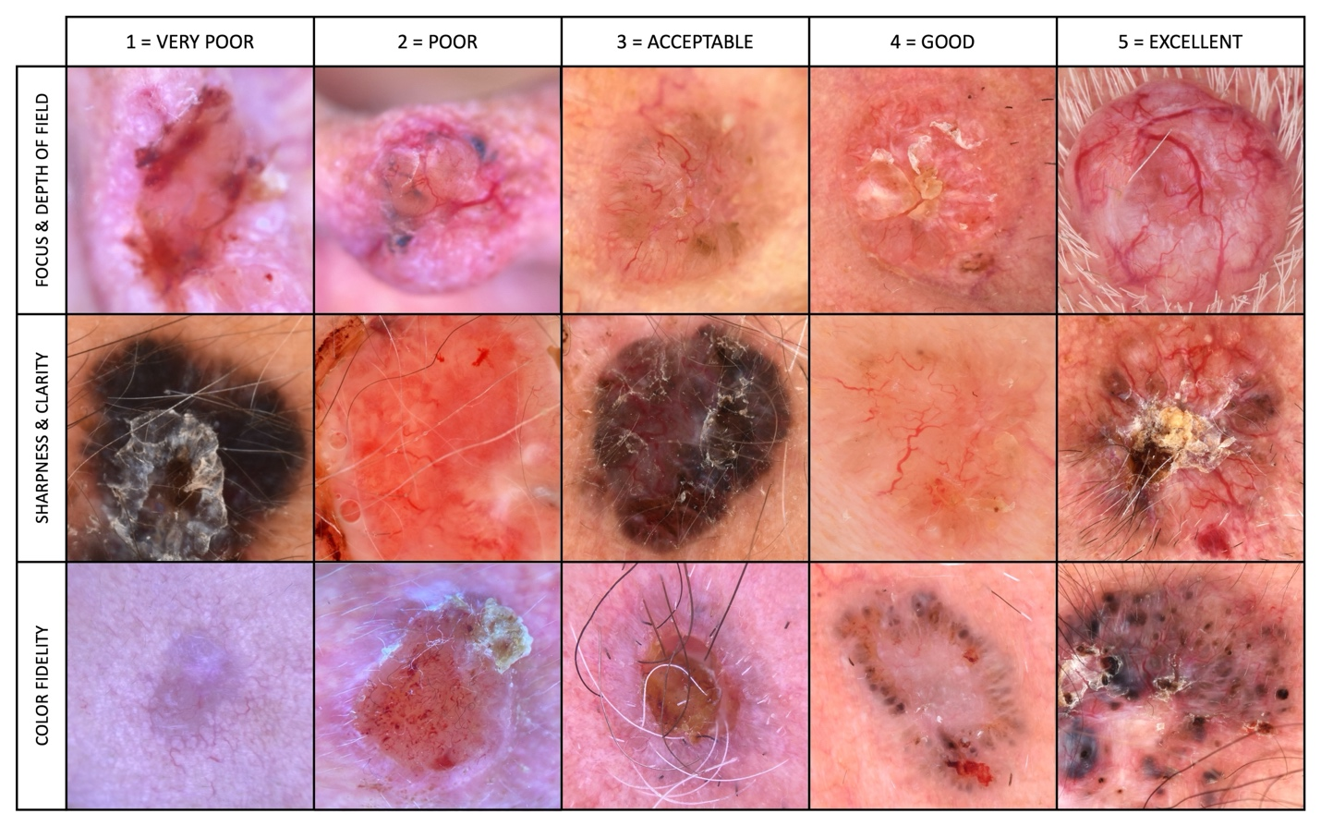
Supplementary Figure 1. Representative examples illustrating the 5-point dermoscopic image quality scale (DIQS-5) across three domains: Focus & depth of field, sharpness & clarity, and colour fidelity. Each row demonstrates a graded series of images for one quality parameter, from score 1 (very poor) to score 5 (excellent). These reference images were used during the assessment process to standardise and guide quality scoring by evaluators.

