Clinical and Economic Burden Following Percutaneous Coronary Intervention for STEMI: A US Real-World Evidence Study

Supplementary Exhibit 1

Claims Data (Linked)
The commercial closed claims data include the combined healthcare claims in the US of patients from dozens of commercial health plans. It reflects about 70 million covered lives over the past year – about 40% of the US commercially insured population, and more than 115 million lives over the past 5 years. The population generally includes ages 0 to 64 years. The database includes data from 2015 forward, with data subject to a 14-day to 120-day lag. All US census regions and states, Washington DC, and Puerto Rico are represented. The data include enrollment history and healthcare claims for both pharmacy and medical benefits from all care settings. Medical claims include diagnoses and procedures for exact dates of service. Pharmacy claims include prescribed medications, prescription date, days’ supply, and quantity dispensed. Provider-identifying fields (e.g., NPI) are available.
The PHD is linked to a closed claims database using a deterministic matching method, ensuring patient confidentiality is maintained. For the subset of applicable patients in the PHD, detailed hospital-reported data are augmented with start and end dates of continuous enrollment, outpatient claims, prescription claims, and inpatient encounters in non-PHD hospitals, providing a unique resource for longitudinal analyses, including analyses of the patient journey. For patients who can be linked to the claims data, the reimbursement amount (payment amount or allowed amount) can be reported separately. Since a closed claims database is used, we can follow patients in different care settings, and the total payment amount will include payments for visits to outpatient clinics, outpatient pharmacy prescriptions, and hospitalizations at different hospitals.

General Mortality Data
In addition to deaths captured by the PHD, the general mortality data provides mortality information obtained from an external data source that covers newspapers, government mortality data, private media, private claims, and funeral homes. The general mortality data captures death dates for roughly 85% of the US population. This database does not provide the cause of death but does provide the date of death and where the death occurred.

Supplementary Table S1: ICD-10-CM Diagnosis / Procedure codes for identifying clinical events
Clinical Event | ICD-10-CM Diagnosis /Procedure  Description | ICD-10-CM Diagnosis / Procedure  Code
STEMI | STEMI involving left main coronary artery | I21.01
STEMI | STEMI involving left anterior descending coronary artery | I21.02
STEMI | STEMI involving other coronary artery of anterior wall | I21.09
STEMI | STEMI involving right coronary artery | I21.11
STEMI | STEMI involving other coronary artery of inferior wall | I21.19
STEMI | STEMI involving left circumflex coronary artery | I21.21
STEMI | STEMI involving other sites | I21.29
STEMI | ST elevation (STEMI) myocardial infarction of unspecified site | I21.3
Heart Failure | Heart failure | I50%
Heart Failure | Post-procedural heart failure | I97.13
Heart Failure | Hypertensive heart disease with heart failure | I11.0
Heart Failure | Hypertensive heart and chronic kidney disease with heart failure and stage 1 through stage 4 chronic kidney disease, or unspecified chronic kidney disease. | I13.0
Heart Failure | Hypertensive heart and chronic kidney disease with heart failure and with stage 5 chronic kidney disease, or end-stage renal disease. | I13.2
Recurrent STEMI | STEMI including subsequent STEMI | I22.0, I22.1, I22.8, I22.9, I21.01, I21.02, I21.09, I21.11, I21.19, I21.21, I21.29, I21.3
Recurrent non-STEMI | Non-STEMI including subsequent non-STEMI | I22.2, I21.4
Reinfarction | Recurrent STEMI and recurrent non-STEMI | I22.0, I22.1, I22.8, I22.9, I21.01, I21.02, I21.09, I21.11, I21.19, I21.21, I21.29, I21.3, I22.2, I21.4
Repeat PCIs | Revascularization | PCI codes^{34,35}
Acute MI | Acute myocardial infarction | I21%
Non-STEMI | Non-ST elevation myocardial infarction | I21.4
Stroke | Cerebral infarction, ischemic stroke / TIA | I63%, I69.3%, G45%, G46%, H34.0%, H34.1%, H34.2%, Z86.73%
Unstable angina | Unstable angina | I20.0, I24.0%, I24.8%, I24.9%
Arrythmias | Atrial Fibrillation | I48.2, I48.20, I48.11, I48.19, I48.0, I48.21, I48.1, I48.91
 | Ventricular Fibrillation | I49.01
 | Ventricular tachycardia | I47.2%
 | Supraventricular tachycardia | I47.1%

Supplementary Table S2: Top 20 Primary Reasons (Diagnosis) for Readmission (n=29,321) at 1 Year Following Index PCI Discharge

Rank | Dx Code | Description | Count
1 | I11.0 | Hypertension heart disease (HT-HRT) with Heart Failure (HF) | 2,932
2 | I13.0 | HT-HRT& Chronic Kidney disease (CKD) with HF & Stage: 1-4 CKD, or unspecified CKD | 2,350
3 | I21.4 | NON-ST Elevation (NSTEMI) Myocardial Infarction (MI) | 2,180
4 | I25.110 | Atherosclerotic heart disease (ATHSCL HRT DZ) of the native coronary artery (NTV COR ART) WITH unstable angina pectoris. | 2,006
5 | A41.9 | SEPSIS Unspecified organism | 1,925
6 | I25.10 | ATHSCL HRT DZ of the NTV COR ART WITHOUT unstable angina pectoris. | 1,709
7 | N17.9 | Acute Kidney Failure unspecified | 878
8 | R07.89 | Other Chest pain | 787
9 | I25.119 | ATHSCL HRT DZ NTV COR ART Unspecified angina Pectoris | 576
10 | J18.9 | Pneumonia unspecified organism | 529
11 | R07.9 | Chest Pain, Unspecified | 527
12 | I21.19 | STEMI involving other coronary artery of inferior wall | 500
13 | I47.2 | Ventricular Tachycardia | 499
14 | I48.0 | Paroxysmal Atrial Fibrillation | 449
15 | J44.1 | COPD with acute exacerbation | 441
16 | I50.23 | Acute on chronic systolic congestive heart failure | 435
17 | T82.855A | Stenosis of a coronary artery stent, during initial encounter | 404
18 | T82.867A | Thrombosis due to cardiac prosthetic devices, implants, and grafts during an initial encounter | 383
19 | U07.1 | COVID-19 | 382
20 | I21.09 | STEMI involving other coronary artery of anterior wall | 368

Supplementary Table S3: Baseline Characteristics of the 3-Year Cohort (PHD, n=63,469) That Underwent PCI for STEMI
Characteristics at Index visit | Levels | N (%)
Age (years) | Mean ± SD  Median (IQR) | 62.2 ± 11.6  62.0 (54,71)
Age Categories (years) | 18-34  35-49  50-64  65-79  80+ | 655 (1.0)  8,663 (13.6)  26,536 (41.8)  21,456 (33.8)  6,159 (9.7)
Sex | Female  Male | 18,454 (29.1)  44,984 (70.9)
Race-Ethnicity | NH-White  NH-Black  NH-Other/unknown  Hispanic | 41,493 (65.4)  4,717 (7.4)  12,537 (19.8)  4,717 (7.4)
Payor Type | Medicare  Medicaid  Commercial  Other/uninsured/unknown | 27,381 (43.1)  7,457 (11.7)  21,149 (33.3)  7,482 (11.8)
Hospital Beds | 1-299  300-499  500+ | 21,135 (33.4)  20,097 (31.8)  22,046 (34.8)
Hospital Region | Northeast  Midwest  West  South | 9,568 (15.1)  13,930 (21.9)  10,056 (15.8)  29,915 (47.1)
Hospital Teaching Status | Teaching  Non-Teaching | 33,224 (52.3)  30,245 (47.7)
Population Served | Rural  Urban | 7,228 (11.4)  56,241 (88.6)
SVI Overall (quintiles) | QT1  QT2  QT3  QT4  QT5 | 6,271 (9.9)  11,971 (18.9)  12,382 (19.5)  20,333 (32.1)  12,381 (19.5)
CCI Score at Index | Mean ± SD  Median (IQR) | 2.2 ± 1.52  2 (1,3)
CCI Categories at Index | 1-3 conditions  4+ conditions | 58,189 (91.7)  5,280 (8.3)
Frequently observed comorbidities at Index | CCF  DM without complications  CPD | 15,796 (24.9)  14,021 (22.1)  8,855 (14.0)
Number of Vessels Involved | Single vessel  Multi-vessel  unknown | 53,536 (85.3)  9,242 (14.7)  691
Medication Use | Beta blocker  CCB ACE inhibitors  Anticoagulants  Antiplatelets  Statin | 54,500 (86.2)  33,186 (52.5)  27,258 (43.1)  61,939 (98.0)  61,869 (97.9)  57,865 (91.5)
APR-DRG Severity of Illness (inpatient) | Minor  Moderate  Severe  Extreme | 22,699 (36.1)  22,079 (35.1)  7,460 (11.9)  10,673 (17.0)
Abbreviations: CCI = Charlson comorbidity index; SVI = Social Vulnerability index; NH = non-Hispanic; APR-DRG = All Patient Refined Diagnosis Related Groups
Supplementary Table S4: Sensitivity Analysis on Outcomes Within 1 Year and 3 Years Following Index Discharge Using PHD Linked Claims Databaseª

Outcomes | 1 Year | 3 Years
 | 19,890 Alive Patients | 7,218 Alive Patients
Death | 132 (0.7) | 238 (3.3)
Clinical:
Cardiac Arrythmias
Atrial Fibrillation | 1,948 (9.8) | 845 (11.7)
Ventricular Fibrillation | 820 (4.1) | 329 (4.6)
Ventricular Tachycardia | 1,277 (6.4) | 537 (7.4)
Supraventricular Tachycardia | 471 (2.4) | 249 (3.5)
Any new HF^{b} diagnosis (primary / secondary) | 2,567 (12.9) | 1.200 (16.6)
Readmission to the index hospital | 3,790 (19.1) | 1,735 (24.0)
Revisits to the index hospital | 17,218 (86.6) | 6,026 (83.5)
Recurrent STEMI | 577 (2.9) | 235 (3.3)
Repeat PCIs | 1,788 (9.0) | 775 (10.7)
Hospitalization for unstable angina | 177 (0.9) | 104 (1.4)
Reinfarction incidence (Primary, inpatient) | 816 (4.1) | 375 (5.2)
Health Care Resource Utilization, Median (IQR):
Hospital Length of Stay (LOS) | 6 (3.0,12.0) | 7 (3.0,15.0)
Cost (adjusted to 2022 $), median (IQR):
Follow-up cost | $9,472 (3,296, 24,538) | $14,773 (4711, 39,837)
Notes: ª Total linked claims patients: n=20,391 patients; ^{b} heart failure (HF): ICD-10 diagnosis codes: I50%, 97.13, I11.0, I13.0, I13.2

Supplemental Figures
Figure S1: KM Curves for CCI (1 year survival)
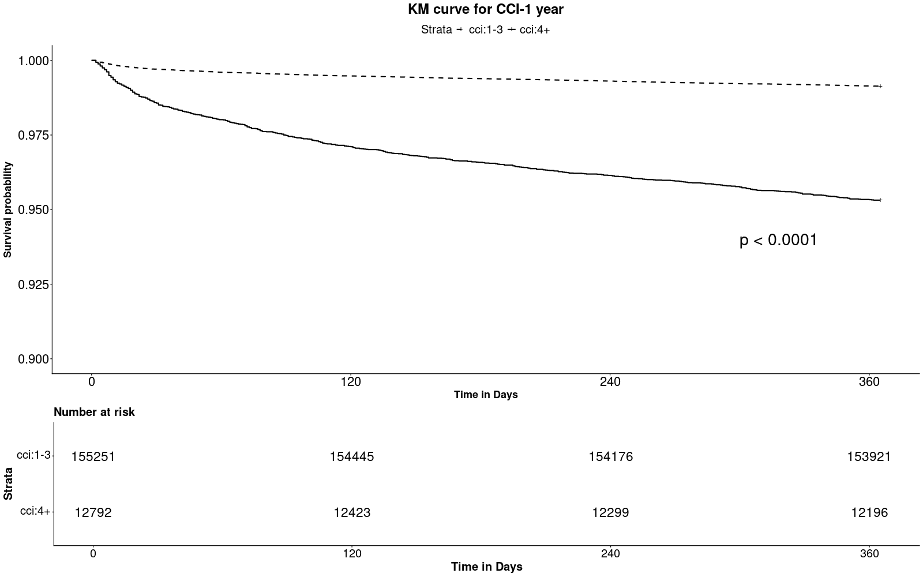
Abbreviations: CCI = Charlson comorbidity index 1-3, 4+

Figure S2: KM Curves for SVI (1 year survival)
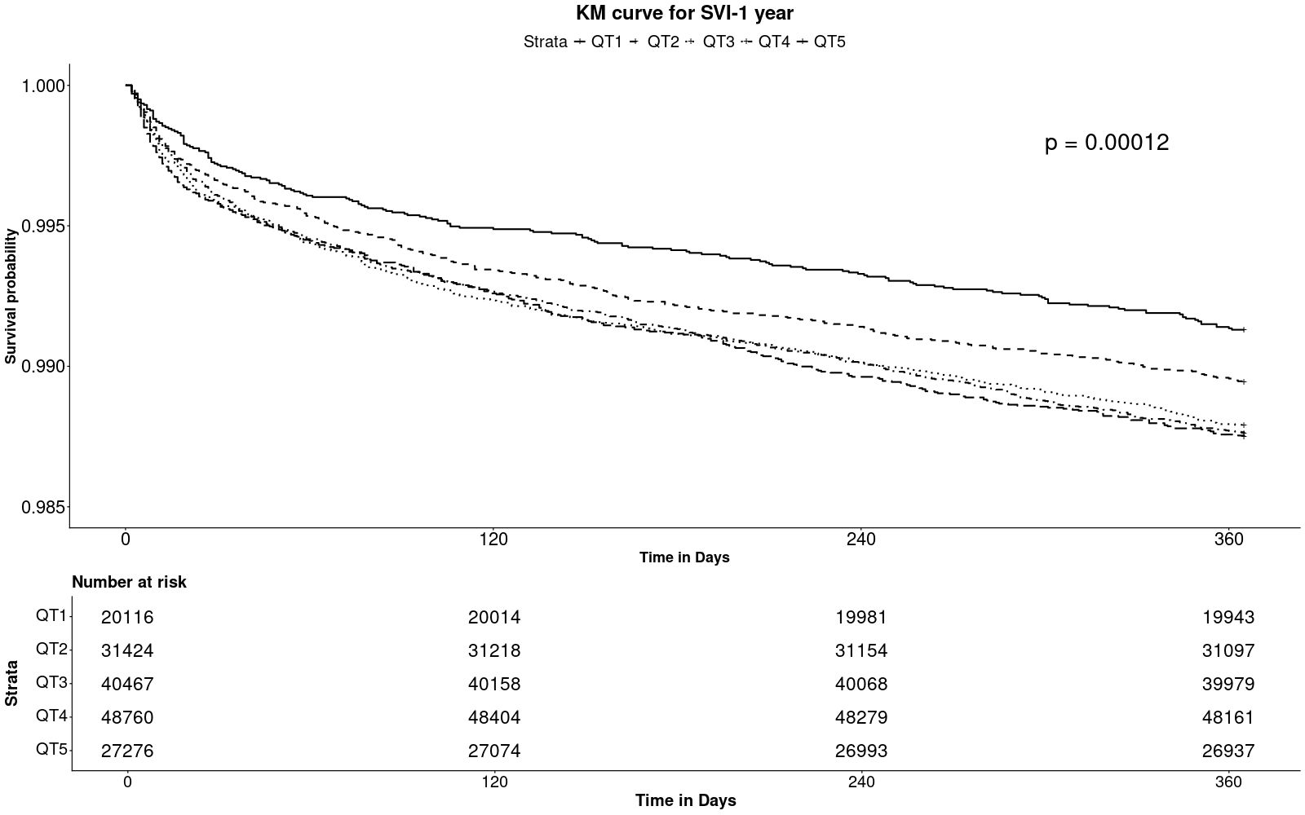
Abbreviations: SVI = Social Vulnerability Index Quintiles

