SUPPLEMENTARY DATA
Supplementary Method 1. Genetic analysis
(1) Library preparation and sequencing
The target capture panel and reagents were developed using the liquid-phase hybridization technology of Celemics, Inc. (Seoul, Republic of Korea). Capture probes were specifically designed to bind complementary target regions.
Genomic DNA (gDNA) was extracted for library preparation, with 100 ng used as input. The DNA was enzymatically fragmented to an average size of approximately 200 bp to facilitate downstream library construction. Fragmented DNA was end-repaired to generate blunt ends, followed by the addition of a single adenine (A) nucleotide to the 3′ ends (dA-tailing) and ligation of Y-shaped Illumina-compatible sequencing adapters. Adapter-ligated products were amplified in 6 cycles of pre-capture PCR to generate indexed DNA libraries using unique dual indexes (UDI).
The libraries were hybridized with biotinylated capture probes from the Celemics Target Enrichment Kit (Celemics, Seoul, Republic of Korea; Custom Panel [MMPP]) to selectively enrich target regions. A total of 1,000 ng of library was used for hybridization. After washing, the captured libraries were further amplified in 16 cycles of post-capture PCR to obtain sufficient material for sequencing.
Finally, the pooled libraries containing enriched DNA fragments were sequenced on an Illumina NextSeq 500 system (Illumina, San Diego, CA, USA) using 150 bp paired-end reads.
(2) Alignment and variant calling
Raw FASTQ file was filtered and trimmed using Adaptor removal 2.3.3. Burrows-Wheeler aligner (BWA; version 0.7.17) mem with default option was used to align reads to human reference genome sequence GRCh37. Sequence alignment map (SAM) file was converted to BAM format using samtools (version 1.15.1). Picard tool (version 2.27.2) was used to sort and remove duplications. GATK (version 4.2.6.1) was used to perform Base quality score re-calibration and variant calling. GATK HaplotypeCaller was used to call variants following the best practices.

Supplementary Table 1. Genotype frequencies of ABCB1 polymorphisms and the results of association analysis with lenalidomide PK parameters
ABCB1  SNP (rsID) | Allele Change ª | Genotype (n) ^{b} | MAF (%) | Tested PK parameter | Minimum Uncorrected p-value ^{c} | FDR adjusted p-value ^{d}
rs1055302 | C>T | CC (18), CT (10), TT (2) | 23.33 | C_{max} | 0.023 | P > 0.05  for all
 |  |  |  | T_{max} | 0.057 | P > 0.05  for all
 |  |  |  | AUC₂₄ | 0.365 | P > 0.05  for all
 |  |  |  | T_{1/2} | 0.734 | P > 0.05  for all
rs41297348 | A>G | AA (29), AG (1), GG (0) | 1.67 | C_{max} | 0.222 | P > 0.05  for all
 |  |  |  | T_{max} | 0.403 | P > 0.05  for all
 |  |  |  | AUC₂₄ | 0.963 | P > 0.05  for all
 |  |  |  | T_{1/2} | 0.741 | P > 0.05  for all
rs57126620 | A>G | AA (28), AG (2), GG (0) | 3.33 | C_{max} | 0.236 | P > 0.05  for all
 |  |  |  | T_{max} | 0.286 | P > 0.05  for all
 |  |  |  | AUC₂₄ | 0.091 | P > 0.05  for all
 |  |  |  | T_{1/2} | 0.114 | P > 0.05  for all
rs3842 | T>C | TT (17), TC (11), CC (2) | 25.00 | C_{max} | 0.091 | P > 0.05  for all
 |  |  |  | T_{max} | 0.01 | P > 0.05  for all
 |  |  |  | AUC₂₄ | 0.365 | P > 0.05  for all
 |  |  |  | T_{1/2} | 0.69 | P > 0.05  for all
rs28364274 | C>T | CC (28), CT (2), TT (0) | 3.33 | C_{max} | 0.229 | P > 0.05  for all
 |  |  |  | T_{max} | 0.487 | P > 0.05  for all
 |  |  |  | AUC₂₄ | 0.171 | P > 0.05  for all
 |  |  |  | T_{1/2} | 0.416 | P > 0.05  for all
rs1045642 | C>T | CC (16), CT (9), TT (5) | 31.67 | C_{max} | 0.716 | P > 0.05  for all
 |  |  |  | T_{max} | 0.103 | P > 0.05  for all
 |  |  |  | AUC₂₄ | 0.588 | P > 0.05  for all
 |  |  |  | T_{1/2} | 0.195 | P > 0.05  for all
rs2032582 | G>T/A | TT (12), TG (11), GG (7) | 41.67 | C_{max} | 0.309 | P > 0.05  for all
 |  |  |  | T_{max} | 0.113 | P > 0.05  for all
 |  |  |  | AUC₂₄ | 0.841 | P > 0.05  for all
 |  |  |  | T_{1/2} | 0.482 | P > 0.05  for all
rs2032582 | G>T/A | AA (5), AT (3), TT (22) | 21.67 | C_{max} | 0.658 | P > 0.05  for all
 |  |  |  | T_{max} | 0.425 | P > 0.05  for all
 |  |  |  | AUC₂₄ | 0.607 | P > 0.05  for all
 |  |  |  | T_{1/2} | 0.552 | P > 0.05  for all
rs2235040 | C>T | CC (27), CT (3), TT (0) | 5.00 | C_{max} | 0.735 | P > 0.05  for all
 |  |  |  | T_{max} | 0.577 | P > 0.05  for all
 |  |  |  | AUC₂₄ | 0.856 | P > 0.05  for all
 |  |  |  | T_{1/2} | 0.914 | P > 0.05  for all
rs2235013 | C>T | CC (14), CT (11), TT (5) | 35.00 | C_{max} | 0.199 | P > 0.05  for all
 |  |  |  | T_{max} | 0.118 | P > 0.05  for all
 |  |  |  | AUC₂₄ | 0.201 | P > 0.05  for all
 |  |  |  | T_{1/2} | 0.397 | P > 0.05  for all
rs34767983 | C>T | CC (30), CT (0), TT (0) | 0.00 | C_{max} | 1.00 | P > 0.05  for all
 |  |  |  | T_{max} | 1.00 | P > 0.05  for all
 |  |  |  | AUC₂₄ | 1.00 | P > 0.05  for all
 |  |  |  | T_{1/2} | 1.00 | P > 0.05  for all
rs1128503 | C>T | TT (14), TC (11), CC (5) | 35.00 | C_{max} | 0.199 | P > 0.05  for all
 |  |  |  | T_{max} | 0.118 | P > 0.05  for all
 |  |  |  | AUC₂₄ | 0.201 | P > 0.05  for all
 |  |  |  | T_{1/2} | 0.397 | P > 0.05  for all
rs2235015 | C>A | CC (28), CA (2), AA (0) | 3.33 | C_{max} | 0.502 | P > 0.05  for all
 |  |  |  | T_{max} | 0.666 | P > 0.05  for all
 |  |  |  | AUC₂₄ | 0.513 | P > 0.05  for all
 |  |  |  | T_{1/2} | 0.646 | P > 0.05  for all
rs2235074 | G>A | GG (27), GA (3), AA (0) | 5.00 | C_{max} | 0.457 | P > 0.05  for all
 |  |  |  | T_{max} | 0.683 | P > 0.05  for all
 |  |  |  | AUC₂₄ | 0.743 | P > 0.05  for all
 |  |  |  | T_{1/2} | 0.689 | P > 0.05  for all
rs2214102 | T>C | TT (0), TC (0), CC (30) | 0.00 | C_{max} | 1.00 | P > 0.05  for all
 |  |  |  | T_{max} | 1.00 | P > 0.05  for all
 |  |  |  | AUC₂₄ | 1.00 | P > 0.05  for all
 |  |  |  | T_{1/2} | 1.00 | P > 0.05  for all
rs3213619 | A>G | AA (27), AG (3), GG (0) | 5.00 | C_{max} | 0.457 | P > 0.05  for all
 |  |  |  | T_{max} | 0.683 | P > 0.05  for all
 |  |  |  | AUC₂₄ | 0.743 | P > 0.05  for all
 |  |  |  | T_{1/2} | 0.689 | P > 0.05  for all
rs34976462 | G>C | GG (26), GC (4), CC (0) | 6.67 | C_{max} | 0.583 | P > 0.05  for all
 |  |  |  | T_{max} | 0.564 | P > 0.05  for all
 |  |  |  | AUC₂₄ | 0.971 | P > 0.05  for all
 |  |  |  | T_{1/2} | 0.689 | P > 0.05  for all
rs3747802 | A>G | AA (27), AG (3), GG (0) | 5.00 | C_{max} | 0.457 | P > 0.05  for all
 |  |  |  | T_{max} | 0.683 | P > 0.05  for all
 |  |  |  | AUC₂₄ | 0.743 | P > 0.05  for all
 |  |  |  | T_{1/2} | 0.689 | P > 0.05  for all
Abbreviations: AUC₂₄, area under the plasma concentration-time curve over the 24-h dosing interval; C_{max}, maximum concentration; FDR, false discovery rate; MAF, minor allele frequency; PK, pharmacokinetics; SNP, single nucleotide polymorphism; T_{1/2}, elimination half-life; T_{max}, time to reach C_{max}.
ª The "Allele Change" column primarily reports reference and alternative alleles in accordance with the human genome reference standard (GRCh38.p12, NIH dbSNP), in which both alleles are designated relative to the forward strand. For three ABCB1 variants of established pharmacogenetic relevance (rs1128503, rs2032582, and rs1045642), however, the conventional pharmacogenetic designations widely adopted in the literature — namely 1236C>T, 2677G>T/A, and 3435C>T, respectively — were retained to preserve consistency with prior reports. It should be noted that these conventional designations are based on the coding (mRNA) sequence of ABCB1, which corresponds to the reverse strand of the genomic reference. Accordingly, the nucleotides shown in the "Genotype" column, which were called directly from sequencing reads aligned to the forward-strand genomic reference, may not match those in the conventional pharmacogenetic notation listed in the "Allele Change" column. For rs2032582, two separate rows are presented because this is a triallelic variant with two known alternative alleles.
^{b} Number of subjects for each genotype, presented as reference homozygote, heterozygote, and variant homozygote, respectively.
^{c} Minimum uncorrected p-value from Fisher's exact tests performed between the SNP and PK parameters.
^{d} The p-value adjusted to control the FDR using the Benjamini-Hochberg procedure. This value was calculated as: (raw p-value) × (N/k), where N was the total number of tests performed and k was the rank of the raw p-value when sorted in the ascending order.

Supplementary Table 2. Results of multi-locus combined analysis of ABCB1 variants (rs1045642, rs2032582, and rs1128503) and their association with lenalidomide PK parameters using the Jonckheere–Terpstra trend test: (A) total and (B) unbound concentrations
(A)
Parameter | JT_stat | p_value | tau_b | tau_lcl | tau_ucl | spearman_rho | n_perm | p_BH | p_Bonferroni
log (C_{max}) | 170 | 0.5738 | -0.0795 | -0.3606 | 0.242 | -0.0883 | 10000 | 0.6372 | 1
T_{max} | 221.5 | 0.204 | 0.1786 | -0.1053 | 0.4364 | 0.2281 | 10000 | 0.6372 | 0.816
λz | 212 | 0.3518 | 0.1293 | -0.154 | 0.3877 | 0.197 | 10000 | 0.6372 | 1
log (AUC₂₄) | 172 | 0.6372 | -0.0696 | -0.3351 | 0.2329 | -0.1021 | 10000 | 0.6372 | 1

(B)
Parameter | JT_stat | p_value | tau_b | tau_lcl | tau_ucl | spearman_rho | n_perm | p_BH | p_Bonferroni
log (C_{max}) | 175 | 0.6948 | -0.0547 | -0.3306 | 0.2555 | -0.0651 | 10000 | 0.6948 | 1
T_{max} | 227.5 | 0.1428 | 0.2092 | -0.0958 | 0.472 | 0.2613 | 10000 | 0.5712 | 0.5712
λz | 215 | 0.2972 | 0.1442 | -0.1582 | 0.3914 | 0.1945 | 10000 | 0.5944 | 1
log (AUC₂₄) | 172 | 0.639 | -0.0696 | -0.3561 | 0.2415 | -0.1003 | 10000 | 0.6948 | 1
Abbreviations: JT_stat, Jonckheere–Terpstra statistic; tau_b, Kendall's τb; tau_lcl/tau_ucl, lower/upper 95% confidence limit of τb; spearman_rho, Spearman's rank correlation coefficient; n_perm, number of permutations; p_BH, Benjamini–Hochberg adjusted p-value; p_Bonferroni, Bonferroni adjusted p-value

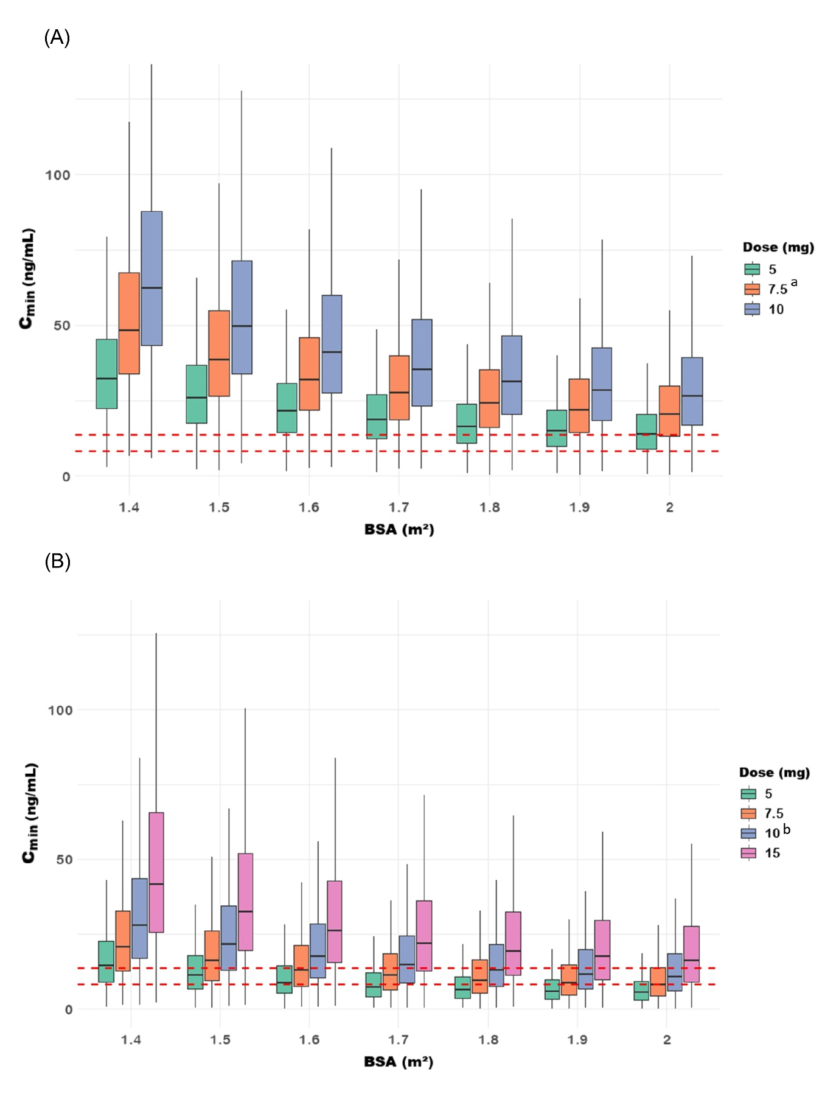
Supplementary Figure 1. Simulated C_{min} distributions of lenalidomide across varying daily doses and body surface areas.
(A) Severe renal impairment group (i.e., eGFR < 30 mL/min/1.73 m²) and (B) moderate renal impairment group (i.e., 30 ≤ eGFR < 60 mL/min/1.73 m²). Boxplots represent the distribution of simulated C_{min} values. Red dashed lines indicate the predefined target C_{min} range (8.21–13.69 ng/mL).
ª Dose approved by regulatory agencies (MFDS and US FDA) for patients with severe renal impairment.
^{b} Dose approved by regulatory agencies (MFDS and US FDA) for patients with moderate renal impairment.
Abbreviations: C_{min}, minimum concentration; BSA, body surface area; eGFR, estimated glomerular filtration rate; MFDS, Ministry of Food and Drug Safety; FDA, Food and Drug Administration.

