Supplementary Material 1. Checklist for reporting discrete choice experiments in health
Section/ Item |  | Section
Purpose and rationale
1 | Describe the real-world context and decision-maker that the hypothetical choice context seeks to replicate or inform | 1. Introduction
2 | Provide a rationale for using a DCE to answer the research question | 1. Introduction
Attributes and levels
3 | Describe how attributes and levels were derived (e.g. literature review, interviews, focus groups, expert input) | 2.1. Attribute Selection
4 | Provide the final list of attributes and levels | Figure 1A
Experimental design
5 | Report the number of alternatives per choice set and whether they were labelled or unlabeled | 2.2. Discrete Choice Experiment (DCE) Design
6 | Describe response options (e.g. forced choice, opt-out, status quo) | 2.2. Discrete Choice Experiment (DCE) Design
7 | Describe the type of experimental design (e.g. orthogonal, D-efficient, Bayesian efficient, partial profile) | 2.2. Discrete Choice Experiment (DCE) Design
8 | Describe which effects are identified in the design (e.g. main effects, higher order interactions, functional form) | Main effects
9 | Describe the number of choice sets, blocks and choice sets per block | 2.5. Survey Instrument
10 | Indicate how the experimental design was obtained (software, catalogue, other) | 2.2. Discrete Choice Experiment (DCE) Design
Survey design
11 | Provide a sample choice set and the instructions and background information given to respondents (e.g. providing the survey as an appendix) | Figure 1 B, Supplementary Material S2
12 | Report any randomization (e.g. choice set order, attribute order, alternative order, framing effects) | N/A
13 | Describe what was checked in piloting (e.g. understanding, respondent burden, timing, wording) | Pre-test with focus groups assessed wording and understanding
14 | Report whether information from the pilot was used to update the experimental design (e.g. priors, functional form of attributes) or survey design | N/A, this is the pilot test.
Sample and data collection
15 | Report respondent inclusion/exclusion criteria | 2.3. Study Sample
16 | Describe how data were collected (e.g. mail, personal interview, web survey) | 2.4. Survey Administration
17 | Report the response rate or cooperation rate, if possible | 2.4. Survey Administration
18 | Report the final sample size and how the sample size was determined | 2.4. Survey Administration
19 | Describe respondent characteristics and representativeness of target population, if known | 3.1. Characteristics of Participants and Their Child, Table 1
Econometric analysis
20 | Indicate coding of data (e.g. effects, dummy, continuous) including definitions | Not applicable
21 | Report whether any respondents were removed and why (e.g. suspected fraudulent responses, rationality tests) | Not applicable
22 | Provide the rationale for model choice (e.g. conditional logit, mixed logit, latent class) and assumptions (e.g. error variance) | Not applicable
23 | Report model specification | Not applicable
Reporting of results
24 | Report the model performance, goodness of fit (if comparing models) | Not applicable
25 | Describe methods used for analysis of model results (e.g. calculation of marginal rate of substitution, attribute relative importance, welfare gain) | 2.6. Statistical Analysis
26 | Report measures of precision for the output(s) of interest (e.g. confidence intervals) and how these were derived | 2.6. Statistical Analysis

Supplementary Material 2. Antipsychotic DCE Survey

Antipsychotic Use to Manage Aggressive Behavior in Children
A Survey for Caregivers

WHAT YOU ARE DOING NOW TO MANAGE THE MENTAL HEALTH CARE NEEDS OF YOUR CHILD?
The first section will ask you a few questions about what you are doing NOW to manage your child’s mental health care needs.

What type of school is your child in NOW?
- Regular public school
- Special program in a regular public school
- Alternative school
- Homeschooled
- My child finished high school
- My child is not able to attend school
- Other (please specify) ________________________________________

Which best reflects you and your child’s social relations NOW? Please check all that apply.
- I do not bring my child to social outings to avoid conflict
- I do not talk about my child’s problems to avoid conflict
- I do not maintain contact with family/friends to avoid conflict
- None of the above
- Other (please specify) ________________________________________

Which best reflects where your child CURRENTLY receives care?
- At home
- At school
- At a community clinic
- At a doctor’s office
- In a voluntary placement outside of the home
- In an involuntary placement outside of the home
- Other (please specify) ________________________________________

Which best reflects how you CURRENTLY manage your other daily responsibilities around your child’s mental health care appointments?
- I rearrange my schedule
- I give up some daily responsibilities
- I give up all daily responsibilities
- Other (please specify) ________________________________________

How has the antipsychotic medicine affected your child? Please check all that apply.
- Weight change (please specify) ________________________________________
- Personality change (please specify) ________________________________________
- Mood change (please specify) ________________________________________
- Other (please specify) ________________________________________
- None
- I decided not to use an antipsychotic medicine or my child.

How has the antipsychotic medicine affected your child’s target symptoms?
- No change
- Partly reduced targeted symptoms
- Reduced all target symptoms

WHAT IS IMPORTANT TO YOU IN DECIDING TO USE AN ANTIPSYCHOTIC FOR YOUR CHILD?

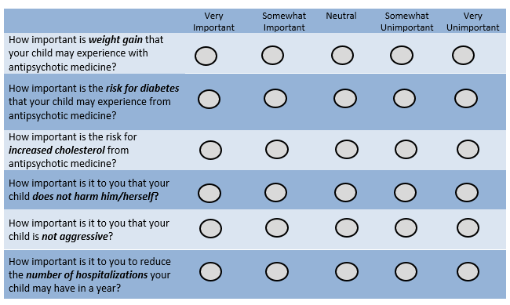
In this section, you will be asked about outcomes that are important to you. Please rate how important each of the following is to you when thinking about outcomes that you want for your child.

WHAT TREATMENT PROFILE DO YOU PREFER?
In this section, we provide you with 3 treatment option profiles for an antipsychotic medication to manage your child’s mental health needs. We ask you to select the treatment option that is most acceptable to you.

Here is an example question to get you started.

If you had to choose an antipsychotic medication to manage your child’s mental health needs, which treatment option would you prefer?
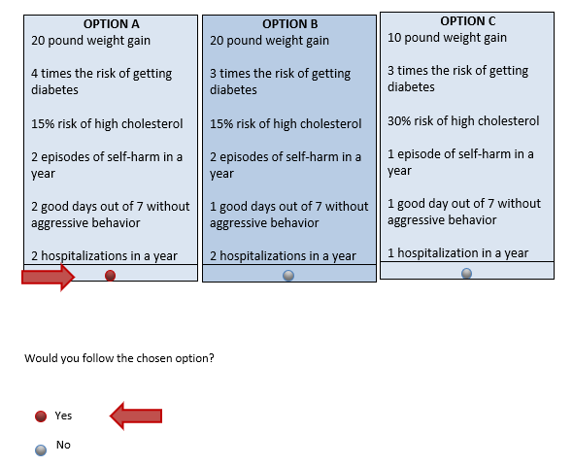
Choose by clicking one of the buttons below the option you prefer:

Question 1:
If you had to choose an antipsychotic medication to manage your child’s mental health needs, which treatment option would you prefer?
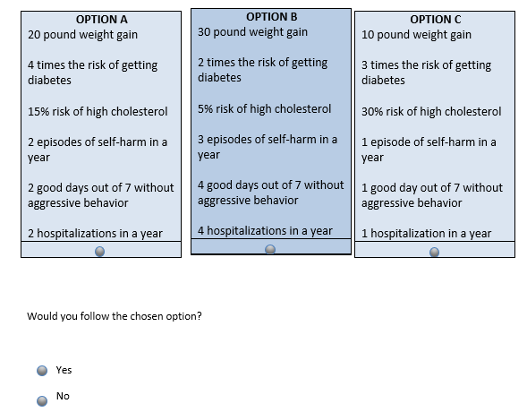
Choose by clicking one of the buttons below the option you prefer:

Question 2:
If you had to choose an antipsychotic medication to manage your child’s mental health needs, which treatment option would you prefer?
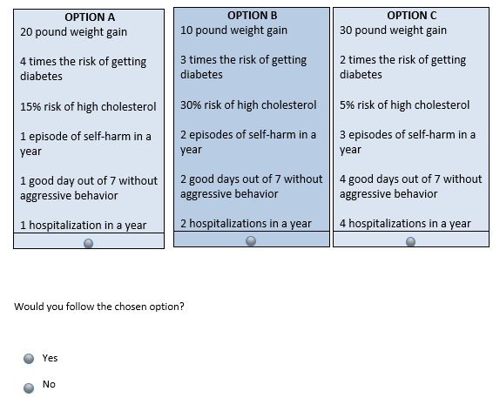
Choose by clicking one of the buttons below the option you prefer:

Question 3:
If you had to choose an antipsychotic medication to manage your child’s mental health needs, which treatment option would you prefer?
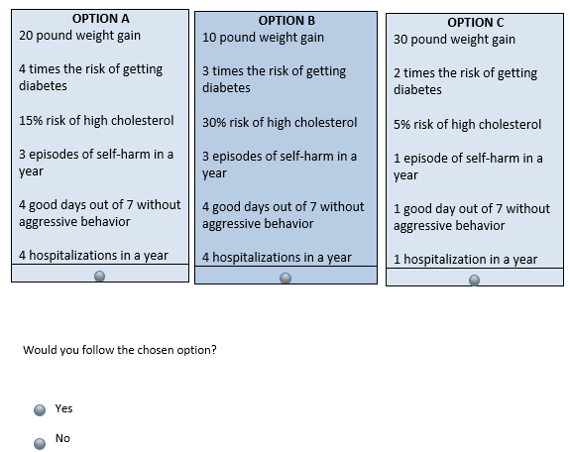
Choose by clicking one of the buttons below the option you prefer:
Question 4:
If you had to choose an antipsychotic medication to manage your child’s mental health needs, which treatment option would you prefer?
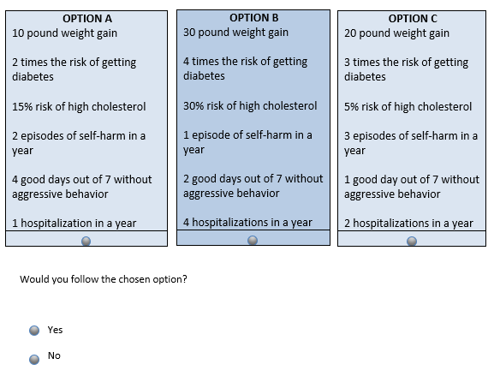
Choose by clicking one of the buttons below the option you prefer:

Question 5:
If you had to choose an antipsychotic medication to manage your child’s mental health needs, which treatment option would you prefer?
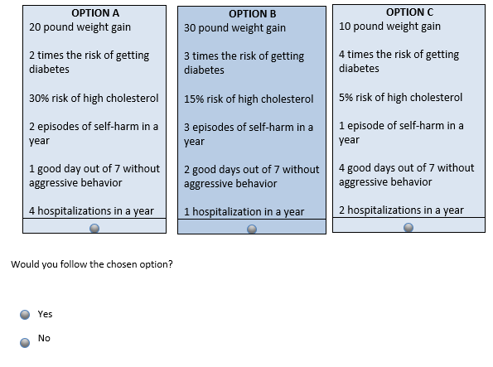
Choose by clicking one of the buttons below the option you prefer:
Question 6:
If you had to choose an antipsychotic medication to manage your child’s mental health needs, which treatment option would you prefer?
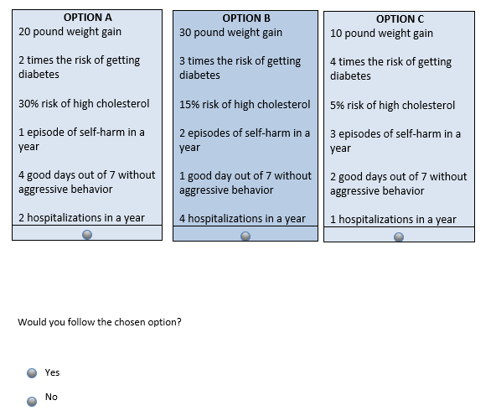
Choose by clicking one of the buttons below the option you prefer:

Question 7:
If you had to choose an antipsychotic medication to manage your child’s mental health needs, which treatment option would you prefer?
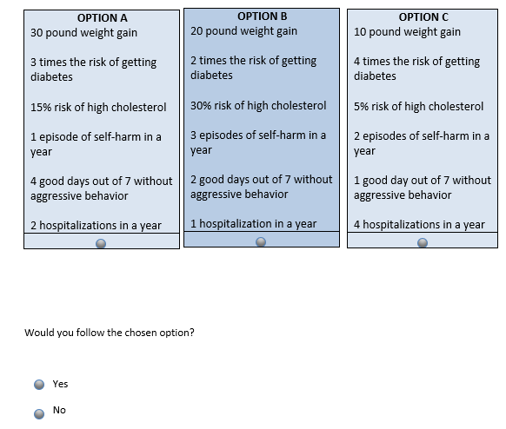
Choose by clicking one of the buttons below the option you prefer:
Question 8:
If you had to choose an antipsychotic medication to manage your child’s mental health needs, which treatment option would you prefer?
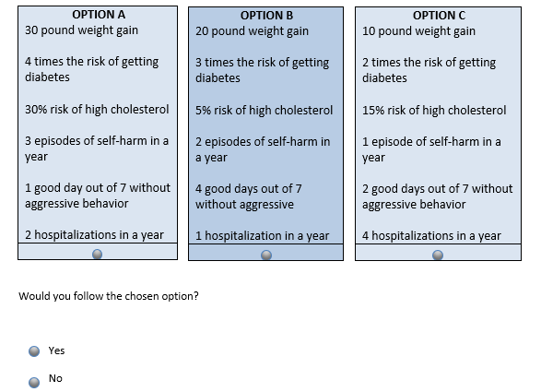
Choose by clicking one of the buttons below the option you prefer:

Question 9:
If you had to choose an antipsychotic medication to manage your child’s mental health needs, which treatment option would you prefer?
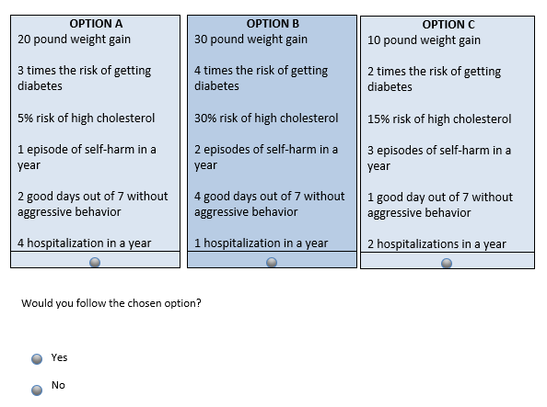
Choose by clicking one of the buttons below the option you prefer:

TELL US ABOUT YOU AND YOUR CHILD
The next few questions will help us to learn a little about you and your child.

How are you related to the child in your care?
- Mother
- Father
- Grandparent
- Uncle/Aunt
- Foster Parent
- Other (please specify) ________________________________________

What is your age (in years)?
_______________

What is your gender?
- Male
- Female
- Other (please specify) _______________________________
- Prefer not to answer

What is your race?
- White
- Black
- Asian/Pacific Islander
- Native American/Alaskan Native
- Other (please specify) ________________________________________

What is your ethnicity?
- Hispanic or Latino
- Other (please specify) ________________________________________

What is your marital status?
- Married
- Never married
- Divorced/Separated
- Widowed
- Other (please specify) ________________________________________
- Don’t know

What is the highest grade of school that YOU have completed?
- Less than high school
- High school
- College
- Postgraduate
- Don’t know

Are you working now?
- Working full time (please specify what you do) _____________________________________
- Working part time (please specify what you do) ____________________________________
- Not working
- Retired (please specify former job) ______________________________________________

What if your family’s yearly household income?
- $7,500 or less
- $7,501 to $15,000
- $15,001 to $25,000
- $25,001 to $35,000
- $35,001 to $50,000
- $50,001 to $75,000
- $75,001 or over
- Don’t know

What state are you currently residing in?
Please provide the full name (no abbreviations) Example: Maryland
________________________________________________________________________

What type of community do you live in?
- Urban
- Suburban
- Rural

The next few questions will be about your child.

What is your child’s gender?
- Male
- Female
- Other

What is your child’s race?
- White
- Black
- Asian/Pacific Islander
- Native American/Alaskan Native
- Other (please specify) ________________________________________

What is your child’s ethnicity?
- Hispanic
- Other (please specify) ________________________________________

What grade is your child currently in? If your child is no longer in school, please specify highest grade attained._______________________________________________________________________

Which of the following conditions does your child have? Please check all that apply.
- Intellectual Disability (e.g., problems with reasoning)
- Communication Disorder (e.g., muffled speech, cannot hold a conversation)
- Autism Spectrum Disorder
- Specific Learning Disorder
- Motor Disorder
- Anxiety Disorder
- Bipolar Disorder
- Depression
- Attention Deficit Hyperactivity Disorder/Attention Deficit Disorder
- Conduct Disorder
- Schizophrenia/Psychoses
- Oppositional Defiant Disorder
- Other (please specify): _____________________________________

Which of the following describes your child?
- Verbal
- Non-Verbal

What medicine is your child CURRENTLY taking? Please check all that apply.
- Medicines for ADHD (please specify) ________________________________________________
- Medicines for depression or sad thoughts (please specify) _______________________________
- Medicines for mood (please specify) ________________________________________________
- Medicines for anxiety and nervousness (please specify) _________________________________
- Medicines for sleep (please specify) _________________________________________________
- Other (please specify) ____________________________________________________________
- My child does not take any medicines

What type of therapy is YOUR CHILD CURRENTLY receiving? Please check all that apply.
- Cognitive Behavioral Therapy
- Other Behavioral Therapy
- Individual Psychotherapy
- Family therapy
- Group therapy
- Occupational therapy
- Physical therapy
- Speech and language therapy
- Other (please specify) ________________________________________
- My child does not receive any therapy

Has your child been hospitalized for a mental health-related condition?
- Yes, please specify the reason for hospitalization _________________________________
- No
How long ago was your child’s most recent mental health-related hospitalization?
For example: yesterday, 1 month, 3 years, 10 years, etc._______________________________________

Which type(s) of aggressive behaviors have you seen in your child? Please check all that apply.
- Aggression towards self (e.g., self-injury)
- Aggression towards others
- Aggression towards property
- My child does not have aggressive behavior

Who is the main caregiver of your child, i.e. the person responsible for making health care decisions? Please check all that apply.
- Mother
- Father
- Grandparent
- Uncle/Aunt
- Foster Parent
- Other (please specify) ________________________________________

How many people are living in the same house with your child, including yourself? _______________

Who lives in the same house with your child? Please check all that apply, including yourself.
- Mother
- Father
- Siblings
- Step-mother or father’s significant other
- Step-father or mother’s significant other
- Other (please specify) ________________________________________
- Don’t know

What type of health insurance do you have for your child? Check only ONE option.
- Public (e.g., Medical Assistance)
- Private (e.g., Blue Cross Blue Shield)
- None
- Other (please specify) ________________________________________

Does anyone help you manage your child’s healthcare needs?
- Yes, (please specify) ________________________________________
- No

Does your child need 24-hour supervision or care?
- Yes
- No

Do you get any financial or other support for healthcare services for your child?
- Yes, (please specify) ________________________________________
- No
- Don’t know

THANK YOU FOR COMPLETING THE SURVEY!
We appreciate your help. If you have any comments that you would like to share with us, please write them in the space below.
_______________________________________________________________________________________________________________________________________________________________________________________________________________________________________________________________

To receive a gift card as a thank you for your time in completing this survey, please enter your email address below. An electronic gift card will be sent to you via email. Your contact information will not be linked to your survey answers.
Email Address: __________________________________
Verify Email Address: ______________________________

If you would not like to receive a gift card, please check the box below.
- I do not wish to receive a gift card

