Figure S1 Learning curve of test AUC with training set sizes ranging from 90 to 230 samples.
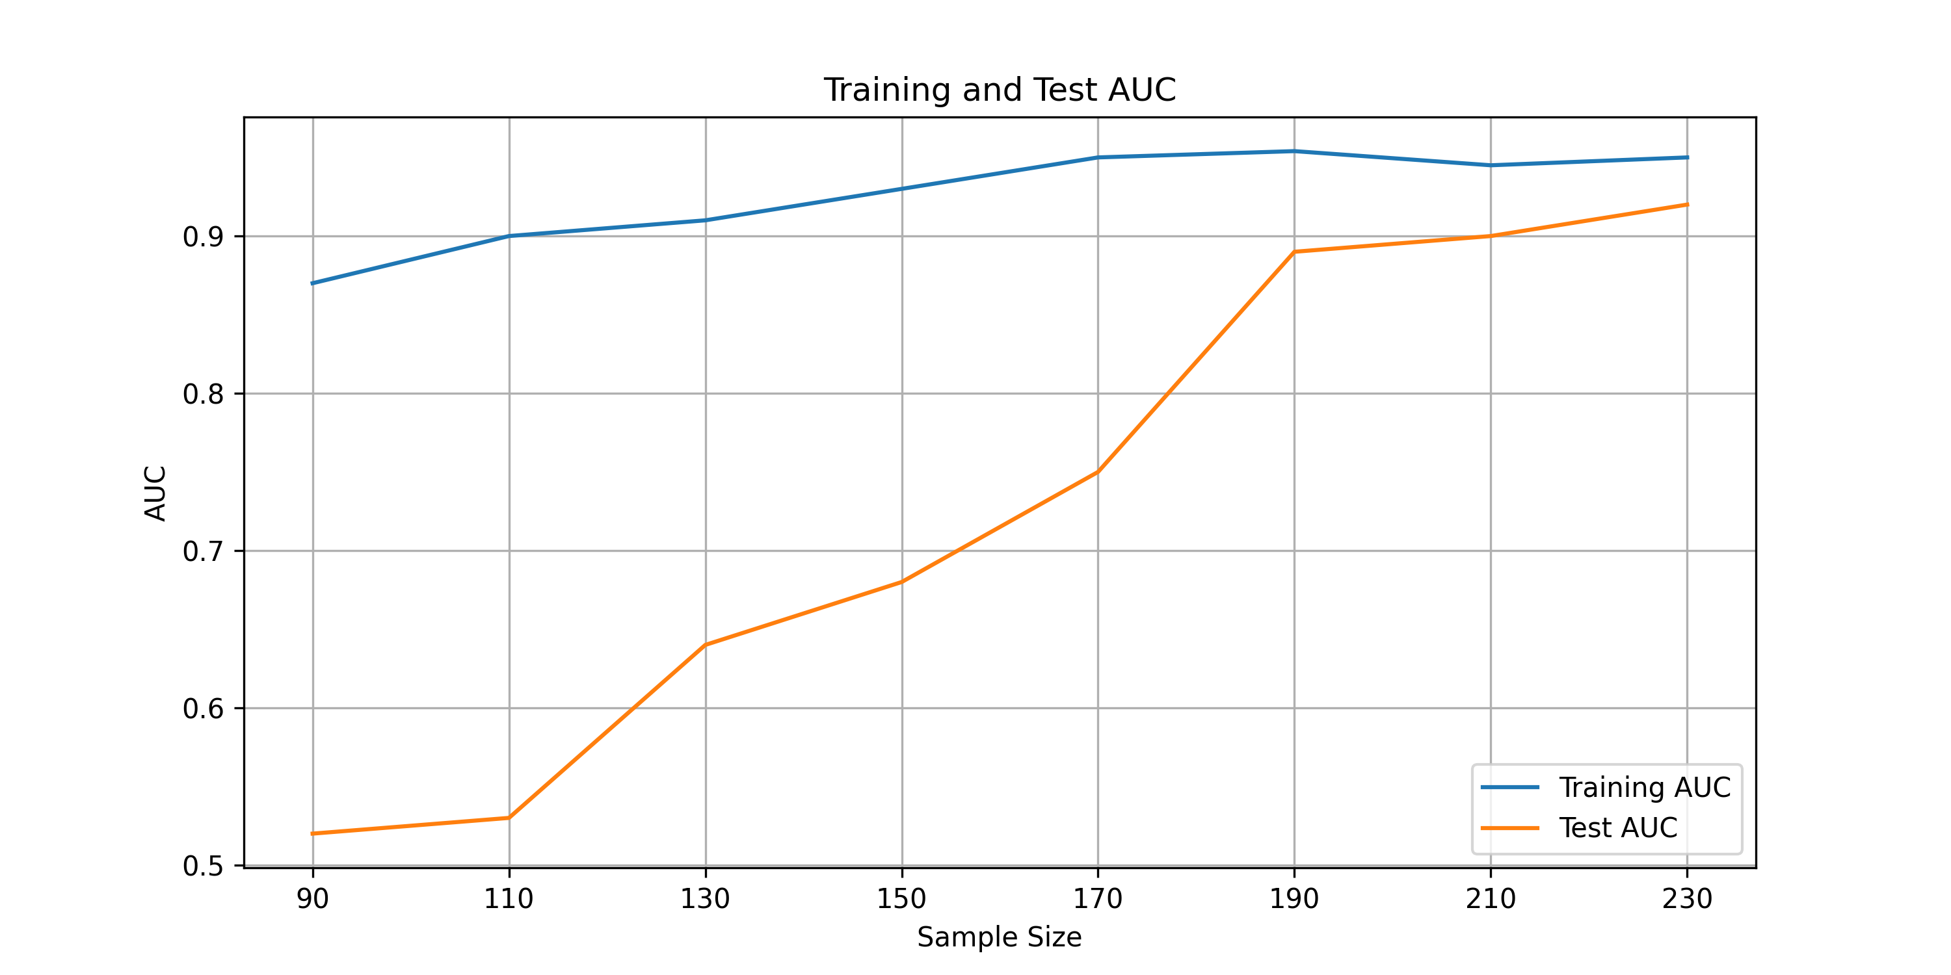
The test AUC rises substantially from ~0.52 at n=90 to ~0.89 at n=190, and begins to plateau beyond n=190–210 (test AUC stabilizing at approximately 0.90–0.92). Crucially, the training AUC remains relatively stable throughout (0.87–0.96), and the train-test AUC gap narrows progressively with increasing sample size, converging to approximately 0.03–0.04 at our full cohort size.
Table S1 Parameters from CT scans in training, validation and testing sets
Sets | Manufacture | Field of view | Image matrix | Tube voltage | Tube current | Slice thickness
Training and validation | GE-Discovery CT750 HD | 30-50cm | 512×512 | 120KV | 206mA | 5mm
Training and validation | Siemens-SOMATOM Force | 30-50cm | 512×512 | 120KV | 210mA | 5mm
test | Philips-Brilliance iCT | 30-50cm | 512×512 | 120KV | 274 mA | 5mm

Table S2 Performance of all 14 machine learning algorithms incorporating clinical features in the three cohorts. ExtraTree was the model with the best prediction performance
Dataset | Model | ACC | AUC(95% CI) | Sensitivity | Specificity | NPV | PPV | F1
train | LR | 0.795 | 0.843 (0.803,0.883) | 0.858 | 0.750 | 0.881 | 0.711 | 0.778
validation | LR | 0.667 | 0.652 (0.549,0.750) | 0.533 | 0.762 | 0.696 | 0.615 | 0.571
test | LR | 0.853 | 0.890 (0.803,0.959) | 0.902 | 0.794 | 0.871 | 0.841 | 0.871
train | NB | 0.819 | 0.833 (0.793,0.871) | 0.783 | 0.845 | 0.845 | 0.783 | 0.783
validation | NB | 0.722 | 0.696 (0.596,0.784) | 0.600 | 0.810 | 0.739 | 0.692 | 0.643
test | NB | 0.680 | 0.715 (0.635,0.795) | 0.463 | 0.941 | 0.593 | 0.905 | 0.613
train | linear_SVM | 0.764 | 0.821 (0.783,0.863) | 0.764 | 0.764 | 0.819 | 0.698 | 0.730
validation | linear_SVM | 0.667 | 0.648 (0.542,0.748) | 0.533 | 0.762 | 0.696 | 0.615 | 0.571
test | linear_SVM | 0.853 | 0.881 (0.790,0.955) | 0.902 | 0.794 | 0.871 | 0.841 | 0.871
train | poly_SVM | 0.791 | 0.831 (0.784,0.880) | 0.840 | 0.757 | 0.868 | 0.712 | 0.771
validation | poly_SVM | 0.667 | 0.659 (0.562,0.761) | 0.600 | 0.714 | 0.714 | 0.600 | 0.600
test | poly_SVM | 0.800 | 0.832 (0.756,0.924) | 0.976 | 0.588 | 0.952 | 0.741 | 0.842
train | sigmoid_SVM | 0.799 | 0.805 (0.747,0.855) | 0.726 | 0.851 | 0.813 | 0.778 | 0.751
validation | sigmoid_SVM | 0.704 | 0.698 (0.604,0.798) | 0.600 | 0.778 | 0.731 | 0.659 | 0.628
test | sigmoid_SVM | 0.747 | 0.749 (0.660,0.869) | 0.805 | 0.676 | 0.742 | 0.750 | 0.776
train | rbf_SVM | 0.799 | 0.858 (0.817,0.900) | 0.868 | 0.750 | 0.888 | 0.713 | 0.783
validation | rbf_SVM | 0.685 | 0.664 (0.568,0.762) | 0.511 | 0.810 | 0.699 | 0.657 | 0.575
test | rbf_SVM | 0.853 | 0.894 (0.819,0.962) | 0.902 | 0.794 | 0.871 | 0.841 | 0.871
train | DT | 0.764 | 0.740 (0.694,0.791) | 0.594 | 0.885 | 0.753 | 0.788 | 0.677
validation | DT | 0.694 | 0.668 (0.596,0.757) | 0.511 | 0.825 | 0.703 | 0.676 | 0.582
test | DT | 0.587 | 0.622 (0.573,0.683) | 0.244 | 1.000 | 0.523 | 1.000 | 0.392
train | RF | 0.787 | 0.865 (0.831,0.910) | 0.830 | 0.757 | 0.862 | 0.710 | 0.765
validation | RF | 0.694 | 0.694 (0.606,0.797) | 0.556 | 0.794 | 0.714 | 0.658 | 0.602
test | RF | 0.853 | 0.914 (0.864,0.956) | 0.854 | 0.853 | 0.829 | 0.875 | 0.864
train | ExtraTree | 0.783 | 0.877 (0.842,0.911) | 0.821 | 0.757 | 0.855 | 0.707 | 0.760
validation | ExtraTree | 0.713 | 0.721 (0.623,0.818) | 0.756 | 0.683 | 0.796 | 0.630 | 0.687
test | ExtraTree | 0.827 | 0.895 (0.833,0.946) | 0.780 | 0.882 | 0.769 | 0.889 | 0.831
train | XGBoost | 0.583 | 0.328 (0.279,0.378) | 0.000 | 1.000 | 0.583 | 0.000 | 0.000
validation | XGBoost | 0.583 | 0.462 (0.403,0.518) | 0.000 | 1.000 | 0.583 | 0.000 | 0.000
test | XGBoost | 0.453 | 0.441 (0.357,0.511) | 0.000 | 1.000 | 0.453 | 0.000 | 0.000
train | AdaBoost | 0.764 | 0.777 (0.732,0.829) | 0.594 | 0.885 | 0.753 | 0.788 | 0.677
validation | AdaBoost | 0.694 | 0.661 (0.556,0.762) | 0.511 | 0.825 | 0.703 | 0.676 | 0.582
test | AdaBoost | 0.853 | 0.853 (0.765,0.926) | 0.878 | 0.824 | 0.848 | 0.857 | 0.867
train | MLP | 0.630 | 0.513 (0.446,0.595) | 0.566 | 0.676 | 0.685 | 0.556 | 0.561
validation | MLP | 0.602 | 0.424 (0.287,0.536) | 0.244 | 0.857 | 0.614 | 0.550 | 0.338
test | MLP | 0.547 | 0.322 (0.238,0.464) | 0.171 | 1.000 | 0.500 | 1.000 | 0.292
train | GBM | 0.783 | 0.760 (0.712,0.808) | 0.585 | 0.926 | 0.757 | 0.849 | 0.693
validation | GBM | 0.694 | 0.669 (0.592,0.755) | 0.511 | 0.825 | 0.703 | 0.676 | 0.582
test | GBM | 0.587 | 0.612 (0.537,0.692) | 0.244 | 1.000 | 0.523 | 1.000 | 0.392
train | LightGBM | 0.583 | 0.500 (0.500,0.500) | 0.000 | 1.000 | 0.583 | 0.000 | 0.000
validation | LightGBM | 0.583 | 0.500 (0.500,0.500) | 0.000 | 1.000 | 0.583 | 0.000 | 0.000
test | LightGBM | 0.453 | 0.500 (0.500,0.500) | 0.000 | 1.000 | 0.453 | 0.000 | 0.000

LR,Logistic Regression;NB,Naive Bayes;linear_SVM,Linear Support Vector Machine;poly_SVM,Polynomial Kernel Support Vector Machine;sigmoid_SVM,Sigmoid Kernel Support Vector Machine;rbf_SVM,Radial Basis Function Kernel Support Vector Machine;DT,Decision Tree;RF,Random Forest;ExtraTree,Extremely Randomized Trees;XGBoost,eXtreme Gradient Boosting;AdaBoost,Adaptive Boosting;MLP,Multi-Layer Perceptron;GBM,Gradient Boosting Machine;LightGBM,Light Gradient Boosting Machine.

Table S3 The 95% CI of accuracy,sensitivity,specificity,NPV,PPV and F1 of the models in the three cohorts
Models | Cohorts |  | Accuracy |  |  | Sensitivity |  |  | Specificity |  |  | NPV |  |  | PPV |  |  | F1
Clinical model | train |  | 0.740 | 0.843 |  | 0.764 | 0.892 |  | 0.692 | 0.831 |  | 0.817 | 0.909 |  | 0.655 | 0.692 |  | 0.831 | 0.817
 | validation |  | 0.634 | 0.815 |  | 0.644 | 0.889 |  | 0.556 | 0.818 |  | 0.720 | 0.893 |  | 0.548 | 0.556 |  | 0.818 | 0.720
 | test |  | 0.747 | 0.907 |  | 0.659 | 0.891 |  | 0.794 | 0.971 |  | 0.677 | 0.868 |  | 0.818 | 0.794 |  | 0.971 | 0.677
Arterial phase model | train |  | 0.673 | 0.780 |  | 0.642 | 0.811 |  | 0.662 | 0.797 |  | 0.734 | 0.844 |  | 0.598 | 0.662 |  | 0.797 | 0.734
 | validation |  | 0.639 | 0.806 |  | 0.578 | 0.823 |  | 0.619 | 0.826 |  | 0.700 | 0.863 |  | 0.557 | 0.619 |  | 0.826 | 0.700
 | test |  | 0.600 | 0.800 |  | 0.537 | 0.805 |  | 0.588 | 0.882 |  | 0.548 | 0.771 |  | 0.647 | 0.588 |  | 0.882 | 0.548
Portal venous phase model | train |  | 0.598 | 0.713 |  | 0.575 | 0.755 |  | 0.574 | 0.723 |  | 0.674 | 0.789 |  | 0.516 | 0.574 |  | 0.723 | 0.674
 | validation |  | 0.602 | 0.778 |  | 0.533 | 0.822 |  | 0.587 | 0.810 |  | 0.676 | 0.847 |  | 0.520 | 0.587 |  | 0.810 | 0.676
 | test |  | 0.586 | 0.787 |  | 0.512 | 0.805 |  | 0.559 | 0.853 |  | 0.531 | 0.744 |  | 0.625 | 0.559 |  | 0.853 | 0.531
Delayed phase model | train |  | 0.602 | 0.724 |  | 0.604 | 0.774 |  | 0.561 | 0.723 |  | 0.686 | 0.805 |  | 0.522 | 0.561 |  | 0.723 | 0.686
 | validation |  | 0.537 | 0.722 |  | 0.511 | 0.778 |  | 0.508 | 0.746 |  | 0.623 | 0.804 |  | 0.455 | 0.508 |  | 0.746 | 0.623
 | test |  | 0.533 | 0.747 |  | 0.488 | 0.780 |  | 0.499 | 0.794 |  | 0.486 | 0.714 |  | 0.579 | 0.499 |  | 0.794 | 0.486
Enhancement model | train |  | 0.705 | 0.811 |  | 0.642 | 0.811 |  | 0.709 | 0.838 |  | 0.748 | 0.857 |  | 0.636 | 0.709 |  | 0.838 | 0.748
 | validation |  | 0.713 | 0.861 |  | 0.644 | 0.889 |  | 0.698 | 0.889 |  | 0.761 | 0.917 |  | 0.639 | 0.698 |  | 0.889 | 0.761
 | test |  | 0.667 | 0.853 |  | 0.659 | 0.902 |  | 0.588 | 0.882 |  | 0.625 | 0.862 |  | 0.682 | 0.588 |  | 0.882 | 0.625
Combined model | train |  | 0.839 | 0.913 |  | 0.840 | 0.953 |  | 0.804 | 0.912 |  | 0.882 | 0.962 |  | 0.767 | 0.804 |  | 0.912 | 0.882
 | validation |  | 0.815 | 0.935 |  | 0.756 | 0.956 |  | 0.810 | 0.968 |  | 0.841 | 0.967 |  | 0.760 | 0.810 |  | 0.968 | 0.841
 | test |  | 0.787 | 0.933 |  | 0.732 | 0.951 |  | 0.765 | 0.971 |  | 0.737 | 0.939 |  | 0.810 | 0.765 |  | 0.971 | 0.737
NPV,negative predictivevalue;PPV,positive predictive value;Cl,confidence interval.

Table S4 Degrees of freedom (df), chi square values (Chi²), and p values (calculated by the Hosmer-Lemeshow test) in the three cohorts reflect the degree of calibration of the prediction models.The Combined model performed best among all six models
Group | train |  |  |  | Validation |  |  |  | test
Group | df | Chi² | p-value |  | df | Chi² | p-value |  | df | Chi² | p-value
Clinical model | 3 | 308.363 | 0.000 |  | 3 | 469.872 | 0.000 |  | 3 | 96.048 | 0.000
Arterial phase model | 78 | 73.582 | 0.621 |  | 78 | 69.367 | 0.747 |  | 48 | 47.788 | 0.481
Portal venous phase model | 78 | 100.508 | 0.044 |  | 78 | 80.559 | 0.399 |  | 48 | 69.256 | 0.024
Delayed phase model | 78 | 119.330 | 0.002 |  | 78 | 108.789 | 0.012 |  | 48 | 64.757 | 0.054
Enhancement model | 78 | 81.390 | 0.374 |  | 78 | 64.247 | 0.868 |  | 48 | 27.973 | 0.991
Combined model | 78 | 78.641 | 0.458 |  | 78 | 46.855 | 0.998 |  | 48 | 35.747 | 0.904

