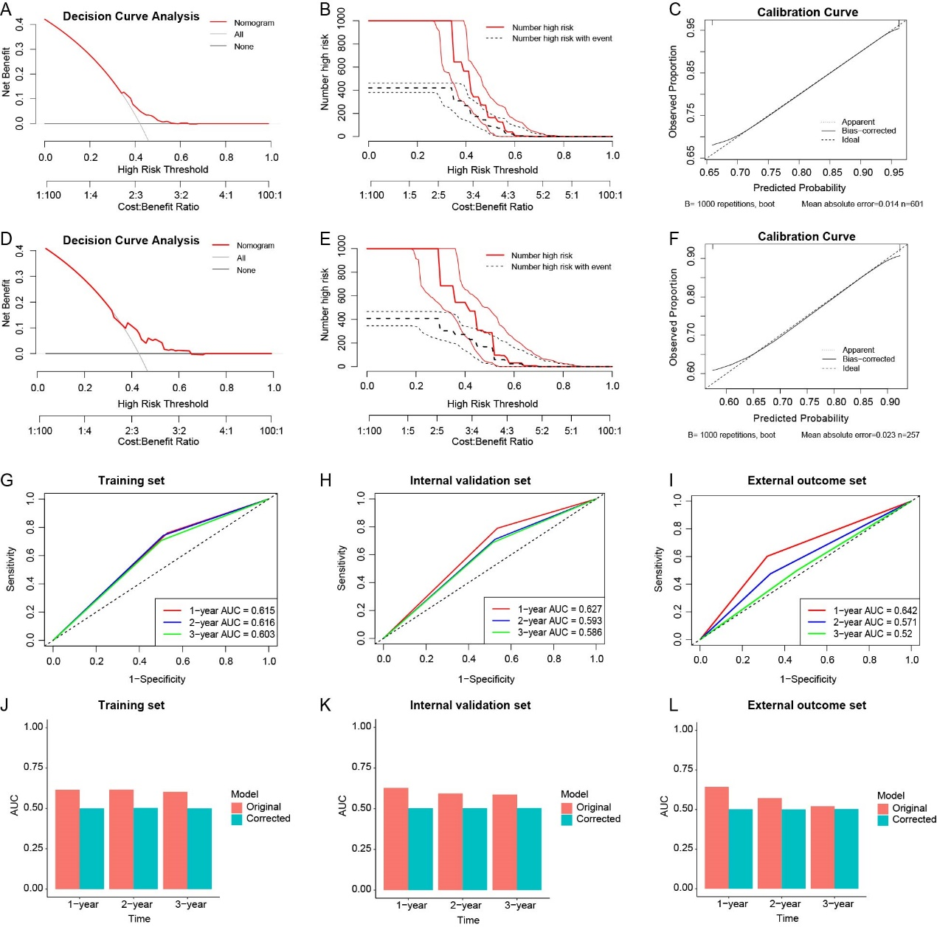
Figure S1. Evaluation of the clinical utility and predictive performance of the model in the training set, internal validation set, and external outcome set.
A, D: Decision curve analysis (DCA) in the training and internal validation sets.
B, E: Clinical impact curves in the training and internal validation sets.
C, F: Calibration curves in the training and internal validation sets.
G–I: Time-dependent ROC curves showing the model’s discriminative ability for 1-, 2-, and 3-year outcomes in the training set, internal validation set, and external outcome set (AUC range: approximately 0.52–0.64).
J–L: Bar plots of AUC values at corresponding time points, comparing the original model with the bootstrap-corrected model, indicating moderate stability but overall modest discriminative performance.

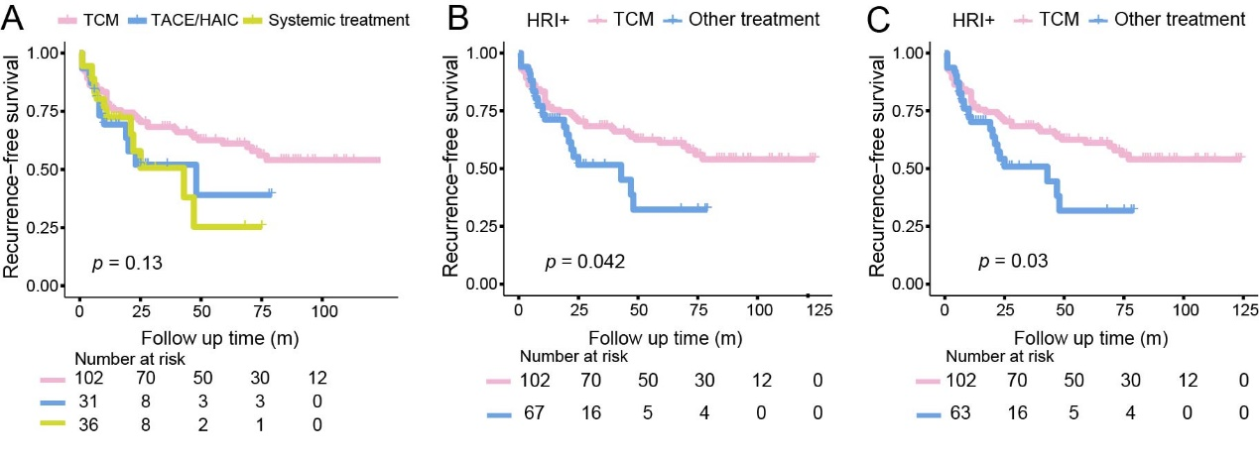
Figure S2. Association between different adjuvant treatment strategies and recurrence-free survival (RFS).
(A) Kaplan–Meier curves comparing RFS among patients receiving traditional Chinese medicine (TCM), transarterial chemoembolization/hepatic arterial infusion chemotherapy (TACE/HAIC), and systemic treatment.
(B) Kaplan–Meier curves comparing RFS between TCM and other treatments in the HRI+ subgroup before propensity score matching (PSM).
(C) Kaplan–Meier curves comparing RFS between TCM and other treatments in the HRI+ subgroup after PSM. HRI, high-risk image feature.
P values were calculated using the log-rank test. Numbers at risk are shown below each plot.

Table S1. MR sequences and parameters.
Sequence | Fat  suppression | TR(ms) | TE(ms) | Flip angle(°) | ST(mm) | Spacing(mm) | Matrix  size | FOV(mm²) | Acquisition Time(s)
Harbin Medical University Cancer Hospital: Philips Ingenia 3.0 T（Multi coil）
T2-weighted 2D FSE | Yes | 2725 | 77.6 | 90 | 5 | 6 | 296×58 | 432×432 | 126
Diffusion-weighted imaging* | Yes | 1405.1 | 55.2 | 90 | 5 | 6 | 120×116 | 384×384 | 168
In- and out-of-phase T1-weighted imaging | No | 3.6 | 2.4/1.2 | 10 | 4 | 2 | 252×248 | 448×448 | 24
Dynamic T1-weighted 3D GRE | Yes | 3.8 | 0 | 10 | 4 | 2 | 268×266 | 480×480 | 14
Shandong Provincial Cancer Hospital: GE Discovery MR 750 3.0 T (16-channel phased-array torsor coil)
T2-weighted 2D FSE | Yes | 6315 | 78 | 111 | 6 | 2 | 288×244 | 360×280 | Respiratory gating
Diffusion-weighted imaging* | Yes | 9230 | Minimum | 90 | 6 | 2 | 128×1280 | 360×380 | Respiratory gating
In- and out-of-phase T1-weighted imaging | No | 150 | 2.5/1.3 | 70 | 6 | 2 | 288×192 | 420×420 | 31
Dynamic T1-weighted 3D GRE | Yes | 4.1 | 1.9 | 15 | 2 | - | 512×512 | 380×300 | 15
Affiliated Hospital of Jining Medical University: Siemens MAGNETOM Skyra 3.0 T (18-channel body array coil)
T2-weighted 2D FSE | Yes | 2160 | 100 | 160 | 6 | 1.8 | 320×288 | 433×433 | 36
Diffusion-weighted imaging* | Yes | 5600 | 68 | 90 | 6 | 1.8 | 100×76 | 380×289 | 233
In- and out-of-phase T1-weighted imaging | No | 81 | 2.72/1.4 | 70 | 6 | 1.8 | 352×286 | 400×325 | 24
Dynamic T1-weighted 3D GRE | Yes | 3.95 | 1.92 | 9 | 2.5 | - | 352×256 | 400×296 | 14
Note. —TR = repetition time; TE = echo time; ST = section thickness; FOV = field of view; 2D = two-dimensional; 3D = three-dimensional; FSE = fast spin-echo; GRE = gradient recall echo.
* Images were acquired under free breath.

Table S2. Definitions of the imaging features.
Imaging features | Definition
LI-RADS major features
Nonrim arterial phase hyperenhancement  (present vs. absent) | Nonrim-like enhancement of the tumor in the arterial phase unequivocally greater in whole or in part than the liver.
Nonperipheral washout  (present vs. absent) | Nonperipheral visually assessed temporal reduction in the enhancement of the tumor in whole or in part relative to composite liver tissue in the portal venous phase or delayed phase.
Enhancing capsule  (present vs. absent) | Smooth, uniform, sharp border around most or all of a tumor, unequivocally thicker or more conspicuous than fibrotic tissue around background nodules, and visible as enhancing rim in portal venous phase, delayed phase, or transitional phase.
Tumor size (mm) | Largest outer-edge-to-outer-edge dimension of a tumor.
LI-RADS ancillary features
Mild-moderate T2 hyperintensity  (present vs. absent) | Signal intensity of the tumor on T2WI higher than the liver, similar to or lower than a non-ironoverloaded spleen, and lower than simple fluid.
Corona enhancement  (present vs. absent) | Peritumoral enhancement in the late arterial phase or early portal venous phase. The enhancement is contiguous with and surrounds all or part of the tumor.
Nodule-in-nodule architecture  (present vs. absent) | Presence of smaller inner nodule within and having different imaging features than larger outer nodule.
Mosaic architecture  (present vs. absent) | Presence of any combination of internal nodules, compartments, or septations, within a solid or mostly solid mass.
Blood products in mass  (present vs. absent) | Intralesional or perilesional hemorrhage in the absence of biopsy, trauma, or intervention.
Fat sparing in solid mass  (present vs. absent) | Relative paucity of fat in solid mass relative to steatotic liver OR in inner nodule relative to steatotic outer nodule.
LR-M features
Necrosis or severe ischemia  (present vs. absent) | Presence of nonenhancing area in a solid mass, not attributable to a cystic component, prior treatment, or intralesional hemorrhage.
Tumor shape
Regularity type | A round expanding nodule with a distinct margin in all imaging planes.
Irregularity type | An expanding tumor with areas of bulging or nodular extranodular projection, a cluster of small and confluent nodules, or the presence of an indistinct margin thought the entire tumor.
Other tumor-related prognostic features
Satellite tumors  (present vs. absent) | Presence of separate unequivocal HCCs within 2 cm of the border of the dominant tumor.
Peritumoral edema¹  (present vs. absent) | High signal intensity in the area of the liver parenchyma around the tumor on T2-weighted images, hypointense on T1-weighted images on plain scan，and no enhancement on the enhanced scan. It is positive for a high fluid-like signal intensity, but not caused by intraductal fluid or cysts.
Transient hepatic intensity differences²  (present vs. absent) | The liver parenchyma demonstrates abnormal enhancement relative to surrounding tissues, particularly evident during the arterial phase, with normalization in subsequent phases.
Concomitant dysplastic nodules  (present vs. absent) | Conventional MRI signal characteristics: On T2WI, low-grade DNs (LGDNs) appear hypointense while high-grade DNs (HGDNs) show mild hyperintensity; T1WI signals are variable (hypo-/iso-/hyperintense); DWI demonstrates isointensity or mild hyperintensity.Dynamic enhancement patterns: LGDNs typically show no arterial-phase enhancement, whereas HGDNs may exhibit arterial enhancement; portal venous phase mostly appears hyper-/isointense; delayed phase shows partial isointensity or hypointensity.
Internal cystic portion | Bright-SI foci on T2WI without contrast enhancement.

Table S3. Inter-rater agreement for all analysed MR imaging features.
Imaging features | Intrareader agreement |  | Interreader agreement
 | ICC | Kappa value | ICC | Kappa value
Tumor size (mm) | 0.951(0.944-0.957) |  | 0.907(0.895-0.918)
Nonrim arterial phase hyperenhancement |  | 0.851(0.795-0.907) |  | 0.760(0.690-0.829)
Nonperipheral washout |  | 0.786(0.712-0.861) |  | 0.713(0.628-0.798)
Enhancing capsule |  | 0.830(0.780-0.880) |  | 0.794(0.740-0.848)
Mild-moderate T2 hyperintensity |  | 0.630(0.476-0.784) |  | 0.665(0.527-0.802)
Corona enhancement |  | 0.799(0.735-0.863) |  | 0.712(0.638-0.787)
Nodule-in-nodule architecture |  | 0.744(0.591-0.896) |  | 0.742(0.612-0.871)
Mosaic architecture |  | 0.791(0.751-0.831) |  | 0.732(0.687-0.777)
Blood products in mass |  | 0.942(0.917-0.968) |  | 0.887(0.852-0.922)
Fat sparing in solid mass |  | 0.883(0.845-0.922) |  | 0.821(0.777-0.871)
Necrosis or severe ischemia |  | 0.975(0.959-0.991) |  | 0.951(0.928-0.973)
Tumor shape |  | 0.901(0.871-0.931) |  | 0.874(0.840-0.907)
Satellite tumors |  | 0.770(0.688-0.852) |  | 0.721(0.631-0.810)
Peritumoral edema |  | 0.835(0.766-0.904) |  | 0.726(0.639-0.812)
Transient hepatic intensity differences |  | 0.971(0.951-0.991) |  | 0.920(0.888-0.953)
Concomitant dysplastic nodules |  | 0.977(0.958-0.997) |  | 0.938(0.905-0.970)
Internal cystic portion |  | 0.851(0.813-0.888) |  | 0.824(0.783-0.865)
Note.—Data in parentheses are 95% CIs. Inter- and intrareader agreement were investigated by computing the Fleiss' κ value for binary variables and the intraclass correlation coefficient (ICC) for tumor size. Agreement was considered poor (κ or ICC < 0.0), slight (κ or ICC: 0.2-0.4), fair (κ or ICC: 0.2-0.4), moderate (κ or ICC: 0.4-0.6), substantial (κ or ICC: 0.6-0.8), or excellent (κ or ICC > 0.8).

Table S4. Types of postoperation adjuvant treatment for all participants.
Treatment Modality | Total Patients (n) | Patients with Recurrence (n)
TCM | 102 | 42
TACE/HAIC | 31 | 13
Immunotherapy | 2 | 2
Targeted therapy | 5 | 1
Targeted immunotherapy | 29 | 11
Note.— TCM = Traditional Chinese medicine;TACE = Transarteria chemoembolization;HAIC = Hepatic arterial infusion chemotherapy.

Table S5. Detailed steps for establishing the high-risk pathological features scoring model.
Step 1 Step 1 Multivariable logistic regression analysis was used to screen features and obtain weight parameters (β).
 | Multivariable Analysis
 | β Coefficient | OR (95%CI) | P-value
Microvascular invasion
AFP (≥400 ng/ml) | 0.48 | 1.62(1.07-2.44) | 0.0218
Tumor shape (irregularity) | 0.79 | 2.21(1.53-3.19) | <0.001
Nonperipheral washout (present) | 0.97 | 2.63(1.23-5.65) | 0.0131
Edmondson-Steiner G3/4
AFP (≥400 ng/m) | 1.13 | 3.1(1.6-6.02) | <0.001
Tumor shape (irregularity) | 1.38 | 3.99(2.3-6.89) | <0.001
Blood products in mass (present) | 1.05 | 2.84(1.54-5.24) | <0.001
Nonperipheral washout (present) | 1.34 | 3.82(1.98-7.38) | <0.001

Step 2 The correlation coefficients were integrated with the regression weight coefficients to assign values to each feature.
Specifically, the associations between HRP ( MVI and Edmondson–Steiner G3/4) and early recurrence were first evaluated using Kendall’s tau-b test, yielding correlation coefficients (r_{MVI}= 0.087, r_{E-S G3/4}= 0.148). These coefficients were then multiplied by the corresponding regression coefficients (β) derived from multivariable logistic regression. Finally, the weighted values of all selected features were summed to generate the overall score.
Score-AFP = 0.087 × 0.48+0.148 × 1.13 = 0.209 ≈ 2
Score-Tumor shape = 0.087 × 0.79+0.148 × 1.38 = 0.27297 ≈ 3
Score-Nonperipheral washout = 0.087 × 0.97+0.148 × 1.05 = 0.23979 ≈ 3
Score-Blood products in mass = 0.148 × 1.34 = 0.19832 ≈ 2

Step 3 Description of image-based feature assignment.
Subsequently, values were assigned to features, and a scoring model that combined these values to produce a continuous high-risk image feature score (HRI-score) was developed to predict HRP in HCC.

Table S6. Univariable logistic analyses of all non-invasive predictors for the high-risk histopathology based on majority interpretations of the training set.
Characteristics | Microvascular invasion |  | Edmondson-Steiner G3/4
Characteristics | OR(95%CI) | P-Value | OR(95%CI) | P-Value
AFP(≥400 ng/ml) | 1.88(1.27-2.78) | <0.001 | 3.52(1.88-6.59) | <0.001
Tumor size (≥50mm) | 1.77(1.26-2.49) | <0.001 | 1.41(0.94-2.12) | 0.09
Tumor shape (irregularity) | 2.58(1.82-3.65) | <0.001 | 4.69(2.76-7.97) | <0.001
Fat sparing in solid mass | 0.76(0.51-1.15) | 0.2 | 1.47(0.89-2.42) | 0.13
Blood products in mass | 1.31(0.9-1.9) | 0.16 | 3.05(1.74-5.33) | <0.001
Satellite tumors | 1.9(1.05-3.43) | 0.03 | 1.43(0.65-3.14) | 0.37
Mild-moderate T2 hyperintensity | 0.93(0.4-2.15) | 0.86 | 1.21(0.47-3.1) | 0.7
Mosaic architecture | 1.68(1.2-2.36) | <0.001 | 1.72(1.16-2.55) | 0.01
Internal cystic portion | 1.57(1.1-2.23) | 0.01 | 1.58(1.02-2.46) | 0.04
Peritumoral edema | 1.21(0.63-2.34) | 0.56 | 1.62(0.67-3.96) | 0.29
Nonrim arterial phase hyperenhancement | 0.82(0.48-1.38) | 0.45 | 0.55(0.26-1.13) | 0.1
Nonperipheral washout | 2.79(1.33-5.86) | 0.01 | 3.68(2.04-6.63) | <0.001
Enhancing capsule | 0.67(0.44-1.04) | 0.07 | 1.57(0.97-2.55) | 0.07
Transient hepatic intensity differences | 1.39(0.92-2.11) | 0.12 | 1.61(0.93-2.78) | 0.09
Corona enhancement | 1.23(0.74-2.04) | 0.43 | 1.57(0.8-3.08) | 0.19
Nodule-in-nodule architecture | 0(0-Inf) | 0.97 | 0.48(0.14-1.67) | 0.25
Necrosis or severe ischemia | 1.69(1.19-2.42) | <0.001 | 1.95(1.23-3.1) | <0.001
Concomitant dysplastic nodules | 1.18(0.75-1.85) | 0.48 | 0.79(0.48-1.32) | 0.37
Note: P values<0.05 are highlighted in bold. OR = Odds ratio; CI = Confidence intervals; AFP = α-fetoprotein.

Table S7. Comparison of clinical and imaging characteristics between patients with and without recurrence in the HRI-negative subgroup.
Characteristics | Level | Non-recurrence group (n=232) | Recurrence group (n=124) | P-Value
Tumo number | unifocal | 221 (95.26) | 117 (94.35) | 0.91
 | multifocal | 11 (4.74) | 7 (5.65)
Sex | female | 48 (20.69) | 16 (12.90) | 0.09
 | male | 184 (79.31) | 108 (87.10)
Age, years | < 65 | 176 (75.86) | 95 (76.61) | 0.98
 | ≥65 | 56 (24.14) | 29 (23.39)
Cirrhosis | Absent | 41 (17.67) | 15 (12.10) | 0.22
 | Present | 191 (82.33) | 109 (87.90)
Alanine aminotransferase, U/L | < 50 | 161 (69.40) | 80 (64.52) | 0.41
 | ≥50 | 71 (30.60) | 44 (35.48)
Aspartate aminotransferase, U/L | < 40 | 148 (63.79) | 72 (58.06) | 0.34
 | ≥40 | 84 (36.21) | 52 (41.94)
Gamma-glutamyl transferase, U/L | < 60 | 149 (64.22) | 67 (54.03) | 0.08
 | ≥60 | 83 (35.78) | 57 (45.97)
Alkaline phosphatase, U/L | < 125 | 197 (84.91) | 111 (89.52) | 0.29
 | ≥125 | 35 (15.09) | 13 (10.48)
Total bilirubin, umol/L | < 21 | 186 (80.17) | 95 (76.61) | 0.52
 | ≥21 | 46 (19.83) | 29 (23.39)
Direct bilirubin, umol/L | < 3.4 | 114 (49.14) | 50 (40.32) | 0.14
 | ≥3.4 | 118 (50.86) | 74 (59.68)
AFP,ng/mL | < 400 | 227 (97.84) | 122 (98.39) | 1.00
 | ≥400 | 5 (2.16) | 2 (1.61)
Tumor size, mm | < 50 | 171 (73.71) | 94 (75.81) | 0.76
 | ≥50 | 61 (26.29) | 30 (24.19)
Tumor shape | Regularity | 230 (99.14) | 118 (95.16) | 0.04
 | Irregularity | 2 (0.86) | 6 (4.84)
Fat sparing in solid mass | No | 186 (80.17) | 101 (81.45) | 0.88
 | Yes | 46 (19.83) | 23 (18.55)
Blood products in mass | No | 226 (97.41) | 119 (95.97) | 0.67
 | Yes | 6 (2.59) | 5 (4.03)
Satellite tumors | No | 223 (96.12) | 117 (94.35) | 0.62
 | Yes | 9 (3.88) | 7 (5.65)
Mild-moderate T2 hyperintensity | No | 6 (2.59) | 8 (6.45) | 0.13
 | Yes | 226 (97.41) | 116 (93.55)
Mosaic architecture | No | 137 (59.05) | 71 (57.26) | 0.83
 | Yes | 95 (40.95) | 53 (42.74)
Internal cystic portion | No | 174 (75.00) | 95 (76.61) | 0.84
 | Yes | 58 (25.00) | 29 (23.39)
Peritumoral edema | No | 219 (94.40) | 121 (97.58) | 0.27
 | Yes | 13 (5.60) | 3 (2.42)
Nonrim arterial phase hyperenhancement | No | 27 (11.64) | 25 (20.16) | 0.04
 | Yes | 205 (88.36) | 99 (79.84)
Nonperipheral washout | No | 32 (13.79) | 29 (23.39) | 0.03
 | Yes | 200 (86.21) | 95 (76.61)
Enhancing capsule | No | 52 (22.41) | 20 (16.13) | 0.20
 | Yes | 180 (77.59) | 104 (83.87)
Transient hepatic intensity differences | No | 190 (81.90) | 89 (71.77) | 0.04
 | Yes | 42 (18.10) | 35 (28.23)
Corona enhancement | No | 209 (90.09) | 112 (90.32) | 1.00
 | Yes | 23 (9.91) | 12 (9.68)
Nodule-in-nodule architecture | No | 227 (97.84) | 118 (95.16) | 0.28
 | Yes | 5 (2.16) | 6 (4.84)
Necrosis or severe ischemia | No | 190 (81.90) | 104 (83.87) | 0.75
 | Yes | 42 (18.10) | 20 (16.13)
Concomitant dysplastic nodules | No | 198 (85.34) | 102 (82.26) | 0.54
 | Yes | 34 (14.66) | 22 (17.74)
Note: Data are numbers of patients, and data in parentheses are percentages P values<0.05 are highlighted in bold. AFP = α-fetoprotein.

Table S8. Baseline Characteristics of the HRI-positive.
Characteristics | Level | TCM | Other treatment | P-Value
 |  | n=102 | n=67
Age(years) | ＜65 | 76 (74.51) | 54 (80.60) | 0.4641
 | ≥65 | 26 (25.49) | 13 (19.40)
AFP(ng/mL) | ＜400 | 60 (58.82) | 30 (44.78) | 0.1025
 | ≥400 | 42 (41.18) | 37 (55.22)
Tumor size(mm) | ＜50 | 53 (51.96) | 27 (40.30) | 0.1842
 | ≥50 | 49 (48.04) | 40 (59.70)
MVI | Negative | 64 (62.75) | 25 (37.31) | 0.0021
 | Positive | 38 (37.25) | 42 (62.69)
Edmondson-Steiner grade | 1/2 | 6 (5.88) | 9 (13.43) | 0.1580
 | 3/4 | 96 (94.12) | 58 (86.57)
number | 1 | 100 (98.04) | 65 (97.01) | 0.4546
 | 2 | 1 (0.98) | 2 (2.99)
 | ≥3 | 1 (0.98) | 0 (0.00)
Note: P values<0.05 are highlighted in bold. TCM = Traditional Chinese medicine; AFP = α-fetoprotein; MVI = Microvascular invasion.

References
1. He HL, Wang Q, Liu L, Luo NB, Su DK, Jin GQ. Peritumoral edema in preoperative magnetic resonance imaging is an independent prognostic factor for hepatocellular carcinoma. Clin Imaging. Jul 2021;75:143-149. doi:10.1016/j.clinimag.2021.01.022
2. Opara NC, Zhou S, Wang W, et al. Transient hepatic intensity differences: correlations with treatment outcomes and adverse events following DEB-TACE in hepatocellular carcinoma. Insights Imaging. Aug 1 2025;16(1):164. doi:10.1186/s13244-025-02041-2

