Supplementary information
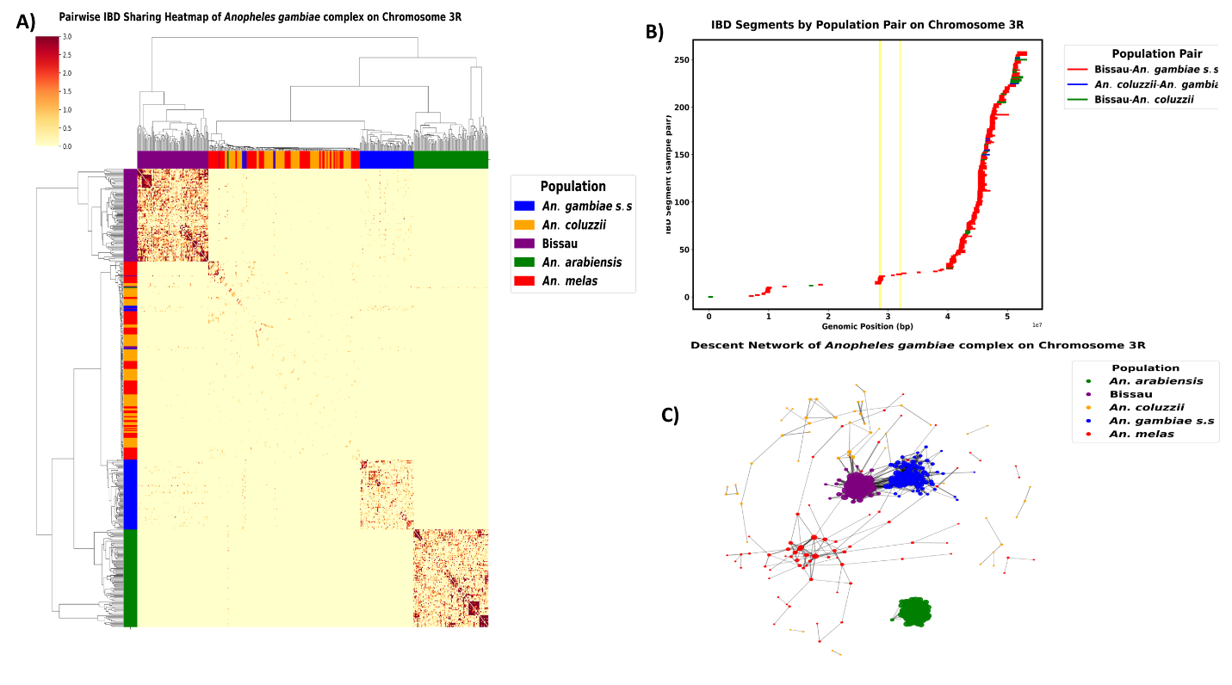
Supplementary Figure S1; A) IBD result based on chromosome arm 3R B) IBD genomic segments per pair of populations C) Network of IBD plots shared between sibling species. Individuals are colored according to their species. The strength of the IBD connection varies with the IBD length (cM) for each pair of individual

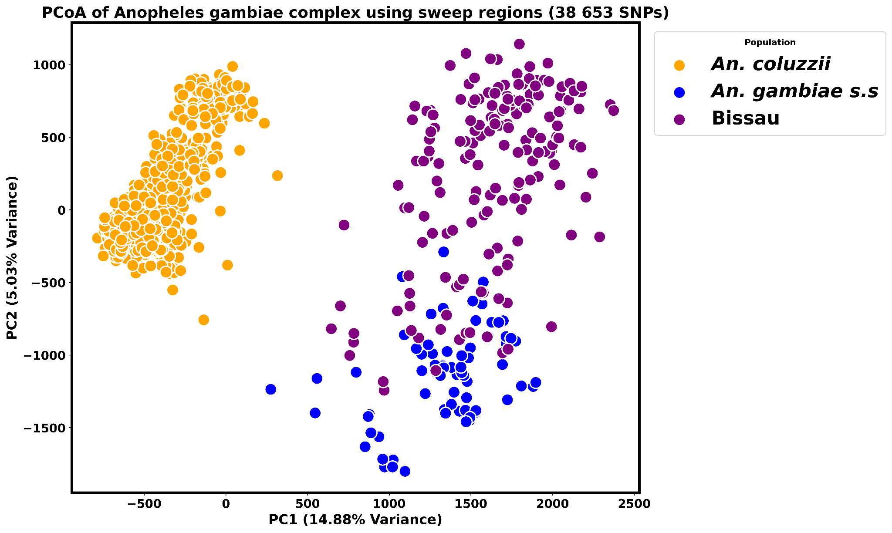
Supplementary Figure S2. PCoA highlighting distinct clustering of An. gambiae complex sibling species. The plot is based on regions under sweep selection.

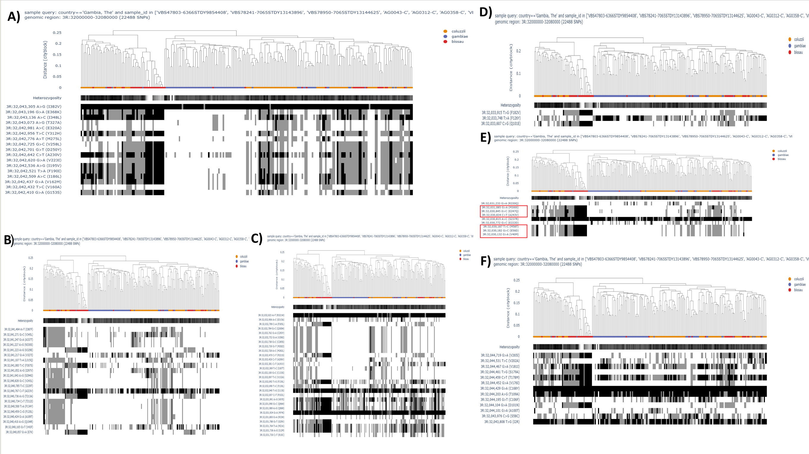
Supplementary Figure S3: Plots of diplotype clustering over OR locus for all sibling taxa A) Or13 B) Or17 C) Or30 D) Or46 E) Or53 F)Or55. Hierarchical clustering dendrogram aligned with observed heterozygosity. The leaves of the dendrogram are colored according to the species of the individual. Substitutions in each individual are presented below the dendrogram with blocks of the same color indicating shared mutation. Low sample heterozygosity is indicative of a selective sweep.
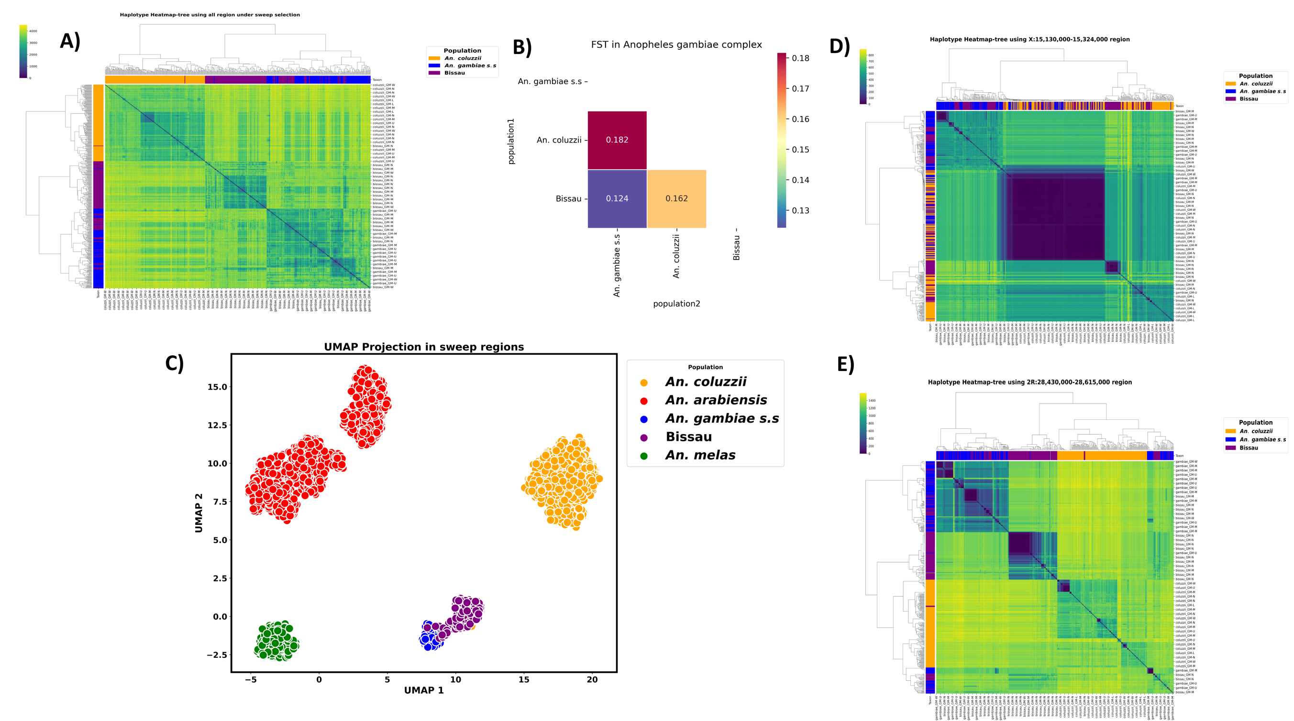
Supplementary Figure S4: Estimated haplotype sharing profile among different populations within An. gambiae s.l. A) Clustering is based on all regions under sweep selection and reveals three distinct clusters and a shared cluster between Bissau and An. gambiae s.s B) Fst analysis displaying some level of genetic differentiation between members of the An. gambiae complex C) UMAP clustering of An. gambiae s.l. taxa D) Clustering based on Chromosome X and reveals a shared cluster between Bissau and An. gambiae s.s as well as a shared cluster among the three taxa E) Haplotype sharing heatmap within An. gambiae s.l. populations computed using SNPs under selection on chromosome arm 2R. Dark blue indicates a shared or isolated haplotype
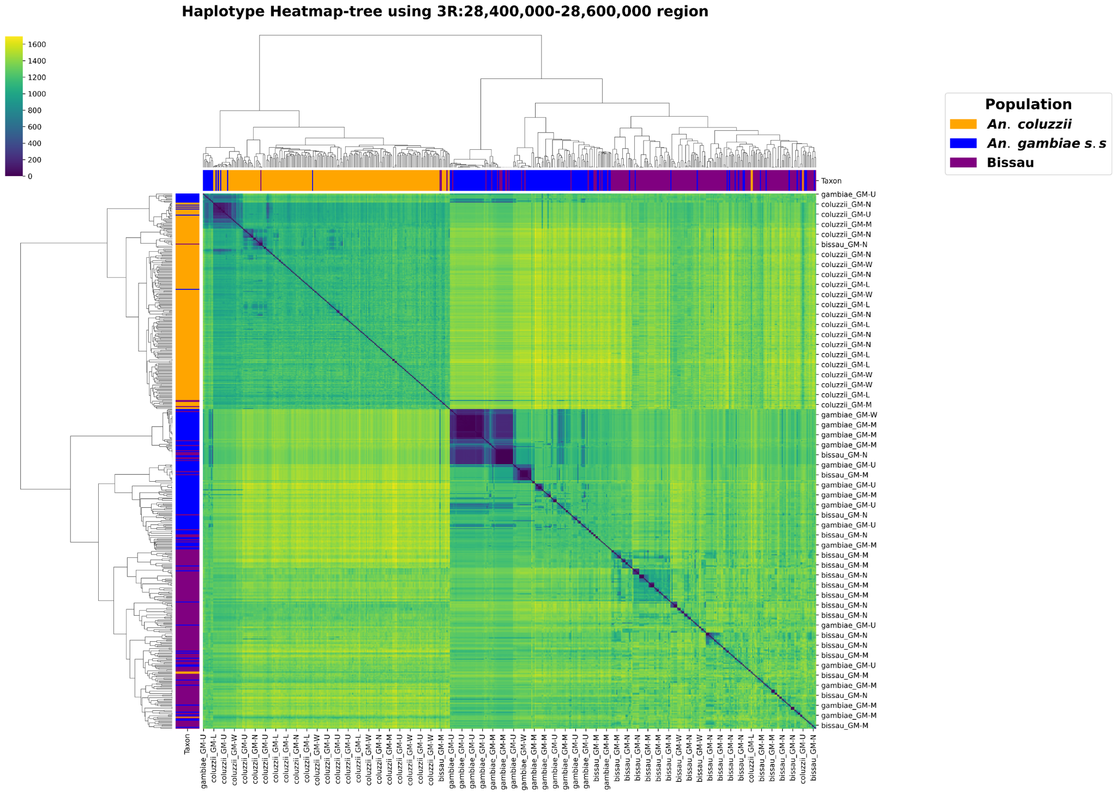
Supplementary Figure S5: Haplotype clustering within a region containing Gste genes. Individuals are ordered by sampling regions and dark blue colour indicate haplotype that are shared between populations.

Supplementary Table S1
Chromosome | Start | End | Genes | Species
2R | 20,405,270 | 20,899,650 | ChAT, AGAP002369, COEAE5O | Bissau
 | 20,650,000 | 21,100,000 | COEAE5O, CYP4K2, CYP4AR1, CYP4D15, CYP4D17, CYP4D16, CYP4D22, CLIPD1 | An. coluzzii
 | 28,073,746 | 28,739,290 | CYP6AA1, CYP6AA2, CYP6P15P, CYP6P3, CYP6P5, CYP6P4, CYP6P1, CYP6P2, CYP6AD1, AGAP00289, AGAP013143, AGAP004671, GPRNP1 | An. gambiae s.s  An. coluzzii  Bissau
 | 32,771,400 | 33,100,000 | AGAP013357 | An. gambiae s.s
 | 50,400,000 | 50,550,000 | Osi3, Osi4, Osi8, Osi6, Osi7 | An. coluzzii
 | 51,188,630 | 51,654,960 | GSTD8, GSTD9, GSTD5, Med22 | Bissau
 | 54,397,975 | 57,008,210 | CLIPC2, CLIPC3, SG5, Or26, Or27, Or56, Or57, GSTD11, GSTD6, GSTD12, GSTD4, GSTD3, GSTD10, IR41t.1, Obp19, IR41t.2 | An. gambiae s.s
2L | 2,300,000 | 2,500,000 | VGSC(para) | An. gambiae s.s  An. coluzzii
 | 9,656,579 | 11,141,057 | AGAP005143 | Bissau
 | 15,800,000 | 15,900,000 | CPR16 | Bissau
 | 25,598,310 | 26,138,770 | CYP4J5, CYP4J9, CYP4J10, CYP301A, Obp71, OBP49, OBP50, Obp51, Obp52, Obp53, OBP54, OBP55 | An. coluzzii
 | 26,926,885 | 27,352,738 | Gr56, CPLCA1, CPLCA2, CPLCA3, CPLCX3 | Bissau
 | 28,500,000 | 28,600,000 | COEAE2F, AGAP006238 | An. gambiae s.s
 | 28,659,805 | 28,937,045 | CPR135 | An. coluzzii
 | 29,938,095 | 31,939,784 | PGRPS2, PGRPS3, AGAP006349, AGAP00641, ABCB4, ABCA1, ABCA2, ABCC7,  CPR144, Obp69, SP24D | An. coluzzii
 | 39,315,967 | 39,707,855 | Gr32 | An. coluzzii
 | 42,350,000 | 42,585,000 | AGAP007086 | An. gambiae s.s
3L | 8,739,027 | 9,057,387 | CPR143, CTLMA7, CTL2, CLIPA8, HPX1 | An. gambiae s.s
 | 9,856,872 | 11,09,0511 | HPX14, HPX15,TEP4 | An. gambiae s.s
 | 10,824,745 | 11,671,070 | CLIPB14 | Bissau
 | 11,117,889 | 11,593,287 | TEP1, TEP3, TEP6, TEP10, TEP11, TEP18, CASPS9, CASPS10, CASPS12, CASPS13 | An. coluzzii
 | 19,567,840 | 20,444,990 | AGAP011231, AGAP011242, AGAP011251 | An. coluzzii
 | 35,793,900 | 35,960,350 | Or60, Or61, Or63, Or64, AGAP011984 | Bissau
3R | 28,265,255 | 29,072,407 | GSTE1, GSTE2, GSTE4, GSTE5, GSTE6, GSTE8, GSTE3, GSTE7, AGAP009188, AGAP009187, AGAP009200, AGAP009201,  SRPN6, SRPN5, SRPN16, CLIPB11, CLIPB12, CLIPB18, AGAP029511 | An. gambiae s.s
 | 28,558,557 | 28,637,079 | GSTE8, GSTE6, GSTE5, GSTE4, GSTE2, GSTE1, GSTE7, GSTE3 | An. coluzzii
 | 29,200,000 | 29,400,000 | CYP4C35, CYP4C36, CYP4C27 | Bissau
 | 37,002,768 | 53,045,890 | SRPN4, AGAP009703 | An. coluzzii
 | 31,978,295 | 32,265,060 | Or13, Or15, Or16, Or17, Or30, Or46, Or47, Or53,Or55, OBP43 | Bissau
X | 14,686,044 | 14,950,132 | GLURIIb, GLURIIa, GPXH2 | Bissau
 | 14,121,394 | 14,789,431 | GLURIIb, GLURIIa, GPXH2, AGAP000787, AGAP000797, GLURIIc, | An. gambiae s.s  An. coluzzii

