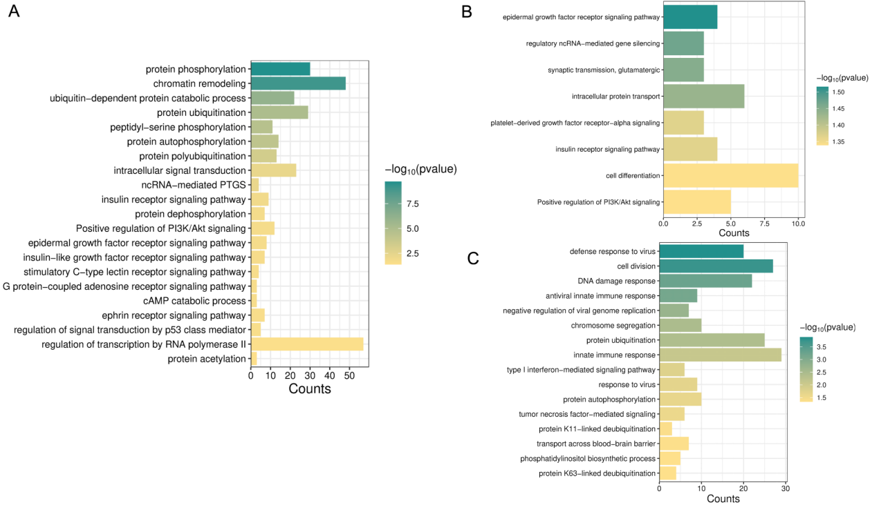

Supplementary Figure S1. Gene Ontology (GO) pathway enrichment analysis of exploratory DEG sets across comparisons.
(A) GO pathway enrichment of exploratory DEGs in IBD patients after RR-MBI compared with before intervention.
(B) GO pathway enrichment of exploratory DEGs in IBS patients after RR-MBI compared with before intervention.
(C) GO pathway enrichment of exploratory DEGs between IBD and IBS at baseline.
Notes: Bar length indicates gene counts associated with each GO term. Color scale represents statistical significance (metric indicated in each panel). Only terms with P < 0.05 are shown. Exploratory DEG sets were defined using nominal P < 0.05 and AFC ≥ 1.2.

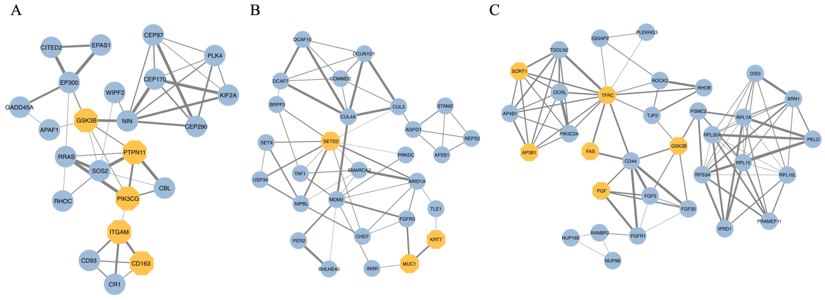

Supplementary Figure S2. MCODE-identified functional modules within PPI networks.
(A, B) Representative network clusters extracted from the IBD post- vs pre-intervention comparison.
(C) Representative cluster extracted from the baseline comparison between IBD and IBS.
Notes: Nodes represent proteins encoded by exploratory DEGs within MCODE-identified PPI modules, and edges indicate predicted protein–protein interactions. Light-blue circles indicate other exploratory DEGs within the corresponding modules. Yellow hexagons indicate genes annotated to the broad disease term “pain” in DisGeNET. Edge thickness reflects the STRING combined interaction score. Exploratory DEG sets were defined using nominal P < 0.05 and AFC ≥ 1.2.

Abbreviations: AFC, absolute fold-change magnitude; DEG, differentially expressed gene; IBD, inflammatory bowel disease; IBS, irritable bowel syndrome; MCODE, Molecular Complex Detection; PPI, protein–protein interaction; RR-MBI, relaxation response–based mind–body intervention.

