Supplementary Figure 1. HCC case-control mean methylation vs. depth. Control and HCC blood-derived DNA show consistent methylation estimates across depth.
Solid lines = mean CpG methylation by coverage; dotted lines (right y-axis) = number of CpG sites (millions) at each coverage. Generated using the Mmint methylation data analysis tool (https://github.com/lijiacd985/Mmint, v0.0.1)

Supplementary Figure 2. Cumulative fraction of CpG sites with ≥N-fold coverage. Control and HCC exhibit comparable coverage profiles. Shows percentage of CpG sites that have coverage of N (x axis value). Generated using the Mmint methylation data analysis tool (https://github.com/lijiacd985/Mmint, v0.0.1).

Supplementary Figure 3. Schematic workflow for determining HCC-derived DMRs. We performed methylation analysis in blood samples to identify DMRs that could be measured in clinically accessible blood and be representative of the liver tissue. DNA was extracted from blood and tissue, and WGBS was performed to detect methylated cytosines at CpG sites in the DNA. MOABS software was used to call methylation sites.

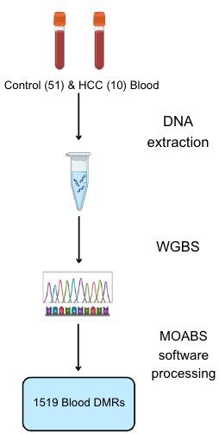

Supplementary Figure 4:A-J Analysis of log2 copy ratios across all autosomes for the ten HCC cases for which WGBS was performed. Performed using CNVkit. For each figure, Y-axis: Chromosomes 1-22, X, Y. X-axis: Copy ratio (log2).

A.
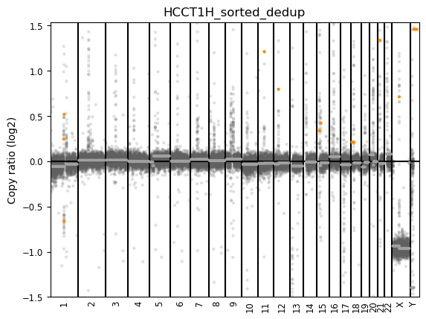
B.
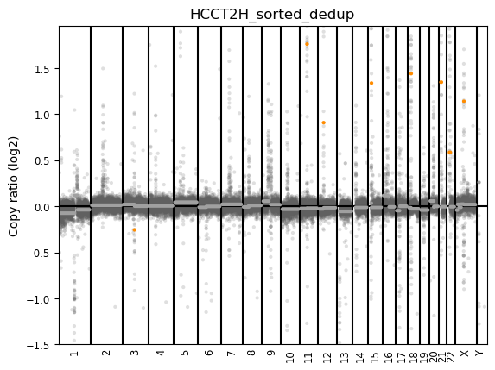
C.
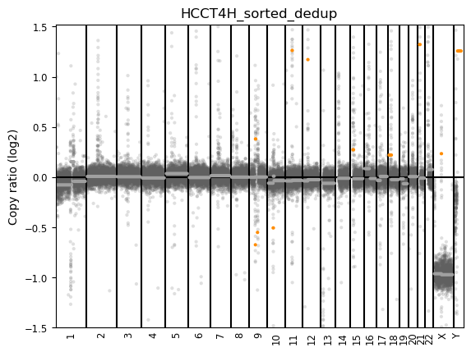
D.
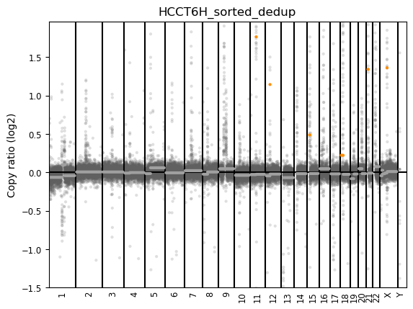
E.
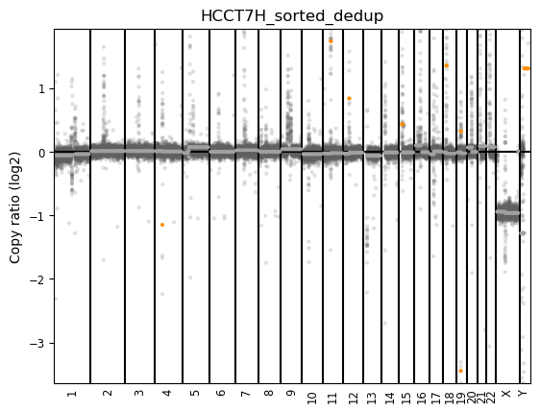
F.
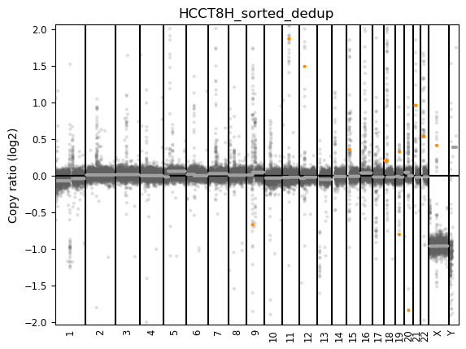
G.
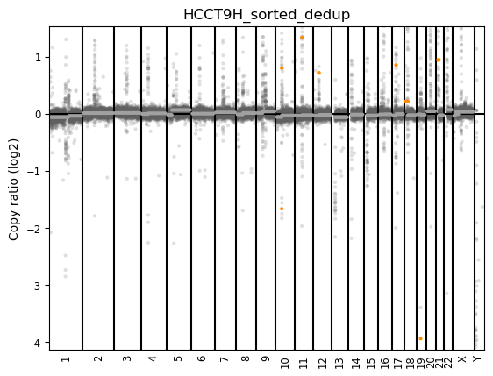
H.
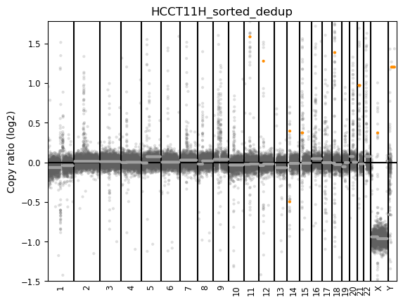
I.
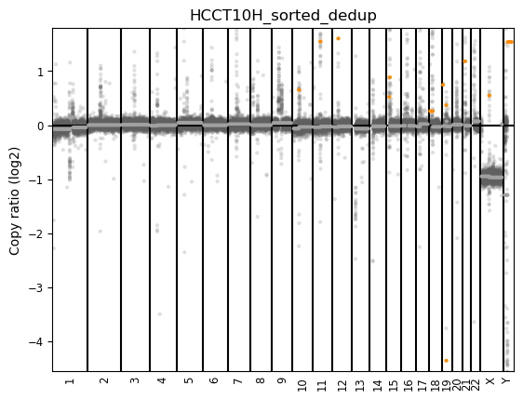

J.
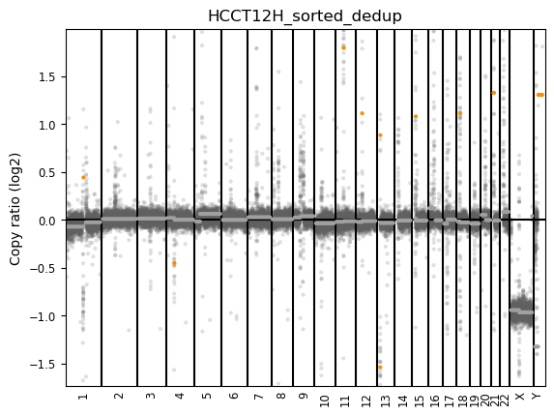

Supplementary Table 1. Data sets used in analyses.
Data set description and source of patients |  |  |  | Sample size | Sex | Self-reported Ethnicity
Lineberger and Duke | 10 primary HCC cases | 70% male, 30% female | 80% non-Hispanic White, 20% Black | Age, range of participants | Source of DNA | Methylation measurement
Lineberger and Duke  NC Cancer Registry and Duke Cancer Institute | 51 controls | 37% male, 63% female | 47% non-Hispanic White, 51% Black, 2% Asian | 67 ± 6 years | Mixed leukocytes | WGBS
 | 29 primary HCC cases | 75% male, 25% female | 76% non-Hispanic White, 24% Black | 63 ± 10 years | Mixed leukocytes | WGBS
NC Cancer Registry and Duke Cancer Institute  Published HCC targets from Pubmed/Google scholar | 36 otherwise healthy controls* | 33% male, 66% female | 61% non-Hispanic White, 27% Black, 6% Asian, 6% unreported | 68 ± 5.4 years | Mixed leukocytes | Human Imprintome Methylation array
 | N/A |  | n/a | 64 ± 7.9 years | Mixed leukocytes | Human Imprintome Methylation array
*The 36 controls are made up of 10 collected at the time of ACE cohort recruitment and 25 collected at a later study recruitment. All controls are otherwise healthy individuals recruited from primary care clinic settings at Duke.

Supplementary Table 2. Summary of BAM-level alignment and pairing statistics for control and HCC blood samples.
Group | Total reads | Properly paired | Singletons | Mapping rate | Duplicates
Control | 9.45 × 10⁹ | 97.00% | 1.23% | 100% | 0
HCC | 1.17 × 10⁹ | 95.20% | 3.96% | 100% | 0
Values obtained from samtools flagstat on merged BAM files per condition. Both control and HCC blood samples showed mapping rate ~100% with a high proportion of properly paired reads and very few singleton reads (≤4%).

Supplementary Table 3: Results of literature review of previously published pre-HCC/HCC risk differential methylation targets.

Number of regions reported | Number of regions included in this analysis | Author | PMID | DNA Source | Ethnic Distribution | Number of Participants | Measurement Technique
3 | 0 | Zeybel et al.⁶⁷ | 27152124 | liver tissue | N/A. Turkey | Discovery cohort:N= 29 HBV-infected. Validation cohort: N=102 liver disease (fibrosis) due to chronic hep B infection | Illumina HumanMethylation450 Array
207 | 2 | Gerhard et al.⁶⁸ | 30005700 | liver tissue | Non-hispanic white | N=15 patients with NAFLD fibrosis, 15 age/sex matched controls (all female) | Illumina HumanMethylation450 Array
6 | 5 | Anwar et al.⁵⁹ | 23145177 | liver tissue | N/A. Germany | N=40 HCC, 10 HCA, 5 FNH, 5 healthy liver specimens. Adjacent liver tissue from same patient for 34 HCC, 8 HCA, 2 FNH | Pyrosequencing
5 | 5 | Sohda et al.⁶⁹ | 9609998 | liver tissue | N/A. Japan | N=27 HCC, 2 CCC, 10 MLC tissue specimens | In-situ hybridization
5 | 0 | Fu et al.⁷⁰ | 37835478 | liver tissue | N/A. Netherlands | N=75 HCC, 30 cirrhosis, 34 hepatitis, 7 benign lesions | qSMP and MeD-seq
8 | 0 | Ammerpohl et al.⁴⁷ | 21500188 | liver tissue | N/A. Germany | N=12 HCC, 15 cirrhotic, 12 normal liver | Illumina HumanMethylation27 Array
13 | 0 | Panagopoulou et al.⁴² | 34769391 | liver tissue | N/A. Japan | DS 1: 30 HCC, 30 adj. liver tissue. DS 2: 19 primary HCC, 18 recurrent HCC, 18 adj. liver tissue. Correlation analysis : 241 HCC/42 adj. liver tissue data from TCGABiolinks | Illumina HumanMethylation450 Array
54 | 0 | Hernandez-Meza et al. ⁷¹ | 33237575 | liver tissue | N/A. Italy, Spain, USA | N=248 patients: 16 normal liver, 139 tumor-adj. cirrhotic, 8 dysplastic nodules, 227 HCC. Validation: 6 cirrhosis, 11 dysplastic nodules, 9 early HCC, 6 progressed HCC, plus TCGA HCC dataset: 50 normal, 256 HCC samples with DNA methylation info available | Illumina HumanMethylation450 Array
13 | 0 | Revill et al.⁴³ | 24012984 | liver tissue | N/A. Spain, Italy, USA | N= 71 HCC (training), 164 mixed etiologies (validation) | Illumina HumanMethylation27 Array; validation: pyrosequencing
12 | 3 | Gentilini et al.⁴⁹ | 28514750 | liver tissue | N/A. Italy | N=69 HCC, 69 paired adjacent noncancerous liver. Reference population: N= 47 healthy liver biopsies | Illumina HumanMethylation450 Array
7 | 0 | Tao et al.⁴⁴ | 21625442 | single hepatocytes, tissue | N/A. Japan | N= 3 HBHC/ paired adjacent tissue for single cell sequencing. Validation: 5 paired and 10 paired HBHC/adjacent tissue. 2 control tissue of patients with hepatic hemangioma. | Illumina HumanMethylation27 Array; validation: COBRA and RT-PCR
3 | 0 | Murphy et al.⁷² | 23916847 | liver tissue | Mixed race/ethnicity | Discovery cohort: N= 56 NAFLD. Replication: N=34 NAFLD. N= 25 contols
4 | 0 | Tsuda et al.⁷³ | 36348017 | liver tissue | N/A. Japan | N= 26 paired HCC patients with compatible NASH features/26 non-cancerous tissue. N= 36 control tissue with liver metastases of primary colorectal cancers. | Illumina HumanMethylation450 Array
7 | 0 | Johnson et al.⁷⁴ | 34353365 | liver tissue | Multirace (3/325 black, 321/325 white, 1 unknown) | N= 325 NAFLD (119 with severe fibrosis, 206 no fibrosis features) | Illumina MethylationEPIC Array
7 | 0 | Zhang et al.⁷⁵ | 36127700 | liver tissue | N/A. | N/A | N/A; Meta-analysis
36 | 0 | Villanueva et al.⁷⁶ | 25645722 | liver tissue | N/A. Spain, France | N= 248 HCC samples. Signature validation:  N= training 221 HCC,  validation 83 HCC. | Illumina HumanMethylation450 Array
6 | 0 | Bai et al.⁷⁷ | 34237708 | liver tissue | N/A. China | Training: N= 96 normal tissue, 402 HCC, 108 ICC. Validation: N= 252 normal, 504 HCC, 96 ICC | Illumina HumanMethylation450 Array
21 | 0 | Kuramoto et al.⁷⁸ | 36471401 | liver tissue | N/A. Japan | Initial: N= 22 NASH-HCC, 91 NASH-obese, 36 normal control. Validation: N=45 mixed etiologies. | Illumina HumanMethylation450 Array, HPLC
9 | 0 | Ahrens et al.⁷⁹ | 23931760 | liver tissue | N/A. Germany | N= 18 controls, 45 obesity (18 healthy, 12 SS, 15 NASH) | Illumina HumanMethylation450 Array
30 | 0 | de Mello et al.⁸⁰ | 28277977 | liver tissue | N/A. Finland | N= 95 obesity (34 normal, 35 SS and 26 NASH) | Illumina HumanMethylation450 Array
3 | 0 | Wegermann et al.⁸¹ | 30265706 | liver tissue | 77 non-Hispanic white, 6 non-Hispanic black | N= 86 NAFLD (47 mild and 39 advanced fibrosis) | Illumina HumanMethylation450 Array
2 | 0 | Walle et al.⁸² | 30654845 | liver tissue | N/A. Finland | N= 95 obesity | Illumina HumanMethylation450 Array
4 | 0 | Kuramoto et al.⁸³ | 28426876 | liver tissue | N/A. Japan | 55 controls,113 NASH, 22 NASH-HCC, | Illumina HumanMethylation450 Array
 |  |  |  |  |  | N= 37 viral hepatitis or cirrhosis, 37 viral-HCC | Illumina HumanMethylation450 Array
4 | 0 | Tian et al.⁸⁴ | 32685988 | liver tissue | N/A. Japan | N= 36 controls, 22 NASH-HCC, 36 viral-HCC | Illumina HumanMethylation450 Array
48 | 0 | Zheng et al.⁸⁵ | 27760737 | liver tissue | N/A. China | TCGA and GEO DNA methylation sets; N=~ 800 clinical samples | Illumina HumanMethylation450 Array
136 | 0 | Xu et al.⁸⁶ | 34124163 | liver tissue | N/A. China | N= 240 HCC cases from TCGA database, 260 HCC cases from ICGC database | Illumina HumanMethylation450 Array
2 | 0 | Holmila et al.⁸⁷ | 28333958 | cfDNA | N/A. France, Thailand | N= 94 HCC, 26 CLD, 84 control | Ion Torrent PGM
1 | 0 | Hardy et al.⁸⁸ | 27002005 | cfDNA | N/A. UK | N= 26 NAFLD, 26 matched controls, 13 cirrhotic ALD | Pyrosequencing
1 | 0 | Miller et al.⁸⁹ | 33420235 | plasma | N/A. USA | N= 20 non-cancerous HCC plasma | Illumina HumanMethylation450 Array
5 | 0 | Hlady et al.⁹⁰ | 31695765 | cfDNa, validation- tissue | N/A. USA | Tissue set 1: N=82 cirrhosis, 109 cirrhotic HCC. 2: N=45 non-tumor, 306 cirrhotic HCC. 3: N= 22 cirrhotic HCC, 22 cirrhosis. Validation cohort: N= 15 cirrhosis, 15 cirrhotic HCC | Illumina HumanMethylation450 Array
38 | 0 | Goncalves et al.⁵⁰ | 35798798 | ctDNA, liquid biopsies | N/A. Portugal | 1551 genome wide DNA methylation arrays from 13 studies; N= 859 samples; signature validation: N= 13 healthy, 11 tumour cfDNA | Illumina HumanMethylation450 Array
1 | 0 | He et al.⁹¹ | 32945374 | blood plasma | Chinese | N= 44 HC, 44 HCC, 298 control | "SensiColon test"
24 | 0 | Shen et al.⁴⁵ | 22234943 | liver tissue, validation-plasma | Taiwanese | N= 62 paired HCC/adj tissue; validation: 38 plasma DNA samples | Illumina HumanMethylation27 Array
10 | 0 | Kisiel et al.⁹² | 30168613 | liver tissue, validation-plasma | N/A. USA | N= 18 HCC, 16 cirrhosis, 35 control tissue; validation: N= 74 HCC, 16 cirrhosis, 13 control tissue. Phase 1 Plasma study: N= 21 HCC/30 cirhhotic control. Phase 2: N= 95 HCC, 51 cirrhotic control, 98 healthy control. | RRBS, qMSP, TELQAS assays
18 | 0 | Xu et al.⁹³ | 29035356 | liver tissue, validation-blood,cfDNA plasma | Chinese | N= 28 paired HCC tissue/plasma cfDNA; validation: N= 1098 HCC, 835 control. Diagnostic analysis: training N= 715 HCC, 560 control, validation N= 383 HCC, 275 control. Prognosis analysis: training N=680 HCC, validation=369 HCC. | Targeted bisulfite sequencing
2322 | 0 | Luo et al.⁹⁴ | 35027051 | liver tissue, validation- plasma | N/A. China | Marker model creation (tissue): N= 31 HCC, 15 healthy liver tissue, 17 LC tissue. Screening model training: N= 120 HCC, 92 LC, 290 healthy plasma; validation: N= 67 HCC, 111 LC, 242 healthy plasma. | Illumina HumanMethylation450 Array; validation: targeted bisulfite sequencing
10 | 0 | Slowly et al.⁴⁸ | 38010586 | peripheral blood | American Indian | N= 21 HCC, 2303 controls | Illumina HumanMethylation850 Array
25 | 0 | Lubecka, et al.⁹⁵ | 29927686 | white blood cells | Mixed race/ethnicity | N= 24 HCC, 24 controls; validation: 21 pre-diagnostic HCC, 21 controls. Second verification: 13 cirrhosis, 23 controls. | Illumina HumanMethylation450 Array
106 | 1 | Moylan et al.⁹⁶ | 35188871 | peripheral blood | Mixed race/ethnicity | N= 90 mother-child dyads | Illumina MethylationEPIC array
22 | 0 | Zhang et al.⁹⁷ | 29375724 | peripheral blood mononuclear cells and T cells | N/A. China | Discovery: N= 10 control, 10 HepB, 10 HepC, 39 HCC. Validation: N=10 control, 10 HepB, 10 HepC, 50 HCC. | Illumina HumanMethylation450 Array; validation: pyroseqencing
1 | 0 | Nano et al.⁹⁸ | 28624579 | peripheral blood | N/A. Netherlands | N= 731 discovery cohort, N= 719 replication cohort. | Illumina HumanMethylation450 Array
2 | 0 | Zhang et al.⁹⁹ | 29568887 | peripheral blood | Chinese Han | N= 30 controls, 35 NAFLD | Illumina HumanMethylation450 Array, pyrosequencing
6 | 0 | Wu et al.¹⁰⁰ | 30270343 | peripheral blood | Chinese Han | N= 32 controls, 35 NAFLD | Illumina HumanMethylation450 Array, pyrosequencing
22 | 0 | Ma et al.¹⁰¹ | 30936141 | peripheral blood | Mixed race/ethnicity | N= 3400 EA, 401 HA, 724 AA | Illumina HumanMethylation450 Array
Sources were identified on PubMed for examining DNA methylation data differential in HCC or pre-HCC cases vs controls or adjacent tissue. Sources were filtered out if specific coordinates were not available, and all coordinates were lifted to the Gr38 genome build before further analysis. The majority of studies lack racial/ethnic data of participants; if no ethnic distribution reported, we report the country the study took place in. The majority of studies were performed with tissue retrieved by liver biopsy of HCC or HCC-related condition patients. Several performed a discovery study in liver tissue and validated with cfDNA samples. Only 9 studies performed their analysis in blood.

Supplementary Table 4. Specialized R packages used in the Imprintome Array panel validation analysis code.
Package | Version | Reference
BiocParallel | 1.36.0 | Morgan et al.⁶⁵
sesame | 1.20.0 | Zhou et al.¹⁰⁵
sesameData | 1.20.0 | Zhou et al.¹⁰⁵
Bioconductor | 3.19 | Gentleman et al.¹⁰⁶
cowplot | 1.1.3 | Cowplot: Streamlined Plot Theme and Plot Annotations for “Ggplot2”¹⁰⁷
doSNOW | 1.0.20 | Daniel et al.¹⁰⁸
magrittr | 2.0.3 | Wickham et al.¹⁰⁹
snow | 0.4-4 | Snow: Simple Network of Workstations¹¹⁰
zoo | 1.8-12 | Zeileis et al.¹¹¹
purrr | 1.02 | Wickham et al.¹¹²
reshape2 | 1.4.4 | Wickham et al.¹¹³

Note: basic packages are omitted (such as tidyverse).

Supplementary Table 5. Summary of Functional Enrichment of 1,519 Blood-Derived HCC Case/Control DMRs.

Functional Feature | Total Overlaps (N) | Percentage of Total DMRs (%)
H3K4Me3 (Liver Tissue) | 268 | 17.6%
H3K4Me3 (Blood/GM12878) | 241 | 15.9%
H3K27Ac (Liver Tissue) | 220 | 14.5%
H3K27Ac (Blood/GM12878) | 198 | 13.0%
Cpg Islands | 403 | 26.5%

Direct overlaps of DMR regions with ENCODE publicly available CHiP-seq experiment regions for H3K4Me3 and K3K27Ac in liver tissue and a blood reference cell line (GM12878) are reported (ENCFF416SIL, ENCFF998CEU, ENCFF951PEM, ENCFF805YRQ bed narrowPeak files). Additionally, direct overlaps with CpG islands in mammals (https://genome.ucsc.edu/cgi-bin/hgTrackUi?hgsid=3564790247_NWaSAOctGsVQ4vD5dafUzrKX1tk4&db=hg38&c=chr7&g=cpgIslandSuper) are reported. 'n_' columns represent the total number of overlaps of a given enrichment for that region, while the other column is binary 0/1 representing whether or not there is an overlap(s). Overlap analysis was performed in R.

Supplementary Table 6. Qiagen IPA Canonical Pathways results for the 1,519 HCC-associated blood-derived DMRs.
Ingenuity Canonical Pathways | -log(p-value) | Ratio | Molecules
Protein Kinase A Signaling | 4.83 | 0.0783 | ADCY8,AKAP10,ANAPC7,ATF1,CREB5,DUSP22,DUSP9,ELK1,FLNA,GNB1,MAPK3,MTMR7,MYL5,NFATC1,NFATC3,NTN1,PALM2AKAP2,PDE12,PDE4A,PDE4B,PLCB2,PRKAG2,PRKAR1A,PTPN1,PTPN2,PTPN23,PTPRE,PTPRQ,PTPRT,RELA,TCF3
Hepatic Fibrosis Signaling Pathway | 4.04 | 0.0721 | ACVR2A,ARAF,CACNA1A,CACNA1F,CACNG8,CREB5,CSNK1G2,CSNK1G3,DVL3,ELK1,ERAS,FLT4,IKBKG,IL1RAPL1,IL1RAPL2,IRAK1,LEP,MAPK3,MTOR,MYL5,PIK3CD,PIK3R3,PRKAG2,PRKAR1A,RELA,RHOH,SMAD2,TCF3,TF,WNT5B
3-phosphoinositide Biosynthesis | 3.86 | 0.0884 | ALPL,DUSP9,INPP5F,MTMR7,MTMR8,NUDT11,OCRL,PI4K2A,PIK3CD,PIK3R3,PPM1J,PRUNE1,PTPN1,PTPN2,PTPN23,PTPRE,PTPRQ,SSH2,TPTE
mRNA 3 Prime End Processing Signaling Pathway | 3.77 | 0.118 | BARD1,CNOT2,CPSF3,CSTF2,EXOSC1,EXOSC10,HNRNPF,MAPK3,PCF11,RBM3,SRRM1,WNK1
Superpathway of Inositol Phosphate Compounds | 3.66 | 0.083 | ALPL,DUSP9,INPP5F,MTMR7,MTMR8,NUDT11,OCRL,PI4K2A,PIK3CD,PIK3R3,PLCB2,PPM1J,PRUNE1,PTPN1,PTPN2,PTPN23,PTPRE,PTPRQ,SSH2,TPTE
Autism Signaling Pathway | 3.43 | 0.0744 | ALDH9A1,CACNA1A,CACNA1F,CACNG8,DVL3,ERAS,FMR1,GRM2,GRM7,HPRT1,IGF1R,IGF2,IGF2R,LEP,MAPK3,MTOR,PIK3CD,PIK3R3,PRKAG2,PRKAR1A,RPTOR,TCF3,WNT5B
Endocannabinoid Developing Neuron Pathway | 3.39 | 0.102 | ADCY8,ARAF,CNR2,CREB5,ERAS,GNB1,MAPK3,MTOR,PIK3CD,PIK3R3,PRKAG2,PRKAR1A,RPTOR
3-phosphoinositide Degradation | 3.32 | 0.085 | ALPL,DUSP9,INPP5F,MTM1,MTMR7,MTMR8,NUDT11,OCRL,PPM1J,PRUNE1,PTPN1,PTPN2,PTPN23,PTPRE,PTPRQ,SSH2,TPTE
Synaptogenesis Signaling Pathway | 3.29 | 0.0728 | ADCY8,CDH12,CDH18,CDH22,CREB5,EFNA1,EFNA5,EFNB1,ERAS,GRM2,GRM7,MAPK3,MTOR,NRXN2,PIK3CD,PIK3R3,PRKAG2,PRKAR1A,SHC2,SNCG,SYN1,THBS3,WAS
Role of Osteoclasts in Rheumatoid Arthritis Signaling Pathway | 3.27 | 0.0726 | ADAM22,ARAF,COL19A1,COL4A1,COL9A3,CREB5,CTNNA3,ELK1,ERAS,IKBKG,IL1RAPL1,IL1RAPL2,MAPK3,MMP26,NFATC1,PIK3CD,PIK3R3,PTH,PTPN1,RELA,RHOH,SHC2,XIAP
D-myo-inositol-5-phosphate Metabolism | 3.22 | 0.0833 | ALPL,DUSP9,INPP5F,MTMR7,MTMR8,NUDT11,OCRL,PLCB2,PPM1J,PRUNE1,PTPN1,PTPN2,PTPN23,PTPRE,PTPRQ,SSH2,TPTE
D-myo-inositol (1,4,5,6)-Tetrakisphosphate Biosynthesis | 3.14 | 0.0847 | ALPL,DUSP9,INPP5F,MTMR7,MTMR8,NUDT11,OCRL,PPM1J,PRUNE1,PTPN1,PTPN2,PTPN23,PTPRE,PTPRQ,SSH2,TPTE
D-myo-inositol (3,4,5,6)-tetrakisphosphate Biosynthesis | 3.14 | 0.0847 | ALPL,DUSP9,INPP5F,MTMR7,MTMR8,NUDT11,OCRL,PPM1J,PRUNE1,PTPN1,PTPN2,PTPN23,PTPRE,PTPRQ,SSH2,TPTE
Oxytocin Signaling Pathway | 3.12 | 0.0737 | ATP2B3,CACNA1A,CACNA1F,CACNG8,CREB5,ERAS,GAST,GNB1,LEP,MAPK3,MYH3,MYL5,NFATC1,NFE2L2,PIK3CD,PIK3R3,PLCB2,PRKAG2,PRKAR1A,RELA,SHC2
Cardiac Hypertrophy Signaling (Enhanced) | 3.11 | 0.0615 | ACVR2A,ADCY8,CACNA1A,CACNA1F,CACNG8,DVL3,ELK1,ERAS,FGF12,FGF13,GNB1,HDAC6,IFNLR1,IGF1R,IKBKG,INPP5F,LEP,MAP3K15,MAP3K6,MAPK3,MTOR,NFATC1,NFATC3,PDE12,PDE4A,PDE4B,PIK3CD,PIK3R3,PLCB2,PRKAG2,PRKAR1A,RELA,WNT5B
NGF Signaling | 3.08 | 0.0992 | CREB5,ELK1,ERAS,IKBKG,MAP3K15,MAP3K6,MAPK3,PIK3CD,PIK3R3,RELA,RPS6KA6,SHC2
Myelination Signaling Pathway | 3.07 | 0.0701 | ACVR2A,ADAM22,ARAF,CNTN6,CREB5,DTX1,ERAS,HDAC6,IGF1R,IGF2R,LAMA2,MAPK3,MBP,MTOR,NFATC1,NFATC3,PIK3CD,PIK3R3,PRKAG2,PRKAR1A,RPTOR,SMAD2,WNT5B
GNRH Signaling | 3.04 | 0.0829 | ADCY8,CACNA1A,CACNA1F,CACNA1I,CACNG8,CREB5,ELK1,ERAS,GNB1,MAP3K15,MAP3K6,MAPK3,PLCB2,PRKAG2,PRKAR1A,RELA
Netrin Signaling | 3.03 | 0.0857 | CACNA1A,CACNA1F,CACNA1I,CACNG8,DOCK1,MAPK3,MTOR,NFATC1,NFATC3,NTN1,PGK1,PIK3CD,PIK3R3,PRKAG2,PRKAR1A
MSP-RON Signaling in Cancer Cells Pathway | 2.94 | 0.0909 | ARAF,CREB5,ELF4,ERAS,FLNA,KLK10,MAPK3,MTOR,PIK3CD,PIK3R3,RELA,SMAD2,TCF3
RANK Signaling in Osteoclasts | 2.93 | 0.108 | ELK1,IKBKG,MAP3K15,MAP3K6,MAPK3,NFATC1,PIK3CD,PIK3R3,RELA,XIAP
Bone Mineralization Signaling Pathway | 2.91 | 0.0903 | ALPL,ATP2B3,FGF12,FGF13,IGF1R,IGF2,IGF2R,PLCB2,PRL,PTH,SLC20A2,TCF3,WNT5B
Glioma Signaling | 2.87 | 0.0938 | CCND3,ERAS,HDAC6,IDH3G,IGF1R,IGF2,IGF2R,MAPK3,MTOR,PIK3CD,PIK3R3,SUV39H1
Transcriptional Regulatory Network in Embryonic Stem Cells | 2.85 | 0.0854 | ACVR2A,ERAS,ESX1,IGF1R,IGF2,IGF2R,ISL1,MAPK3,PIK3CD,PIK3R3,SMAD2,TCF3,WNT5B,ZFHX3
Insulin Receptor Signaling | 2.84 | 0.093 | ERAS,GRB10,INPP5F,MAPK3,MTOR,OCRL,PIK3CD,PIK3R3,PRKAG2,PRKAR1A,PTPN1,RPTOR

For space reasons, we present the top 25 pathways. For full results, please contact the author. © 2000-2025 QIAGEN. All rights reserved.

Supplementary Table 7. Previously published pre-HCC/HCC risk differential methylation targets intersecting 97 HCC-associated putative ICRs.

Number of DMRs | DMRs included in analysis | Overlapping Imprintome ICR ID | Nearest/Overlapping Gene(s) | PMID | DNA Source
207 | 2 | ICR_992, ICR_1192 | TCRBV20S1, BLCAP/NNAT | 30005700 | liver tissue
6 | 5 | ICR_871 (2), ICR_873 (3). | IG-DMR(1), IG-DMR(2), MEG3-DMR(1), MEG3-DMR (2), MEG3-DMR(3) | 23145177 | liver tissue
5 | 5 | ICR_409, ICR_410, ICR_716, ICR_717, ICR_718 | DLK1, IGF2, H19 | 9609998 | liver tissue
12 | 3 | ICR_437, ICR_496, ICR_497, ICR_631, ICR_632 | ADARB2, PTPRN2, SDK1 | 28514750 | liver tissue
106 | 1 | ICR_721 | KCNQ1 | 35188871 | peripheral blood

Sources were identified on PubMed for examining differential DNA methylation data in HCC or pre-HCC cases vs controls or adjacent tissue. Sources were filtered out if specific coordinates were not available, and all coordinates were lifted to the hg38 genome build before further analysis. 'Number of DMRs' are the total number of DMRs identified in the study, and 'DMRs included in analysis' displays the number of regions that overlapped with a putative ICR from Jima et al.⁶³ and/or Akbari et al.⁶⁷

Supplementary Table 8: List of Known ICRs.
Chromosome | Start | End | Gene name | Expressed allele
chr1 | 3652516 | 3736201 | TP73 | Maternal
chr1 | 7784320 | 7845177 | PER3 | Paternal
chr1 | 7810242 | 7827342 | RP3-467L1.4 | Paternal
chr1 | 7843083 | 7853512 | UTS2 | NA
chr1 | 39491636 | 39529869 | BMP8A | Paternal
chr1 | 39522280 | 39525685 | PPIEL | Paternal
chr1 | 39522280 | 39546187 | RP11-69E11.4 | Paternal
chr1 | 39560709 | 39576790 | PABPC4 | Paternal
chr1 | 44731055 | 44731170 | RNU5D-1 | Paternal
chr1 | 68045886 | 68051631 | DIRAS3 | Paternal
chr1 | 156212993 | 156240042 | PMF1 | Isoform dependent
chr2 | 112784453 | 112784903 | IL1A | NA
chr2 | 80288351 | 80304752 | LRRTM1 | Paternal
chr2 | 113211421 | 113276581 | PAX8-AS1 | Maternal
chr2 | 113215997 | 113278921 | PAX8 | Maternal
chr2 | 206175316 | 206218047 | GPR1 | Paternal
chr2 | 206203543 | 206265326 | GPR1-AS | Paternal
chr2 | 206274663 | 206314427 | ZDBF2 | Paternal
chr2 | 206443532 | 206621127 | ADAM23 | Paternal
chr2 | 228850526 | 229271287 | PID1 | Maternal
chr3 | 6692319 | 6693088 | AC069277.2 | Paternal
chr3 | 27110085 | 27369460 | NEK10 | Maternal
chr3 | 41194741 | 41260096 | CTNNB1 | Isoform dependent
chr3 | 46712115 | 46812574 | AC109583.1 | NA
chr3 | 49412206 | 49416475 | TCTA | Paternal
chr3 | 101779202 | 101828231 | NXPE3 | Paternal
chr3 | 156673235 | 156706770 | TIPARP | Paternal
chr3 | 185190624 | 185281990 | EHHADH | Paternal
chr4 | 53286 | 88208 | ZNF595 | Maternal
chr4 | 56530606 | 56603507 | THEGL | NA
chr4 | 69480165 | 69495861 | UGT2B4 | NA
chr4 | 88523810 | 88708450 | HERC3 | Isoform dependent
chr4 | 88695913 | 88697829 | NAP1L5 | Paternal
chr4 | 118591773 | 118633729 | RP11-384K6.6 | Paternal
chr4 | 189940870 | 189963202 | FRG1 | NA
chr5 | 80626226 | 80654983 | DHFR | Isoform dependent
chr5 | 95713522 | 95824383 | RHOBTB3 | Paternal
chr5 | 96875986 | 96919703 | ERAP2 | Paternal
chr5 | 103548855 | 103562790 | NUDT12 | Paternal
chr5 | 136080470 | 136080597 | VTRNA2-1 | Paternal
chr6 | 3268962 | 3457050 | SLC22A23 | Maternal
chr6 | 3722614 | 3751713 | PXDC1 | Paternal
chr6 | 3849341 | 3851320 | FAM50B | Paternal
chr6 | 11712054 | 11807046 | ADTRP | Maternal
chr6 | 57946074 | 57961501 | LINC00680 | Paternal
chr6 | 104936616 | 105083332 | LIN28B | Paternal
chr6 | 106360717 | 106572017 | CRYBG1 | Paternal
chr6 | 143536845 | 143831185 | PHACTR2 | Maternal
chr6 | 143940300 | 144064599 | PLAGL1 | Paternal
chr6 | 144004916 | 144008262 | HYMAI | Paternal
chr6 | 159969082 | 160113507 | IGF2R | Maternal
chr6 | 160171061 | 160277638 | SLC22A2 | Maternal
chr6 | 160348378 | 160452577 | SLC22A3 | Maternal
chr6 | 167996241 | 168029524 | KIF25 | NA
chr6 | 169457212 | 169702067 | WDR27 | Isoform dependent
chr7 | 726699 | 786475 | DNAAF5 | Paternal
chr7 | 5103719 | 5120245 | OR10AH1P | Paternal
chr7 | 5121239 | 5144546 | ZNF890P | Paternal
chr7 | 23310209 | 23470491 | IGF2BP3 | Paternal
chr7 | 23490473 | 23491364 | RPS2P32 | Paternal
chr7 | 38341577 | 38378804 | TRG-AS1 | Paternal
chr7 | 43112629 | 43566001 | HECW1 | Paternal
chr7 | 44044640 | 44069456 | DBNL | Paternal
chr7 | 50458436 | 50565405 | DDC | Isoform dependent
chr7 | 50590063 | 50793462 | GRB10 | Isoform dependent/Maternal
chr7 | 78017055 | 79453667 | MAGI2 | Maternal
chr7 | 93424486 | 93574730 | CALCR | Maternal
chr7 | 93885396 | 93890753 | TFPI2 | Maternal
chr7 | 94524204 | 94656572 | SGCE | Paternal
chr7 | 94656325 | 94669695 | PEG10 | Paternal
chr7 | 94907202 | 95296415 | PPP1R9A | Maternal
chr7 | 97020396 | 97024950 | DLX5 | Maternal
chr7 | 106654360 | 106661158 | CCDC71L | Paternal
chr7 | 130293134 | 130324180 | CPA4 | Maternal
chr7 | 130344816 | 130368730 | CPA5 | Maternal
chr7 | 130393771 | 130442433 | CEP41 | Maternal
chr7 | 130486042 | 130491033 | MESTIT1 | Paternal
chr7 | 130486171 | 130506465 | MEST | Paternal
chr7 | 130543453 | 130546810 | COPG2IT1 | Paternal
chr7 | 130730697 | 130734207 | KLF14 | Maternal
chr8 | 737628 | 1708476 | DLGAP2 | Paternal
chr8 | 2045046 | 2165552 | MYOM2 | Paternal
chr8 | 2666079 | 2728451 | RP11-134O21.1 | Paternal
chr8 | 2727318 | 2822482 | GS1-57L11.1 | Paternal
chr8 | 27869883 | 27992673 | SCARA5 | Paternal
chr8 | 37736601 | 37758422 | ERLIN2 | Paternal
chr8 | 102528740 | 102538668 | KB-1980E6.3 | Paternal
chr8 | 134477788 | 134713049 | ZFAT | Paternal
chr8 | 134598071 | 134600689 | ZFAT-AS1 | Paternal
chr8 | 139600838 | 139704109 | KCNK9 | Maternal
chr8 | 139727725 | 140458579 | TRAPPC9 | Isoform dependent
chr8 | 140094894 | 140100543 | PEG13 | Paternal
chr8 | 143574785 | 143578649 | NAPRT | Isoform dependent
chr9 | 3824127 | 4348392 | GLIS3 | Paternal
chr9 | 95099054 | 95426796 | FANCC | Maternal
chr9 | 112878920 | 112890876 | SLC46A2 | Paternal
chr10 | 27397121 | 27414368 | PTCHD3 | Paternal
chr10 | 119726042 | 119829147 | INPP5F | Paternal
chr10 | 133553901 | 133565583 | SYCE1 | NA
chr11 | 1995176 | 2001470 | H19 | Maternal
chr11 | 1996759 | 1996831 | MIR675 | NA
chr11 | 2108907 | 2109133 | TMED1 | Isoform dependent/Paternal
chr11 | 2129112 | 2141238 | IGF2 | Paternal
chr11 | 2140501 | 2148666 | IGF2-AS | Paternal
chr11 | 2159779 | 2161221 | INS | Paternal
chr11 | 2444684 | 2849105 | KCNQ1 | Maternal
chr11 | 2608328 | 2699994 | KCNQ1OT1 | Paternal
chr11 | 2699959 | 2700208 | KCNQ1|KCNQ1OT1 | Maternal
chr11 | 2870033 | 2872105 | KCNQ1DN | Maternal
chr11 | 2883213 | 2885775 | CDKN1C | Maternal
chr11 | 2899721 | 2925246 | SLC22A18 | Maternal
chr11 | 2928273 | 2929420 | PHLDA2 | Maternal
chr11 | 3087107 | 3166739 | OSBPL5 | Maternal
chr11 | 10308313 | 10507579 | AMPD3 | Isoform dependent
chr11 | 32387775 | 32435564 | WT1 | Paternal
chr11 | 32435518 | 32458769 | WT1-AS | Paternal
chr11 | 70078302 | 70189528 | ANO1 | Maternal
chr11 | 77878720 | 77994671 | INTS4 | Isoform dependent
chr11 | 110093392 | 110171841 | ZC3H12C | Paternal
chr11 | 131370478 | 132336822 | NTM | Maternal
chr12 | 106524 | 111850 | RP11-598F7.3 | Maternal
chr12 | 190077 | 214570 | SLC6A12 | Maternal
chr12 | 7115736 | 7128889 | RBP5 | Maternal
chr12 | 22063773 | 22437041 | ST8SIA1 | Paternal
chr12 | 31111652 | 31201235 | AC024940.1 | Paternal
chr12 | 65050626 | 65121305 | WIF1 | Maternal
chr12 | 120978543 | 121002512 | HNF1A | NA
chr13 | 27945260 | 27945415 | ATP5F1EP2 | Maternal
chr13 | 48303744 | 48599436 | RB1 | Maternal
chr13 | 48316863 | 48320475 | PPP1R26P1 | Maternal
chr13 | 48340797 | 48341330 | RP11-305D15.8 | Paternal
chr13 | 48389567 | 48444667 | LPAR6 | Isoform dependent/Paternal
chr13 | 48488963 | 48533256 | RCBTB2 | Maternal
chr13 | 48653711 | 48711226 | CYSLTR2 | Maternal
chr13 | 60274776 | 60276006 | TARDBPP2 | Paternal
chr14 | 64084232 | 64338112 | ESR2 | NA
chr14 | 69854131 | 70032366 | SMOC1 | Maternal
chr14 | 76959638 | 76965802 | LINC01629 | NA
chr14 | 92936914 | 93116320 | ITPK1 | Maternal
chr14 | 100725705 | 100738224 | DLK1 | Paternal
chr14 | 100779410 | 100861031 | MEG3 | Maternal
chr14 | 100836269 | 100947194 | AL117190.1 | NA
chr14 | 100874493 | 100874585 | MIR337 | Maternal
chr14 | 100879753 | 100903722 | RTL1 | Paternal
chr14 | 100894770 | 101038859 | MEG8 | Maternal
chr14 | 100924824 | 100924892 | SNORD113-1 | Maternal
chr14 | 100949833 | 100949904 | SNORD114-1 | Maternal
chr14 | 101054687 | 101054759 | MIR134 | Maternal
chr14 | 101068283 | 101072931 | MEG9 | Maternal
chr14 | 101552221 | 101560431 | DIO3OS | Maternal
chr14 | 101561351 | 101563452 | DIO3 | Paternal
chr15 | 23565674 | 23630075 | MKRN3 | Paternal
chr15 | 23643549 | 23647867 | MAGEL2 | Paternal
chr15 | 23685400 | 23687305 | NDN | Paternal
chr15 | 24101827 | 24445011 | PWRN1 | NA
chr15 | 24675775 | 24683393 | NPAP1 | Paternal
chr15 | 24823278 | 24978723 | SNRPN | Paternal
chr15 | 24954986 | 24977850 | SNURF | Paternal
chr15 | 24955034 | 25000276 | AC124312.1 | NA
chr15 | 24978583 | 24991753 | SNHG14 | Paternal
chr15 | 24981994 | 24982068 | SNORD107 | Paternal
chr15 | 24984864 | 24985173 | RP11-701H24.5 | Paternal
chr15 | 24985053 | 24988232 | PWAR5 | Paternal
chr15 | 24985100 | 24985166 | SNORD64 | Paternal
chr15 | 24986925 | 24986995 | SNORD108 | Paternal
chr15 | 25027736 | 25032047 | RP11-701H24.3 | Paternal
chr15 | 25031873 | 25036490 | PWAR6 | Paternal
chr15 | 25041918 | 25042428 | RP11-701H24.8 | Paternal
chr15 | 25041974 | 25042040 | SNORD109A | Paternal
chr15 | 25051476 | 25106603 | SNORD116@ | Paternal
chr15 | 25059538 | 25059633 | SNORD116-4 | Paternal
chr15 | 25062333 | 25062427 | SNORD116-5 | Paternal
chr15 | 25085385 | 25085476 | SNORD116-18 | Paternal
chr15 | 25087661 | 25088896 | RP11-701H24.4 | Paternal
chr15 | 25116545 | 25122476 | IPW | Paternal
chr15 | 25135642 | 25138055 | PWAR1 | Paternal
chr15 | 25170723 | 25269858 | SNORD115@ | Paternal
chr15 | 25278343 | 25278409 | SNORD109B | Paternal
chr15 | 25333728 | 25439051 | UBE3A | Maternal
chr15 | 25677271 | 25865184 | ATP10A | Maternal
chr15 | 25708470 | 25710869 | RP11-345J18.2 | Paternal
chr15 | 78959906 | 79090780 | RASGRF1 | Paternal
chr15 | 98646951 | 98647371 | IRAIN | Paternal
chr15 | 98648539 | 98964530 | IGF1R | Paternal
chr16 | 788046 | 800737 | CHTF18 | Paternal
chr16 | 805444 | 813862 | PRR25 | Paternal
chr16 | 2817180 | 2826304 | PRSS21 | Maternal
chr16 | 3367719 | 3369246 | MTCO1P28 | Maternal
chr16 | 3369957 | 3370906 | MTND1P8 | Maternal
chr16 | 3370979 | 3372668 | MTRNR2L4 | Maternal
chr16 | 3432414 | 3443504 | ZNF597 | Maternal
chr16 | 3443649 | 3486953 | NAA60 | Maternal
chr16 | 66566393 | 66579137 | CMTM1 | Paternal
chr16 | 68530090 | 68576072 | ZFP90 | Paternal
chr17 | 3278776 | 3386340 | RP11-64J4.2 | Maternal
chr17 | 4897771 | 4934438 | CHRNE | Paternal
chr17 | 4899418 | 4902934 | C17orf107 | Paternal
chr17 | 7661779 | 7687538 | TP53 | NA
chr17 | 32492522 | 32877177 | MYO1D | Isoform dependent
chr17 | 41688885 | 41692668 | EIF1 | Paternal
chr17 | 57989039 | 57994850 | RP11-159D12.2 | Maternal
chr18 | 35366694 | 35377337 | ZNF396 | Paternal
chr18 | 47028202 | 47030078 | ELOA3 | Maternal
chr18 | 80109262 | 80147523 | ADNP2 | Isoform dependent
chr18 | 80147924 | 80179839 | PARD6G-AS1 | Isoform dependent
chr18 | 80157232 | 80247514 | PARD6G | Maternal
chr19 | 1505022 | 1513604 | ADAMTSL5 | Maternal
chr19 | 2511219 | 2702694 | GNG7 | Isoform dependent
chr19 | 10133342 | 10231286 | DNMT1 | Paternal
chr19 | 17309518 | 17323298 | DDA1 | Maternal
chr19 | 21082159 | 21125270 | ZNF714 | Paternal
chr19 | 21123817 | 21124188 | VN1R81P | Paternal
chr19 | 21142024 | 21196053 | ZNF431 | Paternal
chr19 | 21483374 | 21503238 | LINC00664 | Paternal
chr19 | 36259540 | 36331770 | LINC00665 | Maternal
chr19 | 51927147 | 51948759 | ZNF613 | Paternal
chr19 | 53159213 | 53193386 | ZNF665 | Paternal
chr19 | 53235381 | 53254898 | ZNF677 | Paternal
chr19 | 53431984 | 53461862 | ZNF761 | Paternal
chr19 | 53467733 | 53496255 | ZNF813 | Paternal
chr19 | 53519527 | 53532808 | ZNF331 | Isoform dependent/Paternal
chr19 | 53666679 | 53762429 | C19MC | Paternal
chr19 | 53787675 | 53787741 | MIR371A | Paternal
chr19 | 54953130 | 55001142 | NLRP2 | Maternal
chr19 | 56368099 | 56379828 | ZNF542P | Paternal
chr19 | 56477250 | 56504362 | ZNF667-AS1 | Paternal
chr19 | 56661980 | 56671783 | ZNF835 | Paternal
chr19 | 56774547 | 56840729 | ZIM2 | Paternal
chr19 | 56810077 | 56840728 | PEG3 | Paternal
chr19 | 56810109 | 56816102 | PEG3-AS1 | Paternal
chr19 | 56839372 | 56839658 | ZIM2|PEG3|MIMT1 | Paternal
chr19 | 56840866 | 56848556 | MIMT1 | Paternal
chr19 | 57191500 | 57222846 | ZNF264 | Paternal
chr19 | 57697367 | 57709194 | ZNF154 | Paternal
chr19 | 58059239 | 58086310 | ZNF135 | Paternal
chr20 | 23747562 | 23750935 | CST1 | NA
chr20 | 31465506 | 31476757 | DEFB124 | Paternal
chr20 | 31514410 | 31577923 | HM13 | Paternal
chr20 | 31547412 | 31548081 | MCTS2P | Paternal
chr20 | 31580890 | 31581214 | RP3-324O17.8 | Maternal
chr20 | 33657087 | 33674463 | NECAB3 | Maternal
chr20 | 33666498 | 33668525 | ACTL10 | Paternal
chr20 | 37492472 | 37527931 | BLCAP | Isoform dependent
chr20 | 37520864 | 37523690 | NNAT | Paternal
chr20 | 43489442 | 43550954 | L3MBTL1 | Paternal
chr20 | 43558968 | 43588237 | SGK2 | Paternal
chr20 | 44247099 | 44280947 | GDAP1L1 | Paternal
chr20 | 53567071 | 53609907 | ZNF217 | Paternal
chr20 | 58817615 | 58817694 | MIR296 | Paternal
chr20 | 58818226 | 58818313 | MIR298 | Paternal
chr20 | 58818919 | 58850903 | GNAS-AS1 | Paternal
chr20 | 58833809 | 58836529 | RP4-806M20.3 | Paternal
chr20 | 58839718 | 58911192 | GNAS | Isoform dependent
chr20 | 58863528 | 58888809 | RP1-309F20.3 | Paternal
chr20 | 58876592 | 58876981 | RP1-309F20.4 | Paternal
chr20 | 58981208 | 58995133 | NELFCD | Maternal
chr20 | 58985686 | 59008238 | CTSZ | Maternal
chr21 | 39377698 | 39428528 | GET1 | Paternal
chr21 | 40010999 | 40847158 | DSCAM | Paternal
chr21 | 46635595 | 46665124 | PRMT2 | Maternal
chr22 | 18906028 | 18914238 | DGCR6 | Random/Maternal
chr22 | 20314238 | 20320080 | DGCR6L | Random
chr22 | 41673933 | 41690504 | SNU13 | Paternal

This list was compiled from the known ICRs reported by Jima et al.63 with the known ICRs reported by Akbari et al.67 Some ICRs may be considered both isoform dependent in certain tissues and paternal or maternal in others.

Supplementary Table 9. Qiagen IPA Canonical Pathways results for the 97 HCC-associated ICRs.
Ingenuity Canonical Pathways | -log(p-value) | p-value | Molecules
PTEN Signaling | 3.04 | 9.12E-04 | IGF1R,IGF2R,INPP5F,MAGIX
IGF-1 Signaling | 2.47 | 3.39E-03 | ELK1,GRB10,IGF1R
Cardiac conduction | 2.22 | 6.03E-03 | FGF12,KCNK15,KCNQ1
April Mediated Signaling | 2.2 | 6.31E-03 | ELK1,NFATC1
B Cell Activating Factor Signaling | 2.18 | 6.61E-03 | ELK1,NFATC1
Ascorbate Recycling (Cytosolic) | 2.07 | 8.51E-03 | GSTO2
Folate Signaling Pathway | 1.95 | 1.12E-02 | ADARB2,DHFR
Transcriptional Regulatory Network in Embryonic Stem Cells | 1.94 | 1.15E-02 | GSX2,IGF1R,IGF2R
Neurexins and neuroligins | 1.94 | 1.15E-02 | DLGAP1,DLGAP2
Myelination Signaling Pathway | 1.85 | 1.41E-02 | IGF1R,IGF2R,LAMA2,NFATC1
Myo-inositol Biosynthesis | 1.85 | 1.41E-02 | INPP5F
dTMP De Novo Biosynthesis | 1.85 | 1.41E-02 | DHFR
Acute Phase Response Signaling | 1.8 | 1.58E-02 | ELK1,IRAK1,TF
UDP-N-acetyl-D-glucosamine Biosynthesis II | 1.77 | 1.70E-02 | GFPT2
Growth Hormone Signaling | 1.76 | 1.74E-02 | ELK1,IGF1R
Extra-nuclear estrogen signaling | 1.74 | 1.82E-02 | ELK1,IGF1R
Cardiac Hypertrophy Signaling (Enhanced) | 1.72 | 1.91E-02 | ELK1,FGF12,IGF1R,INPP5F,NFATC1
Phosphatidylcholine Biosynthesis I | 1.7 | 2.00E-02 | PHKA1
Adenine and Adenosine Salvage III | 1.7 | 2.00E-02 | ADARB2
Toll-like Receptor Signaling | 1.68 | 2.09E-02 | ELK1,IRAK1
Signaling by MET | 1.67 | 2.14E-02 | LAMA2,RANBP9
Purine Ribonucleosides Degradation to Ribose-1-phosphate | 1.65 | 2.24E-02 | ADARB2
Estrogen-Dependent Breast Cancer Signaling | 1.64 | 2.29E-02 | ELK1,IGF1R
PDGF Signaling | 1.59 | 2.57E-02 | ELK1,INPP5F
RANK Signaling in Osteoclasts | 1.56 | 2.75E-02 | ELK1,NFATC1
Protein Kinase A Signaling | 1.53 | 2.95E-02 | AKAP10,ELK1,NFATC1,PTPRQ
Metabolism of folate and pterines | 1.44 | 3.63E-02 | DHFR
Cargo recognition for clathrin-mediated endocytosis | 1.43 | 3.72E-02 | IGF2R,TF
Acetylcholine binding and downstream events | 1.41 | 3.89E-02 | CHRNE
Response of EIF2AK1 (HRI) to heme deficiency | 1.38 | 4.17E-02 | GRB10
Choline Biosynthesis III | 1.38 | 4.17E-02 | PHKA1
D-myo-inositol (1,4,5)-trisphosphate Degradation | 1.35 | 4.47E-02 | INPP5F
Adenosine Nucleotides Degradation II | 1.35 | 4.47E-02 | ADARB2
p38 MAPK Signaling | 1.34 | 4.57E-02 | ELK1,IRAK1
Signaling by Type 1 Insulin-like Growth Factor 1 Receptor (IGF1R) | 1.33 | 4.68E-02 | IGF1R
1D-myo-inositol Hexakisphosphate Biosynthesis II (Mammalian) | 1.33 | 4.68E-02 | INPP5F
D-myo-inositol (1,3,4)-trisphosphate Biosynthesis | 1.33 | 4.68E-02 | INPP5F
RHOA Signaling | 1.31 | 4.90E-02 | IGF1R,RDX
L1CAM interactions | 1.31 | 4.90E-02 | RANBP9,RDX
Glioma Signaling | 1.31 | 4.90E-02 | IGF1R,IGF2R
Metabolism of cofactors | 1.28 | 5.25E-02 | DHFR
Purine Nucleotides Degradation II (Aerobic) | 1.28 | 5.25E-02 | ADARB2
Clathrin-mediated endocytosis | 1.28 | 5.25E-02 | IGF2R,TF
fMLP Signaling in Neutrophils | 1.27 | 5.37E-02 | ELK1,NFATC1
Apelin Liver Signaling Pathway | 1.26 | 5.50E-02 | APLN
STAT3 Pathway | 1.25 | 5.62E-02 | IGF1R,IGF2R
Insulin Receptor Signaling | 1.22 | 6.03E-02 | GRB10,INPP5F
Superpathway of D-myo-inositol (1,4,5)-trisphosphate Metabolism | 1.22 | 6.03E-02 | INPP5F
Vitamin-C Transport | 1.2 | 6.31E-02 | GSTO2
For space reasons, we present the top 50 pathways. For full results, please contact the author. © 2000-2025 QIAGEN. All rights reserved.

