STROBE Statement—Checklist of items that should be included in reports of cross-sectional studies
Section/Topic | Item No. | Recommendation | Reported on Page No
Title and abstract | 1 | (a) Indicate the study's design with a commonly used term in the title or the abstract | Page 2
 |  | (b) Provide in the abstract an informative and balanced summary of what was done and what was found | Page 2-3
Introduction
Background/rationale | 2 | Explain the scientific background and rationale for the investigation being reported | Page 3-8
Objectives | 3 | State specific objectives, including any prespecified hypotheses | Page 9
Methods
Study design | 4 | Present key elements of study design early in the paper | Page 9
Setting | 5 | Describe the setting, locations, and relevant dates, including periods of recruitment, exposure, follow-up, and data collection | Page 9-10，12
Participants | 6 | (a) Give the eligibility criteria, and the sources and methods of selection of participants | Page 9-10
Variables | 7 | Clearly define all outcomes, exposures, predictors, potential confounders, and effect modifiers. Give diagnostic criteria, if applicable | Page 11，13
Data sources/measurement | 8 | For each variable of interest, give sources of data and details of methods of assessment (measurement). Describe comparability of assessment methods if there is more than one group | Page 9-11,13-14
Bias | 9 | Describe any efforts to address potential sources of bias | Page 12
Study size | 10 | Explain how the study size was arrived at | Page 10
Quantitative variables | 11 | Explain how quantitative variables were handled in the analyses. If applicable, describe which groupings were chosen and why | Page 13-14
Statistical methods | 12 | (a) Describe all statistical methods, including those used to control for confounding | Page 12-14
 |  | (b) Describe any methods used to examine subgroups and interactions | NA
 |  | (c) Explain how missing data were addressed | Page 12
 |  | (d) If applicable, describe analytical methods taking account of sampling strategy | Page 13-14
 |  | (e) Describe any sensitivity analyses | NA
Results
Participants | 13 | (a) Report numbers of individuals at each stage of study—e.g., numbers potentially eligible, examined for eligibility, confirmed eligible, included in the study, completing follow-up, and analyzed | Page 15
 |  | (b) Give reasons for non-participation at each stage | NA
 |  | (c) Consider use of a flow diagram | NA
Descriptive data | 14 | (a) Give characteristics of study participants (e.g., demographic, clinical, social) and information on exposures and potential confounders | Page 15
 |  | (b) Indicate the number of participants with missing data for each variable of interest | Page 15
Outcome data | 15 | Report numbers of outcome events or summary measures | Page 16
Main results | 16 | (a) Give unadjusted estimates and, if applicable, confounder-adjusted estimates and their precision (e.g., 95% confidence interval). Make clear which confounders were adjusted for and why they were included | NA
 |  | (b) Report category boundaries when continuous variables were categorized | Page 16
 |  | (c) If relevant, consider translating estimates of relative risk into absolute risk for a meaningful time period | NA
Other analyses | 17 | Report other analyses done—e.g., analyses of subgroups and interactions, and sensitivity analyses | NA
Discussion
Key results | 18 | Summarize key results with reference to study objectives | Page 17
Limitations | 19 | Discuss limitations of the study, taking into account sources of potential bias or imprecision. Discuss both direction and magnitude of any potential bias | Page 24
Interpretation | 20 | Give a cautious overall interpretation of results considering objectives, limitations, multiplicity of analyses, results from similar studies, and other relevant evidence | Page 17-22
Generalizability | 21 | Discuss the generalizability (external validity) of the study results | Page 23
Other information
Funding | 22 | Give the source of funding and the role of the funders for the present study and, if applicable, for the original study on which the present article is based | Page 26

*Give information separately for exposed and unexposed groups.

Note: “NA”means not applicable, indicates that the checklist item was not relevant to the design or conduct of this cross-sectional study. An Explanation and Elaboration article discusses each checklist item and gives methodological background and published examples of transparent reporting. The STROBE checklist is best used in conjunction with this article (freely available on the Web sites of PLoS Medicine at http://www.plosmedicine.org/, Annals of Internal Medicine at http://www.annals.org/, and Epidemiology at http://www.epidem.com/). Information on the STROBE Initiative is available at www.strobe-statement.org.

Supplementary Table S1. Traditional Kano model categories.
Functional \ Dysfunctional | Like | Must-be | Neutral | Live with | Dislike
Like | Q | A | A | A | O
Must-be | R | I | I | I | M
Neutral | R | I | I | I | M
Live with | R | I | I | I | M
Dislike | R | R | R | R | Q

Supplementary Table S2. Participant sociodemographic and clinical characteristics(N=428).
Variable | Subcategory | n | %
Age (years) | Mean (SD) | 40.49 (10.56) | –
Educational level | Below primary school | 5 | 1.2
 | Primary school | 14 | 3.3
 | Junior high school | 56 | 13.1
 | High school or technical secondary school | 67 | 15.7
 | Junior college | 94 | 22.0
 | Undergraduate | 158 | 36.9
 | Master degree or above | 34 | 7.9
Monthly household income (RMB) | ≤2000 | 36 | 8.4
 | 2001-4000 | 78 | 18.2
 | 4001-6000 | 84 | 19.6
 | 6001-8000 | 53 | 12.4
 | 8001-10000 | 59 | 13.8
 | >10000 | 118 | 27.6
Cervical cancer screening frequency | Never | 70 | 16.4
 | Once every 3 years or more | 44 | 10.3
 | Every two years | 58 | 13.6
 | Once a year | 220 | 51.4
 | Multiple times a year | 36 | 8.4
Marital status | Unmarried | 59 | 13.8
 | Divorced | 47 | 11.0
 | Widow | 6 | 1.4
 | Married | 316 | 73.8
Husband educational level* | Below primary school | 3 | 0.9
 | Primary school | 16 | 5.1
 | Junior high school | 59 | 18.7
 | High school or technical secondary school | 46 | 14.6
 | Junior college | 67 | 21.2
 | Undergraduate | 107 | 33.9
 | Master degree or above | 18 | 5.7
Lifestyle (with husband) | Cohabitation | 246 | 77.8
 | Live apart | 56 | 17.7
 | Other | 14 | 4.4
Sexual frequency (with husband) | 1-3 times a month | 234 | 83.9
 | 1-3 times a week | 37 | 13.3
 | 4-6 times a week | 5 | 1.8
 | 7 or more times a week | 3 | 1.1
Whether have a sexual partner | Yes | 69 | 61.6
 | No | 43 | 38.4
Sexual partner educational level | Below primary school | 2 | 2.9
 | Primary school | 1 | 1.4
 | Junior high school | 6 | 8.7
 | High school or technical secondary school | 11 | 15.9
 | Junior college | 16 | 23.2
 | Undergraduate | 22 | 31.9
 | Master degree or above | 11 | 15.9
Lifestyle with sexual partner | Cohabitation | 34 | 49.3
 | Live apart | 31 | 44.9
 | Other | 4 | 5.8
Frequency of intercourse with partner | 1-3 times a month | 40 | 59.7
 | 1-3 times a week | 16 | 23.9
 | 4-6 times a week | 9 | 13.4
 | 7 or more times a week | 2 | 3.0
Age of first sexual intercourse | Never | 0 | 0
 | <16 | 0 | 0
 | 16-25 | 11 | 2.6
 | 26-35 | 371 | 86.7
 | >35 | 46 | 10.7
Contraceptive measure | None | 42 | 9.8
 | Condom | 310 | 72.4
 | Oral contraceptive | 98 | 22.9
 | Contraceptive ring | 104 | 24.3
 | Other | 19 | 4.4
Frequency of oral contraceptive use | Less than once a month | 85 | 92.4
 | 1-3 times a month | 5 | 5.4
 | 3 or more times per month | 2 | 2.2
Number of pregnancies | Never | 69 | 16.1
 | 1 | 76 | 17.8
 | 2 | 89 | 20.8
 | ≥3 | 194 | 45.3
Number of sexual partners (currently) | 1 | 176 | 41.1
 | 2 | 106 | 24.8
 | ≥3 | 146 | 34.1
Note: *Only for married participants (n=316). SD, standard deviation.

Supplementary Table S3. KANO Model Attributes of Health education demand for Patients with HPV infection.

Item | Brief description | KANO category | Better | Worse | Priority tier
1 | Health guidance on HPV prevention | O | 0.73 | 0.49 | Tier 2
2 | Information about HPV vaccine | O | 0.71 | 0.49 | Tier 2
3 | Health education on HPV screening | O | 0.81 | 0.58 | Tier 2
4 | HPV screening guidance for sexual partners | O | 0.75 | 0.57 | Tier 2
5 | HPV-cervical lesions relationship | O | 0.89 | 0.58 | Tier 2
6 | Guidance on HPV-related tests | O | 0.82 | 0.62 | Tier 2
7 | Follow-up method and timing | O | 0.84 | 0.79 | Tier 2
8 | Treatment information for self and partner | O | 0.72 | 0.60 | Tier 2
9 | Prognosis (quality of life, recurrence) | O | 0.81 | 0.70 | Tier 2
10 | Self-care guidance and precautions | O | 0.90 | 0.75 | Tier 2
11 | Avoid risk factors for recurrence | O | 0.86 | 0.62 | Tier 2
12 | Latest developments in HPV treatment | O | 0.86 | 0.55 | Tier 2
13 | Understand doctors' areas of expertise | O | 0.88 | 0.64 | Tier 2
14 | Fertility and reproductive decision-making | O | 0.66 | 0.48 | Tier 2
15 | Platforms for expressing emotions | O | 0.66 | 0.41 | Tier 2
16 | Professional psychological support | O | 0.77 | 0.46 | Tier 2
17 | Family involvement in disease management | O | 0.72 | 0.54 | Tier 2
18 | Family accompaniment when needed | O | 0.65 | 0.48 | Tier 2
19 | Maintain intimate relationships | A | 0.72 | 0.38 | Tier 3
20 | Health education environment | A | 0.71 | 0.35 | Tier 3
21 | SMS or push notification content | A | 0.74 | 0.36 | Tier 3
22 | HPV health education manuals | A | 0.72 | 0.39 | Tier 3
23 | Doctors participate in HPV education | O | 0.79 | 0.46 | Tier 2
24 | Case management platform | O | 0.70 | 0.39 | Tier 2
25 | Online HPV health consultation | O | 0.81 | 0.46 | Tier 2
26 | Online articles about HPV | O | 0.77 | 0.43 | Tier 2
27 | Online HPV education videos | O | 0.77 | 0.42 | Tier 2
28 | Online psychological counseling | A | 0.75 | 0.38 | Tier 3

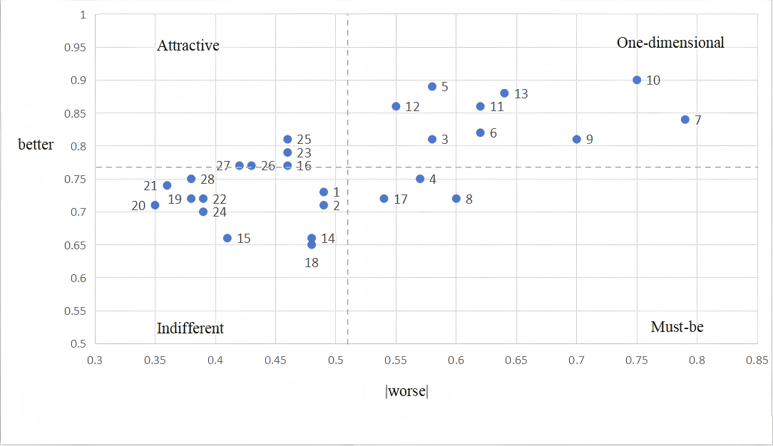
S1 Fig. Attributes on the better-worse plot. Each point represents one of the 28 health education demand items (numbered according to Table 3). The x-axis represents dissatisfaction impact (absolute value of the worse coefficient), and the y-axis represents satisfaction impact (better coefficient). Dashed lines indicate the median values of better and worse coefficients, dividing the plot into four quadrants. Quadrant I (upper right): One-dimensional (O) attributes-high satisfaction impact, high dissatisfaction impact. Quadrant II (upper left): Attractive (A) attributes-high satisfaction impact, low dissatisfaction impact. Quadrant III (lower left): Indifferent (I) attributes-low satisfaction impact, low dissatisfaction impact. Quadrant IV (lower right): Must-be (M) attributes-low satisfaction impact, high dissatisfaction impact.

