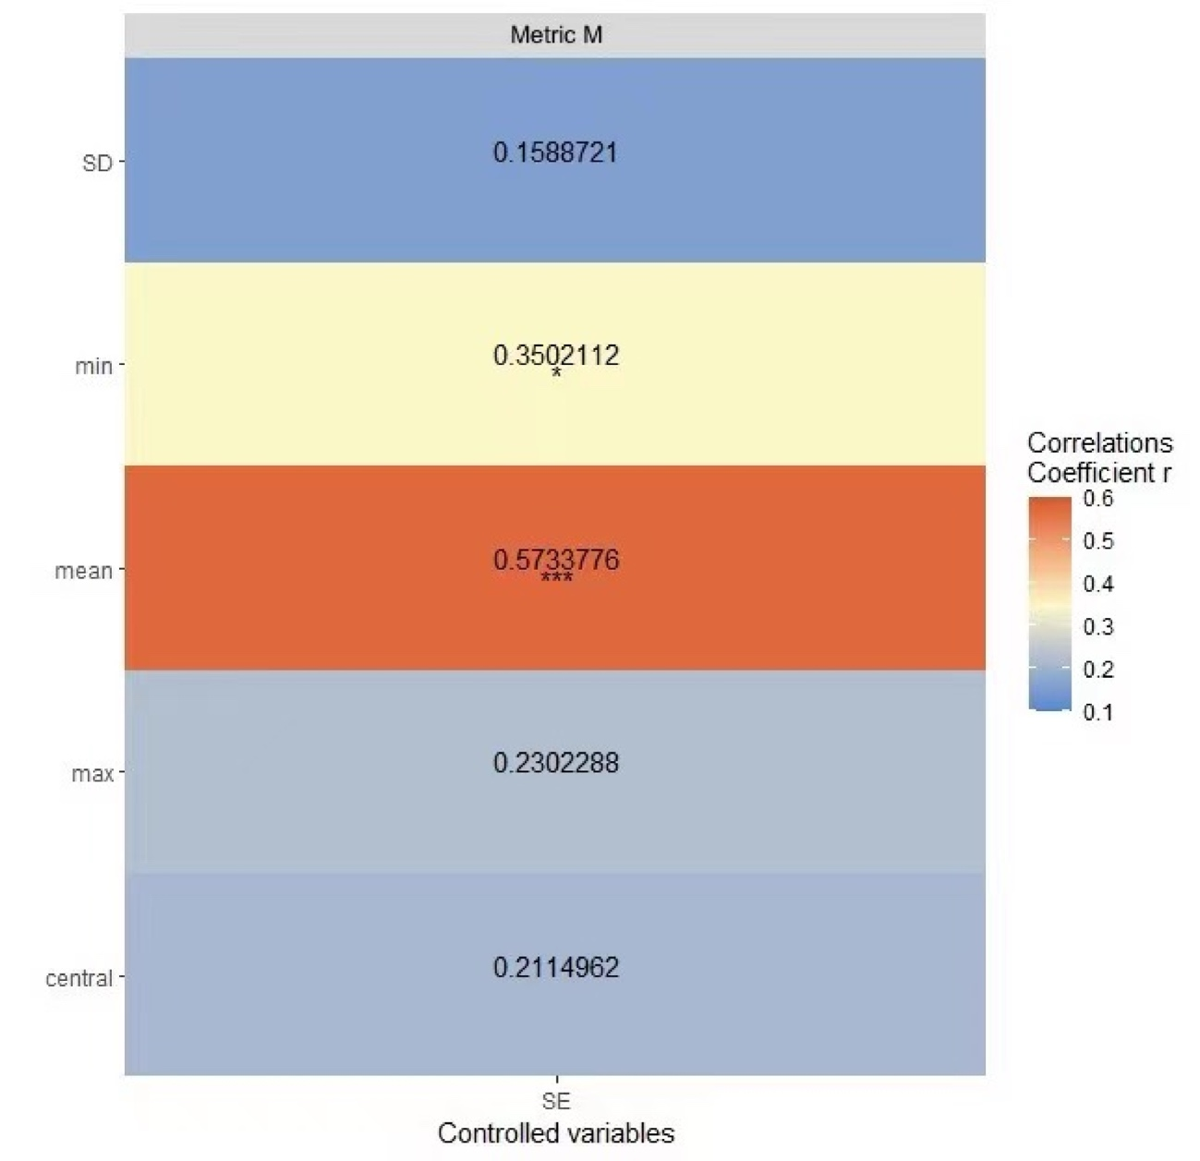

Supplemental Figure 1. Partial correlation analysis of corneal biomechanical Brillouin modulus changes and metric M, controlling for spherical equivalent. The Stripe color represents the numerical magnitude of the correlation coefficient r. The statistically significant results are denoted as follows: *P < 0.05, ***P < 0.001.

