Supplementary Figure 1. Double immunofluorescence staining of α7nAChR with NeuN, Iba1, and GFAP
1.1 Tissue Preparation
Mice were deeply anesthetized with intraperitoneal injection of 1% sodium pentobarbital (50 mg/kg) and transcardially perfused with saline followed by 4% paraformaldehyde. L4–L6 spinal cord segments were dissected, post-fixed in 4% paraformaldehyde for 4 hours, and cryoprotected by sequential immersion in 15% and 30% sucrose solutions (4°C, overnight each) until tissue sank. Segments were embedded in OCT compound (Sakura, Japan) and frozen at -80°C. Serial 10-μm sections of the spinal dorsal horn were cut using a cryostat (Leica CM1950) and mounted on slides.
1.2 Immunofluorescence Staining Protocol
All steps were performed at room temperature unless specified, with washes in PBST (0.1% Tween-20 in PBS) between incubations: Sections were treated with 3% hydrogen peroxide for 15 minutes to block endogenous peroxidase activity, then washed 3×5 minutes in PBST. Slides were incubated in 5% normal goat serum (Solarbio, China) in PBST for 1 hour to reduce non-specific binding. For α7nAChR/NeuN/Iba1/GFAP co-staining: Sections were incubated overnight at 4°C with rabbit anti-α7nAChR antibody (Abcam, 1:2000) and mouse anti-NeuN antibody (Proteintech, 1:2000)、mouse anti-Iba1 antibody (Abcam, 1:1000)、mouse anti-GFAP antibody (abcam, 1:1000) diluted in PBST containing 1% BSA. After 3×5-minute washes, sections were incubated with species-specific HRP-conjugated secondary antibodies (TSA kit, Aifang Biological, China) for 30 minutes. Finally, sections were cover-slipped with anti-fade mounting medium containing DAPI and imaged using an inverted fluorescence microscope (Leica DMI8).
1.3 Imaging and Colocalization Analysis
Colocalization quantification: Colocalization of α7nAChR with NeuN/Iba1/GFAP was analyzed using the JACoP plugin in ImageJ. Pearson's Coefficient were calculated:
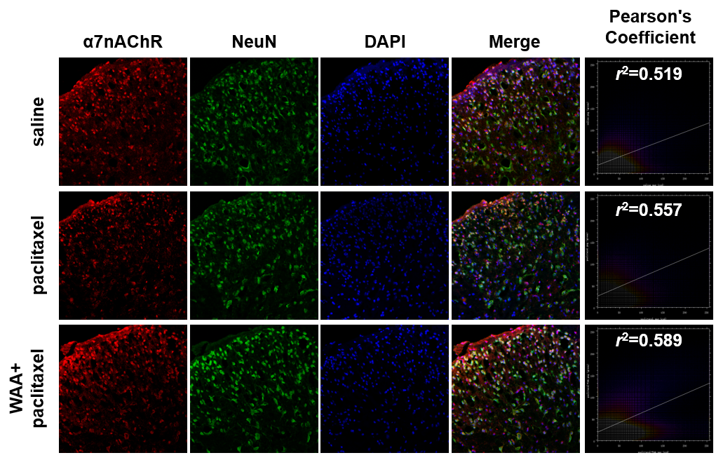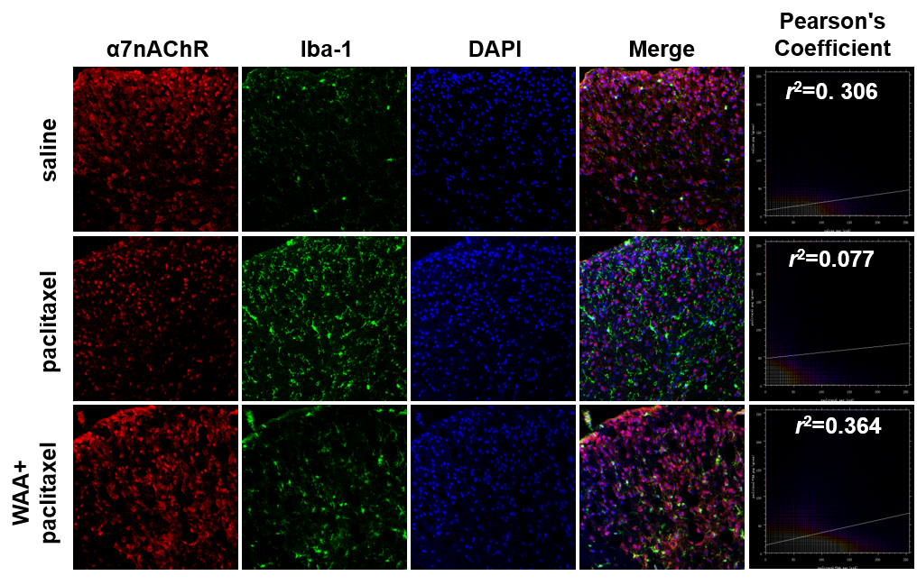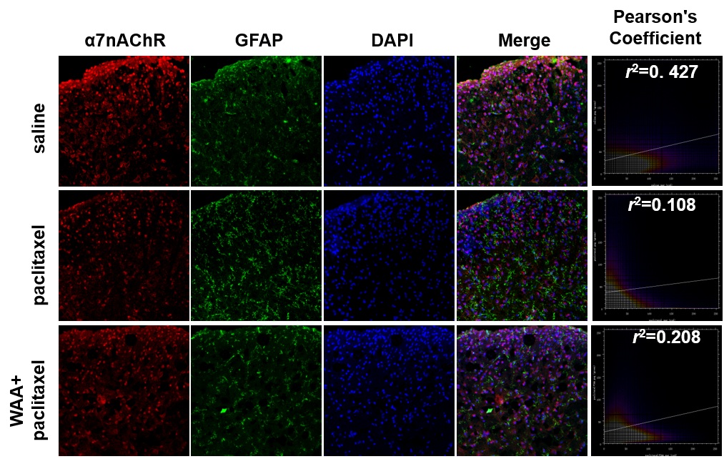

Supplementary Figure 2. c-fos immunoreactivity in the spinal dorsal horn.
Quantification of c-Fos fluorescence intensity (mean value, %, N = 3; F = 25.67, P < 0.01). Data are presented as mean ± SEM. **P < 0.01.
Immunofluorescence Staining for c-Fos
Blocking and pre-treatment: Sections were incubated with 3% hydrogen peroxide (15 min) and 5% normal goat serum (1 h) as described in the aforementioned protocol. Rabbit anti-c-Fos antibody (CST, 1:200) diluted in 1% BSA/PBST was applied overnight at 4°C. After 3×5-minute washes, sections were incubated with species-specific HRP-conjugated secondary antibodies (TSA kit, Aifang Biological, China) for 30 minutes, followed by 488-TSA fluorescent dye (green) for 5 min (TSA kit, Aifang Biological). Finally, sections were cover-slipped with anti-fade mounting medium containing DAPI and imaged using an inverted fluorescence microscope (Leica DMI8).
