Figure S1 The flow chart.
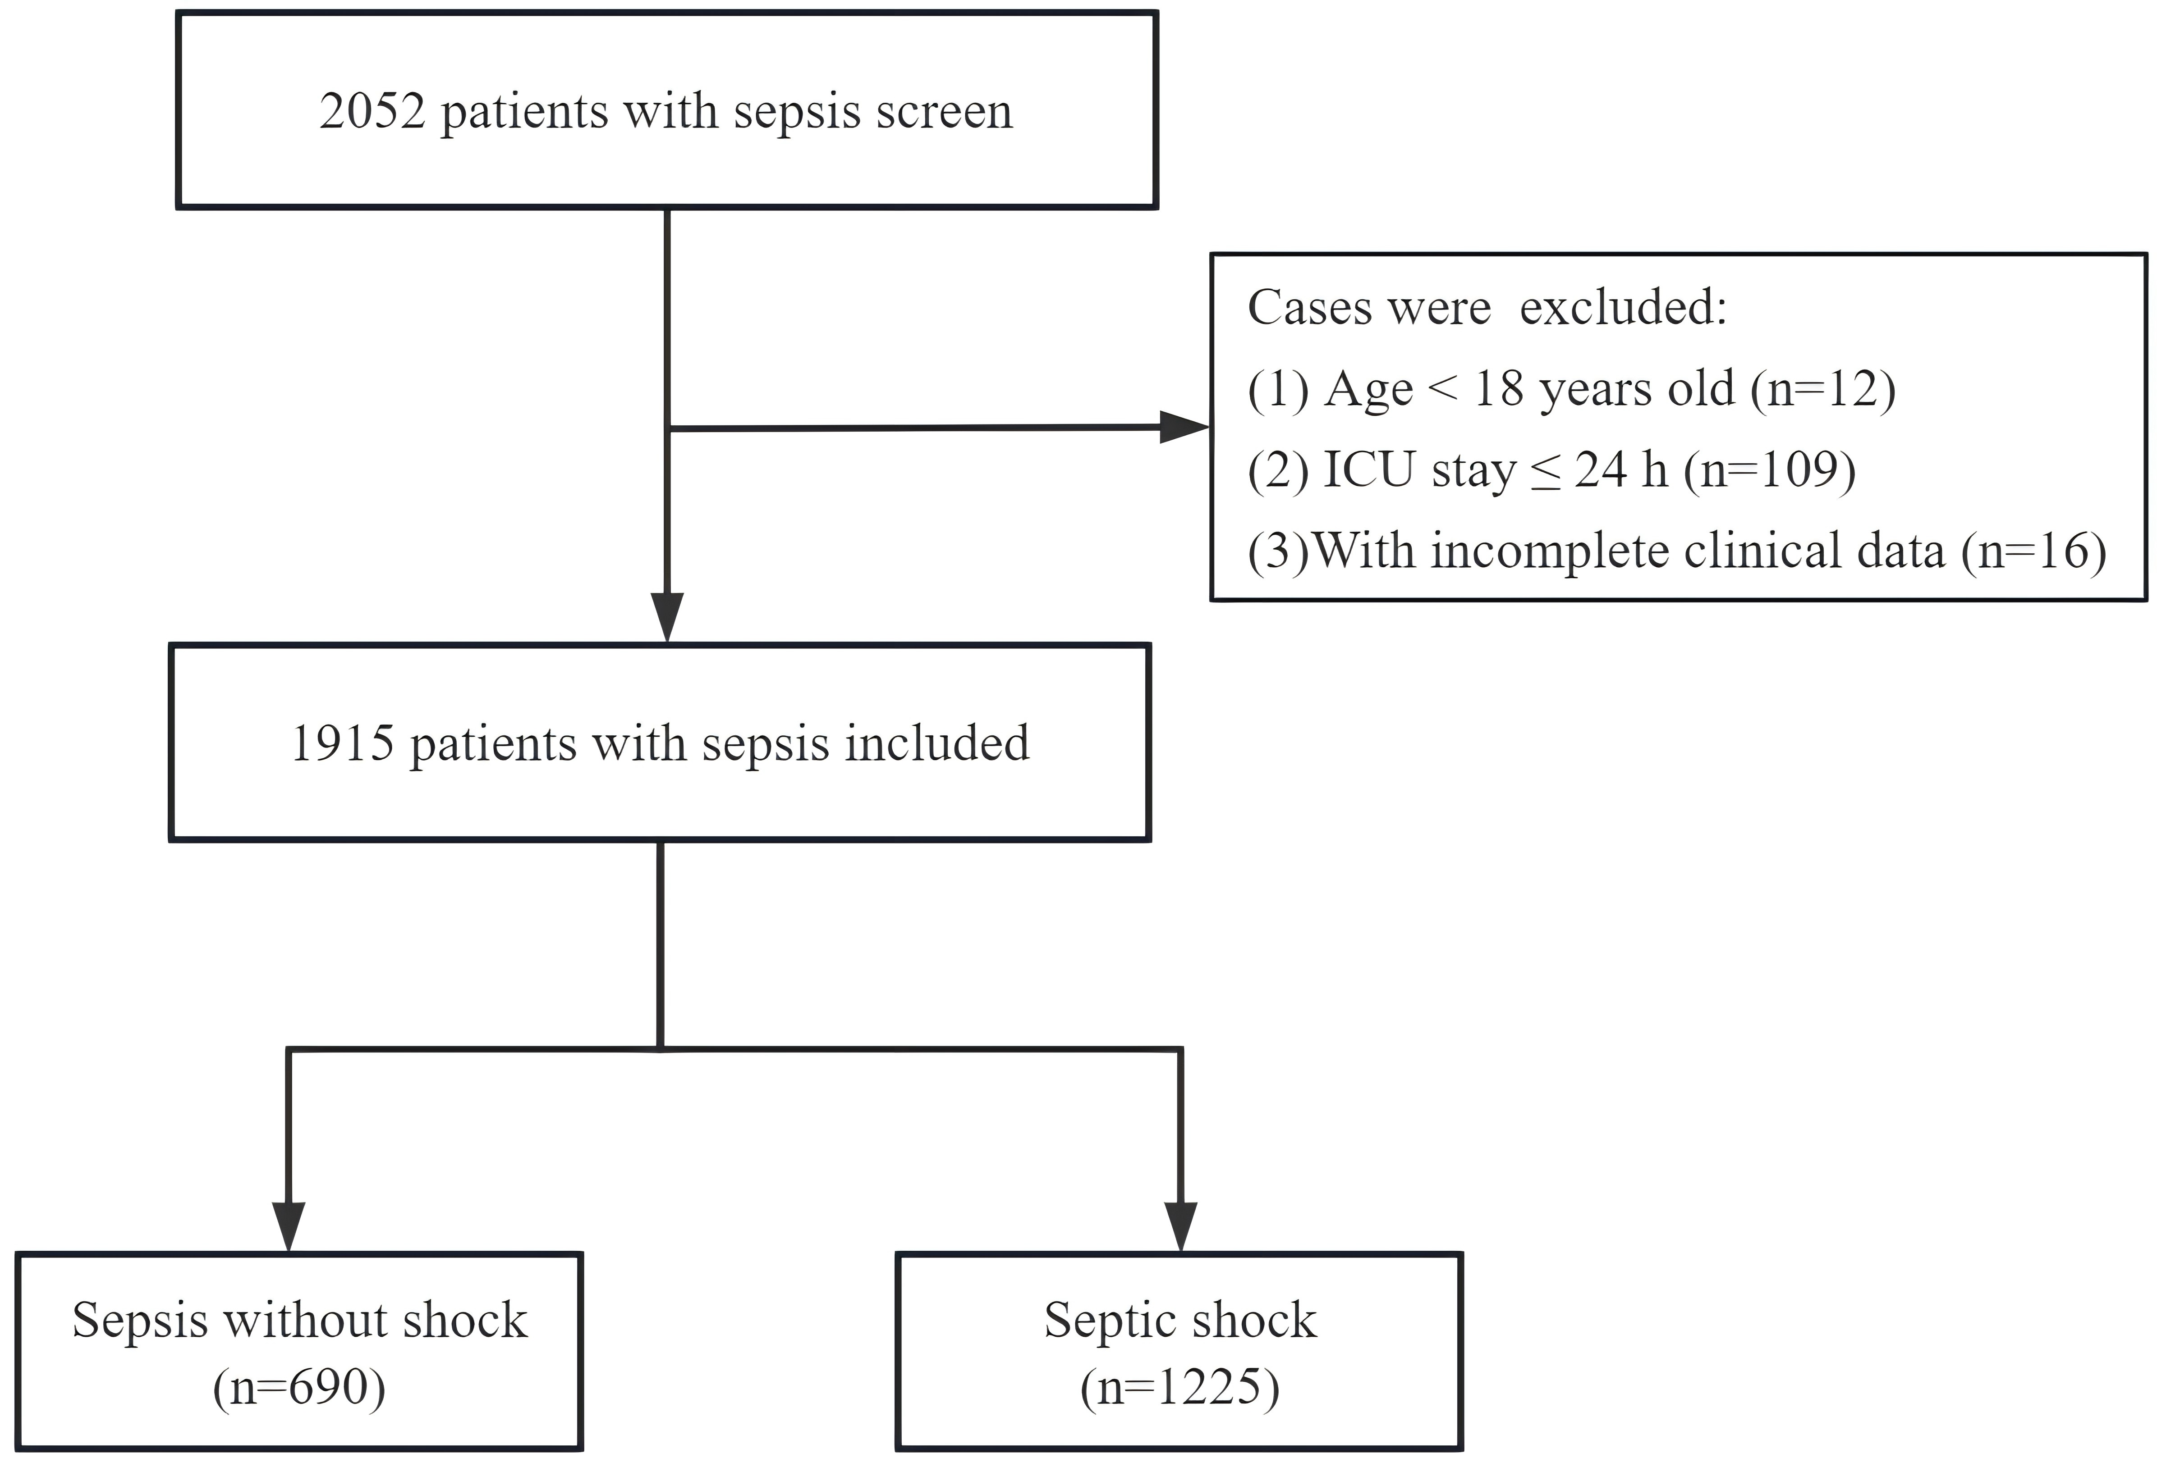
Figure S2 The association of PNI, NRI, and CONUT scores with ICU mortality in sepsis patients.
Figure S3 Cut-off values of PNI, NRI, and CONUT scores with ICU mortality in sepsis patients.

Figure S4 Venn diagram of the number of patients with malnutrition diagnosed using different diagnostic criteria.
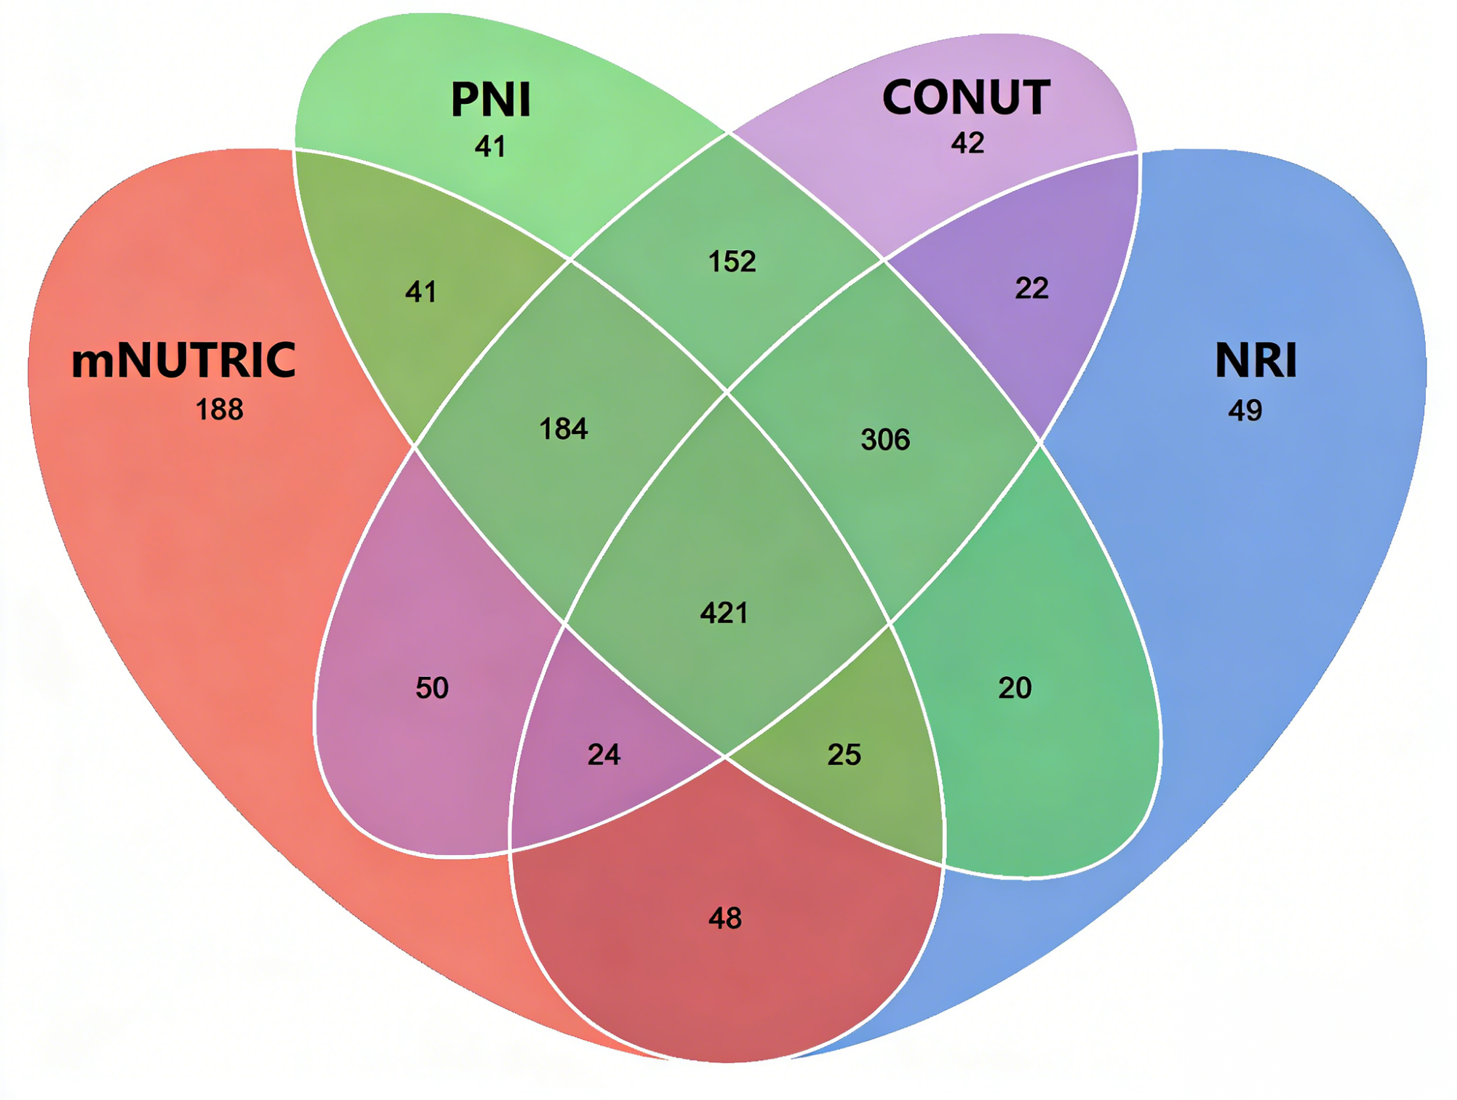
Figure S5 The Kaplan-Meier curves of sepsis patients with malnutrition and no malnutrition based on mNUTRIC index.
Notes: A. total population; B. patients with septic shock; C. patients with sepsis without shock.
Figure S6 The Kaplan-Meier curves of sepsis patients with malnutrition and no malnutrition based on PNI index.
Notes: A. total population; B. patients with septic shock; C. patients with sepsis without shock.
Figure S7 The Kaplan-Meier curves of sepsis patients with malnutrition and no malnutrition based on NRI index.
Notes: A. total population; B. patients with septic shock; C. patients with sepsis without shock.
Figure S8 The Kaplan-Meier curves of sepsis patients with malnutrition and no malnutrition based on CONUT index.
Notes: A. total population; B. patients with septic shock; C. patients with sepsis without shock.

Figure S9 The coefficient bar plot of LASSO regression.
Notes: The x-axis displays LASSO coefficient values, with red bars denoting positive correlations and blue bars denoting negative ones.
ANC: Absolute Neutrophil Count; BUN: Blood Urea Nitrogen; Hb: Hemoglobin; Lac: Lactate; PA: Prealbumin; PCT: Procalcitonin; PLT: Platelet; TG: Triglyceride

Figure S10 ROC analysis of nutrition-related indicators for discriminating ICU mortality in patients with sepsis by excluding patients with short-term deaths(72 hours).
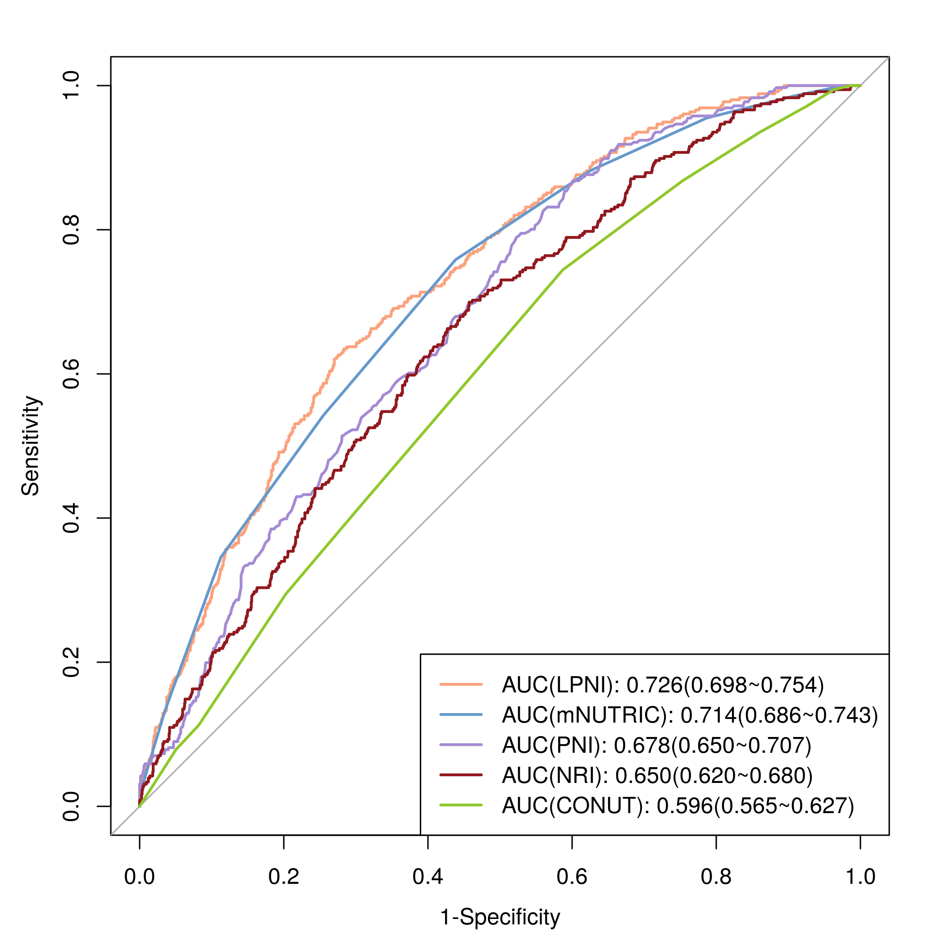

Figure S11 ROC analysis of nutrition-related indicators for discriminating ICU mortality in patients with sepsis.
Notes: A. train cohort; B. test cohort.

Table S1 Characteristics of sepsis patients grouped by LPNI-derived nutritional status
Variables | Total  (n = 1915) | No malnutrition  (n = 1555) | Malnutrition  (n = 360) | P
Age, years | 65.70 ± 16.44 | 65.87 ± 16.41 | 64.95 ± 16.59 | 0.340
Male sex, n(%) | 1258 (65.69) | 1029 (66.17) | 229 (63.61) | 0.356
BMI, kg/m² | 23.51 ± 4.12 | 23.63 ± 4.18 | 22.99 ± 3.83 | 0.009
Presumed site of infection causing sepsis, n(%) |  |  |  | <0.001
Respiratory tract | 1006 (52.53) | 851 (54.73) | 155 (43.06)
Intra-abdominal | 530 (27.68) | 391 (25.14) | 139 (38.61)
Urinary tract | 155 (8.09) | 130 (8.36) | 25 (6.94)
Bloodstream | 67 (3.50) | 55 (3.54) | 12 (3.33)
Skin and soft tissue | 59 (3.08) | 47 (3.02) | 12 (3.33)
Central nervous system | 53 (2.77) | 46 (2.96) | 7 (1.94)
Other | 45 (2.35) | 35 (2.25) | 10 (2.78)
Septic shock, n(%) | 1225 (63.97) | 927 (59.61) | 298 (82.78) | <0.001
APACHE II score | 19.00 (14.00, 25.00) | 18.00 (13.00, 23.00) | 23.00 (17.00, 30.00) | <0.001
SOFA score | 7.00 (4.00, 10.00) | 7.00 (4.00, 9.00) | 10.00 (7.00, 13.00) | <0.001
Comorbid conditions, n(%)
Hypertension | 975 (50.91) | 801 (51.51) | 174 (48.33) | 0.277
Cerebrovascular disease, n(%) | 597 (31.17) | 499 (32.09) | 98 (27.22) | 0.072
Diabetes mellitus | 547 (28.56) | 440 (28.30) | 107 (29.72) | 0.589
Solid tumor, n(%) | 371 (19.37) | 276 (17.75) | 95 (26.39) | <0.001
Chronic kidney disease, n(%) | 335 (17.49) | 234 (15.05) | 101 (28.06) | <0.001
Coronary artery disease | 334 (17.44) | 277 (17.81) | 57 (15.83) | 0.372
Chronic pulmonary disease, n(%) | 200 (10.44) | 168 (10.80) | 32 (8.89) | 0.284
CCI score | 2 (1, 3) | 2 (0, 3) | 2 (1, 3) | <0.001
Mechanical ventilation, n(%) | 1797 (93.84) | 1452 (93.38) | 345 (95.83) | 0.081
CRRT, n(%) | 465 (24.28) | 361 (23.22) | 104 (28.89) | 0.024
ECMO, n(%) | 83 (4.33) | 64 (4.12) | 19 (5.28) | 0.329
ICU length of stay, days | 9.07 (4.37, 16.74) | 9.60 (4.74, 17.61) | 6.79 (3.12, 14.83) | <0.001
28-d ICU-free days | 15.00 (0.00, 22.00) | 16.38 (0.00, 22.94) | 0.00 (0.00, 19.56) | <0.001
ICU mortality, n(%) | 423 (22.09) | 243 (15.63) | 180 (50.00) | <0.001
Abbreviations: BMI, body mass index; APACHE II, acute physiology and chronic health evaluation II; SOFA, sequential organ failure assessment; CCI, charlson comorbidity index; CRRT, continuous renal replacement therapy; ECMO, extracorporeal membrane oxygenation; ICU, intensive care unit.

